**SQL – Assignment 2**

**Title: Analyzing Game Sales Across Regions and Platforms**

1. Insert a new game with the title "Future Racing", genre "Racing", release date "2024-10-01", and developer "Speed Studios".

Sol)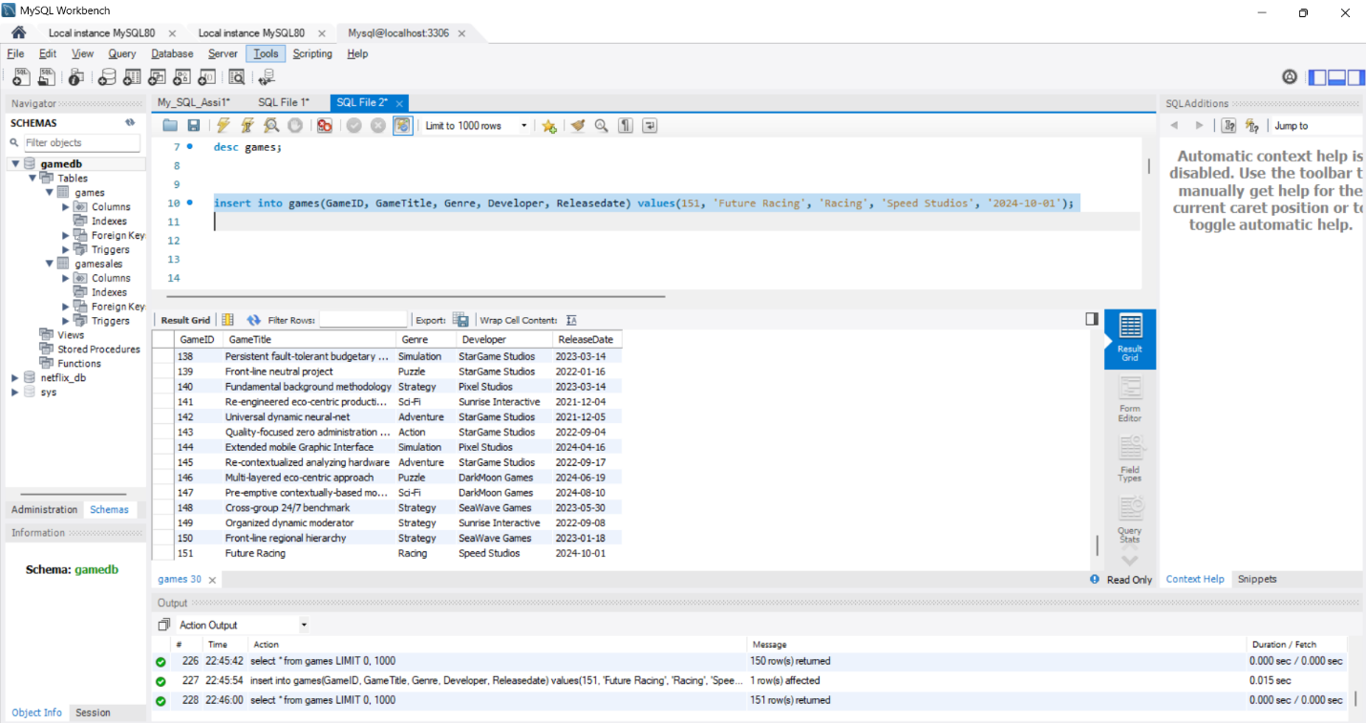

1. Update the price of the game with GameID 2 on the PlayStation platform to 60.

Sol)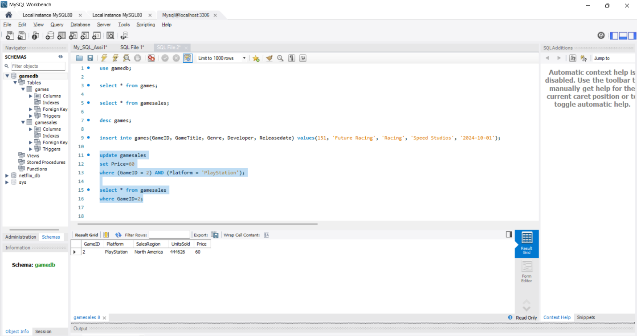

1. Delete the record of the game with GameID 5 from the Game Sales table.

Sol)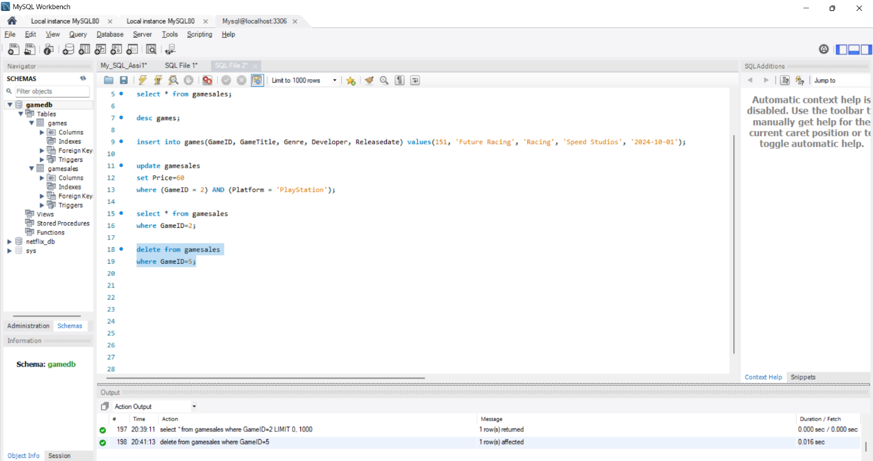

1. Calculate the total number of units sold for each game across all platforms and regions.

Sol)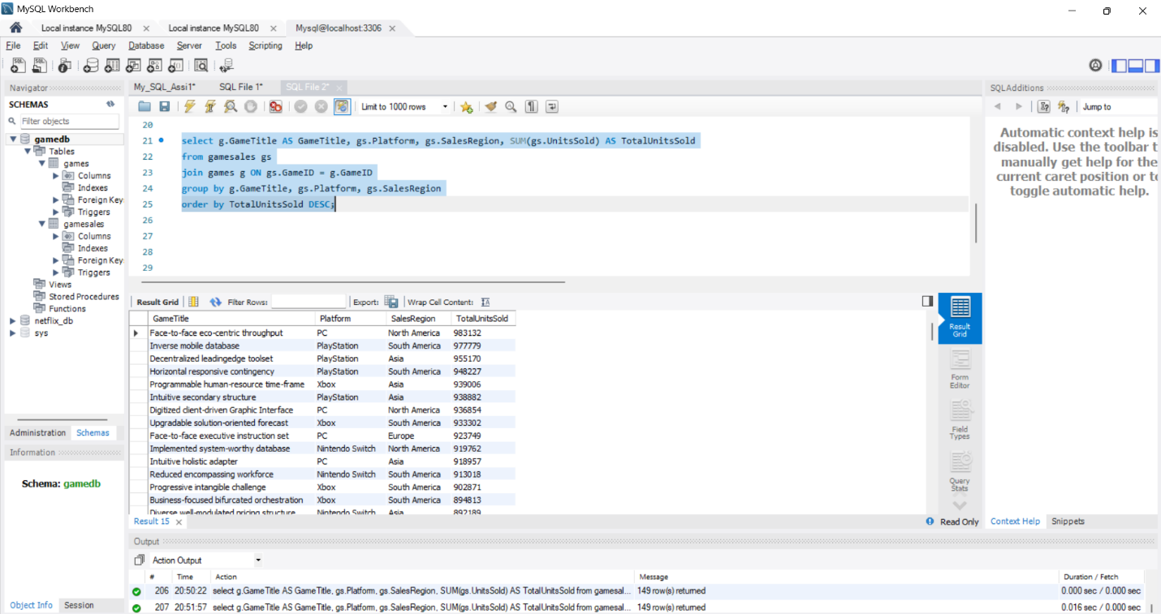

1. Identify the game with the highest number of units sold in North America.

Sol)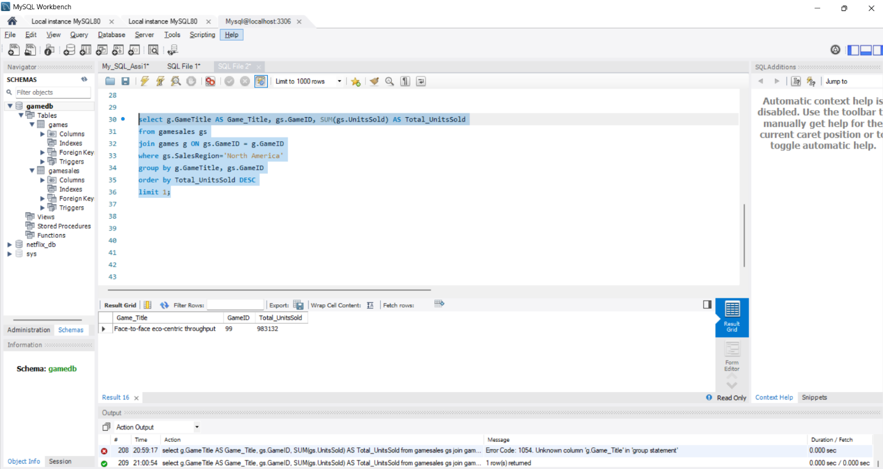

1. Get the game titles, platforms, and sales regions along with the units sold for each game.

Sol)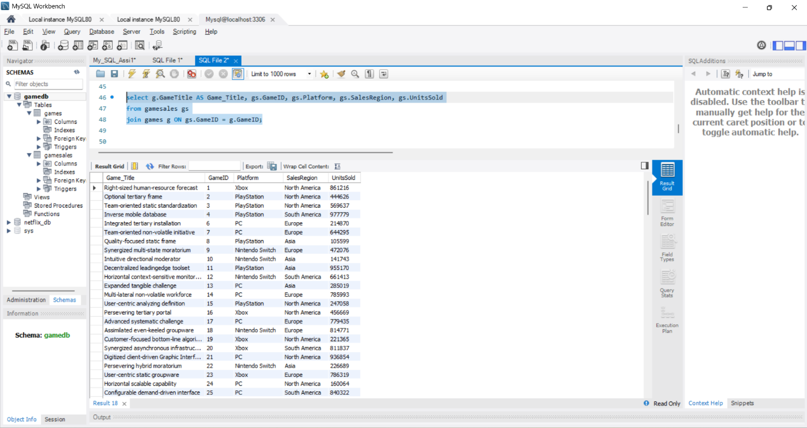

1. Find all games, including those that have no sales data in the Game Sales table.

Sol)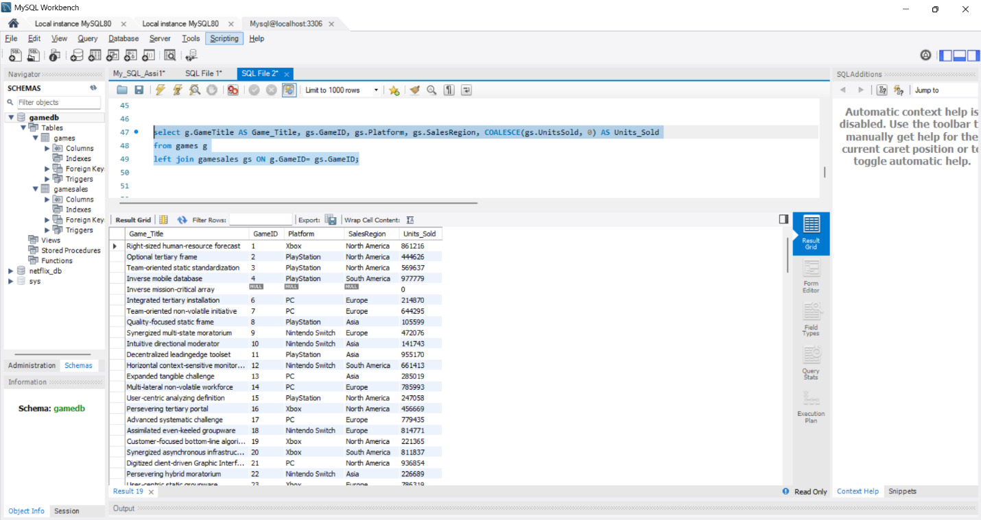

1. Retrieve sales records where the game details are missing in the Games table.

Sol)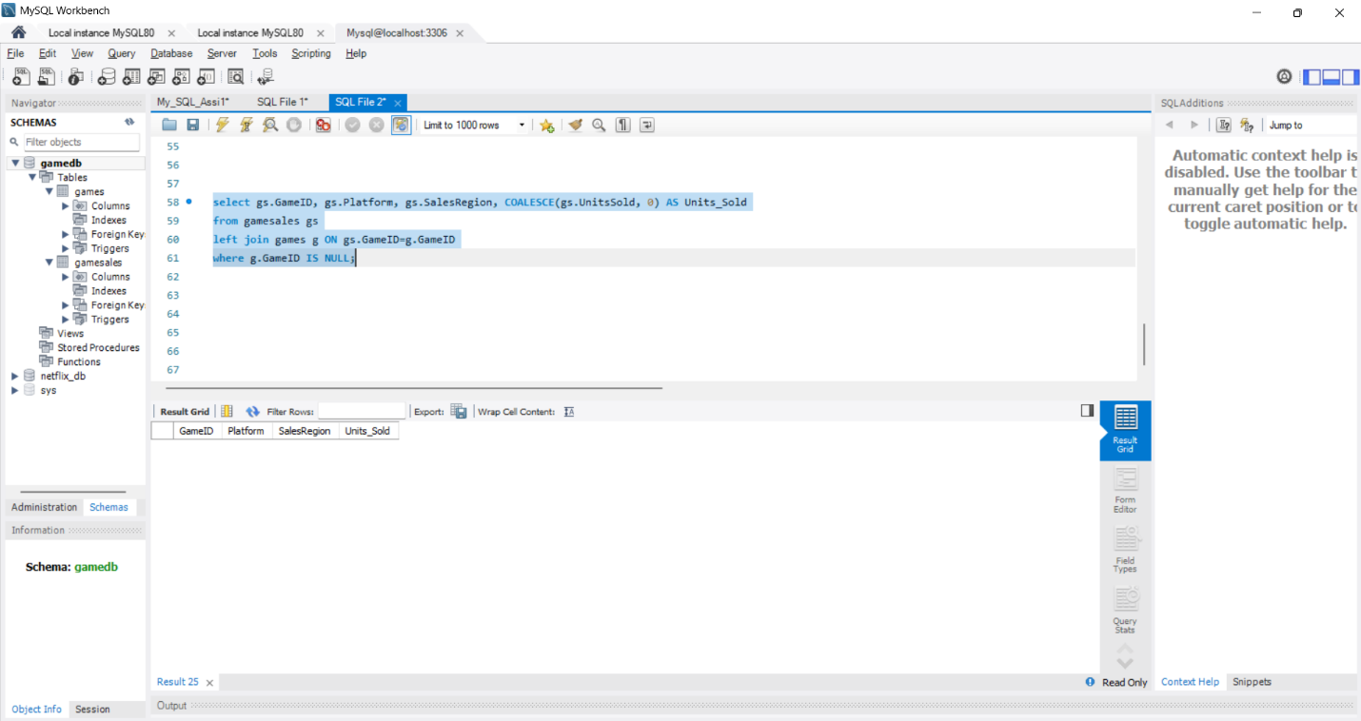

* **Since no rows are returned, all the games in gamesales table have corresponding entries in games table. This is good data integrity.**

1. Retrieve game sales data for North America and Europe removing duplicate records.

Sol)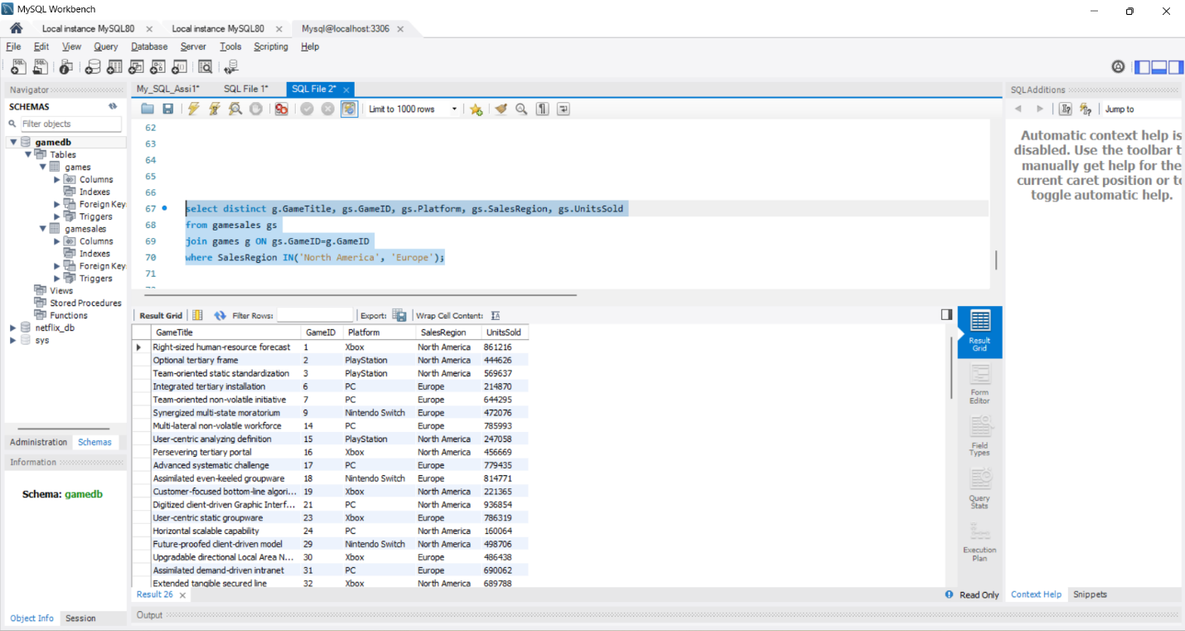

* **I have used distinct keyword to select the distinct rows as we need to avoid the duplicates.**

10.Retrieve all game sales data from North America and Europe without removing duplicate records.

Sol)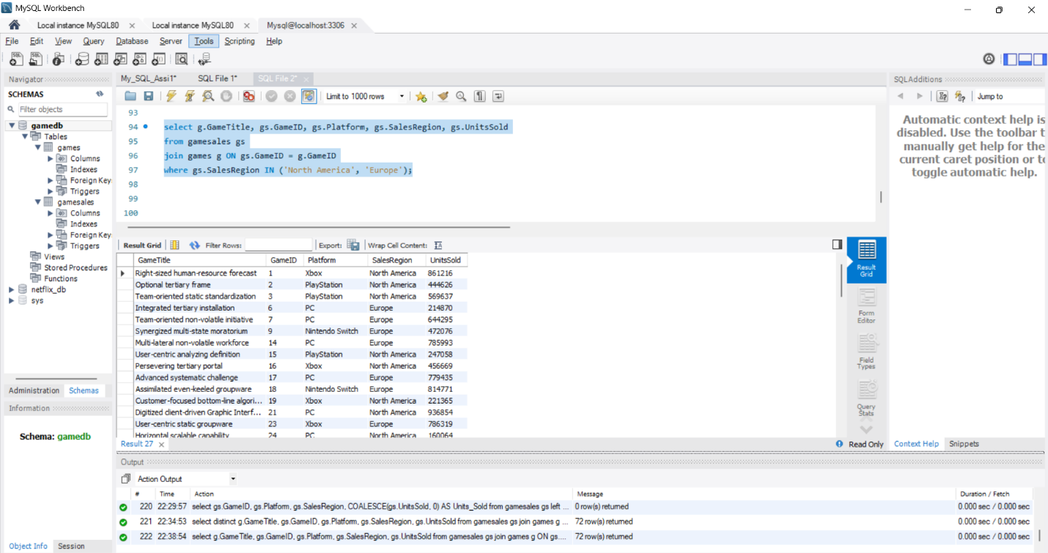

* **Just as before, but this time without the keyword ‘distinct’ as duplicates are allowed.**