
MINISTRY OF EDUCATION, CULTURE AND RESEARCH
OF THE REPUBLIC OF MOLDOVA
Technical University of Moldova
Faculty of Computers, Informatics and Microelectronics
Department of Software Engineering and Automation

Report
on laboratory work no. 2
of Cryptography and Security
Topic: Cryptanalysis of Monoalphabetic Ciphers

Done by: st. gr. FAF-243, Augustin Carazanu
Checked by: assist. univ. Maia Zaica
FCIM, UTM

Chișinău – 2026
Purpose of the work
The purpose of this laboratory work is to break a monoalphabetic substitution cipher with a frequency-analysis attack. The intercepted message (variant 3) is known to be English text in which only the letters were encrypted; spaces, digits and punctuation were left as they are. To support the analysis I wrote a small Python program with a Tkinter interface that counts the letter frequencies, compares them with English, shows the most frequent digrams and trigrams, and applies a partial key to the ciphertext after every guess.
1. Short theory
In a monoalphabetic cipher every plaintext letter is always replaced by the same ciphertext letter. The substitution hides the letters, but not their frequencies: the most frequent symbol in the ciphertext is very probably the image of one of the most frequent letters of the language. For English the frequencies are given in Table 1.1.
Table 1.1 – Letter frequencies of the English language, %
Letter | A | B | C | D | E | F | G | H | I | J | K | L | M
% | 8.17 | 1.49 | 2.78 | 4.25 | 12.70 | 2.23 | 2.01 | 6.09 | 6.97 | 0.15 | 0.77 | 4.03 | 2.41

Letter | N | O | P | Q | R | S | T | U | V | W | X | Y | Z
% | 6.75 | 7.51 | 1.93 | 0.09 | 5.99 | 6.33 | 9.06 | 2.76 | 0.98 | 2.36 | 0.15 | 1.97 | 0.07

Replacing the letters only by their rank in this table almost never gives the plaintext directly, because a particular text does not follow the average frequencies exactly. The cryptanalyst therefore also uses other properties of the language: the most common digrams (TH, HE, AN, IN, ER, ON, RE), trigrams (THE, AND, ING, ENT, ION), the one-letter words (A and I), the frequent short words (OF, TO, IN, IS, THE, AND) and, after a few substitutions, partly solved words whose missing letters can be guessed from the context. Every guess is checked against the rest of the text; a wrong guess quickly produces impossible words.
2. The task (variant 3)
The intercepted ciphertext has 2457 letters. Its first lines are:
Unsfaxdp tgo nwqvip gvkvi ptxo rqvwqvi tgf nc wqv pdapwxwdwxnghxuqvip wqvf
ovphixavo rviv thwdtssf dpvo, tgo pn wqv cxipw twwvpwvo dpv ncwqtw jvgiv xg
unsxwxhts tcctxip hnzv cinz wqv Inztgp — tgo cinz wqv jivtwvpw Inztg nc wqvz
tss. EdsxdpHtvpti wqdp xzuivppvo qxp gtzv uviztgvgwsf xgwn hifuwnsnjf.Xw zdpw av
wqtw tp pnng tp t hdswdiv qtp ivthqvo t hviwtxg svkvs,uinatasf zvtpdivo stijvsf
af xwp sxwvithf, hifuwnjituqf tuuvtippungwtgvndpsf — tp xwp utivgwp, stgjdtjv
[...]

As in the lab example, during the attack the letters that are already solved are written in lowercase and the cipher letters that are not solved yet stay in UPPERCASE.
3. Implementation
The program has two files. analysis.py contains the counting and substitution functions, and gui.py contains the Tkinter window. The window shows the ciphertext, a bar chart that compares its letter frequencies with English, a table of the letters sorted by frequency, the most frequent digrams and trigrams, 26 fields for the key and the partly decrypted text, which is updated after every change of the key.
3.1. Counting the frequencies
def letters(text):
"""Only the Latin letters of the text, in uppercase."""
return [ch.upper() for ch in text if ch.upper() in ALPHABET]

def frequencies(text):
"""Return {letter: (count, percent)} for all 26 letters."""
found = letters(text)
total = len(found) or 1
cnt = Counter(found)
return {ch: (cnt[ch], 100 * cnt[ch] / total) for ch in ALPHABET}

def sorted_by_frequency(freq):
"""Letters in decreasing order of frequency (ties in alphabetical order)."""
return sorted(ALPHABET, key=lambda ch: (-freq[ch][0], ch))

frequencies() counts only the Latin letters, ignoring the case, and returns the count and the percentage of each letter. sorted_by_frequency() gives the letters in decreasing order of frequency, which is used for Table 4.2 and for the first, naive guess of the key.
3.2. Digrams, trigrams and short words
def ngrams(text, n, top=10):
"""Most frequent letter n-grams that stay inside one word."""
cnt = Counter()
for word in "".join(ch.upper() if ch.isalpha() else " " for ch in text).split():
for i in range(len(word) - n + 1):
cnt[word[i:i + n]] += 1
return cnt.most_common(top)

def words_of_length(text, n, top=10):
"""Most frequent cipher words that have exactly n letters."""
cnt = Counter(w for w in "".join(ch.upper() if ch.isalpha() else " " for ch in text).split()
if len(w) == n)
return cnt.most_common(top)

ngrams() counts the letter groups that stay inside one word, and words_of_length() finds the most frequent cipher words of a given length. They are the main clues for the letters that cannot be decided from frequencies alone.
3.3. Applying a partial key
def apply_key(text, key):
"""Replace the cipher letters found in `key` (cipher -> plain).

As in the lab example, a recovered letter is written in lowercase and a
cipher letter that is not solved yet stays in UPPERCASE, so the two can be
told apart while the text is being broken.
"""
out = []
for ch in text:
up = ch.upper()
if up in ALPHABET:
out.append(key[up].lower() if key.get(up) else up)
else:
out.append(ch)
return "".join(out)

apply_key() replaces only the cipher letters that already have a value in the key. Solved letters are written in lowercase and the others stay in uppercase, exactly like the intermediate texts of the lab example, so it is easy to see which words are almost solved.
3.4. Checking the key
def check_key(key):
"""Return an error message if two cipher letters map to the same plain letter."""
used = {}
for c, p in key.items():
if not p:
continue
if len(p) != 1 or p.upper() not in ALPHABET:
return f"'{p}' is not a letter (cipher letter {c})."
p = p.upper()
if p in used:
return f"Plain letter {p} is used twice: for {used[p]} and for {c}."
used[p] = c
return None

Because the cipher is a one-to-one substitution, two different cipher letters cannot correspond to the same plaintext letter. check_key() detects such a mistake and the GUI shows it in red (Figure 3.1).
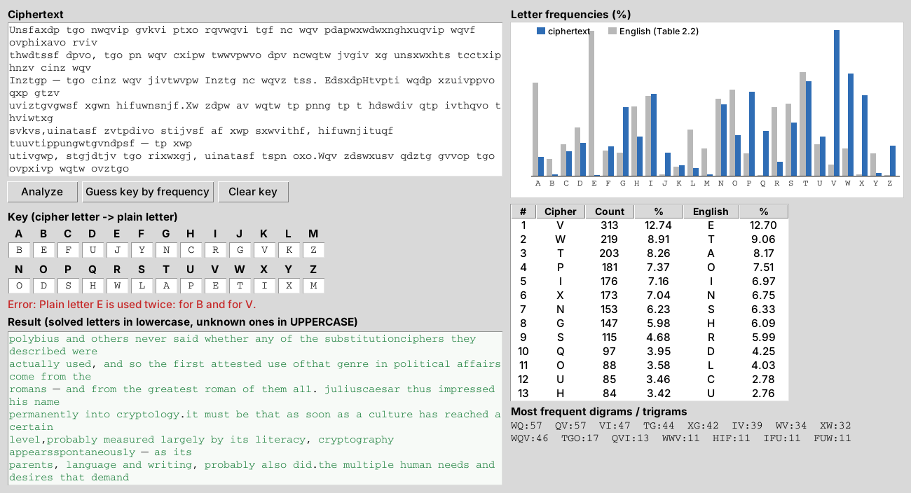
Figure 3.1 – The GUI rejects a key in which the plaintext letter E is used twice
4. Breaking the cipher
4.1. Letter frequencies
The first step is to find the frequencies of all the letters in the ciphertext (Table 4.1).
Table 4.1 – Letter frequencies in the intercepted ciphertext
Letter | A | B | C | D | E | F | G | H | I | J | K | L | M
Count | 41 | 3 | 52 | 70 | 2 | 63 | 147 | 84 | 176 | 50 | 22 | 16 | 3
% | 1.67 | 0.12 | 2.12 | 2.85 | 0.08 | 2.56 | 5.98 | 3.42 | 7.16 | 2.04 | 0.90 | 0.65 | 0.12

Letter | N | O | P | Q | R | S | T | U | V | W | X | Y | Z
Count | 153 | 88 | 181 | 97 | 30 | 115 | 203 | 85 | 313 | 219 | 173 | 6 | 65
% | 6.23 | 3.58 | 7.37 | 3.95 | 1.22 | 4.68 | 8.26 | 3.46 | 12.74 | 8.91 | 7.04 | 0.24 | 2.65

For convenience the table is sorted in decreasing order of frequency and placed next to the English letters of the same rank (Table 4.2).
Table 4.2 – Ciphertext letters sorted by frequency, next to the English order
Cipher | V | W | T | P | I | X | N | G | S | Q | O | U | H
% | 12.74 | 8.91 | 8.26 | 7.37 | 7.16 | 7.04 | 6.23 | 5.98 | 4.68 | 3.95 | 3.58 | 3.46 | 3.42
English | E | T | A | O | I | N | S | H | R | D | L | C | U
% | 12.70 | 9.06 | 8.17 | 7.51 | 6.97 | 6.75 | 6.33 | 6.09 | 5.99 | 4.25 | 4.03 | 2.78 | 2.76

Cipher | D | Z | F | C | J | A | R | K | L | Y | B | M | E
% | 2.85 | 2.65 | 2.56 | 2.12 | 2.04 | 1.67 | 1.22 | 0.90 | 0.65 | 0.24 | 0.12 | 0.12 | 0.08
English | M | W | F | G | Y | P | B | V | K | J | X | Q | Z
% | 2.41 | 2.36 | 2.23 | 2.01 | 1.97 | 1.93 | 1.49 | 0.98 | 0.77 | 0.15 | 0.15 | 0.09 | 0.07

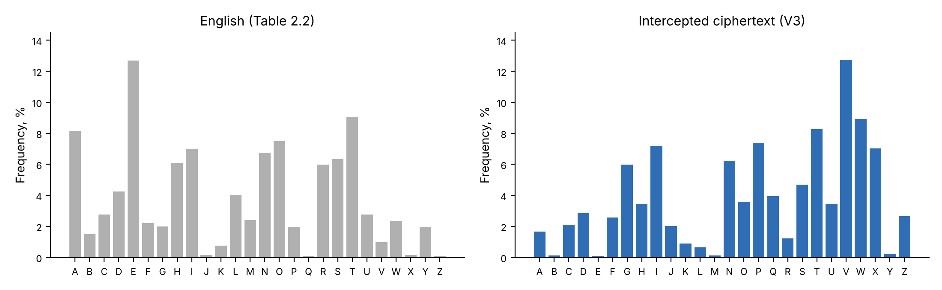
Figure 4.1 – Letter frequencies of English (left) and of the intercepted message (right)
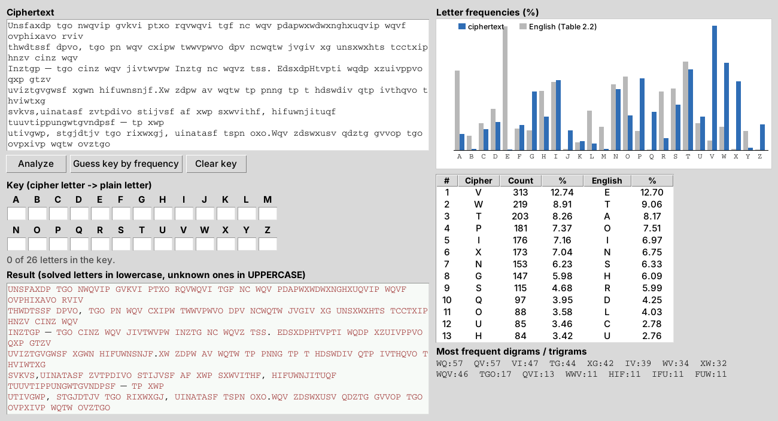
Figure 4.2 – The ciphertext loaded in the program, with its frequency chart and table
The most frequent digrams are WQ (57), QV (57), VI (47), TG (44), XG (42), IV (39), WV (34), XW (32), and the most frequent trigrams are WQV (46), TGO (17), QVI (13), WWV (11), HIF (11), IFU (11), FUW (11), WVI (11).
If all the letters are simply replaced according to their rank (V→E, W→T, T→A, P→O, …), the result is not readable, as Figure 4.3 shows. It is only a starting point, so the key has to be built step by step, using the frequencies together with the structure of the words.
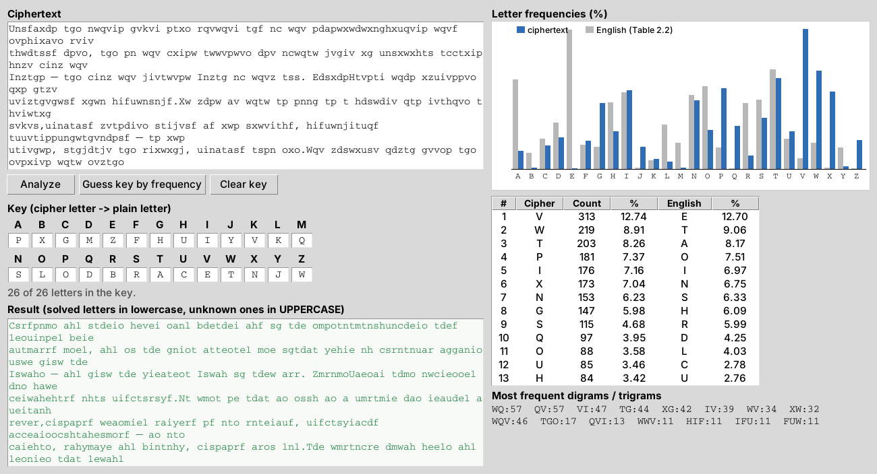
Figure 4.3 – A key taken only from the frequency ranks does not give readable text
4.2. Step 1 – E and T
The most frequent letter of the ciphertext is “V” (12.74 %), followed by “W” (8.91 %). These values are very close to the frequencies of “e” (12.70 %) and “t” (9.06 %) in English, so we assume V→e and W→t:
UNSFAXDP TGO NtQeIP GeKeI PTXO RQetQeI TGF NC tQe PDAPtXtDtXNGHXUQeIP tQeF
OePHIXAeO ReIe THtDTSSF DPeO, TGO PN tQe CXIPt TttePteO DPe NCtQTt JeGIe XG
UNSXtXHTS TCCTXIP HNZe CINZ tQe INZTGP — TGO CINZ tQe JIeTtePt INZTG NC tQeZ
TSS. EDSXDPHTePTI tQDP XZUIePPeO QXP GTZe UeIZTGeGtSF XGtN HIFUtNSNJF.Xt ZDPt Ae
tQTt TP PNNG TP T HDStDIe QTP IeTHQeO T HeItTXG SeKeS,UINATASF ZeTPDIeO STIJeSF
AF XtP SXteITHF, HIFUtNJITUQF TUUeTIPPUNGtTGeNDPSF — TP XtP UTIeGtP, STGJDTJe
[...]

4.3. Step 2 – H, from the word “the”
The trigram “WQV” is by far the most frequent one (46 times), and “WQV” is also the most frequent three-letter word (28 times). After the first step it reads “tQe”. The most common word of three letters in English is “the”, so Q→h. This also agrees with the frequent digrams WQ and QV (th and he):
UNSFAXDP TGO NtheIP GeKeI PTXO RhetheI TGF NC the PDAPtXtDtXNGHXUheIP theF
OePHIXAeO ReIe THtDTSSF DPeO, TGO PN the CXIPt TttePteO DPe NCthTt JeGIe XG
UNSXtXHTS TCCTXIP HNZe CINZ the INZTGP — TGO CINZ the JIeTtePt INZTG NC theZ
TSS. EDSXDPHTePTI thDP XZUIePPeO hXP GTZe UeIZTGeGtSF XGtN HIFUtNSNJF.Xt ZDPt Ae
thTt TP PNNG TP T HDStDIe hTP IeTHheO T HeItTXG SeKeS,UINATASF ZeTPDIeO STIJeSF
AF XtP SXteITHF, HIFUtNJITUhF TUUeTIPPUNGtTGeNDPSF — TP XtP UTIeGtP, STGJDTJe
[...]

4.4. Step 3 – A, N and D, from the words “a” and “and”
The only frequent one-letter word in the ciphertext is “T” (10 times), and in English it can only be “a” or “I”. The frequency of T (8.26 %) is very close to that of “a” (8.17 %), so T→a. The second most frequent three-letter word, “TGO” (10 times), now reads “aGO”, which suggests “and”, so G→n and O→d:
UNSFAXDP and NtheIP neKeI PaXd RhetheI anF NC the PDAPtXtDtXNnHXUheIP theF
dePHIXAed ReIe aHtDaSSF DPed, and PN the CXIPt attePted DPe NCthat JenIe Xn
UNSXtXHaS aCCaXIP HNZe CINZ the INZanP — and CINZ the JIeatePt INZan NC theZ
aSS. EDSXDPHaePaI thDP XZUIePPed hXP naZe UeIZanentSF XntN HIFUtNSNJF.Xt ZDPt Ae
that aP PNNn aP a HDStDIe haP IeaHhed a HeItaXn SeKeS,UINAaASF ZeaPDIed SaIJeSF
AF XtP SXteIaHF, HIFUtNJIaUhF aUUeaIPPUNntaneNDPSF — aP XtP UaIentP, SanJDaJe
[...]

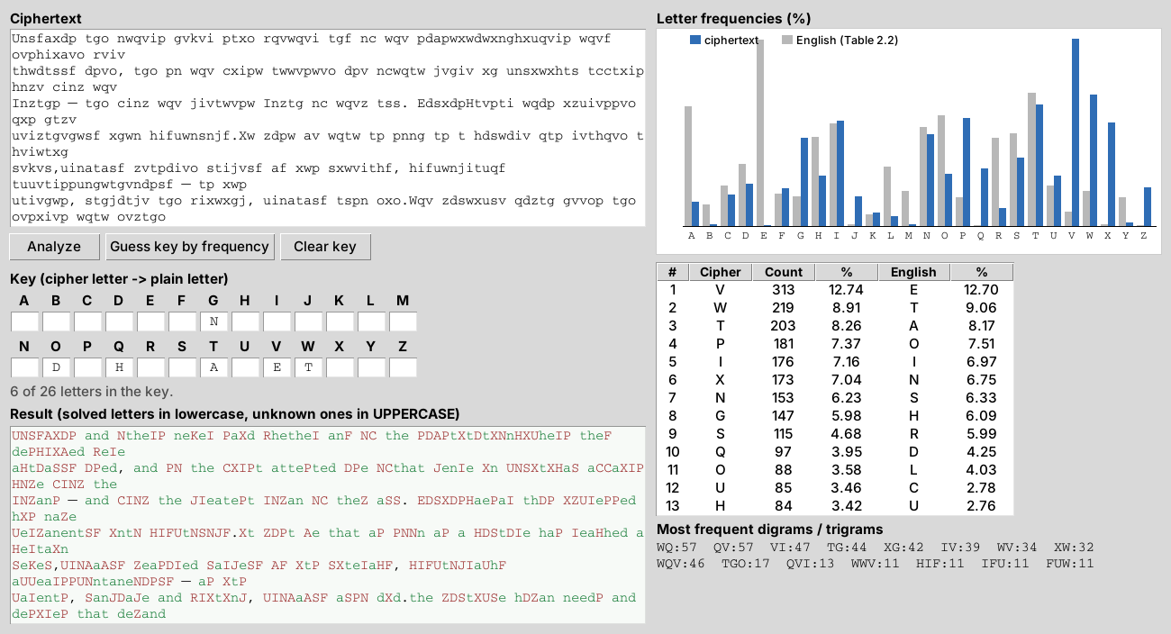
Figure 4.4 – The program after step 3: six letters of the key are known
4.5. Step 4 – O and F, from the word “of”
The most frequent two-letter word is “NC” (16 times). It usually stands right before “the”: “NC the”. The obvious candidate is “of the”, so N→o and C→f. The frequency of N (6.23 %) also fits “o” well:
UoSFAXDP and otheIP neKeI PaXd RhetheI anF of the PDAPtXtDtXonHXUheIP theF
dePHIXAed ReIe aHtDaSSF DPed, and Po the fXIPt attePted DPe ofthat JenIe Xn
UoSXtXHaS affaXIP HoZe fIoZ the IoZanP — and fIoZ the JIeatePt IoZan of theZ
aSS. EDSXDPHaePaI thDP XZUIePPed hXP naZe UeIZanentSF Xnto HIFUtoSoJF.Xt ZDPt Ae
that aP Poon aP a HDStDIe haP IeaHhed a HeItaXn SeKeS,UIoAaASF ZeaPDIed SaIJeSF
AF XtP SXteIaHF, HIFUtoJIaUhF aUUeaIPPUontaneoDPSF — aP XtP UaIentP, SanJDaJe
[...]

4.6. Step 5 – I, S and R
The second most frequent two-letter word, “XG” (15 times), now reads “Xn”. The best fit is “in”, so X→i (7.04 % against 6.97 %). The fragment “the fXIPt attePted DPe” then becomes “the fiIPt …”, which can only be “the first”, giving I→r and P→s. The word “Pa?d” becomes “said” and “otheIP” becomes “others”:
UoSFAiDs and others neKer said Rhether anF of the sDAstitDtionHiUhers theF
desHriAed Rere aHtDaSSF Dsed, and so the first attested Dse ofthat Jenre in
UoSitiHaS affairs HoZe froZ the roZans — and froZ the Jreatest roZan of theZ
aSS. EDSiDsHaesar thDs iZUressed his naZe UerZanentSF into HrFUtoSoJF.it ZDst Ae
that as soon as a HDStDre has reaHhed a Hertain SeKeS,UroAaASF ZeasDred SarJeSF
AF its SiteraHF, HrFUtoJraUhF aUUearssUontaneoDsSF — as its Uarents, SanJDaJe
[...]

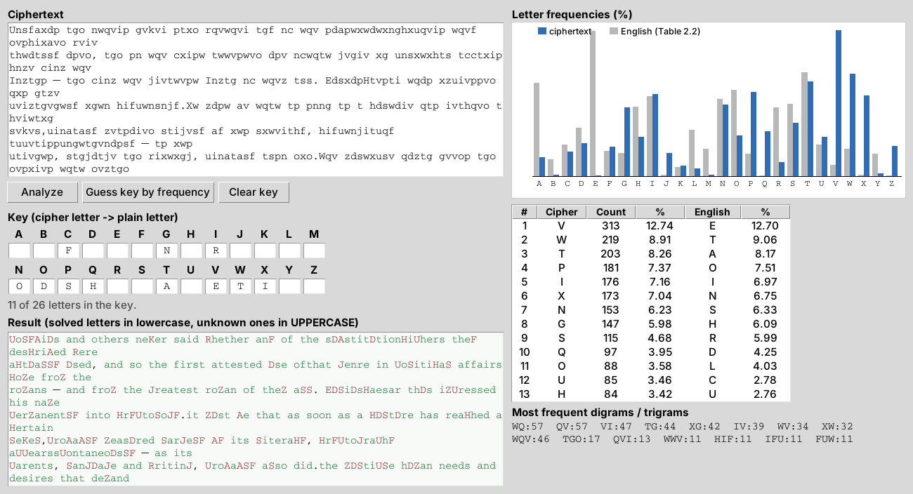
Figure 4.5 – After step 5 most short words of the text are readable
4.7. Step 6 – C, Y, P, L and G, from the word “cryptology”
The text now contains the word “HrFUtoSoJF” three times. Its pattern ?r??to?o?? and the topic of the text (codes and ciphers) point to “cryptology”, which gives H→c, F→y, U→p, S→l and J→g at once. The words “HrFUtoJraUhF” → “cryptography”, “UoSitiHaS” → “political” and “JreatePt” → “greatest” confirm them:
polyAiDs and others neKer said Rhether any of the sDAstitDtionciphers they
descriAed Rere actDally Dsed, and so the first attested Dse ofthat genre in
political affairs coZe froZ the roZans — and froZ the greatest roZan of theZ
all. EDliDscaesar thDs iZpressed his naZe perZanently into cryptology.it ZDst Ae
that as soon as a cDltDre has reached a certain leKel,proAaAly ZeasDred largely
Ay its literacy, cryptography appearsspontaneoDsly — as its parents, langDage
[...]

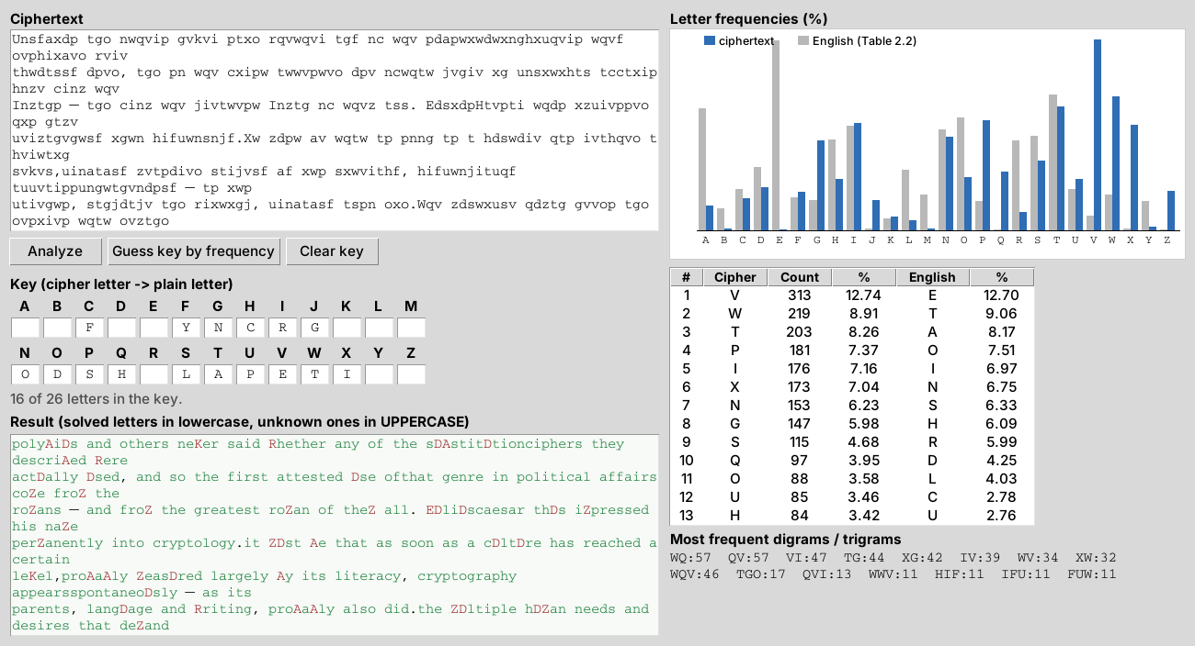
Figure 4.6 – After step 6 the text is almost readable
4.8. Step 7 – B and U
The first word of the text is now “polyAiDs”, the name of the Greek historian Polybius, known for the Polybius square, so A→b and D→u. This also gives “described”, “actually”, “used”, “culture” and “probably”:
polybius and others neKer said Rhether any of the substitutionciphers they
described Rere actually used, and so the first attested use ofthat genre in
political affairs coZe froZ the roZans — and froZ the greatest roZan of theZ
all. Euliuscaesar thus iZpressed his naZe perZanently into cryptology.it Zust be
that as soon as a culture has reached a certain leKel,probably Zeasured largely
by its literacy, cryptography appearsspontaneously — as its parents, language
[...]

4.9. Step 8 – W, M and V
The remaining capital letters are easy to read from the context: “neKer” and “leKel” are “never” and “level” (K→v), “Rhether”, “Rere” and “Rriting” are “whether”, “were” and “writing” (R→w), and “froZ”, “Zust” and “naZe” are “from”, “must” and “name” (Z→m):
polybius and others never said whether any of the substitutionciphers they
described were actually used, and so the first attested use ofthat genre in
political affairs come from the romans — and from the greatest roman of them
all. Euliuscaesar thus impressed his name permanently into cryptology.it must be
that as soon as a culture has reached a certain level,probably measured largely
by its literacy, cryptography appearsspontaneously — as its parents, language
[...]

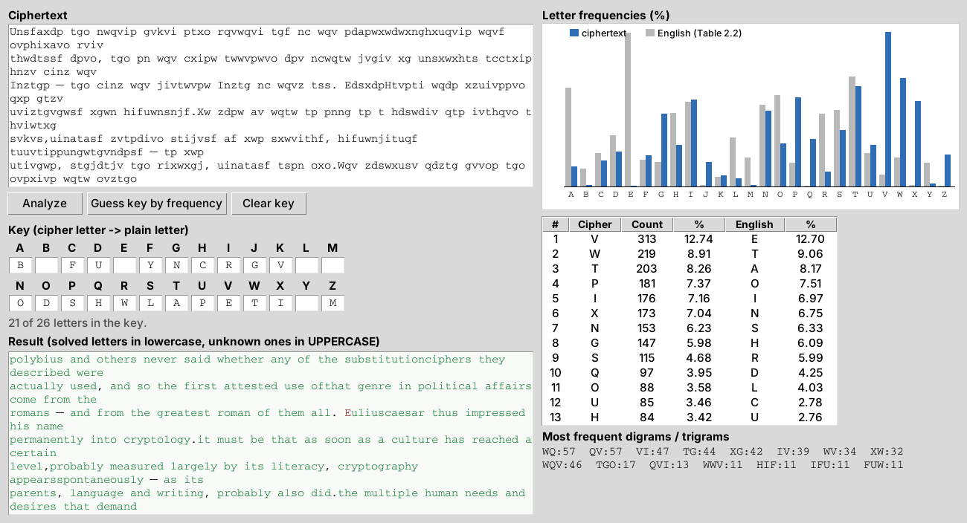
Figure 4.7 – After step 8 only five rare letters are still unknown
4.10. Step 9 – the rare letters K, X, J, Z and Q
The last five cipher letters are rare, both in the ciphertext and in English, and each of them appears in only a few words: “Eulius Caesar” → “Julius Caesar” (E→j), “Lind” → “kind” (L→k), “eYplanation” → “explanation” (Y→x), “YeMidis” → “Yezidis” (M→z) and “IraB” and “eBual” → “Iraq” and “equal” (B→q). With these the key is complete and the whole message can be read.
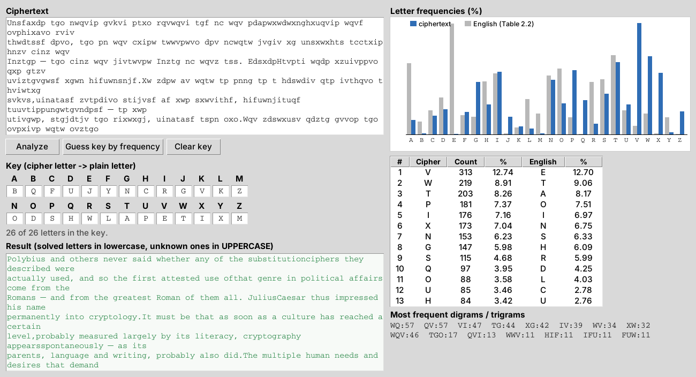
Figure 4.8 – The complete key and the decrypted message
4.11. The decrypted message
Polybius and others never said whether any of the substitutionciphers they
described were actually used, and so the first attested use ofthat genre in
political affairs come from the Romans — and from the greatest Roman of them
all. JuliusCaesar thus impressed his name permanently into cryptology.It must be
that as soon as a culture has reached a certain level,probably measured largely
by its literacy, cryptography appearsspontaneously — as its parents, language
and writing, probably also did.The multiple human needs and desires that demand
privacy among twoor more people in the midst of social life must inevitably lead
tocryptology wherever men thrive and wherever they write. Culturaldiffusion
seems a less likely explanation for its occurrence in. so manyareas, many of
them distant and isolated.The Yezidis, an obscure sect of about 25,000 people
in, northern Iraq,use a cryptic script in their holy books because they fear
persecution bytheir Moslem neighbors. Tibetans use a kind of cipher called "rin-
spuns"for official correspondence; it is named for its inventor
Rin-c'(hhen-)spuns(-pa), who lived in the 1300s. The Nsibidi secret society of
Nigeriakeeps its pictographic script from Europeans as much as possiblebecause
it is used chiefly to express love in rather direct imagery, andsamples appear
to be at least as pornographic as they are cryptographic.The cryptography of
Thailand developed under Indian influence. Anembryonic study of the subject even
appears in a grammatical workentitled Poranavakya by Hluang Prasot Aksaraniti
(Phe). One system,called "the erring Siamese," substitutes one delicate Siamese
letter foranother. In another system, consonants are divided into seven groups
of five letters;a letter is indicated by writing the Siamese number of its group
andplacing vertical dots under it equal in number to the letter's place in
itsgroup. A system called "the hermit metamorphosing letters" writes thetext
backwards.In the Europe of the Latin alphabet—from which modern cryptologywould
spring—cryptography flickered weakly. With the collapse of theRoman empire,
Europe had plunged into the obscurity of the Dark Ages.Literacy had all but
disappeared. Arts and sciences were forgotten, andcryptography was not excepted.
Only during the Middle Ages occasionalmanuscripts, with an infrequent signature
or gloss or "deo gratias" that abored monk put into cipher to amuse himself,
fitfully illuminate thecryptologic darkness, and, like a single candle guttering
in a greatmedieval hall, their feeble flarings only emphasize the gloom.The
systems used were simple in the extreme. Phrases were writtenvertically or
backwards; dots were substituted for vowels;foreign alphabets, as Greek, Hebrew,
and Armenian, were used; eachletter of the plaintext was replaced by the one
that follows it; in the mostadvanced system, special signs substituted for
letters. For almost athousand years, from before 500 to 1400, the cryptology of
Westerncivilization stagnated.

The text speaks about Polybius and Julius Caesar, about cryptography appearing in many cultures (the Yezidis of Iraq, Tibet, the Nsibidi society of Nigeria, Thailand) and about the decline of cryptology in Europe during the Middle Ages. It appears to be an excerpt from David Kahn's book “The Codebreakers”.
4.12. The recovered key
By putting the cipher alphabet next to the plaintext alphabet we obtain the key of the cipher (Table 4.3). It is useful if other messages from the same sender are intercepted, because they were probably encrypted with the same key.
Table 4.3 – Reconstructed key: ciphertext letter → plaintext letter
Cipher | A | B | C | D | E | F | G | H | I | J | K | L | M
Plain | b | q | f | u | j | y | n | c | r | g | v | k | z

Cipher | N | O | P | Q | R | S | T | U | V | W | X | Y | Z
Plain | o | d | s | h | w | l | a | p | e | t | i | x | m

Table 4.4 – The same key as an encryption alphabet: plaintext letter → ciphertext letter
Plain | a | b | c | d | e | f | g | h | i | j | k | l | m
Cipher | T | A | H | O | V | C | J | Q | X | E | L | S | Z

Plain | n | o | p | q | r | s | t | u | v | w | x | y | z
Cipher | G | N | U | B | I | P | W | D | K | R | Y | F | M

Applying this key to the entire ciphertext gives a fully meaningful English text, with no remaining unknown letters, which confirms that the key is correct.
5. Conclusions
A monoalphabetic substitution cipher keeps the frequencies of the language, so a sufficiently long ciphertext can be broken without knowing the key. In this variant the frequencies of the three most frequent cipher letters (V, W, T) matched “e”, “t” and “a” almost exactly, and that was enough to start the attack.
Frequencies alone were not enough to finish it. A key taken directly from the frequency ranks produced unreadable text, because the order of the less frequent letters in a single text differs from the average order of the language. The decisive clues were the structure of the words: the trigram “the”, the short words “a”, “and”, “of”, “in”, and then partly solved long words such as “cryptology”, “Polybius” and “explanation”. Each guess was checked on the rest of the text before moving on.
This work showed that, even though the key space of a simple substitution cipher is huge (26! ≈ 4 × 10²⁶ keys), it offers practically no security against frequency analysis. A program that counts the frequencies and applies the partial key instantly makes the attack much faster, but the decisions still need a human who knows the language.
6. Source code
The full source code is available on GitHub: https://github.com/Afyze/cs-2026-AugustinCarazanu/tree/main/lab2

