
MINISTRY OF EDUCATION, CULTURE AND RESEARCH
OF THE REPUBLIC OF MOLDOVA
Technical University of Moldova
Faculty of Computers, Informatics and Microelectronics
Department of Software Engineering and Automation

Report
on laboratory work no. 3
of Operating Systems
Topic: The Command Line: Shell, Pipes and Text Filters

Done by: st. gr. FAF-243, Augustin Carazanu
Checked by: assist. univ. Patricia Reițman
FCIM, UTM

Chișinău – 2026
Purpose of the work
The purpose of this laboratory work is to learn to work efficiently in the bash shell. That means predicting how the shell transforms a command line before it runs (globbing, quoting, expansions), redirecting standard output and standard error, chaining commands, and controlling background jobs. It also means answering real questions about a data set with one-line pipelines of small text filters, and turning them into a first bash script. The work was done on Ubuntu 24.04.3 ARM64, running in a Parallels virtual machine.
Before you start
The working directory ~/os-lab3 was created, and the artificial access log was generated with the loop from the lab sheet. The check passed: the file has exactly 500 lines, and each line has the form date time user result page.
Part 1. Move fast, find help
Tab completion. Typing ls /usr/sh and pressing Tab once completed the path to /usr/share/, because it was the only match. Pressing Tab a second time asked "Display all 253 possibilities? (y or n)", meaning it was ready to list everything inside the directory. cd /et + Tab completed to cd /etc/ with a single press.
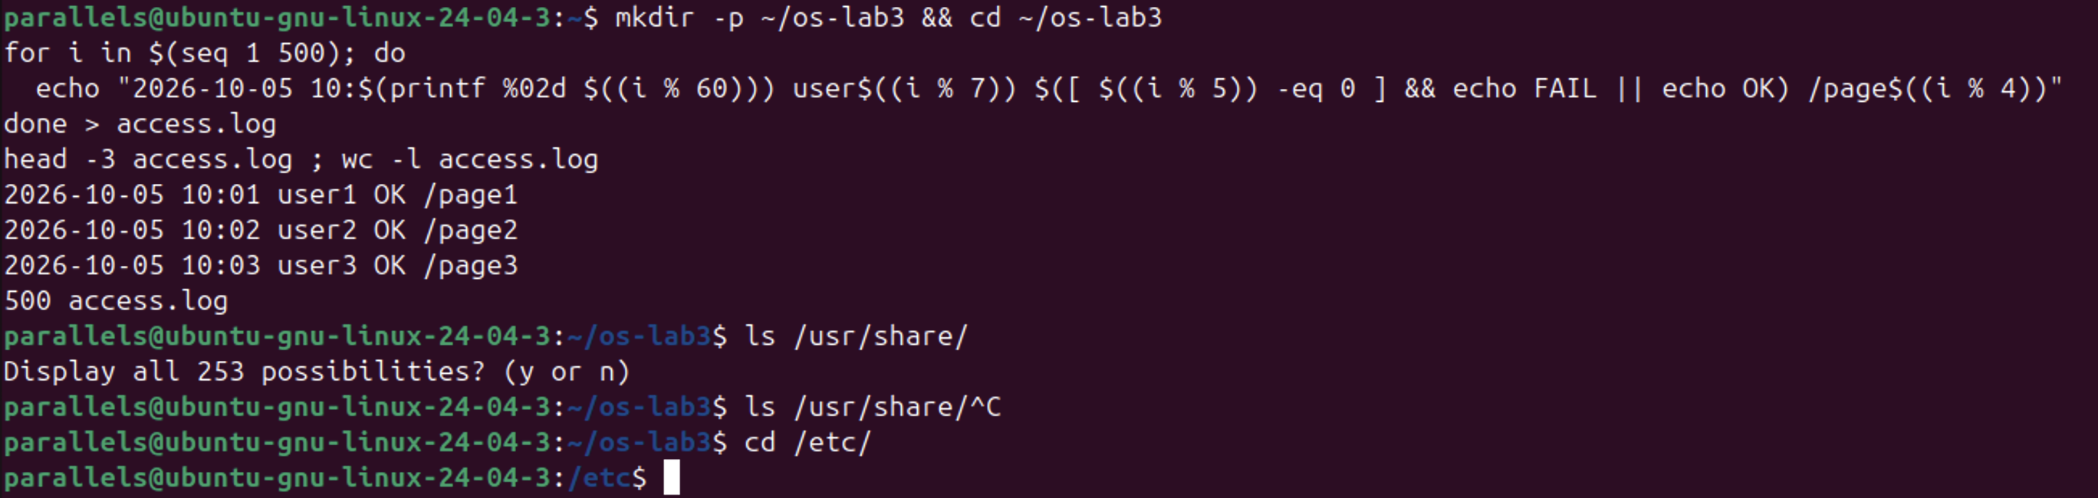
Figure 1.1 – Generating access.log and Tab completion
Ctrl+R. After running date, whoami and pwd, I pressed Ctrl+R and typed dat. The reverse history search found the earlier date command, and Enter ran it again: the new time is 03:47:47, while the first run showed 03:47:14.
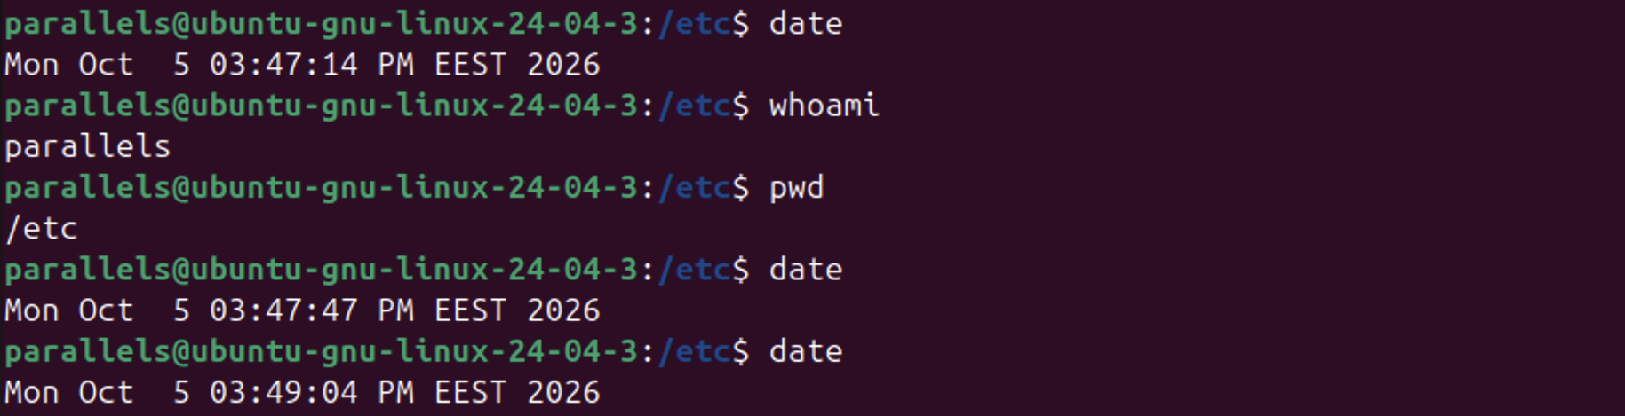
Figure 1.5 – Re-running a command from history with Ctrl+R
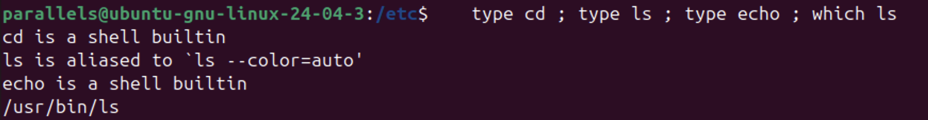
Figure 1.2 – Output of type and which
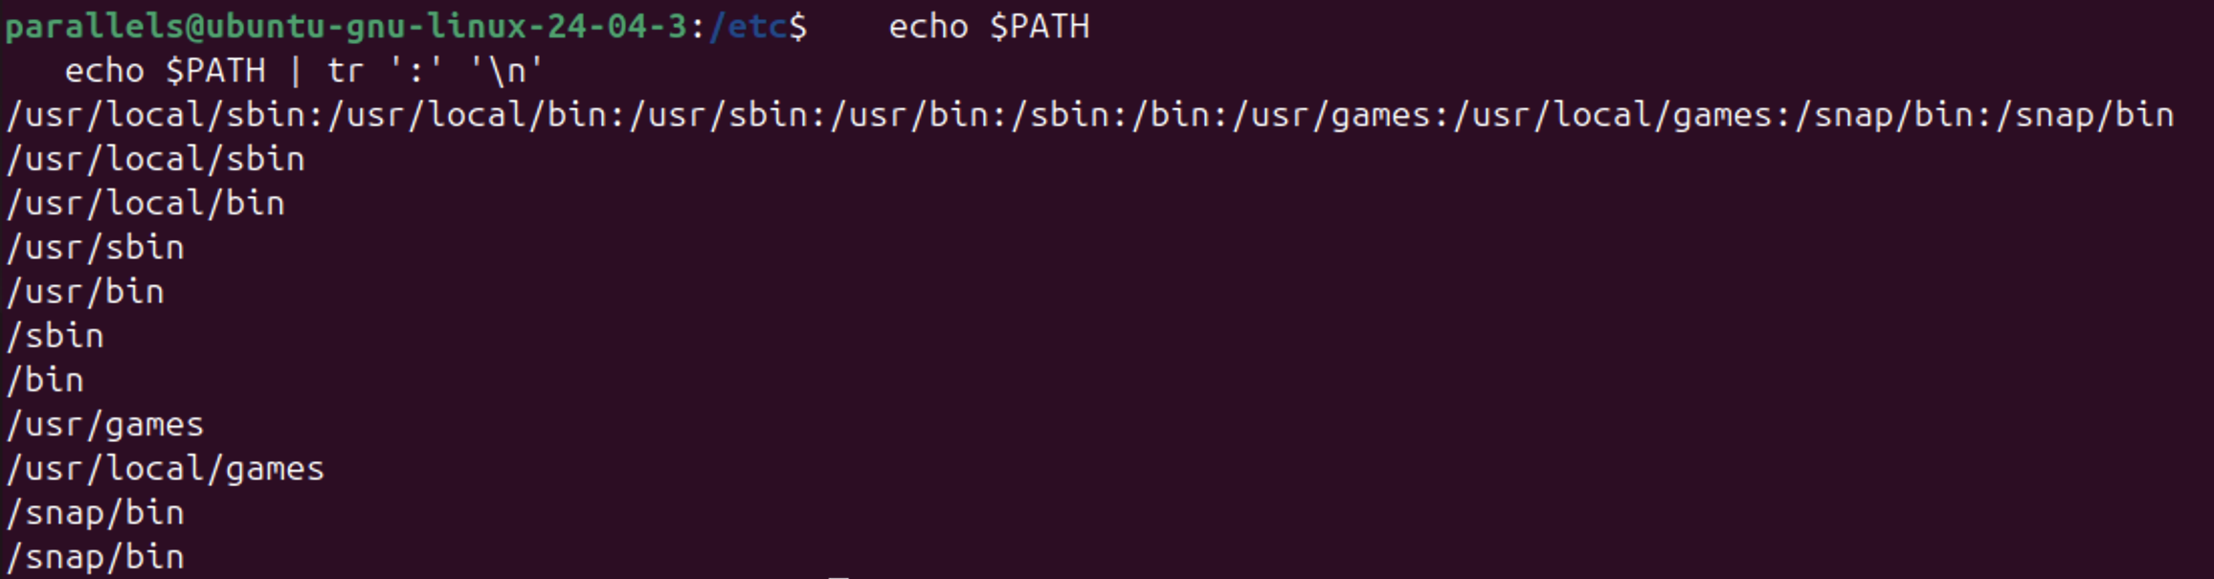
Figure 1.3 – The directories in PATH
Figure 1.4 – Exit code of a missing command
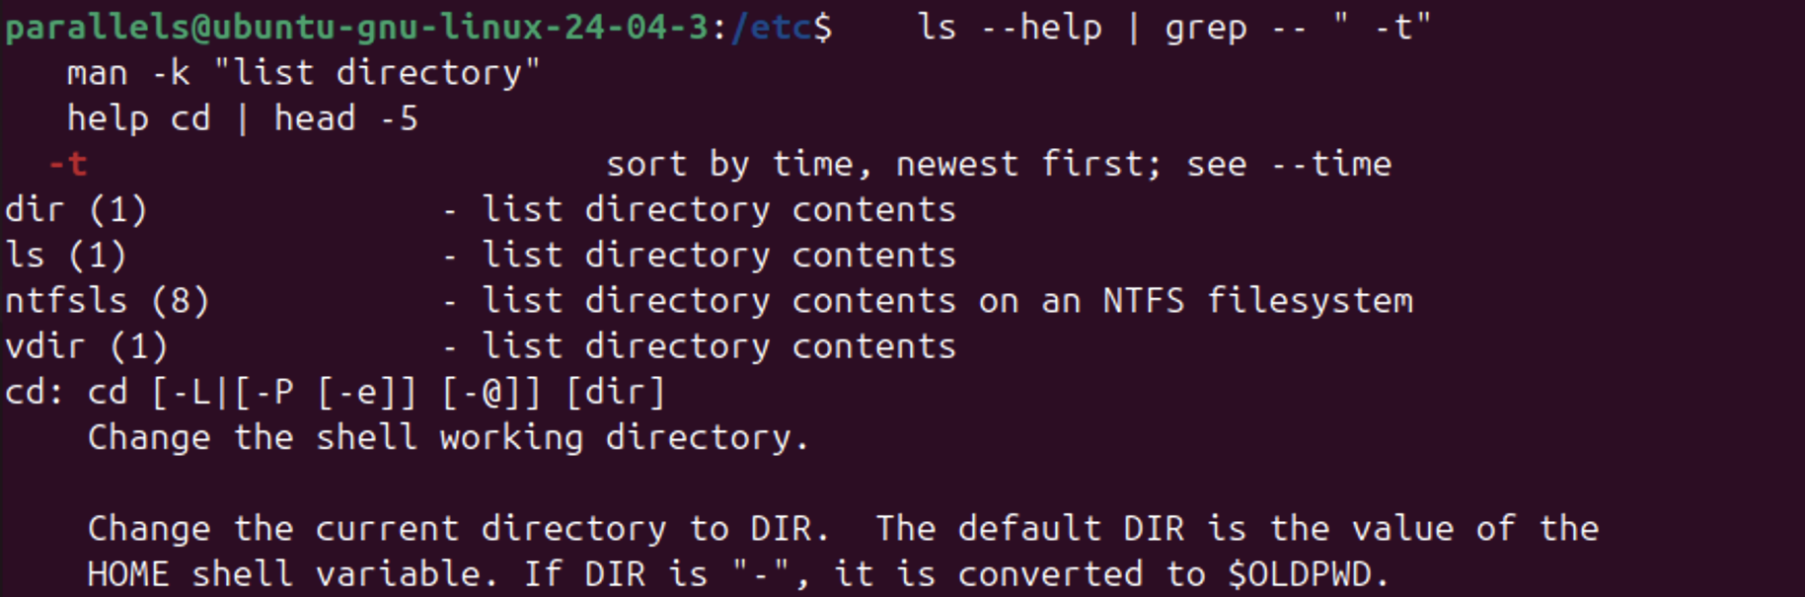
Figure 1.6 – Finding help: ls --help, man -k and help cd
Observe (1). Which of cd, ls, echo are built-ins, and why must cd be one?
cd and echo are shell built-ins. ls is an external program, /usr/bin/ls; in this shell it is also an alias for ls --color=auto. cd must be a built-in because the current directory is a property of each process. An external program runs as a child process, so it could only change its own directory, which would be lost the moment it exits. Only the shell itself can change the shell's directory.
Observe (2). How many directories are in PATH, and in which one is ls?
PATH contains 10 entries: /usr/local/sbin, /usr/local/bin, /usr/sbin, /usr/bin, /sbin, /bin, /usr/games, /usr/local/games, /snap/bin and /snap/bin again. That is 9 distinct directories, because /snap/bin appears twice. ls is in /usr/bin (which ls printed /usr/bin/ls).
Observe (3). What exit code does a command that is not found return?
127: nosuchprog: command not found, followed by exit code: 127.
Observe (4). Which option of ls sorts by modification time?
-t: "sort by time, newest first". man -k "list directory" found the relevant manual pages (ls, dir, vdir, ntfsls), and help cd showed the built-in's own help, since built-ins have no separate man page.
Part 2. What the shell does to your line
A test directory ~/os-lab3/play was created with the files a.c, b.c, file1.txt, file2.txt, notes.txt and alfa beta.txt. The last name contains a space.
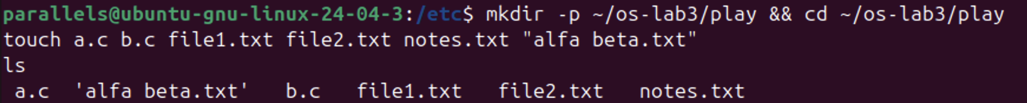
Figure 2.1 – Files created in the play directory
Before running each line, I wrote down a prediction. The results are in the table below.
Command | My prediction | Real output | Explanation (if different)
echo *.c | a.c b.c | a.c b.c | –
echo file?.txt | file1.txt file2.txt | file1.txt file2.txt | –
echo [a-b]* | a.c b.c | a.c alfa beta.txt b.c | I forgot that alfa beta.txt also starts with a, so the pattern matches it too.
echo *.xyz | an empty line | *.xyz | When a pattern matches nothing, bash leaves it unchanged and passes it to echo literally.
ls alfa beta.txt | alfa beta.txt | two errors: cannot access 'alfa' and cannot access 'beta.txt' | The space splits the name into two separate arguments.
ls "alfa beta.txt" | alfa beta.txt | 'alfa beta.txt' | ls puts quotes around names that contain a space.
echo '$HOME' "$HOME" \$HOME | $HOME /home/parallels /home/parallels | $HOME /home/parallels $HOME | The backslash escapes $, so the third word is not expanded.
echo {1..5} ; echo $((7 * 6)) | 1 2 3 4 5 and 42 | 1 2 3 4 5 and 42 | –
echo "today is $(date +%A), I am $(whoami)" | today is Monday, I am parallels | today is Monday, I am parallels | –
touch log{1..3}.txt && ls log* | log1.txt log2.txt log3.txt | log1.txt log2.txt log3.txt | –

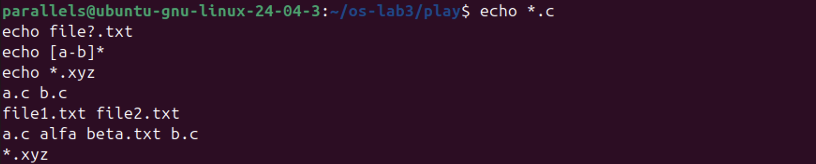
Figure 2.2 – Globbing results
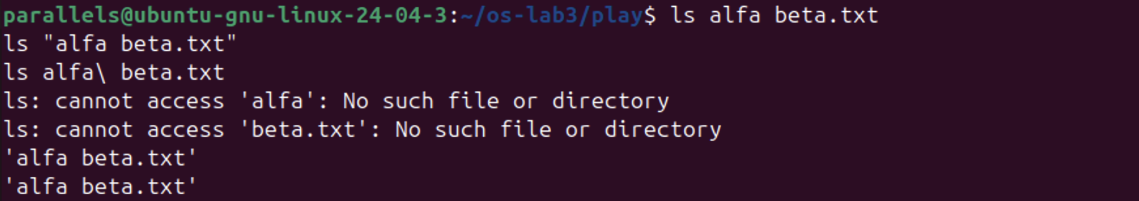
Figure 2.3 – The ls error on a name with a space, and the fix
Figure 2.4 – Single quotes, double quotes and backslash
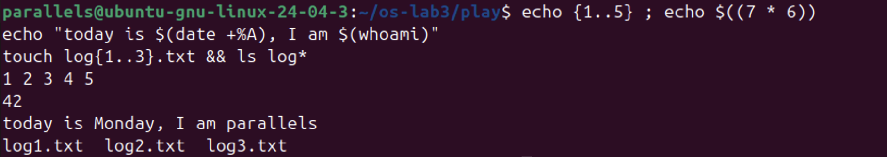
Figure 2.5 – Brace expansion, arithmetic and command substitution
Observe (2). echo knows nothing about files, yet echo *.c printed file names. Who produced them?
The shell did. Before starting echo, bash performs filename expansion (globbing): it replaces *.c with the sorted list of matching names. echo only receives the arguments a.c and b.c and prints them.
Observe (3). Why did ls alfa beta.txt fail? Give two ways to fix it.
The shell splits the command line into words at spaces, so ls received two arguments, alfa and beta.txt, and neither file exists. One fix is to put the name in quotes: ls "alfa beta.txt" (or 'alfa beta.txt'). The other is to escape the space with a backslash: ls alfa\ beta.txt. Both fixes are shown in Figure 2.3. Pressing Tab after ls al also inserts the escaped form automatically.
Observe (4). What is the difference between single and double quotes?
Inside single quotes, everything is literal: '$HOME' stays $HOME. Inside double quotes, the shell still expands variables ($HOME), command substitution ($(...)) and arithmetic. However, double quotes still prevent word splitting and globbing, so the result stays one argument.
Note. ls shows the file as 'alfa beta.txt' because, when its output goes to a terminal, it quotes names that contain spaces or special characters. This makes it clear that the name is a single file, and the name can be copied and pasted back into a command as it is.
Part 3. Redirection, chaining and jobs

Figure 3.1 – stdout and stderr in separate files
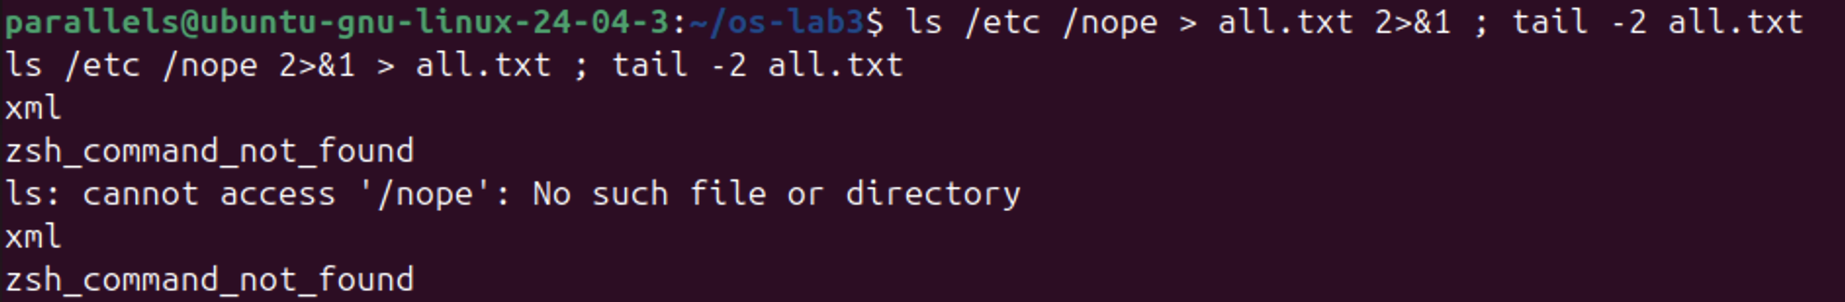
Figure 3.2 – Comparing the order of redirections
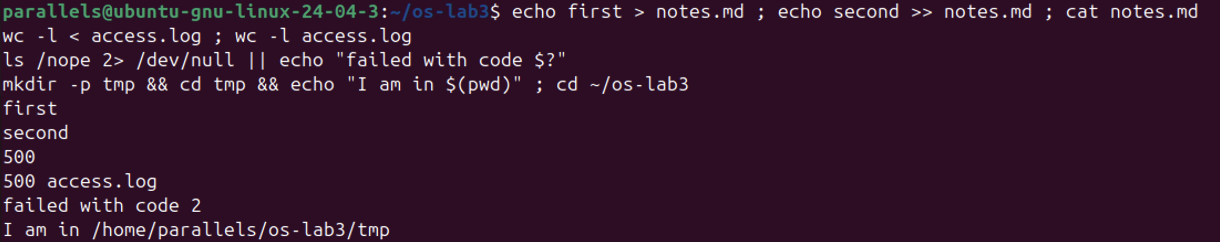
Figure 3.3 – The ; && || operators
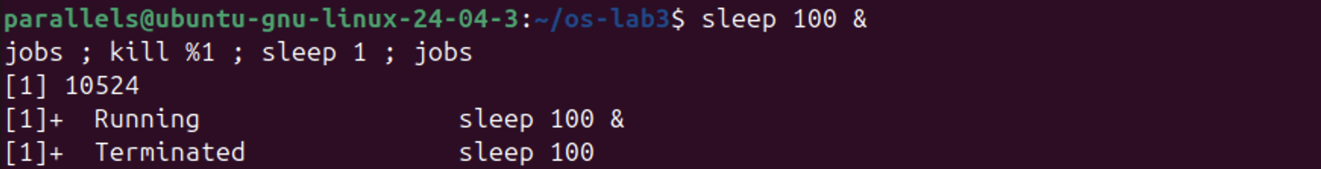
Figure 3.4 – Running a background job and stopping it
Observe (1). Which file got the error message, and which got the listing?
out.txt received the listing of /etc (stdout, 235 lines). err.txt received the error ls: cannot access '/nope': No such file or directory (stderr).
The listing has 235 lines, while /etc has 234 entries. When ls is given more than one argument, it prints the header /etc: before the list, which adds one line.
Observe (2). What is the difference between > all.txt 2>&1 and 2>&1 > all.txt?
Redirections are applied from left to right, and 2>&1 means "make stderr point to wherever stdout points right now".
• In > all.txt 2>&1, stdout is first sent to the file, and then stderr is copied from stdout. Both streams go into all.txt. The error is at the top of the file, so the tail -2 output (xml, zsh_command_not_found) shows only the end of the listing.
• In 2>&1 > all.txt, stderr is first copied from stdout while stdout is still the terminal, and only then is stdout moved to the file. The error message therefore appeared on the screen, and the file contains only the listing.
Observe (3). Why does wc -l < access.log print only a number?
With <, the shell opens the file and connects it to wc's standard input. wc never receives a file name, so it cannot print one: the output is 500. With wc -l access.log, the name is passed as an argument. wc opens the file itself and prints 500 access.log.
Observe (4). Explain ; && ||.
• ; runs the next command unconditionally, after the previous one finishes.
• && runs the next command only if the previous one succeeded (exit code 0). For example, mkdir -p tmp && cd tmp && echo ... printed I am in /home/parallels/os-lab3/tmp.
• || runs the next command only if the previous one failed. For example, ls /nope 2> /dev/null || echo ... printed failed with code 2.
Jobs. sleep 100 & started a background job: [1] 10524 is the job number and the PID. jobs showed it as Running. kill %1 sent it SIGTERM, and the next jobs showed Terminated.
Part 4. Answer questions with one-liners
Each line of access.log has five fields: date, time, user, result and page.
Figure 4.1 – Number of failed requests
Q1. How many requests failed? grep -c FAIL access.log → 100.
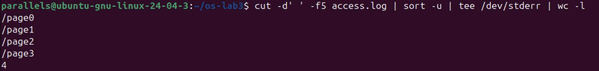
Figure 4.2 – Different pages requested
Q2. How many different pages were requested, and which? cut -d' ' -f5 access.log | sort -u | tee /dev/stderr | wc -l → 4 pages: /page0, /page1, /page2, /page3. tee /dev/stderr shows the names while wc -l counts them.
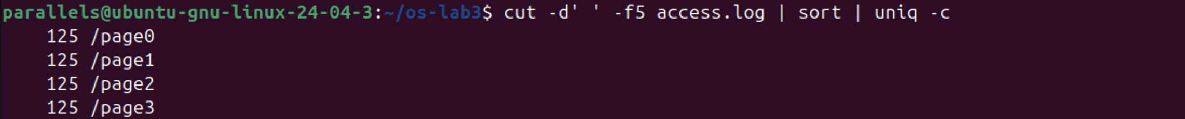
Figure 4.3 – Requests per page
Q3. How many requests did each page get? cut -d' ' -f5 access.log | sort | uniq -c → 125 for each page. Check: 4 × 125 = 500.
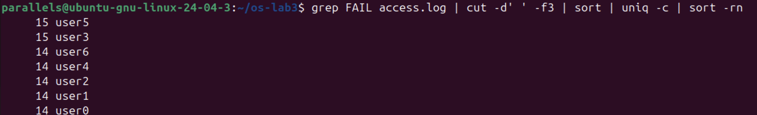
Figure 4.4 – Failed requests per user
Q4. Which user or users have the most failed requests? grep FAIL access.log | cut -d' ' -f3 | sort | uniq -c | sort -rn → user3 and user5, with 15 failures each. The other five users have 14 each. Check: 15 + 15 + 5 × 14 = 100, which equals Q1. In oneliners.sh, this pipeline ends with awk 'NR==1{m=$1} $1==m', so it prints only the users that share the maximum.
Figure 4.5 – Requests and failures of user3
Q5. How many requests did user3 make, and how many failed? → 72 requests, 15 failed. The spaces around ' user3 ' make sure the match is the whole user field.
Figure 4.6 – The last 3 failed requests
Q6. The last 3 failed requests (time and user). grep FAIL access.log | tail -3 | cut -d' ' -f2,3 → 10:10 user0, 10:15 user5, 10:20 user3.
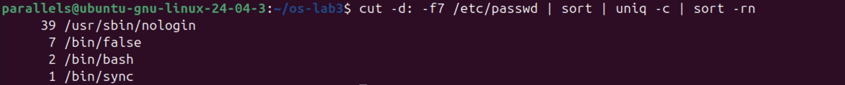
Figure 4.7 – Login shells in /etc/passwd
Q7. Which login shells appear in /etc/passwd, and how many accounts use each? cut -d: -f7 /etc/passwd | sort | uniq -c | sort -rn → /usr/sbin/nologin 39, /bin/false 7, /bin/bash 2, /bin/sync 1. Most accounts are system service accounts that cannot log in.
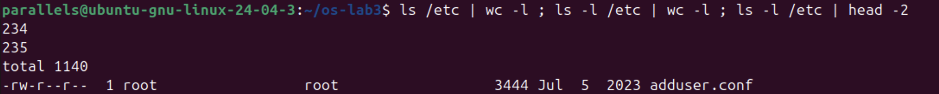
Figure 4.8 – ls /etc versus ls -l /etc
Q8. Why do ls /etc | wc -l and ls -l /etc | wc -l differ by exactly one?
Prediction: the long format adds an extra line at the top. Result: 234 and 235. ls -l prints a first line, total 1140, which is the number of disk blocks used by the listed files, and then one line per entry. Plain ls prints only the names.
When its output goes to a pipe instead of a terminal, ls also writes one name per line rather than in columns. That is why wc -l counts the entries correctly.
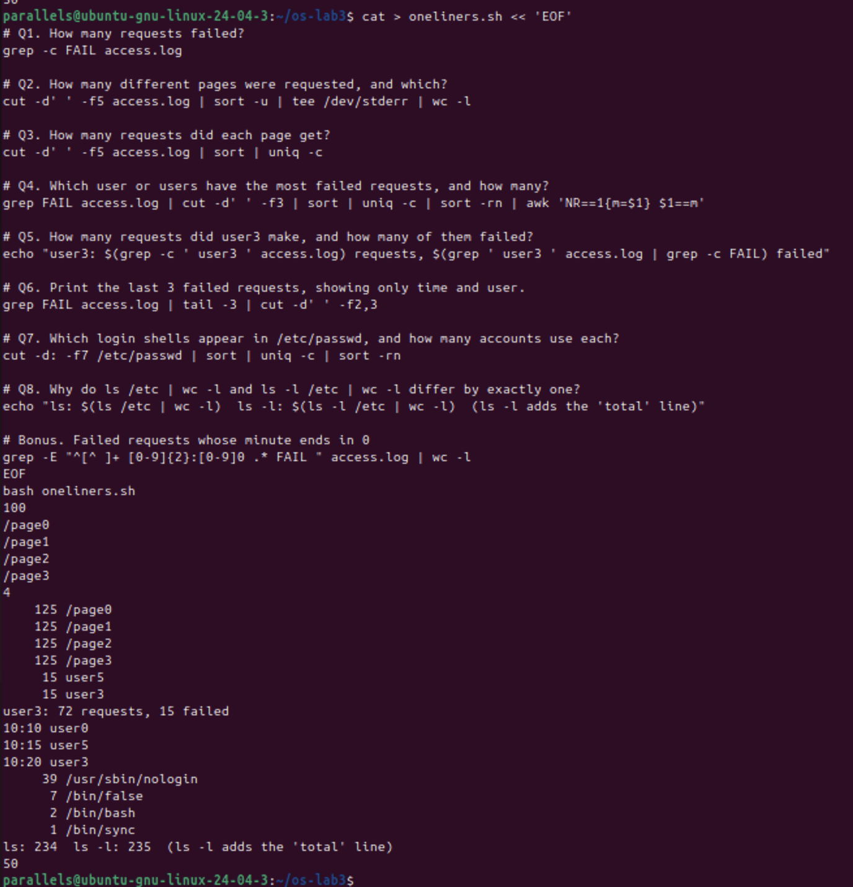
Figure 4.9 – Full run of oneliners.sh
All the commands were saved in oneliners.sh, one per question, with the question as a comment above it. bash oneliners.sh ran it from top to bottom inside ~/os-lab3.
Figure 4.10 – Bonus: failed requests whose minute ends in 0
Bonus. grep -E "^[^ ]+ [0-9]{2}:[0-9]0 .* FAIL " access.log | wc -l → 50. The regular expression requires the time field to end in 0 (10:00, 10:10, ...) and the result to be FAIL.
Part 5. Your first script
The TODO in report.sh was completed with a loop over the seven users:
for n in 0 1 2 3 4 5 6; do
echo "user$n: $(grep " user$n " "$log" | grep -c FAIL) failures"
done
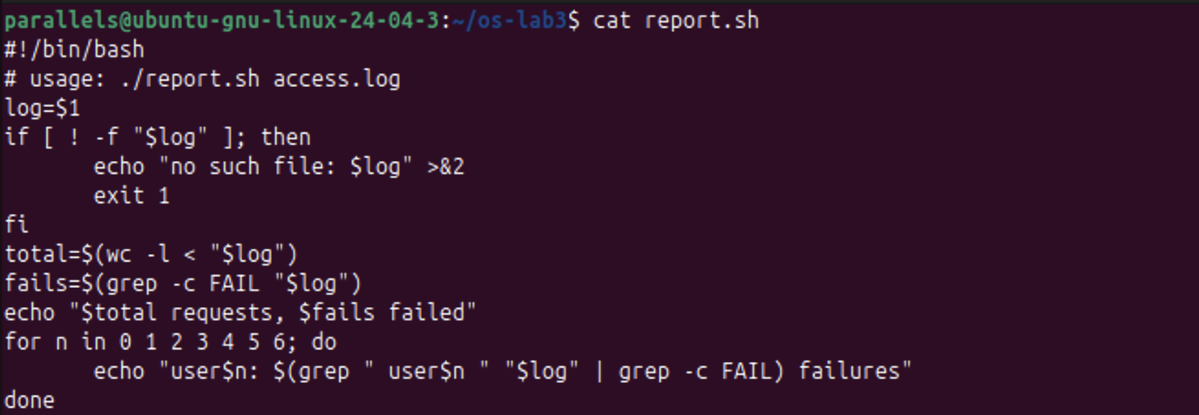
Figure 5.1 – Contents of report.sh
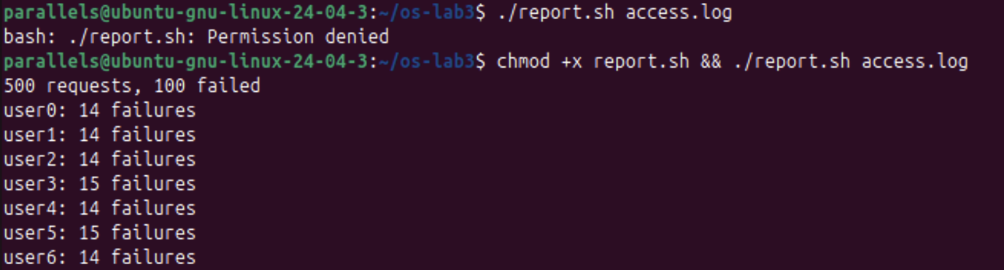
Figure 5.2 – Running the script on access.log
Figure 5.3 – Error handling for a missing file
The script prints 500 requests, 100 failed, followed by the failures of each user (14, 14, 14, 15, 14, 15, 14). These match Q1 and Q4.
Observe (1). What does #!/bin/bash do, and what happens before chmod +x?
The first line, the "shebang", tells the kernel which interpreter to use when the file is executed directly: /bin/bash. Before chmod +x, the file has no execute permission, so ./report.sh access.log failed with bash: ./report.sh: Permission denied. It could still be run as bash report.sh access.log, because then bash only reads the file.
Observe (2). Why ./report.sh and not report.sh?
A command name without a slash is looked up only in the directories listed in PATH, and the current directory is not one of them. That is a deliberate safety measure, so that a file in some folder cannot replace a system command. ./ gives an explicit path to the file in the current directory.
Observe (3). Why >&2 and exit 1?
>&2 writes the error message to standard error rather than to standard output. That way it does not mix with the normal results, and it stays visible even when the output is redirected to a file or a pipe. exit 1 makes the script finish with a non-zero exit code, so the caller ($?, &&/||, or another script or cron) can tell that it failed. The test printed no such file: nope.log and exit code: 1.
Bonus: running the script with cron. A crontab line was added that runs the script every minute and appends its output, including errors, to report.log:
* * * * * /home/parallels/os-lab3/report.sh /home/parallels/os-lab3/access.log >> /home/parallels/os-lab3/report.log 2>&1
After about two minutes, report.log contained the report twice, once for each run. The crontab was then removed with crontab -r, and crontab -l confirmed it: no crontab for parallels. Full paths are needed because cron runs jobs with a minimal environment, in the home directory and with a short PATH.
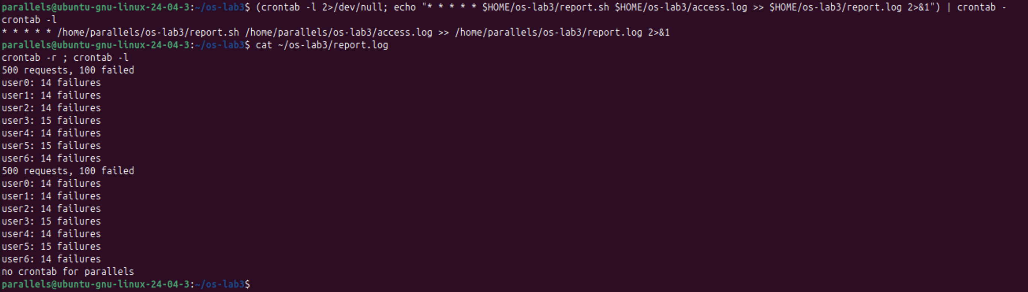
Figure 5.4 – Running report.sh every minute with cron
Conclusions
This laboratory work showed that much of what seems to be done by commands is really done by the shell before the command starts. Globs, quotes, variables, braces, arithmetic and $(...) are all expanded first. This explains why echo *.c prints file names and why a name with a space breaks unless it is quoted.
Redirection showed that every process has separate stdout and stderr streams, that the order of > and 2>&1 matters, and that the exit codes $? (0, 1, 2, 127) drive the && and || operators.
With small filters (grep, cut, sort, uniq, wc, tail) joined by pipes, every question about the 500-line log was answered with one line, and the totals were cross-checked (125 × 4 = 500; the per-user failures add up to 100). Finally, the best one-liners became a reusable script with proper error handling and exit codes, and it was scheduled with cron.

