
MINISTRY OF EDUCATION, CULTURE AND RESEARCH
OF THE REPUBLIC OF MOLDOVA
Technical University of Moldova
Faculty of Computers, Informatics and Microelectronics
Department of Software Engineering and Automation

Report
on laboratory work no. 4
of Operating Systems
Topic: The xv6 Shell from the Outside

Done by: st. gr. FAF-243, Augustin Carazanu
Checked by: assist. univ. Patricia Reițman
FCIM, UTM

Chișinău – 2026
Purpose of the work
The purpose of this laboratory work is to study the xv6 shell (user/sh.c, about 500 lines) from the outside. I ran the same commands in bash and in xv6 to find out by experiment what a shell must do and what bash adds on top. A small program that prints its own argv showed who expands *, who removes quotes and who splits a command line into words. Finally, I read the parts of sh.c that explain the observed behaviour. The work was done on Ubuntu 24.04.3 ARM64 in a Parallels virtual machine, with xv6-riscv running in QEMU 8.2.
Before you start
bash os2026-setup.sh --check confirmed that all the tools are present (git, make, gcc, the riscv64-linux-gnu-gcc cross-compiler and QEMU 8.2). It also confirmed that the existing xv6 tree in ~/xv6-riscv was left untouched, and that xv6 builds, boots and runs ls. The check ended with "All set".
Part 1. Fix sleep for the current xv6
grep -n "pause\|sleep" user/user.h found only one line, 25:int pause(int);. This means the current tree uses the new name of the system call: in August 2025 the xv6 authors renamed sleep() to pause().
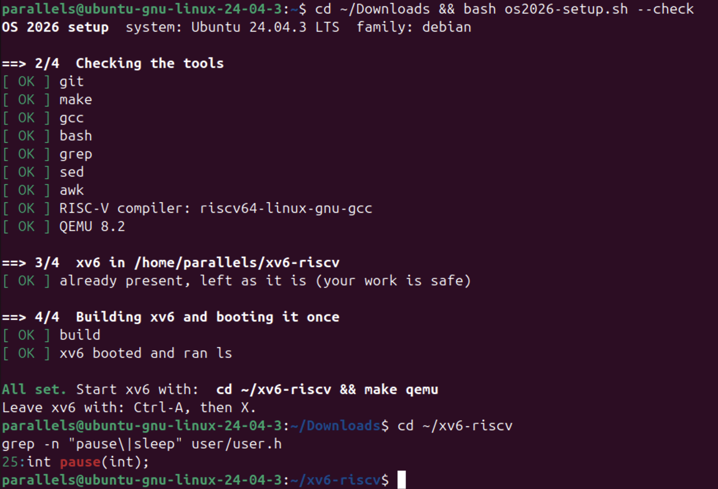
Figure 1.1 – The grep result in user.h
My user/sleep.c from Lab 2 already calls pause(atoi(argv[1])), because I ran into this rename in Lab 2 and fixed it there. The Makefile contains $U/_sleep\ on line 135, in the UPROGS list.
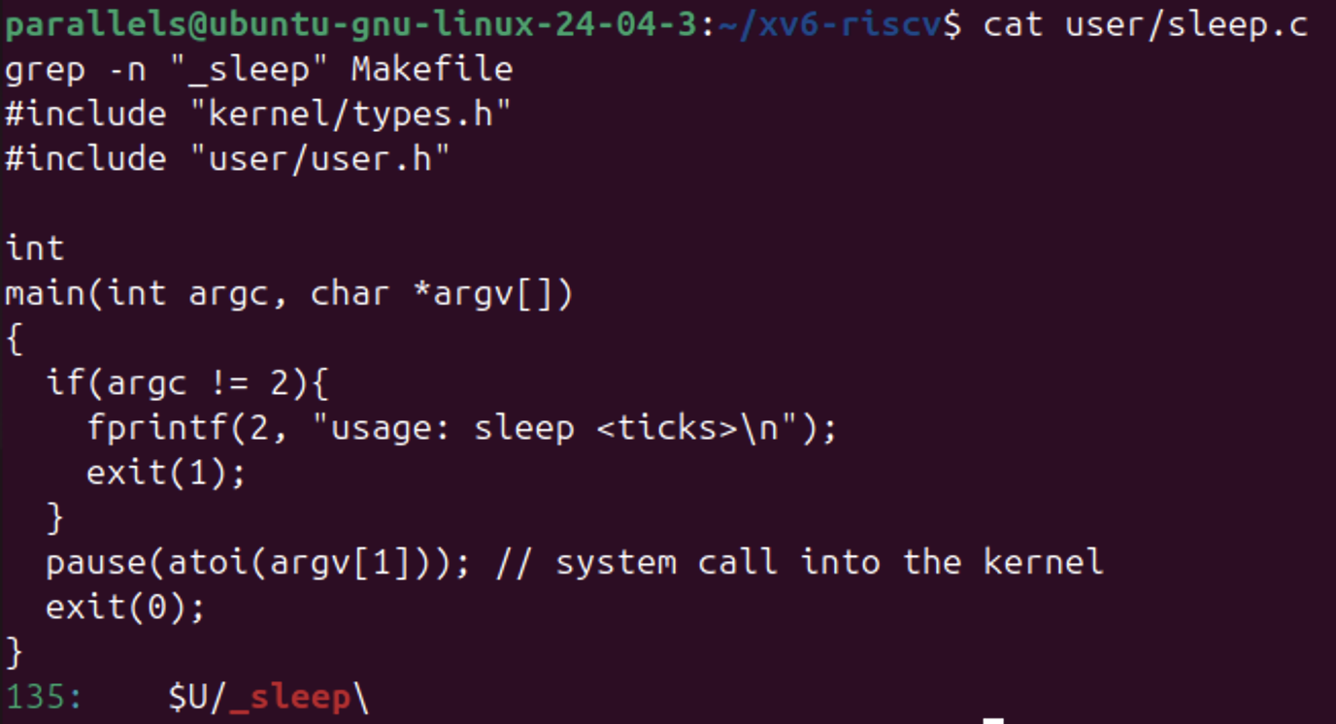
Figure 1.2 – The updated sleep.c and the UPROGS line
After make qemu, sleep 20 paused for 20 clock ticks (about 2 seconds) and then returned to the prompt. sleep with no argument printed usage: sleep <ticks>. The word sleep appears on the line under sleep 20 because I typed the second command while the first was still pausing. The console echoes the typed characters, and the shell reads them only after the first command finishes.
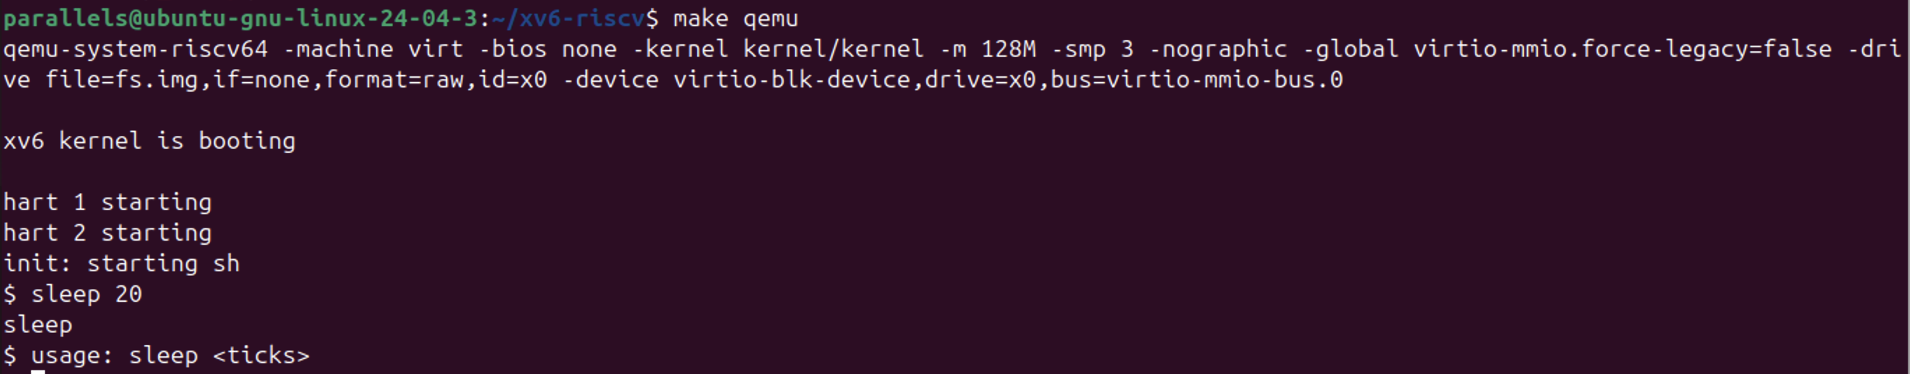
Figure 1.3 – sleep running in xv6, with and without an argument
Part 2. bash versus the xv6 shell
Every command was run in bash, in the empty test folder ~/shtest that contains README, and then at the xv6 $ prompt.
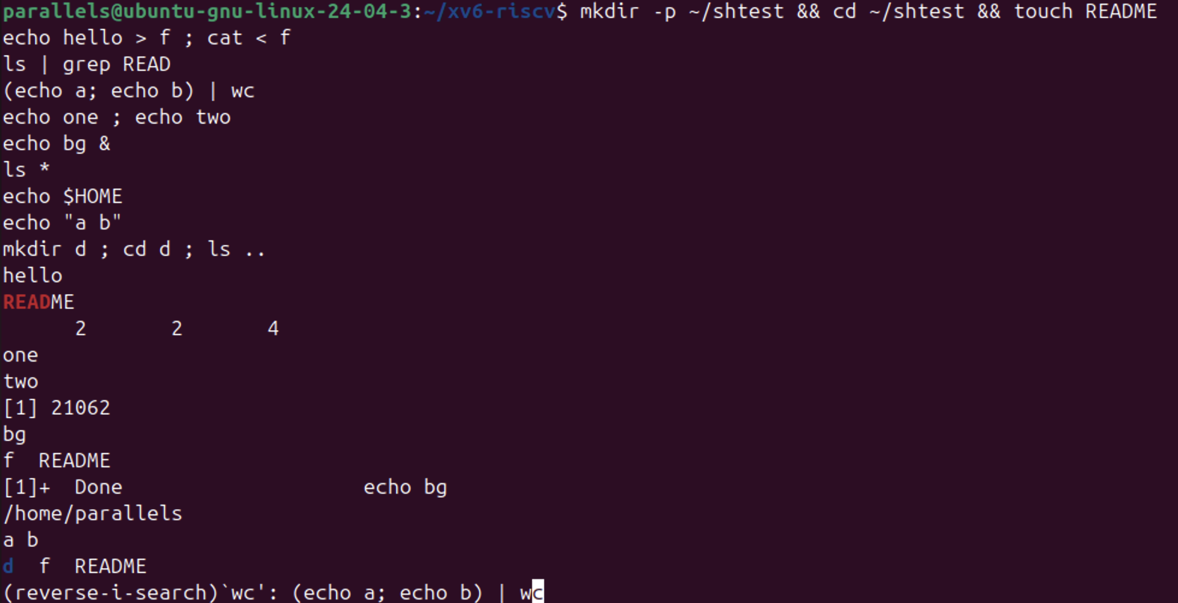
Figure 2.1 – The commands run in bash, and Ctrl+R history search
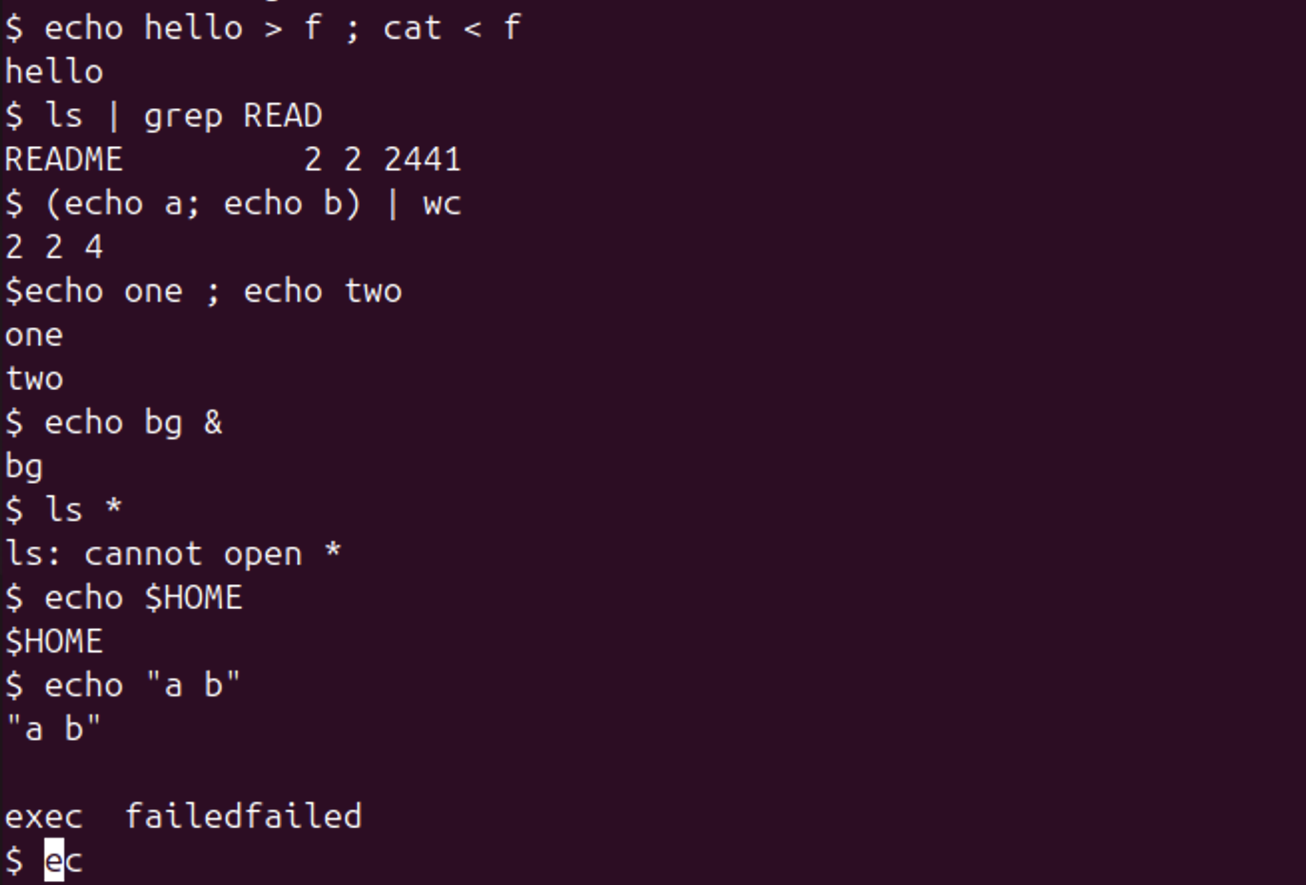
Figure 2.2 – The same commands run in xv6
Command | Tests | bash | xv6 | Why
echo hello > f ; cat < f | redirection | hello | hello | Both shells open the file and connect it to stdout or stdin before exec.
ls | grep READ | pipe | README | README 2 2 2441 | Both create a pipe. xv6 ls also prints the type, inode and size.
(echo a; echo b) | wc | grouping, list | 2 2 4 | 2 2 4 | Both support ( ) and ;, so two lines and four bytes reach wc.
echo one ; echo two | sequence | one, two | one, two | ; runs the commands one after the other in both shells.
echo bg & | background | [1] 21062, bg, later [1]+ Done | bg | xv6 runs the command in the background, but it has no job control (no job numbers, no Done message).
ls * | globbing | f README | ls: cannot open * | bash expands * into file names. xv6 passes the literal * to ls.
echo $HOME | variables | /home/parallels | $HOME | xv6 has no variables, so the text is passed unchanged.
echo "a b" | quotes | a b | "a b" | bash removes the quotes. In xv6 they are ordinary characters, printed as they are.
mkdir d ; cd d ; ls .. | PATH | d f README | exec cd failed, then the listing of / | xv6 recognizes cd only at the start of a line, so here it tries to run a program called cd.
arrow up, Tab, Ctrl+R | history, completion | Recalls the last command, completes names, (reverse-i-search) | The cursor moves up, then exec failed | xv6 has no line editing. The escape codes of the keys are read as a command name.

Because cd d inside the ; list failed, I repeated the PATH test with cd d on its own line. Inside d, ls printed exec ls failed. The same program started by its full path, /ls .., worked and listed the root directory, where all the xv6 programs live.
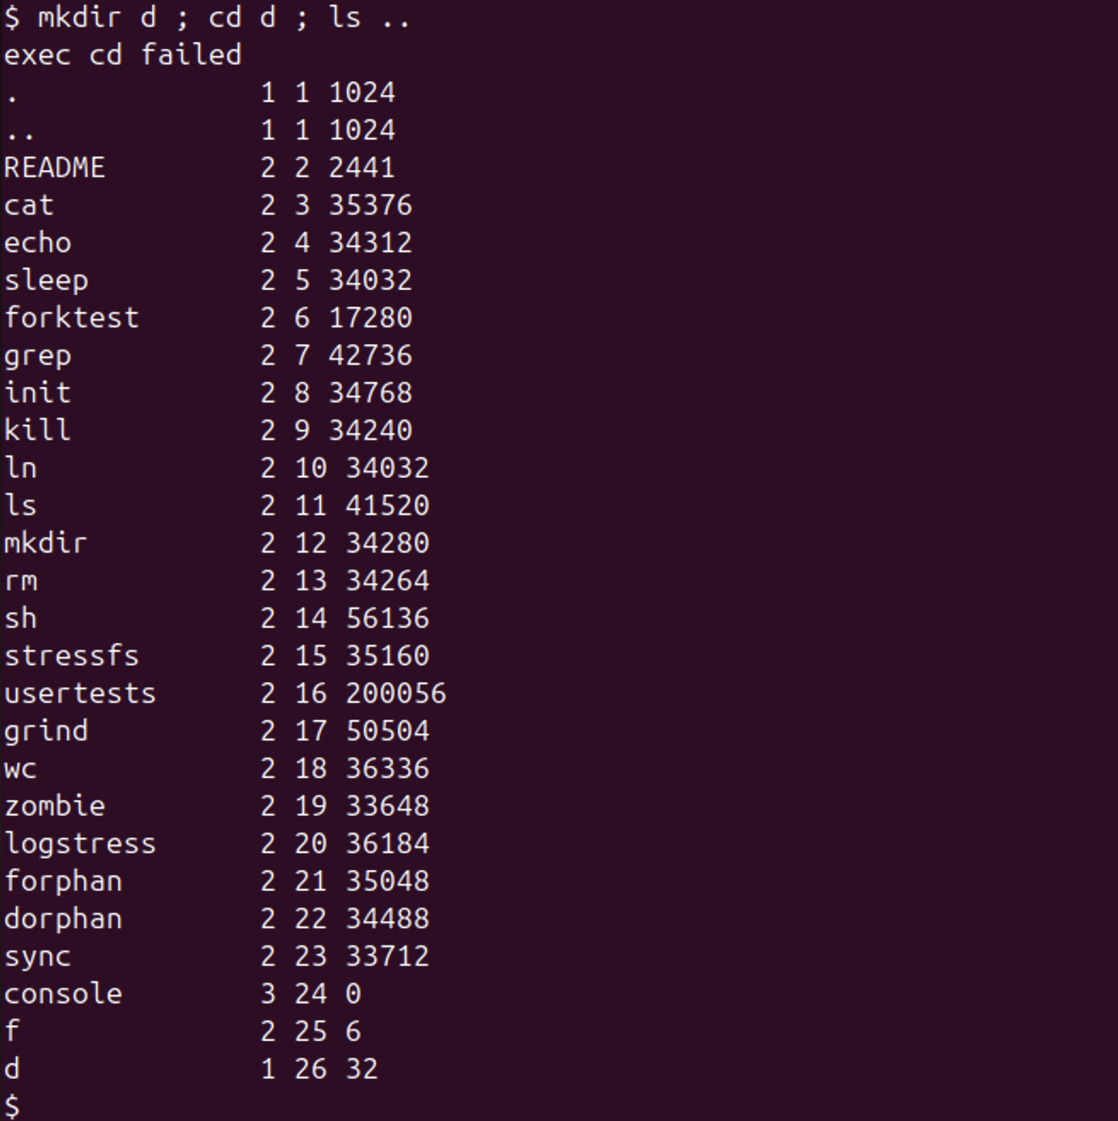
Figure 2.3 – cd inside a list is not handled by the xv6 shell
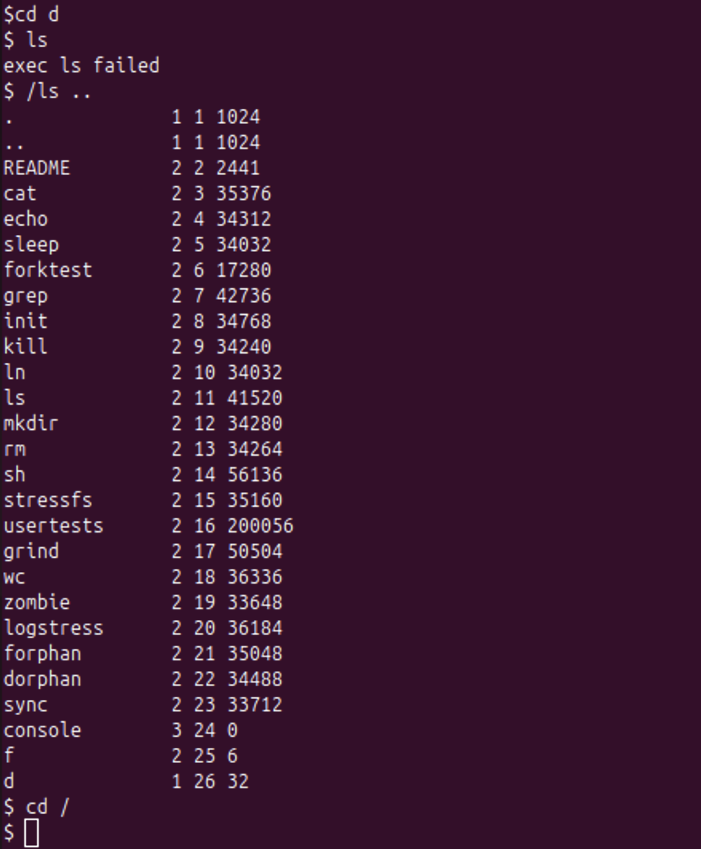
Figure 2.4 – ls failing after cd d, and the working alternative /ls ..
Observe (1). Which features do both shells have, and which only bash?
Both shells have the core of a Unix shell:
• running a program with arguments
• redirection with <, > and >>
• pipes |
• grouping with ( )
• sequences with ;
• background execution with &
• cd as a built-in
Only bash has:
• filename expansion (globbing: *, ?, [...])
• variables and $... expansion
• quote handling and quote removal
• a search of the PATH directories
• command history (arrow keys, Ctrl+R) and Tab completion
• job control (job numbers, the Done message, jobs, fg)
• cd anywhere in a command line
• command substitution, &&, || and scripting constructs
Observe (2). Why does ls stop working after cd d, and how can it still be run?
The xv6 shell has no PATH. It passes the command name to exec() exactly as it was typed, so ls is looked up as a file relative to the current directory. All the xv6 programs live in the root directory /. That is why ls works from /, but inside d there is no file d/ls, and exec fails. The program can still be run with an explicit path: /ls .. (or ../ls).
Observe (3). Which missing feature would I miss most, and which would be easiest to add?
In daily work, I would miss command history and Tab completion the most, together with globbing. Retyping every command and every file name is slow and error-prone.
The easiest feature to add is a minimal PATH lookup. In runcmd, if exec(argv[0], ...) fails and the name does not start with /, the shell could retry with "/" prepended to the name. That is a few lines of C, and it would make ls work from any directory.
Part 3. Who expands *? A program that prints its argv
The program user/args.c was created, and $U/_args\ was added to UPROGS (line 136, right after _sleep). The build compiled user/_args, and mkfs included it in fs.img.
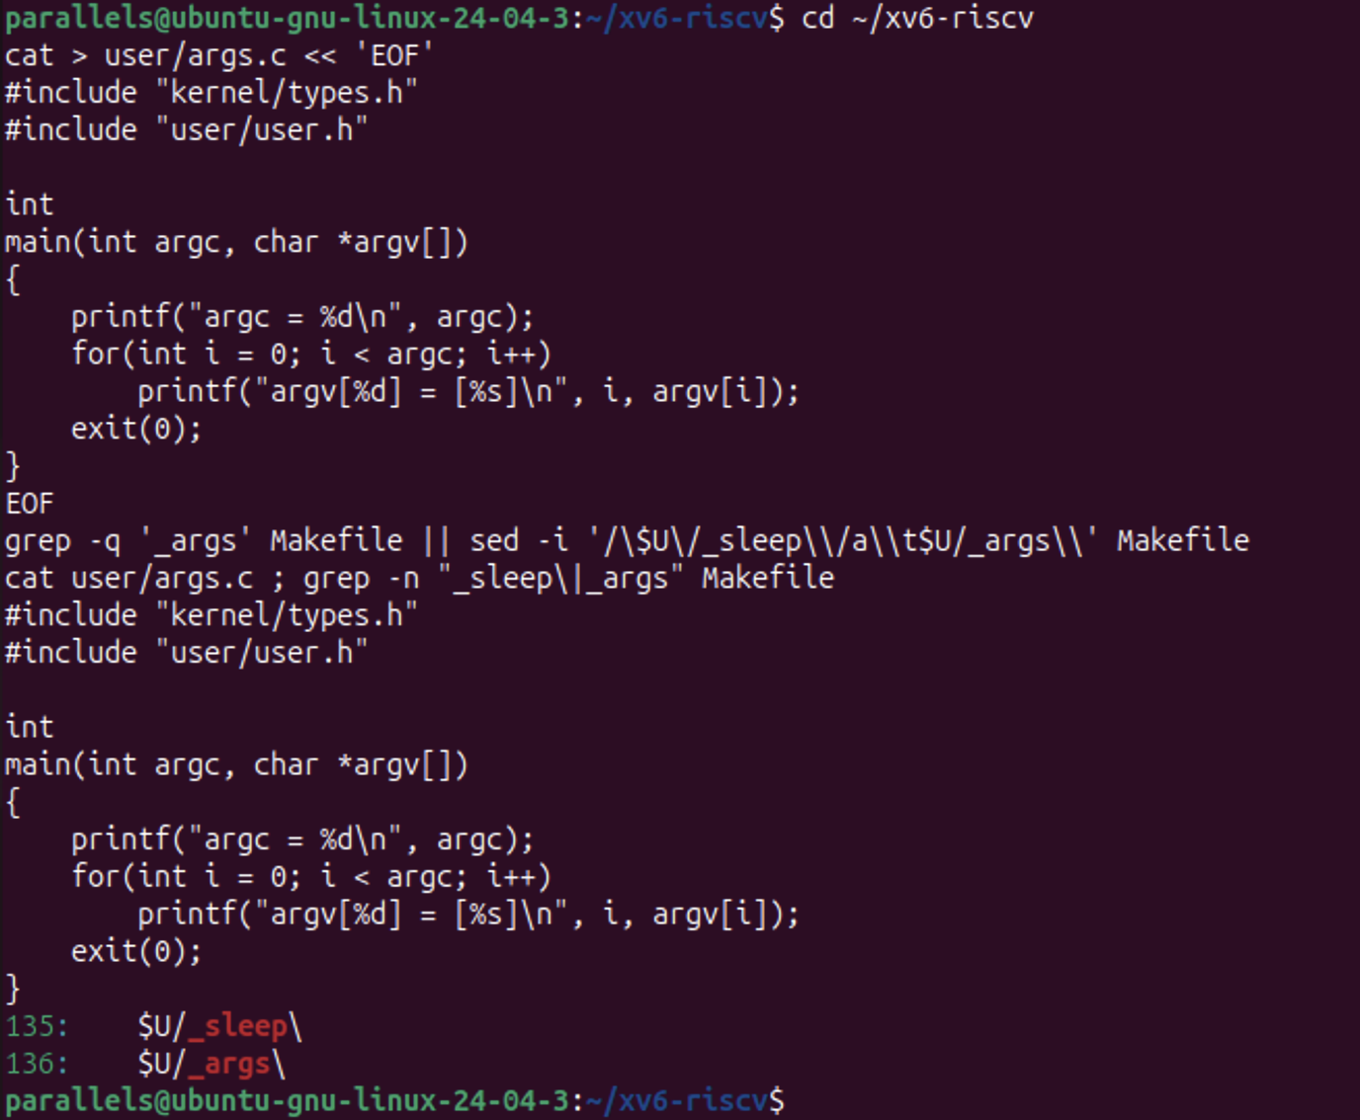
Figure 3.1 – args.c and the UPROGS line
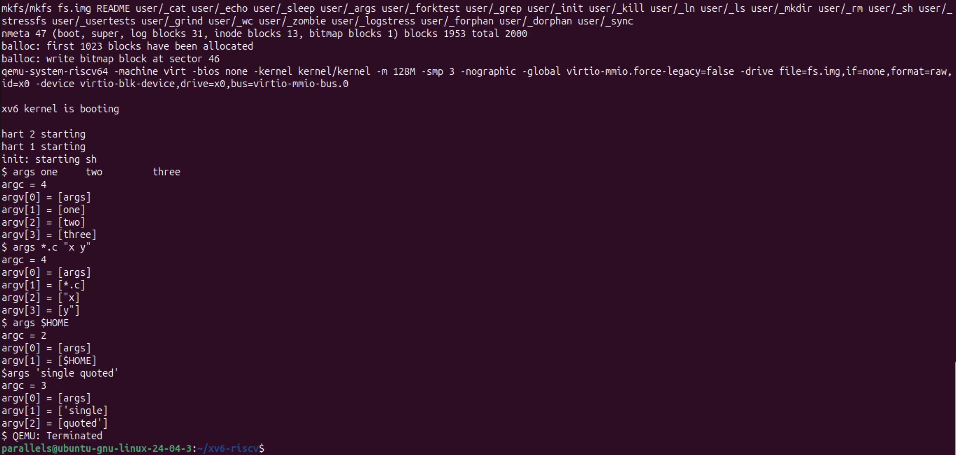
Figure 3.2 – args output in xv6
The Linux version, args_linux.c, uses <stdio.h> and return 0. It was compiled with gcc -o args args_linux.c in the folder ~/argstest, which contains a.c, b.c and args_linux.c.
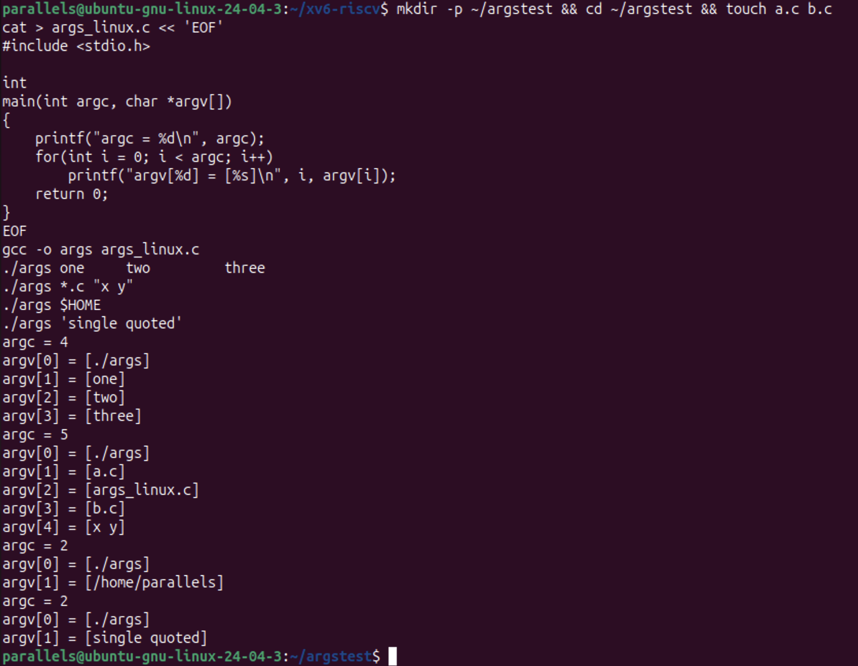
Figure 3.3 – args_linux output in bash
Command line | xv6 (argc, argv) | bash (argc, argv)
args one two three | 4: [args] [one] [two] [three] | 4: [./args] [one] [two] [three]
args *.c "x y" | 4: [args] [*.c] ["x] [y"] | 5: [./args] [a.c] [args_linux.c] [b.c] [x y]
args $HOME | 2: [args] [$HOME] | 2: [./args] [/home/parallels]
args 'single quoted' | 3: [args] ['single] [quoted'] | 2: [./args] [single quoted]

Observe (1). How many arguments did each program receive for args *.c "x y"?
In xv6, argc = 4: [args] [*.c] ["x] [y"]. The *.c arrived as written, and "x y" was split at the space into two words that still contain the quote characters. In bash, argc = 5: [./args] [a.c] [args_linux.c] [b.c] [x y]. *.c became the three matching file names in sorted order, and "x y" became one argument without quotes.
Observe (2). Who turns *.c into file names and removes the quotes?
The shell. The program only prints what it received, and it is identical in both systems. The kernel's exec copies the argv strings into the new process exactly as it is given them. bash expands *.c, removes quotes and substitutes $HOME before calling exec. The xv6 shell does none of this, so the same program receives the raw text.
Observe (3). What happened to the extra spaces in one two three?
They disappeared in both shells: each program received exactly three words, one, two and three. When a shell splits a line into words, any run of spaces and tabs counts as one separator, and the separators are not passed to the program. To keep the spaces, the words would have to be quoted in bash. In xv6 that is impossible, since its shell has no quoting.
Part 4. Read the shell
wc -l user/sh.c reported 499 lines. These are the whole user interface of xv6.
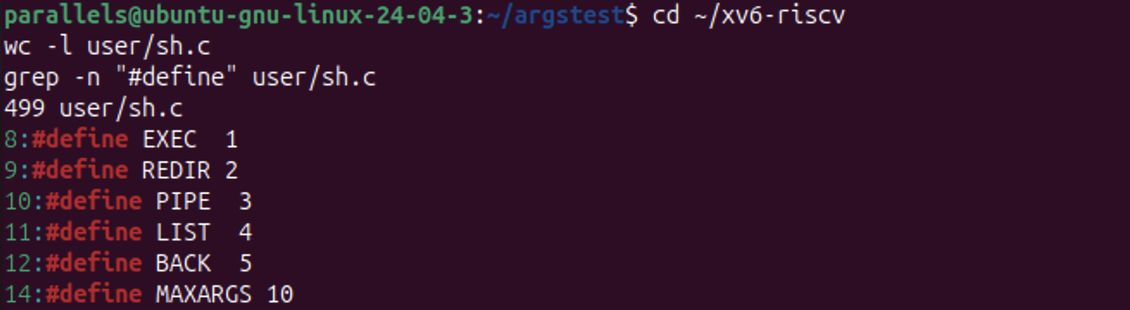
Figure 4.1 – The command kinds defined in sh.c
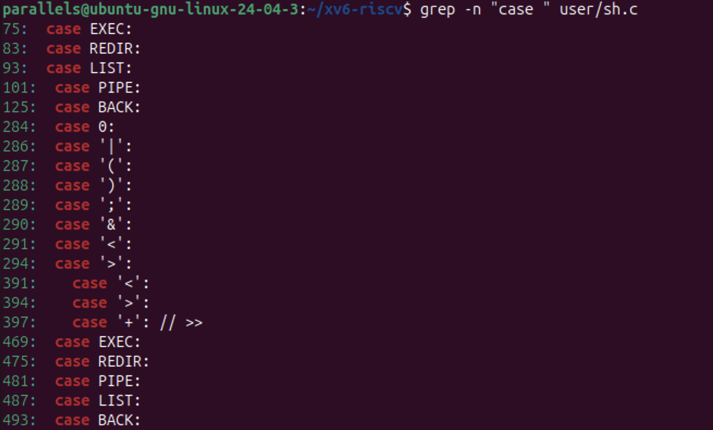
Figure 4.2 – Where each kind is run
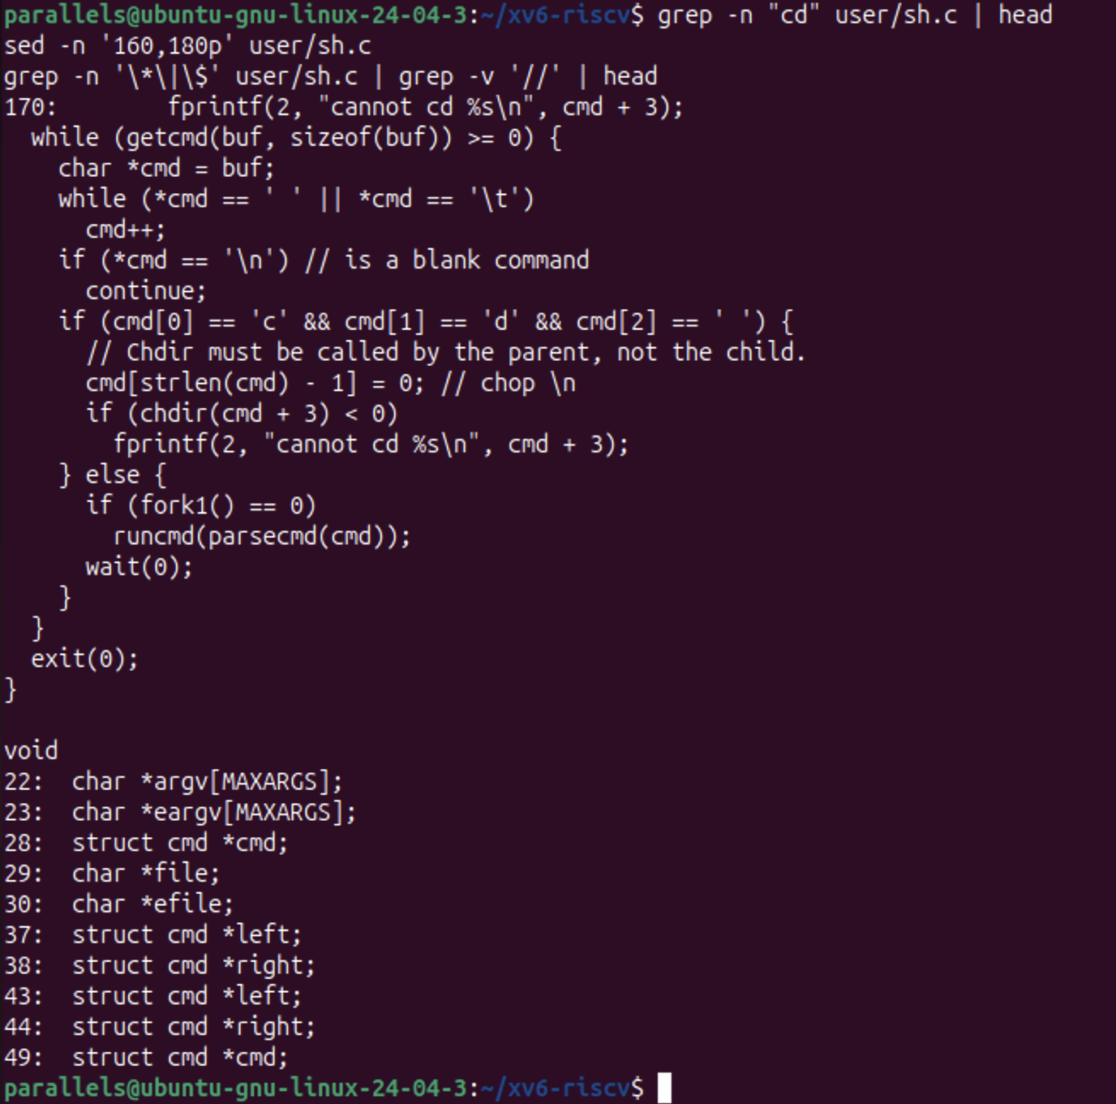
Figure 4.3 – The code that handles cd
Observe (1). The five kinds of command and the character that produces each.
They are defined on lines 8–12 of sh.c:
• EXEC (1): a simple command, a program name with its words. It needs no special character.
• REDIR (2): produced by <, > and >>. The tokenizer returns >> as +, as line 397 shows.
• PIPE (3): produced by |.
• LIST (4): produced by ;.
• BACK (5): produced by &.
The characters are recognized by gettoken (lines 284–294). The parentheses ( ) only group commands (parseblock); they do not create a separate kind. Each kind is executed in runcmd, in a switch with case EXEC (line 75), REDIR (83), LIST (93), PIPE (101) and BACK (125). The second set of cases (lines 469–493) is in nulterminate, which ends each word of the parsed tree with a \0.
Observe (2). Where is cd handled, and why is it not run as a separate program?
cd is handled directly in main(), in the loop that reads commands. If a line starts with the three characters c, d and a space, the shell removes the trailing newline and calls chdir(cmd + 3) itself. On failure it prints cannot cd ... (line 170). Every other line is handled with fork1(), runcmd(parsecmd(cmd)) and wait(0).
The source comment gives the reason: "Chdir must be called by the parent, not the child." The current directory belongs to each process separately. A cd program running as a child would change only its own directory and then exit, and the shell would stay where it was.
This also explains the result in Part 2. cd is only recognized at the very start of a line, so in mkdir d ; cd d ; ls .. it went to the forked child, which tried exec("cd") and failed with exec cd failed.
Observe (3). Code that handles * or $, and what it explains.
Searching sh.c for * and $ only finds C pointer declarations, such as char *argv[MAXARGS] and struct cmd *cmd. Nothing in the file treats * or $ in the command text specially. The tokenizer knows only whitespace and the symbols < | > & ; ( ).
This explains everything seen in Part 2 and Part 3:
• ls * received a literal *.
• echo $HOME printed $HOME.
• Quotes are not special either, so "a b" stayed with its quotes and was split at the space.
In bash, all of these expansions are done by the shell, which is a large program. They are not done by the kernel or by the programs.
Conclusions
Running the same commands in two shells showed that the essential job of a Unix shell is small. It reads a line, splits it into words, builds a tree of commands from < > | ; & ( ), and uses fork, exec, pipe, dup and wait to run that tree. The xv6 shell does exactly this in 499 lines. Redirection, pipes, lists and background execution behaved the same as in bash.
Everything else that makes bash comfortable is extra work done by the shell before exec: globbing, variables, quote removal, the PATH search, history, completion and job control. The args program proved this directly. It is the same code on both systems, yet it received 4 arguments from xv6 and 5 from bash for the same line, because only bash expanded *.c and removed the quotes. The kernel just passes the strings it is given.
Finally, reading sh.c explained two surprises: why ls fails after cd (no PATH, programs live in /) and why cd must be a built-in that the parent executes. I also updated sleep for the renamed pause() system call, and it builds and runs on the current xv6.

