
MINISTRY OF EDUCATION, CULTURE AND RESEARCH
OF THE REPUBLIC OF MOLDOVA
Technical University of Moldova
Faculty of Computers, Informatics and Microelectronics
Department of Software Engineering and Automation

Report
on laboratory works nos. 5–6
of Operating Systems
Topics: The File System with Your Own Hands; Inside the xv6 File System

Done by: st. gr. FAF-243, Augustin Carazanu
Checked by: assist. univ. Patricia Reițman
FCIM, UTM

Chișinău – 2026
Laboratory work no. 5. The File System with Your Own Hands
Purpose of the work
The purpose of this laboratory work is to check, on my own Linux system, how a file system works: the directory tree and the file types, inodes behind the names, hard and symbolic links, permissions, and the disks and kernel interfaces underneath. There is no programming in this lab. The work consists of commands, careful observation and short explanations.
The work was done on Ubuntu 24.04.3 ARM64, running in a Parallels virtual machine on Apple Silicon. Every command was run as the normal user parallels, not as root, because root ignores most permission checks.
Part 1. The tree and the file types
whoami printed parallels, which confirms the normal user. The working folder ~/os-lab5 was created. ls / shows the top of the tree: bin, boot, dev, etc, home, lib, proc, sys, tmp, usr, var and others. On this Ubuntu system there are also the markers bin.usr-is-merged, lib.usr-is-merged and sbin.usr-is-merged, and the swap file swap.img.
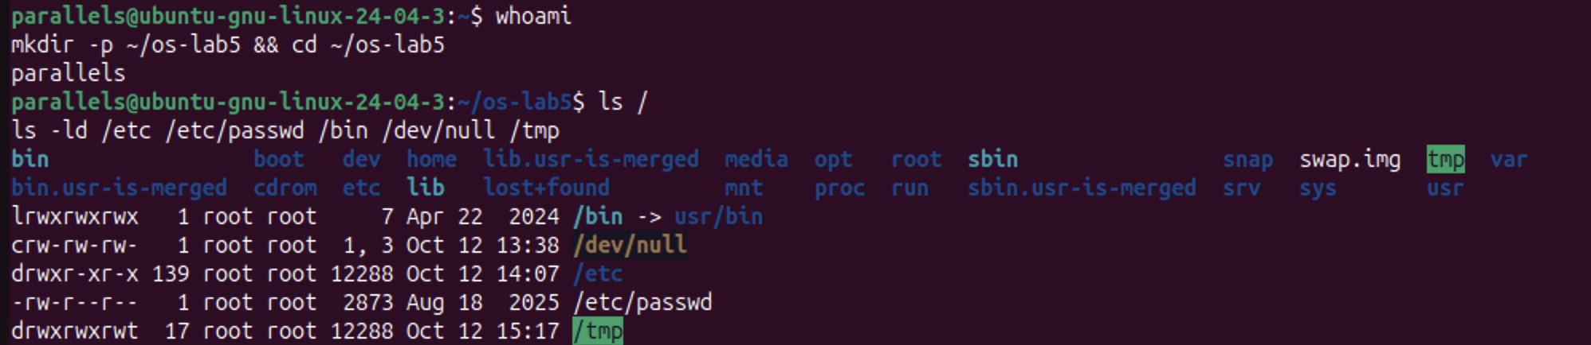
Figure 1.1.1 – whoami, the root of the tree and the types of five paths
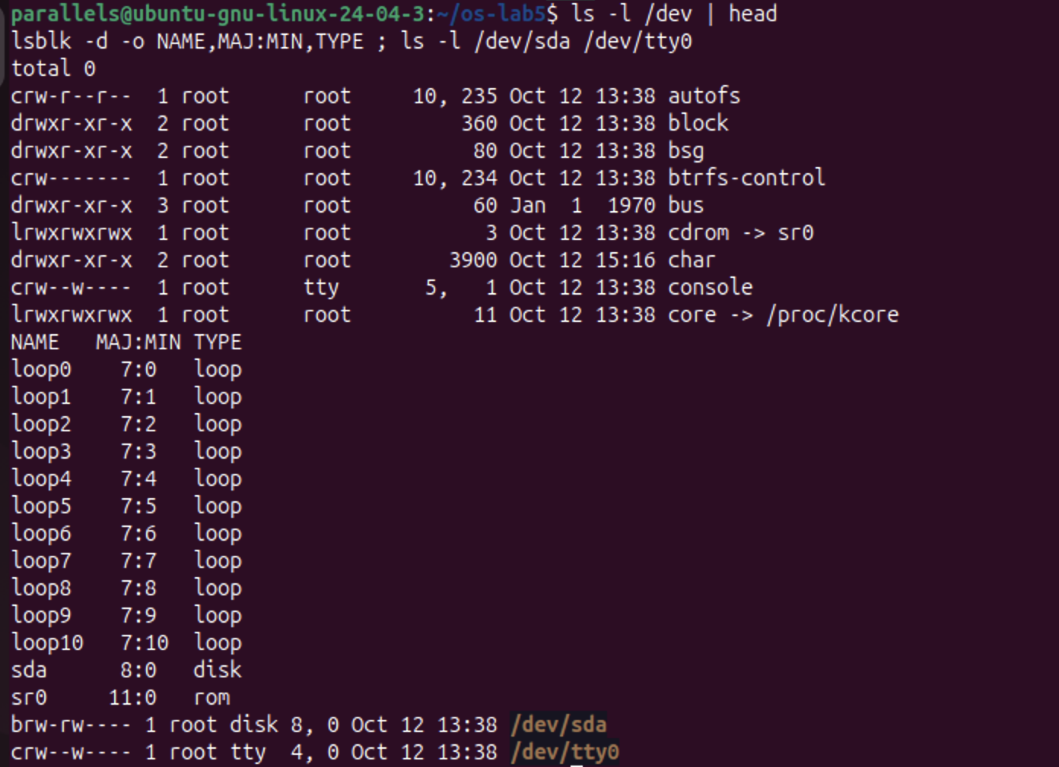
Figure 1.1.2 – The first entries of /dev, and a block device next to a character device
Figure 1.1.3 – file on three paths and the size of /var/log and /usr
Observe (1). The type of each path, from the first letter of ls -l:
Path | ls -ld output | First letter | Type
/etc | drwxr-xr-x 139 root root 12288 | d | directory
/etc/passwd | -rw-r--r-- 1 root root 2873 | - | regular file (text)
/bin | lrwxrwxrwx 1 root root 7 ... /bin -> usr/bin | l | symbolic link
/dev/null | crw-rw-rw- 1 root root 1, 3 | c | character device
/tmp | drwxrwxrwt 17 root root 12288 | d | directory, with the sticky bit t

Observe (2). What is /bin?
/bin is not a directory. It is a symbolic link to usr/bin: ls -ld shows /bin -> usr/bin, and file /bin prints symbolic link to usr/bin. Modern Ubuntu "merged /usr", so the programs really live in /usr/bin. The link is only 7 bytes long, which is exactly the length of the text usr/bin.
Observe (3). One character device and one block device in /dev:
• Character device: /dev/tty0 (crw--w---- root tty 4, 0), a terminal. /dev/null (c, major 1, minor 3) and /dev/console are character devices too. They transfer data as a stream of bytes.
• Block device: /dev/sda (brw-rw---- root disk 8, 0), the virtual 64 GB disk of the VM. A block device is read and written in fixed-size blocks.
Instead of a file size, devices show two numbers, the major and minor numbers (for example 8, 0). The major number selects the kernel driver, and the minor number selects the exact device.
Observe (4). Which is bigger, /var/log or /usr?
/usr (4.4 GB) is much bigger than /var/log (100 MB), about 45 times bigger, or roughly 4.3 GB more. /usr holds all installed programs and libraries, while /var/log holds only text log files.
file also identified /usr/bin/ls as ELF 64-bit LSB pie executable, ARM aarch64, a compiled program for this ARM CPU, and /etc/passwd as ASCII text.
Part 2. Inodes and links
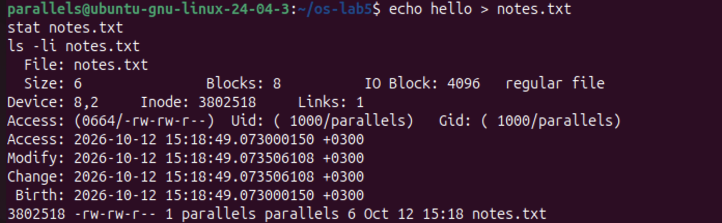
Figure 1.2.1 – stat shows the inode of notes.txt
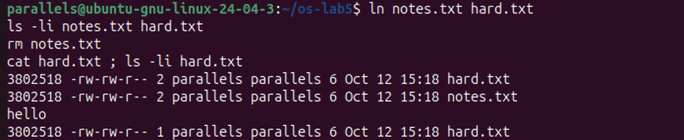
Figure 1.2.2 – A hard link survives the removal of the original name
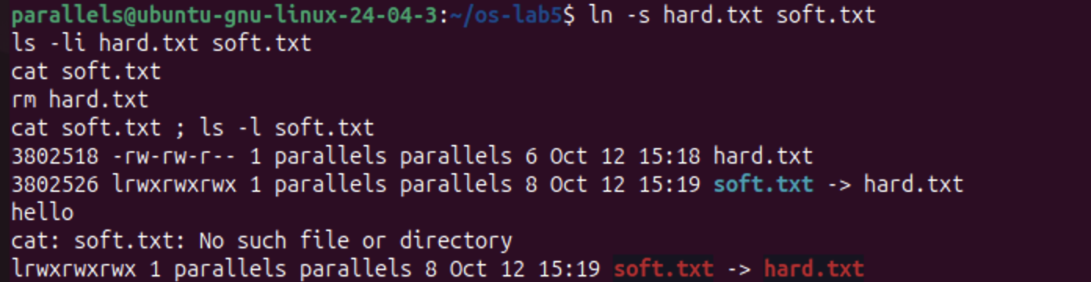
Figure 1.2.3 – A symbolic link breaks when its target is removed
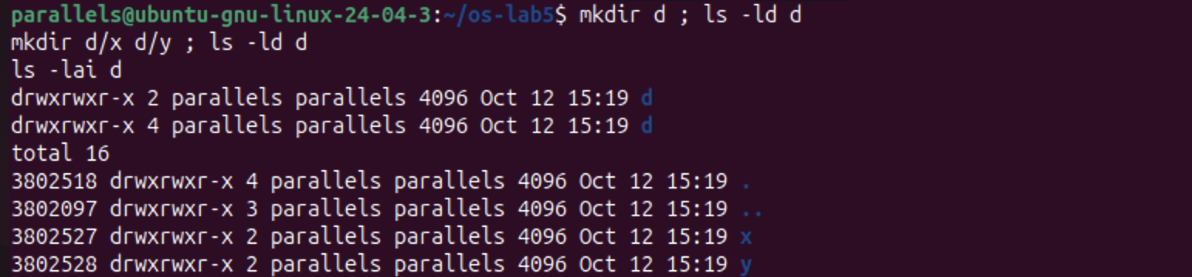
Figure 1.2.4 – Link count of a directory before and after creating two subdirectories
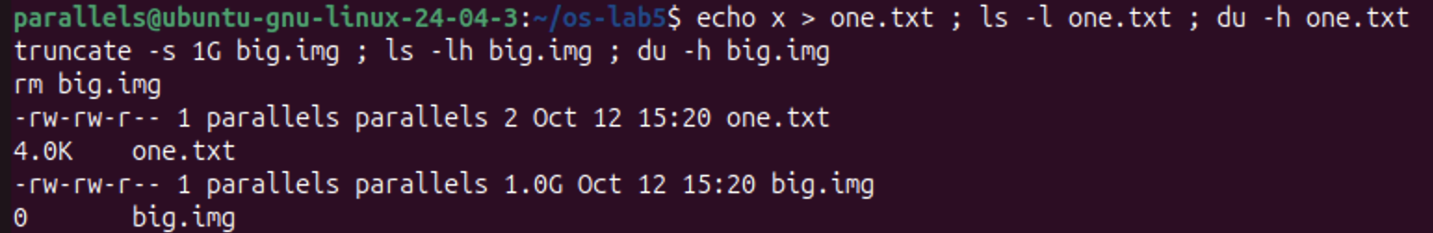
Figure 1.2.5 – Size is not space: a 2-byte file and a 1 GB sparse file
Observe (1). Which number in stat is the inode, and which is the number of names?
stat notes.txt printed Inode: 3802518 and Links: 1. The inode number is 3802518, and ls -li shows the same number in its first column. Links is the number of names (directory entries) that point to this inode, which is 1 for a new file. The inode also stores the size (6 bytes), the blocks used (8 sectors of 512 bytes, so 4 KB), the permissions (0664), the owner (1000/parallels) and four timestamps. It does not store the file's name.
Observe (2). Why could I still read hard.txt after rm notes.txt? What does rm really remove?
ln notes.txt hard.txt created a second name for the same inode: both names show inode 3802518, and the link count became 2. rm does not delete the file's data. It removes one name (one directory entry) and decreases the link count by one. After rm notes.txt, the count dropped to 1, and hard.txt still pointed to the inode, so cat hard.txt printed hello. The kernel frees the inode and its blocks only when the link count reaches 0 and no process still has the file open.
Observe (3). Why did cat soft.txt fail, and why is soft.txt 8 bytes?
A symbolic link is a separate small file with its own inode (3802526, not 3802518). It contains only a path, the text hard.txt. When hard.txt was removed, the target name no longer existed. cat soft.txt followed the stored path and found nothing, so it printed No such file or directory, even though soft.txt itself still exists. ls shows the broken link in red.
The size of soft.txt is 8 bytes, because hard.txt has exactly 8 characters. The link stores the target's name, not its data.
Observe (4). A new directory has 2 links, and 4 after two subdirectories. Where does each come from?
Prediction: 2, then 4. Result: drwxrwxr-x 2 ... d, then drwxrwxr-x 4 ... d, as predicted.
• Link 1 is the entry d in its parent directory (~/os-lab5).
• Link 2 is the entry . inside d, which points to d itself.
• Links 3 and 4 are the .. entries inside d/x and d/y. Each subdirectory's .. points back to d.
ls -lai d confirms it: . is inode 3802518 with 4 links, while x and y have 2 links each. So a directory's link count is always 2 plus its number of subdirectories.
The new directory d received inode 3802518, the same number that notes.txt/hard.txt used before. That inode had been freed when its last name was removed, so the file system reused it.
Observe (5). Why does a 2-byte file use 4.0K, and a 1 GB file use 0?
• one.txt contains 2 bytes (x and a newline), but disk space is allocated in whole blocks of 4096 bytes. Even the smallest non-empty file takes one full block, so du reports 4.0K.
• truncate -s 1G big.img only set the size recorded in the inode to 1 GB, without writing any data. This is a sparse file: no data blocks are allocated until something is written, so ls -lh shows 1.0G while du -h shows 0.
ls reports the size (the logical length), while du reports the space really used on disk.
Part 3. Permissions
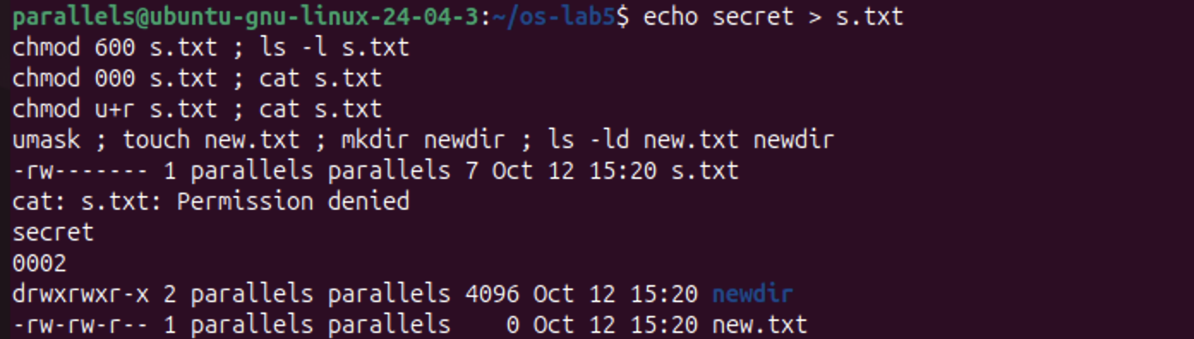
Figure 1.3.1 – chmod on a file, and the umask applied to new files and directories
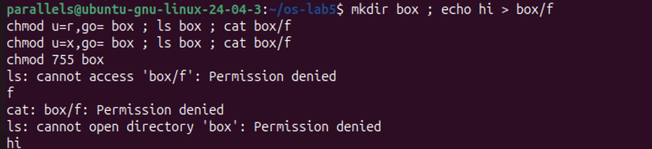
Figure 1.3.2 – The box experiment: read-only and execute-only permission on a directory
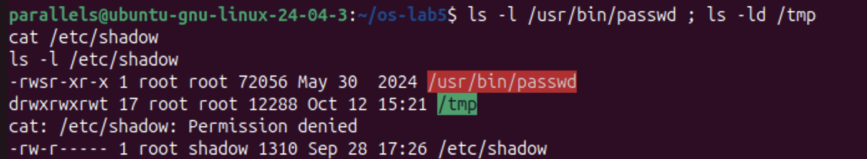
Figure 1.3.3 – The setuid bit on passwd, the sticky bit on /tmp, and the protected /etc/shadow
Observe (1). 600, 644, 755 and 700 as rwx strings, with a real use for each:
Octal | rwx | Real use
600 | rw------- | Private files that only the owner may read: ~/.ssh/id_rsa, or s.txt in this lab
644 | rw-r--r-- | Ordinary public files: /etc/passwd, web pages, documents
755 | rwxr-xr-x | Programs and directories everyone may use: /usr/bin/*, /etc, home folders
700 | rwx------ | Private directories or scripts: ~/.ssh, a personal scripts folder

Each octal digit is the sum of r = 4, w = 2 and x = 1, for the owner, the group and others in that order.
Observe (2). With chmod 000 I own the file but cannot read it. Why does ownership not help?
The kernel checks the permission bits of the class that applies to me, and for the owner that is the first rwx triplet. With 000, the owner's triplet is ---, so the read was refused: cat: s.txt: Permission denied. Being the owner does not bypass the bits. It only gives me the right to change them with chmod, which I did with chmod u+r, and then cat printed secret. Only root ignores these bits.
Observe (3). What is my umask, and how does it explain new.txt and newdir?
The umask is 0002, which removes the write permission for others. New files start from 666 and new directories from 777, and the umask bits are then cleared:
• new.txt: 666 minus 002 gives 664, -rw-rw-r--.
• newdir: 777 minus 002 gives 775, drwxrwxr-x.
Files don't get x by default, because a new file is not normally a program.
Observe (4). The box experiment: what do r and x mean on a directory?
A directory is a list of (name → inode) entries.
• r only (chmod u=r): I can read the list of names. ls box printed f, but ls also said cannot access 'box/f': Permission denied, because it could not open the entry to read the inode's details. cat box/f was denied for the same reason.
• x only (chmod u=x): I can pass through the directory and use a name I already know, but not list it. ls box failed with cannot open directory 'box', while cat box/f printed hi.
So r means "see which names exist", and x means "enter the directory and reach a file by name". To use a directory normally, both are needed (755).
Prediction vs. result: I predicted that with r only, ls would work completely. In fact it printed the name with an error, because ls --color also needs x to read each file's type.
Observe (5). The s in /usr/bin/passwd and the t in /tmp:
• -rwsr-xr-x root root /usr/bin/passwd: the s (setuid) in place of the owner's x means the program runs with the privileges of its owner (root), not of the user who started it. passwd needs this because passwords are stored in /etc/shadow (-rw-r----- root shadow), which a normal user cannot read or write: cat /etc/shadow gave Permission denied. setuid lets any user change their own password through a trusted program, without being given access to the file itself.
• drwxrwxrwt /tmp: the t (sticky bit) means that in this directory, which everyone can write to, a file can be deleted or renamed only by its owner (or root). Users can share /tmp without deleting each other's files.
Part 4. Disks and the kernel as files
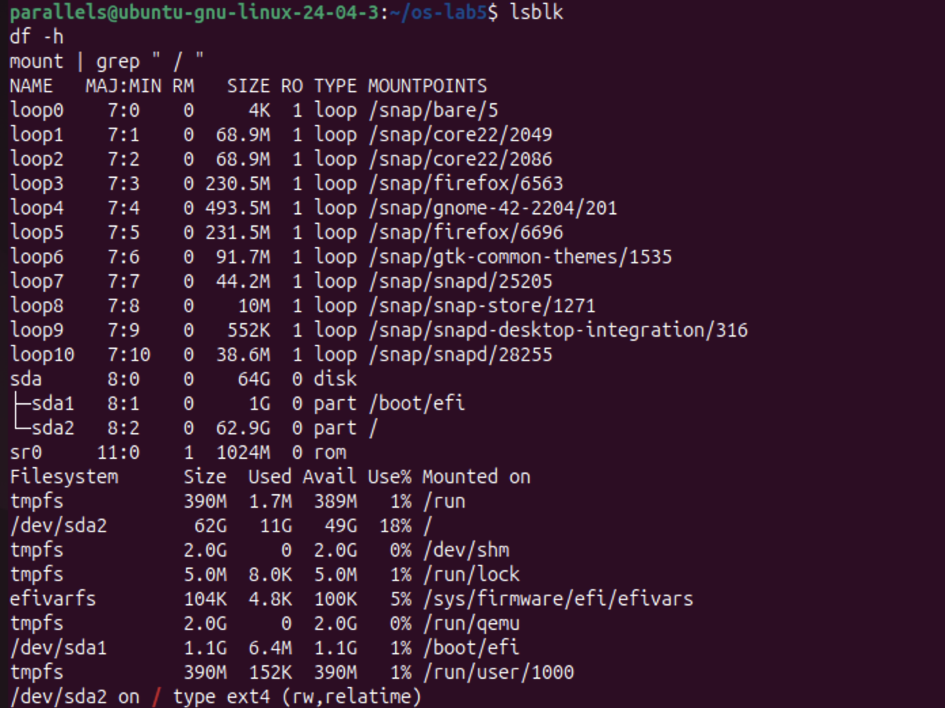
Figure 1.4.1 – lsblk, df -h and the file system mounted at /
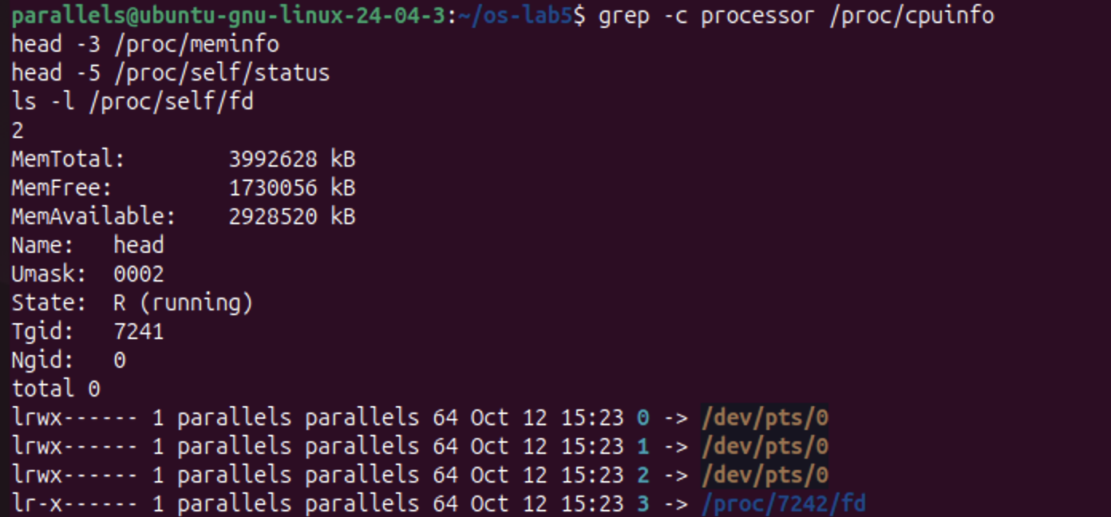
Figure 1.4.2 – CPU cores, memory and the current process, read from /proc
Observe (1). My disk:
sda (8:0) 64 GB virtual disk (Parallels)
├── sda1 (8:1) 1 GB mounted at /boot/efi EFI system partition
└── sda2 (8:2) 62.9 GB mounted at / ext4 (rw,relatime)
sr0 (11:0) virtual CD/DVD drive
loop0 … loop10 read-only snap packages, mounted under /snap/…
The root file system is /dev/sda2, formatted as ext4 (mount printed /dev/sda2 on / type ext4 (rw,relatime)). The loopN devices are not real disks. They are image files (snap packages) that the kernel presents as block devices and mounts read-only.
Observe (2). How full is the root file system?
df -h shows /dev/sda2 62G 11G 49G 18% /, so 18% is used: 11 GB used and 49 GB available. The other entries (tmpfs on /run, /dev/shm and others) live in RAM, not on the disk.
Observe (3). CPU cores and RAM, according to /proc:
grep -c processor /proc/cpuinfo printed 2, so the VM has 2 CPU cores. /proc/meminfo shows MemTotal: 3992628 kB, about 3.8 GiB (the 4 GB given to the VM, minus memory the kernel reserves), with MemAvailable: 2928520 kB. These are the resources the virtual machine gives to Ubuntu, not those of the whole Mac.
Observe (4). /proc/self/status showed the name of a program. Which one, and why?
It showed Name: head. /proc/self is a special link that always points to the directory of the process that is reading it. The file was opened by head -5 /proc/self/status, so "self" was head itself (PID 7241).
The next command proves the same idea. ls -l /proc/self/fd listed the open files of the ls process: 0, 1 and 2 (stdin, stdout and stderr) all point to the terminal /dev/pts/0, and descriptor 3 points to /proc/7242/fd, the directory ls itself had opened (PID 7242, the next process). The kernel's state appears as ordinary files, read with ordinary tools.
Part 5. Stretch tasks
Figure 1.5.1 – Magic number: gzip data renamed to notes.txt
(a) Magic numbers. The compressed copy of /etc/passwd was saved as notes.txt, which has a misleading extension. file still recognized it: gzip compressed data, was "passwd". xxd shows the first bytes 1f 8b 08 08 .... The bytes 1f 8b are the gzip magic number, and 08 means the deflate compression method. file reads these bytes from the content and ignores the extension, because on Linux the name of a file does not determine its type.
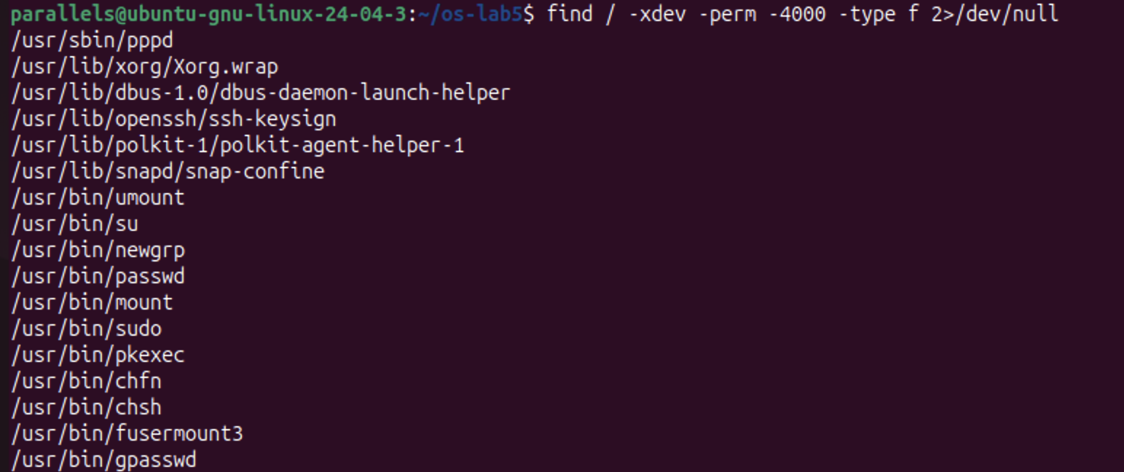
Figure 1.5.2 – All setuid programs on the root file system
(b) Hunting for setuid programs. find / -xdev -perm -4000 -type f found 17 setuid-root programs. They include the classic ones from the lecture: passwd, su, sudo, mount, umount, chsh, chfn, newgrp and gpasswd. It also found ones specific to this desktop installation: pkexec and polkit-agent-helper-1 (graphical admin prompts), snap-confine (snap packages), fusermount3 (user-space file systems), Xorg.wrap (the display server), dbus-daemon-launch-helper, ssh-keysign and pppd. Each of them is a program that has to do one privileged task on behalf of a normal user, which is why the list is kept as short as possible.
Conclusions
This laboratory work showed that a file name and a file are different things. The file itself is an inode that holds the size, owner, permissions and the location of the data, while names are only directory entries that point to it.
That explains everything observed:
• A hard link is a second name for the same inode, and rm only removes a name.
• A symbolic link is a separate tiny file that stores a path, so it breaks when the target is gone.
• A directory's link count comes from its own . and each child's ...
• The size of a file and the space it uses differ, because of 4 KB blocks and sparse files.
Permissions are checked by the kernel on every access, even against the owner. On a directory, r lists the names and x lets you reach them. The umask sets the default permissions of new files, and the special bits setuid and sticky solve two real problems: changing a password without access to /etc/shadow, and sharing /tmp safely.
Finally, the disk itself (/dev/sda, partitioned into an EFI partition and an ext4 root partition at 18% use) and the running kernel (/proc/cpuinfo, /proc/meminfo, /proc/self) are all presented as files. This is the Unix idea that "everything is a file", seen directly.
Laboratory work no. 6. Inside the xv6 File System
Purpose of the work
The xv6 file system uses the same ideas as ext4 (inodes, directories stored as tables of entries, hard links and a journal), but in a few hundred readable lines of C. The purpose of this laboratory work is to:
• read what xv6 shows about its files;
• write my own mystat program and use it to watch hard links at work;
• measure the limits written in kernel/fs.h;
• write find, which walks the directory tree recursively.
The work was done in my ~/xv6-riscv tree from the previous labs, on the same Ubuntu ARM64 virtual machine. The two new programs were added to the UPROGS list in the Makefile, after _sleep and _args from Labs 2 and 4.
Part 1. Read what xv6 shows you
After make qemu, ls in the root directory prints four columns for each entry: name, type, inode number and size in bytes. Then I ran mkdir a and ls a.
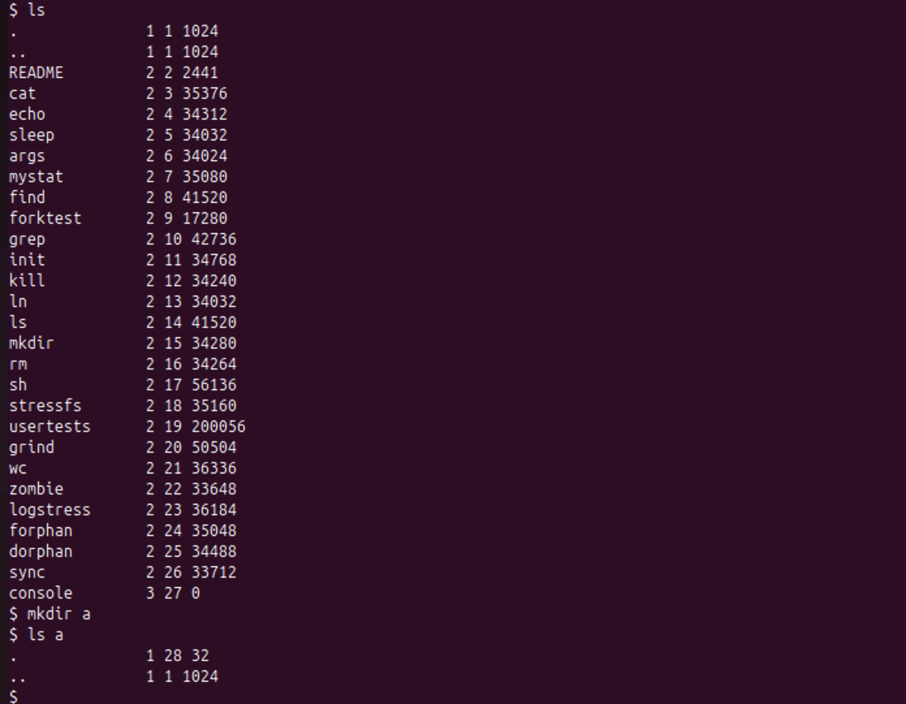
Figure 2.1.1 – ls of the root directory and of a new empty directory a
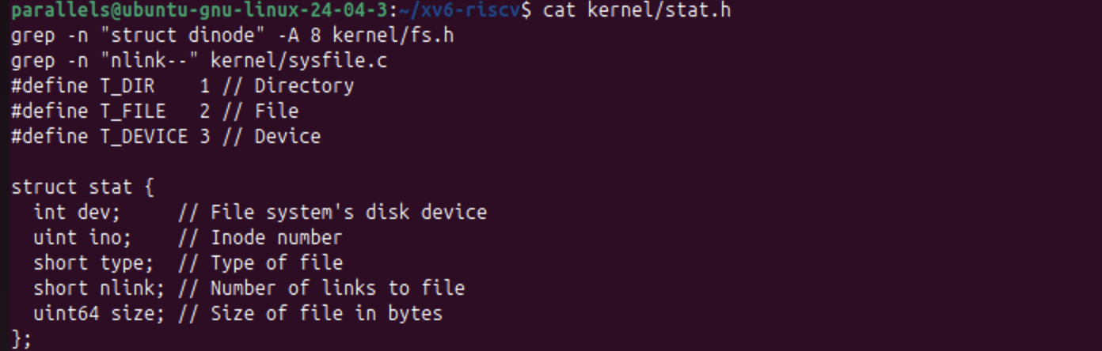
Figure 2.1.2 – The file types and struct stat in kernel/stat.h
Observe (1). What do types 1, 2 and 3 mean?
kernel/stat.h defines them:
• T_DIR 1 is a directory (., .. and a).
• T_FILE 2 is a regular file (README, cat, echo and the other programs).
• T_DEVICE 3 is a device (console, inode 27, size 0).
Observe (2). Which inode does the root directory have, and why are . and .. the same there?
The root directory is inode 1 (ROOTINO), and both . and .. show 1 1 1024. Normally .. points to the parent directory, but the root has no parent. When mkfs creates the file system, it sets the root's .. entry to point to the root itself. So cd .. from / stays in /, exactly as on Linux.
Observe (3). The empty directory a has size 32. How big is one entry, and which two entries does it contain?
a contains exactly two entries: . (inode 28, which is a itself) and .. (inode 1, the root). Two entries take 32 bytes, so one directory entry is 16 bytes. This is struct dirent in kernel/fs.h: a ushort inum (2 bytes) plus char name[DIRSIZ] (14 bytes) gives 2 + 14 = 16. The root directory has size 1024 because it holds many entries and fills a whole block.
Part 2. Write mystat
user/mystat.c fills in the two TODOs:
• typename() maps T_DIR, T_FILE and T_DEVICE to text with a switch.
• main() calls stat(argv[i], &st) for every argument. If it fails, it prints mystat: cannot stat NAME to file descriptor 2 and continues with the next argument. Otherwise it prints the name, type, inode, link count and size.
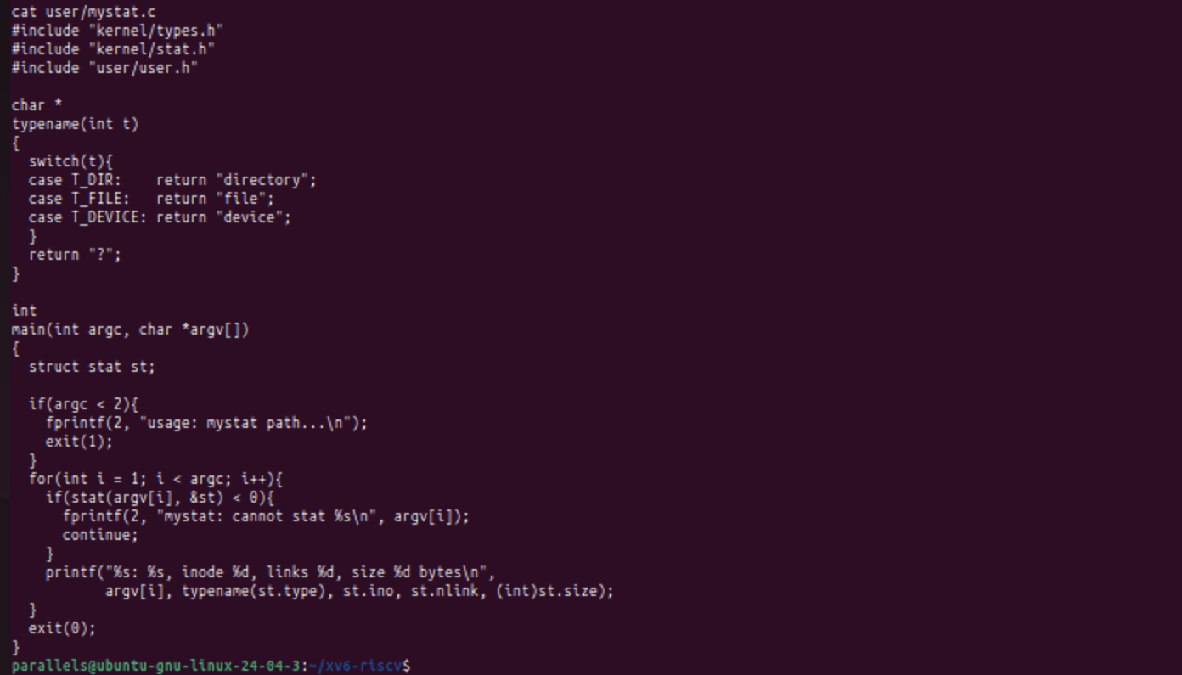
Figure 2.2.1 – The source code of user/mystat.c
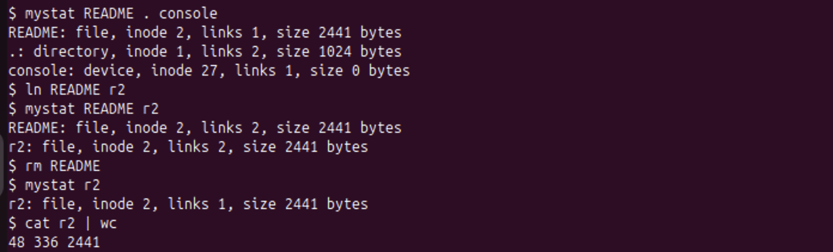
Figure 2.2.2 – mystat watching a hard link: after ln and after rm
Observe (1). Outputs after ln and after rm. What changed and what did not?
$ mystat README . console
README: file, inode 2, links 1, size 2441 bytes
.: directory, inode 1, links 2, size 1024 bytes
console: device, inode 27, links 1, size 0 bytes
$ ln README r2
$ mystat README r2
README: file, inode 2, links 2, size 2441 bytes
r2: file, inode 2, links 2, size 2441 bytes
$ rm README
$ mystat r2
r2: file, inode 2, links 1, size 2441 bytes
$ cat r2 | wc
48 336 2441
• After ln, README and r2 show the same inode (2) and the link count changed from 1 to 2. There is one file with two names.
• After rm README, only the link count changed, from 2 to 1. The inode number (2), the type and the size (2441 bytes) did not change, and cat r2 | wc still reads all 48 lines, 336 words and 2441 bytes. rm removed a name, not the file.
• Unlike the example in the lab sheet, the root . shows links 2. I had already run mkdir a, and the .. entry of a is one more link to the root.
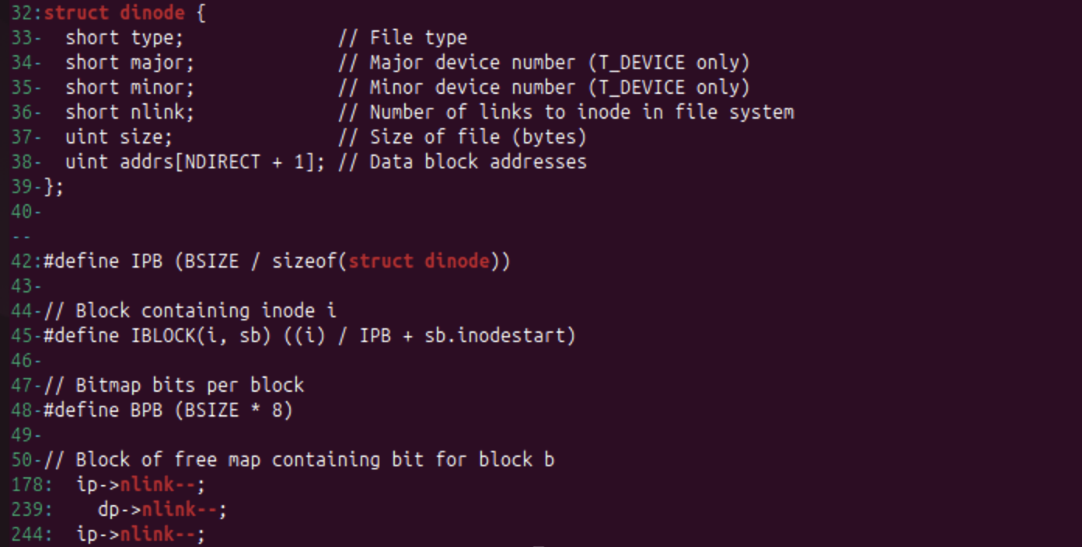
Figure 2.2.3 – struct dinode in kernel/fs.h and the nlink-- lines in kernel/sysfile.c
Observe (2). Which line in sys_unlink decrements the link count? When are the data blocks freed?
grep -n "nlink--" kernel/sysfile.c found three lines:
• Line 178 is in sys_link. It undoes the increment if creating the new name fails.
• Line 239, dp->nlink--;, is in sys_unlink. It is used only when the removed entry is a directory, because the directory's .. stops pointing to its parent dp.
• Line 244, ip->nlink--;, is the line in sys_unlink that decrements the link count of the removed file's inode.
The data blocks are not freed at that moment. sys_unlink only writes the updated inode and calls iunlockput(ip). The blocks are freed later, in iput() (kernel/fs.c): when the last in-memory reference is dropped (ip->ref == 1) and ip->nlink == 0, iput calls itrunc(ip), which frees the data blocks, and then marks the inode free. So a file that still has another name (like r2), or that some process still has open, keeps its data.
Observe (3). Which fields does an xv6 inode have?
struct dinode in kernel/fs.h (lines 32–39) has only six fields:
• short type: file, directory or device, and 0 for a free inode.
• short major and short minor: the device numbers (devices only).
• short nlink: the number of directory entries that point to this inode.
• uint size: the size of the file in bytes.
• uint addrs[NDIRECT+1]: 12 direct block addresses and one indirect block address.
The inode stores no owner, no permissions and no timestamps, which is why xv6 has no permissions. It also has no type for symbolic links. Like on Linux, the inode stores no name: names exist only in directory entries.
Part 3. Measure the limits
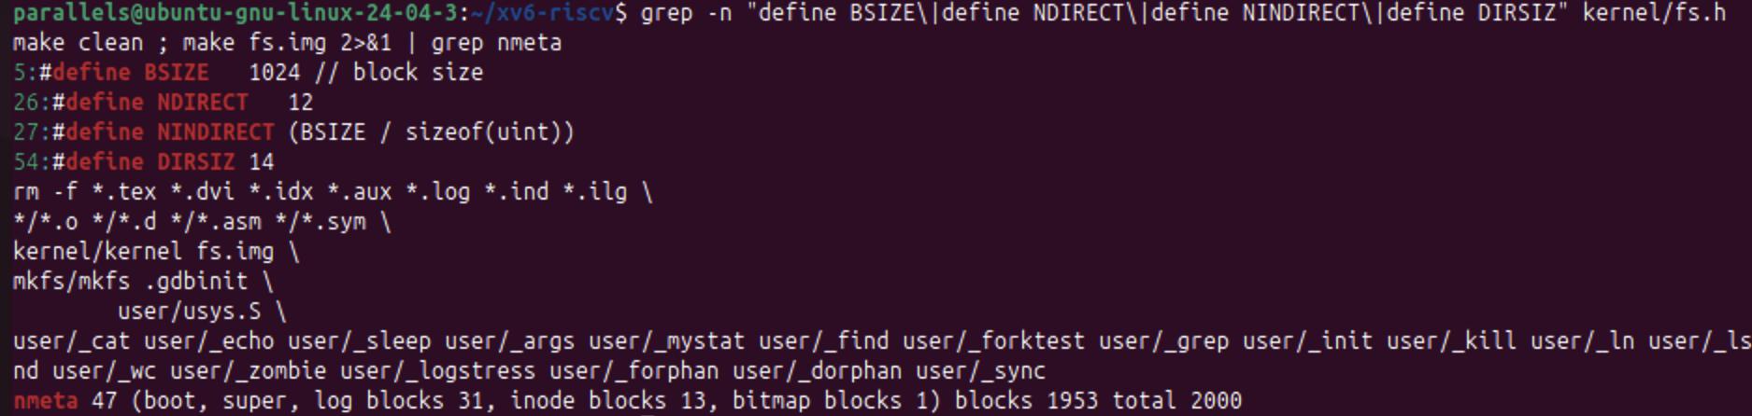
Figure 2.3.1 – The constants in kernel/fs.h and the disk layout printed by mkfs
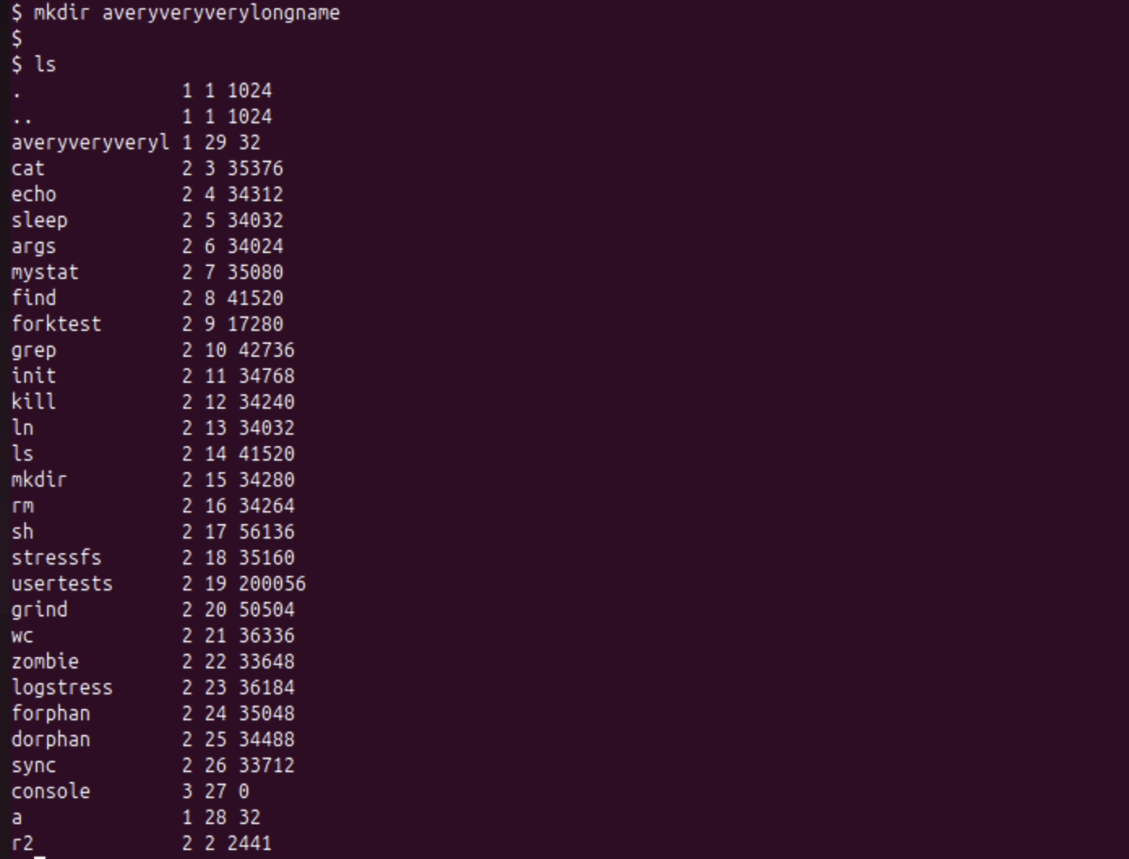
Figure 2.3.2 – A directory with a long name is truncated to 14 characters
Observe (1). What does ls show for averyveryverylongname, and which constant explains it?
ls shows averyveryveryl, only the first 14 characters (averyveryveryl 1 29 32). The constant is DIRSIZ 14 in kernel/fs.h, the size of the name field in struct dirent. Longer names are cut to 14 characters when the entry is written, and there is no room for a terminating zero when the name is exactly 14 characters long.
Observe (2). The largest file xv6 can hold:
From kernel/fs.h: BSIZE = 1024, NDIRECT = 12, and NINDIRECT = BSIZE / sizeof(uint) = 1024 / 4 = 256.
MAXFILE = NDIRECT + NINDIRECT = 12 + 256 = 268 blocks
largest file = 268 × BSIZE = 268 × 1024 = 274 432 bytes ≈ 268 KB
• The 12 direct blocks hold 12 × 1024 = 12 288 bytes.
• The single indirect block holds 256 block numbers, which point to another 256 × 1024 = 262 144 bytes.
This is the limit of 268 KB. For comparison, ext4 reaches terabytes by using extents or double and triple indirect blocks.
Observe (3). The nmeta line: total blocks, log, inodes and data.
make fs.img printed:
nmeta 47 (boot, super, log blocks 31, inode blocks 13, bitmap blocks 1) blocks 1953 total 2000
The disk has 2000 blocks of 1 KB (FSSIZE):
Region | Blocks
Boot block | 1
Superblock | 1
Log (journal) | 31 (a header plus 30 data blocks)
Inodes | 13 (200 inodes, 16 per block)
Free-block bitmap | 1
Metadata total (nmeta) | 47
Data blocks | 1953

47 + 1953 = 2000.
Part 4. Write find
user/find.c is based on user/ls.c. The function find(path, name):
• opens path and calls fstat;
• prints path if its last component (computed by basename) equals name;
• if path is a directory, reads it one struct dirent at a time, skips free slots (inum == 0) and the entries . and .., builds path/entry in a 512-byte buffer and calls itself recursively;
• closes every directory it opens, because a process can have only 16 open files, and a deep tree would otherwise run out of file descriptors.
The optional third argument -n (the stretch task) also prints the inode number of each match.
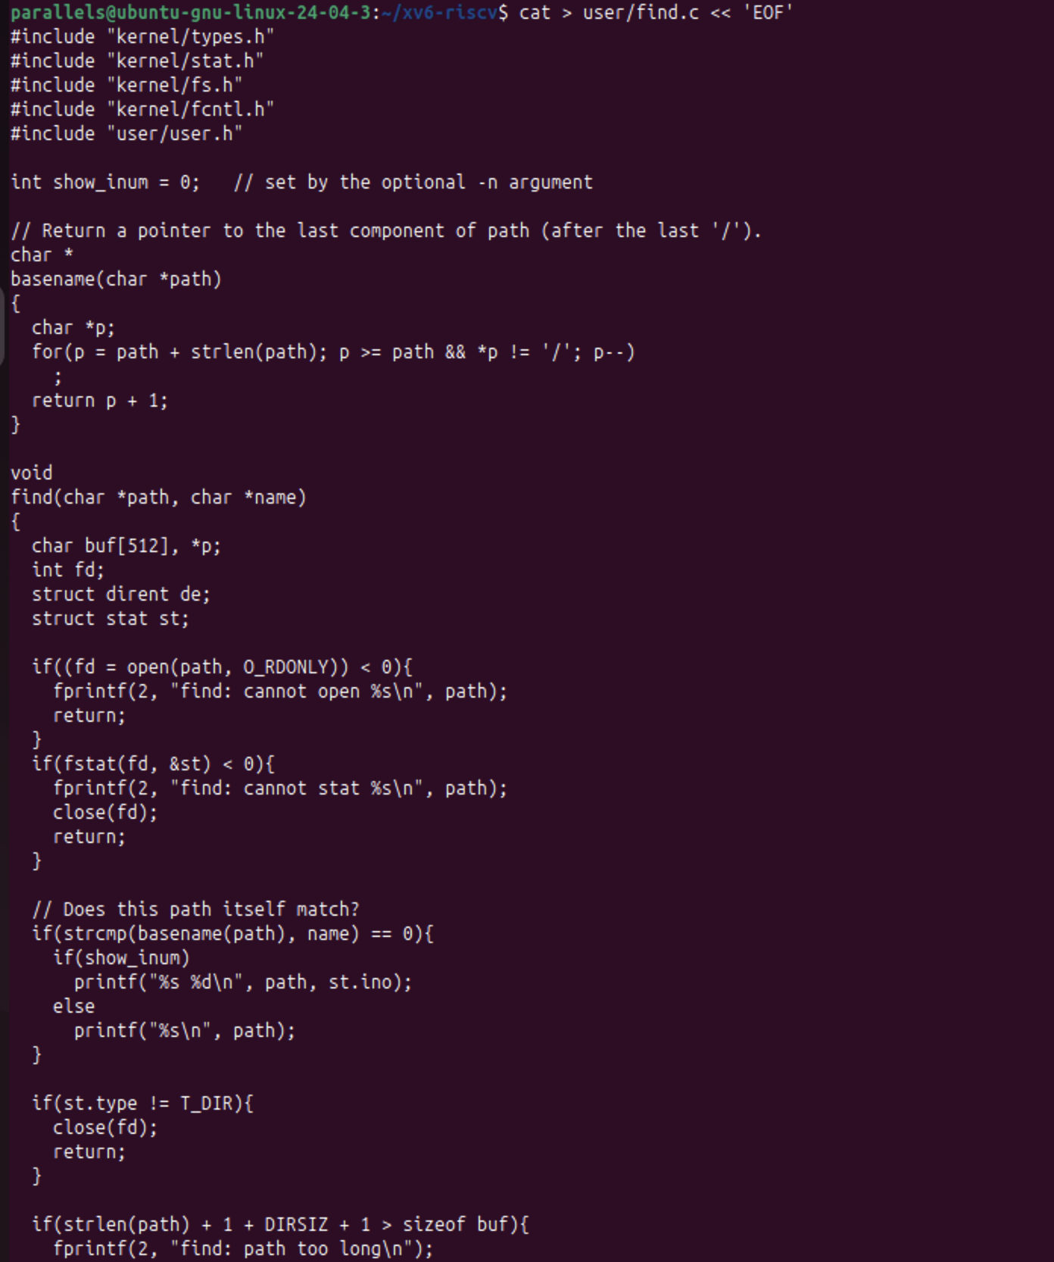
Figure 2.4.1 – The source code of user/find.c (first half)
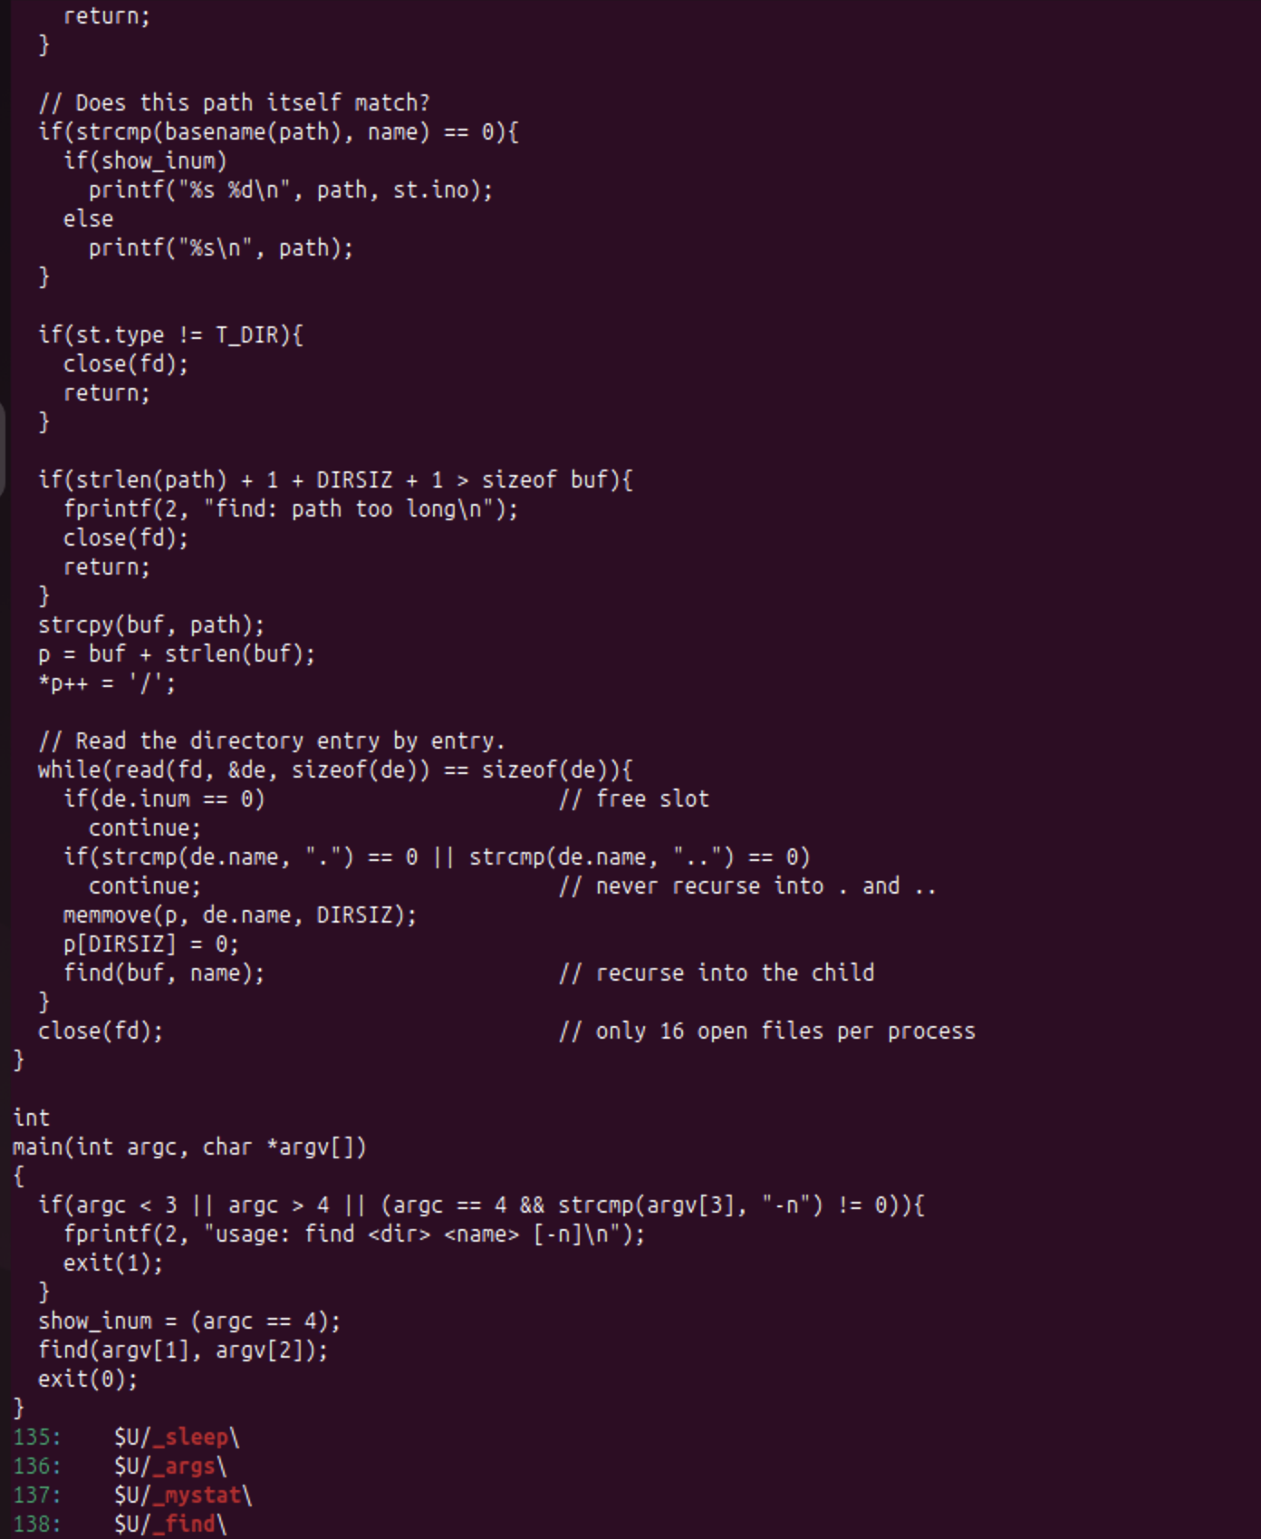
Figure 2.4.2 – The source code of user/find.c (second half) and the UPROGS lines
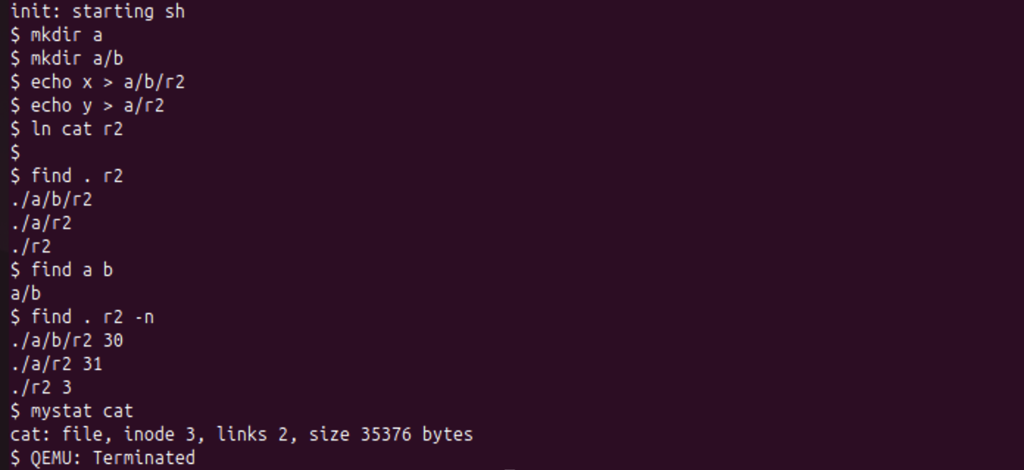
Figure 2.4.3 – Testing find on a fresh disk, and the stretch task find . r2 -n
The test on a fresh disk (make clean ; make qemu):
$ find . r2
./a/b/r2
./a/r2
./r2
$ find a b
a/b
$ find . r2 -n
./a/b/r2 30
./a/r2 31
./r2 3
$ mystat cat
cat: file, inode 3, links 2, size 35376 bytes
find . r2 found all three files called r2, at every depth of the tree. find a b found the directory a/b, because find also matches directories, not only files.
Stretch. Which of the three r2 files is the same file as cat?
Only ./r2. It has inode 3, the same inode as cat, because it was created with ln cat r2. mystat cat confirms that inode 3 now has 2 links. The other two (./a/b/r2, inode 30, and ./a/r2, inode 31) are new files created by echo, with their own inodes.
Conclusions
xv6 confirmed the ideas from Lab 5 in readable code. An inode (struct dinode) holds only the type, the link count, the size and 13 block addresses. A directory is just a file of 16-byte entries (inum, name[14]), so . and .. cost 32 bytes, names are cut at 14 characters, and the root's .. points to itself.
mystat showed that ln adds a name and increments nlink, while rm (sys_unlink, line 244) only decrements it. The data is freed later, in iput, when the link count is 0 and nothing holds the inode.
The limits in fs.h give a maximum file size of (12 + 256) × 1024 = 274 432 bytes, on a 2000-block disk where 47 blocks are metadata (31 of them for the log).
Finally, find showed how a recursive tree walk is built from the same system calls as ls (open, fstat, read of dirent entries and close). The -n option identified which r2 is a hard link to cat.

