
MINISTRY OF EDUCATION, CULTURE AND RESEARCH
OF THE REPUBLIC OF MOLDOVA
Technical University of Moldova
Faculty of Computers, Informatics and Microelectronics
Department of Software Engineering and Automation

Report
on laboratory work no. 10
of Operating Systems
Topic: Add Your Own System Call: trace

Done by: st. gr. FAF-243, Augustin Carazanu
Checked by: assist. univ. Patricia Reițman
FCIM, UTM

Chișinău – 2026
Purpose of the work
The purpose of this laboratory work is to change the kernel itself for the first time. I added a new system call, trace, to xv6, so that a process can ask the kernel to print every system call it makes (on Linux, strace did this in Lab 9, now I built it myself). I followed one number, 23, from a user program down to a function in the kernel, and then tried the call with different masks. The work was done in my copy of xv6 (~/xv6-riscv, course revision 06aad25) on Ubuntu 24.04.3 ARM64 in a Parallels virtual machine, and the programs run inside QEMU.
Before you start
Our xv6 is newer than the version in the MIT instructions, and two details are different. In our tree number 22 is already sync, so the new call gets 23. The kernel print function is called printk, not printf. In the Makefile the new line must start with a TAB.
Part 1. The number and the user side
A system call is a path with several stops: the user program calls a stub, the stub puts the number in register a7 and runs ecall, and the kernel looks the number up in a table. In Part 1 I built the user side. There are five small edits:
File | Edit
kernel/syscall.h | #define SYS_trace 23
user/user.h | int trace(int); (after int sync(void);)
user/usys.pl | entry("trace"); (the build turns it into li a7, SYS_trace; ecall; ret)
user/trace.c | new program: sets the mask on itself with trace(), then becomes the command with exec()
Makefile | $U/_trace\ in UPROGS, after $U/_zombie\

I applied them with a few shell commands (echo >>, sed, a here-document for trace.c, and a small Python script for the Makefile). trace.c is the following program:
#include "kernel/types.h"
#include "kernel/stat.h"
#include "user/user.h"

int
main(int argc, char *argv[])
{
if (argc < 3) {
fprintf(2, "usage: trace mask command [args...]\n");
exit(1);
}
if (trace(atoi(argv[1])) < 0) {
fprintf(2, "trace: failed\n");
exit(1);
}
exec(argv[2], argv + 2);
fprintf(2, "trace: exec %s failed\n", argv[2]);
exit(1);
}

The program first sets the mask on its own process, and after that it replaces itself with the command by exec. The mask stays, because exec keeps the process and only changes its program.
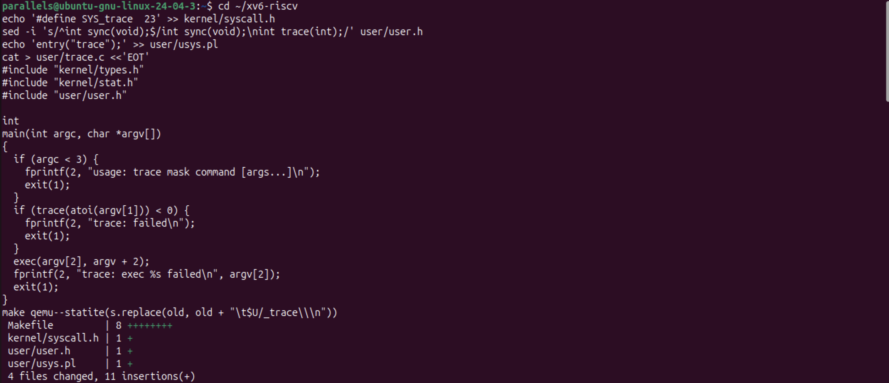
Figure 1.1 – The Part 1 edits applied in ~/xv6-riscv, with git diff --stat at the end
git diff --stat shows 4 changed files and 11 insertions. The Makefile shows 8 insertions, and not 1, because my Makefile already contained the user programs of the earlier labs (sleep, args, mystat, find, run, pingpong, primes); the new part is only the $U/_trace\ line. The odd line make qemu--statite(s.replace(... between the code and the diff is only a leftover of the terminal paste (the end of my Python script was echoed in the middle of the next command); the diff and the build show that all edits were applied.
Check 1. Before Part 2 the kernel does not know number 23 yet. So trace must fail in a clear way:
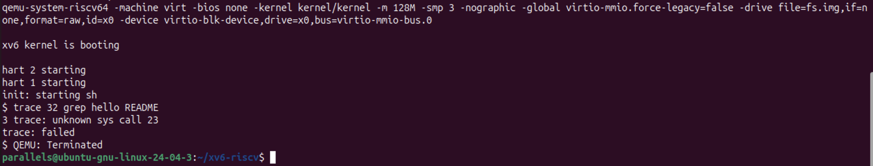
Figure 1.2 – Check 1: the kernel does not know system call 23 yet
The stub ran ecall with 23 in a7, and the kernel found nothing in its table for this number. So it printed 3 trace: unknown sys call 23 (the number 3 is the pid of the process) and returned -1, and trace.c printed trace: failed. This is exactly the expected result of the check: the user side works and reaches the kernel, but the kernel side is still missing.
Part 2. The kernel side
Now the kernel gets the handler, the mask and the printing. There are five more edits:
• kernel/proc.h: a new field in struct proc, int trace_mask;. Each process has its own mask. 0 means "print nothing".
• kernel/sysproc.c: the handler sys_trace, which reads argument 0 with argint(0, &mask) and stores it in myproc()->trace_mask. It returns 0.
• kernel/syscall.c: extern uint64 sys_trace(void); and the table entry [SYS_trace] = sys_trace. This is the stop where the number 23 becomes the function.
• kernel/syscall.c: a table syscallnames[] with the name of each call, and in syscall() a check after the call: if bit num of the mask is on, printk("%d: syscall %s -> %ld\n", p->pid, syscallnames[num], p->trapframe->a0);.
• kernel/proc.c, in kfork(): np->trace_mask = p->trace_mask;, so that the child inherits the mask of its parent.
The check in syscall() is (p->trace_mask >> num) & 1. It shifts the mask num places to the right and looks at the lowest bit, so a call is printed exactly when its own bit is on. The print is placed after syscalls[num](), because the line has to show the return value, which is in a0.
Check 2. After make qemu I ran the command from the goal of the lab:
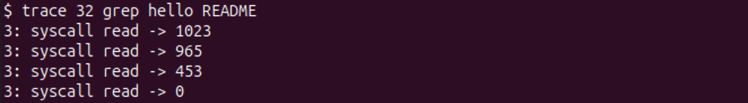
Figure 2.1 – Check 2: trace 32 grep hello README prints only the read calls
The output has four read lines with the same pid (3). The return values 1023, 965, 453 and 0 are the sizes of the pieces in which grep reads the file README, and the final 0 means the end of the file. The check passes.
Part 3. Play with the mask
The mask is a number read in binary: bit N on means "print the call number N". The numbers of the calls that I use are: fork = 1, read = 5, exec = 7, open = 15, write = 16, close = 21 and trace = 23.
3.1 All the calls. The mask 2147483647 is 2^31 − 1, so bits 0 to 30 are on and every call is printed:
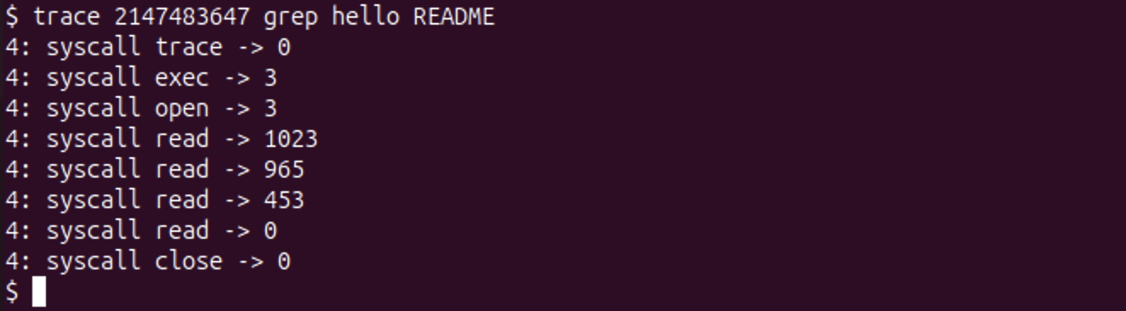
Figure 3.1 – trace 2147483647 grep hello README: all the calls
The first line is trace -> 0: the process printed its own call to trace, because the mask was already set when the call returned. After it, exec -> 3 (the value 3 is the number of arguments, grep hello README), open -> 3 (the file README got descriptor 3), four read calls and close -> 0. All lines have pid 4, because the mask stayed through exec.
3.2 Only fork. The mask 2 is bit 1 (fork). The test forkforkfork of usertests forks until the process table is full:
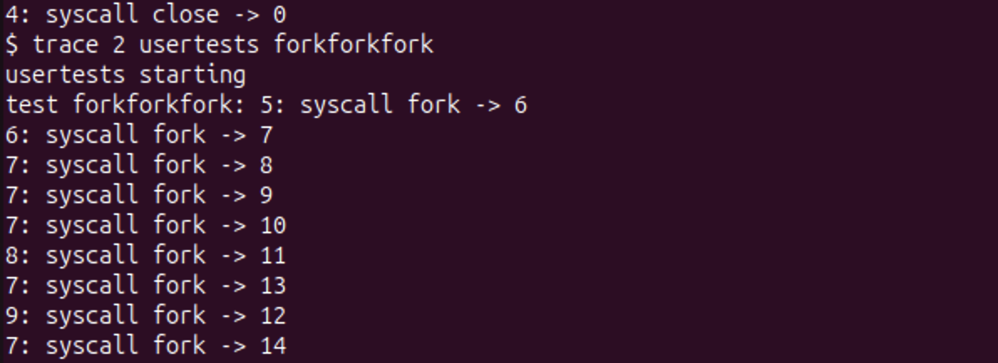
Figure 3.2a – trace 2 usertests forkforkfork: the beginning
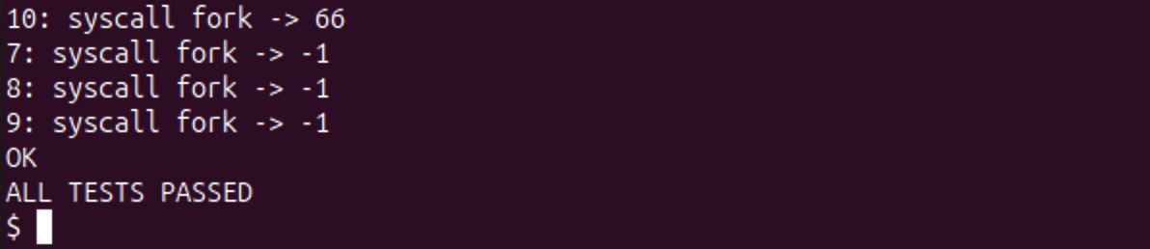
Figure 3.2b – trace 2 usertests forkforkfork: the end, fork returns -1 and the test passes
Many different pids print lines (5, 6, 7, 8, 9, 10, 32, 43 and others), and not only the first one. At the end the last successful fork returned 66, then the process table was full and fork returned -1 for several processes, and the test ended with OK and ALL TESTS PASSED. The pids are not in a fixed order, because the processes run on the 3 CPUs at the same time.
3.3 Only write. The mask 65536 is 2^16, bit 16 (write):
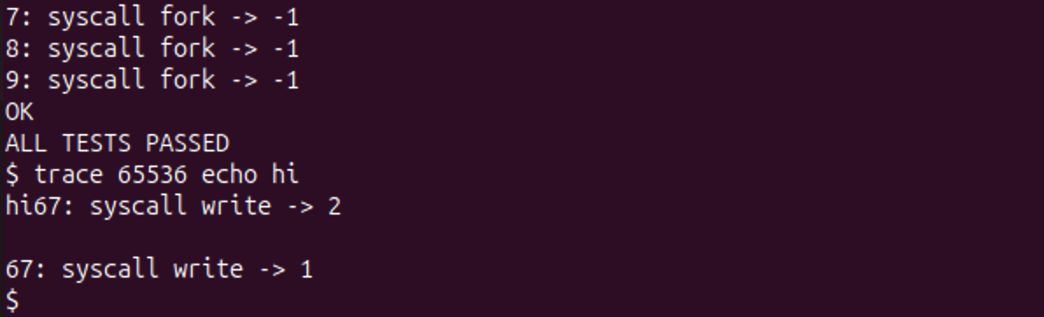
Figure 3.3 – trace 65536 echo hi: the trace line is between hi and the new line
3.4 Open and close. I used open (15) and close (21). Their masks are 2^15 = 32768 and 2^21 = 2097152, and the sum is 2129920:
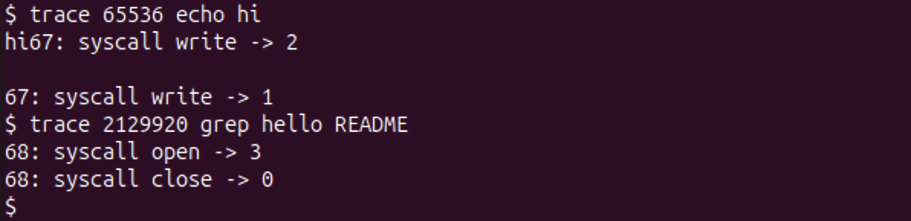
Figure 3.4 – trace 2129920 grep hello README: only open and close
Only two lines were printed: open -> 3 and close -> 0 (pid 68). The read calls and exec did not appear, because their bits are off.
Answers to the Observe questions
Observe 1. In trace 32 grep hello README why do you see only read, and not open or close?
The mask 32 is 2^5, so only bit 5 is on, and 5 is the number of read. After every system call the kernel checks (p->trace_mask >> num) & 1 and prints the line only if the bit of that call is on. grep still calls open and close, as Figure 3.1 shows, but their bits (15 and 21) are off in the mask 32, so these two calls are made silently.
Observe 2. In forkforkfork, three different pids print lines. Which line of code from Part 2 makes that possible?
The line np->trace_mask = p->trace_mask; in kfork() (kernel/proc.c). fork makes the child as a copy of the parent, and this line copies the mask too. So every child, and every grandchild, has the same mask and prints its own fork calls under its own pid. Without this line only the first process would print, and the children would have mask 0. In my run even more than three pids appear (Figure 3.2a), because each child continues to fork.
Observe 3. In trace 65536 echo hi the trace line is printed between "hi" and the new line. Why? (How many times does echo call write?)
echo calls write two times: first for the text hi (2 bytes, the call returns 2) and then for the new line (1 byte, returns 1). The kernel prints the trace line right after each call has finished. After the first write the screen already shows hi, so 67: syscall write -> 2 comes directly after it on the same line. The \n at the end of this trace line ends the line, then the second write of echo prints its new line, which gives the empty line, and then the trace line of the second write follows (67: syscall write -> 1). So the trace line stands between the text and the new line of echo.
Observe 4. Which mask traces both open (15) and close (21), and nothing else?
The mask 2129920 = 2^15 + 2^21 = 32768 + 2097152. Only the bits 15 and 21 are on. Figure 3.4 shows that grep hello README printed only open -> 3 and close -> 0.
Conclusions
I added the system call trace to xv6 and followed the number 23 through all its stops: the number in syscall.h, the declaration in user.h, the stub made by usys.pl (li a7, SYS_trace; ecall; ret), the entry in the syscalls[] table, the handler sys_trace, and the field trace_mask in struct proc. Check 1 showed what happens when the user side exists and the kernel side does not: unknown sys call 23 and trace: failed.
The mask is a bitmask: bit N decides whether call N is printed, so one number can select any set of calls (32 for read, 2 for fork, 65536 for write, 2129920 for open and close). exec keeps the mask, so trace can set it on itself and then become the command, and fork copies it, so the children are traced too. I also saw that the trace line is printed after the call has finished, which explains the order in the echo hi example.
The files of this work are in the folder lab10 of the repository: trace.c, lab10.patch (all the changes of xv6 against revision 06aad25), the changed xv6 files themselves (syscall.h, syscall.c, sysproc.c, proc.h, proc.c, user.h, usys.pl and Makefile, which has only the $U/_trace\ line added) and notes.txt with the answers to the Observe questions.

