
MINISTRY OF EDUCATION, CULTURE AND RESEARCH
OF THE REPUBLIC OF MOLDOVA
Technical University of Moldova
Faculty of Computers, Informatics and Microelectronics
Department of Software Engineering and Automation

Report
on laboratory work no. 5
of Operating Systems
Topic: The File System with Your Own Hands

Done by: st. gr. FAF-243, Augustin Carazanu
Checked by: assist. univ. Patricia Reițman
FCIM, UTM

Chișinău – 2026
Purpose of the work
The purpose of this laboratory work is to check, on my own Linux system, how a file system works: the directory tree and the file types, inodes behind the names, hard and symbolic links, permissions, and the disks and kernel interfaces underneath. There is no programming in this lab. The work consists of commands, careful observation and short explanations.
The work was done on Ubuntu 24.04.3 ARM64, running in a Parallels virtual machine on Apple Silicon. Every command was run as the normal user parallels, not as root, because root ignores most permission checks.
Part 1. The tree and the file types
whoami printed parallels, which confirms the normal user. The working folder ~/os-lab5 was created. ls / shows the top of the tree: bin, boot, dev, etc, home, lib, proc, sys, tmp, usr, var and others. On this Ubuntu system there are also the markers bin.usr-is-merged, lib.usr-is-merged and sbin.usr-is-merged, and the swap file swap.img.
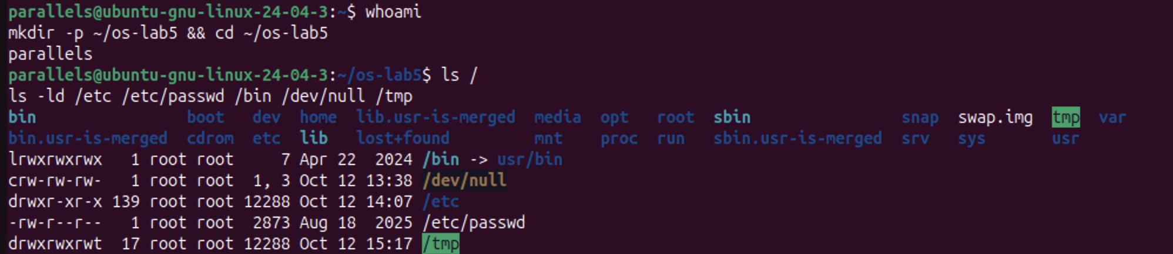
Figure 1.1 – whoami, the root of the tree and the types of five paths
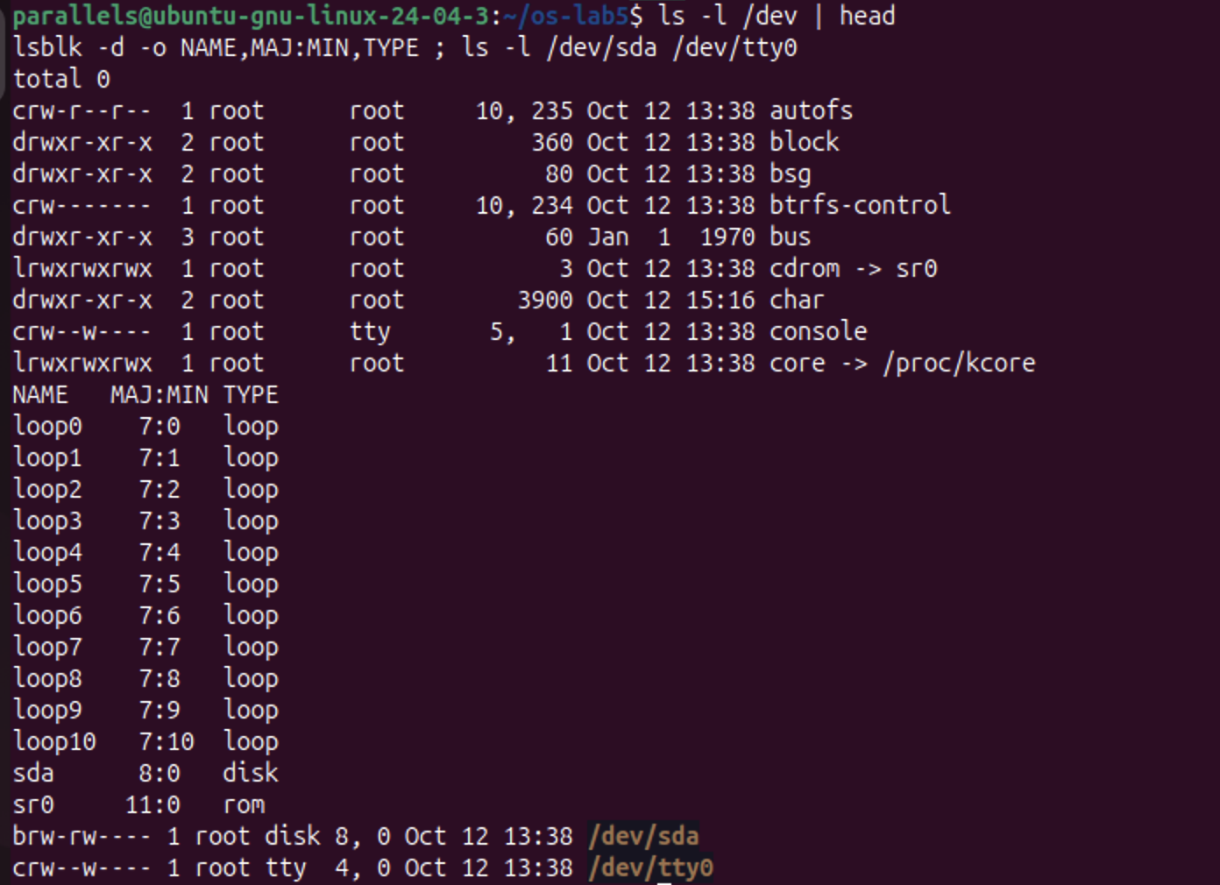
Figure 1.2 – The first entries of /dev, and a block device next to a character device
Figure 1.3 – file on three paths and the size of /var/log and /usr
Observe (1). The type of each path, from the first letter of ls -l:
Path | ls -ld output | First letter | Type
/etc | drwxr-xr-x 139 root root 12288 | d | directory
/etc/passwd | -rw-r--r-- 1 root root 2873 | - | regular file (text)
/bin | lrwxrwxrwx 1 root root 7 ... /bin -> usr/bin | l | symbolic link
/dev/null | crw-rw-rw- 1 root root 1, 3 | c | character device
/tmp | drwxrwxrwt 17 root root 12288 | d | directory, with the sticky bit t

Observe (2). What is /bin?
/bin is not a directory. It is a symbolic link to usr/bin: ls -ld shows /bin -> usr/bin, and file /bin prints symbolic link to usr/bin. Modern Ubuntu "merged /usr", so the programs really live in /usr/bin. The link is only 7 bytes long, which is exactly the length of the text usr/bin.
Observe (3). One character device and one block device in /dev:
• Character device: /dev/tty0 (crw--w---- root tty 4, 0), a terminal. /dev/null (c, major 1, minor 3) and /dev/console are character devices too. They transfer data as a stream of bytes.
• Block device: /dev/sda (brw-rw---- root disk 8, 0), the virtual 64 GB disk of the VM. A block device is read and written in fixed-size blocks.
Instead of a file size, devices show two numbers, the major and minor numbers (for example 8, 0). The major number selects the kernel driver, and the minor number selects the exact device.
Observe (4). Which is bigger, /var/log or /usr?
/usr (4.4 GB) is much bigger than /var/log (100 MB), about 45 times bigger, or roughly 4.3 GB more. /usr holds all installed programs and libraries, while /var/log holds only text log files.
file also identified /usr/bin/ls as ELF 64-bit LSB pie executable, ARM aarch64, a compiled program for this ARM CPU, and /etc/passwd as ASCII text.
Part 2. Inodes and links
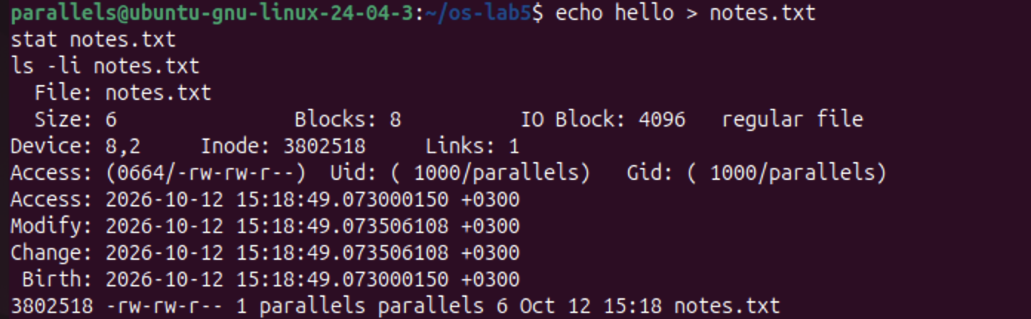
Figure 2.1 – stat shows the inode of notes.txt
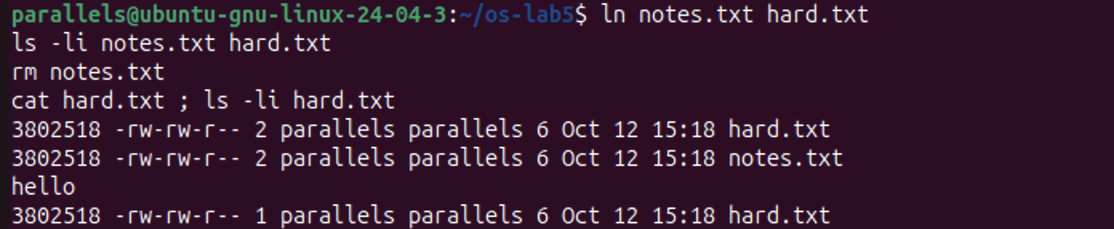
Figure 2.2 – A hard link survives the removal of the original name
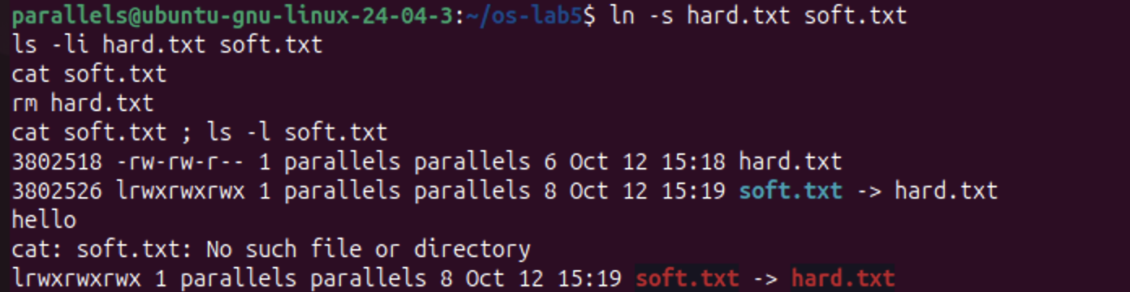
Figure 2.3 – A symbolic link breaks when its target is removed
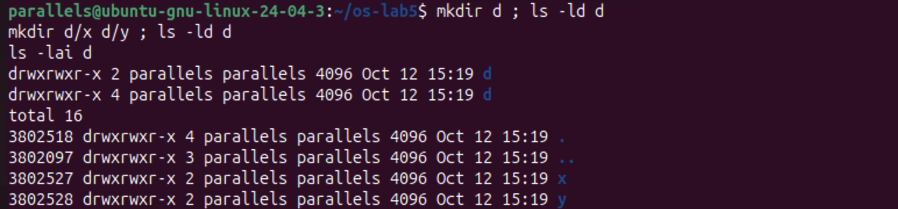
Figure 2.4 – Link count of a directory before and after creating two subdirectories
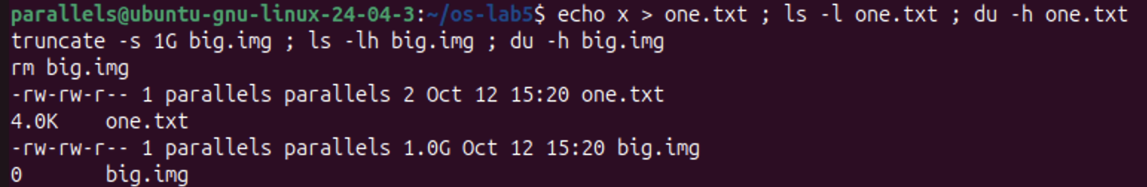
Figure 2.5 – Size is not space: a 2-byte file and a 1 GB sparse file
Observe (1). Which number in stat is the inode, and which is the number of names?
stat notes.txt printed Inode: 3802518 and Links: 1. The inode number is 3802518, and ls -li shows the same number in its first column. Links is the number of names (directory entries) that point to this inode, which is 1 for a new file. The inode also stores the size (6 bytes), the blocks used (8 sectors of 512 bytes, so 4 KB), the permissions (0664), the owner (1000/parallels) and four timestamps. It does not store the file's name.
Observe (2). Why could I still read hard.txt after rm notes.txt? What does rm really remove?
ln notes.txt hard.txt created a second name for the same inode: both names show inode 3802518, and the link count became 2. rm does not delete the file's data. It removes one name (one directory entry) and decreases the link count by one. After rm notes.txt, the count dropped to 1, and hard.txt still pointed to the inode, so cat hard.txt printed hello. The kernel frees the inode and its blocks only when the link count reaches 0 and no process still has the file open.
Observe (3). Why did cat soft.txt fail, and why is soft.txt 8 bytes?
A symbolic link is a separate small file with its own inode (3802526, not 3802518). It contains only a path, the text hard.txt. When hard.txt was removed, the target name no longer existed. cat soft.txt followed the stored path and found nothing, so it printed No such file or directory, even though soft.txt itself still exists. ls shows the broken link in red.
The size of soft.txt is 8 bytes, because hard.txt has exactly 8 characters. The link stores the target's name, not its data.
Observe (4). A new directory has 2 links, and 4 after two subdirectories. Where does each come from?
Prediction: 2, then 4. Result: drwxrwxr-x 2 ... d, then drwxrwxr-x 4 ... d, as predicted.
• Link 1 is the entry d in its parent directory (~/os-lab5).
• Link 2 is the entry . inside d, which points to d itself.
• Links 3 and 4 are the .. entries inside d/x and d/y. Each subdirectory's .. points back to d.
ls -lai d confirms it: . is inode 3802518 with 4 links, while x and y have 2 links each. So a directory's link count is always 2 plus its number of subdirectories.
The new directory d received inode 3802518, the same number that notes.txt/hard.txt used before. That inode had been freed when its last name was removed, so the file system reused it.
Observe (5). Why does a 2-byte file use 4.0K, and a 1 GB file use 0?
• one.txt contains 2 bytes (x and a newline), but disk space is allocated in whole blocks of 4096 bytes. Even the smallest non-empty file takes one full block, so du reports 4.0K.
• truncate -s 1G big.img only set the size recorded in the inode to 1 GB, without writing any data. This is a sparse file: no data blocks are allocated until something is written, so ls -lh shows 1.0G while du -h shows 0.
ls reports the size (the logical length), while du reports the space really used on disk.
Part 3. Permissions
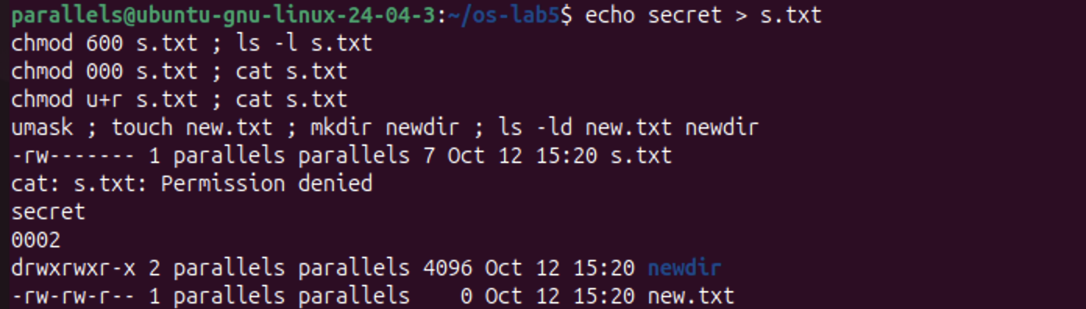
Figure 3.1 – chmod on a file, and the umask applied to new files and directories
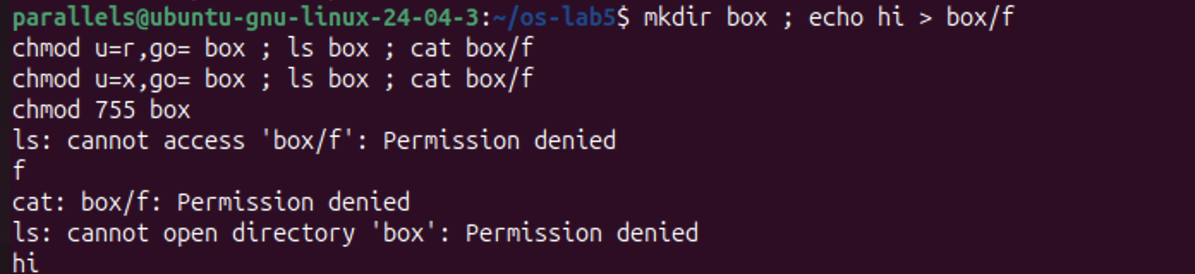
Figure 3.2 – The box experiment: read-only and execute-only permission on a directory
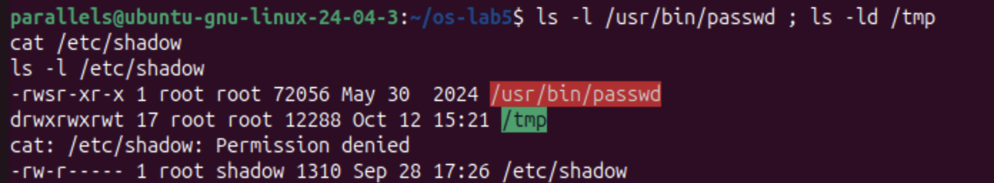
Figure 3.3 – The setuid bit on passwd, the sticky bit on /tmp, and the protected /etc/shadow
Observe (1). 600, 644, 755 and 700 as rwx strings, with a real use for each:
Octal | rwx | Real use
600 | rw------- | Private files that only the owner may read: ~/.ssh/id_rsa, or s.txt in this lab
644 | rw-r--r-- | Ordinary public files: /etc/passwd, web pages, documents
755 | rwxr-xr-x | Programs and directories everyone may use: /usr/bin/*, /etc, home folders
700 | rwx------ | Private directories or scripts: ~/.ssh, a personal scripts folder

Each octal digit is the sum of r = 4, w = 2 and x = 1, for the owner, the group and others in that order.
Observe (2). With chmod 000 I own the file but cannot read it. Why does ownership not help?
The kernel checks the permission bits of the class that applies to me, and for the owner that is the first rwx triplet. With 000, the owner's triplet is ---, so the read was refused: cat: s.txt: Permission denied. Being the owner does not bypass the bits. It only gives me the right to change them with chmod, which I did with chmod u+r, and then cat printed secret. Only root ignores these bits.
Observe (3). What is my umask, and how does it explain new.txt and newdir?
The umask is 0002, which removes the write permission for others. New files start from 666 and new directories from 777, and the umask bits are then cleared:
• new.txt: 666 minus 002 gives 664, -rw-rw-r--.
• newdir: 777 minus 002 gives 775, drwxrwxr-x.
Files don't get x by default, because a new file is not normally a program.
Observe (4). The box experiment: what do r and x mean on a directory?
A directory is a list of (name → inode) entries.
• r only (chmod u=r): I can read the list of names. ls box printed f, but ls also said cannot access 'box/f': Permission denied, because it could not open the entry to read the inode's details. cat box/f was denied for the same reason.
• x only (chmod u=x): I can pass through the directory and use a name I already know, but not list it. ls box failed with cannot open directory 'box', while cat box/f printed hi.
So r means "see which names exist", and x means "enter the directory and reach a file by name". To use a directory normally, both are needed (755).
Prediction vs. result: I predicted that with r only, ls would work completely. In fact it printed the name with an error, because ls --color also needs x to read each file's type.
Observe (5). The s in /usr/bin/passwd and the t in /tmp:
• -rwsr-xr-x root root /usr/bin/passwd: the s (setuid) in place of the owner's x means the program runs with the privileges of its owner (root), not of the user who started it. passwd needs this because passwords are stored in /etc/shadow (-rw-r----- root shadow), which a normal user cannot read or write: cat /etc/shadow gave Permission denied. setuid lets any user change their own password through a trusted program, without being given access to the file itself.
• drwxrwxrwt /tmp: the t (sticky bit) means that in this directory, which everyone can write to, a file can be deleted or renamed only by its owner (or root). Users can share /tmp without deleting each other's files.
Part 4. Disks and the kernel as files
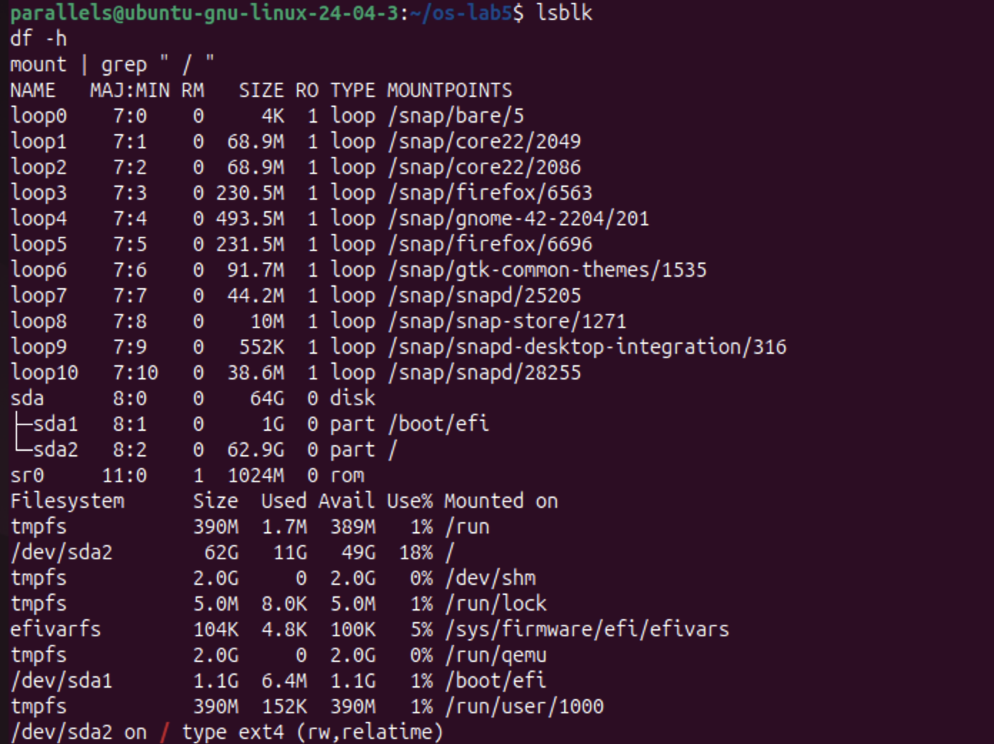
Figure 4.1 – lsblk, df -h and the file system mounted at /
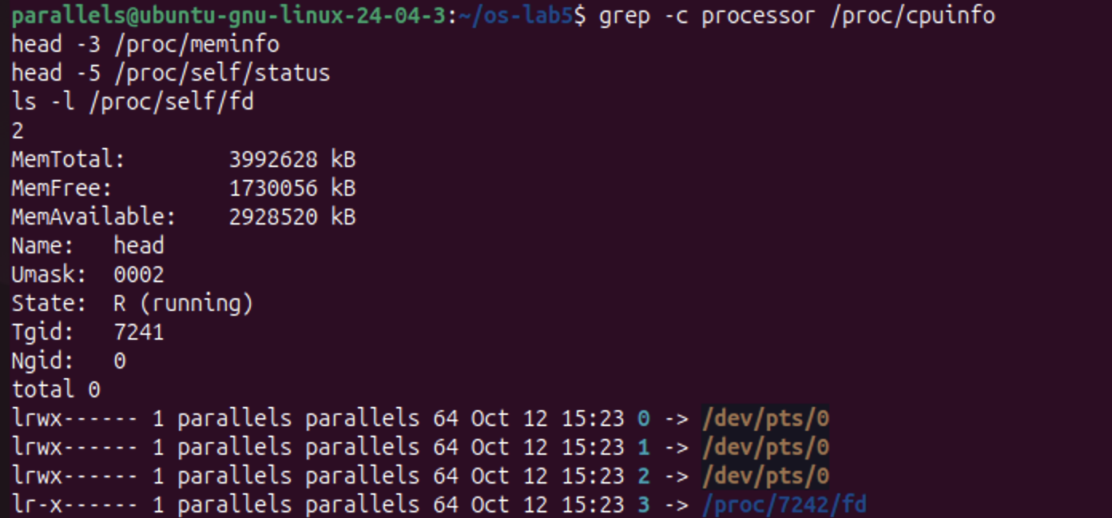
Figure 4.2 – CPU cores, memory and the current process, read from /proc
Observe (1). My disk:
sda (8:0) 64 GB virtual disk (Parallels)
├── sda1 (8:1) 1 GB mounted at /boot/efi EFI system partition
└── sda2 (8:2) 62.9 GB mounted at / ext4 (rw,relatime)
sr0 (11:0) virtual CD/DVD drive
loop0 … loop10 read-only snap packages, mounted under /snap/…
The root file system is /dev/sda2, formatted as ext4 (mount printed /dev/sda2 on / type ext4 (rw,relatime)). The loopN devices are not real disks. They are image files (snap packages) that the kernel presents as block devices and mounts read-only.
Observe (2). How full is the root file system?
df -h shows /dev/sda2 62G 11G 49G 18% /, so 18% is used: 11 GB used and 49 GB available. The other entries (tmpfs on /run, /dev/shm and others) live in RAM, not on the disk.
Observe (3). CPU cores and RAM, according to /proc:
grep -c processor /proc/cpuinfo printed 2, so the VM has 2 CPU cores. /proc/meminfo shows MemTotal: 3992628 kB, about 3.8 GiB (the 4 GB given to the VM, minus memory the kernel reserves), with MemAvailable: 2928520 kB. These are the resources the virtual machine gives to Ubuntu, not those of the whole Mac.
Observe (4). /proc/self/status showed the name of a program. Which one, and why?
It showed Name: head. /proc/self is a special link that always points to the directory of the process that is reading it. The file was opened by head -5 /proc/self/status, so "self" was head itself (PID 7241).
The next command proves the same idea. ls -l /proc/self/fd listed the open files of the ls process: 0, 1 and 2 (stdin, stdout and stderr) all point to the terminal /dev/pts/0, and descriptor 3 points to /proc/7242/fd, the directory ls itself had opened (PID 7242, the next process). The kernel's state appears as ordinary files, read with ordinary tools.
Stretch tasks
Figure 5.1 – Magic number: gzip data renamed to notes.txt
(a) Magic numbers. The compressed copy of /etc/passwd was saved as notes.txt, which has a misleading extension. file still recognized it: gzip compressed data, was "passwd". xxd shows the first bytes 1f 8b 08 08 .... The bytes 1f 8b are the gzip magic number, and 08 means the deflate compression method. file reads these bytes from the content and ignores the extension, because on Linux the name of a file does not determine its type.
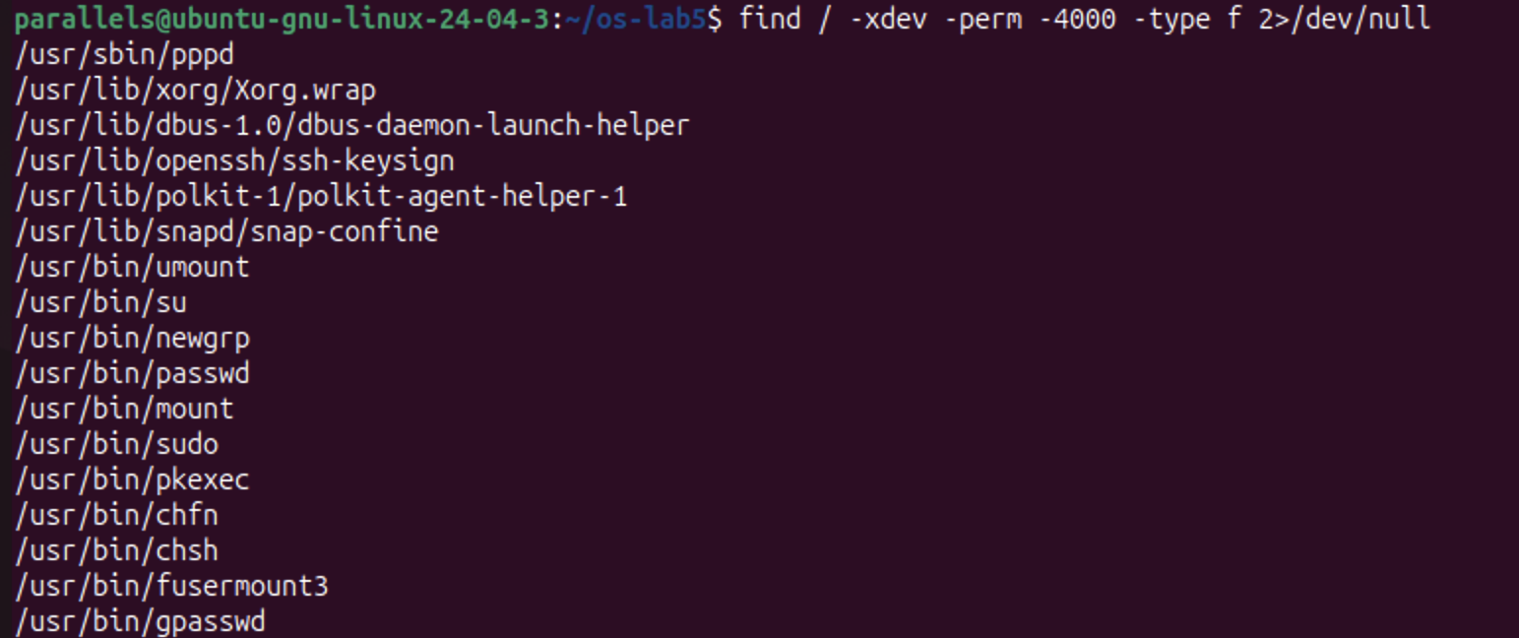
Figure 5.2 – All setuid programs on the root file system
(b) Hunting for setuid programs. find / -xdev -perm -4000 -type f found 17 setuid-root programs. They include the classic ones from the lecture: passwd, su, sudo, mount, umount, chsh, chfn, newgrp and gpasswd. It also found ones specific to this desktop installation: pkexec and polkit-agent-helper-1 (graphical admin prompts), snap-confine (snap packages), fusermount3 (user-space file systems), Xorg.wrap (the display server), dbus-daemon-launch-helper, ssh-keysign and pppd. Each of them is a program that has to do one privileged task on behalf of a normal user, which is why the list is kept as short as possible.
Conclusions
This laboratory work showed that a file name and a file are different things. The file itself is an inode that holds the size, owner, permissions and the location of the data, while names are only directory entries that point to it.
That explains everything observed:
• A hard link is a second name for the same inode, and rm only removes a name.
• A symbolic link is a separate tiny file that stores a path, so it breaks when the target is gone.
• A directory's link count comes from its own . and each child's ...
• The size of a file and the space it uses differ, because of 4 KB blocks and sparse files.
Permissions are checked by the kernel on every access, even against the owner. On a directory, r lists the names and x lets you reach them. The umask sets the default permissions of new files, and the special bits setuid and sticky solve two real problems: changing a password without access to /etc/shadow, and sharing /tmp safely.
Finally, the disk itself (/dev/sda, partitioned into an EFI partition and an ext4 root partition at 18% use) and the running kernel (/proc/cpuinfo, /proc/meminfo, /proc/self) are all presented as files. This is the Unix idea that "everything is a file", seen directly.

