
MINISTRY OF EDUCATION, CULTURE AND RESEARCH
OF THE REPUBLIC OF MOLDOVA
Technical University of Moldova
Faculty of Computers, Informatics and Microelectronics
Department of Software Engineering and Automation

Report
on laboratory works nos. 7–8
of Operating Systems
Topics: Three Small Programs: Processes, Redirection, a Pipe; The Same Calls, Inside Your Own OS

Done by: st. gr. FAF-243, Augustin Carazanu
Checked by: assist. univ. Patricia Reițman
FCIM, UTM

Chișinău – 2026
Laboratory work no. 7. Three Small Programs: Processes, Redirection, a Pipe
Purpose of the work
The lecture asked three questions: how a process is born, where printf writes, and how ls | wc -l works. The purpose of this laboratory work is to answer them by running four short C programs on Linux:
• run.c copies itself with fork, becomes ls with exec, and waits for it with wait.
• zombie.c produces a zombie process on purpose.
• redirect.c does by hand what the shell does for ls -l > out.txt.
• pipeline.c builds ls /etc | wc -l from one pipe and two forks.
I also wrote the optional pipeline3.c, which builds a three-stage pipeline. The work was done in ~/os-lab7 on Ubuntu 24.04.3 ARM64 (Parallels), with gcc 13.3.0. Every program compiles with -Wall -Wextra without warnings.
Part 1. fork + exec + wait
run.c was created exactly as given in the lab sheet.
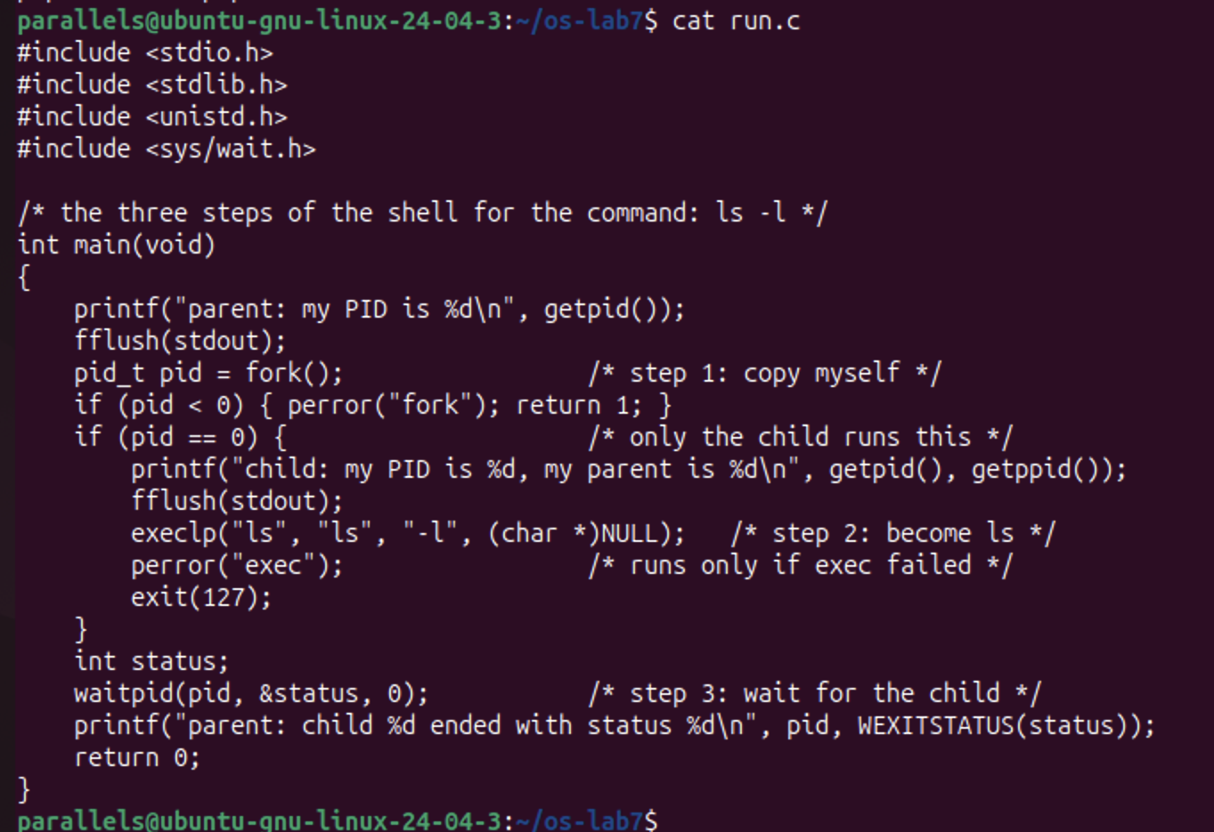
Figure 1.1.1 – The source code of run.c
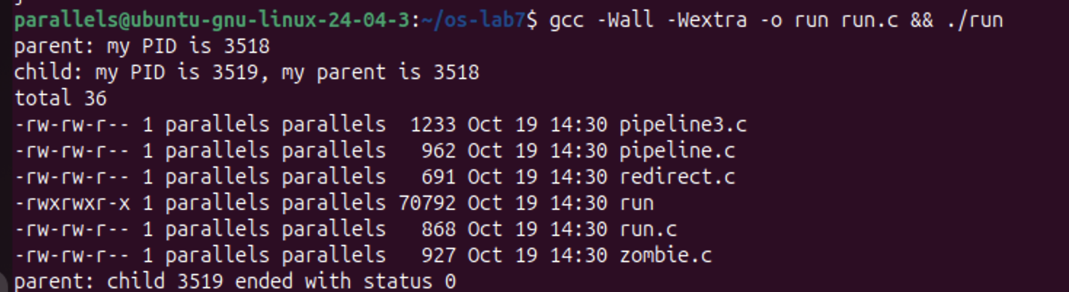
Figure 1.1.2 – run.c: the child becomes ls -l and the parent waits for it
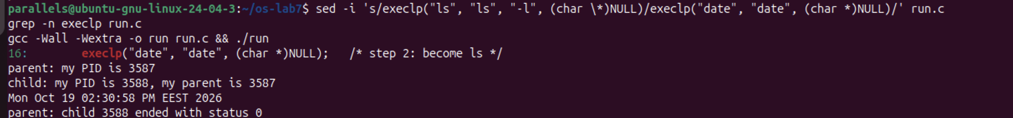
Figure 1.1.3 – The child runs date instead of ls
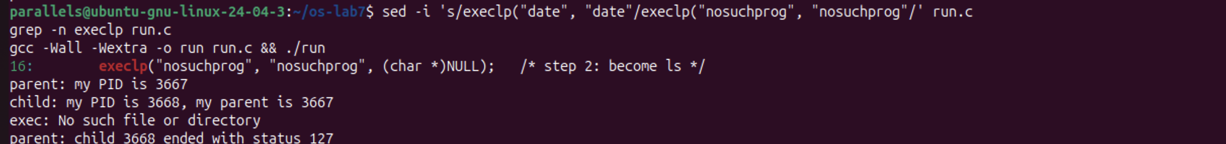
Figure 1.1.4 – The child asks for a program that does not exist
The order of the lines is always the same:
1. the parent prints its PID;
2. the child prints its own PID and its parent's PID;
3. the output of the new program (ls -l or date) appears;
4. only then does the parent print the child's exit status.
The parent prints last because waitpid blocks it until the child has ended.
Observe (1). Why is perror("exec") printed only with nosuchprog?
When execlp succeeds, it replaces the child's whole program (its code, data and stack) with the new program (ls or date). execlp never returns, so the lines after it no longer exist in that process. It returns only if it fails. With nosuchprog, execlp searched every directory in PATH, found nothing and returned −1. The child then continued to the next line, perror("exec"), which printed exec: No such file or directory, and then called exit(127).
Observe (2). Which number does the child print as "my parent", and whose PID is it?
The child printed my parent is 3518, which is exactly the PID the parent printed on the first line (parent: my PID is 3518). The same holds for the other runs (3587 and 3667). getppid() returns the PID of the process that called fork, which is our ./run.
Observe (3). What status does the parent see with ls, and with nosuchprog?
• With ls (and with date): ended with status 0. The program ran successfully and returned 0.
• With nosuchprog: ended with status 127. That is the value passed to exit(127) after the failed exec. 127 is also the code bash uses for "command not found", as seen in Lab 3.
Part 2. A zombie, on purpose
zombie.c is run.c with one extra line, sleep(20);, right before waitpid. The program was started in the background, and ps ran while the parent was still sleeping.
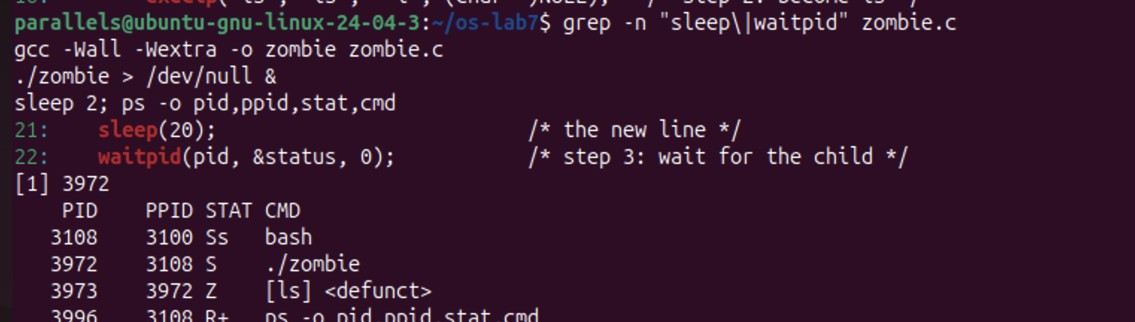
Figure 1.2.1 – zombie.c: the ls child is a zombie while the parent sleeps
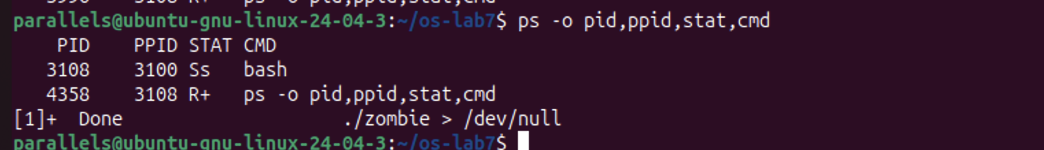
Figure 1.2.2 – After 20 seconds the zombie has disappeared
PID PPID STAT CMD
3108 3100 Ss bash
3972 3108 S ./zombie
3973 3972 Z [ls] <defunct>
Observe (1). Which letter does ls have in the STAT column, and what does it mean?
Z stands for zombie, and ps also marks it as <defunct>. ls finished almost immediately, so its code and memory were freed. However, the kernel keeps a small entry for it in the process table, with its PID (3973) and its exit status, until the parent (PPID 3972, ./zombie) collects that status with wait. The parent itself is in state S (sleeping), because it is inside sleep(20).
Observe (2). After 20 seconds, is the [ls] <defunct> line still there? Which line removed it?
No. The second ps showed only bash and ps, and the shell reported [1]+ Done ./zombie > /dev/null. The zombie was removed by line 22, waitpid(pid, &status, 0);. When the parent woke up from sleep(20) and called waitpid, it read the child's exit status, and the kernel freed the last trace of the child. Then the parent itself exited.
Part 3. Redirection: ls -l > out.txt
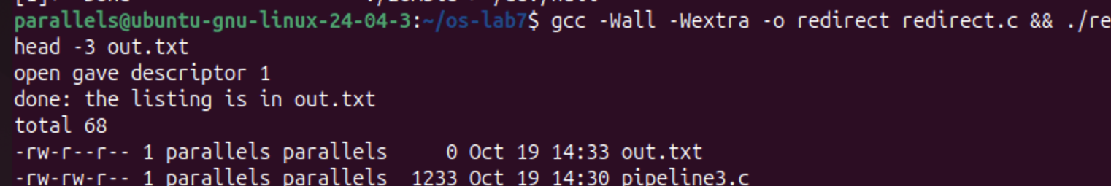
Figure 1.3.1 – redirect.c: open receives descriptor 1 and the listing goes into out.txt
open gave descriptor 1
done: the listing is in out.txt
total 68
-rw-r--r-- 1 parallels parallels 0 Oct 19 14:33 out.txt
-rw-rw-r-- 1 parallels parallels 1233 Oct 19 14:30 pipeline3.c
Observe (1). Which number did open give, and why exactly that one?
open returned 1. The kernel always gives a new file the smallest free descriptor number in the process. Descriptor 0 (stdin) was still open, and the line just before had closed 1, so 1 was the smallest free number.
Observe (2). ls was not changed. Why does its listing not appear on the screen?
ls always writes its output to descriptor 1. It does not know or care what that descriptor points to. In the child, descriptor 1 now points to out.txt instead of the terminal, and that change survives exec, because open descriptors are inherited by the new program. So the listing went into the file. This is exactly what the shell does for >.
out.txt even appears in its own listing, with size 0. The file was created (and emptied by O_TRUNC) before ls ran, and ls measured it before writing anything into it.
Observe (3). To redirect the errors instead (2> err.txt), which descriptor would be closed?
Descriptor 2 (stderr). After close(2), the next open("err.txt", ...) would receive 2, and every error message the program writes would go into the file. The message open gave descriptor 1 still appeared on the screen because it was written with fprintf(stderr, ...) to descriptor 2, which was not redirected.
Part 4. A pipe: ls /etc | wc -l
Figure 1.4.1 – pipeline.c and the shell give the same number
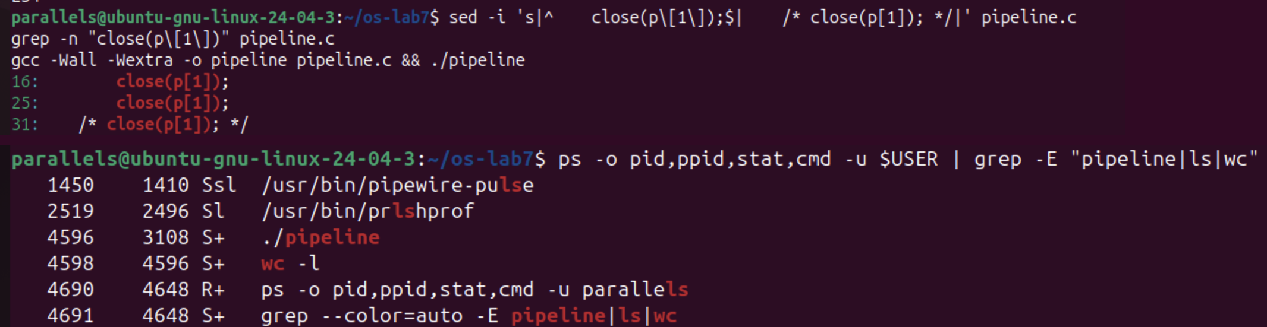
Figure 1.4.2 – Without close(p[1]) in the parent, wc never ends: ./pipeline and wc are still alive
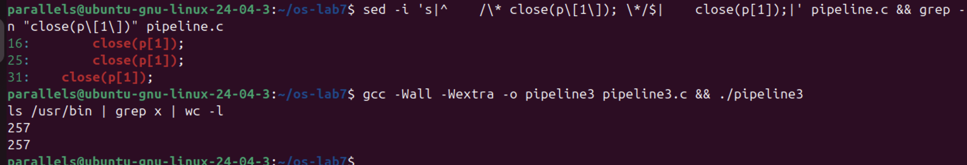
Figure 1.4.3 – The restored pipeline.c, and the optional pipeline3.c compared with the shell
Observe (1). Did ./pipeline and ls /etc | wc -l give the same number?
Yes, both printed 234. In the first child, close(1) followed by dup(p[1]) made descriptor 1 the write end of the pipe. In the second child, close(0) followed by dup(p[0]) made descriptor 0 the read end. dup, like open, uses the smallest free number. So ls wrote into the pipe and wc read from it, without either program knowing.
Observe (2). After the change, which of the two children never ends, ls or wc?
wc. With the parent's close(p[1]) turned into a comment (line 31, /* close(p[1]); */), the program hung. A ps in a second terminal showed:
4596 3108 S+ ./pipeline
4598 4596 S+ wc -l
ls was no longer in the list: it had written its 234 lines and exited. wc (PID 4598) was asleep (S), and the parent ./pipeline was blocked in wait, waiting for wc. The program had to be stopped with Ctrl-C.
Observe (3). Why, in one sentence: what is wc waiting for?
wc waits for end-of-file on the pipe, which the kernel delivers only when every write end of the pipe is closed. The parent still held p[1] open, so wc's read kept blocking forever, waiting for data that could still, in theory, arrive.
Optional: three stages. pipeline3.c builds ls /usr/bin | grep x | wc -l with two pipes and three children. Each child uses dup2 to connect its stdin and stdout, then closes all four pipe ends, and the parent closes all four as well. It printed 257, the same as the shell. Afterwards, pipeline.c was restored (line 31 is again close(p[1]);) before it was submitted.
Conclusions
The shell's three jobs turned out to be three system calls:
• fork copies the process;
• exec replaces the copy's program, and it returns only on failure, which is why perror ran only for nosuchprog, with status 127;
• wait lets the parent collect the child's status.
Without wait, a finished child stays in the process table as a zombie (Z, <defunct>) until the parent finally calls it.
Redirection and pipes rely on one rule: open and dup return the smallest free descriptor. Closing 1 and then opening a file (or duplicating a pipe end) silently changes where an unmodified program like ls writes. A pipe delivers end-of-file only when all of its write ends are closed. A single forgotten close(p[1]) in the parent was enough to make wc wait forever.
Laboratory work no. 8. The Same Calls, Inside Your Own OS
Purpose of the work
The purpose of this laboratory work is to run the same fork, exec and wait program inside xv6, the small OS built this semester, and to see that the calls are the same as on Linux. A second goal is to make two processes talk through pipes (pingpong). I also wrote the optional primes.c, a prime sieve built from a chain of processes. The programs were added to the UPROGS list of the Makefile in my ~/xv6-riscv tree.
Part 1. run, inside xv6
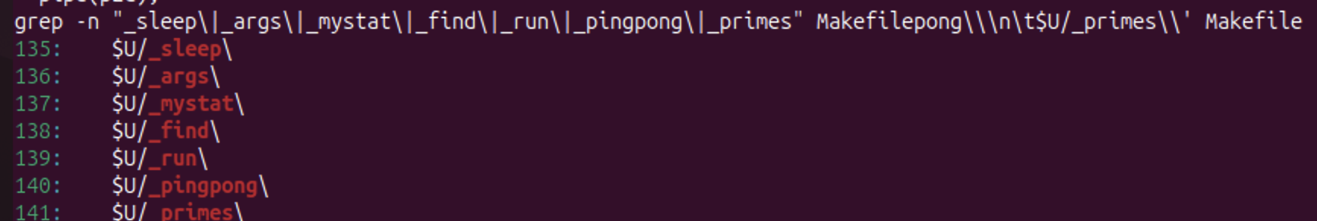
Figure 2.1.1 – The UPROGS lines in the Makefile, including _run, _pingpong and _primes
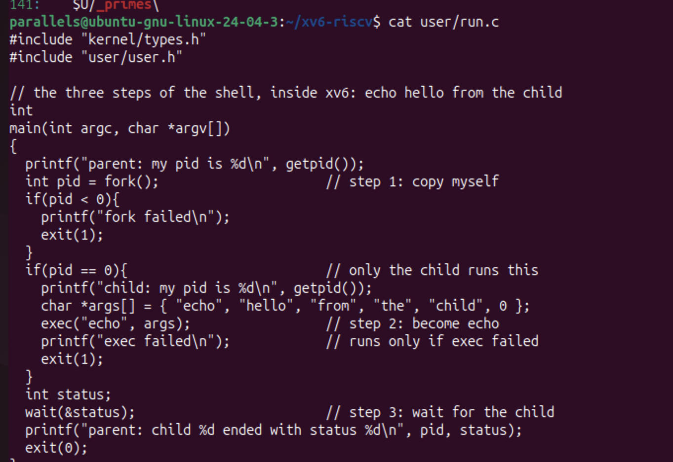
Figure 2.1.2 – The source code of user/run.c
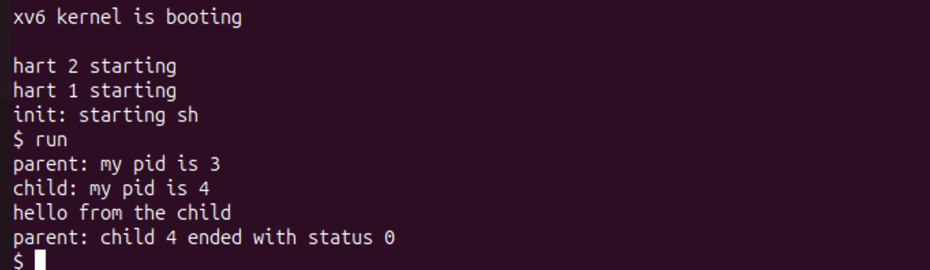
Figure 2.1.3 – run in xv6: the child becomes echo
$ run
parent: my pid is 3
child: my pid is 4
hello from the child
parent: child 4 ended with status 0
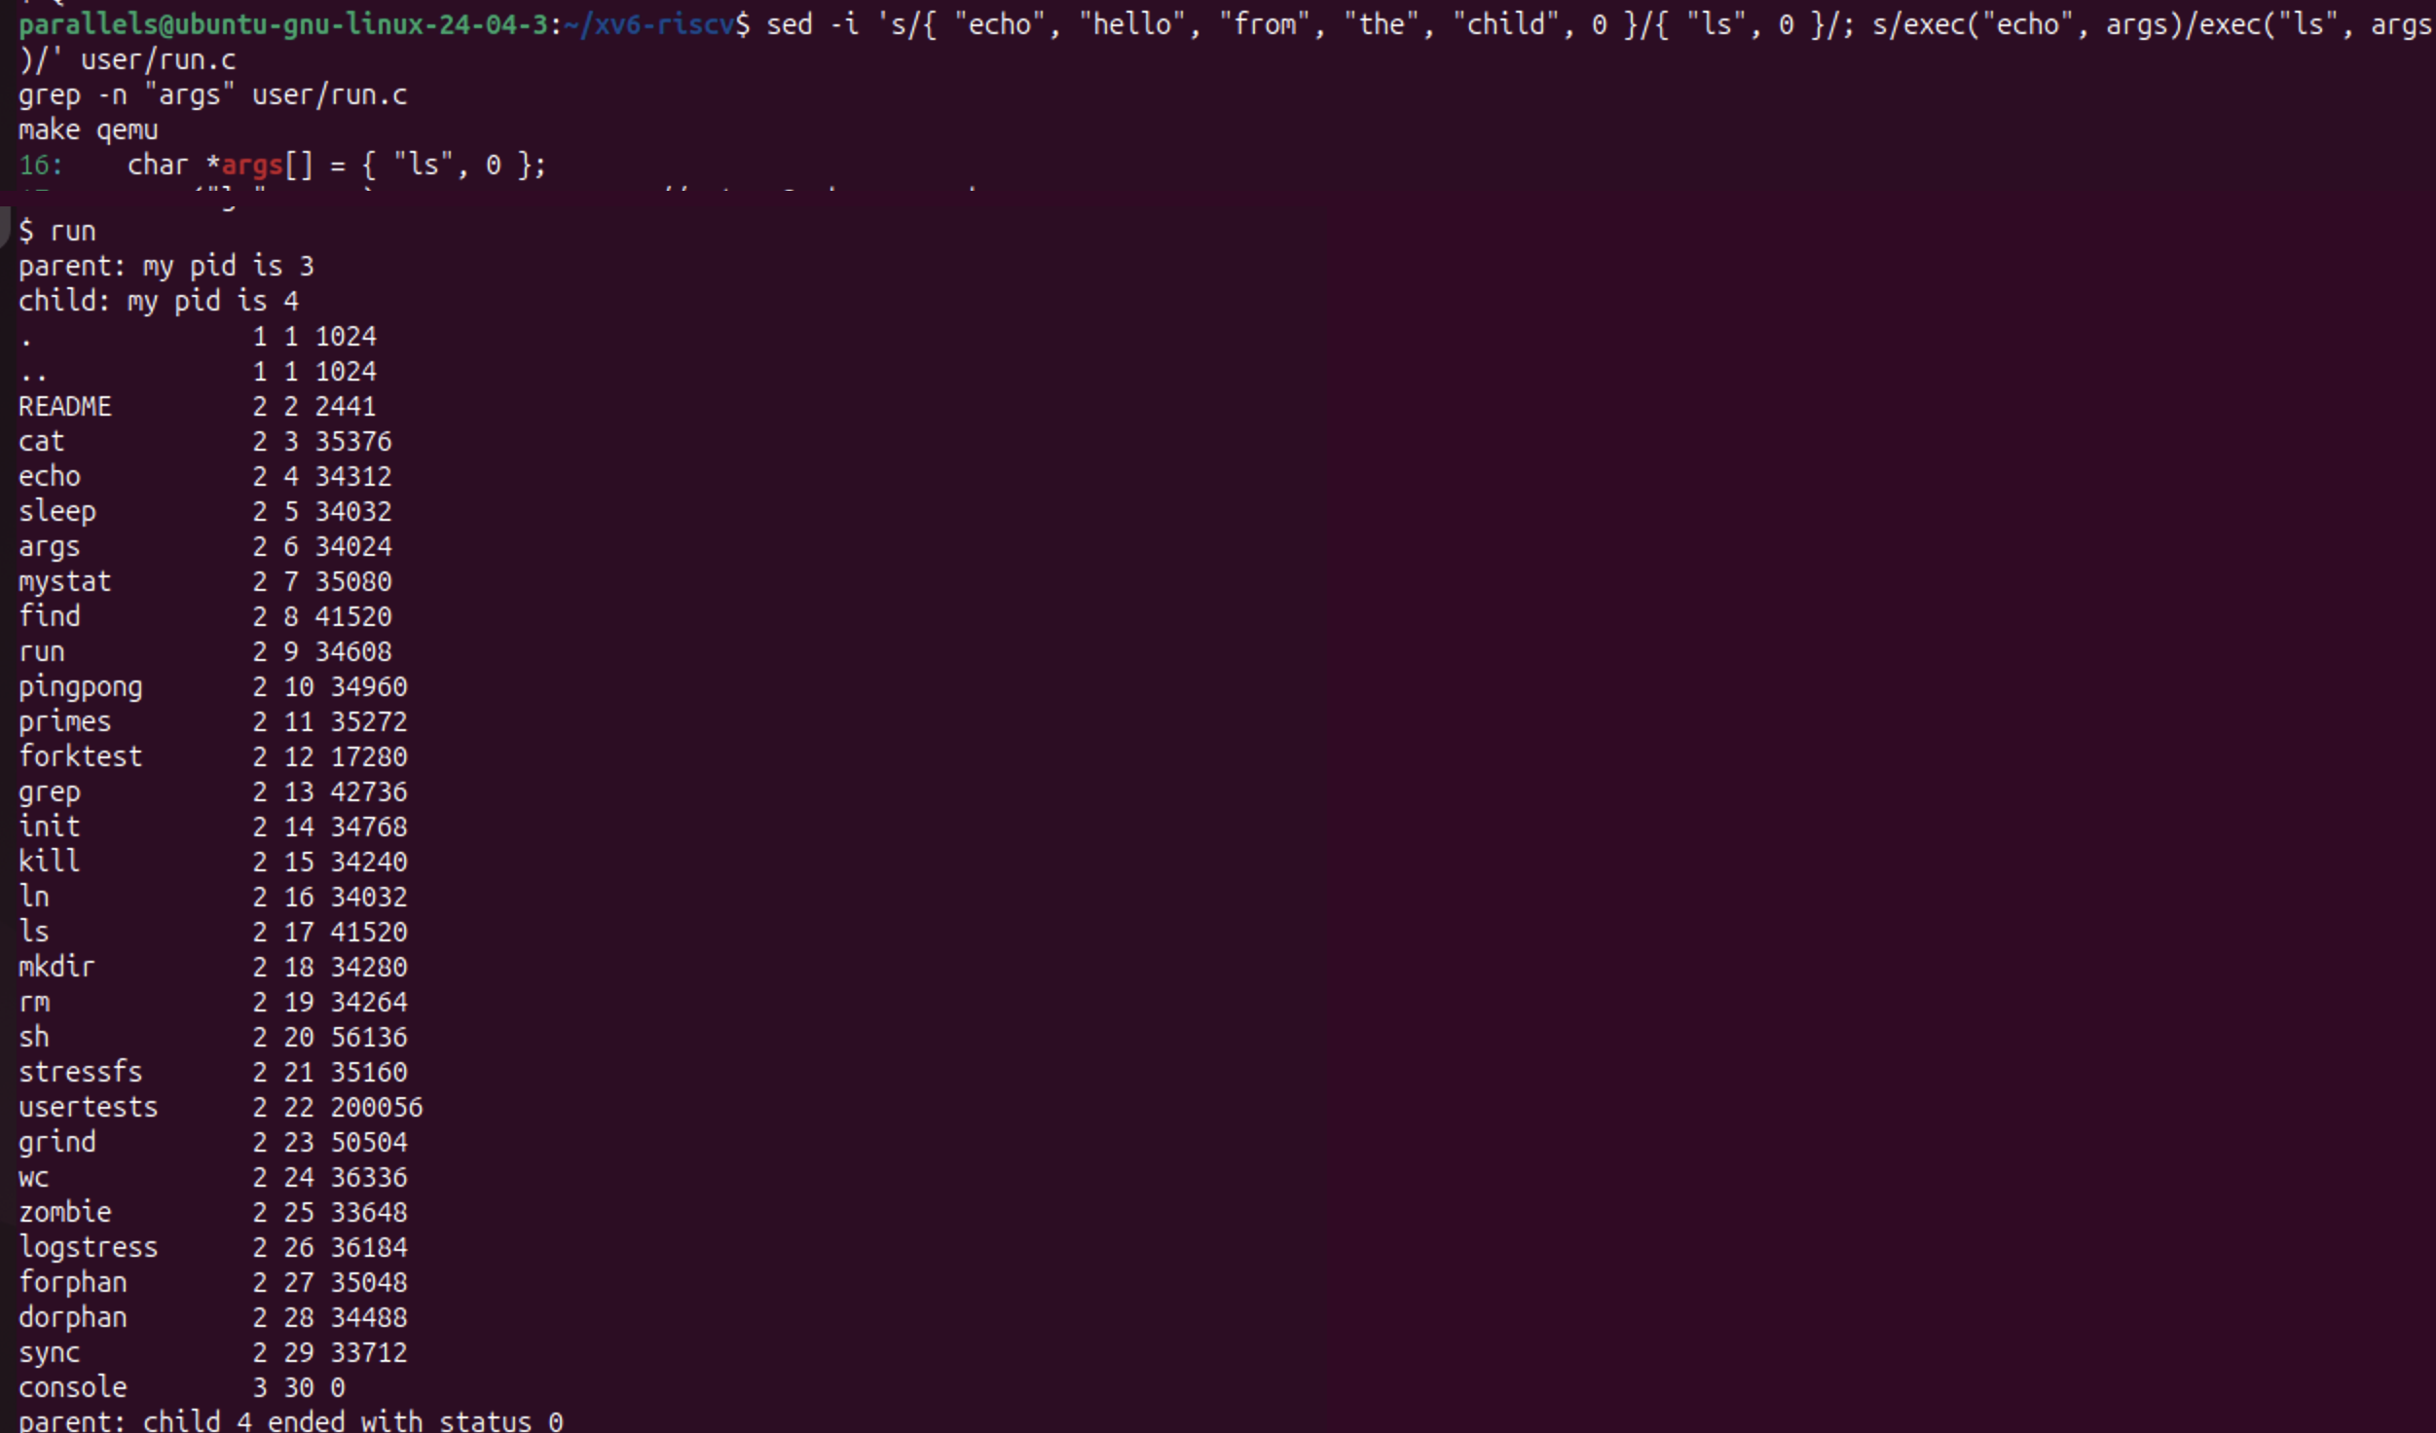
Figure 2.1.4 – The child runs ls instead of echo
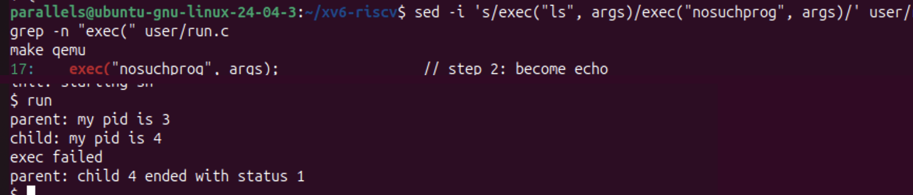
Figure 2.1.5 – exec of a program that does not exist: exec failed, status 1
With { "ls", 0 } and exec("ls", args), the child printed the xv6 directory listing, and the parent reported status 0. With exec("nosuchprog", args), the output ended with exec failed and parent: child 4 ended with status 1. Afterwards, run.c was restored to the echo version for submission.
Observe (1). The three calls in xv6 and on Linux. What is the same?
Step | Linux (Lab 7, run.c) | xv6 (user/run.c)
1. copy myself | fork() | fork()
2. become another program | execlp("ls", "ls", "-l", NULL) | exec("echo", args)
3. wait for the child | waitpid(pid, &status, 0) | wait(&status)

The idea and the order are the same: fork returns 0 in the child and the child's PID in the parent, exec replaces the program and returns only on failure, and the parent blocks in wait until the child ends. Even the names are almost identical.
The differences are only in the library:
• execlp is a glibc wrapper that takes a list of arguments and searches PATH, while xv6's exec takes an array and a path. It works here because the programs are in /, the current directory.
• waitpid waits for one specific child, while wait waits for any child.
• On Linux the status must be decoded with WEXITSTATUS, while xv6 gives the exit code directly.
Observe (2). Who prints hello from the child: the code of run, or echo?
echo. The child's code in run.c only prints child: my pid is 4, then calls exec("echo", args). From that moment, the child process (still PID 4) is running the echo program, which prints its arguments hello from the child. run.c contains no such printf. Its only following line is printf("exec failed\n"), which never runs when exec succeeds.
Observe (3). Why is the status 1 here and 127 on Linux?
Because each program chooses its own exit code after a failed exec. On Linux, run.c has exit(127); after execlp, while in xv6 user/run.c has exit(1); after exec. The kernel simply passes that number to the parent's wait. The value 127 is only a convention borrowed from the shell, not something the kernel imposes.
Part 2. pingpong
user/pingpong.c completes the four TODO lines:
• the child does read(p2c[0], &b, 1), prints received ping, then does write(c2p[1], &b, 1);
• the parent does write(p2c[1], &b, 1), then read(c2p[0], &b, 1), then prints received pong.
Each process first closes the two pipe ends it does not use, and both check that read really returned 1 byte.
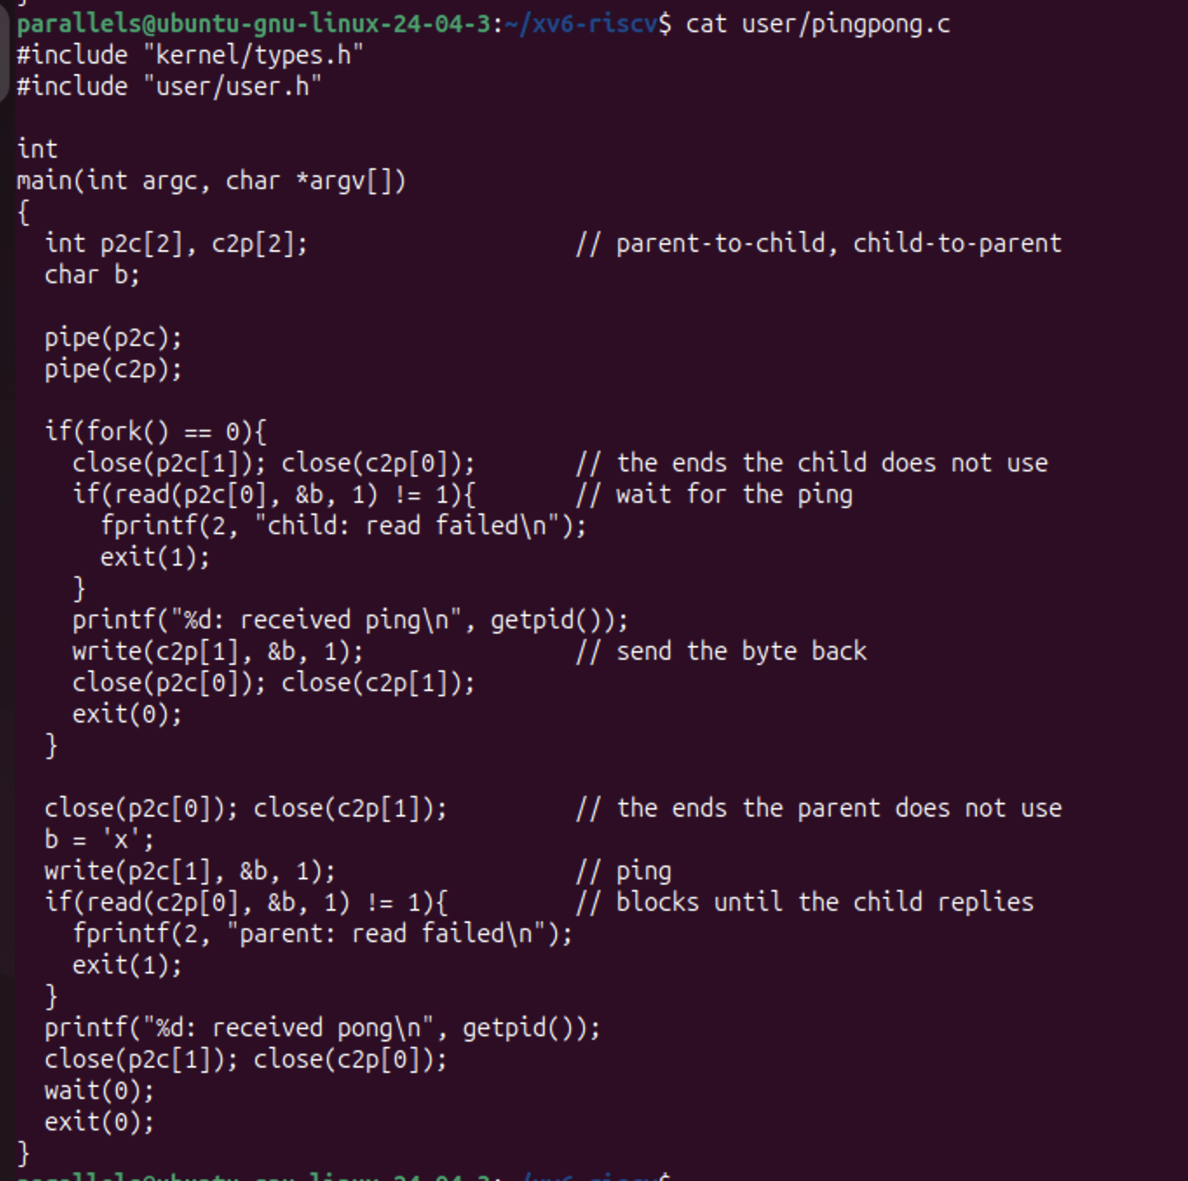
Figure 2.2.1 – The source code of user/pingpong.c
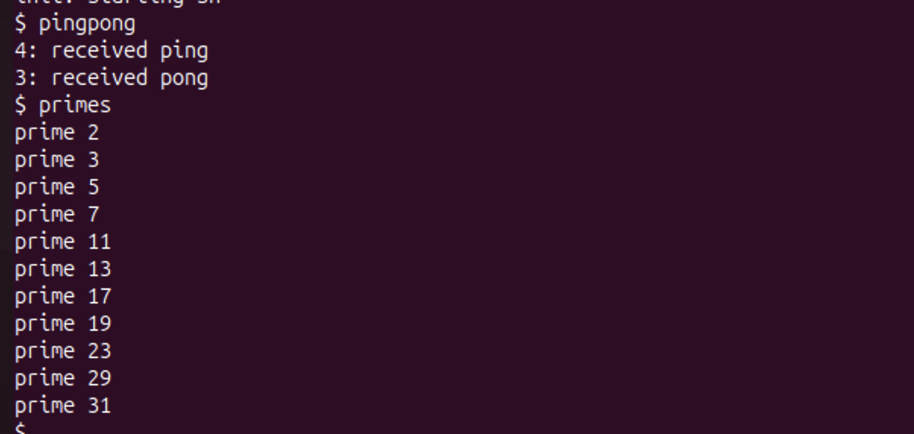
Figure 2.2.2 – pingpong and the optional primes running in xv6
$ pingpong
4: received ping
3: received pong
The child (PID 4) prints ping first, and then the parent (PID 3) prints pong, exactly in the required order.
Observe (1). Why are TWO pipes needed, and not one for both directions?
A pipe is a one-way channel: whatever is written into p[1] is read from p[0], by any process that holds that end. With a single pipe, the parent could write the ping and then immediately read it back itself, before the child had a chance, and the child would then block forever. Nothing would guarantee who receives which byte. With two pipes, each direction has its own channel: p2c carries only parent-to-child data and c2p only child-to-parent data, so each byte reaches the right process.
Observe (2). Nothing in the code says "wait until the child has replied". Which call makes the parent wait?
read(c2p[0], &b, 1). When a pipe is empty, read blocks: the kernel puts the process to sleep until data arrives, or until all write ends are closed. The parent sleeps inside this read until the child writes its byte into c2p[1]. The child also waits in the same way, inside its own read(p2c[0], ...), until the ping arrives. The final wait(0) only collects the child's exit status.
Optional: primes. user/primes.c prints the primes from 2 to 35 with a chain of processes. The first process writes the numbers 2–35 into a pipe. Each stage reads its first number p (always a prime), prints prime p, creates a pipe and a child for the next stage, and forwards only the numbers not divisible by p. Every stage closes the pipe ends it does not use, and closes its write end when it is done, so that the next stage sees end-of-file and the chain ends cleanly. The output was prime 2, 3, 5, 7, 11, 13, 17, 19, 23, 29, 31.
Conclusions
The same program, with the same three calls fork, exec and wait, behaved identically on Linux and in xv6. This shows that these system calls are the real interface of a Unix kernel, and that glibc only adds convenience wrappers around them (execlp, waitpid, WEXITSTATUS). The exit status after a failed exec (1 here, 127 on Linux) is chosen by the program, not by the kernel.
With pingpong, two processes synchronized using nothing but pipes. A pipe is one-way, so two-way talk needs two pipes, and a blocking read on an empty pipe is what makes each side wait for the other.
The optional pipeline3 and primes programs showed that the same rule from Lab 7 applies everywhere: a reader sees end-of-file only when every write end is closed. Closing every unused end is what lets a chain of processes finish.

