
MINISTRY OF EDUCATION, CULTURE AND RESEARCH
OF THE REPUBLIC OF MOLDOVA
Technical University of Moldova
Faculty of Computers, Informatics and Microelectronics
Department of Software Engineering and Automation

Report
on laboratory work no. 12
of Operating Systems
Topic: Producer, Consumer and the Other Tools

Done by: st. gr. FAF-243, Augustin Carazanu
Checked by: assist. univ. Patricia Reițman
FCIM, UTM

Chișinău – 2026
Purpose of the work
In Lab 11 I used one semaphore at a time. The purpose of this laboratory work is to make the synchronization tools work together on the classic problems of operating systems: producer and consumer (two semaphores and a mutex around a buffer), the condition variable, readers and writers, and a deadlock that I build and then remove. The work was done on Ubuntu 24.04.3 ARM64 in a Parallels virtual machine, in the folder ~/os-lab12. Every program was compiled with gcc -Wall -pthread.
Part 1. Producer and consumer
prodcons.c has a buffer of 4 slots, a fast producer that puts 8 items and a slow consumer (usleep(300000) after each item). Three tools work together: the semaphore empty counts the free slots (it starts at 4), the semaphore full counts the filled slots (it starts at 0), and the mutex lock protects the buffer and the indexes in, out and count.
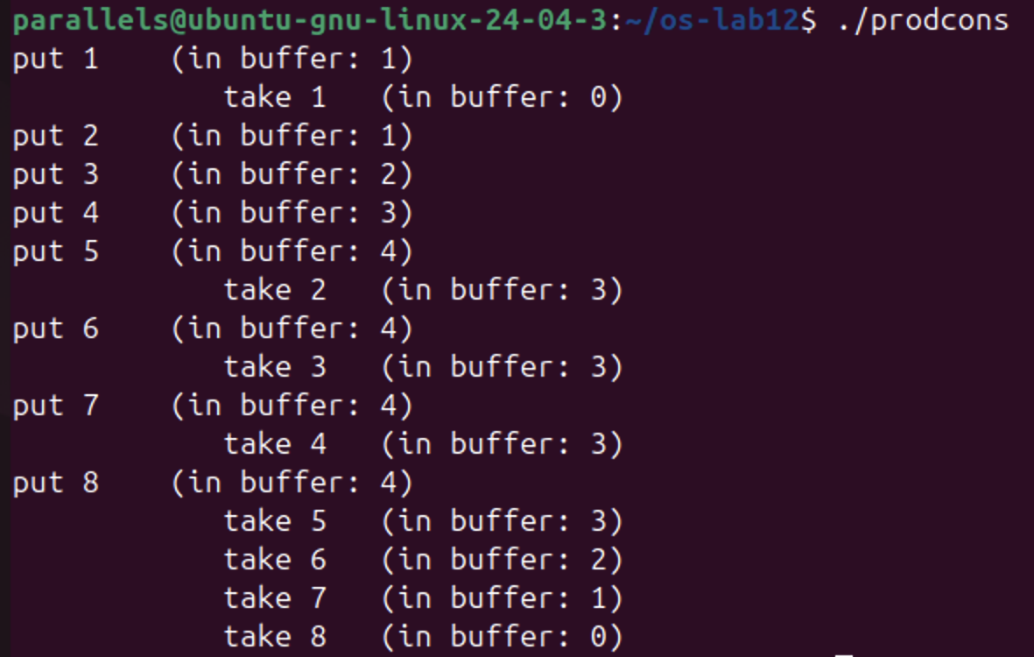
Figure 1.1 – ./prodcons: the buffer never holds more than 4 items
In my run the consumer took item 1 at once (in buffer: 0), then the producer filled the buffer with items 2 to 5 while the consumer was sleeping. From there the two alternate: the producer can put one item only after the consumer takes one, so in buffer stays between 3 and 4. After item 8 the producer is finished and the consumer empties the buffer to 0. The order of the first lines is different from the sheet (there the producer puts 4 items first), because it depends on which thread runs first, but the rule "never more than 4" holds.
For Observe 3 I made a copy, prodcons_swap.c, where the producer locks the mutex before sem_wait(&empty) (lines 21 and 22 in the grep output). I ran it with timeout 5 instead of stopping it with Ctrl-C:
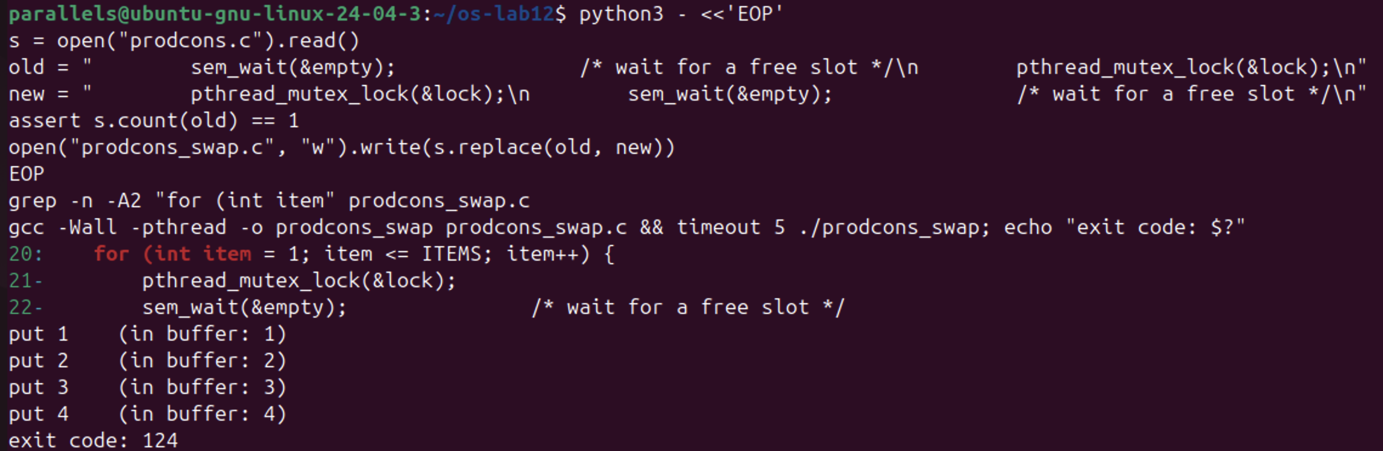
Figure 1.2 – prodcons_swap.c: the mutex is taken before sem_wait(&empty); the program hangs
Observe 1. The producer is fast, yet "in buffer" never goes above 4. Which call stops it?
sem_wait(&empty); at the beginning of the loop in producer(). empty starts at 4 and loses one unit for each item put. When the buffer is full, empty is 0, so the producer blocks there until the consumer takes an item and calls sem_post(&empty). In Figure 1.1 this is why put 6 comes only after take 2, put 7 only after take 3, and so on.
Observe 2. Who waits at the start: the consumer or the producer? Which call makes it wait?
The consumer. It is created first, but full starts at 0 (nothing in the buffer yet), so it blocks in sem_wait(&full);. It continues only when the producer calls sem_post(&full) after the first item. In my run you can see it: the consumer was already waiting, so it took item 1 immediately after put 1. The producer does not wait at the start, because empty starts at 4.
Observe 3. Lock the mutex BEFORE sem_wait(&empty). What happens when the buffer is full, and why?
The program prints put 1 to put 4 and then hangs; timeout had to kill it (exit code: 124). This is a deadlock. When the buffer is full, the producer takes the mutex and then waits in sem_wait(&empty) for a free slot, still holding the mutex. A free slot can only come from the consumer, but the consumer must first take the same mutex to remove an item, so it blocks in pthread_mutex_lock. The producer waits for the consumer and the consumer waits for the producer, forever. (In my run the consumer did not even get to take item 1, because the producer locked the mutex again right after each unlock.) The rule is: wait for the semaphore first, and take the mutex only for the short time when you touch the buffer; never sleep while holding a mutex.
Part 2. The condition variable
condvar.c solves the problem of order.c from Lab 11 in another way. The state is a normal variable ready, protected by the mutex lock. The condition variable changed is only the place where B sleeps: pthread_cond_wait releases the mutex, sleeps, and takes the mutex again before it returns. For Observe 2 I made a copy, condvar_if.c, with if (!ready) instead of while (!ready):
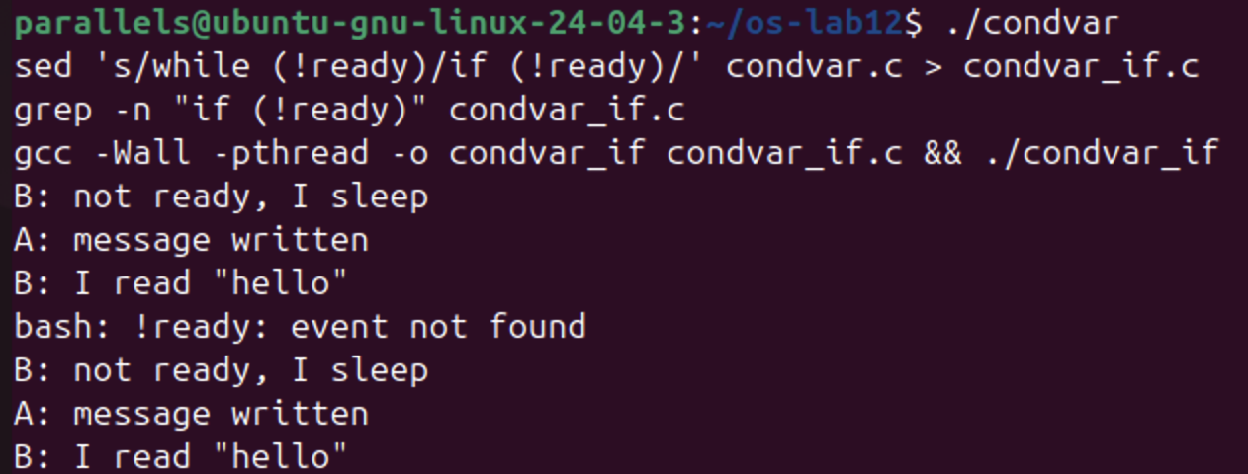
Figure 2.1 – ./condvar and the copy condvar_if (with if instead of while)
Both versions print B: not ready, I sleep, then after one second A: message written and B: I read "hello". The line bash: !ready: event not found is not an error of the program: in the grep command I had written "if (!ready)" in double quotes, and bash treats ! as a history command there, so only that grep line failed. The sed line uses single quotes, so condvar_if.c was created correctly with if (!ready) (the file is in the repository), and it was compiled and run.
Observe 1. In order.c the semaphore itself remembered that the message was ready. Here, which variable remembers it?
The variable ready (the int protected by the mutex lock). The condition variable changed remembers nothing: if pthread_cond_signal is called when nobody is waiting, the signal is lost. That is why B first checks ready under the mutex and goes to sleep only if it is still 0.
Observe 2. Replace while (!ready) with if (!ready), compile, run. Does it still work here?
Yes. condvar_if printed exactly the same three lines (Figure 2.1). Here there is only one reader and one writer, A sets ready = 1 before it signals, and the one wake-up of B always comes after that, so checking once is enough in this run.
Observe 3. Then why do we write while? Give one reason why a thread can wake up and still find ready == 0.
Because waking up does not guarantee that the condition is true. POSIX allows spurious wake-ups: pthread_cond_wait may return even though nobody called pthread_cond_signal, and then ready is still 0. A second reason: with several waiting threads (or pthread_cond_broadcast), between the signal and the moment the woken thread takes the mutex again, another thread can come first and use the message and set ready back to 0. With while the thread checks again and goes back to sleep; with if it would read a message that is not there.
Part 3. Readers and writers
In readers.c many readers may read the shared value together, but a writer must be alone. Two semaphores do it: room (1 = the room is free for a writer) and rlock, a lock around the counter readers. The first reader who enters locks the room for all readers, and the last one who leaves unlocks it.
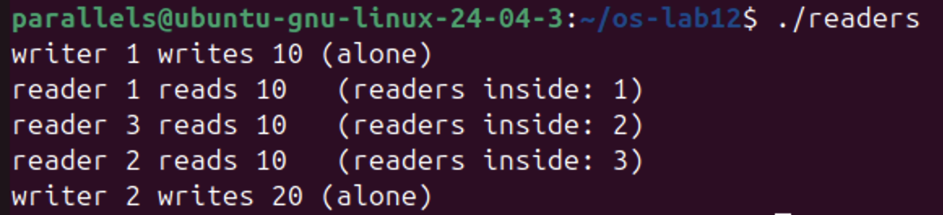
Figure 3.1 – ./readers: three readers together, each writer alone
Writer 1 wrote 10 alone. Then readers 1, 3 and 2 were inside at the same time (readers inside 1, 2, 3) and all read 10. Writer 2 wrote 20 only after all the readers had left.
Observe 1. Three readers are inside at the same time, but a writer is always alone. Which two lines of reader() make that possible?
if (++readers == 1) sem_wait(&room); and if (--readers == 0) sem_post(&room);. Only the first reader takes the room; the next readers find readers already above 0 and go in without touching room, so they read together. The room is given back only by the last reader. A writer needs the room for itself (sem_wait(&room) in writer()), so it can never be inside together with readers or with another writer.
Observe 2. Why does the counter readers need its own lock (rlock)? What could go wrong without it?
++readers and --readers are read-modify-write operations, just like counter++ in Lab 11, and the test == 1 or == 0 must happen together with the change. Without rlock two readers arriving at the same time could both read 0 and both write 1, and then both think they are the first one: the second one would call sem_wait(&room) on a room that is already taken by the readers and block forever. Or the counter could become wrong when the readers leave: if it reaches 0 too early, the room is given to a writer while a reader is still reading, and the writer changes value in the middle of a read; if it never reaches 0, the room is never freed and the writers wait forever.
Observe 3. Imagine readers that keep arriving without a pause. What happens to writer 2?
Writer 2 waits forever. As long as at least one reader is inside, new readers enter at once (they do not wait for room), so the counter readers never comes back to 0 and the room is never given back. The writer is ready to run but is always passed by new readers: this is starvation. A fix is to give writers priority, for example a turnstile semaphore that new readers must pass, which a waiting writer closes.
Part 4. Build a deadlock, then remove it
In deadlock.c thread one takes mutex A, sleeps one second, then wants B; thread two takes B, sleeps one second, then wants A. I ran it with timeout 5:
Figure 4.1 – timeout 5 ./deadlock: both threads stop, timeout kills the program
Both lines I have A, I want B and I have B, I want A appeared, then nothing for 5 seconds, then exit code: 124: timeout had to kill the program, because the two threads were waiting for each other.
Without sleep(1). I kept the original in deadlock_orig.c, made deadlock_nosleep.c without the two sleep(1) lines (grep -c prints 0), and ran it ten times with timeout 2:
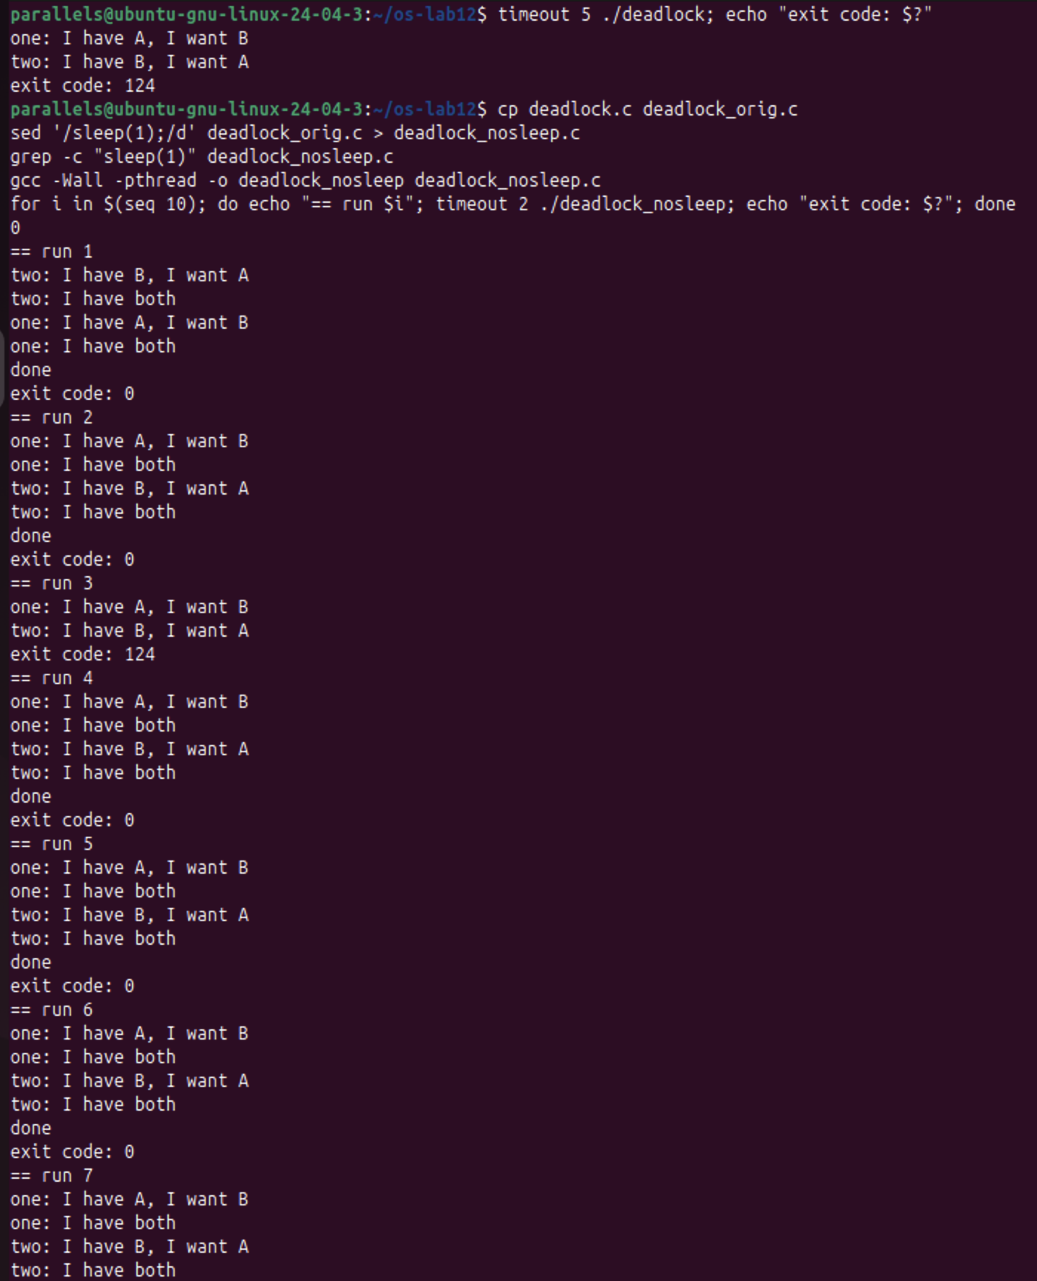
Figure 4.2 – deadlock_nosleep, runs 1 to 7
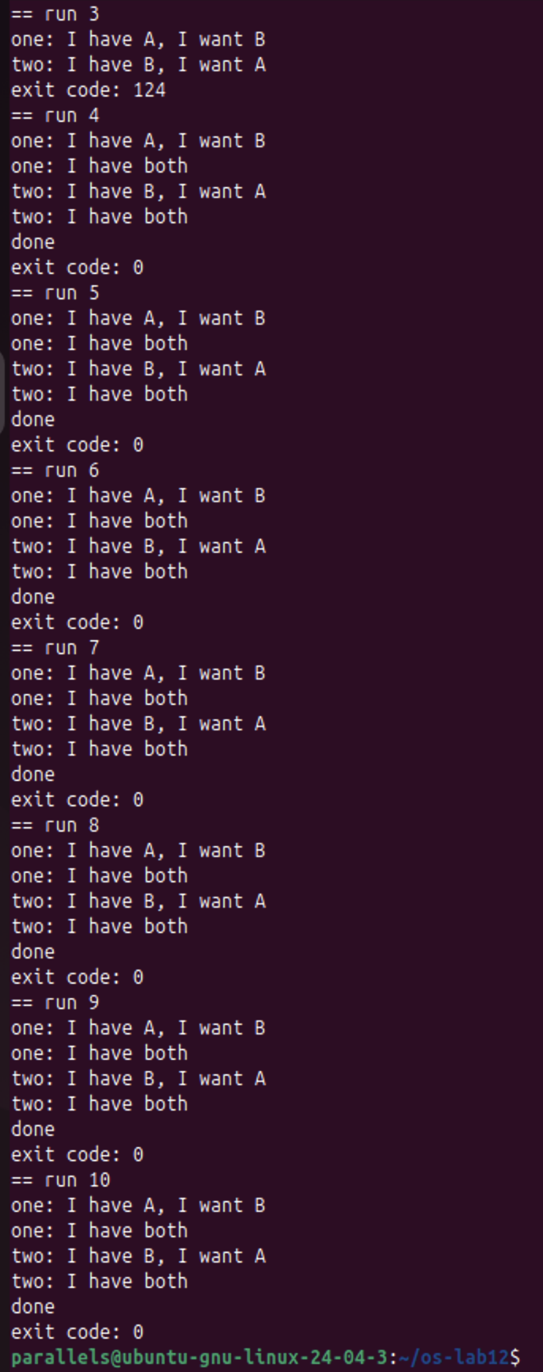
Figure 4.3 – deadlock_nosleep, runs 3 to 10
Only run 3 got stuck (exit code: 124); the other nine runs finished with done and exit code: 0. In those runs one thread took both mutexes before the other thread started, so they never crossed (in run 1 thread two was even first).
The fix. In two() I swapped the two pthread_mutex_lock lines and the two pthread_mutex_unlock lines, so two() takes A first and then B, the same order as one() (the sed output shows the new function). The text of its printf was not changed, so it still says "I have B, I want A":
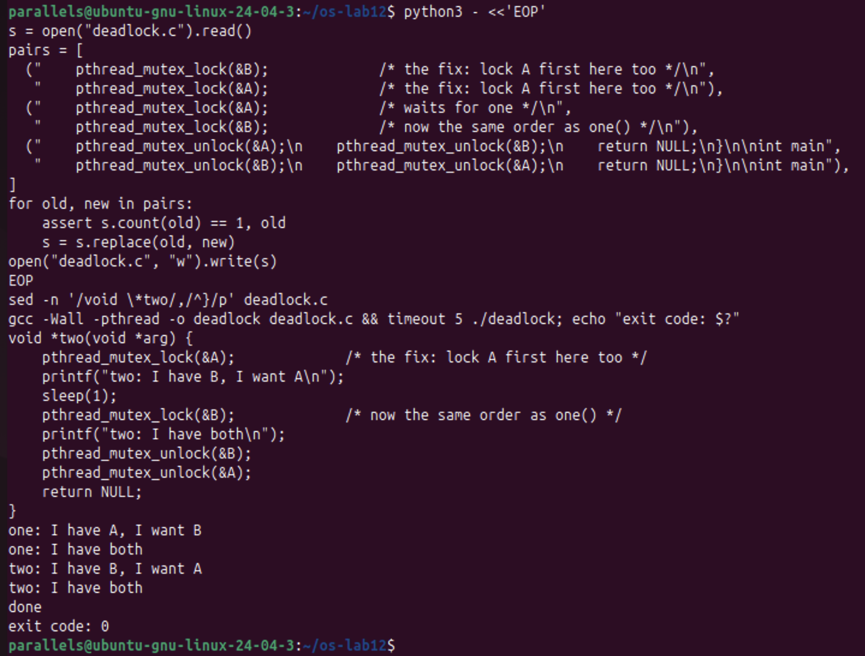
Figure 4.4 – The fixed deadlock.c: both threads finish, exit code 0
Now one got both mutexes, released them, then two got both, and the program printed done with exit code: 0. This fixed version is the deadlock.c that I hand in.
Observe 1. In the stuck run, which thread holds which mutex, and which one is each thread waiting for? Draw the circle.
Thread one holds A and waits for B; thread two holds B and waits for A. Each one holds what the other needs, so the waiting goes round in a circle:
one ---- waits for ----> B
^ |
| held by
held by |
| v
A <---- waits for ---- two

one waits for B, which is held by two; two waits for A, which is held by one. Neither can continue, so neither ever releases anything: a circular wait, which is a deadlock.
Observe 2. Remove both sleep(1) lines from the ORIGINAL version and run it ten times. Does it still always hang? Why is that worse, not better?
No. In my ten runs it hung only once (run 3, exit code: 124); nine runs ended normally. Without sleep(1) the dangerous moment is only the few instructions between the two pthread_mutex_lock calls, so usually one thread takes both mutexes before the other one starts. This is worse, because the bug is still there but now it is hidden: the program passes most tests, and then it freezes at random, rarely, maybe only on a user's machine under load, and it is very hard to reproduce and debug. With sleep(1) the bug showed every time, so it was easy to see and fix.
Observe 3. In one sentence: why can taking the locks in the same order never deadlock?
Because when every thread takes A before B, the thread that holds A is the only one that can be waiting for B, and a thread waiting for A holds nothing yet, so a circle of waiting can never close.
Conclusions
In this work the tools worked together. In producer and consumer, two counting semaphores (empty and full) block the producer when the buffer is full and the consumer when it is empty, and a mutex protects the buffer itself; the order matters, because waiting on a semaphore while holding the mutex turned the program into a deadlock. The condition variable lets a thread sleep until a normal variable changes; the variable (ready) remembers the state, the condition variable does not, and the check must be done in a while because a thread can wake up without the condition being true.
Readers and writers showed how a counter and two semaphores let many readers in together while a writer stays alone, and also the price of this solution: writers can starve. Finally, two mutexes taken in opposite order gave a circular wait that stopped both threads; without sleep(1) the same bug appeared only in 1 of 10 runs, which makes it more dangerous, and taking the locks always in the same order removed it.
The files of this work are in the folder lab12 of the repository: prodcons.c, condvar.c, readers.c, deadlock.c (the fixed version), the copies used for the experiments (prodcons_swap.c, condvar_if.c, deadlock_orig.c, deadlock_nosleep.c), report.md and the screenshots.

