
MINISTRY OF EDUCATION, CULTURE AND RESEARCH
OF THE REPUBLIC OF MOLDOVA
Technical University of Moldova
Faculty of Computers, Informatics and Microelectronics
Department of Software Engineering and Automation

Report
on laboratory work no. 9
of Operating Systems
Topic: Watching System Calls with strace

Done by: st. gr. FAF-243, Augustin Carazanu
Checked by: assist. univ. Patricia Reițman
FCIM, UTM

Chișinău – 2026
Purpose of the work
The purpose of this laboratory work is to watch the door between a program and the kernel: the system call. With strace I looked at the system calls made by a real command, ls -l. Then I wrote a small C program, syscalls.c, that opens a file, writes a line into it and reads it back using open, write, read and close, and I followed the same program from the outside to see which real system calls it makes. At the end I counted the calls with strace -c. The work was done on Ubuntu 24.04.3 ARM64 in a Parallels virtual machine, in the folder ~/lab9.
Before you start
strace was already installed: sudo apt install -y strace reported that version 6.8-0ubuntu2 is the newest version. All the commands below were run in the folder ~/lab9, which was empty at the beginning.
Part 1. See the calls of a real command
strace runs a command and prints every system call it makes, one line per call. I ran ls -l under it and asked only for the four kinds of calls that matter here: openat, read, write and close (-e trace=...). The option -f also follows child processes.
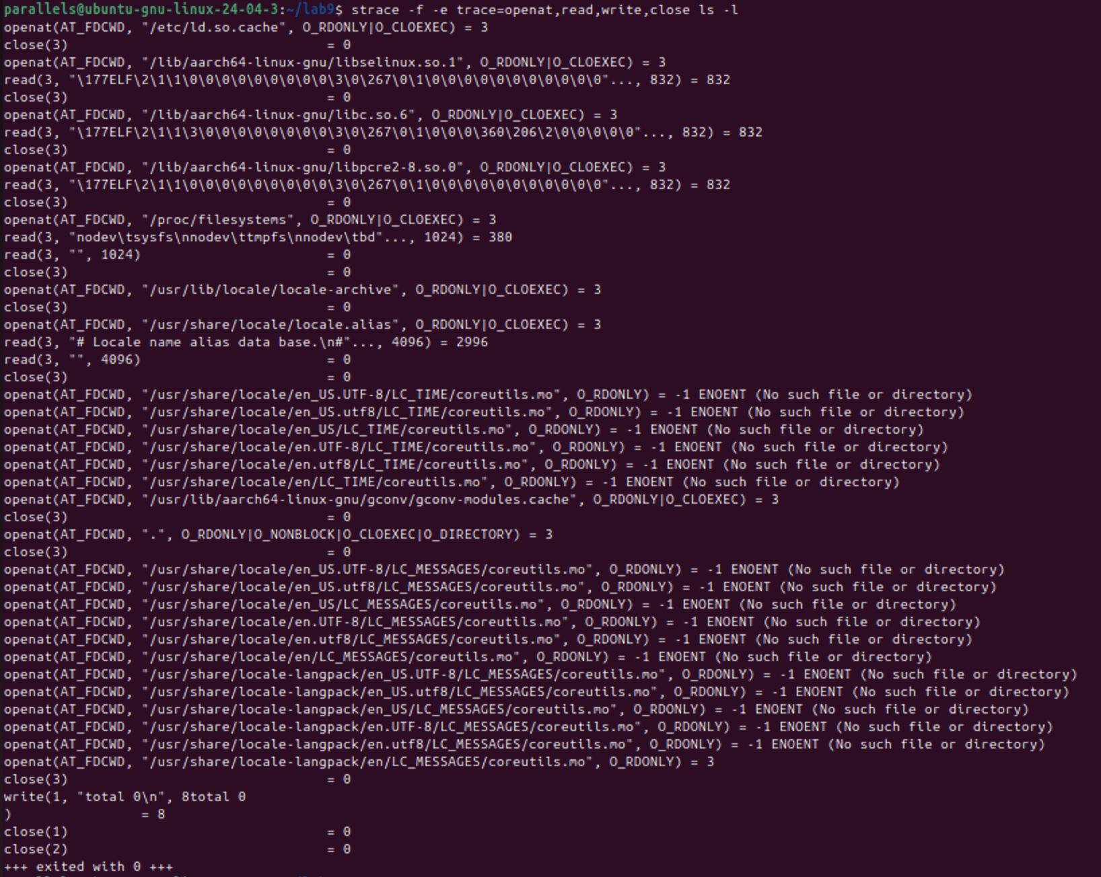
Figure 1.1 – strace -f -e trace=openat,read,write,close ls -l
Reading the trace from top to bottom:
• At the start, the dynamic loader opens /etc/ld.so.cache and the shared libraries libselinux.so.1, libc.so.6 and libpcre2-8.so.0. Each one is opened with openat and closed again, and for the libraries the first 832 bytes (the ELF header) are read. Every one of them gets descriptor 3.
• Then ls opens /proc/filesystems and looks for its translation files. The many lines ending in -1 ENOENT (No such file or directory) are failed attempts: ls tries coreutils.mo in several folders, and the last attempt, in locale-langpack/en, succeeds and returns 3.
• openat(AT_FDCWD, ".", O_RDONLY|O_NONBLOCK|O_CLOEXEC|O_DIRECTORY) = 3 is ls opening the current directory, because a directory is a file whose content it has to read. (The call that reads the entries, getdents64, is not in my filter.)
• The last real call is write(1, "total 0\n", 8) = 8, followed by close(1) and close(2) as ls ends.
Because the folder is empty, ls -l prints a single line, total 0. The text also appears inside the strace line itself (8total 0), because strace writes its trace and ls writes its output to the same terminal.
To count the calls roughly, I ran the same command without a filter and counted the lines of the trace: strace -f ls -l 2>&1 | wc -l. The 2>&1 is needed because strace prints to the error stream, and a pipe carries only the standard output.
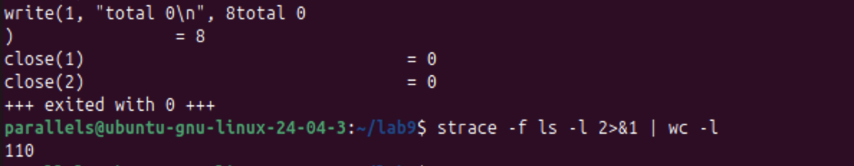
Figure 1.2 – The number of lines of the unfiltered trace of ls -l
It printed 110. So even ls on an empty folder makes roughly a hundred system calls, and only one of them produces the output. The trace in Figure 1.1 shows only the four kinds I asked for; the other calls are of other kinds, for example memory mapping.
Observe. Which system call does ls use to print to the screen? To which descriptor does it write?
ls uses write, and it writes to descriptor 1, the standard output: write(1, "total 0\n", 8) = 8. The first argument is the descriptor, the second the bytes and the third their number. The return value 8 means that the kernel accepted all 8 bytes (total 0 and the newline). ls does not know that descriptor 1 leads to the screen. The shell set it up before ls started, and ls would write to a file or to a pipe in exactly the same way.
Part 2. A program that calls the kernel directly
The program syscalls.c opens note.txt for writing, writes the line hello, kernel, closes the file, opens it again for reading, reads the line back and closes it. I created the file with a here-document in the shell and listed it with cat -n.
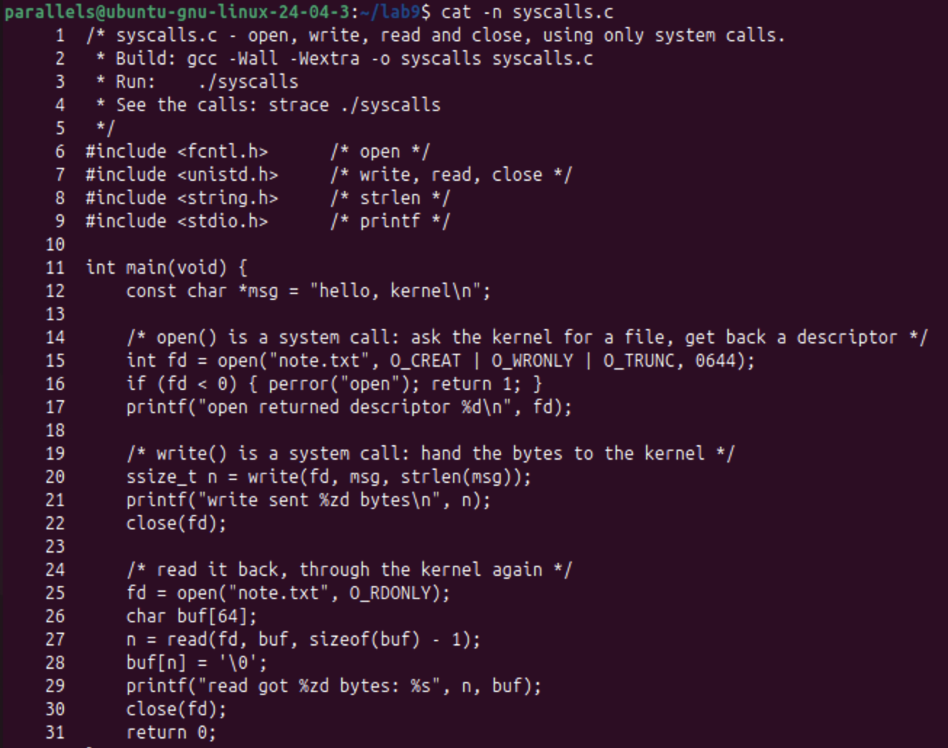
Figure 2.1 – The source code of syscalls.c, listed with cat -n
It was compiled with gcc -Wall -Wextra -o syscalls syscalls.c. There were no warnings, and the output is the expected one: the first descriptor is 3, 14 bytes were written and the same 14 bytes were read back (hello, kernel has 13 characters, plus the newline).
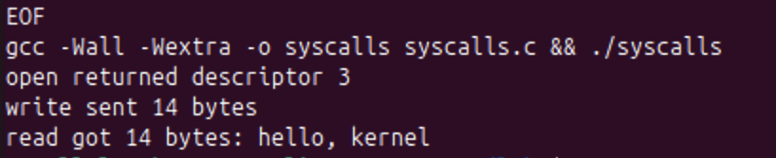
Figure 2.2 – Compiling and running syscalls
Then I watched the same program from the outside, with strace -e trace=openat,write,read,close ./syscalls.
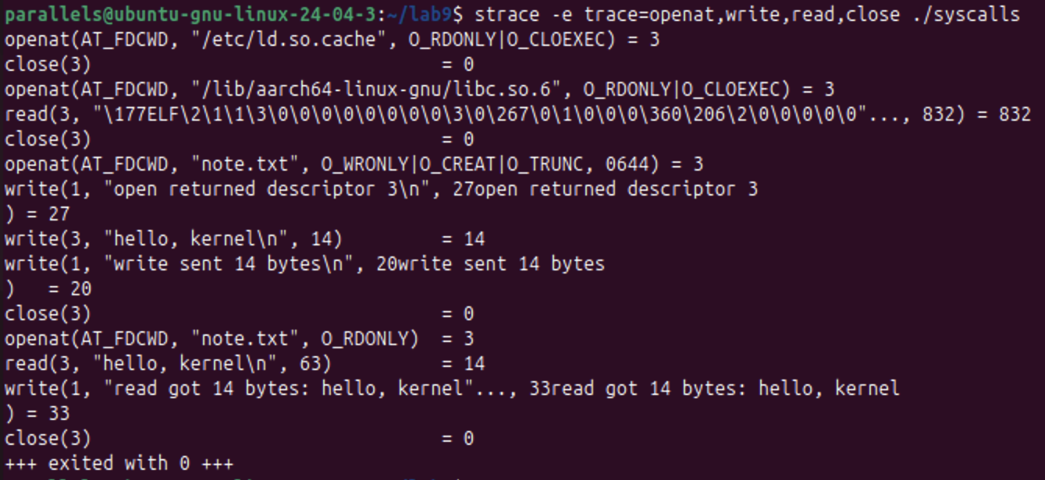
Figure 2.3 – strace of ./syscalls, showing openat, write, read and close
The first lines of the trace are the loader (/etc/ld.so.cache and libc.so.6), as in Part 1. My own calls follow. Each C function became exactly one system call:
C call in syscalls.c | System call seen in strace | Result
open("note.txt", O_CREAT|O_WRONLY|O_TRUNC, 0644) | openat(AT_FDCWD, "note.txt", O_WRONLY|O_CREAT|O_TRUNC, 0644) | 3
write(fd, msg, strlen(msg)) | write(3, "hello, kernel\n", 14) | 14
close(fd) | close(3) | 0
open("note.txt", O_RDONLY) | openat(AT_FDCWD, "note.txt", O_RDONLY) | 3
read(fd, buf, sizeof(buf) - 1) | read(3, "hello, kernel\n", 63) | 14
close(fd) | close(3) | 0

• open() is a function of the C library, and the system call behind it is openat. AT_FDCWD means "relative to the current directory". The flags are the ones I passed, and the mode is 0644.
• The lines write(1, ...) are the three printf calls. printf is a library function that finally calls write on descriptor 1, with 27, 20 and 33 bytes. They are mixed into the trace because strace and the program share the terminal. The only write into the file is write(3, "hello, kernel\n", 14) = 14.
• read(3, ..., 63) = 14: the program asked for at most 63 bytes (sizeof(buf) - 1, so that one place stays free for the final '\0'), and the kernel returned the 14 bytes that exist in the file.
The libraries make the trace long, so I also filtered it with grep. The 2>&1 is again needed, because strace prints to the error stream.
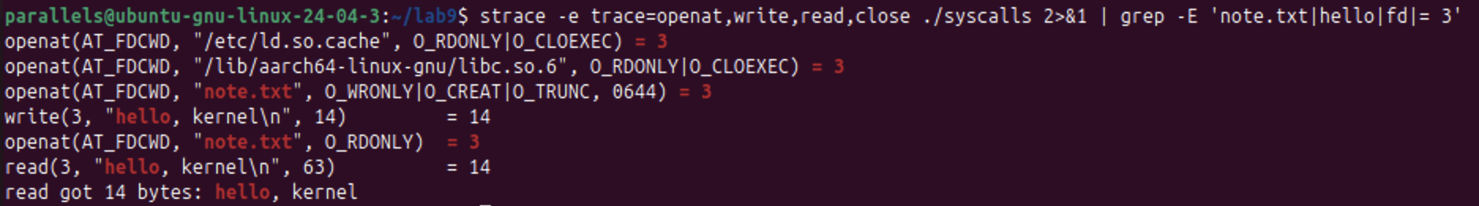
Figure 2.4 – The same trace filtered with grep
The two openat calls of the loader (/etc/ld.so.cache and libc.so.6) also return 3 here. They happen before my calls, and they are part of the answer below.
Observe. The descriptor returned by the first openat is 3, not 0, 1 or 2. Why are those three already taken?
Every process starts with three descriptors already open: 0 (stdin), 1 (stdout) and 2 (stderr). The shell prepares them before the program starts (fork copies the descriptor table and exec keeps it), so ./syscalls inherits the terminal as 0, 1 and 2. The kernel always gives open the smallest free number, and the smallest free one is 3.
Figure 2.3 shows this rule at work. The loader's openat returns 3, then close(3) frees it, so the next openat (libc.so.6) returns 3 again. Later note.txt gets 3 for writing, and after close(3) it gets 3 again for reading. The descriptor 1 is really used by the program: its printf calls end up as write(1, ...).
Part 3. Count one kind of call
The overview of the lab sheet lists this part, "Count one kind of call", but the sheet gives no commands for it. I used strace -c, which does not print the calls but counts them and prints a summary table when the program ends.
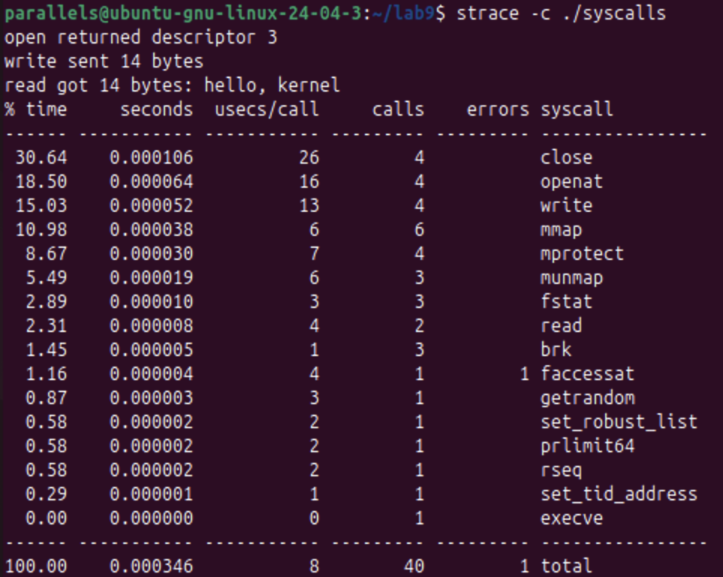
Figure 3.1 – strace -c ./syscalls: the number of calls of each kind
Call | Calls | Where they come from
openat | 4 | 2 mine (note.txt twice), 2 of the loader (ld.so.cache, libc.so.6)
close | 4 | 2 mine, 2 of the loader
write | 4 | all mine: 3 printf lines to descriptor 1, 1 into note.txt
read | 2 | 1 mine (note.txt), 1 of the loader (the ELF header of libc.so.6)
mmap | 6 | starting the program (memory mapping), not my code
all kinds | 40 | 1 call failed: a faccessat of the start-up

Of the 40 calls, only 9 come directly from my code: 2 openat, 2 close, 1 read and 4 write. The other 31 are the program starting up, loading libc.so.6 and preparing memory and the C library. The only call that failed (the errors column) is a faccessat of this start-up, not one of mine. According to strace, all 40 calls together took 0.000346 seconds.
Conclusions
strace made the boundary between a program and the kernel visible. ls prints with write to descriptor 1, and it needs about a hundred system calls even for an empty folder, most of them only to start up.
In my own program, each C library function became one system call: open became openat, and write, read and close stayed the same, while every printf became a write(1, ...). The first descriptor returned by open was 3, because 0, 1 and 2 are the standard streams that every process inherits and open always returns the smallest free number. After close(3) the same number was used again.
strace -c showed that of 40 system calls only 9 were made by my code; the rest belong to starting a dynamically linked program. The source file syscalls.c is in the folder lab9 of the repository.

