
MINISTRY OF EDUCATION, CULTURE AND RESEARCH
OF THE REPUBLIC OF MOLDOVA
Technical University of Moldova
Faculty of Computers, Informatics and Microelectronics
Department of Software Engineering and Automation

Report
on laboratory work no. 13
of Operating Systems
Topic: Semaphores in Your Own Kernel

Done by: st. gr. FAF-243, Augustin Carazanu
Checked by: assist. univ. Patricia Reițman
FCIM, UTM

Chișinău – 2026
Purpose of the work
In Labs 11 and 12 I used semaphores from the C library. The purpose of this laboratory work is to build them myself, inside the xv6 kernel, as three new system calls: sem_init, sem_down and sem_up (numbers 24, 25 and 26). A semaphore turns out to be only a number, a spinlock that protects the number, and the kernel's sleep and wakeup; a process that waits really sleeps and uses no CPU. The work was done in my xv6 tree ~/xv6-riscv (course revision 06aad25, which already has trace from Lab 10, number 23) on Ubuntu 24.04.3 ARM64 in Parallels.
Part 1. The numbers and the user side
This is the same recipe as trace in Lab 10, three times. I applied the edits with a small Python script that checks that every anchor exists exactly once:
File | Edit
kernel/syscall.h | #define SYS_sem_init 24, SYS_sem_down 25, SYS_sem_up 26
user/user.h | int sem_init(int, int); int sem_down(int); int sem_up(int);
user/usys.pl | entry("sem_init"); entry("sem_down"); entry("sem_up");
user/semtest.c | test 1: order (semaphore 0 starts at 0); test 2: ping-pong (semaphores 1 and 2)
user/mix.c | two processes print 5 lines each, one letter per write(); "mix lock" uses semaphore 3
Makefile | $U/_semtest\ and $U/_mix\ in UPROGS, after $U/_zombie\

Check 1. The calls already reach the kernel, but the kernel does not know them yet:
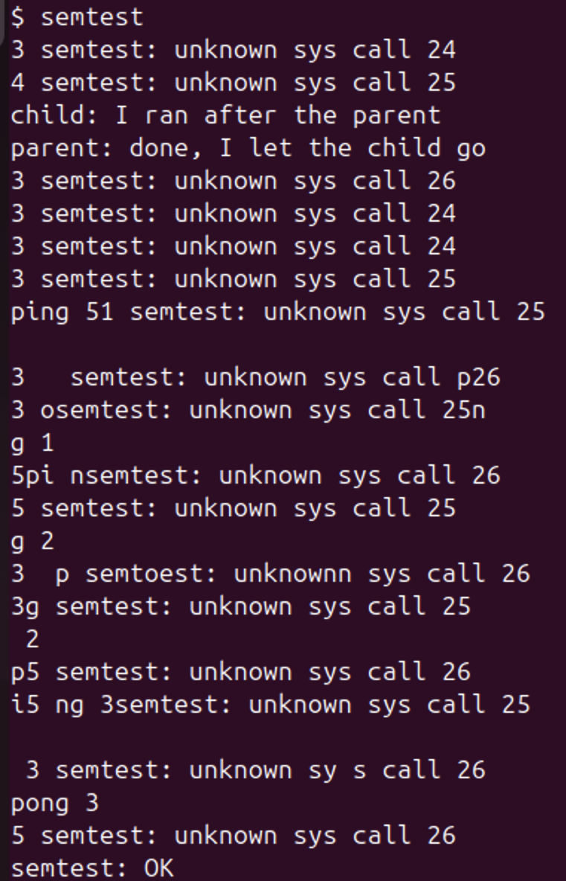
Figure 1.1 – Check 1: semtest before Part 2, unknown sys call 24, 25, 26
The first lines are exactly the expected ones: 3 semtest: unknown sys call 24 (the parent's sem_init), 4 semtest: unknown sys call 25 (the child's sem_down), and then child: I ran after the parent before parent: done, I let the child go. Every call returned -1 without waiting, so the child did not wait for the parent at all. After that the ping and pong lines are mixed with the error lines, because nothing makes them take turns. This is what Part 2 fixes.
Part 2. The kernel side
kernel/sem.c is a new file with a table of 8 semaphores shared by all processes; each one is a struct spinlock and an int value. The heart is sys_sem_down:
acquire(&s->lock);
while (s->value == 0) {
sleep_prepare(s); // I will sleep on the address of s
release(&s->lock); // never sleep holding a spinlock
sleep(); // returns at once if sem_up came in between
acquire(&s->lock);
if (killed(myproc())) { release(&s->lock); return -1; }
}
s->value--;
release(&s->lock);

sys_sem_up takes the spinlock, adds 1 and calls wakeup(s), which wakes every process that sleeps on the address of s. sys_sem_init sets the start value. Our xv6 sleeps in two steps, sleep_prepare(chan) and then sleep(), not with sleep(chan, lock) as in the xv6 book. I also added $K/sem.o to OBJS in the Makefile, the three extern declarations and table entries in kernel/syscall.c, and (because my tree has trace) the names sem_init, sem_down, sem_up in the syscallnames[] table of Lab 10.
The first time I pasted Part 2 something went wrong in my terminal, so I ran it again with a script that first removes every Part 2 line from Makefile and syscall.c and then adds each one exactly once; it printed Part 2 edits are in, once each and the counts 1 (sem.o in the Makefile) and 6 (sys_sem_ lines in syscall.c).
Check 2.
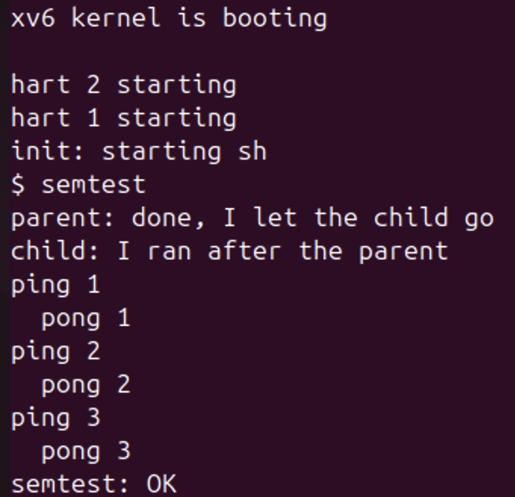
Figure 2.1 – Check 2: semtest after Part 2
Now parent: done, I let the child go comes first and child: I ran after the parent second. The parent waited 10 ticks (pause(10)) before sem_up(0), and still the child printed second: it was asleep in sem_down(0) all that time. Ping and pong take turns strictly, three times each, and the test ends with semtest: OK.
Part 3. A semaphore as a lock: mix
mix starts two processes; the parent prints 5 lines of A, the child 5 lines of b, one letter per write(). make qemu uses 3 CPUs, so the two processes really run at the same time. I ran it twice without the lock:
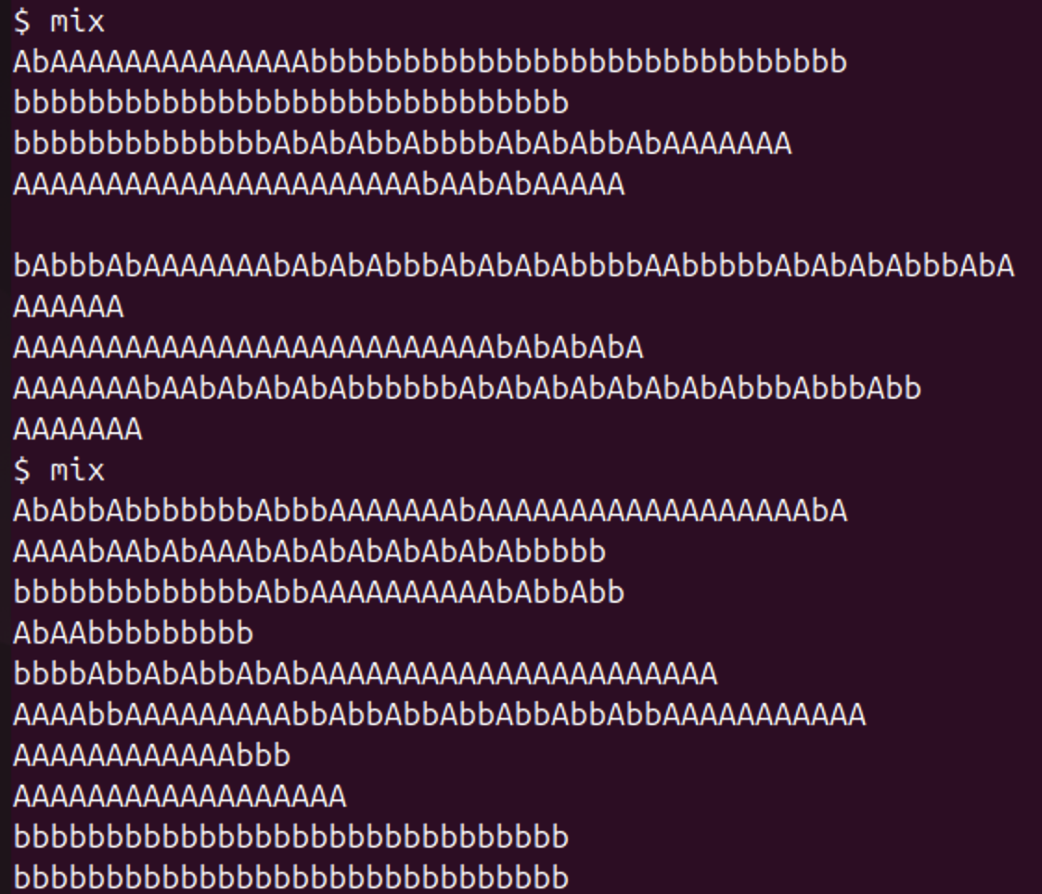
Figure 3.1 – mix, two runs without the lock: the letters mix
Both runs are mixed, and in a different way each time; some lines are long mixtures of A and b, some are short pieces, and a few lines came out whole by chance. Then with the lock (semaphore 3, started at 1):
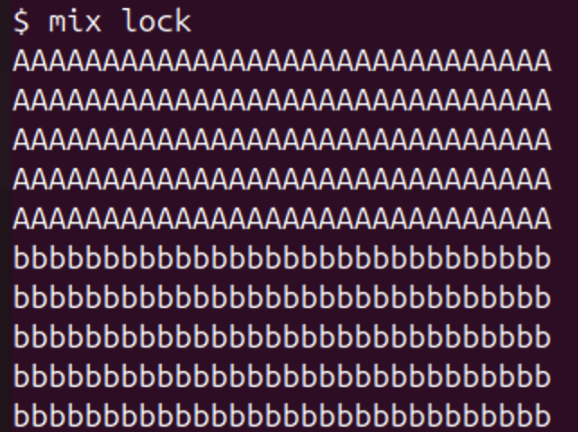
Figure 3.2 – mix lock: every line is whole
Every line is whole: first the 5 A lines, then the 5 b lines. Extra: with the trace call from Lab 10 and the mask 2^25 = 33554432 (only bit 25, sem_down), I could see when each process comes back from sem_down:
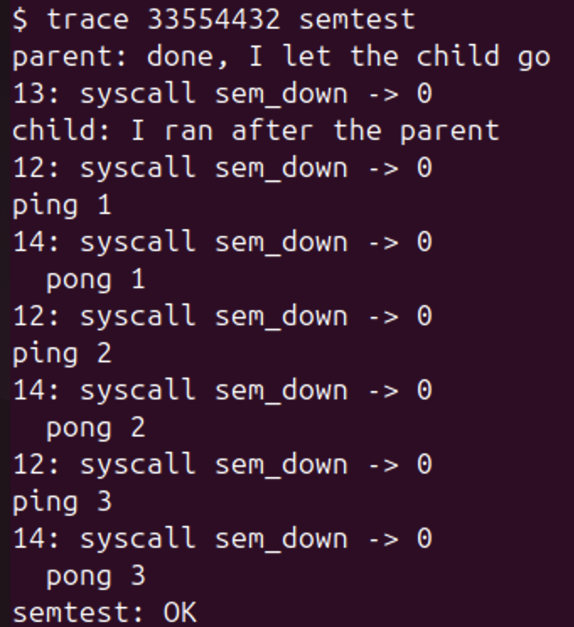
Figure 3.3 – trace 33554432 semtest: the returns from sem_down
The line 13: syscall sem_down -> 0 (the child of test 1) appears only after parent: done, I let the child go, and then process 12 (ping) and process 14 (pong) come back from sem_down one after the other, each one right before its own line. This shows directly that each process was blocked in the kernel until the other one called sem_up.
Finally I committed my xv6 tree (the commit also contains trace from Lab 10 and the programs of the earlier labs, which had not been committed yet). Git first asked for my identity, so I set my name and my GitHub e-mail with git config --global and committed again:
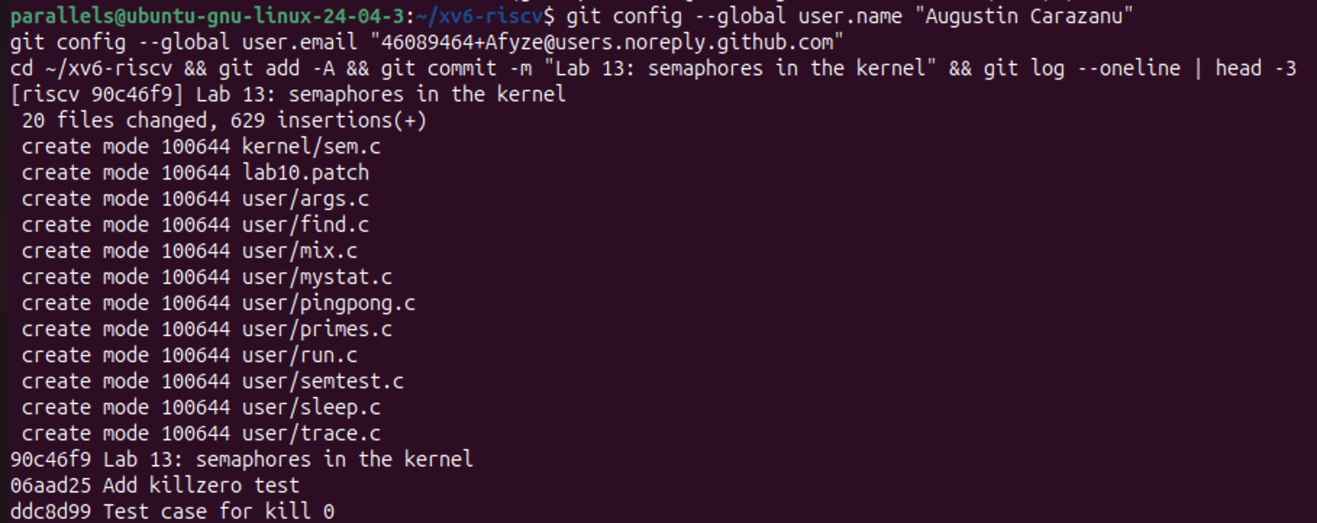
Figure 4.1 – git commit of the xv6 tree: 90c46f9 Lab 13: semaphores in the kernel
Answers to the Observe questions
Observe 1. Without the lock, why do the letters mix? (How many system calls does one line cost?)
One line costs 31 system calls: mix.c calls write(1, p, 1) once for every letter, 30 letters and the new line. The parent and the child run at the same time on different CPUs, and between any two write() calls of one process the other one can put its own letters on the console. Each single write() is done whole, but nothing keeps the 31 writes of one line together, so the lines mix, differently at every run (Figure 3.1).
Observe 2. With the lock every line is whole. Which two lines of mix.c make one line a critical section?
if (uselock) sem_down(3); before the loop that writes the letters, and if (uselock) sem_up(3); after it. Semaphore 3 starts at 1 (sem_init(3, 1)), so it works as a lock: the process that passes sem_down(3) takes the only unit, and the other one sleeps in sem_down until the whole line is written and sem_up(3) gives the unit back.
Observe 3. In sem_down the test is "while (s->value == 0)", not "if". Why can a process wake up and still find 0?
Because being woken up does not mean that the unit is still free. wakeup(s) wakes every process that sleeps on s, but sem_up gave back only one unit, so only one of them can take it; the others must check again and sleep again. Also, between the wake-up and the moment the woken process takes s->lock again, another process can call sem_down and take the unit first. My mix lock run shows this: after each line the parent gives the lock back with sem_up(3) and wakes the child, but it loops at once to sem_down(3) and takes the unit again before the child gets to run, so all 5 A lines came first and only then the 5 b lines. The child woke up, found 0 and went back to sleep; with if it would have made the value -1 and entered the critical section together with the parent.
Observe 4. sem_down calls release(&s->lock) BEFORE sleep(). What would go wrong if it slept holding the spinlock?
Nobody could ever wake it up. sem_up must take the same s->lock to add 1 and call wakeup(s), so it would spin forever on a lock that belongs to a sleeping process: a deadlock, with a CPU spinning with interrupts off. In our xv6 it would not even get that far: sleep() calls sched(), which checks that the process holds only its own p->lock (mycpu()->noff != 1) and stops the kernel with panic("sched locks"). The order sleep_prepare(s), release, sleep() is safe because s is registered before the lock is released: if sem_up comes in between, wakeup clears p->chan and sleep() returns at once, so the wake-up is not lost.
Conclusions
I built counting semaphores inside the xv6 kernel as three system calls. A kernel semaphore is just a number, a spinlock that protects it, and sleep and wakeup on its address: sem_down takes a unit or sleeps until there is one, and sem_up gives a unit back and wakes the sleepers. Check 1 showed what happens without them (the child ran before the parent and ping and pong mixed with the errors), and Check 2 showed the semaphore as a signal (start 0: the child waited 10 ticks in sem_down) and as a pair that passes the turn (ping-pong).
In mix the same semaphore with start value 1 became a lock that keeps the 31 write() calls of one line together. Two details of sem_down matter: the while, because a process can be woken up and still find 0 (in mix lock the parent took the unit back every time before the child), and releasing the spinlock before sleeping, otherwise sem_up could never get in and the kernel would deadlock or panic.
The files of this work are in the folder lab13 of the repository: sem.c, semtest.c, mix.c, the changed xv6 files (syscall.h, syscall.c, user.h, usys.pl, Makefile), lab13.patch (only the changes of this lab, on top of Lab 10), git-log.txt with my commit, notes.txt with the answers, report.md and the screenshots.

