
MINISTRY OF EDUCATION, CULTURE AND RESEARCH
OF THE REPUBLIC OF MOLDOVA
Technical University of Moldova
Faculty of Computers, Informatics and Microelectronics
Department of Software Engineering and Automation

Report
on laboratory work no. 11
of Operating Systems
Topic: The Race and the Semaphore

Done by: st. gr. FAF-243, Augustin Carazanu
Checked by: assist. univ. Patricia Reițman
FCIM, UTM

Chișinău – 2026
Purpose of the work
The purpose of this laboratory work is to see a race condition happen on a real system and to fix it. Two threads add 1 to the same counter one million times each, and some of the additions are lost. Then I protect the counter with a mutex and with a semaphore, and I use the same semaphore in three ways: as a lock (start value 1), as a signal (start value 0) and as a counter (start value N). The work was done on Ubuntu 24.04.3 ARM64 in a Parallels virtual machine, in the folder ~/os-lab11. All programs were compiled with gcc -Wall -pthread and without -O2, so that counter++ really goes through memory.
Part 1. See the race
The program race.c starts two threads with pthread_create. Each thread runs counter++ one million times on the global variable counter, so the right answer is 2 000 000. I ran it three times:
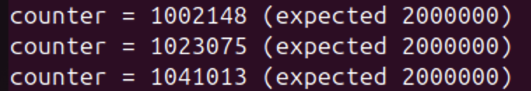
Figure 1.1 – Three runs of ./race: about half of the additions are lost
None of the three results is 2 000 000: I got 1 002 148, 1 023 075 and 1 041 013, so about one million additions were lost each time. To see what counter++ really is, I asked gcc for the assembly code of the function add (gcc -S):
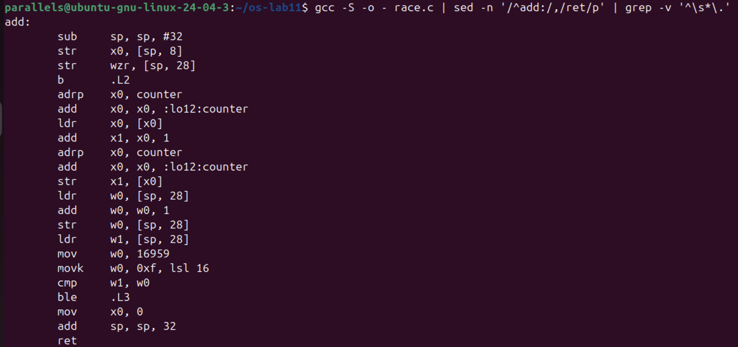
Figure 1.2 – The assembly code of add(): counter++ is ldr, add, str
The line counter++ became three ARM64 instructions: ldr x0, [x0] loads the value of counter from memory into the register x0, add x1, x0, 1 adds 1 inside the CPU, and str x1, [x0] writes the new value back to memory. (The two lines before each of them, adrp and add ... :lo12:counter, only compute the address of counter.) The second group ldr, add, str on [sp, 28] is i++ of the loop, which is private to each thread.
Observe 1. counter++ looks like one step. Write the three steps the CPU really does.
1) read: load the value of counter from memory into a register (ldr); 2) add: add 1 to the register (add); 3) write back: store the register into counter in memory (str). Between these steps the other thread can run.
Observe 2. Describe, with those steps, how two threads can lose one addition.
Suppose counter is 5. Thread A reads 5 into its register. Before A writes, thread B also reads 5. A adds 1 and writes 6. B adds 1 to its own copy and also writes 6. Two additions were made, but counter grew only by 1: the write of B covered the write of A, so one addition is lost. This is a race condition, and counter++ is a critical section that both threads entered at the same time.
Observe 3. Why is the result different at every run?
Because the interleaving of the two threads is different at every run. When each thread starts, on which CPU core it runs, and when the scheduler stops it are decided by the operating system and are never exactly the same, so the number of lost additions changes too (1 002 148, 1 023 075, 1 041 013). It can even be correct by chance: in Figure 2.2 one run of race printed 2 000 000, because that time one thread finished its loop before the other one really started, so they did not overlap. A correct result once does not mean the program is correct.
Part 2. Fix it: mutex, then semaphore
In mutex.c the line counter++ is between pthread_mutex_lock(&lock) and pthread_mutex_unlock(&lock). This makes it a critical section with mutual exclusion: at most one thread can be inside. In sem.c the same is done with a semaphore that starts at 1: sem_wait takes the unit (1 → 0) and the other thread has to wait at 0, sem_post gives it back (0 → 1). I ran each program three times:
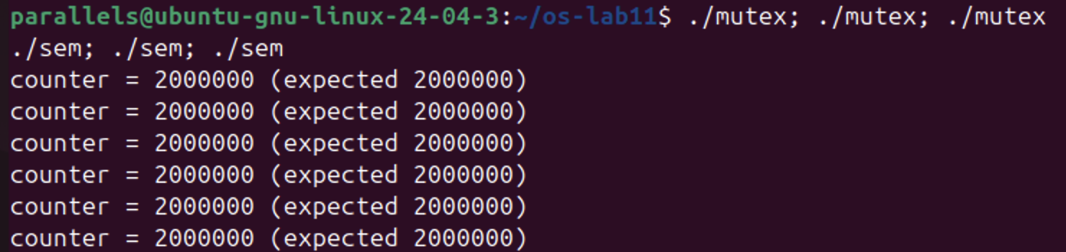
Figure 2.1 – ./mutex and ./sem, three runs each: always 2 000 000
The price of the lock. I measured the three versions with time:
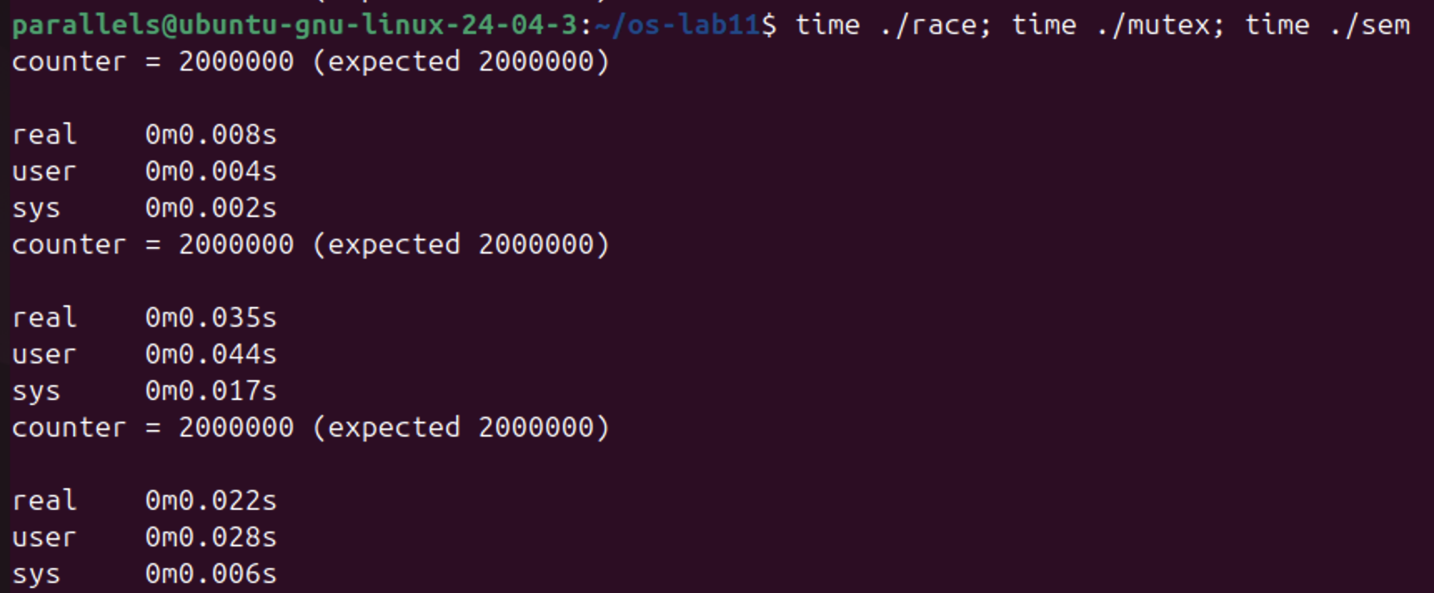
Figure 2.2 – time ./race, time ./mutex, time ./sem
Program | Result | real time
race | 2 000 000 (by chance, see Observe 1.3) | 0.008 s
mutex | 2 000 000 | 0.035 s
sem | 2 000 000 | 0.022 s

A semaphore that starts at 2. I made a copy sem2.c with sem_init(&s, 0, 2) (the grep line shows the change) and ran it three times:
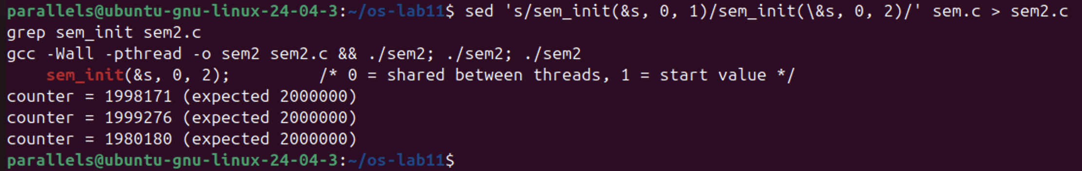
Figure 2.3 – sem2.c (start value 2): the result is wrong again
Observe 1. Run mutex and sem three times each. Is the answer always 2 000 000?
Yes. All six runs printed counter = 2000000 (Figure 2.1). Only one thread can be between lock and unlock (or between sem_wait and sem_post), so the three steps of counter++ of one thread can no longer be mixed with the steps of the other, and no addition is lost.
Observe 2. What would happen in sem.c with sem_init(&s, 0, 2)? Try it and explain.
The semaphore starts with two units, so both threads can pass sem_wait at the same time: there are two threads inside the critical section and the race is back. I got 1 998 171, 1 999 276 and 1 980 180 (Figure 2.3), all below 2 000 000. Fewer additions are lost than in race.c, because the threads spend part of each step in sem_wait and sem_post, so their counter++ overlap less often, but the result is still wrong. A semaphore works as a lock only when it starts at 1.
Observe 3. Why is the locked version slower?
Because every single addition now costs much more than the addition itself: a lock and an unlock (or sem_wait and sem_post), which are atomic instructions, and the variable of the lock has to move between the two CPU cores all the time. When the lock is taken, the other thread has to wait, and sometimes it is put to sleep by the kernel (a futex system call) and woken up later, which shows as sys time (0.017 s for mutex). The two threads also cannot work in parallel any more on the counter. On my machine race took 0.008 s, mutex 0.035 s and sem 0.022 s. Unlike the reference machine, sem was a little faster than mutex in my run; times of a few hundredths of a second change from run to run, but both locked versions are clearly slower than the version without a lock.
Part 3. A semaphore as a signal
In order.c the problem is the order, not two threads at once: thread B must read the message only after thread A has written it. The semaphore ready starts at 0, so B blocks at sem_wait until A calls sem_post. B is created first on purpose:
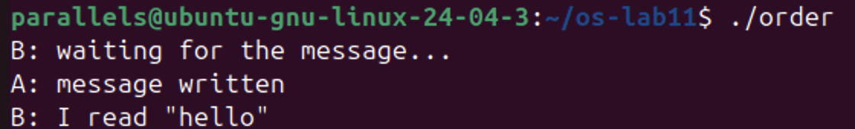
Figure 3.1 – ./order: B waits until A has written the message
B printed waiting for the message... at once, then nothing happened for about one second (the sleep(1) of A), then A wrote the message and B read "hello". Then I made a copy order1.c with the start value 1:
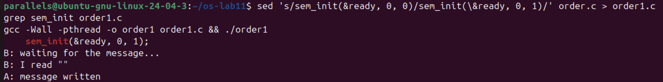
Figure 3.2 – order1.c (start value 1): B reads an empty message before A writes
Observe 1. Change the start value to 1, compile, run. What does B read now, and why?
B reads an empty string "", and A: message written appears only after it (Figure 3.2). With the start value 1 the semaphore already has a unit, so sem_wait of B does not block: it takes the unit (1 → 0) and B continues at once, while A is still in sleep(1). The array message is still empty (a global array starts with zeros), so B prints nothing. The order is no longer guaranteed.
Observe 2. Put it back to 0. In one sentence: what does a semaphore that starts at 0 mean?
A semaphore that starts at 0 means "nothing is ready yet": whoever calls sem_wait waits until another thread signals with sem_post that it is ready.
Part 4. A semaphore as a counter: the parking lot
In parking.c six cars (threads) share three places. The semaphore places starts at 3 and counts the free places: each car calls sem_wait(&places) before it enters and sem_post(&places) when it leaves. The mutex only keeps the change of inside and its printf together.
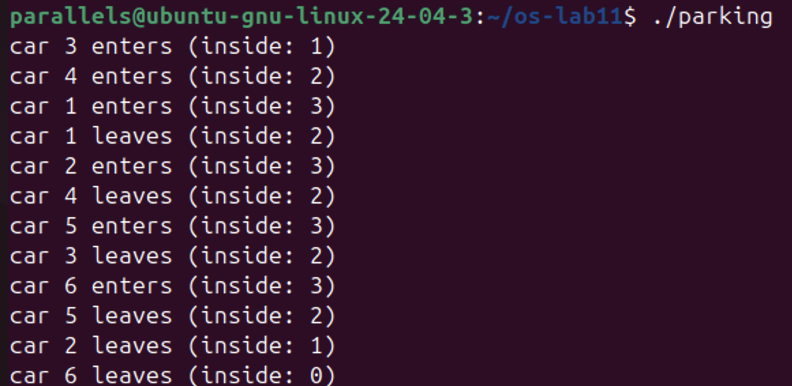
Figure 4.1 – ./parking: 6 cars, 3 places
Cars 3, 4 and 1 entered first, and inside reached 3. Car 2 entered only after car 1 left, car 5 only after car 4 left and car 6 only after car 3 left: every new car waited for a free place. Then I set PLACES to 1 in a copy, parking1.c:
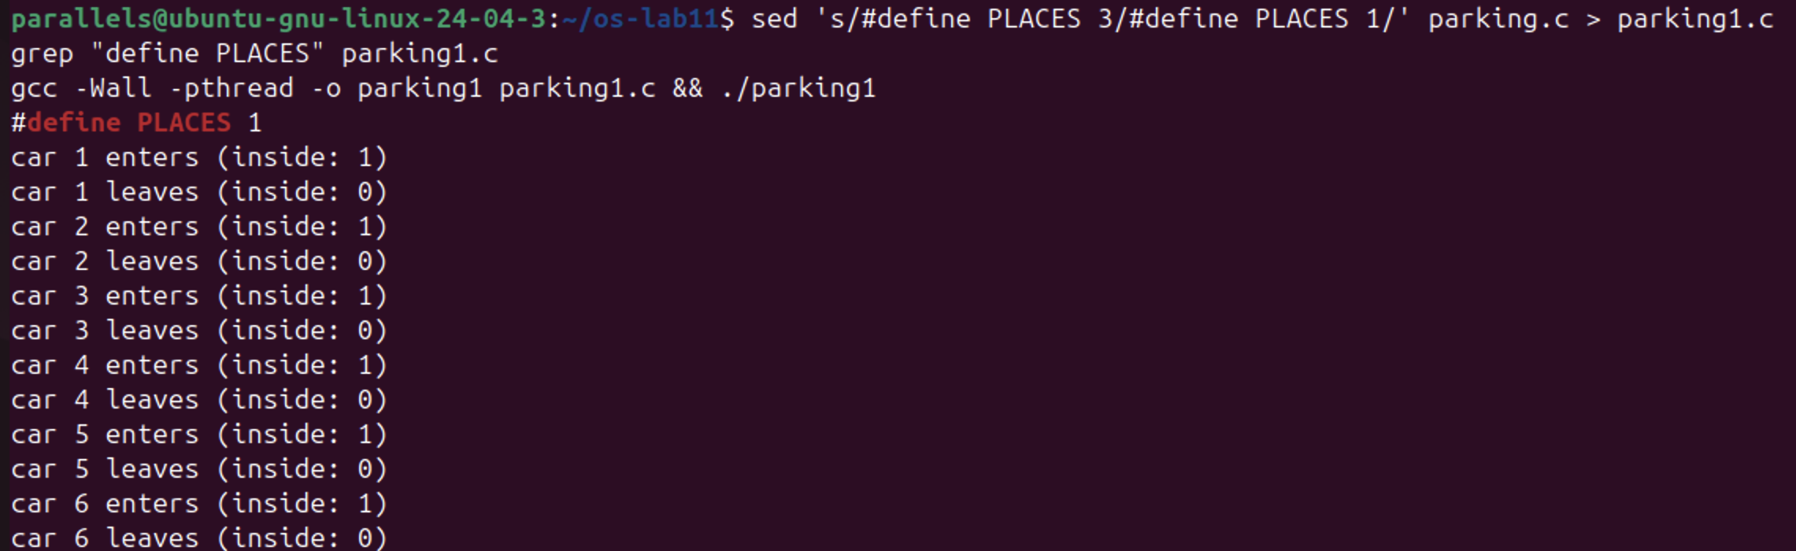
Figure 4.2 – parking1.c (PLACES 1): one car at a time
Observe 1. What is the largest value of "inside" you see? Which line of code guarantees it?
The largest value is 3 (Figure 4.1). It is guaranteed by the semaphore: sem_init(&places, 0, PLACES) gives it 3 units, and sem_wait(&places); at the beginning of car() takes one unit before the car enters. After three cars the value is 0, so a fourth car blocks in sem_wait until a car leaves and calls sem_post(&places).
Observe 2. Set PLACES to 1. What does the semaphore become?
With one place the semaphore starts at 1, so it becomes a lock (a binary semaphore, like a mutex): only one car can be inside at a time. In Figure 4.2 each car enters and leaves before the next one enters, and inside is only 1 or 0.
Optional: no lock at all (atomic)
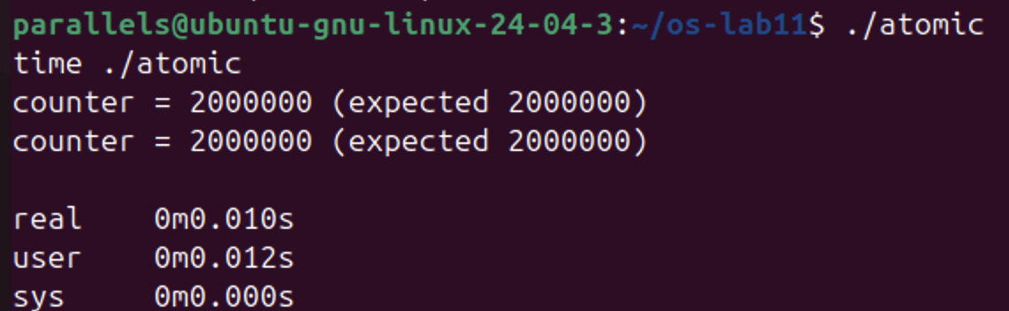
Figure 5.1 – ./atomic and time ./atomic
atomic.c uses atomic_fetch_add, which does the read, the addition and the write as one indivisible step, so no other thread can cut in between. The result is 2 000 000 every time and the time was 0.010 s, much less than the 0.035 s of the mutex and close to the 0.008 s of the unprotected version, because there is no lock and no waiting, only one atomic instruction for each addition.
Conclusions
I saw that counter++ is not one step but three (read, add, write back: ldr, add, str), and that two threads which mix these steps lose additions: about one million out of two million in my runs, and a different number each time, because the interleaving is decided by the scheduler. Even a correct result can appear by chance, so testing alone cannot prove that such a program is correct.
A mutex makes counter++ a critical section with mutual exclusion and always gives 2 000 000, but it is slower, because every addition now needs a lock and an unlock. A semaphore is a number that never goes below 0, and its start value decides what it does: with 1 it is a lock, with 2 it lets two threads in and the race comes back, with 0 it is a signal that makes one thread wait for another (with 1 instead, B read an empty message), and with N it counts free resources, as in the parking lot, where there were never more than 3 cars inside. For a single counter, an atomic operation is the fastest correct solution.
The files of this work are in the folder lab11 of the repository: race.c, mutex.c, sem.c, order.c, parking.c, atomic.c, the copies used for the experiments (sem2.c, order1.c, parking1.c), report.md and the screenshots.

