
MINISTRY OF EDUCATION, CULTURE AND RESEARCH
OF THE REPUBLIC OF MOLDOVA
Technical University of Moldova
Faculty of Computers, Informatics and Microelectronics
Department of Software Engineering and Automation

Report
on laboratory work no. 2
of Techniques and Mechanisms of Software Design
Topic: Structural Design Patterns (Adapter, Decorator, Facade)

Done by: st. gr. FAF-243, Augustin Carazanu
Checked by: assist. univ. Daniel Istrati
FCIM, UTM

Chișinău – 2026

1. Objectives
- Study the structural design patterns: Adapter, Bridge, Composite, Decorator, Facade, Flyweight and Proxy.
- Implement three of them in one Swift project: Adapter, Decorator and Facade.
- Show with a demo program, UML diagrams and unit tests what problem each pattern solves, and know the purpose and structure of the other four.

2. Theoretical background
Structural patterns describe how classes and objects are combined into larger structures while keeping those structures flexible. Creational patterns (previous laboratory work) answer “how is an object created?”; structural patterns answer “how do objects fit together?”. Most of them rely on composition: an object holds a reference to another object, often behind a common interface, and adds, translates or hides behaviour.
Pattern | Intent | Typical use
Adapter | Convert the interface of a class into the interface clients expect. | Third-party libraries, legacy code, external APIs.
Bridge | Separate an abstraction from its implementation so the two can vary independently. | Shapes × renderers, reports × output formats, remotes × devices.
Composite | Compose objects into tree structures and treat single objects and groups uniformly. | Folders and files, menus, bundles of products, UI view hierarchies.
Decorator | Attach additional responsibilities to an object dynamically by wrapping it. | Optional extras, streams, middleware, logging/caching wrappers.
Facade | Provide one simple interface to a complex subsystem. | Checkout, booking, video conversion, library entry points.
Flyweight | Share common state between many fine-grained objects to save memory. | Characters in a text editor, map tiles, particles, cover styles.
Proxy | Provide a placeholder that controls access to another object. | Lazy loading, access control, caching, remote objects, logging.
Table 1 — Structural design patterns
This laboratory work implements Adapter, Decorator and Facade. Bridge, Composite, Flyweight and Proxy are explained with short Swift examples and diagrams in section 5.

3. Implementation
The project continues the online bookstore from the previous laboratory works. It is a Swift Package with three targets: StructuralCore (library with the patterns), StructuralDemo (executable) and StructuralTests (XCTest unit tests). The three patterns cooperate in one use case, placing an order. CheckoutFacade is the single entry point. It prices the cart, where every line is an OrderItem that may be wrapped in decorators, and it pays through a PaymentProcessor, which is an adapter over a third-party payment API.
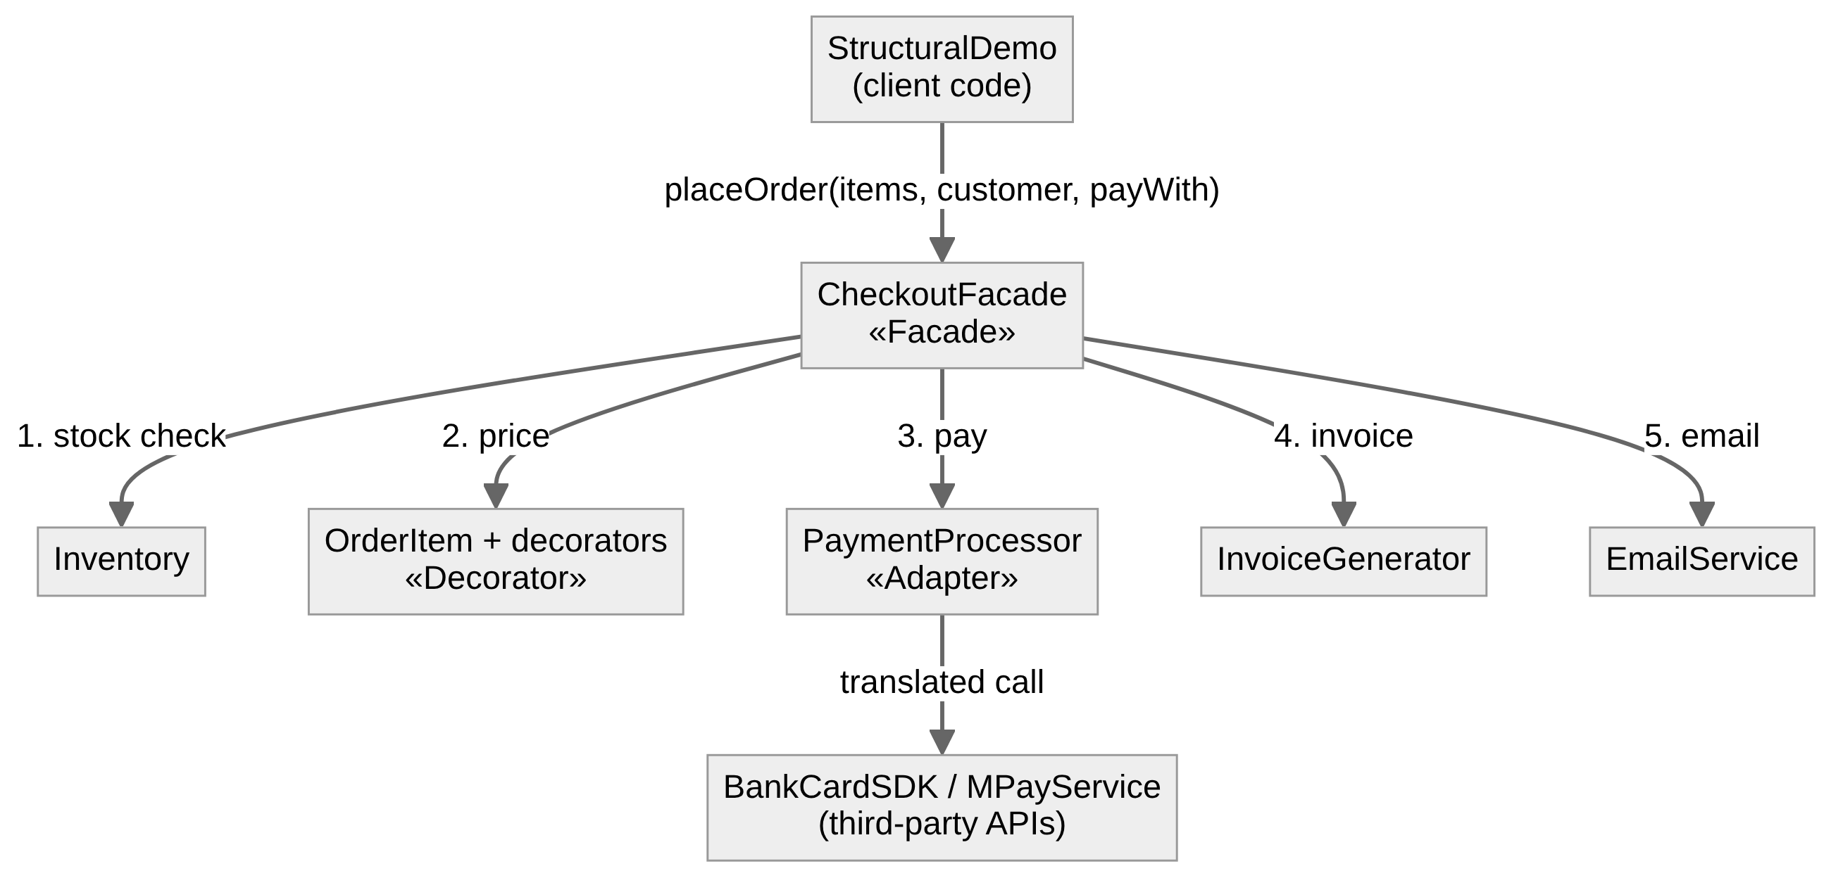
Figure 1 — How the three patterns cooperate
import Foundation

/// A book sold by the online bookstore (the same domain as Lab 0 and Lab 1).
public struct Book: Equatable {
public let title: String
public let author: String
public let price: Double

public init(title: String, author: String, price: Double) {
self.title = title
self.author = author
self.price = price
}
}

/// Formats an amount as "123.45 MDL".
public func money(_ amount: Double) -> String {
String(format: "%.2f MDL", amount)
}
Listing 1 — Shared model (Models.swift)

3.1 Adapter — payment providers
Problem
The shop works with one simple payment interface: an amount in MDL and a clear approved/declined result. The two payment providers it must support come as third-party libraries that cannot be modified, and neither matches that interface. BankCardSDK expects the amount in bani (Int, 1 MDL = 100 bani) and answers with numeric codes (0 = OK, 51 = insufficient funds). MPayService expects the amount as text and answers with a text response such as “STATUS=OK;TXN=MP-5001”. Calling them directly would spread conversions and code parsing across the whole shop.
Solution
PaymentProcessor is the target interface. BankCardSDK and MPayService are the adaptees. BankCardAdapter and MPayAdapter implement PaymentProcessor, hold a reference to their adaptee (object adapter, by composition) and translate both ways: MDL to bani or text on the way in, codes or text responses to PaymentStatus on the way out. The rest of the shop, including the Facade, sees only PaymentProcessor.
// ADAPTER — the target interface
//
// This is the only payment interface the bookstore knows: an amount in MDL
// (Double), a customer, and a clear result. Every payment provider must be
// usable through it, no matter what its own API looks like.

public enum PaymentStatus: Equatable {
case approved(transactionID: String)
case declined(reason: String)
}

public protocol PaymentProcessor {
var name: String { get }
func pay(amount: Double, customer: String) -> PaymentStatus
}
Listing 2 — Target interface (PaymentProcessor.swift)
import Foundation

// ADAPTER — the adaptees
//
// Two third-party payment libraries. We cannot change their code, and their
// interfaces do not match PaymentProcessor:
// - BankCardSDK works in bani (1 MDL = 100 bani, Int) and answers with
// numeric codes (0 = OK, 51 = insufficient funds).
// - MPayService takes the amount as text and answers with a text
// response such as "STATUS=OK;TXN=MP-5001".

/// Card-processing SDK provided by a bank.
public final class BankCardSDK {
public private(set) var lastAmountInBani: Int?
private var lastReference = 7000
private let limitInBani = 500_000 // 5000 MDL per transaction

public init() {}

public func authorize(amountInBani: Int, cardholderEmail: String) -> (code: Int, reference: String) {
lastAmountInBani = amountInBani
guard amountInBani <= limitInBani else {
return (code: 51, reference: "")
}
lastReference += 1
return (code: 0, reference: "BC-\(lastReference)")
}
}

/// Government payment service with a text-based API.
public final class MPayService {
private var lastTransaction = 5000
private let limit = 10_000.0 // MDL per payment

public init() {}

public func submitPayment(sum: String, payerID: String) -> String {
guard let value = Double(sum), value > 0 else {
return "STATUS=ERROR;MSG=invalid sum"
}
guard value <= limit else {
return "STATUS=ERROR;MSG=limit exceeded"
}
lastTransaction += 1
return "STATUS=OK;TXN=MP-\(lastTransaction)"
}
}
Listing 3 — Adaptees: third-party APIs (ThirdPartyPaymentAPIs.swift)
import Foundation

// ADAPTER — the adapters
//
// Each adapter implements the target interface (PaymentProcessor) and
// translates the call into the adaptee's own language:
// MDL Double -> bani Int / text amount, and
// numeric code / text response -> PaymentStatus.
// The rest of the shop never sees BankCardSDK or MPayService directly.

public struct BankCardAdapter: PaymentProcessor {
public let name = "Bank card"
private let sdk: BankCardSDK

public init(sdk: BankCardSDK = BankCardSDK()) {
self.sdk = sdk
}

public func pay(amount: Double, customer: String) -> PaymentStatus {
let bani = Int((amount * 100).rounded()) // MDL -> bani
let result = sdk.authorize(amountInBani: bani, cardholderEmail: customer)
switch result.code { // code -> status
case 0: return .approved(transactionID: result.reference)
case 51: return .declined(reason: "insufficient funds (code 51)")
default: return .declined(reason: "bank error (code \(result.code))")
}
}
}

public struct MPayAdapter: PaymentProcessor {
public let name = "MPay"
private let service: MPayService

public init(service: MPayService = MPayService()) {
self.service = service
}

public func pay(amount: Double, customer: String) -> PaymentStatus {
let sum = String(format: "%.2f", amount) // Double -> text
let response = service.submitPayment(sum: sum, payerID: customer)
let fields = parse(response) // text -> status
if fields["STATUS"] == "OK", let txn = fields["TXN"] {
return .approved(transactionID: txn)
}
return .declined(reason: fields["MSG"] ?? "unknown MPay error")
}

/// "STATUS=OK;TXN=MP-5001" -> ["STATUS": "OK", "TXN": "MP-5001"]
private func parse(_ response: String) -> [String: String] {
var fields: [String: String] = [:]
for pair in response.split(separator: ";") {
let parts = pair.split(separator: "=", maxSplits: 1)
if parts.count == 2 {
fields[String(parts[0])] = String(parts[1])
}
}
return fields
}
}
Listing 4 — Adapters (PaymentAdapters.swift)
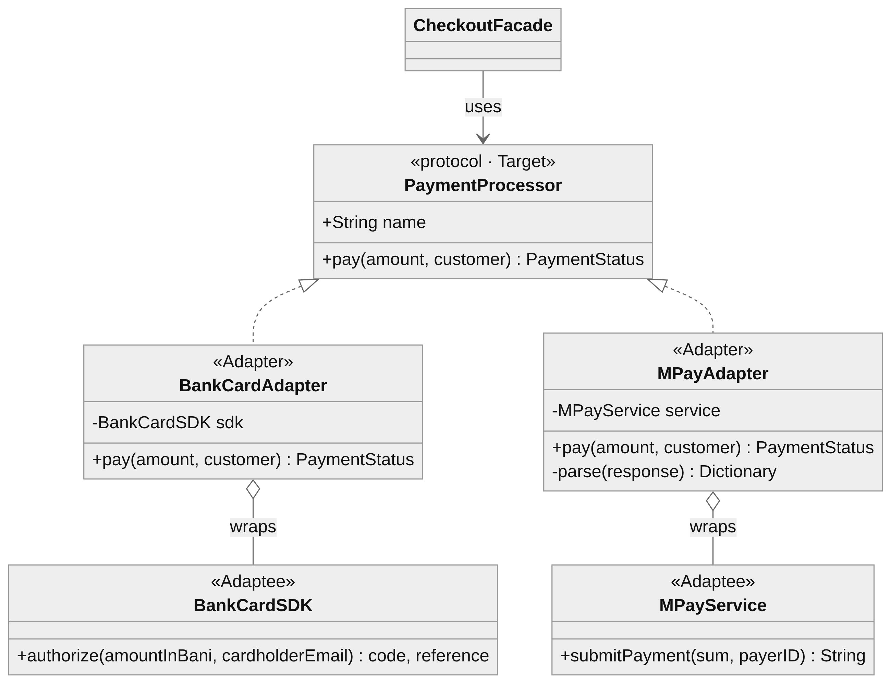
Figure 2 — Adapter class diagram
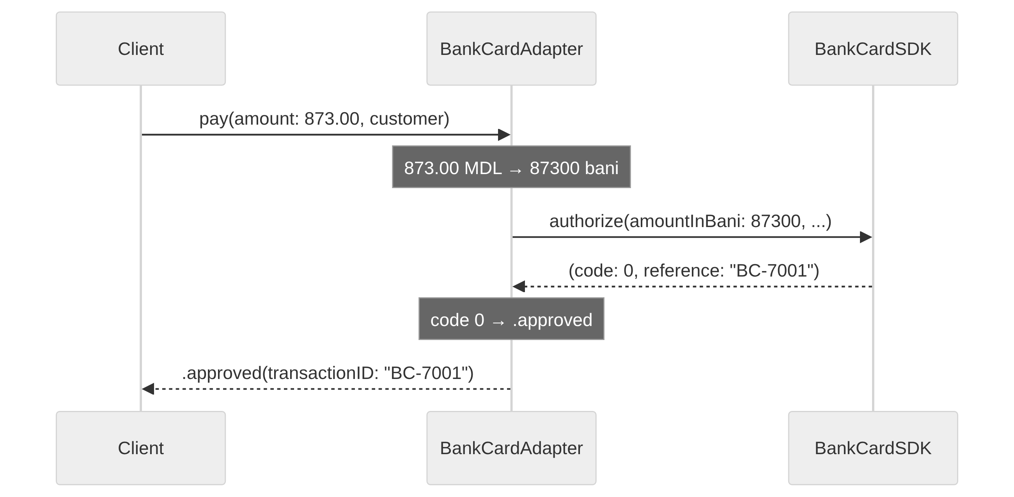
Figure 3 — Adapter translating one payment call

3.2 Decorator — order extras
Problem
Any book in the cart can receive optional extras: gift wrapping (+25 MDL), express delivery (+60 MDL), insurance (+2%) and a student discount (−10%). Modelling each combination as a subclass (GiftWrappedExpressBook, DiscountedInsuredBook, …) explodes quickly: four extras already give 15 combinations. A single class with four Boolean flags and an if for each would have to be edited for every new extra.
Solution
OrderItem is the component interface (book, description, price). BookItem is the concrete component, a book with no extras. Every decorator is itself an OrderItem and holds the OrderItem it wraps. It forwards the call to the wrapped item and adds its own part on top. Decorators can be stacked in any number and order at runtime; a protocol extension adds fluent helpers, so BookItem(swiftBook).studentDiscount().giftWrapped().express() reads like a sentence.
// DECORATOR — the component and the concrete component
//
// Every line in the cart is an OrderItem: it has a description and a price.
// A plain book is the simplest item. Extras (gift wrap, express delivery,
// insurance, discounts) are added by wrapping it in decorators.

public protocol OrderItem {
var book: Book { get }
var description: String { get }
var price: Double { get }
}

/// Concrete component: a book with no extras.
public struct BookItem: OrderItem {
public let book: Book
public init(_ book: Book) { self.book = book }
public var description: String { book.title }
public var price: Double { book.price }
}
Listing 5 — Component and concrete component (OrderItem.swift)
// DECORATOR — the decorators
//
// Each decorator IS an OrderItem and HAS an OrderItem (the wrapped one).
// It forwards the call to the wrapped item and adds its own behaviour on
// top. Decorators can be stacked in any number and any order at runtime:
//
// BookItem(swift).studentDiscount().giftWrapped().express()
//
// Without decorators we would need a subclass for every combination
// (GiftWrappedExpressBook, DiscountedInsuredBook, ...): 4 extras already
// give 15 combinations.

public struct GiftWrapped: OrderItem {
let wrapped: OrderItem
public var book: Book { wrapped.book }
public var description: String { wrapped.description + " + gift wrap" }
public var price: Double { wrapped.price + 25 }
}

public struct ExpressDelivery: OrderItem {
let wrapped: OrderItem
public var book: Book { wrapped.book }
public var description: String { wrapped.description + " + express delivery" }
public var price: Double { wrapped.price + 60 }
}

public struct Insured: OrderItem {
let wrapped: OrderItem
public var book: Book { wrapped.book }
public var description: String { wrapped.description + " + insurance 2%" }
public var price: Double { wrapped.price * 1.02 }
}

public struct StudentDiscount: OrderItem {
let wrapped: OrderItem
public var book: Book { wrapped.book }
public var description: String { wrapped.description + " - student discount 10%" }
public var price: Double { wrapped.price * 0.90 }
}

/// Fluent helpers, so decorators read like a sentence.
public extension OrderItem {
func giftWrapped() -> OrderItem { GiftWrapped(wrapped: self) }
func express() -> OrderItem { ExpressDelivery(wrapped: self) }
func insured() -> OrderItem { Insured(wrapped: self) }
func studentDiscount() -> OrderItem { StudentDiscount(wrapped: self) }
}
Listing 6 — Decorators (ItemDecorators.swift)
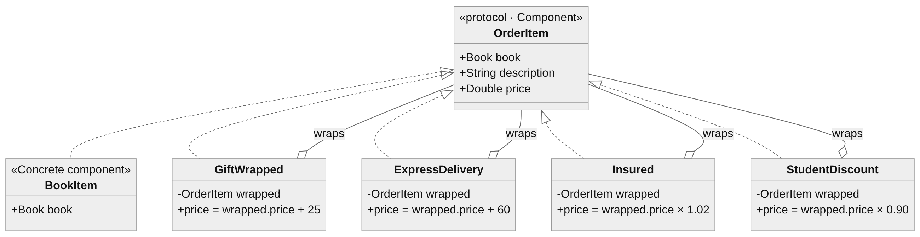
Figure 4 — Decorator class diagram
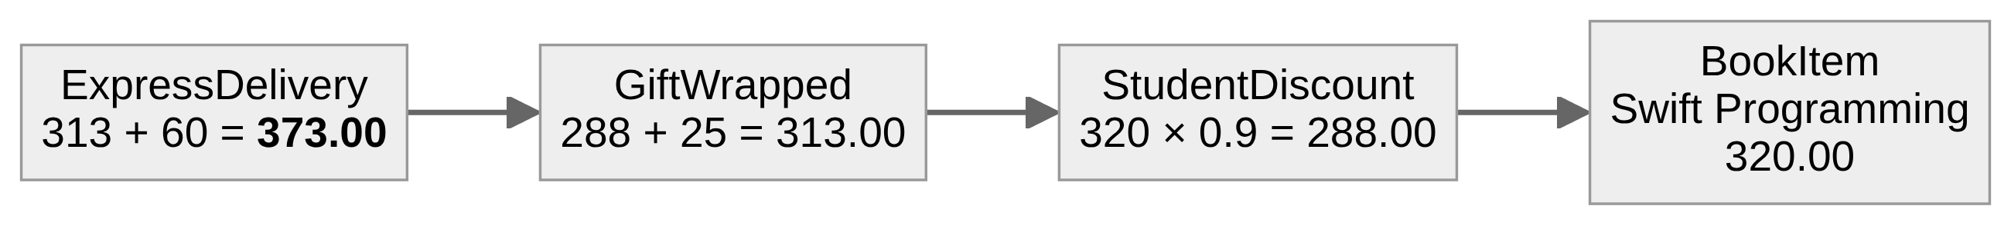
Figure 5 — Three decorators wrapped around one book (320 → 373 MDL)
Because each decorator works on the result of the wrapped item, the order matters. A discount applied after gift wrapping, (520 + 25) × 0.9 = 490.50 MDL, is not the same as one applied before it, 520 × 0.9 + 25 = 493.00 MDL. The demo and the unit tests show both cases.

3.3 Facade — CheckoutFacade
Problem
Placing an order needs five subsystems in the right order: check stock in Inventory, compute the total of the (decorated) items, charge through a PaymentProcessor, reserve the stock, create an invoice with InvoiceGenerator and send it with EmailService. Every failure must stop the process at the right point. A declined payment must not reserve stock, and an out-of-stock item must not be charged. If every screen did this itself, the logic would be duplicated and easy to get wrong.
Solution
CheckoutFacade offers one method, placeOrder(items:customer:payWith:), and runs the whole sequence behind it, returning a simple CheckoutResult (success with order number, total and transaction, or failure with a reason). The subsystems stay public, so code that needs fine control can still use them directly; the facade only makes the common case simple. The facade depends on the PaymentProcessor and OrderItem abstractions, so it works with any adapter and any combination of decorators.
// FACADE — the subsystems
//
// Placing an order touches several independent parts of the shop. Each one
// is simple on its own, but the client would have to call them in the right
// order and handle every failure in between.

/// Keeps how many copies of each book are in stock.
public final class Inventory {
private var stock: [String: Int]

public init(stock: [String: Int]) {
self.stock = stock
}

public func isAvailable(_ book: Book) -> Bool {
(stock[book.title] ?? 0) > 0
}

public func reserve(_ book: Book) {
stock[book.title] = max(0, (stock[book.title] ?? 0) - 1)
}

public func count(of title: String) -> Int {
stock[title] ?? 0
}
}

/// Builds the text of an invoice.
public struct InvoiceGenerator {
public init() {}

public func makeInvoice(number: String, customer: String, items: [OrderItem],
total: Double, paidWith: String, transactionID: String) -> String {
var lines = ["INVOICE \(number) - \(customer)"]
for item in items {
lines.append(" \(item.description): \(money(item.price))")
}
lines.append(" TOTAL: \(money(total)) (paid via \(paidWith), \(transactionID))")
return lines.joined(separator: "\n")
}
}

public struct Email: Equatable {
public let to: String
public let subject: String
public let body: String
}

/// Sends emails (here: keeps them in an outbox).
public final class EmailService {
public private(set) var outbox: [Email] = []
public init() {}

public func send(to: String, subject: String, body: String) {
outbox.append(Email(to: to, subject: subject, body: body))
}
}
Listing 7 — Subsystems (Subsystems.swift)
// FACADE
//
// CheckoutFacade gives the client ONE simple method, placeOrder(...), and
// hides the subsystems behind it: stock check, price calculation (Decorator
// items), payment (Adapter processors), stock reservation, invoice and email.
//
// The subsystems are still public. Code that needs fine control can use
// them directly; the facade only makes the common case simple.

public enum CheckoutResult: Equatable {
case success(orderNumber: String, total: Double, transactionID: String)
case failure(reason: String)
}

public final class CheckoutFacade {
private let inventory: Inventory
private let invoices: InvoiceGenerator
public let emailService: EmailService
private var lastOrderNumber = 2000

public init(inventory: Inventory,
invoices: InvoiceGenerator = InvoiceGenerator(),
emailService: EmailService = EmailService()) {
self.inventory = inventory
self.invoices = invoices
self.emailService = emailService
}

public func placeOrder(items: [OrderItem], customer: String,
payWith processor: PaymentProcessor) -> CheckoutResult {
// 1. Stock
guard !items.isEmpty else {
return .failure(reason: "the cart is empty")
}
for item in items where !inventory.isAvailable(item.book) {
return .failure(reason: "'\(item.book.title)' is out of stock")
}

// 2. Price (each item may be decorated)
let total = items.reduce(0) { $0 + $1.price }

// 3. Payment (through any adapter)
let status = processor.pay(amount: total, customer: customer)
guard case .approved(let transactionID) = status else {
if case .declined(let reason) = status {
return .failure(reason: "payment declined by \(processor.name): \(reason)")
}
return .failure(reason: "payment failed")
}

// 4. Reserve stock, number the order, invoice and notify
items.forEach { inventory.reserve($0.book) }
lastOrderNumber += 1
let number = "BK-\(lastOrderNumber)"
let invoice = invoices.makeInvoice(number: number, customer: customer, items: items,
total: total, paidWith: processor.name,
transactionID: transactionID)
emailService.send(to: customer,
subject: "Order \(number) confirmed (\(money(total)))",
body: invoice)
return .success(orderNumber: number, total: total, transactionID: transactionID)
}
}
Listing 8 — Facade (CheckoutFacade.swift)
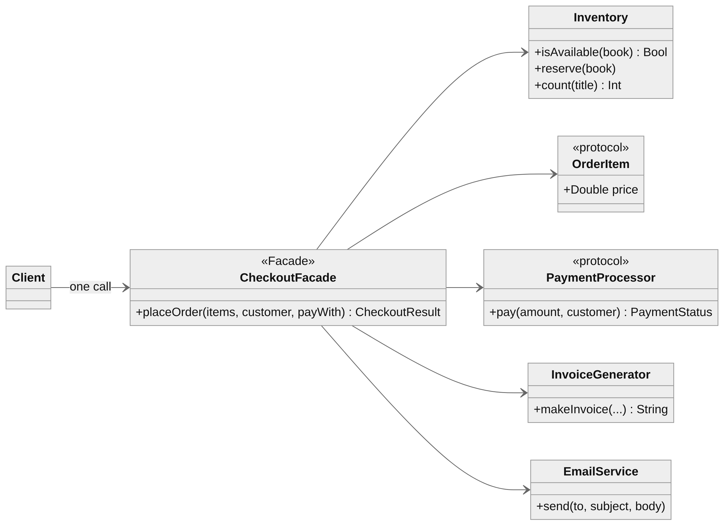
Figure 6 — Facade class diagram
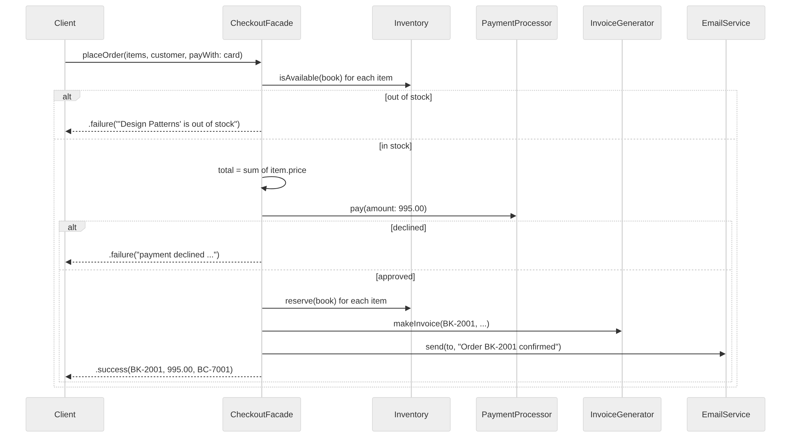
Figure 7 — Facade orchestrating the subsystems

4. Testing and results
The StructuralTests target checks each pattern with XCTest:
- Adapter — BankCardAdapter converts 873.50 MDL into exactly 87 350 bani and maps code 0 to approved and code 51 to “insufficient funds”; MPayAdapter parses the text response into approved or declined; client code works with any adapter through PaymentProcessor.
- Decorator — decorators stack (100 + 25 + 60 = 185 MDL) and keep the original book; insurance adds 2%; the order matters ((100 + 25) × 0.9 = 112.50 vs 100 × 0.9 + 25 = 115 MDL).
- Facade — a successful order reserves stock and sends one email; an out-of-stock item never calls the payment processor (checked with a spy); a declined payment reserves nothing and sends no email.
Running swift run StructuralDemo produces the output below. In the Adapter section the same two calls go to two completely different APIs. In the Decorator section prices are built from layers. In the Facade section four orders show the success path and both failure paths: Order 2 fails because the only copy of Design Patterns was sold in Order 1, and Order 4 is declined by the card limit, so its stock remains untouched.
========== ADAPTER - two foreign payment APIs behind one interface ==========
[Bank card] 873.00 MDL -> approved, transaction BC-7001
[MPay] 873.00 MDL -> approved, transaction MP-5001
[Bank card] 7500.00 MDL -> declined: insufficient funds (code 51)
[MPay] 7500.00 MDL -> approved, transaction MP-5002

========== DECORATOR - extras wrapped around a book at runtime ==========
Clean Code: 450.00 MDL
Design Patterns + gift wrap: 545.00 MDL
Design Patterns + insurance 2%: 530.40 MDL
Swift Programming - student discount 10% + gift wrap + express delivery: 373.00 MDL

The order of decorators matters:
Design Patterns + gift wrap - student discount 10%: 490.50 MDL
Design Patterns - student discount 10% + gift wrap: 493.00 MDL

========== FACADE - one call places the whole order ==========
Order 1 (augustin@example.md, Bank card): SUCCESS BK-2001, 995.00 MDL, transaction BC-7001
Order 2 (ana@example.md, Bank card): FAILED: 'Design Patterns' is out of stock
Order 3 (student@utm.md, MPay): SUCCESS BK-2002, 465.00 MDL, transaction MP-5001
Order 4 (collector@example.md, Bank card): FAILED: payment declined by Bank card: insufficient funds (code 51)

Emails sent:
To augustin@example.md: Order BK-2001 confirmed (995.00 MDL)
To student@utm.md: Order BK-2002 confirmed (465.00 MDL)

First invoice:
INVOICE BK-2001 - augustin@example.md
Clean Code: 450.00 MDL
Design Patterns + gift wrap: 545.00 MDL
TOTAL: 995.00 MDL (paid via Bank card, BC-7001)

Stock left: Clean Code 1, Design Patterns 0, Swift Programming 0, Collector's Edition 1
Listing 9 — Program output (swift run StructuralDemo)

5. The other structural patterns

5.1 Bridge
Bridge splits one large hierarchy into two independent ones, an abstraction and an implementation, connected by a reference (the “bridge”). Without it, two report types and two formats would need four classes (SalesPDF, SalesCSV, StockPDF, StockCSV), and each new format would add a class per report. With Bridge, adding a format adds one class.
protocol ReportRenderer { // implementor
func render(title: String, rows: [String]) -> String
}
struct PDFRenderer: ReportRenderer { ... }
struct CSVRenderer: ReportRenderer { ... }

class Report { // abstraction
let renderer: ReportRenderer // the bridge
init(renderer: ReportRenderer) { self.renderer = renderer }
func export() -> String { fatalError("override") }
}
final class SalesReport: Report {
override func export() -> String { renderer.render(title: "Sales", rows: [...]) }
}
SalesReport(renderer: CSVRenderer()).export()
Listing 10 — Bridge (example)
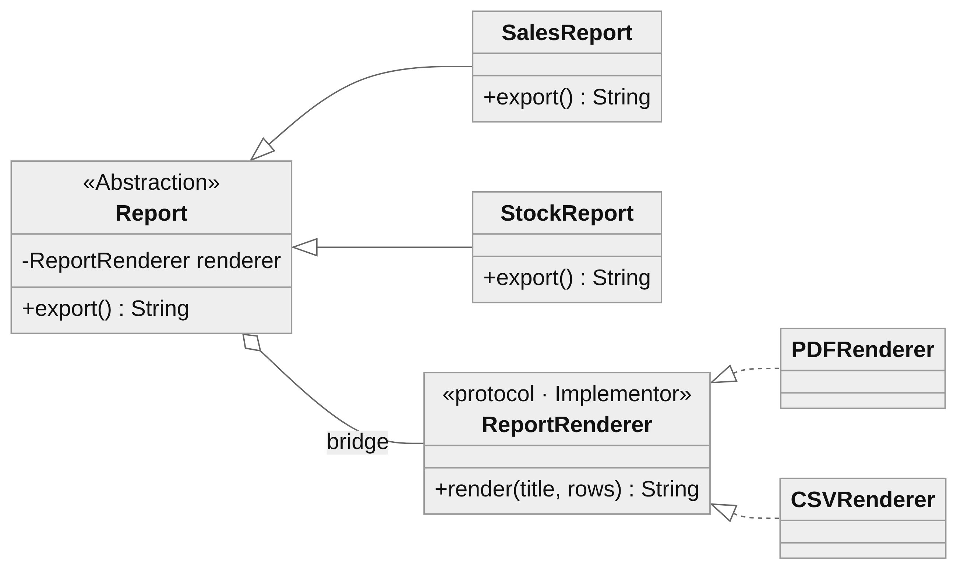
Figure 8 — Bridge

5.2 Composite
Composite lets single objects and groups of objects be treated the same way through one interface, forming a tree. A bundle of books has a price like a single book does, and a bundle can contain other bundles.
protocol CartComponent { var name: String { get }; var price: Double { get } }

struct SingleBook: CartComponent { let name: String; let price: Double } // leaf

final class BookBundle: CartComponent { // composite
let name: String
private var children: [CartComponent] = []
init(name: String) { self.name = name }
func add(_ c: CartComponent) { children.append(c) }
var price: Double { children.reduce(0) { $0 + $1.price } * 0.85 } // -15% bundle
}
let starter = BookBundle(name: "Swift starter pack")
starter.add(SingleBook(name: "Swift Programming", price: 320))
starter.add(SingleBook(name: "Clean Code", price: 450))
starter.price // 654.50, same call as for one book
Listing 11 — Composite (example)
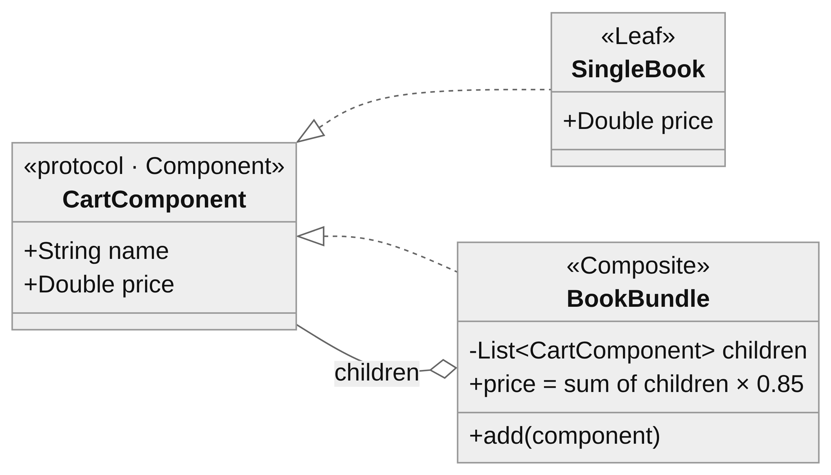
Figure 9 — Composite

5.3 Flyweight
Flyweight saves memory when there are very many similar objects. The heavy state that many objects have in common (intrinsic state) is stored once and shared. Only the small unique part (extrinsic state) is kept per object. A catalogue of 100 000 book cards from 20 publishers needs only 20 cover styles (font, logo, colours), not 100 000.
final class CoverStyle { // flyweight: shared, immutable
let font: String; let logo: Data; let colors: String
}
final class CoverStyleFactory {
private var cache: [String: CoverStyle] = [:]
func style(for publisher: String) -> CoverStyle {
if let s = cache[publisher] { return s } // reuse
let s = CoverStyle(...) // create once
cache[publisher] = s
return s
}
}
struct BookCard { let title: String; let price: Double; let style: CoverStyle }
Listing 12 — Flyweight (example)
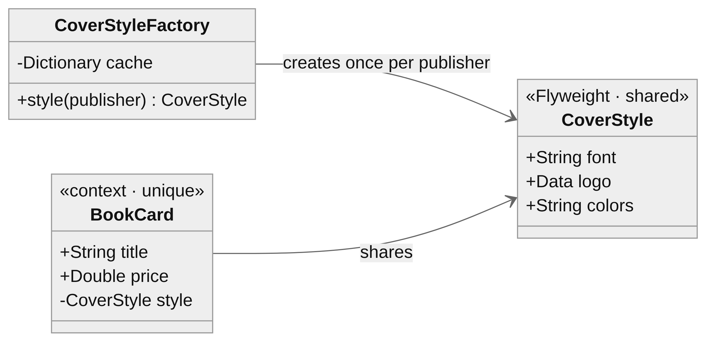
Figure 10 — Flyweight

5.4 Proxy
A Proxy has the same interface as the real object and stands in front of it to control access. It can create the real object only when it is first needed (virtual proxy), check permissions (protection proxy), cache results, log calls or talk to a remote server. The client does not notice the difference.
protocol BookPreview { func pages() -> [String] }

final class RealBookPreview: BookPreview { // expensive: downloads the PDF
func pages() -> [String] { ... }
}
final class BookPreviewProxy: BookPreview {
private lazy var real = RealBookPreview() // created only when needed
private let hasAccess: Bool
init(hasAccess: Bool) { self.hasAccess = hasAccess }
func pages() -> [String] {
hasAccess ? real.pages() : Array(real.pages().prefix(3)) // free preview: 3 pages
}
}
Listing 13 — Proxy (example)
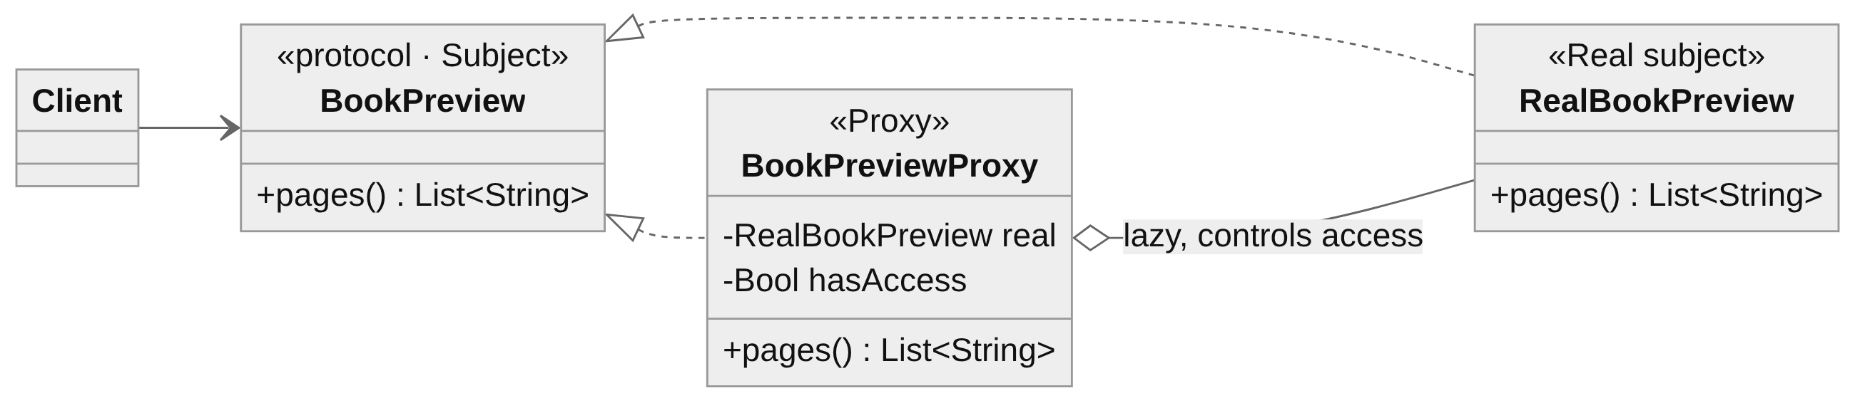
Figure 11 — Proxy
 | Adapter | Decorator | Proxy | Facade
Interface | Changes it to the one the client expects | Same as the wrapped object | Same as the real object | New, simpler one
Purpose | Make incompatible code work together | Add behaviour | Control access | Hide complexity
Wraps | One adaptee | One component (stackable) | One real subject | A whole subsystem
Table 2 — Wrapper-like patterns compared

Conclusion
In this laboratory work three structural design patterns were implemented in Swift and combined in one checkout flow of the bookstore application.
The Adapter made two third-party payment APIs with incompatible interfaces (amounts in bani with numeric codes, and amounts as text with text responses) usable through one PaymentProcessor interface, so the rest of the shop never depends on a vendor library. The Decorator replaced a combinatorial explosion of subclasses with small wrappers that are stacked at runtime. It also showed that the order of decorators can change the result. The Facade hid five subsystems behind a single placeOrder call and placed the failure handling in one place: an out-of-stock item is never charged, and a declined payment never reserves stock.
Bridge, Composite, Flyweight and Proxy were also studied. All structural patterns rely mainly on composition over inheritance: they combine objects behind interfaces so that each part can change, be added or be replaced without affecting the rest.

Bibliography
- Gamma, E., Helm, R., Johnson, R., Vlissides, J. Design Patterns: Elements of Reusable Object-Oriented Software. Addison-Wesley, 1994.
- Shvets, A. Dive Into Design Patterns. refactoring.guru, 2021.
- Apple Inc. The Swift Programming Language — Protocols, Extensions, Enumerations. docs.swift.org.
Repository: https://github.com/Afyze/tmps-2026-AugustinCarazanu/tree/main/lab2

