Fuel Fraud Detection System
Solution Design File
Prepared by Afza Imtiaz (Fizzy)
Phase 2 Deliverable — Solution Design File
Scope note
This document describes the system as implemented in the three n8n workflows delivered alongside this file (Daily Reconcile, Weekly Rollup, Real-Time Alert). It is a design and disclosure document, not new engineering.

1. System Architecture
The system is a five-stage pipeline: raw GPS data is collected from truck-mounted devices, normalized by Traccar, reconciled against driver fuel claims by n8n, stored in Google Sheets as the system of record, and surfaced through Slack and periodic reports.
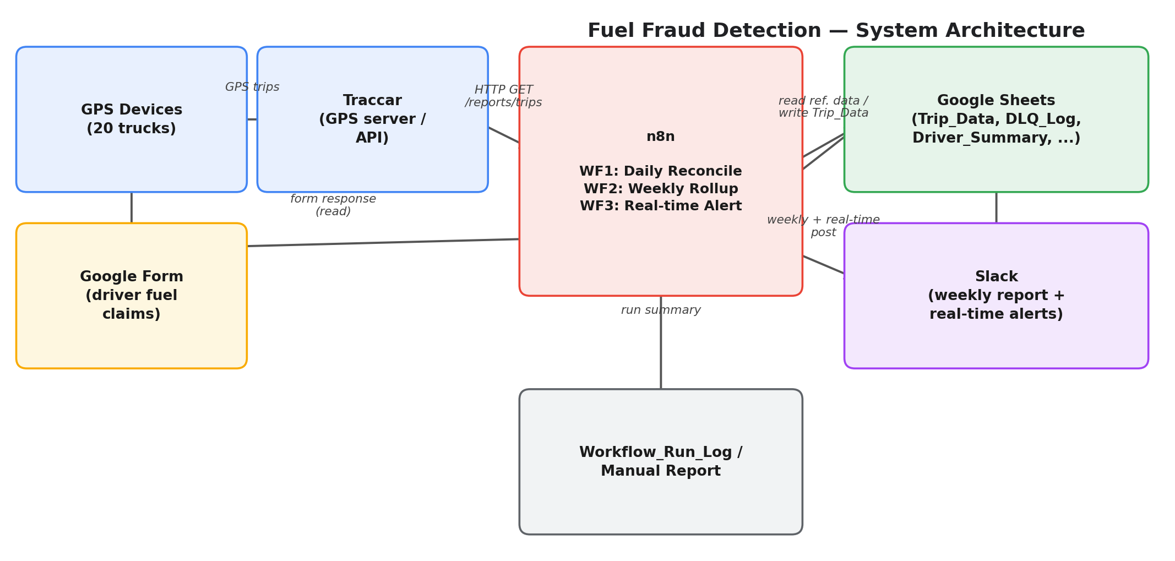

1.1 Data Flow
- GPS Devices — installed on each of the 20 trucks, continuously reporting position (and, where a fuel sensor is wired in, fuel level) to Traccar.
- Traccar — the GPS/fleet server. n8n calls its /api/reports/trips endpoint per truck per day to pull trip-level distance, duration, timestamps, and (if available) fuel consumption.
- Google Form — the driver-facing side. After each trip, the driver logs claimed distance, fuel added, route, and odometer readings.
- n8n — the orchestration layer running three workflows (see Section 3) that reconcile GPS data against form claims, compute variance, and apply risk flags.
- Google Sheets — the system of record. Nine tabs (Section 2) hold reference data, reconciled trip data, raw audit data, and run/summary logs.
- Slack — the notification layer. Weekly top-5 variance reports and real-time high-variance alerts are posted here.

1.2 Design Principles
- No silent failures: every trip that can't be matched (missing Traccar data, missing form response) is written to DLQ_Log rather than dropped.
- Idempotency: each Trip_Data row carries a Reconciliation_Key and Idempotency_Key so re-running a day's reconciliation does not create duplicate rows.
- Config-driven thresholds: fuel cost, efficiency defaults, and GREEN/AMBER/RED cutoffs live in the Config sheet, not hardcoded in workflow logic.
- Raw data preserved separately: Traccar_Trips_Raw keeps the untouched API response alongside the computed Trip_Data, so any calculation can be audited or recomputed later.

2. Google Sheets Schema
All nine tabs live in a single Google Sheet, acting as the system's database. Reference tabs (Master_Trucks, Form_Responses, Driver_ID_Lookup, Config) are maintained manually or via the Google Form; the remaining tabs are written by the workflows.

Master_Trucks
Field | Type | Description
Truck_ID | text | Unique internal truck identifier, primary key referenced by all downstream tables.
Registration | text | Vehicle registration / plate number, used in reports and Slack messages.
Traccar_Device_Name | text | Device name as registered in Traccar; used to match GPS trips back to a truck.
Traccar_Device_Id | text | Traccar's internal device ID, used to query the Traccar trips report.
Active_Flag | TRUE/FALSE | Whether the truck is currently in the reconciliation run. Inactive trucks are skipped.
Fuel_Efficiency_KmL | number | Truck-specific fuel efficiency (km per litre). Falls back to Config.Default_Truck_Fuel_Efficiency_KmL if blank.

Form_Responses
Field | Type | Description
Timestamp | datetime | Google Form submission timestamp.
Driver_ID | text | Foreign key into Driver_ID_Lookup.
Assigned_Truck_Registration | text | Truck registration as entered by the driver; matched against Master_Trucks.
Trip_Start_Date | date | Date of the trip being claimed. Matched against the GPS trip date.
Trip_Route | text | Free-text or selected route identifier.
Claimed_Trip_Distance_Km | number | Distance the driver claims to have driven.
Fuel_Added_This_Trip_Litres | number | Fuel the driver claims was added for this trip.
Start_Odometer_Reading_Km | number | Driver-entered start odometer reading (form-sourced, not GPS-sourced — see Limitations).
End_Odometer_Reading_Km | number | Driver-entered end odometer reading (form-sourced, not GPS-sourced — see Limitations).

Driver_ID_Lookup
Field | Type | Description
Driver_ID | text | Internal driver identifier used across Form_Responses and Trip_Data.
Traccar_Driver_UniqueId | text | Corresponding driver ID inside Traccar, when known.
Mapping_Status | text | CONFIRMED or PENDING — whether the Traccar identity has been verified as belonging to this driver.

Config
Field | Type | Description
Fuel_Cost_Per_Litre | number | PKR cost per litre, used to convert km variance into a PKR figure.
Default_Truck_Fuel_Efficiency_KmL | number | Fallback efficiency used when a truck has no value in Master_Trucks.
Amber_Threshold_Pct | number | Variance % below which a trip is flagged GREEN; above it, AMBER.
Red_Threshold_Pct | number | Variance % above which a trip is flagged RED.
Demo_Mode | TRUE/FALSE | When TRUE, populates odometer and idle-time fields from form data for demo purposes (see Limitations).
Demo_Idle_Time_Pct_Placeholder | number | Percentage of trip duration used to fabricate an Idle_Minutes value in Demo_Mode.
Reconciliation_Date_Override | date, optional | If set, forces the daily run to reconcile a specific date instead of 'yesterday' — used for testing/demo.

Trip_Data
Field | Type | Description
Trip_ID | text | Truck_ID + date, primary key for the row.
Trip_Date / Truck_ID / Driver_ID / Route_ID | text/date | Identifying fields carried through from the match.
Trip_Start_Timestamp / Trip_End_Timestamp | datetime | From the Traccar trip record.
GPS_Km | number | Distance reported by Traccar for the matched trip(s), in km.
GPS_Km_Source | text | Always 'TRIPS_REPORT_DISTANCE' — documents that this is Traccar's trip-report distance, not raw odometer.
GPS_Start_Odometer_Km / GPS_End_Odometer_Km | number, nullable | Only populated in Demo_Mode, and sourced from the form — not a real GPS odometer reading (see Limitations).
Claimed_Km | number | Driver's claimed distance from the form.
Variance_Km | number | Claimed_Km minus GPS_Km.
GPS_Fuel_Theoretical_Litres | number | GPS_Km divided by truck efficiency — a theoretical fuel figure, not a measured one.
Traccar_Fuel_Consumed_Litres | number, nullable | Traccar's spentFuel field. Null unless the truck has a wired fuel sensor (see Limitations).
Claimed_Fuel_Litres | number | Driver's claimed fuel added.
Fuel_Variance_Litres / Fuel_variance_pct | number, nullable | Only computable when Traccar_Fuel_Consumed_Litres is present.
Variance_Percent | number | Variance_Km as a percentage of GPS_Km.
Variance_PKR | number | Variance_Km converted to a cost figure using Config.Fuel_Cost_Per_Litre and truck efficiency.
Flag_Colour | GREEN/AMBER/RED/GREY_UNMATCHED | Risk flag derived from Variance_Percent against Config thresholds.
High_Variance_Unmatched_Alert | TRUE/FALSE | TRUE when variance exceeds the RED threshold — feeds WF3's real-time alert.
Idle_Minutes | number, nullable | Demo_Mode-only placeholder estimate, not a real telemetry value (see Limitations).
Reconciliation_Key / Idempotency_Key | text | Used to prevent duplicate rows on re-runs.
Reconciliation_Status | text | 'MATCHED' for successfully reconciled rows.

DLQ_Log
Field | Type | Description
Reason | text | Why the row failed reconciliation: NO_TRACCAR_TRIP, NO_FORM_MATCH, or a Traccar API error.
Truck / Date / Details | text | Context needed to manually investigate the failure.

Traccar_Trips_Raw
Field | Type | Description
Raw_Record_ID | text | Unique ID per raw trip record, for audit trail.
Ingested_At / Provider | datetime/text | When it was pulled, and 'TRACCAR' as the source system.
Device_Id / Registration / Traccar_Driver_UniqueId | text | Identifying fields from the raw Traccar payload.
Start_Timestamp / End_Timestamp / Trip_Distance_Meters / Duration_Seconds | various | Core trip metrics exactly as Traccar returned them.
Spent_Fuel_Litres | number | Raw fuel figure from Traccar — 0 if no sensor is present, not necessarily 'zero consumption'.
Max_Speed_Knots / Average_Speed_Knots | number | Speed metrics from Traccar, in knots.
Start_Address / End_Address | text | Reverse-geocoded addresses from Traccar.
Raw_JSON | text | Full raw trip object (truncated to 45,000 chars) for debugging.

Workflow_Run_Log
Field | Type | Description
Run_Timestamp | datetime | When the daily reconcile run executed.
Trip_Data_Count / DLQ_Count | number | Counts of successful vs. failed reconciliations for that run, for quick health checks.

Driver_Summary
Field | Type | Description
Week_Ending_Date / Driver_ID | date/text | Identifies the weekly summary row.
Total_Trips_Week | number | Trips reconciled for that driver in the week.
Total_GPS_Km_Week / Total_Claimed_Km_Week / Total_Variance_Km_Week | number | Weekly distance totals and variance.
Total_Variance_PKR_Week | number | Weekly cost of variance for that driver.
Avg_Variance_Percent_Week | number | Average variance % across the week's trips.
RED_Flag_Count_Week / AMBER_Flag_Count_Week | number | Count of flagged trips in the week.
Risk_Tier | LOW/MEDIUM/HIGH | Derived from RED_Flag_Count_Week (>=3 HIGH, >=1 MEDIUM, else LOW) — see Limitations on this threshold.

3. Workflow Descriptions

3.1 WF1 — Fuel Fraud Audit: Daily Reconcile
Trigger: daily at 8:00 PM.
Reads Master_Trucks, Form_Responses, Driver_ID_Lookup, and Config, filters to active trucks, then loops through each truck: calls Traccar for that truck's trips on the target date, matches the aggregated trip to the driver's form response for the same registration and date, and computes GPS vs. claimed distance/fuel variance, a PKR cost figure, and a GREEN/AMBER/RED flag against Config thresholds.
Unmatched trips (no Traccar data returned, or no matching form response) are written to DLQ_Log with a reason code (NO_TRACCAR_TRIP / NO_FORM_MATCH) instead of being silently skipped. Every raw Traccar trip is also archived to Traccar_Trips_Raw in parallel, independent of whether it successfully matched. At the end of the run, a summary row (counts of matched vs. DLQ rows) is written to Workflow_Run_Log.
A Reconciliation_Date_Override in Config lets this run be pointed at a specific date for testing or demo purposes, instead of always defaulting to 'yesterday'.

3.2 WF2 — Weekly Driver Summary & Slack Report
Trigger: weekly, Sunday at 7:00 AM.
Reads the week's Trip_Data rows, aggregates them per driver (total trips, total GPS/claimed km, total variance in km and PKR, average variance %, RED/AMBER flag counts), and assigns a Risk_Tier (HIGH / MEDIUM / LOW) based on how many RED-flagged trips that driver had in the week. Writes one row per driver to Driver_Summary, then posts a formatted 'Top 5 Variance Drivers' message to Slack. If there were no trips that week, it posts a no-data notice instead of a broken report.

3.3 WF3 — Real-Time High-Variance Alert
Trigger: every 5 minutes.
Polls Trip_Data for newly-added rows flagged High_Variance_Unmatched_Alert = TRUE and posts an immediate Slack alert for each. If the Slack post itself fails, the alert is written to DLQ_Log so it isn't lost silently — this is the one place the pipeline has a fallback for its own notification channel failing.

4. Known Limitations
These are disclosed explicitly and are not hidden in the implementation. Anyone deploying this system should be aware of them before relying on its outputs for disciplinary or financial decisions.

4.1 Fuel-Data Caveat
Traccar's fuel figure is not universally reliable
Traccar_Fuel_Consumed_Litres comes from Traccar's spentFuel field, which is only meaningful if the truck has a physical fuel-level sensor wired into its GPS unit. For trucks without a sensor, this value is null or zero — it does not mean zero fuel was consumed, it means no measurement exists. GPS_Fuel_Theoretical_Litres (GPS distance divided by rated efficiency) is used as the primary fuel comparison for exactly this reason, but it is a theoretical estimate, not a measured value. Any fuel-variance conclusion drawn from Traccar_Fuel_Consumed_Litres should first confirm the truck in question actually has a working fuel sensor.

4.2 Odometer-Source Caveat
There is no real GPS odometer reading in this system
GPS_Start_Odometer_Km and GPS_End_Odometer_Km are named as if they come from the GPS device, but they do not. They are populated only when Config.Demo_Mode = TRUE, and even then the values are pulled from the driver's own form submission (Start_Odometer_Reading_Km / End_Odometer_Reading_Km) — the same self-reported source the system exists to check. There is currently no independent GPS-based odometer reading feeding this system. The naming should not be read as implying GPS verification of odometer values; only GPS_Km (trip-report distance) is genuinely GPS-sourced.

4.3 Other Disclosed Limitations
- Idle_Minutes is a Demo_Mode-only placeholder (trip duration × a configurable percentage), not a real idle-time measurement from telemetry.
- Risk_Tier thresholds (RED_Flag_Count_Week ≥ 3 = HIGH, ≥ 1 = MEDIUM) are an assumption made in the absence of a specified policy, and should be reviewed/approved before being used to justify action against a driver.
- Google Sheets as the system of record does not scale well past a modest number of trucks/rows and has no row-level access control — appropriate for a pilot, not for a long-term production deployment at fleet scale.
- A single Google account owns the Sheets OAuth credential; if that account is deprovisioned, all three workflows stop functioning until credentials are re-pointed.
- Trip matching is date + registration based; a truck used for more than one trip per day, or a form submitted against the wrong date, can produce a false NO_FORM_MATCH or an incorrect match.
- There is no automated retry for Traccar API failures beyond logging to DLQ_Log — a truck with a persistent Traccar outage will show up in DLQ_Log daily until manually investigated.

5. Technical Solution Package — Folder Structure
The accompanying Technical Solution zip is organized as follows:
- /workflows/ — Fuel_Fraud_Audit_Daily_Reconcile.json, WF2.json, WF3.json (n8n exports)
- /data/ — the Google Sheets schema, exported as .xlsx, mirroring the structure in Section 2
- /simulator/ — the Python trip/GPS data simulator used to generate demo datasets
- /docs/ — this Solution Design File
Note: as of this version, the workflow exports are finalized; the xlsx schema export and Python simulator are being organized into the package and will be added as they're finalized.

