The University of Azad Jammu and Kashmir
Department of Software Engineering
Digital Image Processing Lab
Lab Task # 03 — Image Enhancement and Intensity Transformations

Field | Details
Student Name | Afzaal Ahmed
Roll Number | 2024-SE-40
Semester / Session | Fifth / 2024-28 (SE)
Lab Instructor | Engr. Fahad Nisar
Assigned On | November 02, 2026
Due Date | November 09, 2026, 11:59 PM
Files Submitted | 2024-SE-40-LAB03.docx (this report), 2024-SE-40-LAB03.ipynb, input image

Objective
To calculate, implement, and compare grayscale intensity transformations, histogram enhancement, and thresholding, while preventing overflow and interpreting the effect of each method. Every operation was first worked out by hand in a dry run on a small set of pixels, then verified in Python, and finally applied to a real grayscale photograph.

0. Image Loading and Numeric Safety
The input image is a landscape photograph (mountain, forest, lake and rocks) loaded as an 8-bit grayscale image with cv2.imread(..., cv2.IMREAD_GRAYSCALE). The notebook checks that the image is uint8, 2-D, and at least 300 × 300 pixels. A separate copy (original) is kept untouched, and all transformations are written to new arrays.
Property | Value
Shape (rows × columns) | 1254 × 1254 (1,572,516 pixels)
Data type | uint8
Minimum intensity | 0
Maximum intensity | 255
Mean intensity | 113.10
Median intensity | 118

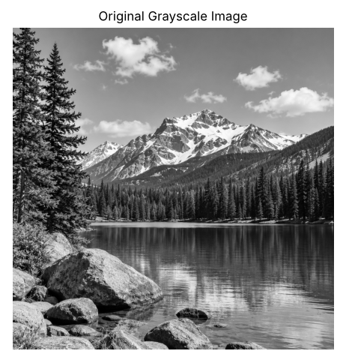
Figure 0: Original grayscale image (display range 0–255)
Numeric safety. uint8 arithmetic wraps around (for example 240 + 40 becomes 24 instead of 280). To avoid this, every operation converts the image to a wider type (int16 or float), applies the formula, clips to 0–255 with np.clip, and only then converts back to uint8. All images are displayed with cmap="gray", vmin=0, vmax=255 so that the original and processed images are compared on the same scale.

1. Brightness Adjustment
Formula: s = r + β, with β = +40 (brighter) and β = −40 (darker). Computed in int16, then clipped to 0–255.

Dry run 1
Input pixels: [30, 80, 128, 180, 240]
Pixel r | Raw r + 40 | Clipped / final (+40) | Raw r − 40 | Clipped / final (−40)
30 | 70 | 70 | -10 | 0
80 | 120 | 120 | 40 | 40
128 | 168 | 168 | 88 | 88
180 | 220 | 220 | 140 | 140
240 | 280 | 255 | 200 | 200

Lost detail: with +40, the value 280 is above the limit and is clipped to 255, so very bright pixels lose their differences. With −40, the value −10 is clipped to 0, so very dark pixels lose their differences. Clipping is a permanent loss; the original values cannot be recovered from the clipped result.
Python verification: raw +40 = [70, 120, 168, 220, 280] → [70, 120, 168, 220, 255]; raw −40 = [−10, 40, 88, 140, 200] → [0, 40, 88, 140, 200]. This matches the hand calculation.

Image result
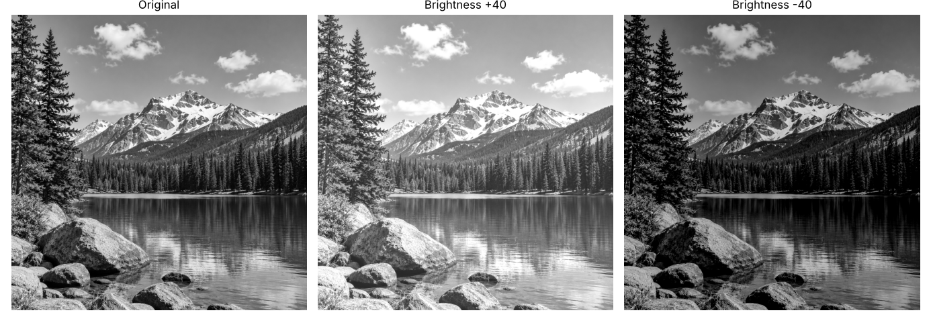
Figure 1: Original, brightness +40, brightness −40
Nested-loop check: The +40 brightness was also implemented with nested for-loops (adding 40 and capping at 255 for each pixel). The loop result matches the NumPy result exactly: True.
Observation: Brightness +40 raises the mean intensity from 113.1 to 152.3, and 84,352 pixels (5.4%) saturate at 255 (only 772 were 255 originally), so snow and cloud detail is partly flattened. Brightness −40 lowers the mean to 75.9, and 238,290 pixels (15.2%) become 0 (was 2,878), so shadow detail in the forest and rocks is lost.

2. Linear Contrast from Zero
Formula: s = αr + β with α = 1.5 and β = 0. The result is clipped to 0–255 and fractional values are truncated.

Dry run 2
Pixel r | Raw 1.5 × r | Clipped to 0–255 | Final uint8 | Saturated?
30 | 45 | 45 | 45 | No
80 | 120 | 120 | 120 | No
128 | 192 | 192 | 192 | No
180 | 270 | 255 | 255 | Yes
240 | 360 | 255 | 255 | Yes

The pixels 180 and 240 are saturated at 255, so they become identical. This means two different bright values can no longer be told apart.
Python verification: raw = [45, 120, 192, 270, 360] → final [45, 120, 192, 255, 255]. Matches.

Image result
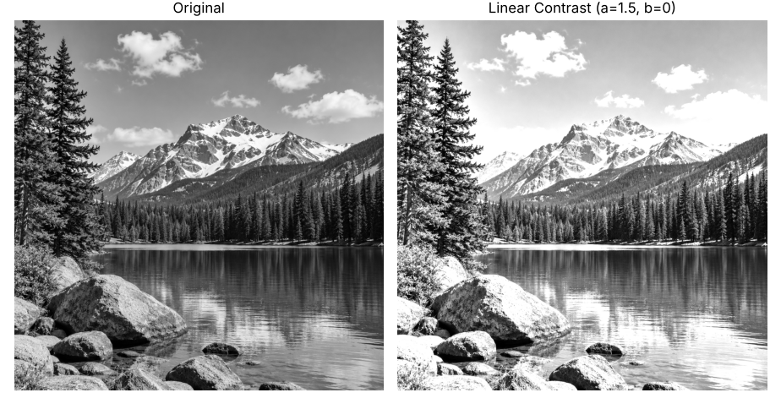
Figure 2: Original vs linear contrast (α = 1.5, β = 0)
Observation: Because the image is scaled from zero, it becomes brighter overall: the mean rises from 113.1 to 160.5. 302,783 pixels (19.3%) saturate at 255, so the sky, clouds, snow and water highlights lose detail. This operation mixes a brightness increase with a contrast increase.

3. Contrast Centered at 128
Formula: s = (r − 128)·α + 128, with α = 1.5 (more contrast) and α = 0.5 (less contrast).

Dry run 3
Pixel r | r − 128 | Raw (α = 1.5) | Final (α = 1.5) | Raw / final (α = 0.5)
30 | -98 | -19 | 0 | 79
80 | -48 | 56 | 56 | 104
128 | 0 | 128 | 128 | 128
180 | 52 | 206 | 206 | 154
240 | 112 | 296 | 255 | 184

Detailed steps for α = 1.5: (30 − 128) × 1.5 + 128 = −147 + 128 = −19 → clipped to 0; (240 − 128) × 1.5 + 128 = 168 + 128 = 296 → clipped to 255. For α = 0.5: (30 − 128) × 0.5 + 128 = −49 + 128 = 79; (240 − 128) × 0.5 + 128 = 56 + 128 = 184; no clipping is needed.
Result at r = 128: the term (r − 128) is zero, so the output is always 128 for any α. The midpoint is the fixed pivot of the transformation; values above it move up (or toward it when α < 1) and values below it move down (or toward it).
Python verification: raw α = 1.5: [−19, 56, 128, 206, 296] → [0, 56, 128, 206, 255]; α = 0.5: [79, 104, 128, 154, 184]. Matches.

Image result
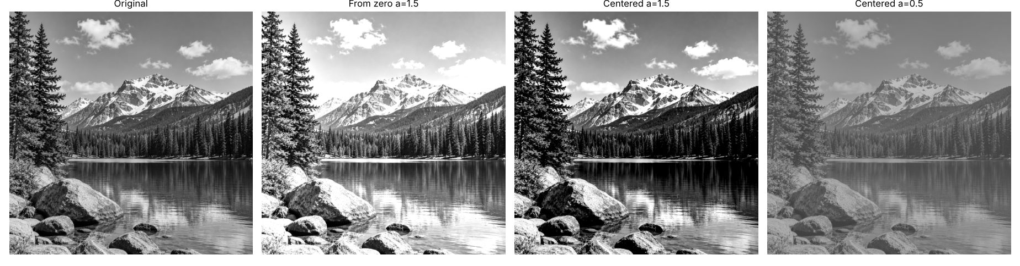
Figure 3: Original, linear from zero (α = 1.5), centered α = 1.5, centered α = 0.5
Observation: Compared with contrast from zero, the centered version keeps the overall brightness close to the original (mean 108.8 for α = 1.5 versus 160.5 for the zero-based one). It increases separation between dark and bright regions, but it clips both ends: 257,629 pixels (16.4%) go to 0 and 91,217 (5.8%) go to 255. With α = 0.5 the output range shrinks to 64–191 with mean 120.3, giving a flat, low-contrast image with no clipping.

4. Image Negative
Formula: s = 255 − r. Dark pixels become bright and bright pixels become dark.

Dry run 4
Pixel r | Negative 255 − r | Negative again 255 − (255 − r) | Same as original?
30 | 225 | 30 | Yes
80 | 175 | 80 | Yes
128 | 127 | 128 | Yes
180 | 75 | 180 | Yes
240 | 15 | 240 | Yes

Applying the negative twice gives 255 − (255 − r) = r, so the transformation is its own inverse and loses no information.
Python verification: negative = [225, 175, 127, 75, 15]; negative again = [30, 80, 128, 180, 240]. Matches.

Image result
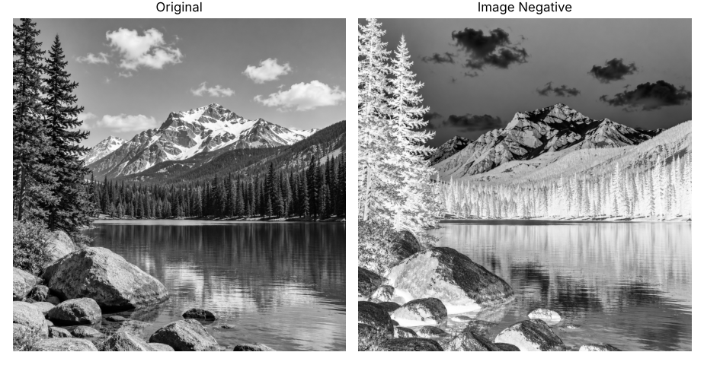
Figure 4: Original vs image negative
Where it helps: A negative can help inspection when the important structures are dark details on a bright background, for example in some medical images (such as X-rays), where subtle dark features are easier to see against light areas.
Observation: The negative swaps dark and bright regions (sky becomes dark, forest becomes light). Applying it a second time restored the original image exactly (np.array_equal = True).

5. Gamma Correction
Formula: s = 255 · (r / 255)^γ, with γ = 0.5 and γ = 2.0. Full precision is kept; only the final output is truncated to uint8.

Dry run 5
Input pixels: [0, 64, 128, 192, 255]. Step 1: normalize r/255. Step 2: raise to γ. Step 3: multiply by 255.
r | r / 255 | Power γ = 0.5 | Scaled γ = 0.5 | Final γ = 0.5 | Power γ = 2.0 | Scaled γ = 2.0 | Final γ = 2.0
0 | 0.00000 | 0.00000 | 0.0000 | 0 | 0.00000 | 0.0000 | 0
64 | 0.25098 | 0.50098 | 127.7498 | 127 | 0.06299 | 16.0627 | 16
128 | 0.50196 | 0.70849 | 180.6654 | 180 | 0.25196 | 64.2510 | 64
192 | 0.75294 | 0.86772 | 221.2691 | 221 | 0.56692 | 144.5647 | 144
255 | 1.00000 | 1.00000 | 255.0000 | 255 | 1.00000 | 255.0000 | 255

Difference from the rounded slide example: the slide example rounds intermediate values (for example 0.25 instead of 0.25098) and rounds the final answer. Here full precision is kept and the final value is truncated. For r = 64 and γ = 0.5 the exact value is 127.75, which truncates to 127 (a rounded answer would be 128). For r = 192 and γ = 2.0 the exact value is 144.56, which truncates to 144 (rounded: 145). Small differences of one gray level are therefore expected.
Endpoints: r = 0 gives 255 · 0^γ = 0 and r = 255 gives 255 · 1^γ = 255 for every γ, so black and white always stay fixed.
Python verification: γ = 0.5 → [0, 127, 180, 221, 255]; γ = 2.0 → [0, 16, 64, 144, 255]. Matches.

Image result
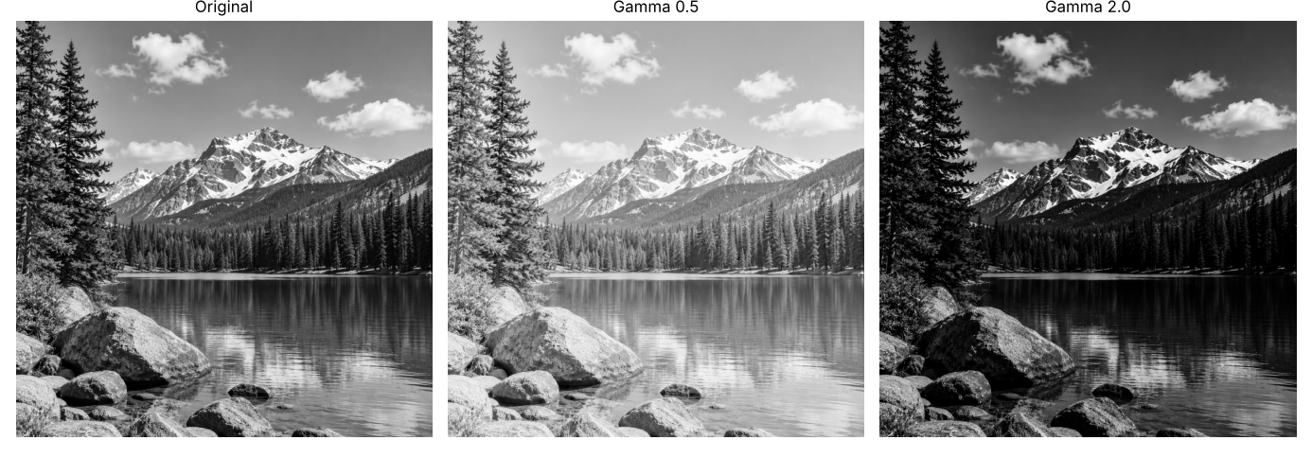
Figure 5: Original, gamma 0.5, gamma 2.0
Observation: In this convention γ < 1 brightens and γ > 1 darkens. γ = 0.5 lifts the dark forest and rock shadows (mean 113.1 → 161.0) and reveals shadow detail, but washes out the bright sky. γ = 2.0 darkens the image (mean → 64.6), compressing dark regions further and keeping contrast in the bright snow and clouds. The output minimum and maximum stayed at 0 and 255 for both γ values, confirming that 0 and 255 are fixed.

6. Grayscale Histogram
A 256-bin histogram counts how many pixels have each intensity value from 0 to 255 (cv2.calcHist).

Dry run 6
A = [[0, 50, 50, 100], [100, 150, 200, 255]] → total pixel count = 2 × 4 = 8.
Intensity | Frequency | Probability (frequency / 8)
0 | 1 | 0.125
50 | 2 | 0.250
100 | 2 | 0.250
150 | 1 | 0.125
200 | 1 | 0.125
255 | 1 | 0.125
Total | 8 | 1.000

Why a histogram does not show positions: it only counts how many pixels have each intensity. The same counts would result if the eight pixels were shuffled into any other arrangement, so the spatial layout (where the pixels are) is lost.
Python verification: np.unique gives values [0, 50, 100, 150, 200, 255] with counts [1, 2, 2, 1, 1, 1] and probabilities [0.125, 0.25, 0.25, 0.125, 0.125, 0.125]. Matches.

Image result
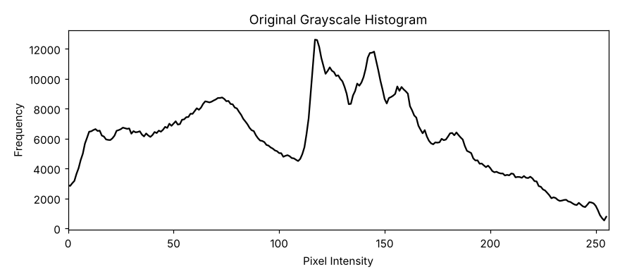
Figure 6: Histogram of the original image (256 bins, range 0–256)
Observation: The histogram is wide and covers almost the full 0–255 range, with a main peak near intensity 117 (mid-gray, mostly sky and water) and a broad hump around 60–80 for the dark forest and rocks. About 37% of pixels are in the dark range (0–85), 44% in the mid range (86–170), and 19% in the bright range (171–255), so the image has good overall contrast with a slight lean toward darker tones.

7. Global Histogram Equalization
cv2.equalizeHist remaps intensities using the cumulative distribution function (CDF) so that the output histogram is spread more evenly over 0–255.

Dry run 7
Input pixels: [50, 50, 100, 150] (4 pixels).
Intensity | Frequency | Cumulative count | CDF | Map 1: 255 × CDF | Map 2: 255 × (CDF − 0.5) / 0.5
50 | 2 | 2 | 0.50 | 127.5 → 128 | 0 → 0
100 | 1 | 3 | 0.75 | 191.25 → 191 | 127.5 → 128
150 | 1 | 4 | 1.00 | 255 → 255 | 255 → 255

CDFmin is the lowest nonzero CDF = 0.50. Rounding is to the nearest integer with .5 rounded upward.
Output list 1 (255 × CDF): [128, 128, 191, 255]
Output list 2 (with CDFmin): [0, 0, 128, 255]
Comparison with OpenCV: cv2.equalizeHist on [50, 50, 100, 150] returned [0, 0, 128, 255], which matches output list 2. The CDFmin version is the one OpenCV uses, because it maps the smallest intensity to 0 and the largest to 255.

Image result
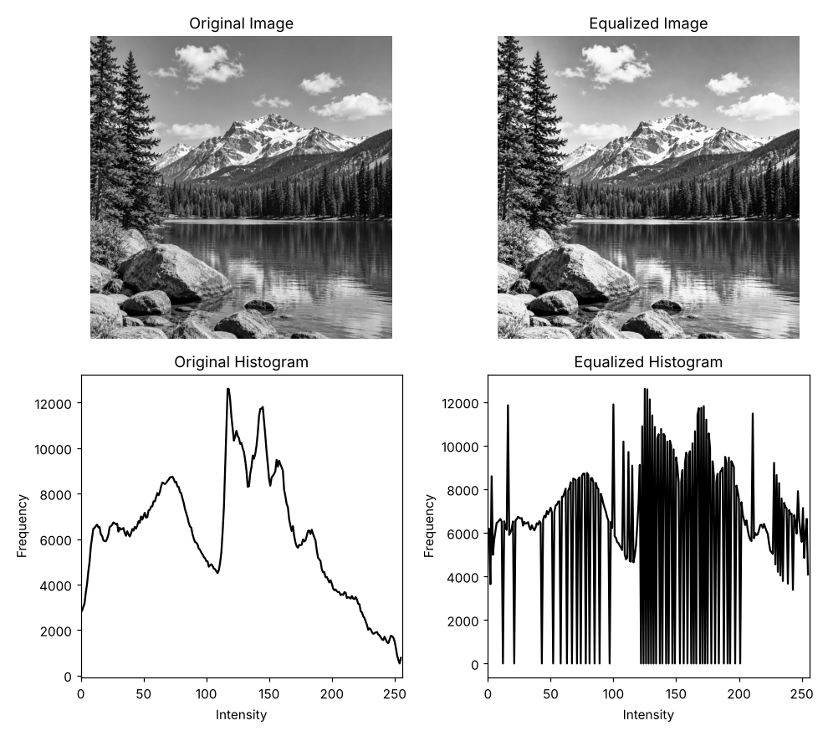
Figure 7: Original and equalized images with their histograms
Observation: Equalization spreads the intensities (mean 113.1 → 127.8, standard deviation 61.6 → 73.7) and the equalized histogram is much flatter. Detail improves in the mountain slopes, rocks and water reflections (average edge strength rises from 25.5 to 30.8). However, the stretch is applied to the whole image with one mapping, so smooth areas such as the sky and water are also stretched, which makes gradients and fine grain more visible; noise becomes stronger in flat regions.

8. CLAHE
CLAHE (Contrast Limited Adaptive Histogram Equalization) was applied with clipLimit = 2.0 and tileGridSize = (8, 8). The grid (8, 8) means 8 tile rows × 8 tile columns (64 tiles in total), not tiles that are 8 × 8 pixels. For this 1254 × 1254 image each tile is roughly 157 × 157 pixels.

Dry run 8
Four-bin histogram [6, 2, 0, 0] with an absolute bin cap of 4 (total = 8 pixels).
Step | Bin 0 | Bin 1 | Bin 2 | Bin 3 | Total
Original histogram | 6 | 2 | 0 | 0 | 8
After clipping at 4 | 4 | 2 | 0 | 0 | 6
Excess = 6 − 4 = 2; 2 / 4 = 0.5 per bin | +0.5 | +0.5 | +0.5 | +0.5 | +2
Redistributed histogram | 4.5 | 2.5 | 0.5 | 0.5 | 8
New CDF (cumulative / 8) | 0.5625 | 0.8750 | 0.9375 | 1.0000 | -

Why interpolation is needed: each tile has its own mapping. Two neighboring pixels with the same intensity but in different tiles would be mapped to different output values, producing visible blocky seams at tile borders. OpenCV blends the mappings of the nearest tiles using bilinear interpolation, so the output changes smoothly across tile boundaries.
Note: this simplified model (absolute cap, fractional redistribution) differs from OpenCV's integer redistribution, and the absolute cap of 4 is not the same as OpenCV's clipLimit = 2.0 parameter.
Python verification: clipped = [4, 2, 0, 0]; excess = 2; redistributed = [4.5, 2.5, 0.5, 0.5]; CDF = [0.5625, 0.875, 0.9375, 1.0]. Matches.

Image result
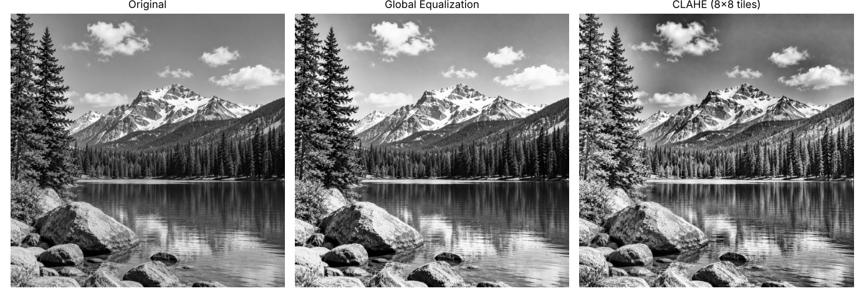
Figure 8: Original, global equalization, CLAHE (8 × 8 tile grid, clipLimit 2.0)
Observation: CLAHE produces the strongest local detail (average edge strength 36.4, versus 30.8 for global equalization and 25.5 for the original), visible in the rock texture, tree branches and snow ridges. Global equalization changes the overall tonal balance (standard deviation 73.7), while CLAHE keeps it close to the original (62.3) and enhances contrast region by region. This makes CLAHE better for uneven lighting, such as bright sky and dark forest in the same scene. The clip limit stops flat areas such as the sky from being over-stretched, though some local texture in the sky is still emphasized.

9. Fixed Binary Thresholding
Rule: cv2.THRESH_BINARY at T = 127: output 255 if r > T, otherwise 0. A pixel equal to T becomes 0.

Dry run 9
Pixel r | r > 127 ? → output (T = 127) | r > 180 ? → output (T = 180)
0 | No → 0 | No → 0
80 | No → 0 | No → 0
127 | No (equal) → 0 | No → 0
128 | Yes → 255 | No → 0
180 | Yes → 255 | No (equal) → 0
255 | Yes → 255 | Yes → 255
White pixels | 3 | 1

T = 127 gives [0, 0, 0, 255, 255, 255] with 3 white pixels; T = 180 gives [0, 0, 0, 0, 0, 255] with only 1 white pixel. A higher threshold keeps fewer pixels white.
Python verification: T = 127 → [0, 0, 0, 255, 255, 255], 3 white; T = 180 → [0, 0, 0, 0, 0, 255], 1 white. Matches.

Image result
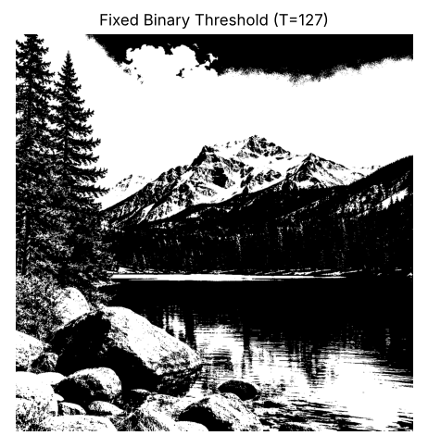
Figure 9: Fixed binary threshold (T = 127)
Unique output values: [0, 255] (only black and white). White pixels: 688,564 (43.8%).
Observation: A single threshold cannot handle the lighting variation in this photo. The sky is darker toward the top and right, so the upper-right sky turns completely black while the sky on the left turns white, even though it is the same sky. Some detail in the forest and rocks is also lost in solid black.

10. Otsu Thresholding
Rule: Otsu chooses the threshold T that maximizes the between-class variance w0·w1·(μ0 − μ1)², with classes r ≤ T and r > T. If several thresholds tie, the smallest T is chosen.

Dry run 10
Input pixels: [0, 1, 4, 5] (without rescaling), 4 pixels.
T | Class 0 (r ≤ T) | Class 1 (r > T) | w0 | w1 | μ0 | μ1 | w0·w1·(μ0 − μ1)²
0 | [0] | [1, 4, 5] | 0.25 | 0.75 | 0.0000 | 3.3333 | 2.0833
1 | [0, 1] | [4, 5] | 0.50 | 0.50 | 0.5000 | 4.5000 | 4.0000
2 | [0, 1] | [4, 5] | 0.50 | 0.50 | 0.5000 | 4.5000 | 4.0000
3 | [0, 1] | [4, 5] | 0.50 | 0.50 | 0.5000 | 4.5000 | 4.0000
4 | [0, 1, 4] | [5] | 0.75 | 0.25 | 1.6667 | 5.0000 | 2.0833

Example (T = 1): w0 = 2/4 = 0.5, w1 = 0.5, μ0 = (0 + 1)/2 = 0.5, μ1 = (4 + 5)/2 = 4.5, so variance = 0.5 × 0.5 × (0.5 − 4.5)² = 0.25 × 16 = 4.0.
The maximum value 4.0 is tied at T = 1, 2 and 3. The smallest tied value is T = 1. Predicted mask (r > 1): [0, 0, 255, 255].
Python verification: OpenCV Otsu on [0, 1, 4, 5] returned threshold 1 and mask [0, 0, 255, 255]. This matches the prediction (T = 1, mask [0, 0, 255, 255]).

Image result
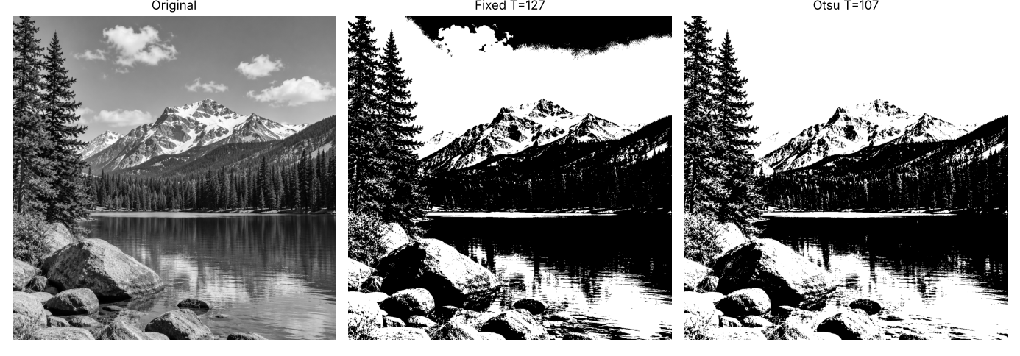
Figure 10: Original, fixed threshold (T = 127), Otsu threshold
Returned Otsu threshold for the image: T = 107. White pixels: 868,709 (55.2%), compared with 43.8% for the fixed threshold. The two masks differ in 11.5% of the pixels.
Observation: Otsu picked a lower threshold (107) than 127 based on the histogram, so more pixels become white. The whole sky is now white and the lake and forest are black, which separates the scene into a bright group and a dark group much better than the fixed threshold. It is still a global threshold, so detail inside the dark forest and shadowed rocks is lost.

11. Adaptive Gaussian Thresholding
Rule: For each pixel, the threshold is the Gaussian-weighted mean of its neighborhood minus C. Output is 255 if r > T, otherwise 0. Image settings: blockSize = 11, C = 2.

Dry run 11
Neighborhood: [[100, 100, 100], [100, 120, 140], [140, 140, 140]]; weights = [[1, 2, 1], [2, 4, 2], [1, 2, 1]] / 16.
Row | Pixels | Weights | Weighted sum
Top | 100, 100, 100 | 1, 2, 1 | 100 + 200 + 100 = 400
Middle | 100, 120, 140 | 2, 4, 2 | 200 + 480 + 280 = 960
Bottom | 140, 140, 140 | 1, 2, 1 | 140 + 280 + 140 = 560
Total |  |  | 400 + 960 + 560 = 1920

- Weighted mean: 1920 / 16 = 120
- Threshold: T = mean − 2 = 118
- Center pixel (120): 120 > 118, so the output is 255 (white).
- A pixel equal to T (118): 118 > 118 is false, so the output is 0 (black).

Python verification: weighted mean = 120.0, T = 118.0, center output = 255, equal-to-T output = 0. Matches.

Image result
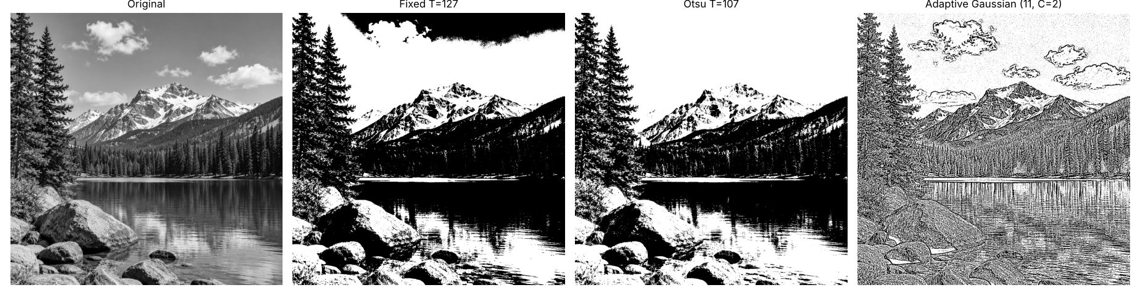
Figure 11: Original, fixed T = 127, Otsu, adaptive Gaussian (blockSize 11, C = 2)
White pixels: 991,147 (63.0%). Summary of the three thresholding methods on this image:
Method | Threshold | White pixels | Share of image
Fixed binary | 127 (global) | 688,564 | 43.8%
Otsu | 107 (global, automatic) | 868,709 | 55.2%
Adaptive Gaussian | Local (11 × 11, C = 2) | 991,147 | 63.0%

Observation: Adaptive thresholding gives a completely different result: instead of large black and white regions, it outlines local edges and textures (cloud edges, mountain ridges, tree branches, rock cracks, water ripples) because each pixel is compared only with its own 11 × 11 neighborhood. It is not affected by the brightness gradient in the sky. The drawback is that flat areas, such as clear sky, show speckle noise, because pixel values there are very close to the local mean. Local thresholds help when illumination is uneven or when the goal is to find edges, text, or fine structures rather than large regions.

12. Key Concepts

Clipping
Clipping limits pixel values to the valid 8-bit range 0–255. Values above 255 become 255 (for example 280 → 255) and values below 0 become 0 (for example −10 → 0). Clipping prevents invalid values but permanently removes detail in the clipped areas.

Overflow and safe arithmetic
A uint8 value cannot hold numbers outside 0–255, so arithmetic done directly in uint8 wraps around (240 + 40 gives 24). To be safe, the image is converted to a wider type such as int16 or float32, the operation is performed, the result is clipped to 0–255, and only then it is converted back to uint8.

Brightness versus contrast
Brightness shifts all intensity values up or down by the same amount (s = r + β). Contrast changes how far apart dark and bright values are (multiplying by α), either from zero or around a midpoint such as 128. In our results, brightness +40 shifted the whole histogram, while centered contrast α = 1.5 spread values away from 128 and α = 0.5 pulled them toward 128.

Gamma convention
This lab uses s = 255 · (r / 255)^γ. With this convention γ < 1 brightens dark and mid tones (γ = 0.5 raised the mean to 161.0), and γ > 1 darkens them (γ = 2.0 lowered the mean to 64.6). The values 0 and 255 never change.

Global versus local enhancement
Global histogram equalization uses a single mapping for the whole image; it is useful when the whole image has poor or narrow contrast, but it may amplify noise in flat areas. CLAHE works on tiles with a clip limit; it is better for uneven lighting or when local detail matters, as in our image with bright sky and dark forest.

Global versus local thresholding
Fixed and Otsu thresholding apply one threshold to the entire image. Fixed needs a manually chosen value; Otsu chooses it automatically and works best when the histogram has two clear groups (foreground and background) under even lighting. Adaptive thresholding calculates a threshold for each pixel from its neighborhood, so it is more useful when illumination changes across the image or when the target is fine detail such as text or edges.

Resolution versus bit depth
Resolution is the number of pixels in the image (here 1254 × 1254). Bit depth is the number of bits per pixel, which sets the number of intensity levels (8 bits give 256 levels, 0–255).

