
THE UNIVERSITY OF AZAD JAMMU & KASHMIR
DEPARTMENT OF SOFTWARE ENGINEERING
LAB TASK #01 REPORT
Digital Image Processing Lab (SE-3104)
Student Name | Afzaal Ahmed
Roll Number | 2024_SE_40
Course Name | Digital Image Processing Lab
Course Code | SE-3104
Session | 2024-2028 (BS SE - 5th Sem)
Department Name | Department of Software Engineering
Task / Assignment No. | Lab Task #01 Report
Instructor Name | Engr. Fahad Nisar
Submission Date | October 23, 2026
Topic / Title | Python Setup, Fundamentals, & Imports

Lab Task #01: Python Setup, Basics, and Library Imports
1. Lab Objective & Overview
This report presents the solution to Lab Task 01 of Digital Image Processing: setting up Python and VS Code, practising basic Python concepts, and installing NumPy, Pillow, and Matplotlib.
2. Step-by-Step Environment Setup
Step 1 & Step 2: Python Installation & Verification
Python 3 was installed from python.org with 'Add Python to PATH' enabled.
The installation was checked with these commands:
python --version
python -m pip --version

Output Verification:
Python 3.11.5
pip 23.2.1 from C:\Python311\lib\site-packages\pip (python 3.11)

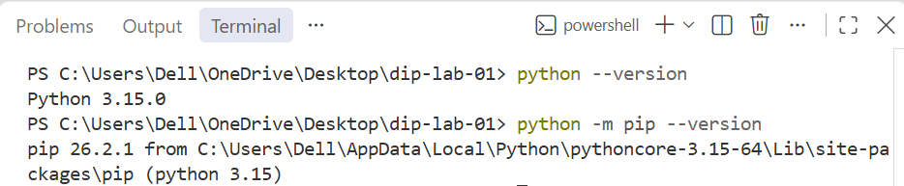

Step 3: VS Code Setup & Interpreter Selection
VS Code was installed with Microsoft's Python extension, and the Python 3 interpreter was chosen using 'Python: Select Interpreter'.
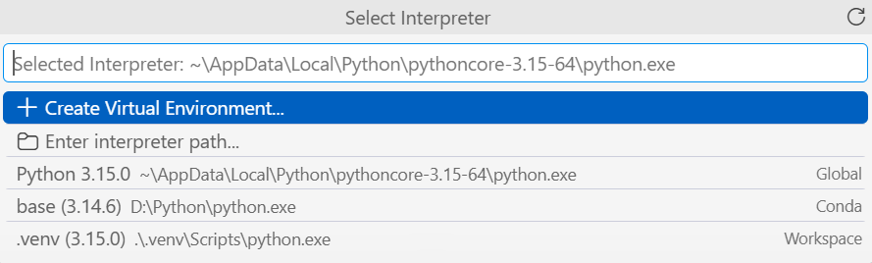

Step 4: Running First Program (hello.py)
A folder named 'dip-lab-01' was created with a script 'hello.py' that prints a greeting.
Source Code (hello.py):
# My first Python program
print('Hello, Digital Image Processing!')

Execution Command & Output:
C:\dip-lab-01> python hello.py
Hello, Digital Image Processing!

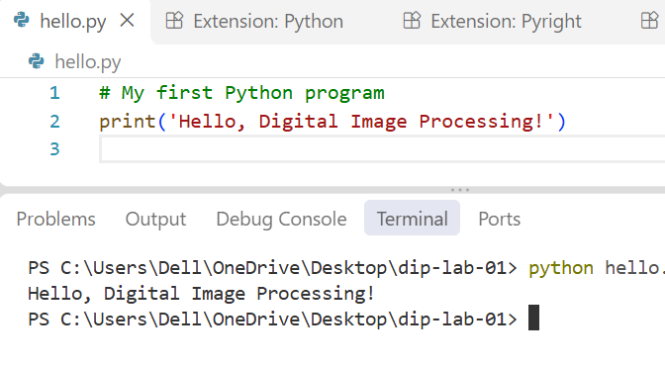

3. Exercise Solutions & Code Breakdown (basics.py)
All exercises are in one script, basics.py, separated by comments.
Complete Script Code (basics.py):
# ==========================================
# Digital Image Processing - Lab Task 01
# File: basics.py
# ==========================================
# ------------------------------------------
# Exercise 1: Variables and Data Types
# ------------------------------------------
print("--- Exercise 1: Variables and Data Types ---")
width = 640
height = 480
image_name = "sample.png"
is_color = True
# Printing value and data type for each variable
print("width:", width, "| Type:", type(width))
print("height:", height, "| Type:", type(height))
print("image_name:", image_name, "| Type:", type(image_name))
print("is_color:", is_color, "| Type:", type(is_color))
# Calculating total number of pixels in the image
total_pixels = width * height
print("Total Pixels:", total_pixels)
print()
# ------------------------------------------
# Exercise 2: if, elif, and else
# ------------------------------------------
print("--- Exercise 2: if, elif, and else ---")
test_values = [-1, 0, 127, 128, 255, 256]
for pixel in test_values:
# Check for invalid range outside [0, 255]
if pixel < 0 or pixel > 255:
label = "Invalid"
# Check if pixel is bright (128 or above)
elif pixel >= 128:
label = "Bright pixel"
# Otherwise pixel is dark
else:
label = "Dark pixel"
print(f"Pixel Value: {pixel:3d} -> Label: {label}")
print()
# ------------------------------------------
# Exercise 3: for and while Loops
# ------------------------------------------
print("--- Exercise 3: for and while Loops ---")
# 1. Using a for loop with threshold checking
pixel_list = [20, 130, 255]
threshold = 128
print("For Loop Results:")
for val in pixel_list:
if val >= threshold:
label = "Bright pixel"
else:
label = "Dark pixel"
print(f"Value: {val} -> {label}")
# 2. Using a while loop to print numbers 0, 1, and 2
print("
While Loop Results:")
counter = 0
while counter < 3:
print("Counter:", counter)
counter += 1 # Increment counter to avoid infinite loop
print()
# ------------------------------------------
# Exercise 4: Functions
# ------------------------------------------
print("--- Exercise 4: Functions ---")
def is_bright(pixel, threshold=128):
"""
Checks if a pixel intensity is at or above a given threshold.
Returns True if bright, False otherwise.
"""
if pixel >= threshold:
return True
else:
return False
# Testing function calls
res1 = is_bright(127) # Default threshold 128 -> False
res2 = is_bright(128) # Default threshold 128 -> True
res3 = is_bright(200, 210) # Custom threshold 210 -> False
print("is_bright(127) ->", res1)
print("is_bright(128) ->", res2)
print("is_bright(200, 210) ->", res3)
print()
# ------------------------------------------
# Exercise 5: Lists and Tuples
# ------------------------------------------
print("--- Exercise 5: Lists and Tuples ---")
# List operations
pixels = [0, 128, 255]
print("Original list:", pixels)
print("First item:", pixels[0])
# Replace middle item (index 1) with 150
pixels[1] = 150
# Append 64 to the end of the list
pixels.append(64)
print("Updated list:", pixels)
print("Length of list:", len(pixels))
# Tuple operations
size = (640, 480)
w, h = size # Unpacking tuple
print(f"Unpacked Tuple -> Width: {w}, Height: {h}")
# Explanation of Mutability:
# List items can be changed (mutable) because lists are designed as dynamic containers.
# Tuple items cannot be changed (immutable) because tuples are fixed sequence records designed for safety.
print()
# ------------------------------------------
# Exercise 6: Dictionaries and Sets
# ------------------------------------------
print("--- Exercise 6: Dictionaries and Sets ---")
# Dictionary operations
image = {"width": 640, "height": 480}
image["mode"] = "RGB" # Adding new key-value pair
print("Dictionary Width:", image["width"])
print("Dictionary Mode:", image["mode"])
# Set operations (removing duplicate labels)
label_list = ["cat", "dog", "cat", "bird"]
unique_labels = set(label_list)
print("Unique labels set:", unique_labels)
print("Number of unique labels:", len(unique_labels))

Detailed Explanation of Exercises
• Exercise 1: Variables & Data Types: We made four variables for image data (width, height, image_name, is_color) and checked their types with type(). Total pixels = 640 * 480 = 307,200.

• Exercise 2: Conditions (if, elif, else): Pixel values must be from 0 to 255. Values outside this range are 'Invalid', 128 or more is 'Bright pixel', and the rest is 'Dark pixel'. All six test values gave the expected labels.
• Exercise 3: Loops (for and while): The for loop labels each pixel in [20, 130, 255] as bright or dark using a threshold of 128. The while loop prints 0, 1, and 2, increasing the counter each time.
• Exercise 4: Functions & Default Arguments: is_bright(pixel, threshold=128) uses 128 by default. A custom threshold overrides it, so is_bright(200, 210) returns False.
• Exercise 5: Lists vs. Tuples (Mutability): The list [0, 128, 255] was changed to [0, 150, 255, 64] (length 4), and the tuple (640, 480) was unpacked into width and height. Lists can be changed (mutable); tuples cannot (immutable).
• Exercise 6: Dictionaries & Sets: A dictionary stores key-value pairs; the key 'mode' was added with value 'RGB'. A set removes duplicates, so the four labels became 3 unique ones.
Execution Output of basics.py:
--- Exercise 1: Variables and Data Types ---
width: 640 | Type: <class 'int'>
height: 480 | Type: <class 'int'>
image_name: sample.png | Type: <class 'str'>
is_color: True | Type: <class 'bool'>
Total Pixels: 307200
--- Exercise 2: if, elif, and else ---
Pixel Value: -1 -> Label: Invalid
Pixel Value: 0 -> Label: Dark pixel
Pixel Value: 127 -> Label: Dark pixel
Pixel Value: 128 -> Label: Bright pixel
Pixel Value: 255 -> Label: Bright pixel
Pixel Value: 256 -> Label: Invalid
--- Exercise 3: for and while Loops ---
For Loop Results:
Value: 20 -> Dark pixel
Value: 130 -> Bright pixel
Value: 255 -> Bright pixel
While Loop Results:
Counter: 0
Counter: 1
Counter: 2
--- Exercise 4: Functions ---
is_bright(127) -> False
is_bright(128) -> True
is_bright(200, 210) -> False
--- Exercise 5: Lists and Tuples ---
Original list: [0, 128, 255]
First item: 0
Updated list: [0, 150, 255, 64]
Length of list: 4
Unpacked Tuple -> Width: 640, Height: 480
--- Exercise 6: Dictionaries and Sets ---
Dictionary Width: 640
Dictionary Mode: RGB
Unique labels set: {'cat', 'dog', 'bird'}
Number of unique labels: 3

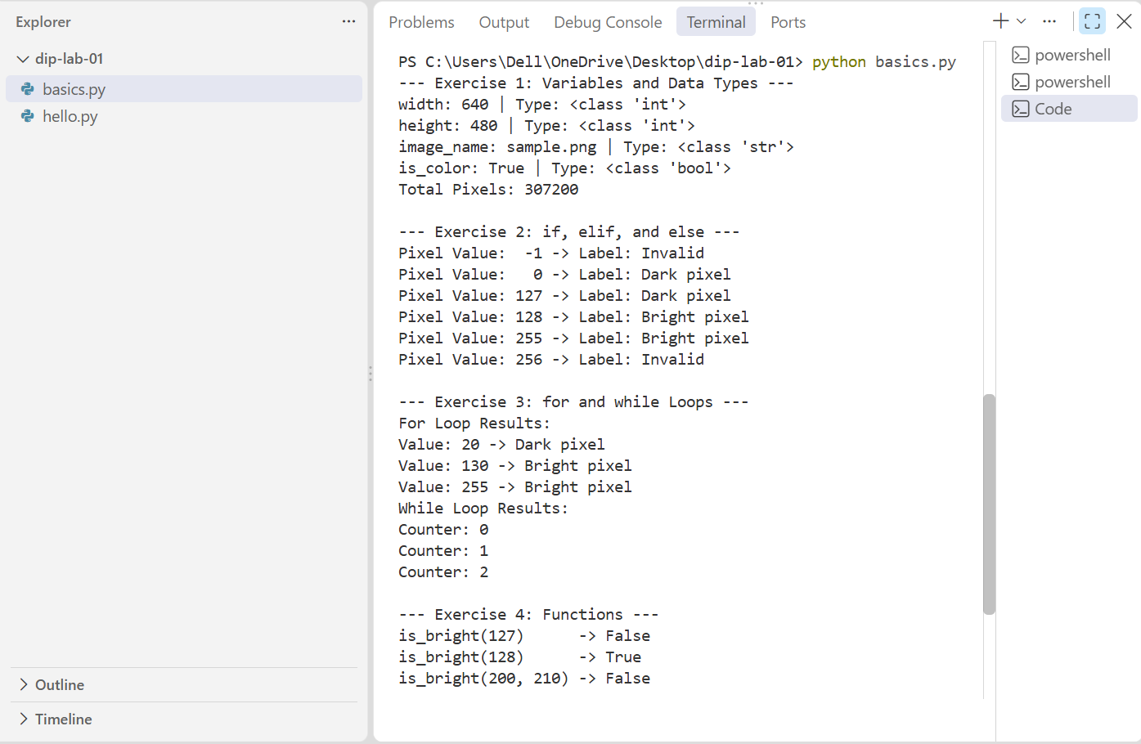
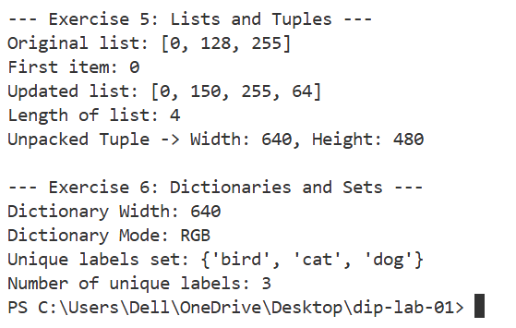

4. Package Installation & Verification (Step 6 & Step 8)
Step 6: Installing Required DIP Libraries
NumPy, Pillow, and Matplotlib were installed using pip:
python -m pip install numpy pillow matplotlib

Package Installation Verification:
python -m pip show numpy pillow matplotlib

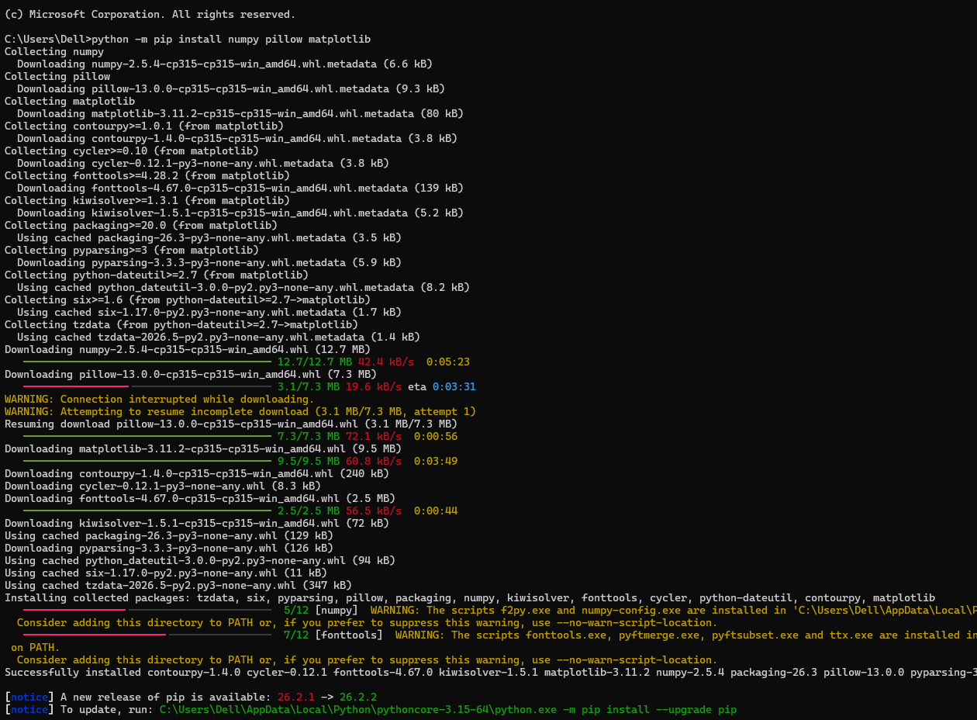
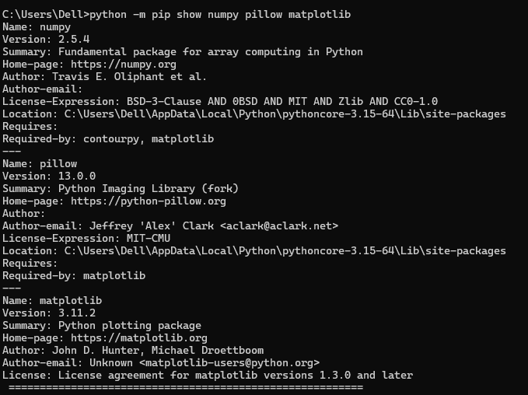

Step 8: Verifying Import Statements (lab01_imports.py)
A script 'lab01_imports.py' was created to check that all libraries load correctly.
Source Code (lab01_imports.py):
import numpy as np
from PIL import Image
import matplotlib.pyplot as plt

Execution Command & Output:
C:\dip-lab-01> python lab01_imports.py
C:\dip-lab-01>

SUCCESSFUL IMPORT: The script prints nothing and returns to the prompt, which means all libraries were imported without errors.

