
THE UNIVERSITY OF AZAD JAMMU & KASHMIR
DEPARTMENT OF SOFTWARE ENGINEERING
LAB TASK #02 REPORT
Digital Image Processing Lab (SE-3104)

Student Name | Afzaal Ahmed
Roll Number | 2024_SE_40
Course Name | Digital Image Processing Lab
Course Code | SE-3104
Session | 2024-2028 (BS SE – 5th Semester)
Department Name | Department of Software Engineering
Task / Assignment No. | Lab Task #02
Instructor Name | Engr. Fahad Nisar
Submission Date | October 31, 2026
Topic / Title | Digital Images, Pixels, Color, and Basic Transformations

Step 1: Create the Project and Virtual Environment
The following was done on Windows using VS Code (PowerShell terminal), with Python 3.13:
- Created a folder named dip-lab-02.
- Opened the folder in VS Code and created a virtual environment with python -m venv .venv.
- Activated it with .\.venv\Scripts\Activate.ps1 (the prompt now shows (.venv)).
- Installed numpy, opencv-python and matplotlib inside the environment.
- Verified the imports and the Python executable path.
- Added .venv/ to .gitignore.
Result:
Figure 1: Virtual environment activated in the VS Code terminal ((.venv))
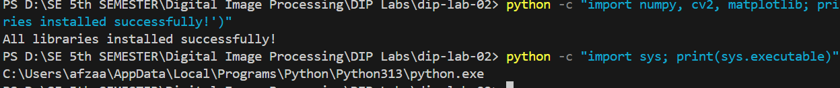
Figure 2: Imports verified and Python executable path printed
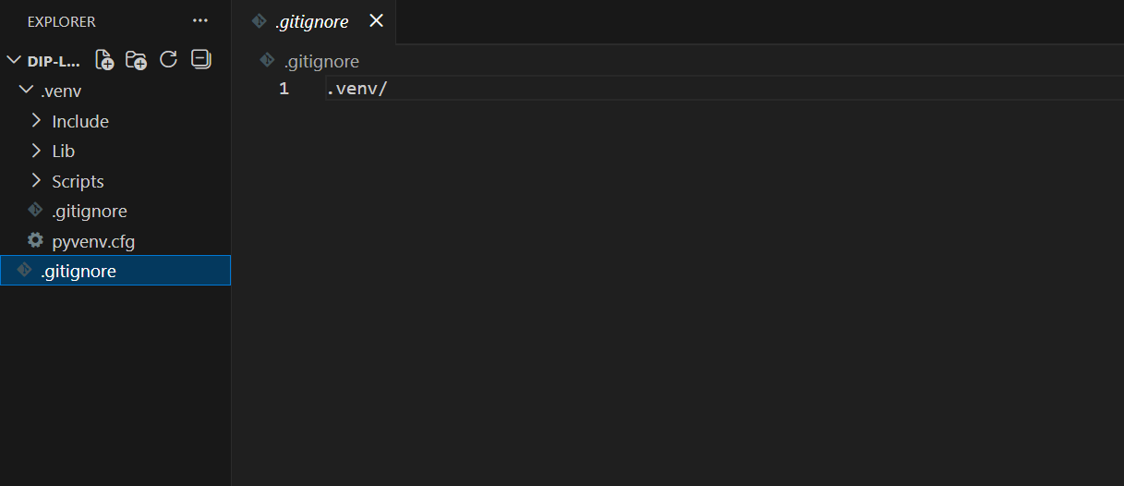
Figure 3: .gitignore containing .venv/
Commands:
mkdir dip-lab-02
cd dip-lab-02
python -m venv .venv
.\.venv\Scripts\Activate.ps1
pip install numpy opencv-python matplotlib

# Verify the imports and the Python executable
python -c "import numpy, cv2, matplotlib; print('All libraries installed successfully!')"
python -c "import sys; print(sys.executable)"

# .gitignore contains one line:
.venv/

Step 2: Load the Image
The image sample-image.jpeg was placed in the project folder and loaded with cv.imread(). If the file is missing, the script raises a FileNotFoundError.
Result:
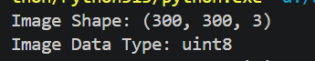
Figure 4: Image shape and data type
Code:
# IMPORTING LIBRARIES
import cv2 as cv
import numpy as np
import matplotlib.pyplot as plt

# Load the image
image = cv.imread("sample-image.jpeg")

# Check if image exists
if image is None:
raise FileNotFoundError("Image not found!")

# Print image information
print("Image Shape:", image.shape)
print("Image Data Type:", image.dtype)

Step 3: Inspect the Image
The height, width and channel count were read from image.shape. Pixels are accessed as [row, column], and the minimum and maximum values were printed for the whole image and for each channel.
Result:
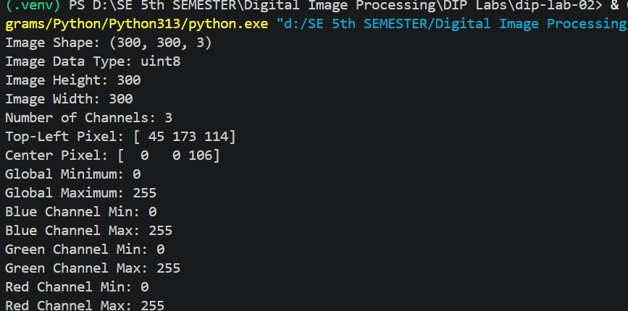
Figure 5: Dimensions, pixel values, global and per-channel minimum/maximum
Code:
# STEP 03
# Print height, width and channels
height, width, channels = image.shape
print("Image Height:", height)
print("Image Width:", width)
print("Number of Channels:", channels)

# Print top-left pixel
print("Top-Left Pixel:", image[0, 0])

# Print center pixel
center_pixel = image[height // 2, width // 2]
print("Center Pixel:", center_pixel)

# Print global minimum and maximum
print("Global Minimum:", np.min(image))
print("Global Maximum:", np.max(image))

# Print per-channel minimum and maximum
print("Blue Channel Min:", np.min(image[:, :, 0]))
print("Blue Channel Max:", np.max(image[:, :, 0]))
print("Green Channel Min:", np.min(image[:, :, 1]))
print("Green Channel Max:", np.max(image[:, :, 1]))
print("Red Channel Min:", np.min(image[:, :, 2]))
print("Red Channel Max:", np.max(image[:, :, 2]))

Explanation: OpenCV stores each pixel as [Blue, Green, Red], so index 0 is blue and index 2 is red. For an 8-bit image every value lies between 0 and 255.

Step 4: Convert Colors and Separate Channels
The image was converted from BGR to RGB for Matplotlib, converted to grayscale, and split into red, green and blue channels. All six views are shown in one 2 × 3 figure. The center pixel’s RGB value was also converted to HEX.
Result:
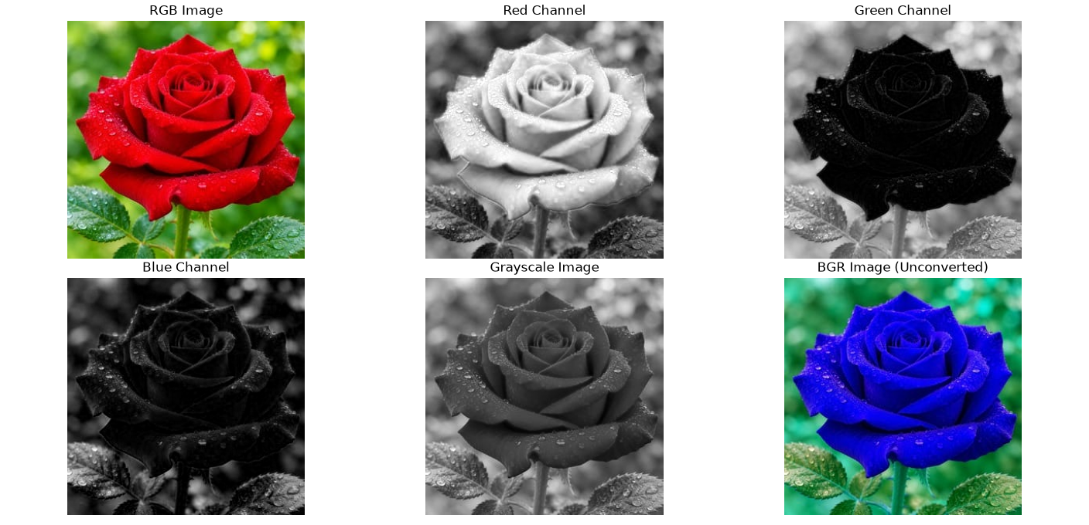
Figure 6: RGB, Red, Green, Blue, Grayscale and unconverted BGR views
Figure 7: Center pixel RGB value and its HEX code
Code:
# STEP 04
# Convert BGR to RGB
rgb_image = cv.cvtColor(image, cv.COLOR_BGR2RGB)

# Convert image to Grayscale
gray_image = cv.cvtColor(image, cv.COLOR_BGR2GRAY)

# Separate Red, Green and Blue channels
red_channel = rgb_image[:, :, 0]
green_channel = rgb_image[:, :, 1]
blue_channel = rgb_image[:, :, 2]

# Create a 2 x 3 figure
plt.figure(figsize=(12, 8))

plt.subplot(2, 3, 1)
plt.imshow(rgb_image)
plt.title("RGB Image")
plt.axis("off")

plt.subplot(2, 3, 2)
plt.imshow(red_channel, cmap="gray")
plt.title("Red Channel")
plt.axis("off")

plt.subplot(2, 3, 3)
plt.imshow(green_channel, cmap="gray")
plt.title("Green Channel")
plt.axis("off")

plt.subplot(2, 3, 4)
plt.imshow(blue_channel, cmap="gray")
plt.title("Blue Channel")
plt.axis("off")

plt.subplot(2, 3, 5)
plt.imshow(gray_image, cmap="gray")
plt.title("Grayscale Image")
plt.axis("off")

# Original BGR image shown without conversion
plt.subplot(2, 3, 6)
plt.imshow(image)
plt.title("BGR Image (Unconverted)")
plt.axis("off")

plt.tight_layout()
plt.show()

# Get center pixel RGB value
center_rgb = rgb_image[height // 2, width // 2]

# Convert RGB to HEX
hex_color = "#{:02X}{:02X}{:02X}".format(
int(center_rgb[0]),
int(center_rgb[1]),
int(center_rgb[2])
)

# Print RGB and HEX values
print("Center Pixel RGB:", center_rgb)
print("Center Pixel HEX:", hex_color)

Explanation: Matplotlib expects RGB order, but OpenCV loads images as BGR. Showing the unconverted image swaps red and blue, so the colors look wrong (see the last panel of the figure). Each channel is shown in gray: a bright area in a channel means that color is strong at that spot.

Step 5: Crop, Resize, and Save
A 100 × 100 region was cut out using image[y_start:y_end, x_start:x_end], enlarged to 200 × 200 with cv.resize(), displayed beside the original, and saved as resized_crop.png after converting back to BGR.
Result:
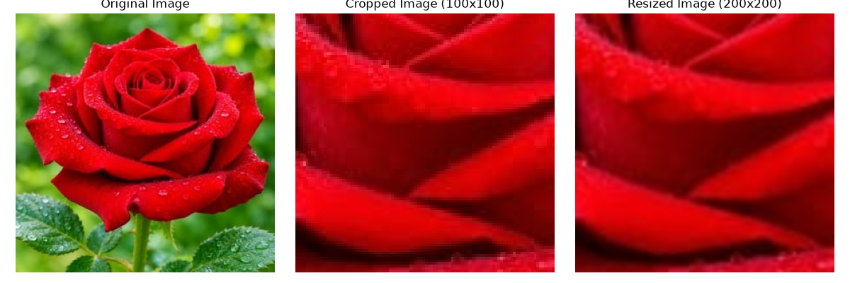
Figure 8: Original image, 100 × 100 crop and 200 × 200 resized crop
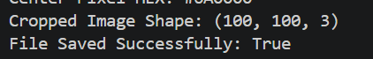
Figure 9: Crop shape and save status
Code:
# STEP 05
# Crop an exact 100 x 100 region
cropped_image = image[100:200, 100:200]

# Print crop shape
print("Cropped Image Shape:", cropped_image.shape)

# Resize crop to 200 x 200 pixels
resized_image = cv.resize(cropped_image, (200, 200))

# Convert images from BGR to RGB for Matplotlib
original_rgb = cv.cvtColor(image, cv.COLOR_BGR2RGB)
cropped_rgb = cv.cvtColor(cropped_image, cv.COLOR_BGR2RGB)
resized_rgb = cv.cvtColor(resized_image, cv.COLOR_BGR2RGB)

# Display original, cropped and resized images side by side
plt.figure(figsize=(12, 4))

plt.subplot(1, 3, 1)
plt.imshow(original_rgb)
plt.title("Original Image")
plt.axis("off")

plt.subplot(1, 3, 2)
plt.imshow(cropped_rgb)
plt.title("Cropped Image (100x100)")
plt.axis("off")

plt.subplot(1, 3, 3)
plt.imshow(resized_rgb)
plt.title("Resized Image (200x200)")
plt.axis("off")

plt.tight_layout()
plt.show()

# Convert resized RGB image back to BGR
resized_bgr = cv.cvtColor(resized_rgb, cv.COLOR_RGB2BGR)

# Save the resized crop
save_status = cv.imwrite("resized_crop.png", resized_bgr)

# Print whether the file was saved successfully
print("File Saved Successfully:", save_status)

Explanation: NumPy slicing takes rows (y) first and columns (x) second. The crop shape (100, 100, 3) confirms the exact size. cv.imwrite() expects BGR, so the RGB image was converted back before saving.

Step 6: Create a Histogram
The grayscale image was flattened into one list of pixel values and plotted as a 256-bin histogram over the range 0–256. The plot was saved as grayscale_histogram.png.
Result:
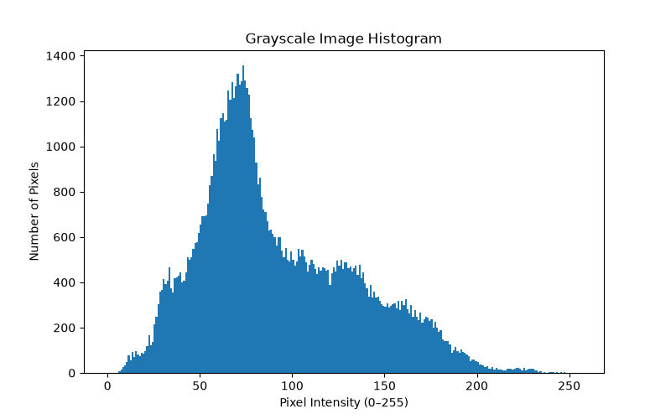
Figure 10: Grayscale histogram (256 bins, saved as grayscale_histogram.png)
Figure 11: Histogram save confirmation
Code:
# STEP 06
# Flatten the grayscale image
flattened_image = gray_image.flatten()

# Plot a 256-bin histogram (range 0-256)
plt.figure(figsize=(8, 5))
plt.hist(flattened_image, bins=256, range=(0, 256))

# Add title and axis labels
plt.title("Grayscale Image Histogram")
plt.xlabel("Pixel Intensity (0-255)")
plt.ylabel("Number of Pixels")

# Save the histogram plot
plt.savefig("grayscale_histogram.png")

# Display the histogram
plt.show()

print("Histogram saved successfully as grayscale_histogram.png")

Interpretation:
The histogram has one large peak at around 70–80 on the 0–255 scale, and most pixels lie between about 30 and 150. Very few pixels are above 200 and almost none are near 255. So the image is mainly dark to medium in brightness (it leans dark) rather than bright. This fits the picture, because the deep red rose turns into dark gray when converted to grayscale.

Step 7: Demonstrate Bit Depth
An 8-bit horizontal gradient (0 to 255) was created and reduced to 1-bit (2 levels), 2-bit (4 levels) and 4-bit (16 levels). All four are shown in one figure and their unique-value counts were printed.
Result:
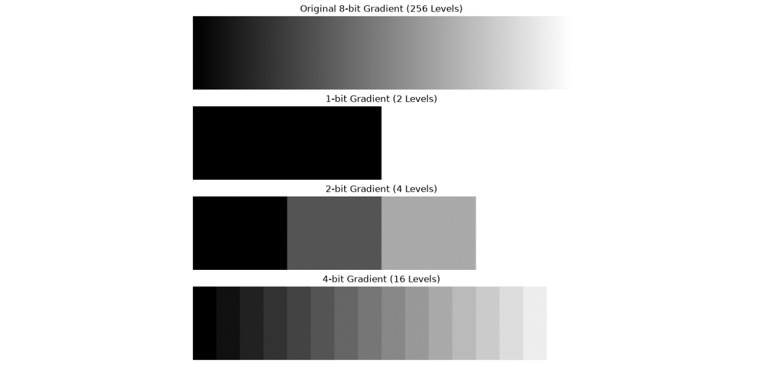
Figure 12: Original 8-bit gradient and its 1-bit, 2-bit and 4-bit versions
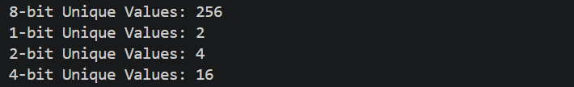
Figure 13: Unique-value counts: 256, 2, 4 and 16
Code:
# STEP 07
# Create an 8-bit horizontal grayscale gradient (0 to 255)
gradient = np.linspace(0, 255, 256, dtype=np.uint8)
gradient = np.tile(gradient, (50, 1))

# Quantize gradient to 1-bit (2 levels)
gradient_1bit = (gradient // 128) * 255

# Quantize gradient to 2-bit (4 levels)
gradient_2bit = (gradient // 64) * 85

# Quantize gradient to 4-bit (16 levels)
gradient_4bit = (gradient // 16) * 17

# Display original and quantized gradients
plt.figure(figsize=(12, 8))

plt.subplot(4, 1, 1)
plt.imshow(gradient, cmap="gray", vmin=0, vmax=255)
plt.title("Original 8-bit Gradient (256 Levels)")
plt.axis("off")

plt.subplot(4, 1, 2)
plt.imshow(gradient_1bit, cmap="gray", vmin=0, vmax=255)
plt.title("1-bit Gradient (2 Levels)")
plt.axis("off")

plt.subplot(4, 1, 3)
plt.imshow(gradient_2bit, cmap="gray", vmin=0, vmax=255)
plt.title("2-bit Gradient (4 Levels)")
plt.axis("off")

plt.subplot(4, 1, 4)
plt.imshow(gradient_4bit, cmap="gray", vmin=0, vmax=255)
plt.title("4-bit Gradient (16 Levels)")
plt.axis("off")

plt.tight_layout()
plt.show()

# Print unique-value counts
print("8-bit Unique Values:", len(np.unique(gradient)))
print("1-bit Unique Values:", len(np.unique(gradient_1bit)))
print("2-bit Unique Values:", len(np.unique(gradient_2bit)))
print("4-bit Unique Values:", len(np.unique(gradient_4bit)))

Explanation: Resolution is how many pixels the image has (width × height). Bit depth is how many different brightness values each pixel can hold (2^n levels). With fewer bits the smooth gradient breaks into visible bands.

Step 8: Complete the Project
The script lab02.py was run from the activated virtual environment and all errors were corrected. It ran successfully and created the output files listed below. When finished, the environment was closed with deactivate. The .venv folder is not included in the submission.
Result: final successful run
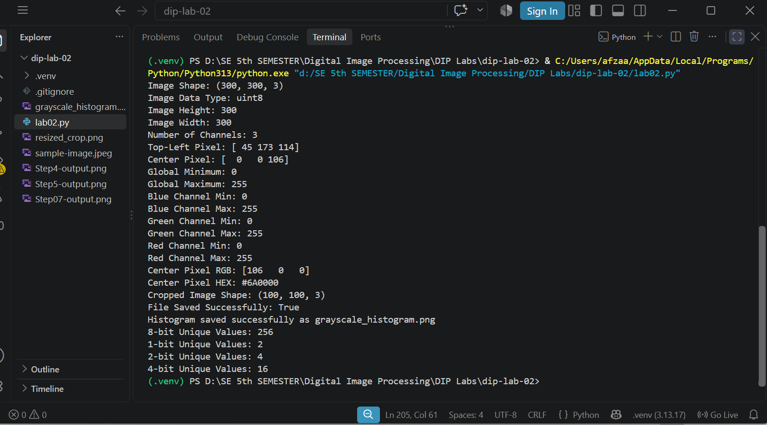
Figure 14: Final successful run of lab02.py with no errors
Submitted files:
- lab02.py
- sample-image.jpeg (input image)
- resized_crop.png
- grayscale_histogram.png
- .gitignore
- This report

Conceptual Explanations

1. BGR versus RGB
Both describe a color using three numbers: how much blue, green and red it has. The only difference is the order they are stored in. OpenCV uses BGR, so for a pixel index 0 is blue, 1 is green and 2 is red. Matplotlib and most other tools use RGB, where index 0 is red and index 2 is blue.
If a BGR image is sent straight to Matplotlib, red and blue swap places. A red object looks blue and a blue object looks red. That is why cv.cvtColor(image, cv.COLOR_BGR2RGB) is used before displaying.

2. Resolution versus Bit Depth
Resolution is the number of pixels in the image, such as 1920 × 1080. More pixels means more detail and sharper edges.
Bit depth is the number of bits used to store each pixel’s brightness, so it sets how many different shades are possible. An n-bit image has 2^n levels: 8-bit has 256, 4-bit has 16 and 1-bit has only 2. Lower bit depth gives visible bands instead of smooth shading, as Step 7 showed. In short, resolution is about how many pixels, and bit depth is about how many shades each pixel can have.

3. What a Histogram Shows and Does Not Show
A histogram counts how many pixels have each brightness value. It shows whether an image is dark, bright or balanced, and whether the contrast is low (values bunched together) or high (values spread out).
It does not show where the pixels are in the picture. Two very different images can have the same histogram. For example, a white square on a black background and a checkerboard with the same amount of black and white give identical histograms, because only the counts matter, not the positions.

