THE UNIVERSITY OF AZAD JAMMU & KASHMIR
Muzaffarabad
DEPARTMENT OF SOFTWARE ENGINEERING

LAB REPORT 02
Activity & State Diagrams
FoodPanda Swimlane, Toaster and Elevator
Student Name | Afzaal Ahmed
Roll Number | 2024-SE-40
Program / Semester | BS Software Engineering, 5th Semester (Session 2024-2028)
Course | Software Construction & Development (Lab)
Course Code | SE-3102
Instructor | Engr. Dr Asma Javaid
Lab Number | Lab 2
Topic | Swimlane Activity Diagram and State Machine Diagrams
Submission Date | October 26, 2026

Software Construction & Development (Lab) | Fall 2026

1. Objective
This lab covers two more UML diagrams. An activity diagram with swimlanes shows who does which step in a process (Q1: the FoodPanda ordering app). A state diagram shows the conditions a thing can be in and what makes it change from one to another (Q2: toaster, Q3: elevator).

2. Background in Words
Term | What it means
Swimlane | A column (or row) for one participant. Every step inside a lane is done by that participant.
Decision (diamond) | A question with two or more ways out, such as “Accept order? Yes / No”.
Connector “A” | A small circle used to continue a diagram on the next page.
State | A condition the object stays in for some time, such as “Toasting”.
entry / do / exit | Activities inside a state: what happens when entering it, while in it, and when leaving it.
Triggered transition | A change caused by an outside event, for example a person pressing a button. Drawn as a solid arrow.
Triggerless transition | A change that happens by itself when the work of the state is finished or a condition becomes true, with no outside trigger. Drawn as a dashed arrow.

3. Question 1: FoodPanda Activity Diagram with Swimlanes

3.1 Lanes
Lane | Responsibility
Customer | Logs in, browses, fills the cart, chooses address and payment, receives the food and rates it.
FoodPanda Platform | Checks the order, works out price and ETA, takes online payment, passes the order on, finds a rider.
Restaurant | Accepts or rejects the order, cooks the food and hands it to the rider.
Delivery Rider | Accepts the delivery, picks the order up and brings it to the customer.

3.2 How the process flows
- Ordering. The customer opens the app, browses menus, adds items and confirms address and payment method. The platform validates the address and calculates the total and delivery time.
- Payment decision. If the customer pays online, the platform charges the card or wallet; if the payment fails, the customer retries or picks another method. Cash on delivery skips this step.
- Restaurant decision. The restaurant gets the order and either accepts it or rejects it. A rejection cancels the order, refunds any online payment and informs the customer.
- Parallel work. Once accepted, the restaurant cooks while the platform finds the nearest rider, so both happen at the same time.
- Delivery. The rider collects the packed order, delivers it, the customer receives it (and pays if cash), and the platform asks for a rating.
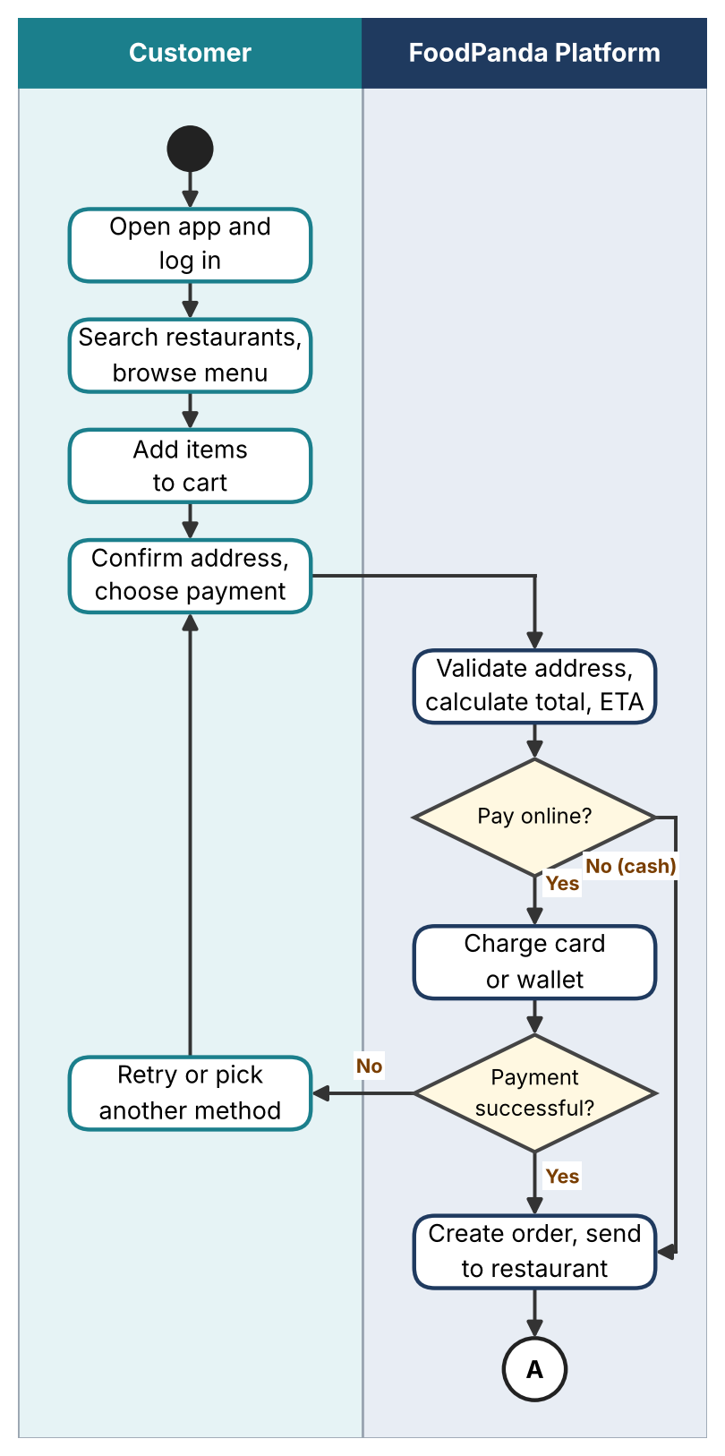
Figure 1(a): FoodPanda swimlane diagram, ordering and payment (continues at connector A)
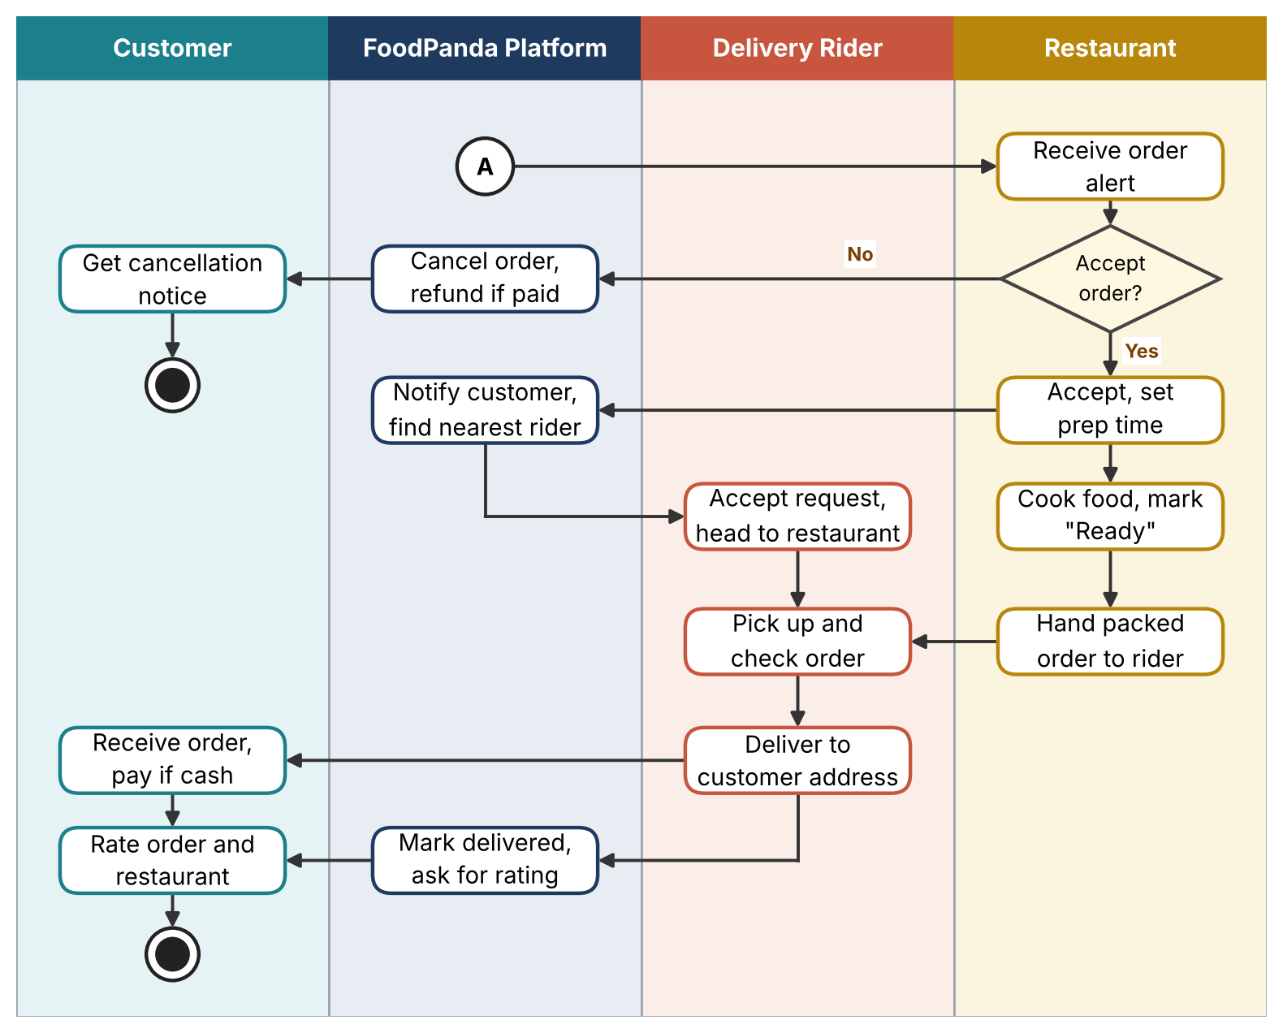
Figure 1(b): FoodPanda swimlane diagram, restaurant, rider and delivery (continues from connector A)

4. Question 2: Toaster State Diagram

4.1 States and their activities
State | Meaning | Activities
Idle (Off) | Plugged in, nothing happening. | entry / heater off, latch released  do / wait for bread to be inserted
Bread Loaded | Bread sits in the slots, lever still up. | entry / bread rests on carriage  do / read browning dial setting
Toasting | Lever is down and locked, heater is on. | entry / lever locks, heater on  do / heat bread, run timer  exit / heater off
Popped Up | Toasting finished, carriage lifted. | entry / spring lifts carriage  do / ring bell (optional)

4.2 Triggered and triggerless events
Transition | Type | Explanation
Idle → Bread Loaded: insert bread | Triggered | The user puts bread into the slots.
Bread Loaded → Idle: remove bread | Triggered | The user takes the bread out again.
Bread Loaded → Toasting: push lever down | Triggered | The user presses the lever.
Toasting → Popped Up: cancel button | Triggered | The user stops the toasting early.
Toasting → Popped Up: timer finished | Triggerless | Happens by itself when the set time runs out.
Toasting → Popped Up: overheat cut-out | Triggerless | Happens by itself when the thermal safety switch detects too much heat.
Popped Up → Idle: take toast out | Triggered | The user removes the toast.
Idle → end: unplug | Triggered | The user disconnects power.
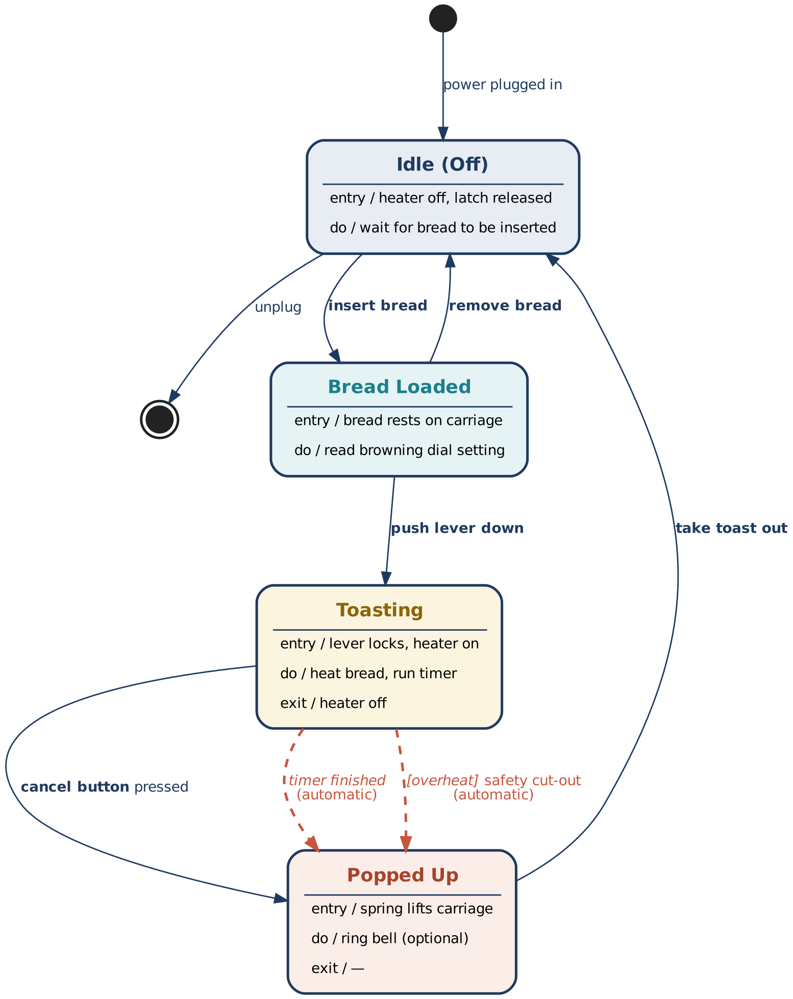
Figure 2: State diagram of a toaster (solid arrows = triggered, dashed = triggerless)

5. Question 3: Elevator / Lift State Machine

5.1 States
State | Meaning | Activities
Idle | Waiting at a floor, doors closed. | do / wait for calls  do / choose the nearest call
Doors Opening | Doors are sliding open. | entry / start door motor  exit / stop door motor
Doors Open | Passengers get in and out. | entry / start 5 s timer  do / keep doors open, watch sensor
Doors Closing | Doors are sliding shut. | entry / start door motor  do / watch obstruction sensor
Moving | Car travels up or down. | entry / release brake, start motor  do / go up or down, count floors  exit / begin slowing down
Stopping at Floor | Car slows and lines up with the floor. | do / slow down, align with floor  exit / apply brake
Overloaded | Too much weight inside. | entry / sound buzzer, show message  do / hold doors open
Emergency Stop | A fault or the emergency button stopped the car. | entry / apply emergency brake  do / sound alarm, call help

5.2 Transitions
From → To | Event or condition | Type
Idle → Doors Opening | Call for the current floor | Triggered
Idle → Moving | Call from another floor | Triggered
Doors Opening → Doors Open | Doors fully open | Triggerless
Doors Open → Doors Closing | 5 s timer ends, or close button | Triggered
Doors Closing → Doors Opening | Obstruction detected, or open button | Triggered
Doors Closing → Idle | Doors locked and no calls waiting | Triggerless
Doors Closing → Moving | Doors locked and a call on another floor | Triggerless
Moving → Stopping at Floor | Floor sensor of the target floor reached | Triggerless
Stopping at Floor → Doors Opening | Car level with the floor | Triggerless
Doors Open → Overloaded | Weight above the limit | Triggered
Overloaded → Doors Open | Weight back within the limit | Triggered
Moving → Emergency Stop | Emergency button or safety fault | Triggered
Emergency Stop → Idle | Technician reset | Triggered

5.3 Safety rule built into the design
The car can only enter Moving from Doors Closing after the doors are closed and locked, and it can only open its doors after it has stopped at a floor. Because the diagram has no arrow from any door state straight to Moving, or from Moving straight to Doors Opening, these rules are enforced by the structure itself.
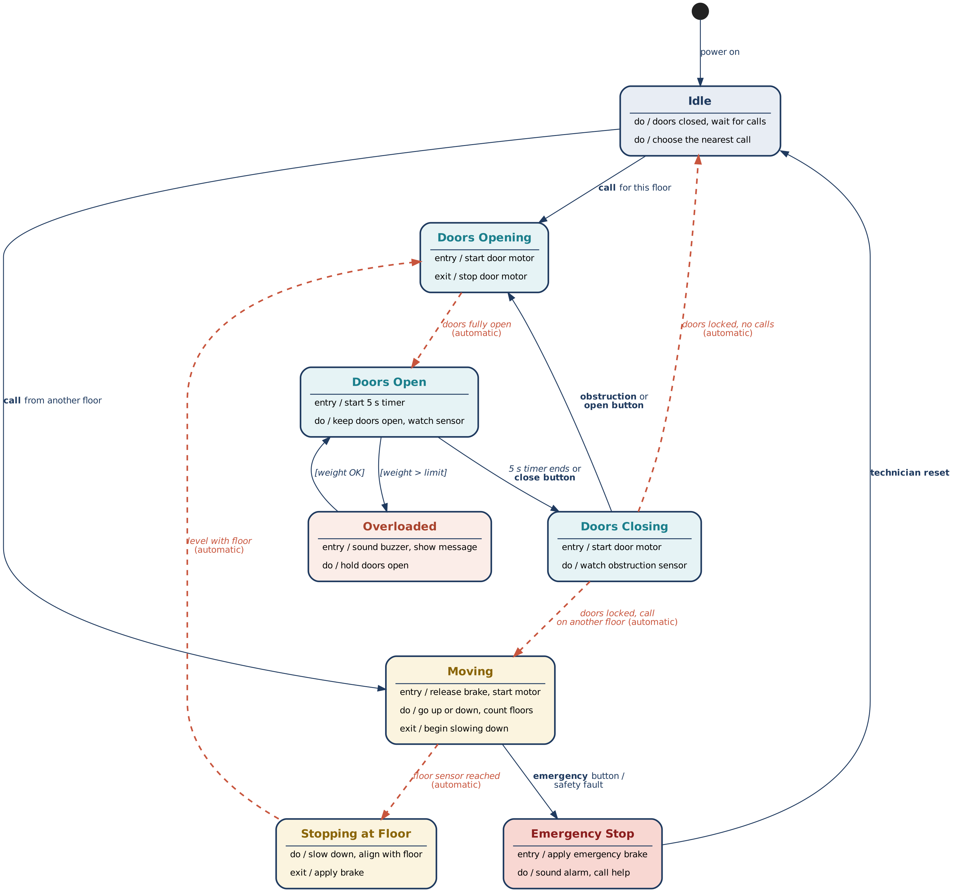
Figure 3: State machine diagram of an elevator (solid arrows = triggered, dashed = triggerless)

6. Conclusion
Swimlanes make it clear who is responsible for each step of a process, and state diagrams make it clear what an object can do at any moment and what moves it to the next state. Separating triggered transitions (caused from outside) from triggerless ones (happening on their own) also helps spot which behaviour depends on users and which on the system itself.

