THE UNIVERSITY OF AZAD JAMMU & KASHMIR
Muzaffarabad
DEPARTMENT OF SOFTWARE ENGINEERING

LAB REPORT 01
Use Case Diagrams
Online Ticket Reservation and Credit Card Processing
Student Name | Afzaal Ahmed
Roll Number | 2024-SE-40
Program / Semester | BS Software Engineering, 5th Semester (Session 2024-2028)
Course | Software Construction & Development (Lab)
Course Code | SE-3102
Instructor | Engr. Dr Asma Javaid
Lab Number | Lab 1
Topic | UML Use Case Diagrams
Submission Date | October 26, 2026

Software Construction & Development (Lab) | Fall 2026

1. Objective
The goal of this lab is to learn how to describe what a system should do, without worrying yet about how it will be built. We do this with UML use case diagrams. Two systems are modelled: an online ticket reservation system (Q1) and a credit card processing system (Q2). For each one we find the actors, list the use cases, and draw the diagram.

2. Background
Term | What it means | Example
Actor | Someone or something outside the system that uses it or is used by it. | Passenger, Payment Gateway
Use case | One useful goal that an actor wants to achieve with the system. Drawn as an oval. | Book ticket
System boundary | The rectangle that separates what is inside the system from what is outside. | The reservation system box
Association | A plain line showing that an actor takes part in a use case. | Passenger — Search trips
«include» | The base use case always needs the other one to finish. The arrow points to the included use case. | Book ticket always includes Make payment
«extend» | An optional use case that only happens in some situations. The arrow points to the base use case. | Receive refund extends Cancel booking

3. Question 1: Online Ticket Reservation System

3.1 How the system works
A passenger opens the website or app, registers or logs in, searches for trips by route and date, picks a seat, pays, and then downloads the e-ticket. If plans change, the passenger can cancel and get money back. Behind the scenes, an administrator keeps the routes, schedules and fares up to date and looks at sales reports. Payments are handled by an outside bank service.

3.2 Actors
Actor | Type | What they do
Passenger | Primary | Registers, searches trips, books and cancels tickets, downloads the e-ticket.
Admin | Primary (back office) | Manages routes and schedules, sets fares, views sales reports.
Payment Gateway | External system | Approves the card payment and sends back refunds.

3.3 Use cases
No. | Use case | Description | Actor
UC1 | Register / Log in | Create an account or sign in so bookings are linked to the passenger. | Passenger
UC2 | Search trips | Find available trips using origin, destination and travel date. | Passenger
UC3 | Book ticket | Main goal: reserve a seat on a chosen trip. | Passenger
UC4 | Choose seat | View the seat layout and pick a free seat. Part of every booking. | Passenger
UC5 | Make payment | Pay for the booking. The bank approves or rejects it. | Payment Gateway
UC6 | Cancel booking | Cancel a confirmed reservation. | Passenger
UC7 | Receive refund | Money is returned after a cancellation (only when the booking was paid). | Payment Gateway
UC8 | Download e-ticket | Save or print the confirmed ticket. | Passenger
UC9 | Manage routes & schedules | Add, change or remove routes and departure times. | Admin
UC10 | Set fares | Update ticket prices. | Admin
UC11 | View sales reports | Check bookings and income over a period. | Admin

3.4 Relationships
- Book ticket «include» Choose seat: a booking is not complete without a seat.
- Book ticket «include» Make payment: every booking needs a payment step.
- Receive refund «extend» Cancel booking: a refund happens only if the cancelled ticket had been paid for, so it is optional.
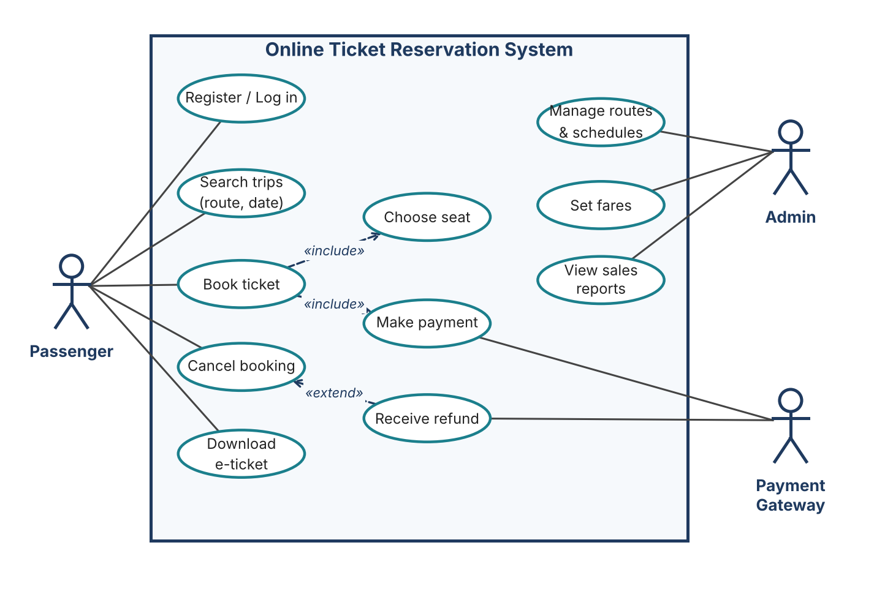
Figure 1: Use case diagram of the Online Ticket Reservation System

4. Question 2: Credit Card Processing System

4.1 Reading the case study
In a shop, the customer chooses an item and wants to pay by credit card. The vendor makes the bill, takes the card and swipes it. The card machine does the transaction, keeps the credit limit in check, and prints a receipt or balance statement. The vendor gives the statement to the customer, who signs the receipt and hands it back.

4.2 Actors
Actor | Type | What they do
Customer | Primary | Chooses the item, gives the card, signs the receipt.
Vendor | Primary | Makes the bill, swipes the card, issues the statement, collects the signed receipt.
Credit Card Machine | External system / device | Processes the transaction, checks the credit limit, prints the receipt.

4.3 Use cases
No. | Use case | Description | Actor
UC1 | Select item | Customer picks the item to buy. | Customer
UC2 | Hand over credit card | Customer gives the card to the vendor for payment. | Customer
UC3 | Prepare bill | Vendor prepares the bill for the chosen item. | Vendor
UC4 | Swipe card | Vendor swipes the card in the reader. | Vendor
UC5 | Process transaction | The machine carries out the required amount transaction. | Credit Card Machine
UC6 | Check credit limit | The machine makes sure the amount does not pass the card limit. | Credit Card Machine
UC7 | Print receipt / statement | The machine prints the receipt and balance statement. | Credit Card Machine
UC8 | Issue balance statement | Vendor gives the printed statement to the customer. | Vendor
UC9 | Sign receipt | Customer signs the receipt. | Customer
UC10 | Collect signed receipt | Vendor takes back the signed receipt. | Vendor

4.4 Relationships
- Swipe card «include» Process transaction: swiping always leads to a transaction.
- Process transaction «include» Check credit limit: no transaction goes through without this check.
- Issue balance statement «include» Print receipt / statement: the vendor can only hand over what the machine has printed.
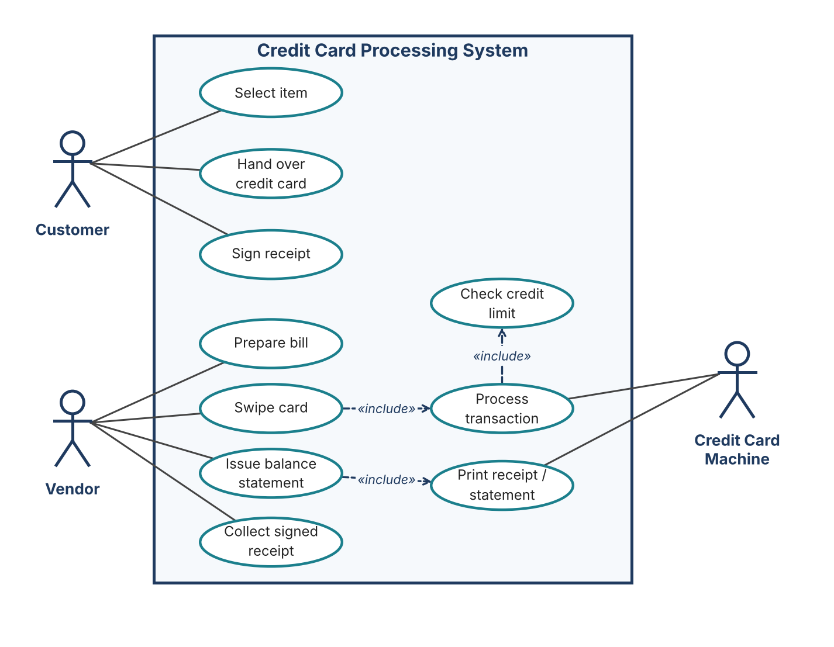
Figure 2: Use case diagram of the Credit Card Processing System

5. Conclusion
Use case diagrams give a quick, non-technical picture of who uses a system and for what. In both examples the actors were found by asking “who or what is outside the system and interacts with it?”, and the use cases by asking “what does each actor want to achieve?”. Using «include» for steps that always happen and «extend» for optional ones keeps the diagrams short and easy to read.

