AI ASSISTED CODING LAB
ASSIGNMENT 12.2
ENROLLMENT NO :2503A51L15
BATCH NO: 19
NAME: MOHAMMAD KHAJA AFZALUDDIN

TASK1
TASK1 DESCRIPTION:-
- Use AI to generate a Python program that implements the Merge Sort algorithm.
- Instructions:
  - Prompt AI to create a function merge sort(art) that sorts a list in ascending order.
  - Ask AI to include time complexity and space complexity in the function docstring.
  - Verify the generated code with test cases.

PROMPT:-
Generate a python program with merge_sort(art) implementing Merge Sort, include docstring with time/space complexity, do not modify input, and add simple tests/examples under __main__.

CODE:-

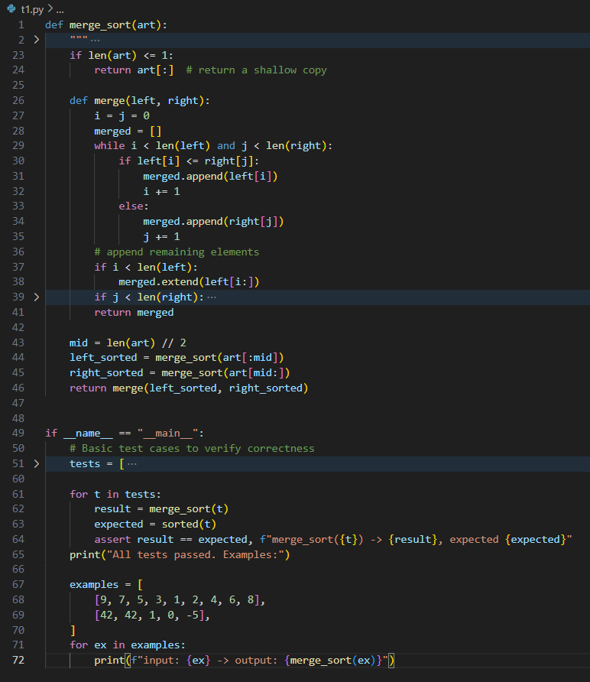

OUTPUT:-
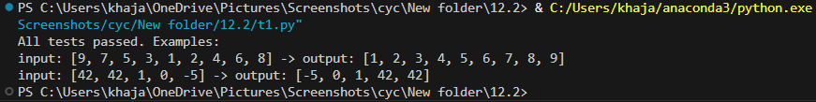
OBSERVATION:-
In this task AI generated merge_sort(art) along with a clear docstring that explains the algorithm and states time (O(n log n)) and space (O(n)) complexity. The implementation returns a new sorted list without modifying the input and includes basic tests and example prints to verify correctness (empty list, single element, duplicates, negatives). This demonstrates how AI can quickly produce both working logic and useful documentation, plus ready-made tests so the implementation can be validated immediately.

TASK2
TASK2 DESCRIPTION:-
- Use AI to create a binary search function that finds a target element in a sorted list.
- Instructions:
  - Prompt AI to create a function binary search (art, target) returning the index of the target or -1 if not found.
  - Include docstrings explaining best, average, and worst-case complexities.
  - Test with various inputs.

PROMPT:-
Create a Python program that implements binary_search(art, target): the function should assume art is sorted in ascending order and return the index of target or -1 if not found, include a docstring explaining the algorithm and best/average/worst-case time complexities and space complexity, use an iterative approach, and include varied tests/examples under if name == "main" to validate behavior.

CODE:-
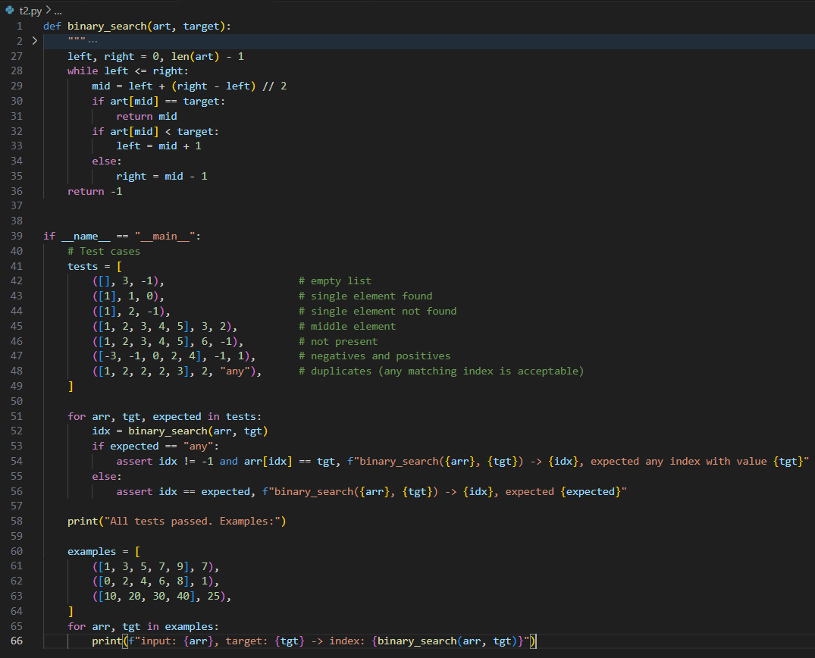
OUTPUT:-
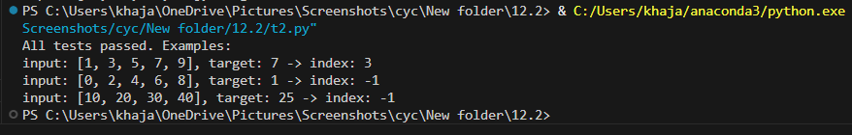

OBSERVATION:-
AI produced an iterative binary_search(art, target) that assumes a sorted input and returns the index or -1; the docstring lists best/average/worst time complexities and space complexity (best O(1), average/worst O(log n), space O(1)). The file includes tests covering empty arrays, single-element cases, not-found cases and duplicates, making it straightforward to confirm correctness. The result shows AI speeds up development by supplying a concise, well-documented, and testable search routine.
TASK3
TASK3 DESCRIPTION:-
Scenario: A retail store’s inventory system contains thousands of products, each with attributes like product ID, name, price, and stock quantity. Store staff need to:
  - Quickly search for a product by ID or name.
  - Sort products by price or quantity for stock analysis.
Task:
  - Use AI to suggest the most efficient search and sort algorithms for this use case.
  - Implement the recommended algorithms in Python.
  - Justify the choice based on dataset size, update frequency, and performance requirements.
PROMPT:-
Create a Python program with a Product dataclass (product_id, name, price, quantity) and an Inventory class implementing add_product, find_by_id, find_by_name(name, exact=True/False), sort_by_price, and sort_by_quantity; document complexity notes (O(1) id lookup via dict, O(n) substring search, O(n log n) sorting), handle duplicate IDs/names sensibly, and include an example dataset plus assertions and demonstration prints under if name == "main".

CODE:-
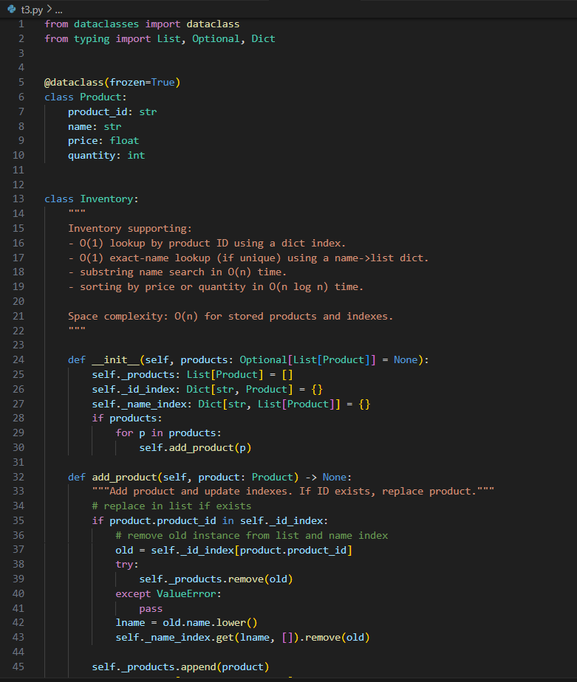

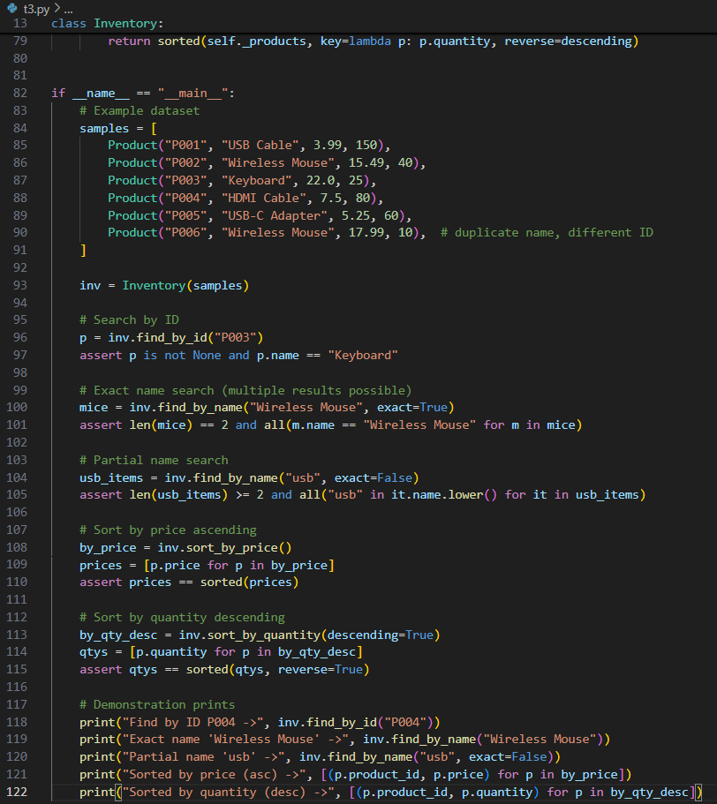
OUTPUT:-
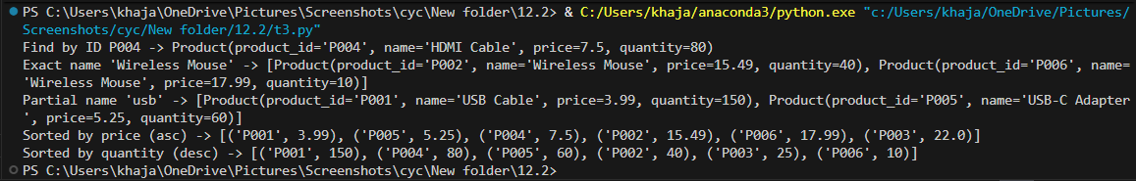

OBSERVATION:-
AI created a Product dataclass and an Inventory class with add_product, find_by_id, find_by_name (exact and substring), sort_by_price, and sort_by_quantity, and documented the complexity and design decisions (dict for O(1) ID lookup, name->list index, substring search O(n), sorting O(n log n)). An example dataset and assertions verify behavior including duplicate names and ID replacement. This highlights how AI can scaffold a small production-like module with indexing, documentation, and tests, enabling quick validation and iteration.

