AI ASSISTED CODING LAB
ASSIGNMENT 11.4
ENROLLMENT NO :2503A51L15
BATCH NO: 19
NAME: MOHAMMAD KHAJA AFZALUDDIN

TASK1
TASK1 DESCRIPTION:-
Use AI to help implement a Stack class in Python with the following operations: push (), pop (), peek (), and is empty ().
Instructions:
  - Ask AI to generate code skeleton with docstrings.
  - Test stack operations using sample data.
  - Request AI to suggest optimizations or alternative implementations (e.g., using collections. Deque).

PROMPT:-
Implement a Stack class with push(item), pop(), peek(), and is_empty(); include Google-style docstrings, inline comments for tricky parts, and a short main that tests pushing 1,2,3 then peeking and popping to show correct LIFO behavior.

CODE:-
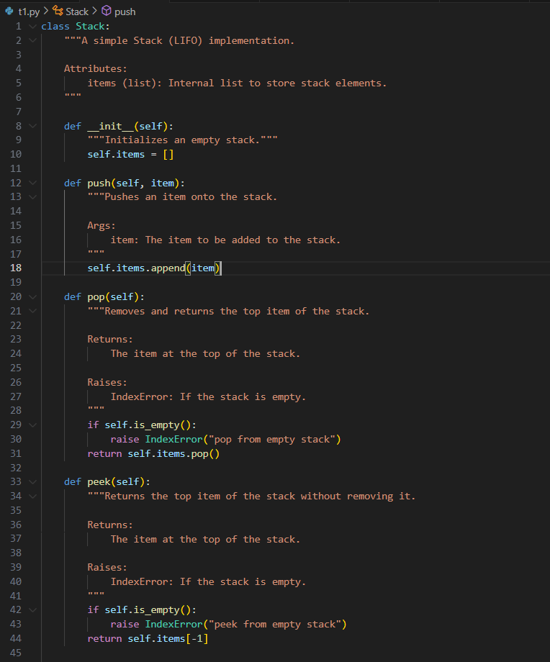
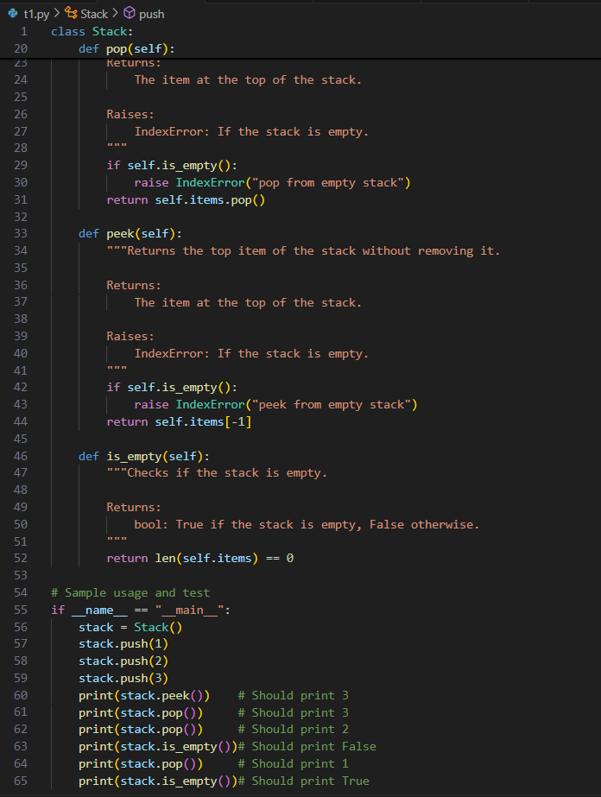

OUTPUT:-
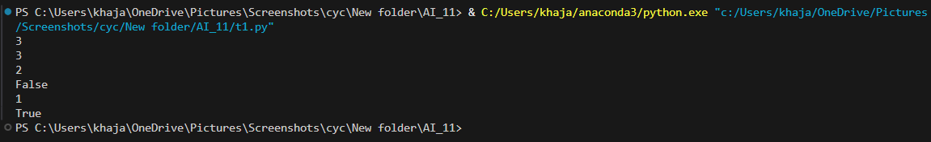
OBSERVATION:-
The Stack implementation provides a simple LIFO container using a Python list with push, pop, peek, and is_empty methods. Pushing and popping at the list end are O(1) amortized, and peek/is_empty are O(1); pop/peek raise IndexError on empty stacks for explicit error handling. The design is minimal and easy to test, suitable for most single-threaded uses; for thread-safety or alternate performance characteristics consider synchronization or other container types.

TASK2
TASK2 DESCRIPTION:-
Implement a Queue with enqueue (), dequeue (), and is empty () methods.
- Instructions:
  - First, implement using Python lists.
  - Then, ask AI to review performance and suggest a more efficient implementation (using collections. Deque).

PROMPT :-
Create ListQueue (using list) and DequeQueue (using collections.deque) with enqueue(item), dequeue(), and is_empty(); add docstrings, note performance differences (O(n) vs O(1)), and include sample code comparing both on a small sequence.

CODE:-
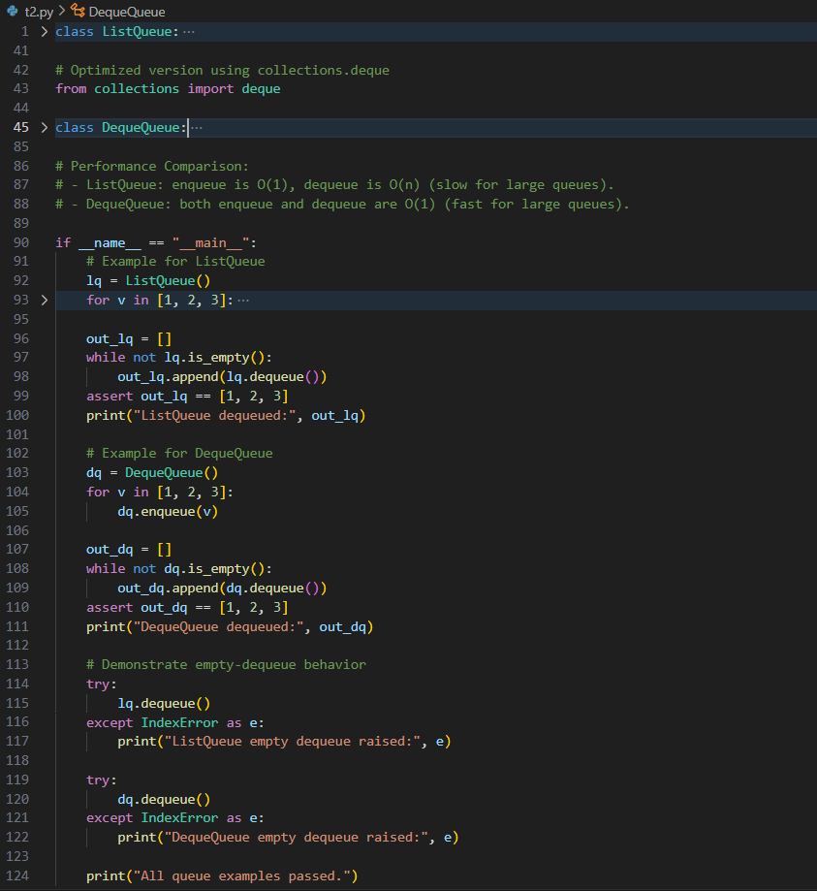

OUTPUT:-
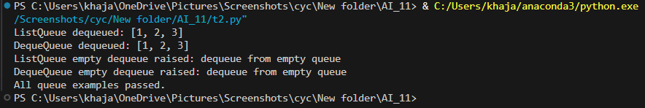

OBSERVATION:-
Two queue variants are provided: ListQueue uses a list where enqueue is O(1) but dequeue (pop(0)) is O(n), while DequeQueue uses collections.deque giving O(1) enqueue and dequeue (append/popleft). The code and comments clearly demonstrate the performance trade-off and make deque the preferred choice for real queues or large workloads. Both implementations raise on empty dequeues, so tests should include empty-queue behavior.

TASK3
TASK3 DESCRIPTION:-
Implement a Singly Linked List with operations: instated (), delete value (), and traverse ().
- Instructions:
  - Start with a simple class-based implementation (Node, LinkedList).
  - Use AI to generate inline comments explaining pointer updates (which are non-trivial).
  - Ask AI to suggest test cases to validate all operations.
PROMPT:-
Implement a singly LinkedList with Node and LinkedList classes supporting insert(value), delete_value(value), and traverse(); include inline comments explaining pointer updates for head/middle/tail deletions, maintain tail and size, and add example tests for head, middle, tail, duplicate and absent deletions.

CODE:-
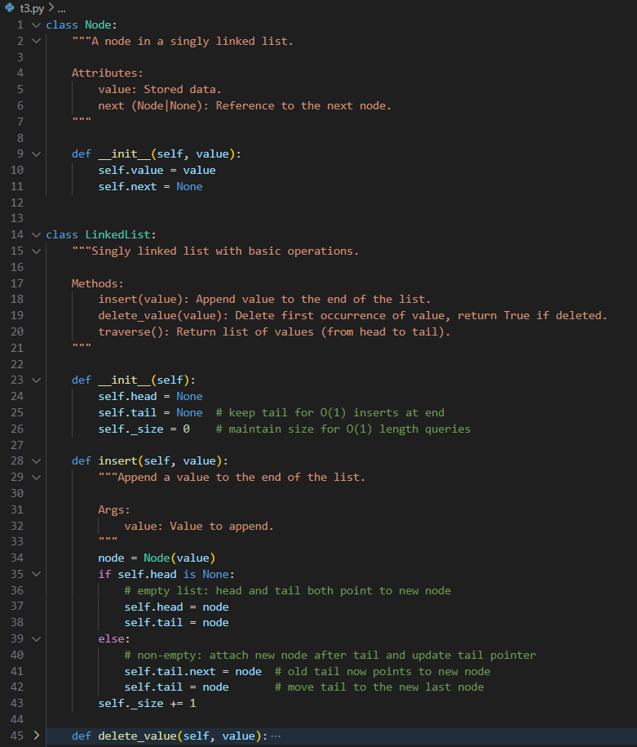

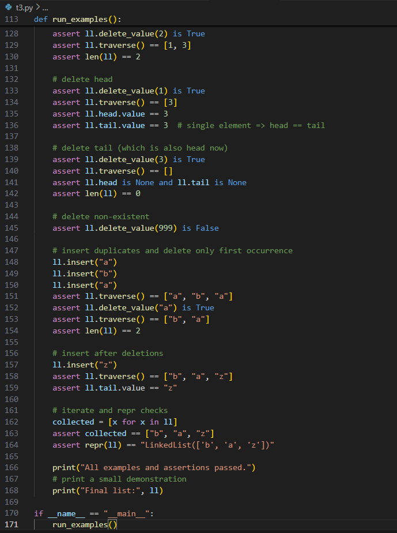

OUTPUT:-
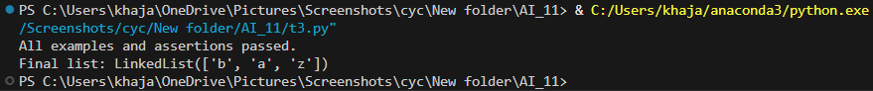
OBSERVATION:-
The linked list implements Node and LinkedList with head, tail, and a maintained size for O(1) append and O(1) length queries; delete_value scans O(n) to remove the first matching node. Inline comments explain pointer updates for deleting head, middle, and tail nodes and ensure tail and size are updated correctly, covering common edge cases (empty list, single element, duplicates). The API (traverse, iter, len, repr) improves testability and readability.

TASK4
TASK4 DESCRIPTION:-
Implement a Binary Search Tree with methods for insert (), search (), and inorder_traversal ().
- Instructions:
  - Provide AI with a partially written Node and BST class.
  - Ask AI to complete missing methods and add docstrings.
Test with a list of integers and compare outputs of search () for present vs absent elements.

PROMPT:-
Implement a BinarySearchTree with Node and BinarySearchTree classes providing insert(value), search(value), and inorder_traversal(); include docstrings, ignore duplicates, and add an example that inserts [7,3,9,1,5,8,10], asserts inorder == sorted(values), and checks search for present and absent keys.

CODE :-

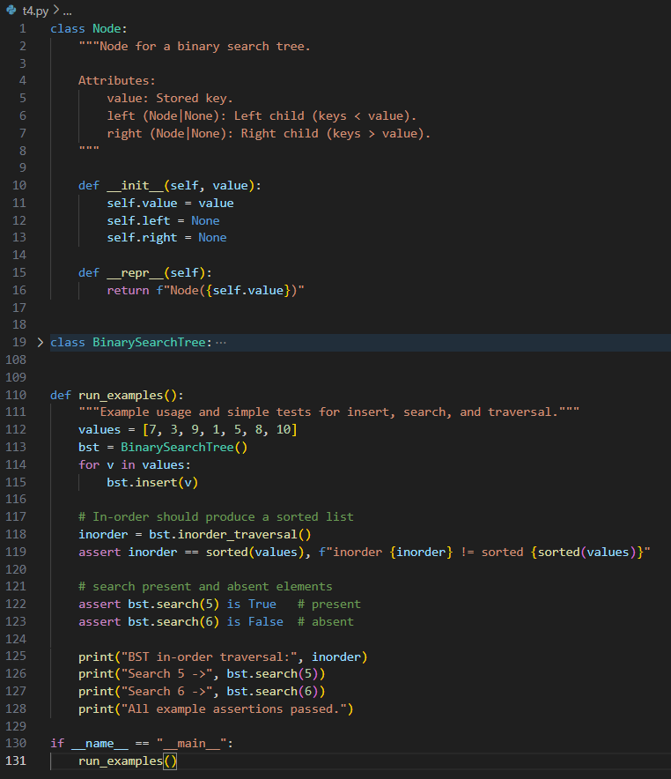
OUTPUT:-
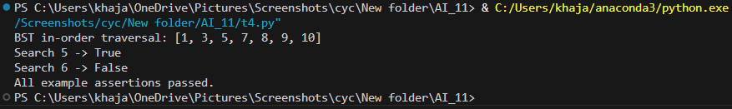OBSERVATION:-Binary Search Tree (BST)
The BST offers insert (ignoring duplicates), iterative search, and recursive inorder_traversal that returns sorted values. Typical complexities are O(log n) average for insert/search and O(n) worst-case for an unbalanced tree; inorder traversal is useful for verification. This simple BST is great for teaching and small datasets; for predictable logarithmic performance consider balanced variants (AVL or red-black trees) when needed.
TASK5
TASK5 DESCRIPTION:-
Implement a Graph using an adjacency list, with traversal methods BFS () and DFS ().
- Instructions:
  - Start with an adjacency list dictionary.
  - Ask AI to generate BFS and DFS implementations with inline comments.
  - Compare recursive vs iterative DFS if suggested by AI.

PROMPT:-
Build a Graph using an adjacency-list dict with add_node/add_edge and traversal methods bfs(start), dfs_recursive(start), dfs_iterative(start); include inline comments about visited marking and queue/stack behavior, compare recursive vs iterative DFS ordering, and add an example graph plus assertions for BFS/DFS outputs.

CODE :-
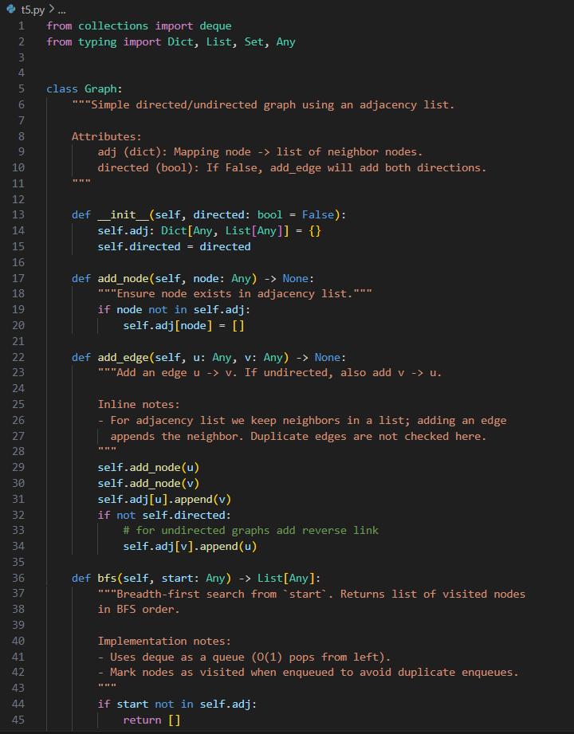

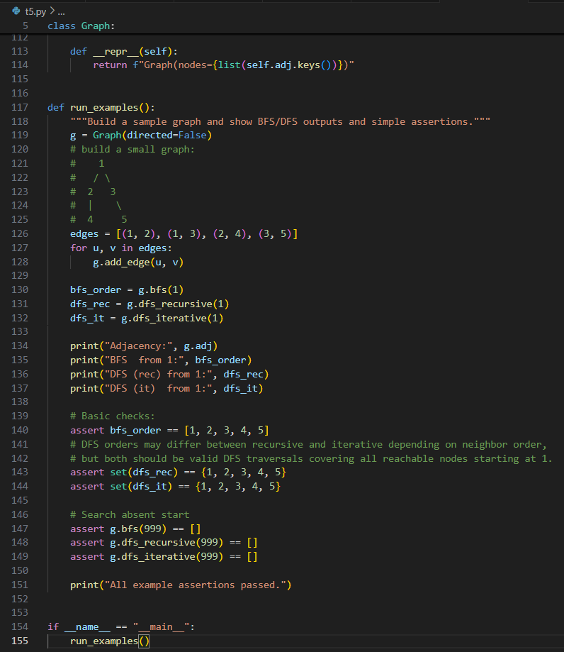
OUTPUT:-
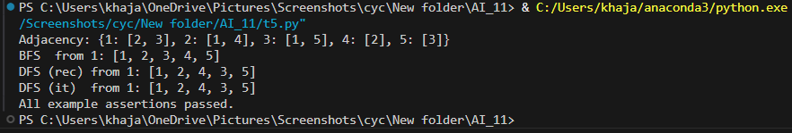

OBSERVATION:-Graph (adjacency list) with BFS/DFS
The Graph uses an adjacency-list dict and supports directed or undirected edges, with BFS (deque-based) and two DFS variants (recursive and iterative). Traversals run in O(V+E), BFS marks visited on enqueue to avoid duplicates, recursive DFS uses the call stack (risking recursion depth issues on deep graphs), and iterative DFS uses an explicit stack and can reverse neighbor order to match recursive visitation. The examples demonstrate expected traversal orders and handle absent-start cases; use iterative DFS or increase recursion limits for very large/deep graphs.

