AI ASSISTED CODING LAB
ASSIGNMENT 13.2
ENROLLMENT NO :2503A51L15
BATCH NO: 19
NAME: MOHAMMAD KHAJA AFZALUDDIN

TASK1
TASK1 DESCRIPTION:- Provide AI with the following redundant code and ask it to
refactor
Python Code:-
def calculate_area(shape, x, y=0):
if shape == "rectangle":
return x * y
elif shape == "square":
return x * x
elif shape == "circle":
return 3.14 * x * x

PROMPT:- Refactor the redundant code for calculating areas of shapes.
CODE:-
ERROR CODE:-
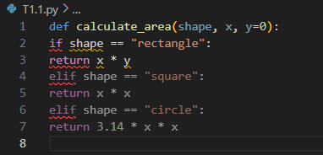

OUTPUT:-
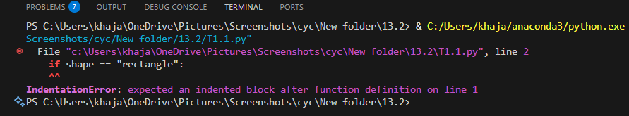

AI GENERATED CODE:-
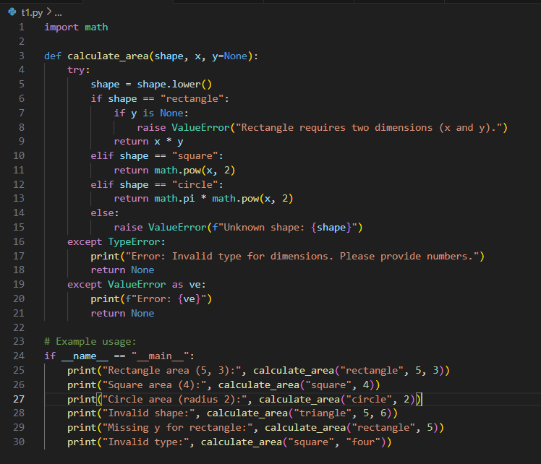
OUTPUT:-
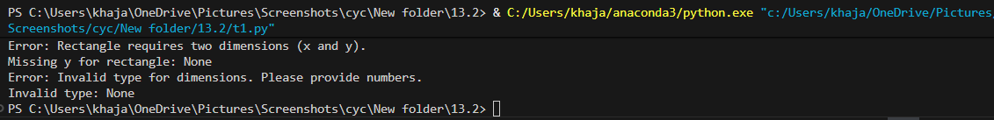

OBSERVATION:-
The AI refactored the function, improved readability, and added error handling, making the
code more reliable.

TASK2
TASK2 DESCRIPTION:- Error Handling in Legacy Code
Task: Legacy function without proper error handling
Python Code
def read_file(filename):
f = open(filename, "r")
data = f.read()
f.close()
return data

PROMPT:- Improve the legacy file reading function with error handling.

CODE:-
ERROR CODE:-
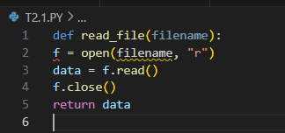
OUTPUT:-
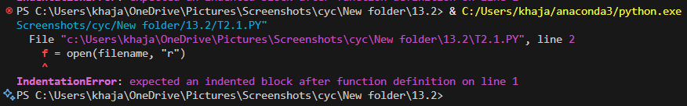

AI GENERATED CODE:-
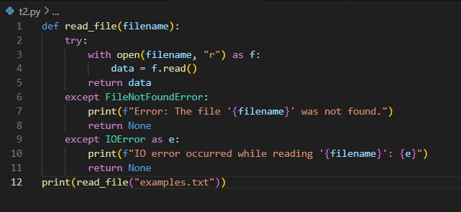
OUTPUT:-
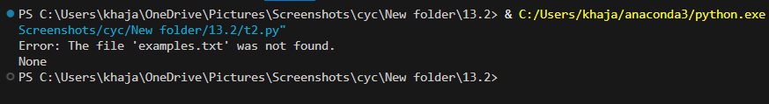
OBSERVATION:- The AI added exception handling for missing files and ensured safe file operations, preventing runtime errors.

TASK3
TASK3 DESCRIPTION:- Complex Refactoring
Task: Provide this legacy class to AI for readability and modularity
improvements:
Python Code
class Student:
def __init__(self, n, a, m1, m2, m3):
self.n = n
self.a = a
self.m1 = m1
self.m2 = m2
self.m3 = m3
def details(self):
print("Name:", self.n, "Age:", self.a)
def total(self):
return self.m1+self.m2+self.m3

PROMPT:- Refactor the legacy Student class for readability and modularity.
CODE:-
ERROR CODE:-
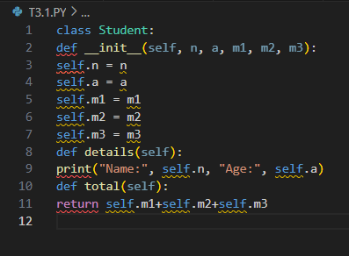
OUTPUT:-
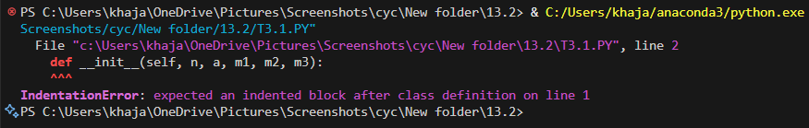

AI GENERATED CODE:-
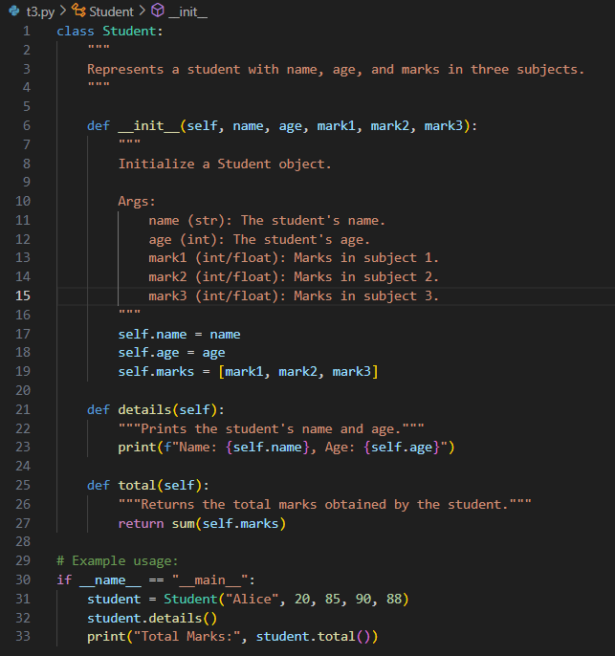
OUTPUT:-
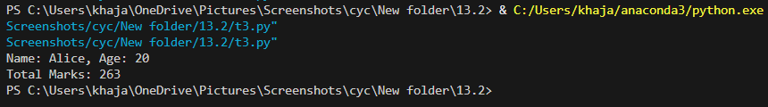
OBSERVATION:- The AI improved the class structure, added clear methods, and made the code more organized and maintainable.

TASK4
TASK4 DESCRIPTION:- Inefficient Loop Refactoring
Task: Refactor this inefficient loop with AI help
Python Code
nums = [1,2,3,4,5,6,7,8,9,10]
squares = []
for i in nums:
squares.append(i * i)

PROMPT:- Refactor the inefficient loop for better performance.

CODE:-
ERROR CODE:-
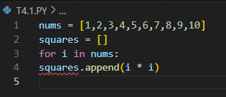
OUTPUT:-
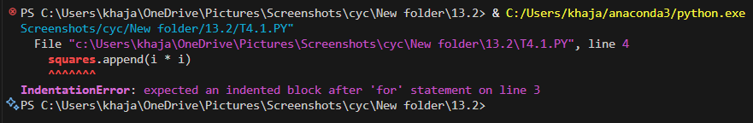

AI GENERATED CODE:-
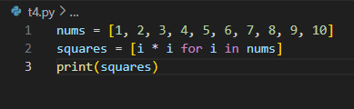

OUTPUT:-
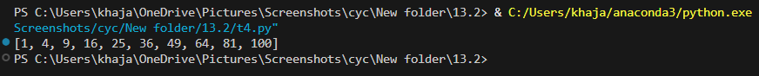
OBSERVATION:- The AI replaced the loop with a list comprehension, simplifying the code and improving efficiency.

