AI ASSISTED CODING LAB
ASSIGNMENT 2.4
ENROLLMENT NO :2503A51L15
BATCH NO: 19
NAME: MOHAMMAD KHAJA AFZALUDDIN
TASK1
TASK1 DESCRIPTION:- Open Google Colab and use Google Gemini to generate Python code that performs sorting of a list using both the bubble sort algorithm and Python’s built-in sort() function. Compare the two implementations.

PROMPT:-Python code that performs sorting of a list using both the bubble sort algorithm and Python’s built-in sort() function. Compare the two implementations.

CODE:-
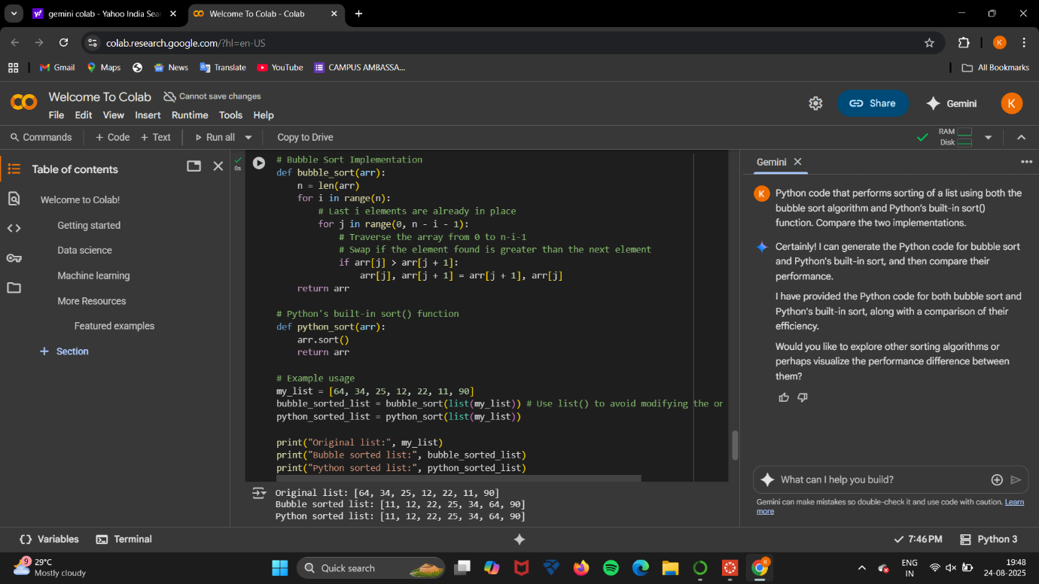
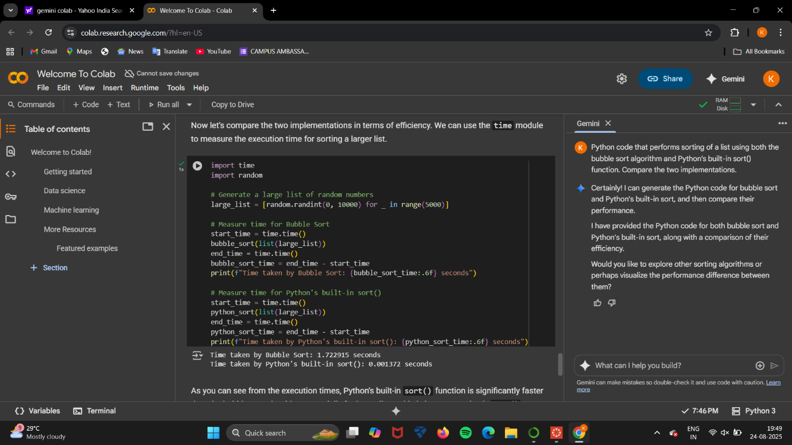

TASK2
TASK2 DESCRIPTION:- In Colab, use Google Gemini to generate a Python function that takes a string and returns The number of vowels, The number of consonants, The number of digits in the string

PROMPT:-Generate a Python function that takes a string and returns: The number of vowels, The number of consonants, The number of digits in the string

CODE:-
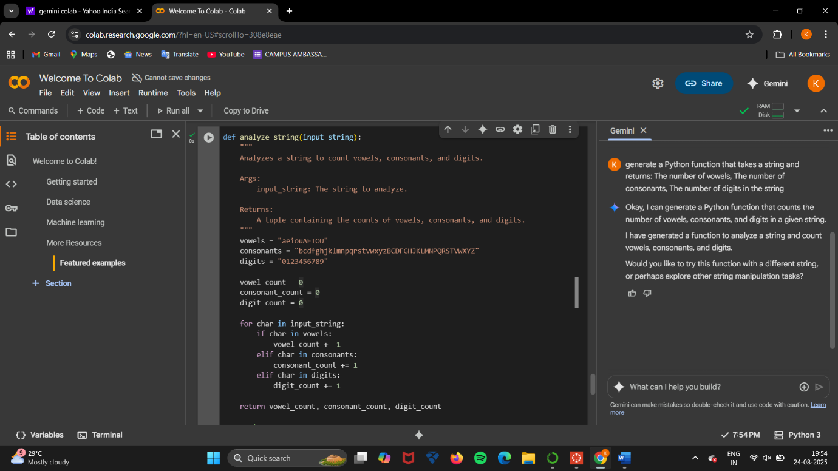
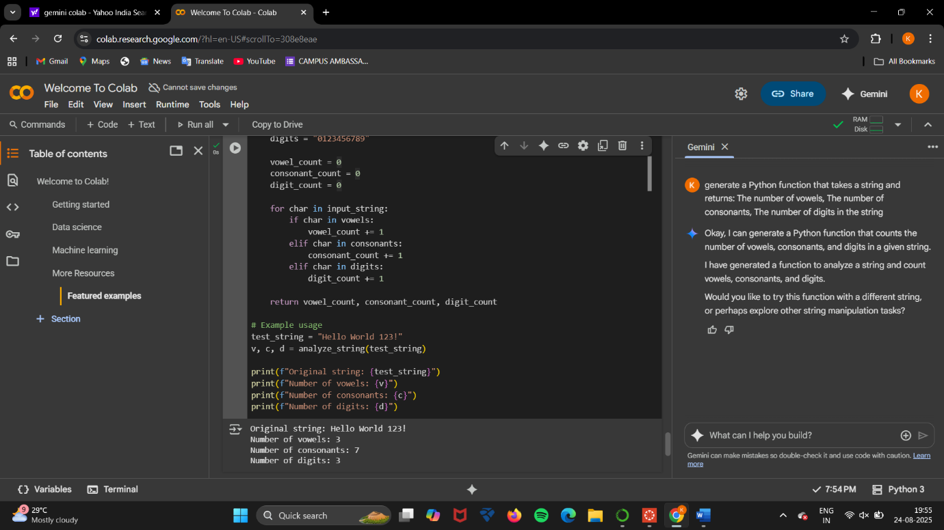

TASK4
TASK4 DESCRIPTION:- Ask Google Gemini to generate a Python program that implements a simple calculator using functions (add, subtract, multiply, divide). Then, ask Gemini to explain how the code works.

PROMPT:-Generate a Python program that implements a simple calculator using functions (add, subtract, multiply, divide).And explain the code.

CODE:-
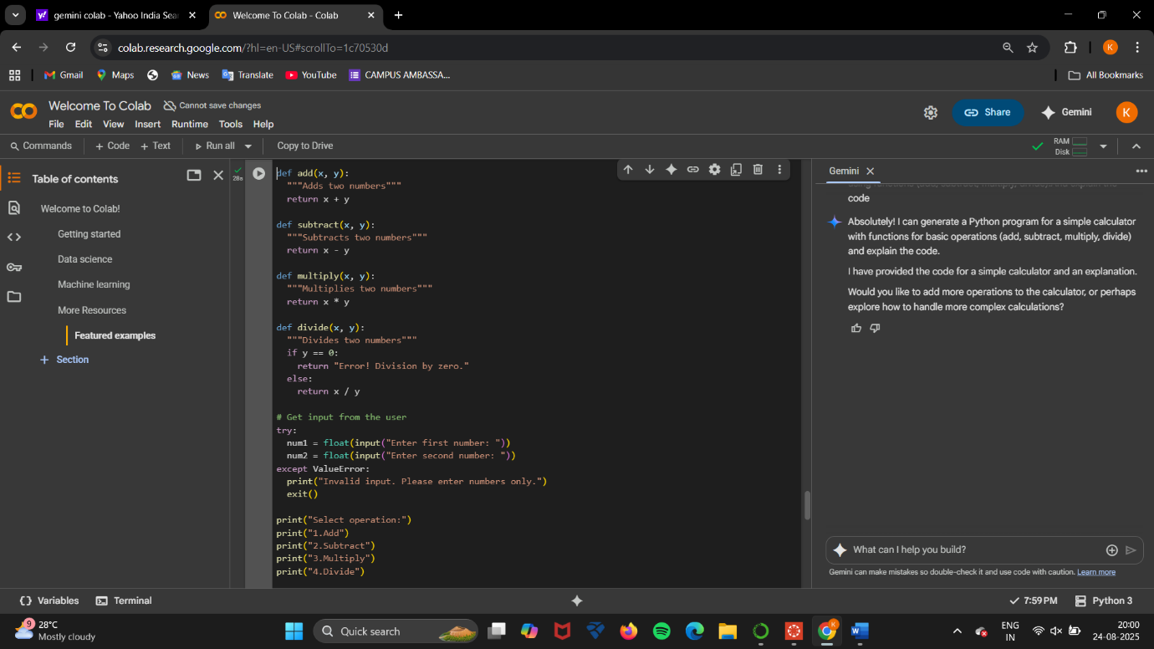
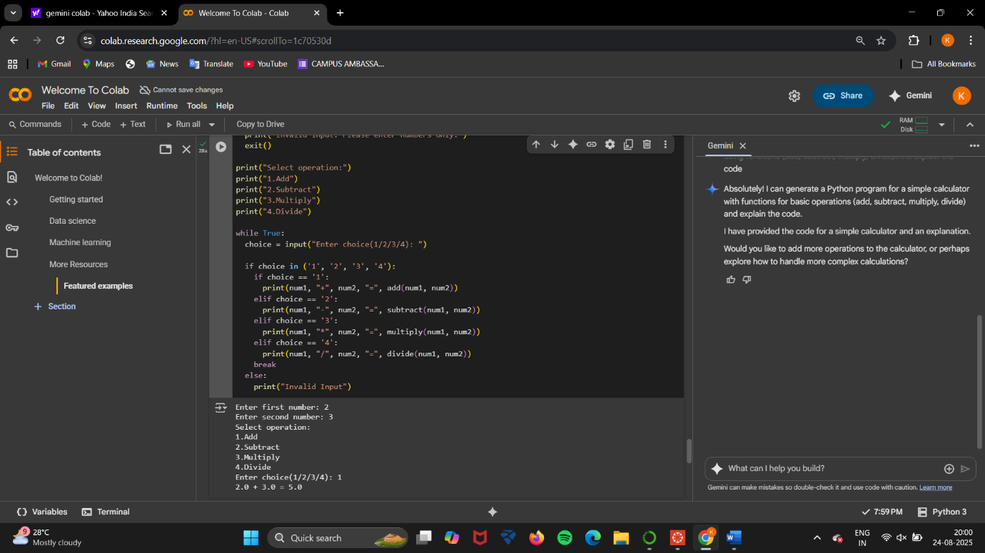
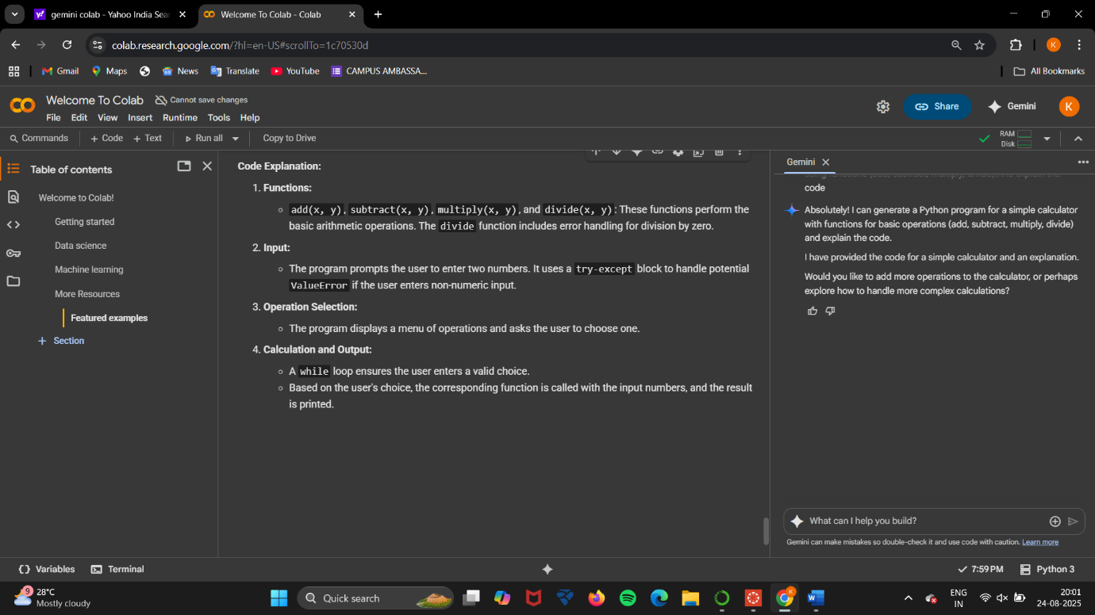

OBSERVATION:-
I observed how Google Gemini can generate Python programs when provided with clear prompts and how different problem-solving approaches can be compared and analyzed.
- In Task 1, Gemini generated two different sorting implementations: one using the manual Bubble Sort algorithm and the other using Python’s built-in sort() function. This highlighted the difference between a step-by-step algorithmic approach and an optimized built-in method, making it clear that while algorithms are useful for learning, built-in functions provide efficiency in practical use.
- In Task 2, I observed that Gemini was able to implement a function that processes a string and accurately counts vowels, consonants, and digits. This task demonstrated the AI’s ability to handle string manipulation and conditional logic effectively.
- In Task 4, Gemini successfully generated a program for a simple calculator using functions for addition, subtraction, multiplication, and division. More importantly, when asked to explain the code, it provided a step-by-step breakdown, showing how AI can assist not only in code generation but also in teaching and concept explanation.

