AI ASSISTED CODING LAB
ASSIGNMENT 4.4
ENROLLMENT NO :2503A51L15
BATCH NO: 19
NAME: MOHAMMAD KHAJA AFZALUDDIN
TASK1
TASK1 DESCRIPTION :- Auto-Complete a Python Class for Bank Account
• Write a class definition comment and start the constructor for a class called Bank Account with account_holder and balance attributes. Use GitHub Copilot to auto-complete the rest of the class, including methods to deposit, withdraw, and display balance.

PROMPT:-Write a Python class called BankAccount with a class definition comment, a constructor that takes account_holder and balance, and methods deposit(self, amount), withdraw(self, amount) with error handling for insufficient funds, and display_balance(self); provide the complete implementation with example.

CODE:-
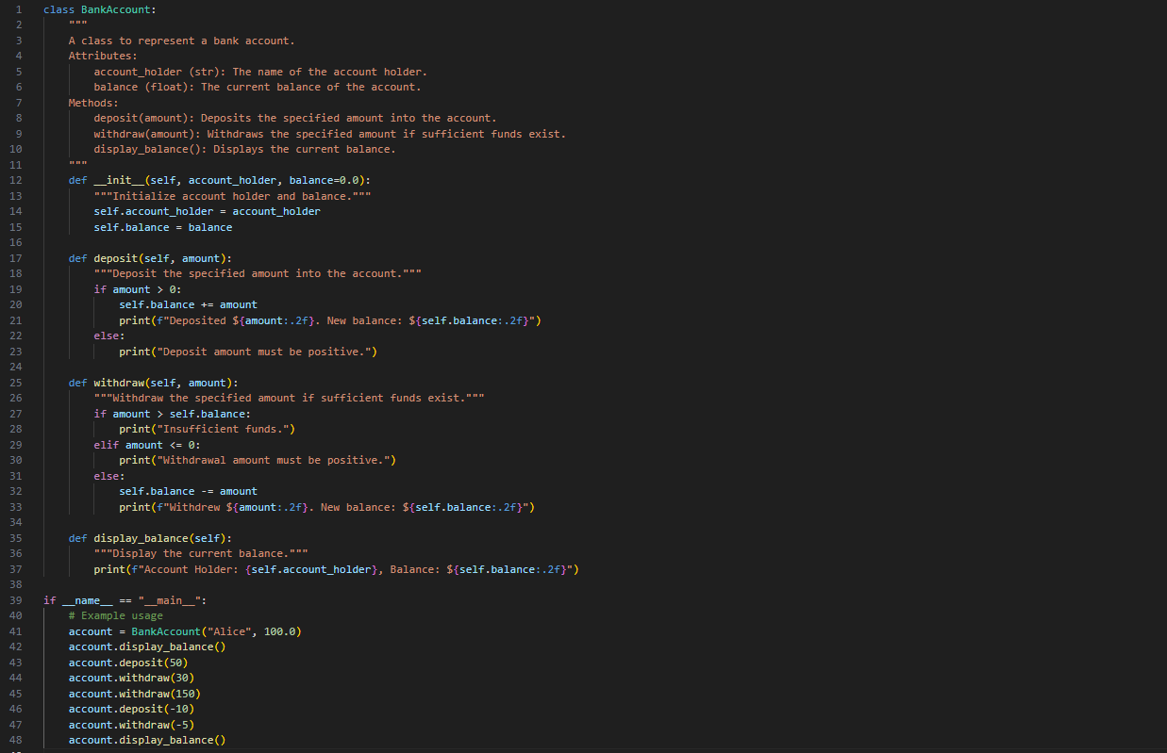
OUTPUT:-
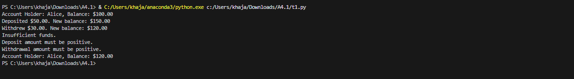

TASK2
TASK2 DESCRIPTION:- Auto-Complete a For Loop to Sum Even Numbers in a List
Write a comment and the initial line of a loop to iterate over a list. Allow GitHub Copilot to complete the logic to sum all even numbers in the list.

PROMPT:-Write a comment and the initial line of a Python loop to iterate over a list, then let GitHub Copilot auto-complete the logic to sum all even numbers in the list and implement with example.

CODE:-
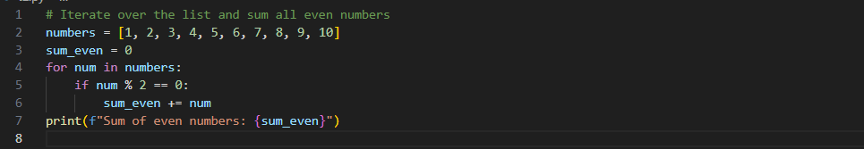
OUTPUT:-

TASK3
TASK3 DESCRIPTION:- Auto-Complete Conditional Logic to Check Age Group
Start a function that takes age as input and returns whether the person is a child, teenager,adult, or senior using if-elif-else. Use Copilot to complete the conditionals

PROMPT:-Generate a python function that takes age as input and returns whether the person is a child, teenager,adult, or senior using if-elif-else.implement with clear example.

CODE:-
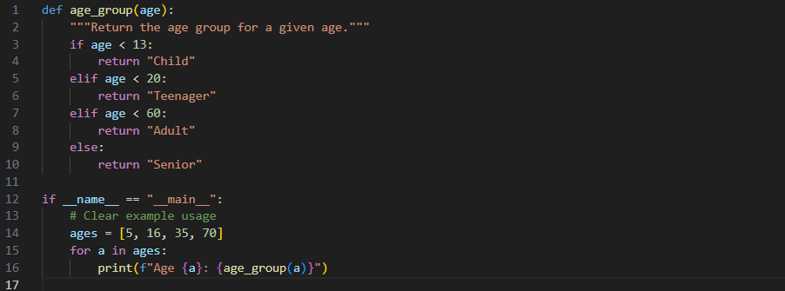
OUTPUT:-
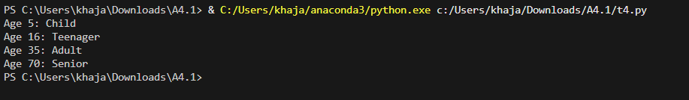

TASK4
TASK4 DESCRIPTION:- Auto-Complete a While Loop to Reverse Digits of a Number
Write a comment and start a while loop to reverse the digits of a number. Let Copilot complete the loop logic.

PROMPT:-Generate a Python comment and start a while loop to reverse the digits of a number. Then use GitHub Copilot to auto-complete the loop logic and implement it with example

CODE:-
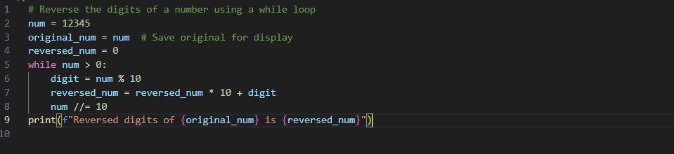

OUTPUT:-

TASK5
TASK5 DESCRIPTION:- Auto-Complete Class with Inheritance (Employee → Manager)
Begin a class Employee with attributes name and salary. Then, start a derived class Manager that inherits from Employee and adds a department. Let GitHub Copilot complete the methods and constructor chaining

PROMPT:- Write the start of a Python class Employee with attributes name and salary, then begin a derived class Manager that inherits from Employee and adds a department attribute. Let GitHub Copilot auto-complete the constructors and any necessary methods, including proper constructor chaining implement with example.

CODE:-
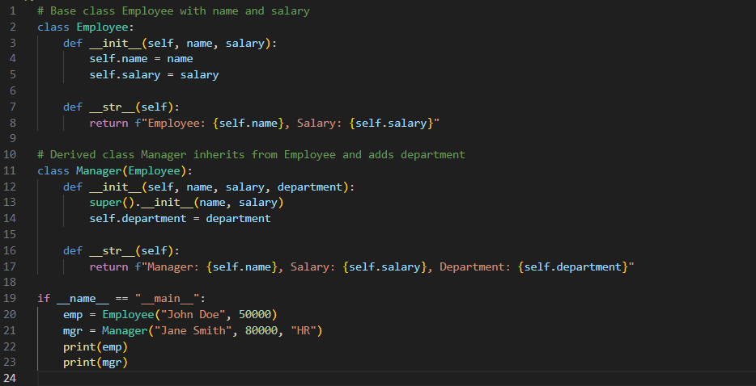
OUTPUT:-

OBSERVATION:- I observed how GitHub Copilot can be effectively used to auto-complete Python code when given the correct prompts. By providing only the initial structure such as a class definition, function header, or loop starter, Copilot was able to generate complete implementations with logical flow.
- In Task 1, I noticed that Copilot could generate a full Python class with constructor, methods, and proper error handling just from a descriptive prompt.
- In Task 2, it correctly completed the loop logic to filter and sum even numbers, showing its ability to understand conditional iteration.
- In Task 3, the function for age classification highlighted how Copilot handles nested conditionals and returns meaningful results.
- In Task 4, the while loop to reverse digits showed Copilot’s capability to handle mathematical logic inside loops.
- In Task 5, I observed how Copilot implements object-oriented concepts like inheritance and constructor chaining effectively.

