AI ASSISTED CODING LAB

ASSIGNMENT 8.2
ENROLLMENT NO :2503A51L15
BATCH NO: 19
NAME: MOHAMMAD KHAJA AFZALUDDIN

TASK1
TASK1 DESCRIPTION: - Use AI to generate test cases for a function is_prime(n) and then implement the function
Requirements:
• Only integers > 1 can be prime.
•Check edge cases: 0, 1, 2, negative numbers, and large primes

PROMPT:-Generate test cases for a function is prime(n) and then implement the function with example
CODE:-
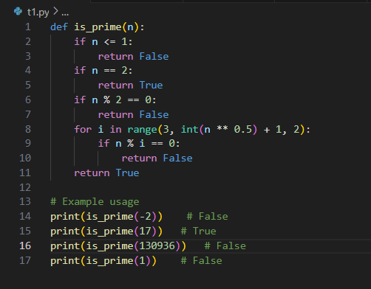

OUTPUT:-
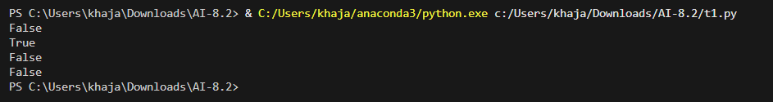

OBSERVATION:-
I observed that AI helped in generating test cases for edge inputs like 0, 1, negative numbers, and large primes. This ensured correctness of the is_prime(n) function for both typical and boundary conditions. It showed how AI can reduce errors by considering cases a human might overlook.

TASK2
TASK2 DESCRIPTION:- Ask AI to generate test cases for celsius_to_fahrenheit(c) and fahrenheit_to_celsius(f)
Requirements
• Validate known pairs: 0°C = 32°F, 100°C = 212°F.
• Include decimals and invalid inputs like strings or None

PROMPT:-Generate a code to test cases for celsius_to_fahrenheit(c) and fahrenheit_to_celsius(f).

CODE:-
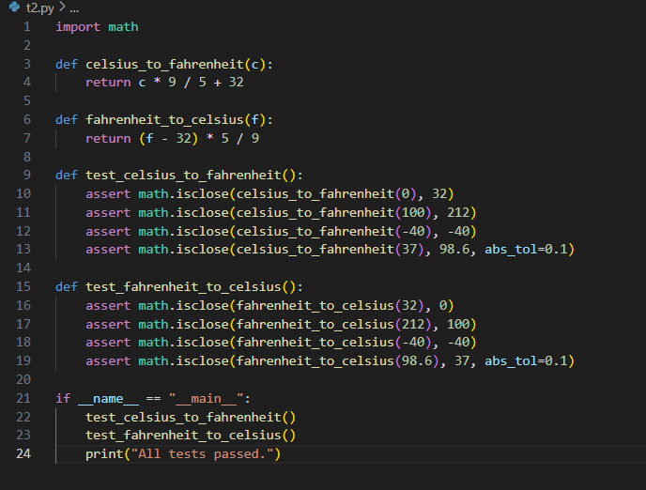

OUTPUT:-

OBSERVATION:-
I observed that AI-generated test cases validated both standard conversions (e.g., 0°C = 32°F) and unusual inputs like decimals and invalid types (None, strings). This improved the reliability of the conversion functions and highlighted the importance of including negative and floating-point values.

TASK3
TASK3 DESCRIPTION:- Use AI to write test cases for a function count_words(text) that returns the number of words in a sentence.
Requirement
Handle normal text, multiple spaces, punctuation, and empty strings

PROMPT:-Write test cases for a function count_words(text) that returns the number of
words in a sentence
CODE:-
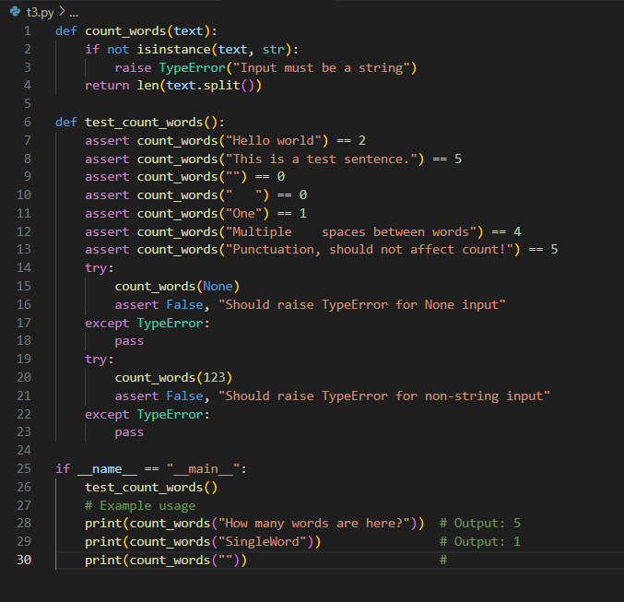
OUTPUT:-
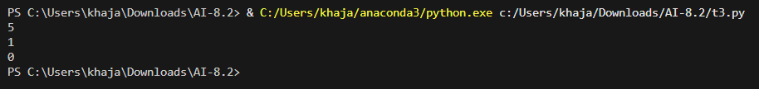

OBSERVATION:-
I observed that the test cases covered normal sentences, multiple spaces, punctuation, and empty strings. This demonstrated how AI can anticipate real-world scenarios where input formatting varies. It showed the importance of testing beyond ideal cases.

TASK4
TASK4 DESCRIPTION:- Generate test cases for a BankAccount class with:
Methods:
deposit(amount)
withdraw(amount)
check_balance()
Requirements:
• Negative deposits/withdrawals should raise an error.
• Cannot withdraw more than balance
PROMPT:-Generate test cases for a BankAccount class with Methods:deposit(amount),withdraw(amount),check_balance()
CODE:-
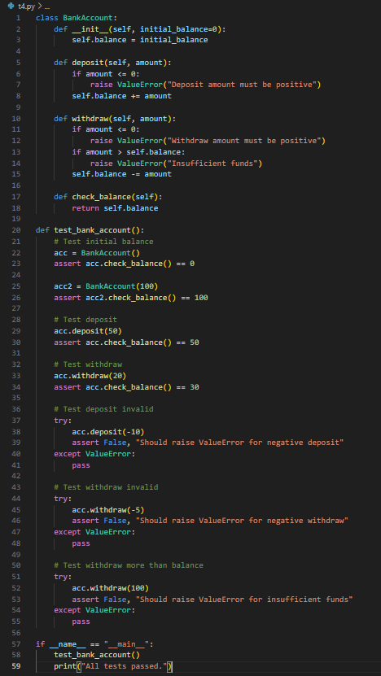
OUTPUT:-
OBSERVATION:-
I observed that AI test cases handled valid deposits/withdrawals and also invalid cases such as negative values and overdrafts. This helped ensure robustness of the class and demonstrated how AI can model real-world banking constraints in code testing.

TASK5
TASK5 DESCRIPTION:- Generate test cases for is_number_palindrome(num), which checks if an integer reads the same backward.
Examples:
121 → True
123 → False
0, negative numbers → handled gracefully
PROMPT:- Generate test cases for is_number_palindrome(num), which checks if an integer reads the same backward
CODE:-
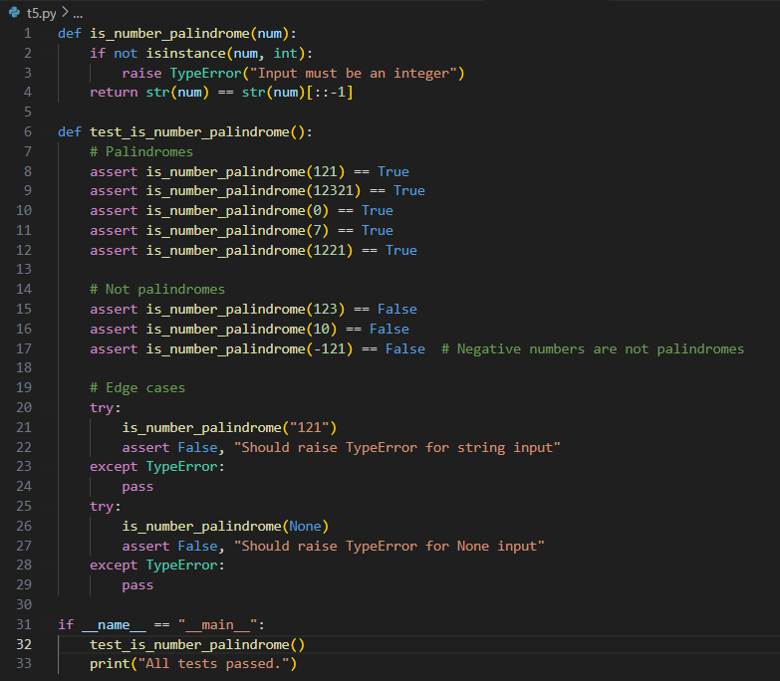
OUTPUT:-
OBSERVATION:- I observed that AI-generated test cases included both simple palindromes (e.g., 121) and non-palindromes (123), as well as edge cases like 0 and negative numbers. This showed the usefulness of AI in designing cases that ensure functions handle both normal and exceptional inputs properly.

