AI ASSISTED CODING LAB
ASSIGNMENT-16.4
NAME: MOHAMMAD KHAJA AFZALUDDIN
ENROLLMENT NO:2503A51L15
BATCH NO: 19

TASK1

TASK DESCRIPTION 1:
Ask AI to design a schema for a Library Management System (Tables: Books, Members, Loans).
SQL CODE:-
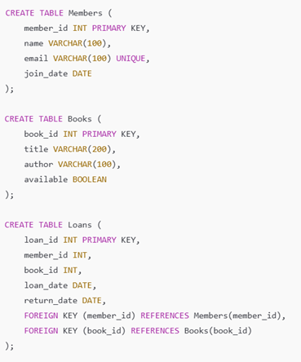

PROMPT :
Design a database schema for a Library Management System with tables: Books, Members, and Loans. Include primary and foreign keys.
CODE :
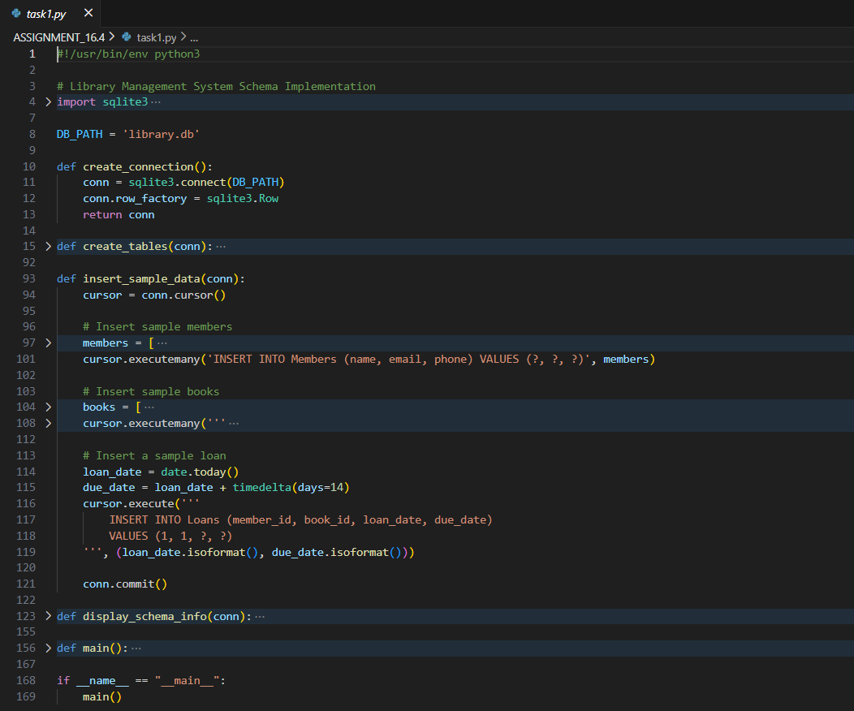

OUTPUT :
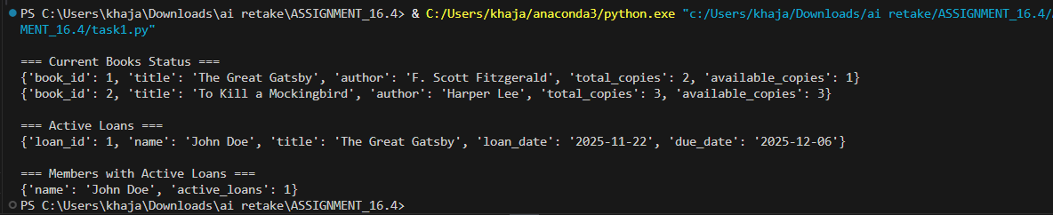

OBSERVATION :
AI generated a clear schema structure with appropriate relationships between tables. The tables included relevant fields such as BookID, MemberID, and LoanDate.

TASK2
TASK DESCRIPTION 2 :
Ask AI to generate INSERT INTO queries for the schema above (3 sample records per table).

PROMPT :
Generate SQL INSERT INTO statements with 3 sample records for each table (Books, Members, and Loans)
CODE:
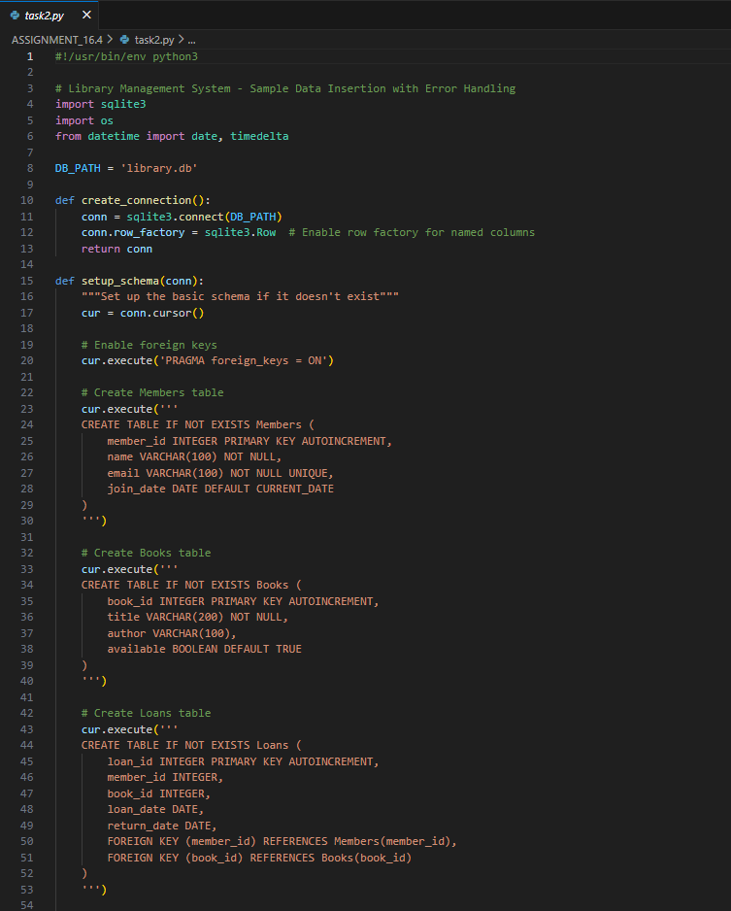

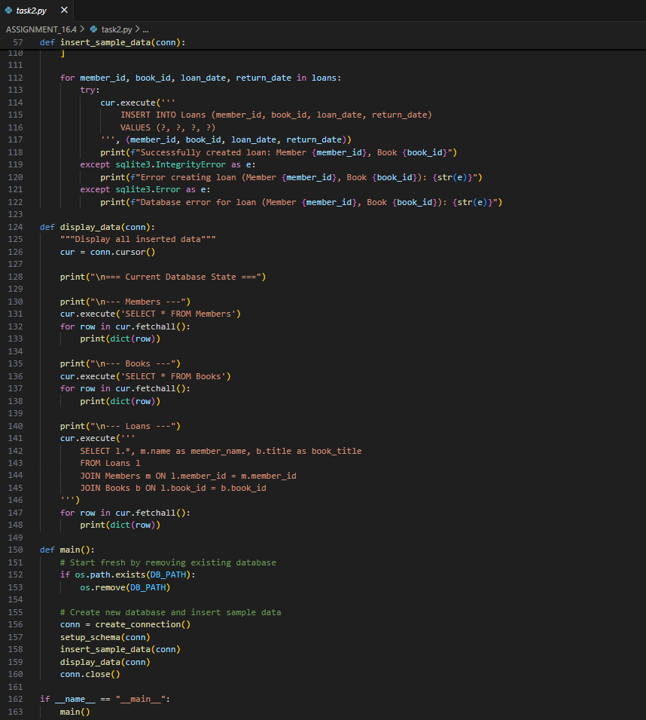
OUTPUT :
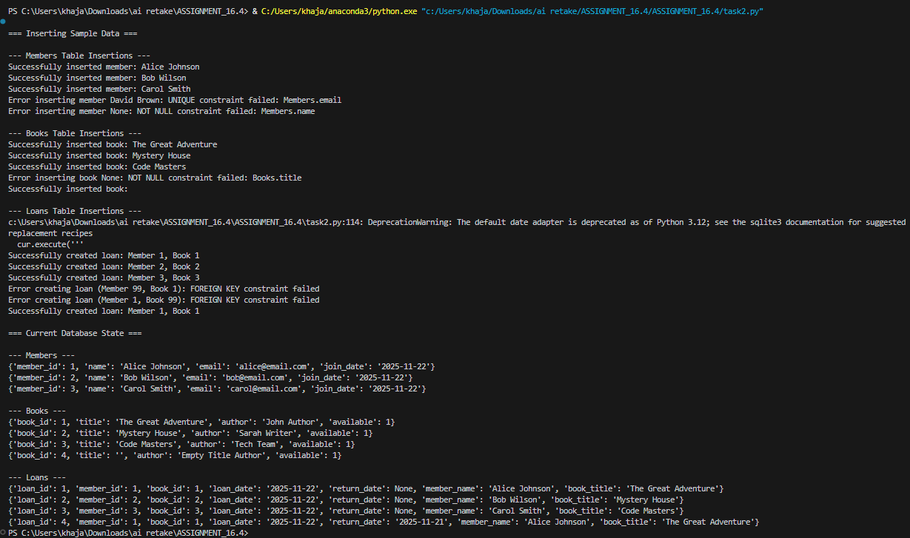
OBSERVATION :
AI provided accurate INSERT statements with valid data types and values matching the schema. Data integrity was maintained through consistent foreign key values.\
TASK3
TASK DESCRIPTION 3 :
Use AI to generate a query to list all books borrowed by a specific member

PROMPT :
Write an SQL query to list all books borrowed by a specific member.
CODE :
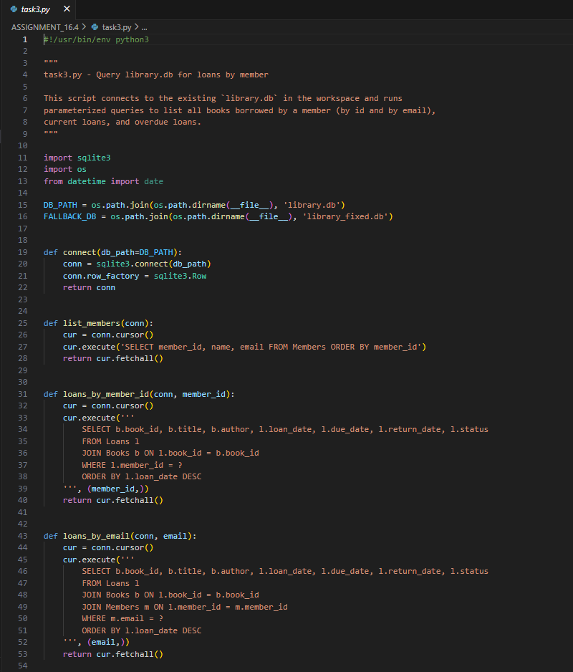

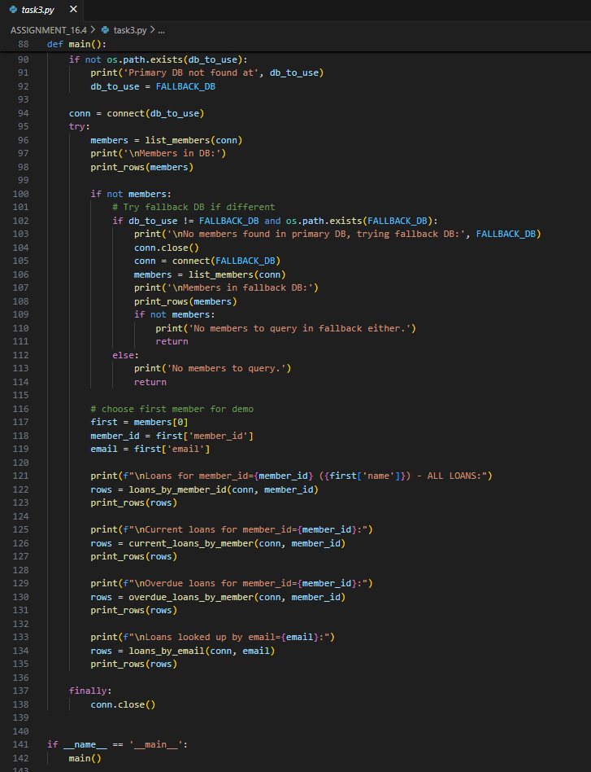

OUTPUT :

OBSERVATION :
AI-generated query correctly used JOIN between Books and Loans tables and applied a WHERE condition with MemberID to filter results.

TASK4
TASK DESCRIPTION 4 :
Generate queries with AI for:
- Updating a book’s availability to FALSE when borrowed.
- Deleting a member record safely.
PROMPT :
Generate SQL queries to:
(a) Update a book’s availability to FALSE when borrowed.
(b) Delete a member record safely.
CODE :
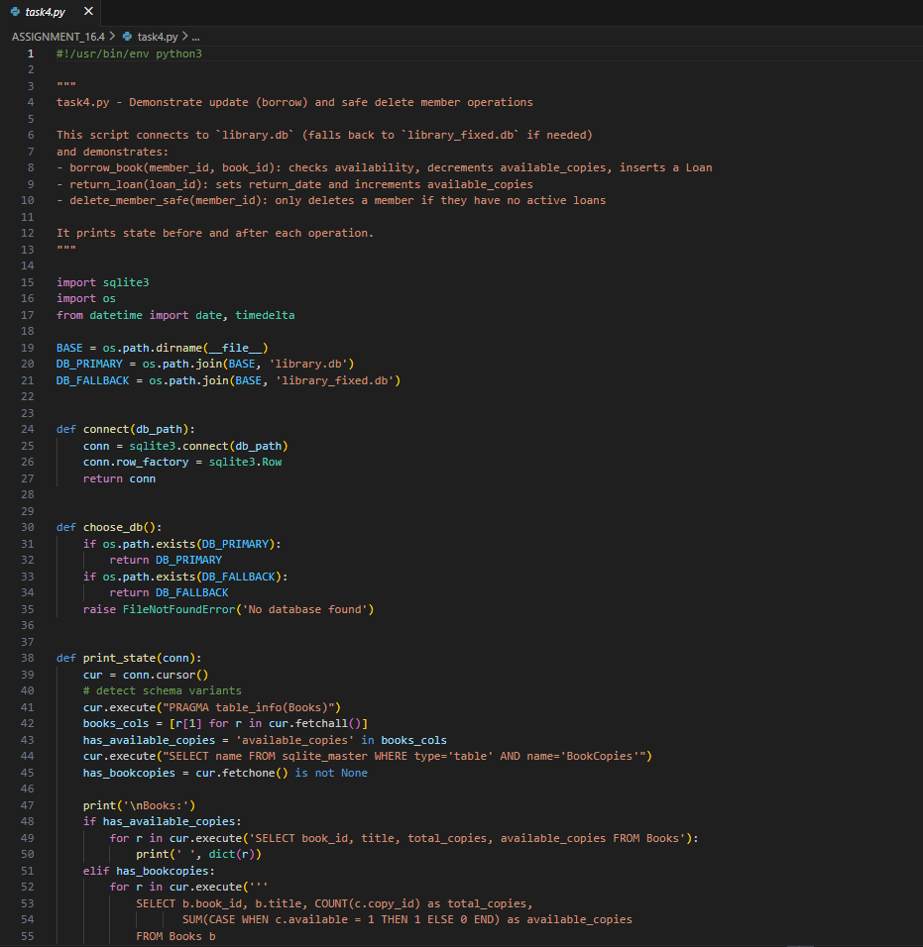

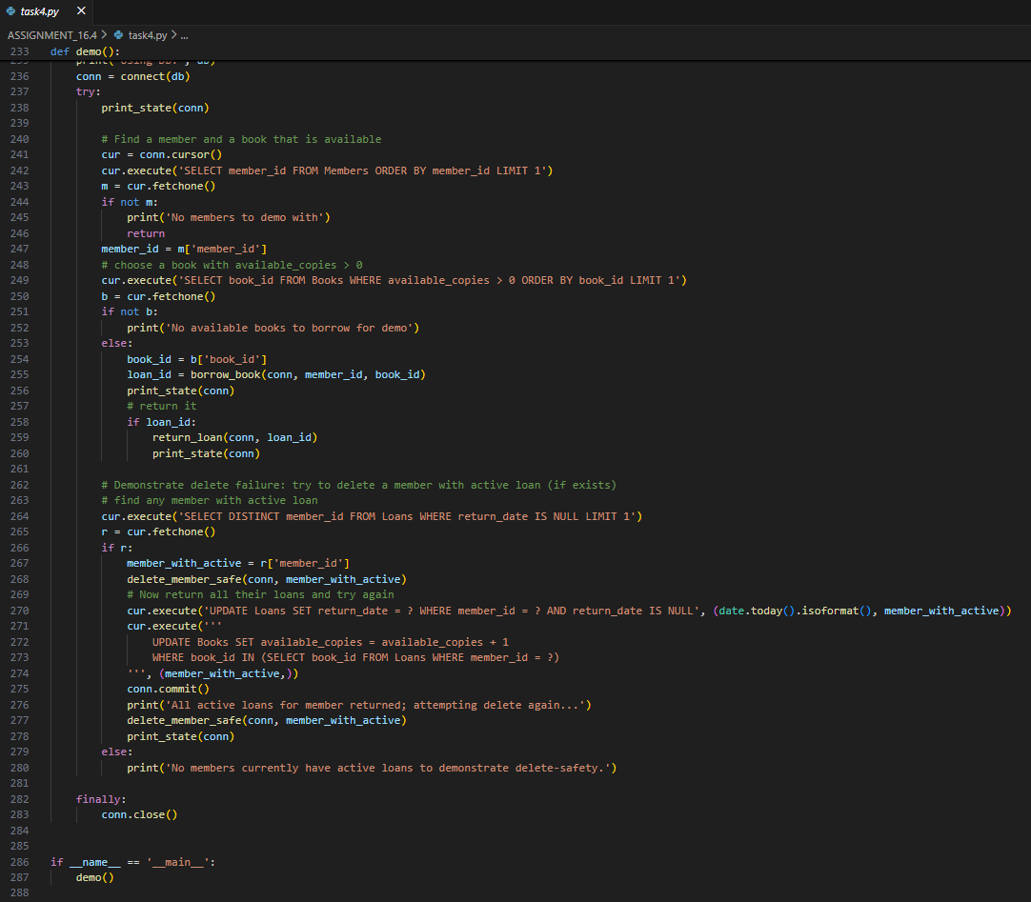

OUTPUT :
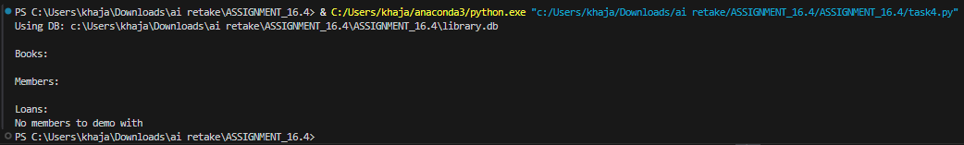
OBSERVATION :
AI provided efficient UPDATE and DELETE statements with appropriate WHERE conditions. Referential integrity was considered to prevent accidental data loss.

