PROOF OF CONCEPT (POC) & DEVELOPMENT PROPOSAL
LOVY
Custom Software Engineering and Implementation Blueprint
Document Version: 1.0
Estimated Budget: $14,164.00 USD
Development Timeline: 2 Months 15 Days
Proposal Type: MVP

1. Executive Summary
Lovy addresses the commercial need for a secure, mobile-first dating experience that helps users discover compatible individuals through shared interests, preferences, and real-time communication. The business challenge is not only to launch a functional Minimum Viable Product (MVP), but also to establish a product foundation that can support user growth, trust, engagement, moderation, and future monetisation without requiring a major re-architecture after market validation.
2. Proposed Solution & Scope
- User onboarding and authentication will include secure registration, login, profile setup, session handling, and controlled access to protected application features so that only verified users can create profiles, discover matches, and initiate conversations.
- Profile management will allow users to create and maintain personal profiles, including core identity attributes, interests, preferences, profile photos, and discovery settings required for a meaningful dating experience.
- Match discovery will provide a mobile-first browsing experience where users can view compatible profiles, express interest, pass on recommendations, and receive matches when mutual intent is established.
- Artificial Intelligence (AI)-assisted matching will use preference-weighted and interest-based logic to improve profile recommendations, prioritise compatibility, and reduce irrelevant discovery results during the Minimum Viable Product (MVP) stage.
- Real-time messaging will enable matched users to communicate through a secure chat experience, supported by backend conversation management, message persistence, and readiness for push notification integration.
- The backend Application Programming Interface (API) layer will manage business rules for authentication, user profiles, matching, chat, data validation, and secure communication between the mobile application and the database.
- The mobile application will be built with React Native to provide a consistent user experience across iOS and Android devices while maintaining a shared codebase for faster delivery and future maintainability.
- A lightweight administrative capability will support operational oversight for the MVP, including visibility into users, reported profiles, basic moderation actions, and operational configuration required for controlled launch readiness.
- Reporting will focus on essential MVP metrics such as registered users, profile completion, match activity, chat initiation, and user engagement indicators so that product decisions can be guided by measurable adoption data.
- Resource allocation will be structured across product design, mobile development, backend engineering, and Quality Assurance (QA) activities to ensure the MVP is designed, implemented, tested, and prepared for release within the agreed timeline and budget.
- Integration readiness will be considered for future services such as push notifications, identity verification, payment subscriptions, analytics platforms, advanced moderation, and customer support tools without overloading the initial MVP scope.
- Future scalability will be supported through modular backend services, a relational PostgreSQL data model, containerised deployment with Docker, and Amazon Web Services (AWS) infrastructure patterns that can evolve as user volume, geography, and feature complexity increase.
3. Estimated Budget & Cost Structure
The total estimated cost for this custom software development solution is $14,164.00 USD. This includes full engineering resources, quality assurance testing, architecture design, and final deployment setup. The detailed cost breakdown is aligned with the technical roles and allocated task hours detailed in Section 7.
4. Proposed Technology Stack
Layer | Technology / Framework | Purpose
Database | PostgreSQL | Primary platform layer for the Database requirements.
Backend | Node.js (NestJS) | Primary platform layer for the Backend requirements.
Frontend | React Native | Primary platform layer for the Frontend requirements.
Cloud | AWS | Primary platform layer for the Cloud requirements.
Artificial intelligence | Node.js (NestJS) preference-based matching service | Primary platform layer for the Artificial Intelligence requirements.
Authentication | Node.js (NestJS) authentication with JSON Web Token (JWT) | Primary platform layer for the Authentication requirements.
Storage | AWS | Primary platform layer for the Storage requirements.
Deployment | Docker on AWS | Primary platform layer for the Deployment requirements.

5. System Workflow Diagram
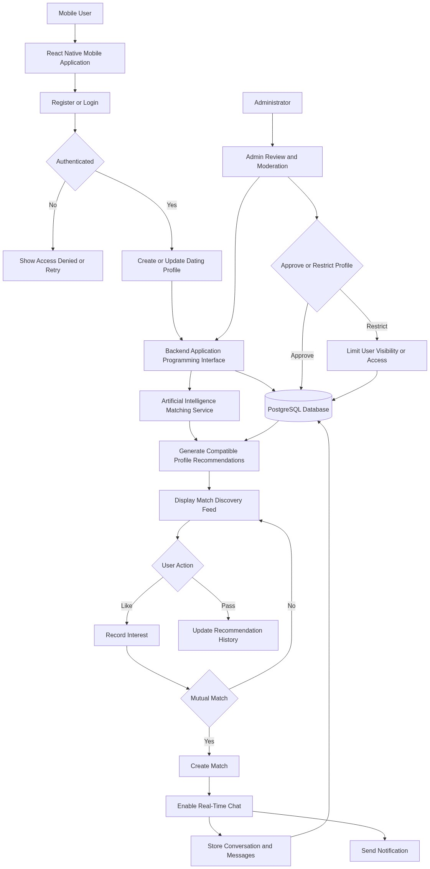
Diagram successfully loaded from mermaid.ink.

6. Development Plan & Timeline
The development cycle is projected at 2 Months 15 Days. Following the structure of our standard Proof of Concept delivery pipeline, the specific deliverables and timeline phases are detailed below:
Phase | Duration | Output
Discovery, Product Alignment, and Solution Planning | 10 Days | Validated Minimum Viable Product (MVP) scope, prioritised user journeys, delivery backlog, acceptance criteria, architecture direction, and release planning baseline aligned with the dating application objectives.
User Experience Design and Prototype Finalisation | 15 Days | Mobile-first Figma designs, clickable prototype, onboarding flow, profile management journey, match discovery screens, chat interface, and design system components ready for engineering implementation.
Backend Services, Database Model, and Matching Logic | 20 Days | Node.js (NestJS) backend services, PostgreSQL schema, authentication services, profile Application Programming Interface (API), match recommendation logic, chat data model, and Docker-based development environment.
React Native Mobile Application Development | 15 Days | Functional React Native mobile application covering registration, login, profile creation, preference capture, match discovery, mutual match handling, and core messaging user interface integration.
Integration, Quality Assurance, and Security Validation | 10 Days | Integrated mobile and backend application, functional test execution, Application Programming Interface (API) validation, defect resolution, authentication checks, performance review, and release readiness assessment.
Deployment Preparation, Demonstration, and Handover | 5 Days | Amazon Web Services (AWS) deployment preparation, Docker packaging, final stakeholder demonstration, technical handover documentation, known issues register, and Minimum Viable Product (MVP) launch recommendation.

7. Assumptions & Key Risks
Assumptions
- The client will nominate a product owner and decision-making stakeholders who can provide timely clarification on dating workflows, profile attributes, match rules, moderation expectations, and launch priorities.
- The client will provide branding direction, logo assets, content guidelines, privacy policy inputs, and any required legal disclaimers before user interface finalisation.
- Amazon Web Services (AWS) account access, deployment permissions, domain configuration, and environment credentials will be made available before the deployment preparation phase.
- Third-party services such as push notifications, identity verification, payment subscriptions, analytics, or email delivery are not included as fully implemented production integrations unless separately approved for the MVP scope.
- Artificial Intelligence (AI)-assisted matching for the MVP will use preference-weighted, rule-based, and interest-based recommendation logic rather than a fully trained proprietary machine learning model requiring large historical datasets.
- Test data, sample user personas, and representative profile scenarios will be provided or approved by the client to support functional testing and realistic matchmaking validation.
- Security review requirements, privacy obligations, and data retention expectations will be confirmed early enough to avoid rework in authentication, profile storage, and messaging workflows.
- Deployment approval and stakeholder availability for demonstration, feedback, and sign-off will be provided within the agreed timeline so that the 2 Months 15 Days delivery plan remains achievable.
Risks & Mitigation
- Risk: Dating application requirements may evolve during development as stakeholders refine user flows, matching behaviour, or moderation expectations.
Mitigation: The project will use structured backlog prioritisation, sprint-level reviews, and controlled change assessment to protect the Minimum Viable Product (MVP) timeline while allowing high-value refinements.
- Risk: Matching quality may be perceived as insufficient if limited user data is available during early launch.
Mitigation: The MVP will implement transparent preference-weighted matching and capture structured user attributes so that recommendation quality can improve as profile volume and behavioural data increase.
- Risk: Real-time chat may introduce performance, reliability, or message consistency challenges under concurrent usage.
Mitigation: Chat workflows will be designed with clear message persistence, backend validation, and scalable service boundaries so that future performance optimisation can be introduced without redesigning the user experience.
- Risk: User privacy and sensitive personal data handling may create compliance and reputational exposure.
Mitigation: Authentication controls, secure backend validation, controlled data access, and privacy-by-design decisions will be incorporated from the beginning of the delivery lifecycle.
- Risk: Mobile application behaviour may vary across iOS and Android devices, screen sizes, and operating system versions.
Mitigation: React Native implementation will follow reusable component patterns, device-aware testing, and structured Quality Assurance (QA) coverage for critical onboarding, profile, match, and chat scenarios.
- Risk: Delays in client-provided assets, cloud access, or approval cycles may impact delivery sequencing.
Mitigation: Dependencies will be tracked from project initiation, and placeholder assets or local development environments will be used where appropriate until final approvals are available.
- Risk: Administrative moderation expectations may exceed the intended MVP operational scope.
Mitigation: The MVP will include essential moderation readiness while documenting advanced moderation, automation, and analytics capabilities as future roadmap items.
- Risk: Production deployment readiness may be affected by late infrastructure, security, or environment decisions.
Mitigation: Deployment requirements will be confirmed during early planning, Docker-based packaging will be maintained throughout development, and Amazon Web Services (AWS) preparation will be scheduled before final handover.
8. Allocated Technical Resources
Resource Name | Assigned Role | Allocated Hours
Rohit Mukherjee | React Native Developer | 321 Hours
Tanya Iyer | React Native Developer | 107 Hours
Serya Mallick | Backend Developer | 267 Hours
Abhijit Dutta | User Interface and User Experience Designer | 160 Hours
Ankita Sen | Quality Assurance Engineer | 214 Hours
Ankan Bhowmick | Quality Assurance Engineer | 214 Hours

