PROOF OF CONCEPT (POC) & DEVELOPMENT PROPOSAL
LOVY
Custom Software Engineering and Implementation Blueprint
Document Version: 1.0
Estimated Budget: $14,164.00 USD
Development Timeline: 2 Months 15 Days
Proposal Type: MVP

1. Executive Summary
Lovy is positioned to address a clear market need for a secure, intuitive, and relationship-oriented dating experience that reduces user friction while enabling meaningful discovery and engagement. The client's immediate business challenge is to deliver a Minimum Viable Product (MVP) that validates core dating workflows, including onboarding, profile creation, discovery, matching, real-time messaging, and secure interactions, without overextending the initial delivery scope or compromising the foundation required for future scale.
2. Proposed Solution & Scope
- Mobile onboarding and authentication workflow will enable users to register, log in, maintain session continuity, and securely access the application through a structured backend authentication layer implemented with Node.js and NestJS.
- User profile management will allow individuals to create and update dating profiles, including personal details, preferences, profile media references, and discovery-related attributes required for meaningful match recommendations.
- Discovery and matching functionality will provide users with a curated browsing experience where profiles are presented based on preferences, compatibility inputs, and MVP-level intelligent matchmaking rules that can later evolve into more advanced Artificial Intelligence (AI)-driven recommendations.
- Match interaction workflows will support like, pass, mutual match detection, and match status management so that conversations are only initiated when both users have expressed reciprocal interest.
- Real-time chat will be delivered using WebSocket-based communication through the backend, enabling matched users to exchange messages with low latency while persisting relevant conversation records in PostgreSQL.
- Push notification capability will be integrated using Firebase Cloud Messaging to notify users about relevant events such as new matches, new chat messages, and important engagement updates.
- Administrative features will include foundational controls for reviewing user activity, supporting moderation workflows, and enabling operational visibility into users, matches, and reported interactions within the MVP scope.
- Reporting capabilities will focus on operational and product metrics such as user registrations, active users, match counts, chat activity, and notification events to help the client evaluate MVP adoption and engagement quality.
- Payment readiness will be supported through Stripe integration planning and foundational backend structure, allowing future monetization features such as premium subscriptions, boosts, or paid visibility options to be incorporated without major architectural rework.
- Resource allocation will use a focused delivery team consisting of React Native development, backend engineering, user experience design, and quality assurance capacity aligned to the MVP timeline and budget.
- The end-to-end generation workflow for recommendations will begin with user profile and preference capture, continue through backend validation and compatibility processing, retrieve eligible profiles from PostgreSQL, apply matchmaking logic, and return a ranked discovery feed to the mobile application.
- Integration possibilities will include future expansion to identity verification, content moderation services, analytics platforms, advanced Artificial Intelligence (AI) models, payment subscriptions, and customer engagement automation.
- Future scalability will be supported through modular NestJS services, PostgreSQL data modeling, Redis-assisted performance optimization, WebSocket separation for real-time communication, and Amazon Web Services deployment patterns suitable for growth beyond the MVP.
3. Estimated Budget & Cost Structure
The total estimated cost for this custom software development solution is $14,164.00 USD. This includes full engineering resources, quality assurance testing, architecture design, and final deployment setup. The detailed cost breakdown is aligned with the technical roles and allocated task hours detailed in Section 7.
4. Proposed Technology Stack
Layer | Technology / Framework | Purpose
Database | PostgreSQL | Primary platform layer for the Database requirements.
Backend | Node.js, NestJS, WebSocket | Primary platform layer for the Backend requirements.
Frontend | React Native | Primary platform layer for the Frontend requirements.
Cloud | AWS | Primary platform layer for the Cloud requirements.
Artificial intelligence | Node.js, NestJS | Primary platform layer for the Artificial Intelligence requirements.
Authentication | Node.js, NestJS | Primary platform layer for the Authentication requirements.
Storage | AWS | Primary platform layer for the Storage requirements.
Deployment | AWS | Primary platform layer for the Deployment requirements.

5. System Workflow Diagram
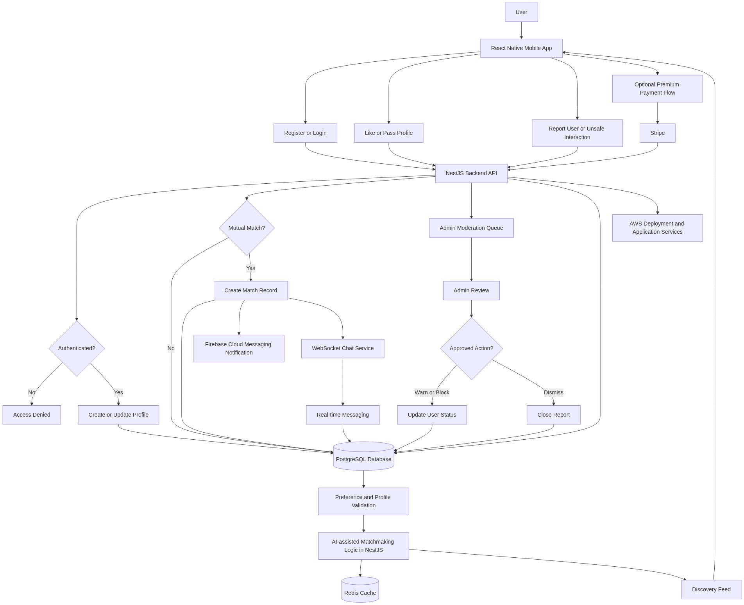
Diagram successfully loaded from mermaid.ink.

6. Development Plan & Timeline
The development cycle is projected at 2 Months 15 Days. Following the structure of our standard Proof of Concept delivery pipeline, the specific deliverables and timeline phases are detailed below:
Phase | Duration | Output
Discovery, MVP Definition, and Product Experience Design | 10 Days | Validated MVP scope, user journey definition, information architecture, screen-level wireframes, Figma-based mobile experience design, and acceptance criteria for onboarding, profiles, discovery, matching, chat, notifications, and administration.
Architecture, Data Modeling, and Backend Foundation | 15 Days | Backend architecture using Node.js and NestJS, PostgreSQL schema design, authentication service foundation, user and profile APIs, match-related domain model, initial administrative API structure, and Amazon Web Services deployment baseline.
Mobile Application Development for Core User Workflows | 15 Days | React Native mobile application screens and navigation flows covering registration, login, profile setup, preference capture, discovery feed, profile actions, match visibility, and core user interaction states.
Matching, Real-time Chat, Notifications, and Integration Build | 15 Days | MVP matchmaking logic, mutual match workflow, WebSocket-based chat capability, message persistence, Firebase Cloud Messaging notification integration, Redis-assisted performance handling, and Stripe-ready backend integration structure.
Quality Assurance, Security Validation, and Stabilization | 10 Days | Functional testing, mobile compatibility testing, Application Programming Interface (API) validation, chat and notification testing, regression testing, defect resolution support, and security checks for authentication, data access, and user interaction workflows.
Deployment, User Acceptance Support, and MVP Handover | 10 Days | MVP deployment to the agreed Amazon Web Services environment, user acceptance testing support, release readiness validation, technical handover documentation, known limitations register, and recommended roadmap for full product expansion.

7. Assumptions & Key Risks
Assumptions
- The client will provide timely access to brand assets, content guidelines, legal disclaimers, privacy policy requirements, and any market-specific compliance expectations required for a dating application.
- The client will nominate business stakeholders who can review user journeys, approve Figma designs, validate MVP functionality, and provide decisions within agreed sprint timelines.
- Amazon Web Services infrastructure access, accounts, permissions, billing configuration, and environment ownership will either be provided by the client or created under a mutually agreed operating model before deployment activities begin.
- Third-party services including Firebase Cloud Messaging and Stripe will be provisioned by the client with production or sandbox credentials, and any commercial fees charged by those providers will remain outside the stated development budget unless separately agreed.
- The MVP will use deterministic and rules-based intelligent matchmaking logic implemented within the Node.js and NestJS backend, while advanced Artificial Intelligence (AI) model training, behavioral learning, and large-scale recommendation optimization will be considered part of a future product phase.
- The testing environment will contain representative but non-sensitive sample data, and the client will not require the use of real personal user data during MVP validation unless appropriate security and privacy approvals are completed.
- Security approvals, application store readiness requirements, and deployment approvals will be coordinated by the client in parallel with development to avoid delays during release preparation.
- The MVP scope assumes standard mobile application workflows and does not include complex identity verification, biometric verification, video calling, advanced content moderation, or full subscription lifecycle automation unless added through a formal change request.
Risks & Mitigation
- Risk: Dating applications process sensitive user profile and interaction data, which may create privacy, trust, and compliance concerns if data access controls are not implemented carefully. Mitigation: The solution will apply secure authentication patterns, role-based administrative access, controlled Application Programming Interface (API) endpoints, and privacy-aware data handling practices from the initial architecture stage.
- Risk: Real-time chat performance may degrade if concurrent usage grows faster than expected after launch. Mitigation: The WebSocket implementation will be designed as a separate backend capability with Redis-assisted performance handling and an architecture that can be scaled independently on Amazon Web Services.
- Risk: Matchmaking expectations may vary significantly between stakeholders and early users, creating pressure to expand beyond the MVP scope. Mitigation: The MVP will focus on transparent preference-based and rules-based matchmaking, with measurable engagement data used to guide future Artificial Intelligence (AI) enhancements.
- Risk: Push notifications may behave differently across iOS and Android devices due to platform-specific permissions and delivery constraints. Mitigation: Firebase Cloud Messaging will be tested across representative mobile devices and user permission scenarios during the quality assurance phase.
- Risk: Changes in business requirements during development may affect the timeline and budget. Mitigation: Agile sprint planning, structured backlog control, and formal change assessment will be used to protect the MVP delivery baseline while allowing prioritized refinements.
- Risk: App store submission, policy review, or production release readiness may take longer than the development schedule. Mitigation: Release preparation activities, policy review considerations, and required mobile assets will be identified early so that the client can prepare submission materials in parallel.
- Risk: Stripe integration may require business, compliance, or account verification steps that are outside the engineering team's direct control. Mitigation: The MVP will establish a Stripe-ready technical foundation while treating final production payment activation as dependent on the client's Stripe account readiness.
- Risk: Limited stakeholder availability may delay design approvals, user acceptance testing, and final release decisions. Mitigation: The project will use planned review checkpoints, documented decisions, and consolidated feedback cycles to reduce dependency-related delays.
8. Allocated Technical Resources
Resource Name | Assigned Role | Allocated Hours
Rohit Mukherjee | React Native Developer | 321 Hours
Tanya Iyer | React Native Developer | 107 Hours
Serya Mallick | Backend Developer | 267 Hours
Abhijit Dutta | UI/UX Designer | 160 Hours
Ankita Sen | QA Engineer | 214 Hours
Ankan Bhowmick | QA Engineer | 214 Hours

