PROOF OF CONCEPT (POC) & DEVELOPMENT PROPOSAL
SHOPY
Custom Software Engineering and Implementation Blueprint
Document Version: 1.0
Estimated Budget: $17,802.00 USD
Development Timeline: 2 Months 15 Days
Proposal Type: MVP

1. Executive Summary
Retailers and brands increasingly require direct-to-consumer digital commerce channels that can be launched quickly, operated securely, and scaled without creating operational complexity for store teams. Shopy addresses this need by delivering a mobile-first e-commerce platform where customers can browse products, manage carts, complete secure checkout, and track orders, while store owners manage catalog, inventory, and order fulfilment through an intuitive administrative experience. The Minimum Viable Product (MVP) is required to validate the core commercial journey, reduce time to market, and establish a reliable foundation for future enterprise capabilities such as advanced analytics, automation, and third-party integrations.
2. Proposed Solution & Scope
- Customer mobile shopping experience: The MVP will deliver a mobile-first storefront using React Native, enabling customers to browse product listings, view product details, manage shopping carts, initiate checkout, and review order status through a streamlined user journey designed for conversion and usability.
- Product catalog and inventory management: Store owners will be able to create, update, and manage products, categories, pricing, product availability, and inventory quantities through an administrative interface supported by structured backend services and PostgreSQL data persistence.
- Secure checkout and order management: The solution will implement a checkout workflow that captures customer details, validates cart information, creates orders, updates inventory, and prepares the platform for integration with payment providers, fulfilment partners, and notification channels during or after the MVP phase.
- Authentication and access control: The platform will separate customer and administrator access patterns through backend-managed authentication and role-aware authorization, ensuring that administrative functions such as inventory updates, order processing, and catalog management are restricted to approved users.
- Backend Application Programming Interface (API) services: NestJS running on Node.js will provide modular backend services for catalog, cart, checkout, inventory, order, and administrative workflows, ensuring that the platform is maintainable, testable, and ready for future web, marketplace, and integration channels.
- Artificial Intelligence readiness and assisted analytics: The MVP will structure commerce, product, and order data in a way that supports future Artificial Intelligence (AI) use cases such as product recommendations, demand forecasting, customer segmentation, fraud pattern identification, and operational insights without disrupting the initial checkout-focused release.
- Administrative features: Store owners will receive core operational capabilities for product maintenance, inventory updates, order review, and order status management, enabling the business to operate the storefront without technical intervention.
- Reporting foundation: The MVP will capture essential transactional and operational data required for future dashboards, including order volume, product activity, inventory movement, and checkout performance indicators, allowing the product to evolve into a more comprehensive analytics platform.
- Integration possibilities: The architecture will be designed to support future integrations with payment gateways, shipping providers, customer relationship management systems, enterprise resource planning platforms, marketing automation tools, and notification services through controlled backend service boundaries.
- Resource allocation and delivery governance: The delivery team will include specialist capacity across user experience design, mobile engineering, backend development, quality assurance, and limited Artificial Intelligence readiness advisory to ensure that the MVP is implemented with appropriate functional quality and future extensibility.
- End-to-end operational workflow: The platform workflow will begin with administrator catalog setup, continue through customer product discovery and checkout, progress into backend order creation and inventory updates, and conclude with order visibility for both customers and store owners.
- Future scalability: The solution will be structured using modern software engineering practices, containerized deployment with Docker, cloud deployment on Amazon Web Services (AWS), modular backend services, and a relational database model that can support additional storefronts, analytics, automation, and enterprise integrations after MVP validation.
3. Estimated Budget & Cost Structure
The total estimated cost for this custom software development solution is $17,802.00 USD. This includes full engineering resources, quality assurance testing, architecture design, and final deployment setup. The detailed cost breakdown is aligned with the technical roles and allocated task hours detailed in Section 7.
4. Proposed Technology Stack
Layer | Technology / Framework | Purpose
Database | PostgreSQL | Primary platform layer for the Database requirements.
Backend | NestJS (Node.js) | Primary platform layer for the Backend requirements.
Frontend | React Native | Primary platform layer for the Frontend requirements.
Cloud | AWS | Primary platform layer for the Cloud requirements.
Artificial intelligence | Not included in the MVP technology stack | Primary platform layer for the Artificial Intelligence requirements.
Authentication | NestJS (Node.js) | Primary platform layer for the Authentication requirements.
Storage | AWS | Primary platform layer for the Storage requirements.
Deployment | Docker | Primary platform layer for the Deployment requirements.

5. System Workflow Diagram
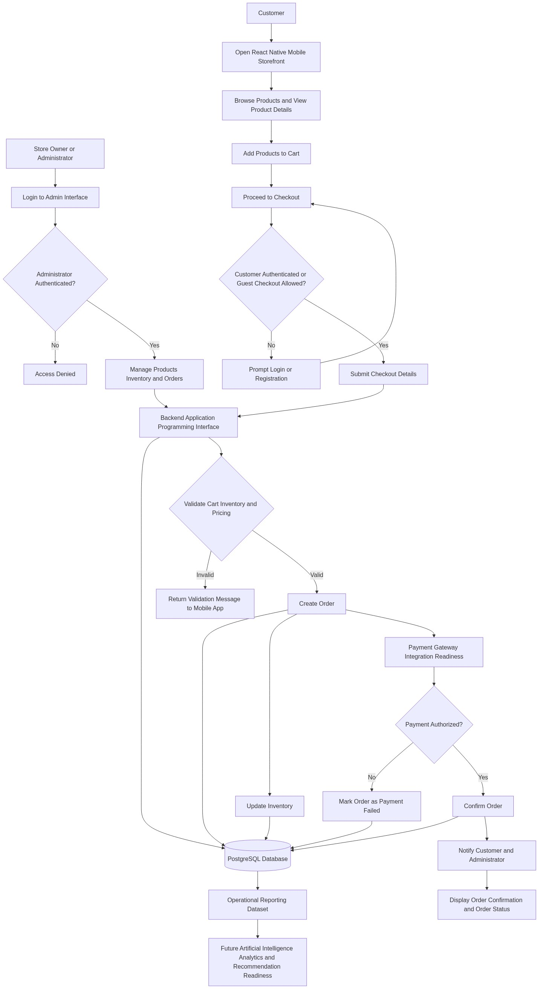
Diagram successfully loaded from mermaid.ink.

6. Development Plan & Timeline
The development cycle is projected at 2 Months 15 Days. Following the structure of our standard Proof of Concept delivery pipeline, the specific deliverables and timeline phases are detailed below:
Phase | Duration | Output
Discovery, Architecture, and MVP Backlog Finalization | 10 Days | Validated MVP scope, prioritized user journeys, functional backlog, technical architecture, data model approach, integration assumptions, delivery plan, and acceptance criteria for the mobile storefront, administration workflows, and backend services.
User Experience Design and Prototype Preparation | 15 Days | Mobile-first customer journey designs, administrative workflow screens, checkout experience prototype, reusable design components, product catalog interaction patterns, and stakeholder-approved user interface direction for implementation.
Core Backend and Database Development | 20 Days | NestJS backend services, PostgreSQL schema, product catalog services, inventory management services, cart and order services, role-aware administrative access structure, Application Programming Interface endpoints, and Docker-based local development configuration.
Mobile Storefront and Admin Workflow Implementation | 15 Days | React Native mobile storefront implementation, product browsing screens, cart and checkout flow, customer order confirmation experience, administrative product and order management workflows, and integration with backend Application Programming Interface services.
Quality Assurance, Stabilization, and Security Validation | 10 Days | Functional test execution, mobile workflow validation, Application Programming Interface testing, checkout scenario testing, defect remediation, regression testing, basic security validation, and MVP release readiness assessment.
Deployment, Demonstration, and Knowledge Transfer | 5 Days | Docker-based deployment package, Amazon Web Services deployment support, final MVP demonstration, release notes, operational handover, technical knowledge transfer, and backlog recommendations for the next product increment.

7. Assumptions & Key Risks
Assumptions
- The client will provide timely access to business stakeholders who can confirm catalog rules, checkout expectations, order statuses, administrative permissions, and MVP acceptance priorities.
- The client will confirm whether the MVP should use a live payment provider, a sandbox payment provider, or a payment-integration-ready checkout flow before development of the checkout module begins.
- Amazon Web Services (AWS) account access, cloud environment permissions, domain configuration, and deployment approvals will be made available in time to support environment setup and release activities.
- Product data, category structures, inventory rules, sample images, pricing logic, tax expectations, and order fulfilment assumptions will be provided by the client or approved as representative sample data for MVP demonstration.
- Third-party services such as payment gateways, shipping providers, e-mail services, short message service providers, or analytics platforms are assumed to be outside the core MVP unless explicitly confirmed during discovery.
- Artificial Intelligence (AI) capabilities in the MVP are limited to data readiness, analytics structuring, and advisory input; dedicated recommendation engines, forecasting models, or automated decision models will be considered future enhancements.
- A dedicated testing environment will be available for functional testing, integration testing, user acceptance testing, and deployment validation before production or pilot release.
- Security approvals, privacy requirements, data retention expectations, and compliance constraints will be reviewed by the client during discovery and will not materially change after the MVP backlog is baselined.
- Client-side user acceptance testing feedback will be provided within agreed review windows so that defects and priority refinements can be incorporated without impacting the 2 Months 15 Days delivery timeline.
- App store publishing, enterprise mobile distribution, production payment certification, and high-volume performance testing are assumed to be post-MVP activities unless specifically included during final scope confirmation.
Risks & Mitigation
- Risk: Payment gateway requirements may introduce additional compliance, certification, or integration complexity beyond the MVP checkout flow. Mitigation: Confirm payment scope during discovery, begin with sandbox or payment-readiness integration where appropriate, and isolate payment processing behind backend service boundaries for later expansion.
- Risk: Changes in product catalog, pricing, inventory, or order management rules during development may affect database design and backend service logic. Mitigation: Establish a prioritized MVP backlog, secure early approval of core commerce rules, and manage refinements through controlled sprint reviews.
- Risk: Mobile checkout usability issues may reduce conversion effectiveness if the customer journey is not validated early. Mitigation: Use clickable design prototypes, review the checkout journey with stakeholders before development, and perform focused usability validation during quality assurance.
- Risk: Administrative workflows may become broader than the MVP timeline allows if advanced merchandising, promotions, returns, refunds, or multi-store operations are introduced. Mitigation: Limit the MVP to product, inventory, and order management fundamentals while documenting advanced capabilities for the post-MVP roadmap.
- Risk: Cloud access, deployment permissions, or environment readiness delays may affect release timing. Mitigation: Initiate Amazon Web Services environment planning in the first phase, maintain Docker-based deployment consistency, and identify required approvals before stabilization begins.
- Risk: Data quality issues in sample product, inventory, or order information may affect testing accuracy and stakeholder confidence. Mitigation: Define required test datasets early, validate sample catalog data with the client, and maintain repeatable test scenarios for customer and administrator workflows.
- Risk: Resource availability constraints may impact delivery velocity during overlapping design, development, and testing activities. Mitigation: Assign clear responsibilities, sequence dependent tasks carefully, conduct weekly delivery governance reviews, and use quality assurance planning early rather than only at the end of the project.
- Risk: Security requirements may expand after implementation has started, particularly around authentication, authorization, personal data handling, and checkout data. Mitigation: Review security expectations during discovery, implement role-aware access controls from the beginning, and conduct security validation before MVP release.
- Risk: Future Artificial Intelligence and analytics expectations may be interpreted as part of the MVP despite the current focus on core shopping and checkout flows. Mitigation: Define Artificial Intelligence scope explicitly as data-readiness and future enablement for MVP, while maintaining a structured roadmap for recommendations, forecasting, and advanced analytics.
8. Allocated Technical Resources
Resource Name | Assigned Role | Allocated Hours
Abhijit Dutta | UI/UX Designer | 120 Hours
Rohit Mukherjee | React Native Developer | 300 Hours
Tanya Iyer | React Native Developer | 120 Hours
Serya Mallick | Backend Developer | 320 Hours
Ankita Sen | QA Engineer | 180 Hours
Arijit Sarkar | Data Scientist | 40 Hours

