PROOF OF CONCEPT (POC) & DEVELOPMENT PROPOSAL
LEARNWITHAI
Custom Software Engineering and Implementation Blueprint
Document Version: 1.0
Estimated Budget: $22,730.00 USD
Development Timeline: 2 Months 15 Days
Proposal Type: MVP

1. Executive Summary
LearnWithAI addresses a critical business challenge in modern education: learners require individualized guidance, timely feedback, and adaptive content pathways, while education providers need a scalable platform that can support diverse learning objectives without increasing the operational burden on instructors or administrators. The Minimum Viable Product (MVP) will establish a secure, web-accessible platform that enables students and professionals to register, complete onboarding, receive personalized learning recommendations, access curated educational content, and complete interactive assessments aligned with their progress and goals.
The proposed solution is required because static learning platforms frequently fail to account for differences in learner proficiency, pace, engagement patterns, and content preferences. By applying Artificial Intelligence (AI) and Machine Learning (ML) capabilities through OpenAI API, Pinecone, and a Python (FastAPI) service layer, LearnWithAI will provide intelligent tutoring support, generate personalized learning paths, retrieve relevant learning material using vector-based search, and support adaptive assessment experiences. This approach improves learning efficiency by enabling the platform to recommend the right content at the right time, while also giving administrators actionable visibility into learner progress and content effectiveness.
The expected business outcomes include faster learner onboarding, higher engagement through personalized journeys, improved completion rates, and a scalable foundation for future monetization models such as professional certification tracks, enterprise learning programs, or premium AI tutoring. The MVP will be designed with maintainability, security, and extensibility as core principles, using React (Next.js) and TypeScript for the frontend, Node.js (NestJS) and Python (FastAPI) for service orchestration and AI workloads, PostgreSQL for structured application data, Pinecone for vector retrieval, Docker for environment consistency, and Amazon Web Services (AWS) for scalable cloud deployment.
Implementation will follow modern software engineering practices, including modular architecture, iterative delivery, design validation through Figma prototypes, secure authentication patterns, structured Application Programming Interface (API) development, automated quality assurance using Playwright-oriented test coverage, and deployment readiness through containerized services. The delivery strategy focuses on building a commercially demonstrable MVP within the agreed timeline, while ensuring the technical foundation can evolve into a full-scale learning experience platform without requiring major reengineering.
2. Proposed Solution & Scope
- The MVP will include learner registration, secure login, learner profile setup, goal capture, proficiency intake, and role-based access so that students, professionals, and administrators can interact with the platform through controlled and auditable user journeys.
- The learner workflow will begin with authentication, followed by onboarding questions that capture learning goals, experience level, subject interests, and preferred learning outcomes; this data will be processed by the backend and AI services to generate an initial personalized learning path.
- The platform will include a responsive web experience built with React (Next.js) and TypeScript, allowing learners to access dashboards, recommended content, tutoring interactions, assessments, progress summaries, and learning history from modern desktop and mobile browsers.
- The core learning module will support structured educational content, lesson sequencing, content discovery, and progress tracking, enabling administrators to maintain learning materials while enabling learners to continue from their current stage without losing context.
- Artificial Intelligence capabilities will include personalized learning path generation, intelligent tutoring responses, contextual content retrieval, and adaptive assessment support using OpenAI API, Pinecone, and a Python (FastAPI) AI service layer designed to separate AI orchestration from core platform transactions.
- The Retrieval-Augmented Generation (RAG) workflow will index approved educational content into Pinecone, retrieve relevant content based on learner questions or learning goals, and use OpenAI API to generate context-aware explanations that remain aligned with the available learning material.
- Authentication will be implemented through backend-managed secure authentication using Node.js (NestJS), with role-based access controls for learners and administrators, protected API endpoints, secure password handling, and session management appropriate for an MVP environment.
- Administrative features will include content management, learner overview, assessment configuration, AI content indexing triggers, and high-level platform monitoring so that authorized administrators can manage the educational experience without direct database intervention.
- Reporting will include learner progress summaries, assessment outcomes, completed modules, engagement indicators, and administrator-facing visibility into platform usage, enabling early business validation of learner adoption and educational effectiveness.
- Integration possibilities will be designed into the architecture through modular APIs, allowing future integration with learning management systems, payment gateways, enterprise identity providers, certification providers, analytics platforms, and notification services without restructuring the MVP foundation.
- The personalized learning plan generation workflow will use onboarding inputs, profile data, historical activity, assessment results, and AI-assisted recommendations to produce a practical learning path that can be refined as the learner completes lessons and assessments.
- Resource allocation will prioritize User Interface/User Experience (UI/UX) design, frontend implementation, AI engineering, data science support, and quality assurance, ensuring that the MVP demonstrates the differentiated learning experience while retaining reliable platform behavior.
- Future scalability will be supported through clear service boundaries, containerized deployment with Docker, structured PostgreSQL schema design, vector-based knowledge retrieval through Pinecone, and AWS-based hosting patterns suitable for incremental growth in users, content volume, and AI workload.
3. Estimated Budget & Cost Structure
The total estimated cost for this custom software development solution is $22,730.00 USD. This includes full engineering resources, quality assurance testing, architecture design, and final deployment setup. The detailed cost breakdown is aligned with the technical roles and allocated task hours detailed in Section 7.
4. Proposed Technology Stack
Layer | Technology / Framework | Purpose
Database | PostgreSQL | Primary platform layer for the Database requirements.
Backend | Node.js (NestJS), Python (FastAPI) | Primary platform layer for the Backend requirements.
Frontend | React (Next.js), TypeScript | Primary platform layer for the Frontend requirements.
Cloud | AWS | Primary platform layer for the Cloud requirements.
Artificial intelligence | OpenAI API, Pinecone | Primary platform layer for the Artificial Intelligence requirements.
Authentication | Node.js (NestJS) | Primary platform layer for the Authentication requirements.
Storage | PostgreSQL, Pinecone, AWS | Primary platform layer for the Storage requirements.
Deployment | Docker, AWS | Primary platform layer for the Deployment requirements.

5. System Workflow Diagram
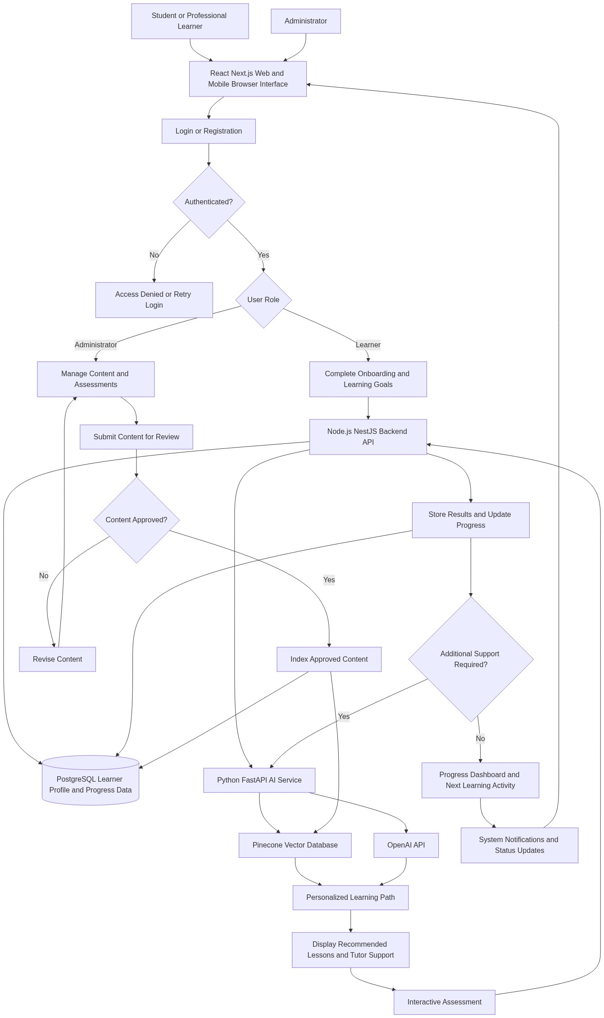
Diagram successfully loaded from mermaid.ink.

6. Development Plan & Timeline
The development cycle is projected at 2 Months 15 Days. Following the structure of our standard Proof of Concept delivery pipeline, the specific deliverables and timeline phases are detailed below:
Phase | Duration | Output
Discovery, Product Definition, and Experience Design | 10 Days | Validated MVP scope, learner and administrator journeys, prioritized product backlog, information architecture, Figma wireframes, responsive interface direction, and acceptance criteria aligned with the personalized learning use cases.
Core Platform Architecture and Foundation Development | 20 Days | Application architecture, PostgreSQL data model, Node.js (NestJS) backend foundation, React (Next.js) frontend foundation, authentication flow, user roles, learner profile services, and Docker-based development environment.
Artificial Intelligence Learning Engine and Content Retrieval Implementation | 20 Days | Python (FastAPI) AI service, OpenAI API integration, Pinecone vector retrieval workflow, learning path generation logic, tutoring interaction flow, content indexing process, and initial prompt engineering framework for adaptive learning support.
Learning Modules, Assessments, Dashboards, and Administration | 15 Days | Learner dashboard, recommended content views, interactive assessment workflow, progress tracking, administrator content management, assessment configuration, reporting views, and integration between learner activity and AI-assisted recommendations.
Quality Assurance, Security Hardening, Deployment Readiness, and MVP Handover | 10 Days | Functional testing, API testing, browser compatibility validation, defect remediation, basic security verification, AWS deployment preparation, Dockerized release package, user acceptance testing support, and MVP handover documentation.

7. Assumptions & Key Risks
Assumptions
- The client will provide timely access to product stakeholders, subject matter experts, and decision makers for requirement clarification, sprint reviews, design approvals, and user acceptance testing.
- The client will provide representative educational content, sample lesson structures, assessment examples, and learning domain priorities before AI content indexing and personalization workflows are finalized.
- The MVP will focus on web and mobile-responsive browser access rather than native iOS or Android mobile applications, allowing the product to validate learner engagement within the agreed budget and timeline.
- AWS account access, deployment permissions, domain configuration, and any required infrastructure approvals will be made available by the client or jointly coordinated before deployment readiness activities begin.
- OpenAI API and Pinecone accounts, usage limits, billing arrangements, and access credentials will be provided or approved by the client, as these third-party services directly influence AI functionality and operating cost.
- The AI outputs will be positioned as learning assistance and tutoring support, with final educational accuracy dependent on the quality of approved content, prompt design, retrieval configuration, and stakeholder validation.
- The testing environment will include representative learner and administrator accounts, sample content, sample assessments, and realistic usage scenarios to support functional, API, and user acceptance testing.
- Security approvals, privacy expectations, and data retention requirements will be confirmed during discovery so that authentication, access control, and learner data handling are implemented appropriately for the MVP scope.
- Any integrations with external learning management systems, payment gateways, enterprise identity providers, or certification platforms are considered future enhancements unless explicitly prioritized during MVP backlog refinement.
- Deployment approval and production release timing will depend on client-side review, environment readiness, third-party service availability, and completion of agreed acceptance criteria.
Risks & Mitigation
- Risk: Educational content may not be available in a structured or validated format during implementation, which could reduce the accuracy of AI-assisted tutoring and content recommendations.
Mitigation: Establish a content readiness checklist during discovery, use a controlled sample knowledge base for the MVP, and validate AI responses against approved learning material before demonstration.
- Risk: AI-generated responses may occasionally be incomplete, overly broad, or misaligned with the intended curriculum if prompts and retrieval context are not sufficiently refined.
Mitigation: Implement Retrieval-Augmented Generation using Pinecone, apply prompt guardrails, restrict responses to indexed educational content where appropriate, and include stakeholder review cycles for tutoring quality.
- Risk: Changes in business priorities during development may expand the MVP beyond the approved budget and timeline.
Mitigation: Use Agile sprint planning, maintain a prioritized backlog, apply formal change control for scope additions, and reserve implementation capacity for the highest-value learning workflows.
- Risk: Third-party service limitations, including OpenAI API rate limits or Pinecone configuration constraints, may affect response time or testing throughput.
Mitigation: Validate service limits early, design retry and error handling patterns, monitor usage during testing, and configure scalable service plans as the user base increases.
- Risk: Authentication and learner data handling requirements may become more stringent after implementation has started, potentially requiring rework.
Mitigation: Confirm baseline security, privacy, and access control expectations during the discovery phase and implement role-based access with secure backend patterns from the start.
- Risk: Browser and device variability may affect the learner experience across desktop and mobile-responsive views.
Mitigation: Define target browsers and devices during discovery, implement responsive design standards, and perform cross-browser validation using automated and manual quality assurance practices.
- Risk: AI personalization effectiveness may be difficult to validate without sufficient learner activity data during the MVP stage.
Mitigation: Use onboarding inputs, sample assessment outcomes, rule-assisted recommendation logic, and stakeholder-reviewed test scenarios until real learner behavior data becomes available.
- Risk: Deployment may be delayed if AWS access, environment configuration, or security approvals are not completed on schedule.
Mitigation: Initiate infrastructure readiness activities early, document required permissions, and conduct deployment preparation before the final quality assurance phase.
- Risk: Resource availability constraints may affect delivery sequencing if specialized AI engineering or quality assurance capacity is reduced during critical phases.
Mitigation: Sequence work around the most specialized tasks first, maintain clear technical documentation, and assign overlapping knowledge-sharing responsibilities across AI, frontend, and testing activities.
8. Allocated Technical Resources
Resource Name | Assigned Role | Allocated Hours
Abhijit Dutta | UI/UX Designer | 160 Hours
Sayan Sen | Frontend Developer | 214 Hours
Avijit Chowdhury | AI Engineer | 321 Hours
Nahid Sinha | AI Engineer | 107 Hours
Arijit Sarkar | Data Scientist | 214 Hours
Ankita Sen | QA Engineer | 214 Hours

