PROOF OF CONCEPT (POC) & DEVELOPMENT PROPOSAL
PRE-SALES AI PLATFORM
Custom Software Engineering and Implementation Blueprint
Document Version: 1.0
Estimated Budget: $16,945.00 USD
Development Timeline: 3 Months
Proposal Type: FULL

1. Executive Summary
Technology service providers often experience significant effort leakage during the pre-sales lifecycle because client requirements, estimation logic, proposal preparation, resource planning, and stakeholder communication are handled across disconnected tools and manual workflows. The Pre-Sales AI Platform addresses this challenge by centralizing requirement intake, intelligent analysis, proposal generation, collaboration, administrative review, and decision support within a single cloud-based operating model. The solution is required to improve estimation consistency, reduce proposal turnaround time, and provide leadership teams with a controlled, auditable mechanism for managing pre-sales opportunities from initial client submission through internal review and final proposal decisioning.
Artificial Intelligence (AI), delivered through the OpenAI Application Programming Interface (API), will strengthen the pre-sales process by interpreting client-provided requirements, identifying delivery complexity, recommending suitable technology stacks, estimating budgets and timelines, and suggesting resource allocations based on defined business logic and available resource data. This AI-assisted workflow will not replace commercial governance; instead, it will accelerate analysis while enabling employees, administrators, and super administrators to validate, refine, approve, and communicate recommendations through structured collaboration and real-time chat.
The expected business outcomes include faster response cycles for client inquiries, improved estimation quality, reduced dependency on manual spreadsheet-based calculations, better utilization visibility across delivery resources, and a more professional proposal management experience for both internal teams and clients. The platform will be designed with role-based access control, structured data persistence in PostgreSQL, maintainable service-oriented backend design using FastAPI, and a responsive React frontend that supports scalable user experiences across client, employee, admin, and super admin personas.
The implementation strategy will follow modern software engineering practices, including modular architecture, iterative delivery, secure authentication patterns, automated and manual quality assurance, Application Programming Interface (API) validation, and deployment readiness activities. The Proof of Concept will establish the complete functional foundation for requirement submission, AI-powered estimation, proposal lifecycle management, real-time collaboration, administration, and reporting, while preserving a scalable architecture that can later support advanced analytics, Customer Relationship Management integration, document automation, and enterprise governance workflows.
2. Proposed Solution & Scope
- Client requirement intake will enable clients to submit structured project details, functional expectations, preferred technologies, timeline expectations, and budget context so that the organization can convert early-stage opportunities into standardized pre-sales records.
- The user workflow will begin with authenticated access, continue through requirement submission or review, trigger backend processing and Artificial Intelligence (AI) analysis, generate recommended estimates, support employee and administrator refinement, and conclude with proposal visibility, collaboration, and decision tracking.
- The major modules will include a client portal, employee workspace, administrator dashboard, super administrator control area, proposal management module, AI estimation module, resource allocation module, real-time chat module, reporting view, and configuration-driven administrative features.
- The Artificial Intelligence capabilities will use the OpenAI Application Programming Interface (API) to analyze submitted requirements, summarize scope, recommend technology options, estimate implementation timeline, support budget generation, and assist with resource allocation recommendations based on defined estimation logic.
- Authentication and authorization will be implemented through role-based access control so that clients, employees, admins, and super admins can access only the workflows, records, conversations, and administrative functions relevant to their responsibilities.
- Resource allocation functionality will use available resource information, role requirements, skill alignment, estimated effort, and budget constraints to present realistic staffing recommendations for pre-sales evaluation and proposal preparation.
- The proposal generation workflow will convert client requirements and AI-generated recommendations into structured proposal information covering scope, cost, duration, technology stack, delivery phases, assumptions, risks, and resource allocation for review and refinement by internal users.
- Reporting capabilities will provide visibility into submitted requirements, generated proposals, estimated budgets, proposed timelines, resource allocation patterns, proposal statuses, and administrative decision points to support operational governance.
- Administrative features will allow authorized users to manage user roles, review submitted opportunities, oversee AI-generated recommendations, approve or adjust proposal outputs, monitor collaboration activity, and maintain control over the pre-sales lifecycle.
- Integration possibilities will be preserved through a FastAPI-based backend architecture that can later support Customer Relationship Management platforms, document generation services, email notification services, calendar systems, enterprise identity providers, and third-party project management tools.
- Future scalability will be supported through a modular React frontend, PostgreSQL relational data model, clearly separated backend services, and AI service abstraction so that the platform can evolve from Proof of Concept to production-grade enterprise capability without requiring a full architectural redesign.
3. Estimated Budget & Cost Structure
The total estimated cost for this custom software development solution is $16,945.00 USD. This includes full engineering resources, quality assurance testing, architecture design, and final deployment setup. The detailed cost breakdown is aligned with the technical roles and allocated task hours detailed in Section 7.
4. Proposed Technology Stack
Layer | Technology / Framework | Purpose
Database | PostgreSQL | Primary platform layer for the Database requirements.
Backend | FastAPI | Primary platform layer for the Backend requirements.
Frontend | React | Primary platform layer for the Frontend requirements.
Cloud | OpenAI API | Primary platform layer for the Cloud requirements.
Artificial intelligence | OpenAI API | Primary platform layer for the Artificial Intelligence requirements.
Authentication |  | Primary platform layer for the Authentication requirements.
Storage |  | Primary platform layer for the Storage requirements.
Deployment |  | Primary platform layer for the Deployment requirements.

5. System Workflow Diagram
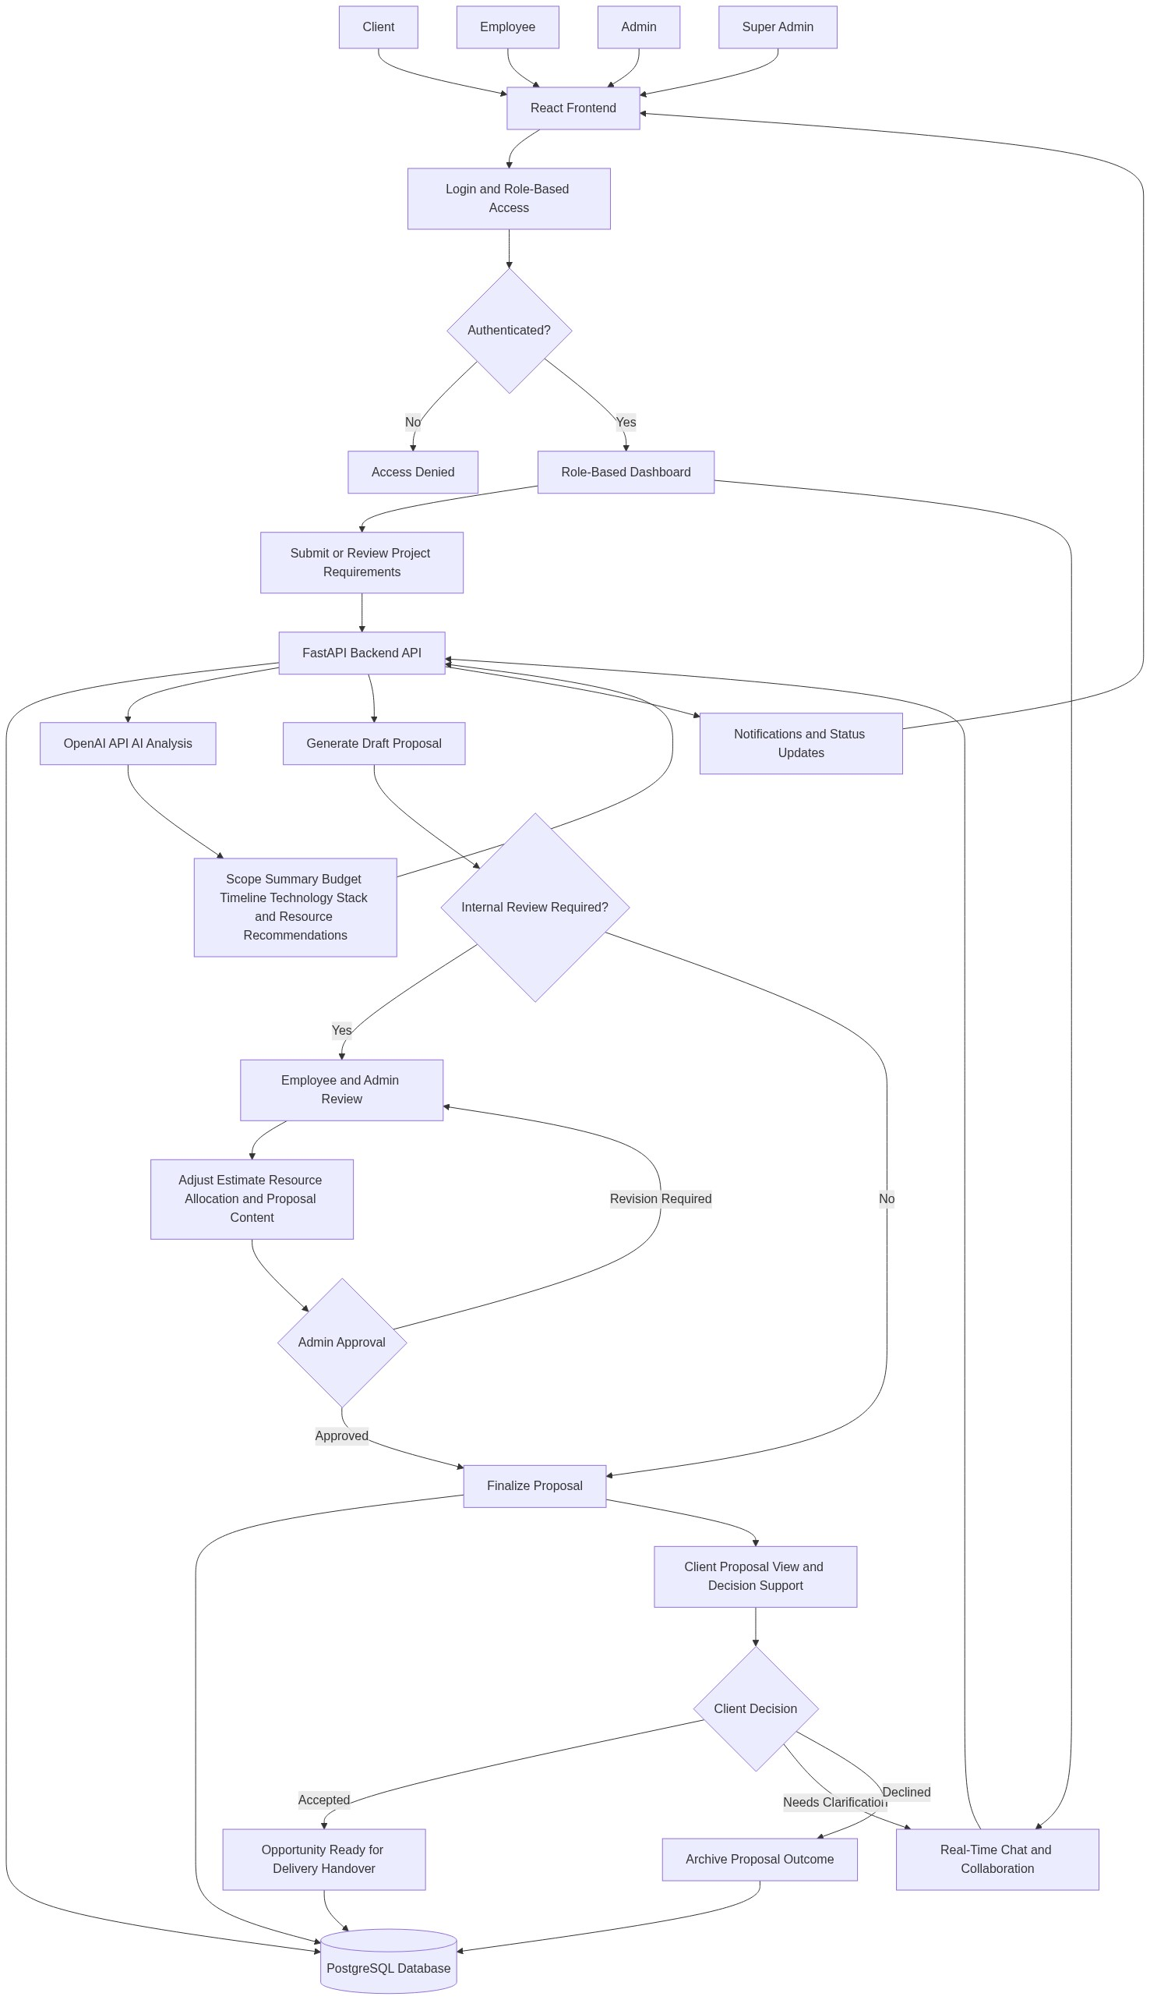
Diagram successfully loaded from mermaid.ink.

6. Development Plan & Timeline
The development cycle is projected at 3 Months. Following the structure of our standard Proof of Concept delivery pipeline, the specific deliverables and timeline phases are detailed below:
Phase | Duration | Output
Phase 1: Discovery, Solution Architecture, and Experience Design | 1 Month | Validated functional requirements, role-based workflow definition, solution architecture, PostgreSQL data model, user journey maps, screen-level design direction, Artificial Intelligence estimation approach, and implementation backlog aligned to the Pre-Sales AI Platform objectives.
Phase 2: Core Platform Development and Artificial Intelligence Integration | 1 Month | React-based client and internal dashboards, FastAPI backend services, PostgreSQL persistence layer, role-based access workflows, requirement submission capability, OpenAI Application Programming Interface integration, budget and timeline recommendation logic, resource allocation workflow, and initial proposal generation capability.
Phase 3: Collaboration, Quality Assurance, Stabilization, and Deployment Readiness | 1 Month | Real-time chat and collaboration workflows, administrative review and approval features, reporting views, end-to-end testing, regression testing, user acceptance testing support, defect remediation, deployment readiness validation, and final Proof of Concept handover documentation.

7. Assumptions & Key Risks
Assumptions
- The client will provide timely access to business stakeholders who can validate pre-sales workflows, approval responsibilities, estimation rules, proposal formats, and resource allocation expectations throughout the project lifecycle.
- The client will provide sample historical proposal data, estimation examples, resource profiles, and representative project requirement scenarios to calibrate the Artificial Intelligence-assisted recommendation approach.
- The required hosting environment, network permissions, domain configuration, and environment access will be made available in time to support development, testing, and deployment readiness activities.
- Third-party service access, including the OpenAI Application Programming Interface, will be provisioned by the client or approved for use with the necessary credentials, usage limits, billing arrangements, and security controls.
- Artificial Intelligence model outputs will be treated as decision-support recommendations that require internal review and approval before being presented as final commercial commitments to clients.
- Stakeholders responsible for user acceptance testing will be available during the final project phase to review workflows, validate role permissions, test proposal outputs, and confirm business readiness.
- A dedicated testing environment with appropriate test data will be available so that functional testing, Application Programming Interface testing, regression testing, and user acceptance testing can be conducted without disrupting production operations.
- Security and compliance approvals related to user access, data handling, Artificial Intelligence usage, and deployment will be completed within the agreed project timeline.
- Deployment approvals, production readiness decisions, and any required infrastructure sign-offs will be provided by the client before final release or operational handover.
- Any integrations beyond OpenAI Application Programming Interface usage, React frontend implementation, FastAPI backend services, and PostgreSQL persistence will be considered future enhancements unless explicitly approved within the current Proof of Concept scope.
Risks & Mitigation
- Risk: Business estimation rules may not be fully defined at the start of delivery, which could affect the accuracy of budget, timeline, and resource recommendations. Mitigation: Conduct structured discovery workshops and use sample proposal scenarios to define initial estimation logic that can be iteratively refined during development.
- Risk: Artificial Intelligence-generated recommendations may occasionally require contextual correction because project requirements can be ambiguous or incomplete. Mitigation: Implement human review checkpoints, transparent proposal editing workflows, and administrator approval before any recommendation is finalized.
- Risk: Changes in business requirements during development may create scope pressure within the three-month delivery timeline. Mitigation: Apply Agile sprint planning, maintain a prioritized backlog, and use formal change control for material enhancements beyond the agreed Proof of Concept scope.
- Risk: OpenAI Application Programming Interface availability, rate limits, or usage costs may affect response times or operating assumptions. Mitigation: Design the AI integration with configurable prompts, error handling, retry logic, and clear service usage monitoring.
- Risk: Role-based access requirements may become more complex as additional organizational governance rules are identified. Mitigation: Implement a modular authorization model that supports client, employee, admin, and super admin roles while allowing future permission expansion.
- Risk: Real-time collaboration features may require additional refinement if chat volume, notification expectations, or auditability requirements increase. Mitigation: Deliver a focused collaboration capability for the Proof of Concept and document scalability enhancements for future production hardening.
- Risk: Data quality issues in resource profiles may reduce the reliability of automated allocation recommendations. Mitigation: Validate resource data fields early, define required attributes, and allow authorized users to review and adjust recommendations before proposal finalization.
- Risk: Testing delays may occur if stakeholders are unavailable for user acceptance testing during the final phase. Mitigation: Agree on a testing calendar at project initiation and provide structured test scripts to accelerate stakeholder validation.
- Risk: Security or deployment approvals may take longer than planned due to client governance processes. Mitigation: Identify approval requirements during Phase 1 and prepare the required technical documentation, access model, and deployment readiness evidence in advance.
8. Allocated Technical Resources
Resource Name | Assigned Role | Allocated Hours
Sayan Sen | Frontend Developer | 514 Hours
Nahid Sinha | AI Engineer | 128 Hours
Serya Mallick | Backend Developer | 321 Hours
Abhijit Bhowmick | Automation Tester | 257 Hours
Sandipan Banerjee | QA Engineer | 128 Hours

