PROOF OF CONCEPT (POC) & DEVELOPMENT PROPOSAL
SHOPY
Custom Software Engineering and Implementation Blueprint
Document Version: 1.0
Estimated Budget: $81,307.00 USD
Development Timeline: 6 Months
Proposal Type: FULL

1. Executive Summary
Retailers and merchants increasingly require a mobile-first digital commerce channel that allows customers to discover products, register securely, add items to a shopping cart, and place orders without friction. Shopy addresses this business challenge by establishing a scalable e-commerce platform that supports customer-facing mobile commerce and merchant-facing administrative operations, enabling the client to move beyond fragmented manual sales processes and toward a structured, data-driven online retail model.
The proposed full product implementation is required to create a dependable foundation for product catalog management, customer onboarding, shopping cart operations, order processing, and administrative control. The solution will be engineered using modern software engineering practices, including modular backend design, responsive mobile user experience, reusable design systems, automated testing, containerized deployment, and Continuous Integration and Continuous Delivery (CI/CD) processes. This approach will help ensure the platform can evolve from an initial commercial release into an enterprise-grade commerce ecosystem with analytics, integrations, and advanced operational capabilities.
Artificial Intelligence (AI) can improve the platform over time by enabling product recommendations, merchandising insights, demand pattern analysis, customer segmentation, and operational anomaly detection once sufficient transactional and behavioral data is available. Although the initial technology stack does not specify a dedicated Artificial Intelligence platform, the architecture will remain AI-ready by structuring catalog, customer, cart, and order data in a manner that can support future machine learning services without requiring a major redesign of the core commerce platform.
The expected business outcomes include faster retailer onboarding, improved customer conversion through a streamlined mobile experience, centralized product and order control, reduced dependency on manual order handling, and a maintainable technical foundation for future growth. Security, scalability, and maintainability will be addressed through role-based access patterns, secure authentication workflows, PostgreSQL-backed transactional consistency, Redis-backed performance optimization, Amazon Web Services (AWS) infrastructure readiness, Docker-based portability, and automated quality assurance using Selenium and QuickTest Professional/Unified Functional Testing (QTP/UFT).
2. Proposed Solution & Scope
- Customer mobile application: The platform will provide a React Native mobile application through which customers can register, authenticate, browse product categories, view product details, manage carts, and place orders through an intuitive mobile-first user experience designed for both iOS and Android usage patterns.
- Merchant and administrative dashboard: The solution will include a Next.js-based administrative dashboard that enables authorized administrators and merchant operators to manage product catalogs, product information, pricing, inventory-related attributes, order records, and platform configuration from a centralized web interface.
- Product catalog management: Administrators will be able to create, update, organize, activate, and deactivate products with structured product data stored in PostgreSQL, while Redis can be used to improve read performance for frequently accessed catalog and session-oriented data.
- Customer registration and authentication: The system will support secure customer registration, login, profile access, and authenticated customer journeys through backend-managed authentication flows implemented within the Node.js (NestJS) service layer.
- Shopping cart and checkout workflow: Customers will be able to add products to a cart, update quantities, remove items, review order details, and submit an order, with backend validation ensuring product availability, pricing integrity, and consistent order creation.
- Order processing module: The backend will manage the order lifecycle from cart conversion to order confirmation, administrative order review, status updates, and customer-facing order visibility, enabling merchants to operate a structured online fulfillment process.
- Artificial Intelligence readiness: The platform will be designed to capture clean, structured customer, catalog, cart, and order data so that future Artificial Intelligence capabilities such as personalized recommendations, demand forecasting, product ranking, and merchant analytics can be introduced without disrupting the core transactional architecture.
- Resource allocation and delivery governance: The delivery team will include project management, solution and technical architecture, user experience design, mobile development, frontend dashboard development, backend engineering, and test automation expertise to ensure coordinated execution across business, design, engineering, testing, and deployment workstreams.
- Reporting and analytics foundation: The full product will establish the data structures required for future analytics dashboards covering order volume, product performance, customer activity, and merchant operational metrics, while the initial implementation will prioritize reliable data capture and administrative visibility.
- Integration possibilities: The architecture will support future integrations with payment gateways, notification providers, logistics platforms, enterprise resource planning systems, customer relationship management tools, and third-party commerce services through secure Application Programming Interface (API) extensions.
- Proposal and document generation workflow readiness: While the primary functional scope is e-commerce rather than proposal automation, the platform architecture can support future generation of order confirmations, invoices, merchant summaries, and operational reports through backend document services if required in later releases.
- Administrative controls: Administrative users will have controlled access to platform management features, including catalog operations, order oversight, customer-related visibility, and configuration functions appropriate for a full commerce platform.
- Quality assurance and release management: Functional testing, regression testing, mobile user journey validation, backend Application Programming Interface validation, and automation coverage using Selenium and QTP/UFT will be incorporated to reduce release risk and improve product reliability.
- Future scalability: The platform will use a modular service-oriented backend structure, PostgreSQL for transactional integrity, Redis for performance optimization, Docker for environment consistency, and Amazon Web Services deployment readiness to support progressive scaling as transaction volumes and merchant adoption increase.
3. Estimated Budget & Cost Structure
The total estimated cost for this custom software development solution is $81,307.00 USD. This includes full engineering resources, quality assurance testing, architecture design, and final deployment setup. The detailed cost breakdown is aligned with the technical roles and allocated task hours detailed in Section 7.
4. Proposed Technology Stack
Layer | Technology / Framework | Purpose
Database | PostgreSQL, Redis | Primary platform layer for the Database requirements.
Backend | Node.js (NestJS) | Primary platform layer for the Backend requirements.
Frontend | React Native (Mobile), Next.js (Admin Dashboard) | Primary platform layer for the Frontend requirements.
Cloud | AWS | Primary platform layer for the Cloud requirements.
Artificial intelligence |  | Primary platform layer for the Artificial Intelligence requirements.
Authentication | Node.js (NestJS) | Primary platform layer for the Authentication requirements.
Storage | AWS | Primary platform layer for the Storage requirements.
Deployment | Docker, CI/CD | Primary platform layer for the Deployment requirements.

5. System Workflow Diagram
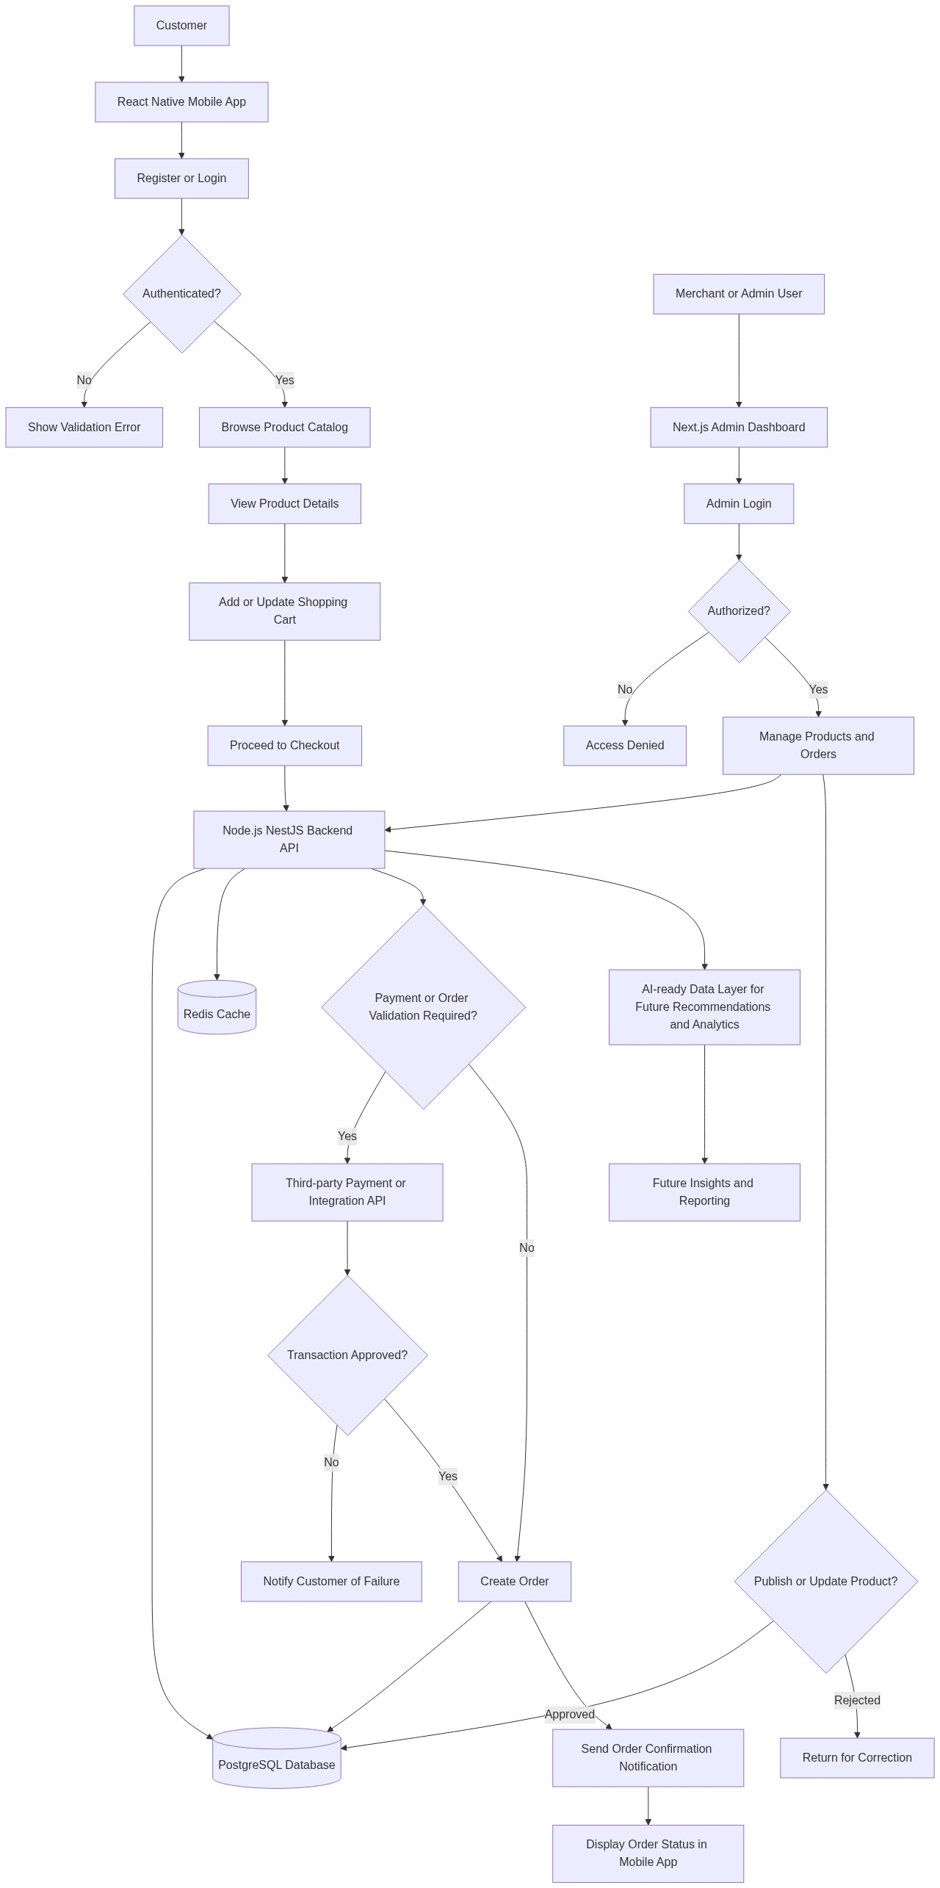
Diagram successfully loaded from mermaid.ink.

6. Development Plan & Timeline
The development cycle is projected at 6 Months. Following the structure of our standard Proof of Concept delivery pipeline, the specific deliverables and timeline phases are detailed below:
Phase | Duration | Output
Phase 1: Discovery, Requirements Validation, and Solution Architecture | 1 Month | Validated functional requirements, prioritized full-product backlog, architecture blueprint, data model direction, delivery plan, risk register, and environment strategy aligned to the mobile-first e-commerce business objectives.
Phase 2: User Experience Design and Technical Foundation | 1 Month | Mobile application user journeys, administrative dashboard wireframes, design system, clickable prototypes, repository structure, backend project foundation, database schema baseline, Docker setup, and Continuous Integration and Continuous Delivery pipeline preparation.
Phase 3: Core Backend and Catalog Management Development | 1 Month | Node.js (NestJS) backend services for authentication, product catalog operations, customer registration, PostgreSQL persistence, Redis caching foundation, administrative catalog capabilities, and initial Application Programming Interface documentation.
Phase 4: Mobile Commerce Experience and Admin Dashboard Development | 1 Month | React Native customer application features for registration, login, catalog browsing, product details, shopping cart operations, and order submission, together with Next.js administrative dashboard screens for product and order management.
Phase 5: Order Processing, Integrations Readiness, Reporting Foundation, and Quality Assurance | 1 Month | Order lifecycle workflows, checkout validation, integration-ready backend interfaces, reporting data foundation, regression test suites, Selenium and QTP/UFT automation coverage for critical journeys, defect remediation, and performance validation.
Phase 6: User Acceptance Testing, Security Hardening, Deployment, and Production Readiness | 1 Month | User Acceptance Testing support, security review closure, release candidate stabilization, Amazon Web Services deployment readiness, operational handover documentation, production launch support, and post-launch improvement backlog.

7. Assumptions & Key Risks
Assumptions
- The client will provide timely access to business stakeholders, merchant representatives, and operational decision-makers for requirements validation, workflow confirmation, User Acceptance Testing, and release approvals.
- The client will confirm product catalog attributes, order lifecycle rules, customer registration requirements, administrative access rules, and any market-specific compliance needs during the discovery phase.
- Amazon Web Services accounts, required cloud permissions, domain configuration, and infrastructure approval processes will be made available in time to support environment setup and deployment planning.
- Third-party integrations such as payment gateways, logistics providers, notification services, or enterprise systems will be treated as integration-ready extension points unless specific provider credentials, documentation, sandbox access, and commercial approvals are provided during the project.
- The initial full product will be designed to be Artificial Intelligence-ready, while production Artificial Intelligence model development will require historical customer, product, cart, and order data that may not be available at the start of implementation.
- A dedicated testing environment with representative test data will be available for functional testing, regression testing, automation testing, and User Acceptance Testing before production release.
- Security, privacy, and compliance approvals related to customer data handling, authentication behavior, cloud deployment, and access management will be reviewed by the client within agreed governance timelines.
- App store publication activities, if required, will depend on the client providing Apple App Store and Google Play Console access, branding assets, legal policies, and approval ownership.
- Deployment approvals, production release windows, rollback expectations, and operational support responsibilities will be agreed before the final launch phase.
- Any material change to scope, such as marketplace functionality, multi-vendor settlement, advanced inventory management, loyalty programs, or full analytics intelligence, will be assessed through formal change control.
Risks & Mitigation
- Risk: Business requirements may evolve as merchant stakeholders review the mobile and administrative workflows in greater detail. Mitigation: The project will use Agile sprint planning, backlog prioritization, and structured stakeholder reviews to validate functionality incrementally and control the impact of changes.
- Risk: Third-party payment, logistics, or notification integrations may be delayed due to provider onboarding, documentation gaps, or sandbox access constraints. Mitigation: The architecture will define integration-ready interfaces early, while dependent features will be isolated so core catalog, cart, and order processing can proceed without blocking.
- Risk: Mobile user experience quality may be affected if customer journeys are not validated with representative retail users. Mitigation: The design phase will include user journey mapping, prototype reviews, usability feedback, and mobile-first interaction validation before major development is finalized.
- Risk: Performance issues may occur if product catalog traffic or cart activity grows faster than expected. Mitigation: PostgreSQL schema design, Redis caching, backend query optimization, and performance testing will be incorporated to support scalable read and transactional workloads.
- Risk: Security vulnerabilities may arise in authentication, customer data handling, or administrative access controls. Mitigation: Secure coding practices, controlled access patterns, validation rules, environment separation, and security review checkpoints will be embedded into the delivery lifecycle.
- Risk: Test coverage may be insufficient for critical commerce journeys such as registration, cart updates, order creation, and administrative catalog changes. Mitigation: Manual test planning, automation coverage using Selenium and QTP/UFT, regression testing, and defect triage governance will be implemented throughout development.
- Risk: Production deployment may be delayed if cloud infrastructure, environment permissions, or release approvals are not available on schedule. Mitigation: Deployment prerequisites will be tracked from the first phase, and Amazon Web Services readiness, Docker packaging, and Continuous Integration and Continuous Delivery setup will be validated before final release.
- Risk: Data quality issues in product catalog content may reduce customer trust and conversion. Mitigation: The administrative dashboard will support structured product entry, and the client will be responsible for validating catalog data accuracy before launch.
- Risk: Future Artificial Intelligence expectations may exceed the available data maturity at launch. Mitigation: The initial release will establish clean data capture and an AI-ready architecture, while advanced recommendation and analytics models will be planned as a future enhancement once sufficient transaction history exists.
8. Allocated Technical Resources
Resource Name | Assigned Role | Allocated Hours
Dipti Bhowmick | Project Manager | 771 Hours
Abhijit Dutta | UI/UX Designer | 385 Hours
Tanya Iyer | React Native Developer | 1028 Hours
Sayan Sen | Frontend Developer | 1028 Hours
Serya Mallick | Backend Developer | 642 Hours
Abhijit Bhowmick | Automation Tester | 514 Hours
Tanya Saha | Solution Architect | 385 Hours
Shreya Sarkar | Technical Architect | 642 Hours

