PROOF OF CONCEPT (POC) & DEVELOPMENT PROPOSAL
TOO DOOO
Custom Software Engineering and Implementation Blueprint
Document Version: 1.0
Estimated Budget: $1,692.00 USD
Development Timeline: 2 Weeks 4 Days
Proposal Type: MVP

1. Executive Summary
Too Dooo addresses the operational challenge faced by individuals and small teams who need a structured, reliable, and accessible way to organize work, track task ownership, monitor progress, and collaborate without relying on fragmented notes, spreadsheets, or disconnected communication channels. The proposed Minimum Viable Product will establish a cloud-based task management platform that provides a modern user experience across devices, enabling users to create, update, categorize, prioritize, and collaborate on tasks through a responsive web application.
The solution is required to create a centralized productivity environment where task data, team visibility, status updates, and workflow actions are consistently managed through secure application interfaces. By using React for the frontend, Node.js with Express.js for backend services, PostgreSQL for structured data persistence, and Amazon Web Services for cloud hosting, the platform will be designed to support maintainability, performance, and future scalability while keeping the first release aligned with the defined budget and timeline.
Artificial Intelligence (AI) is not positioned as a mandatory production capability within the provided technology stack for this Minimum Viable Product; however, the architecture will be structured so that future AI-enabled features such as task prioritization recommendations, workload insights, due-date risk indicators, and productivity summaries can be integrated without redesigning the core platform. This approach allows the client to validate core product adoption first while preserving a clear technical path for intelligence-driven workflow optimization in later releases.
The expected business outcomes include improved task visibility, faster daily planning, better team coordination, reduced manual follow-up, and a more consistent execution process for recurring work. The implementation strategy follows modern software engineering practices, including component-based frontend development, representational state transfer Application Programming Interfaces (REST APIs), normalized relational data modeling, responsive interface design, environment-based deployment, and secure access controls suitable for an enterprise-ready Minimum Viable Product foundation.
2. Proposed Solution & Scope
- User onboarding and authentication: The platform will include a secure entry point for users to access their task workspace, ensuring that task information is available only to authorized users and that each user can manage work within an authenticated session.
- Responsive task dashboard: Users will be provided with a modern React-based dashboard that presents active tasks, task status, priority, due dates, and key productivity indicators in a clean and usable interface designed with Figma and implemented using Tailwind CSS.
- Task creation and management: The core functional scope will allow users to create, view, edit, update, and delete tasks with relevant attributes such as title, description, status, priority, due date, assignee, and ownership information.
- Team collaboration workflow: The Minimum Viable Product will support collaboration by allowing tasks to be assigned, updated, and tracked in a centralized workspace, helping teams maintain shared visibility over responsibilities and completion progress.
- User workflow: A user will log in, access the dashboard, create or review tasks, update task attributes, assign or track ownership where applicable, and monitor task progress through status-based views until completion.
- Backend and Application Programming Interface layer: Node.js with Express.js will provide the backend services required to process user actions, validate requests, enforce business rules, and expose REST APIs for the frontend application.
- Data persistence: PostgreSQL will store user, task, status, priority, and collaboration-related records using a structured relational model that supports consistency, reporting, and future extensibility.
- Artificial Intelligence readiness: Although no Artificial Intelligence service is included in the specified Minimum Viable Product stack, the solution will use modular service boundaries so future AI capabilities such as smart prioritization, task recommendations, productivity insights, and workload forecasting can be added through dedicated services or third-party AI integrations.
- Proposal generation workflow: This project scope is focused on the Too Dooo task management product rather than an automated proposal generation system; however, the delivery workflow will include requirement validation, interface design, feature implementation, quality assurance, and client review prior to production-ready handover.
- Reporting and visibility: The platform will include basic reporting-oriented views such as task counts by status, pending work visibility, and completion-oriented dashboard summaries to support practical day-to-day decision-making within the Minimum Viable Product scope.
- Administrative features: Administrative capability will be limited to essential user and task governance suitable for the first release, with future expansion available for roles, permissions, team management, audit trails, and configurable workflow rules.
- Integration possibilities: The REST API-based architecture will allow future integration with calendar tools, notification services, productivity suites, third-party identity providers, and Artificial Intelligence services when the product roadmap requires these capabilities.
- Resource allocation: Delivery will be supported by two Full Stack Developers responsible for frontend, backend, database, and integration implementation, and one User Interface/User Experience Designer responsible for interface design, responsive layouts, and user experience alignment.
- Future scalability: The solution will be implemented with a maintainable component structure, clean API boundaries, PostgreSQL-backed data design, and Amazon Web Services deployment alignment so the platform can evolve from Minimum Viable Product to a larger team productivity solution.
3. Estimated Budget & Cost Structure
The total estimated cost for this custom software development solution is $1,692.00 USD. This includes full engineering resources, quality assurance testing, architecture design, and final deployment setup. The detailed cost breakdown is aligned with the technical roles and allocated task hours detailed in Section 7.
4. Proposed Technology Stack
Layer | Technology / Framework | Purpose
Database | PostgreSQL | Primary platform layer for the Database requirements.
Backend | Node.js/Express.js | Primary platform layer for the Backend requirements.
Frontend | React | Primary platform layer for the Frontend requirements.
Cloud | AWS | Primary platform layer for the Cloud requirements.
Artificial intelligence |  | Primary platform layer for the Artificial Intelligence requirements.
Authentication |  | Primary platform layer for the Authentication requirements.
Storage | AWS | Primary platform layer for the Storage requirements.
Deployment | AWS | Primary platform layer for the Deployment requirements.

5. System Workflow Diagram
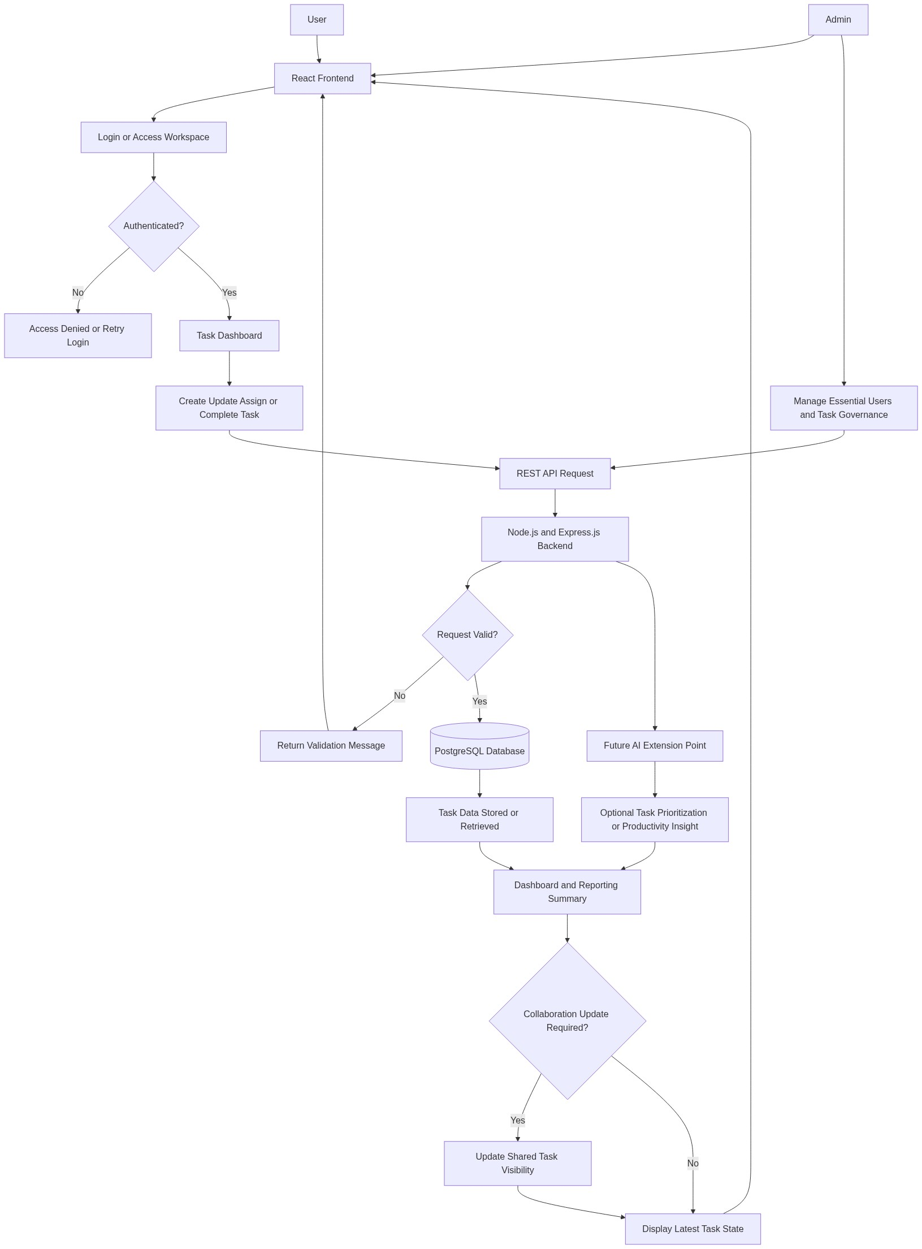
Diagram successfully loaded from mermaid.ink.

6. Development Plan & Timeline
The development cycle is projected at 2 Weeks 4 Days. Following the structure of our standard Proof of Concept delivery pipeline, the specific deliverables and timeline phases are detailed below:
Phase | Duration | Output
Discovery, Requirements Validation, and Delivery Planning | 2 Days | Confirmed Minimum Viable Product scope, validated user workflows, prioritized feature backlog, implementation plan, and acceptance criteria aligned with the budget and delivery timeline.
User Experience Design and Interface Prototyping | 3 Days | Figma-based responsive user interface designs for login, dashboard, task list, task form, status views, and core interaction patterns, prepared for implementation using Tailwind CSS.
Frontend, Backend, and Database Development | 5 Days | Implemented React frontend components, Node.js and Express.js REST APIs, PostgreSQL data model, task management workflows, authentication flow foundation, and core dashboard functionality.
Integration, Quality Assurance, and Refinement | 4 Days | Integrated frontend and backend services, validated task workflows, resolved functional defects, improved usability, verified responsive behavior, and completed Minimum Viable Product readiness testing.
Deployment Preparation, Client Review, and Handover | 4 Days | Amazon Web Services deployment preparation, environment configuration guidance, final client walkthrough, handover documentation, known limitations register, and recommendations for the next product release.

7. Assumptions & Key Risks
Assumptions
- The client will provide timely clarification on workflow expectations, task attributes, collaboration rules, and any preferred terminology required for the Too Dooo product experience.
- The Minimum Viable Product will focus on essential task management and collaboration capabilities, while advanced enterprise features such as granular role-based access control, complex workflow automation, and native mobile applications will be considered for future phases.
- Amazon Web Services account access, deployment permissions, environment details, and any required cloud governance approvals will be provided by the client before deployment preparation begins.
- Third-party Application Programming Interface integrations are not included in the first release unless explicitly approved as a change in scope, although the REST API architecture will support future integration.
- Artificial Intelligence models are not included as production services in the provided technology stack, and any future Artificial Intelligence capability will require separate model selection, data readiness review, and implementation planning.
- Client stakeholders will be available for design review, feature validation, progress feedback, and final acceptance within the agreed two weeks and four days delivery window.
- A suitable testing environment or deployment target will be available for quality assurance activities, integration validation, and client review before final handover.
- Security and deployment approvals required by the client organization will be completed within the project timeline to avoid delays in environment configuration and release readiness.
- The selected resources will remain available for the allocated hours defined in the project resource plan, and any material change in availability may require replanning of delivery sequencing.
- The estimated budget is based on the provided resource allocation and does not include additional third-party subscription fees, cloud consumption charges, paid notification services, or external security audit costs.
Risks & Mitigation
- Risk: Requirements may expand beyond the Minimum Viable Product boundary during implementation, particularly if advanced collaboration, notifications, or administrative controls are requested. Mitigation: Maintain a prioritized backlog, confirm acceptance criteria during discovery, and route additional functionality through a structured change control process.
- Risk: Stakeholder feedback delays may affect design approval and feature validation within the short two weeks and four days timeline. Mitigation: Schedule focused review checkpoints early, define decision owners, and use rapid feedback cycles to prevent downstream rework.
- Risk: Cloud environment access or Amazon Web Services deployment permissions may not be available when required. Mitigation: Identify infrastructure prerequisites during the first phase and request required access before development reaches deployment preparation.
- Risk: Authentication expectations may be more complex than the Minimum Viable Product scope, such as enterprise single sign-on or multi-factor authentication. Mitigation: Implement a pragmatic authentication foundation for the first release and document advanced identity capabilities as a future enhancement unless approved within scope.
- Risk: User interface expectations may change after implementation begins, causing rework across React components and responsive layouts. Mitigation: Use Figma prototypes for early validation and obtain design confirmation before major frontend build activities.
- Risk: Data model changes may arise if task hierarchy, labels, recurring tasks, or team structures become mandatory after development starts. Mitigation: Design the PostgreSQL schema with sensible extensibility while limiting the first release to confirmed task management entities.
- Risk: Quality assurance time may be compressed because of the aggressive delivery schedule. Mitigation: Conduct incremental testing during each development activity, validate Application Programming Interface behavior continuously, and reserve a dedicated stabilization phase before handover.
- Risk: Future Artificial Intelligence expectations may be assumed as part of the initial release even though no Artificial Intelligence technology has been specified in the stack. Mitigation: Clearly document Artificial Intelligence as a future-ready architectural extension and exclude production model delivery from Minimum Viable Product acceptance unless separately approved.
- Risk: Resource availability may change because selected personnel have limited available hours in the resource plan. Mitigation: Sequence work according to role priority, keep tasks clearly assigned, and escalate any availability constraint immediately for resource replanning.
8. Allocated Technical Resources
Resource Name | Assigned Role | Allocated Hours
Afzal Iyer | Full Stack Developer | 64 Hours
Serya Bose | Full Stack Developer | 38 Hours
Abhijit Dutta | UI/UX Designer | 38 Hours

