PROOF OF CONCEPT (POC) & DEVELOPMENT PROPOSAL
SHOPY
Custom Software Engineering and Implementation Blueprint
Document Version: 1.0
Estimated Budget: $20,477.00 USD
Development Timeline: 2 Months 15 Days
Proposal Type: MVP

1. Executive Summary
Shopy addresses the commercial need for a mobile-first e-commerce channel that enables retailers and merchants to move product discovery, customer registration, cart management, and order processing into a seamless digital buying experience. The business challenge is not only to launch an online storefront, but to establish a scalable transactional foundation that can support future expansion into advanced administration, analytics, integrations, and enterprise-grade operational controls without requiring a major platform redesign after the Minimum Viable Product (MVP) is validated.
The proposed solution is required to provide merchants with a structured product catalog, customers with an intuitive mobile shopping journey, and the business with a reliable backend capable of handling product, user, cart, and order data consistently. Although Artificial Intelligence (AI) is not included as a core technology in the current MVP technology stack, the platform architecture will be designed so that AI capabilities can be introduced in later releases for product recommendations, demand insights, personalized search, automated merchandising, and intelligent customer engagement. This approach allows the MVP to remain focused, cost-controlled, and deliverable within the defined timeline while preserving a practical pathway to AI-enabled commerce maturity.
The expected business outcomes include faster market entry, improved customer accessibility through mobile channels, standardized order processing, reduced manual sales handling, and a technical foundation that can be extended for merchant dashboards, analytics, payment integrations, inventory synchronization, and promotional workflows. The implementation strategy will follow modern software engineering practices, including component-based mobile development, modular backend services, secure Application Programming Interface (API) design, relational data modeling, containerized deployment, automated testing discipline, and Agile delivery governance.
Scalability, maintainability, and security will be embedded through a Node.js with NestJS backend, PostgreSQL database design, Docker-based deployment readiness, and authentication patterns suitable for customer and administrative access. The MVP will prioritize the highest-value user journeys first, validate the end-to-end shopping and ordering workflow, and create a production-oriented baseline that the client can confidently evolve into a broader e-commerce ecosystem.
2. Proposed Solution & Scope
- Functional scope: The MVP will include customer registration, secure login, product browsing, product detail viewing, shopping cart management, and order placement so that the end-to-end customer purchasing journey can be validated in a mobile-first environment.
- Product catalog management: The solution will support foundational catalog structures, including product names, descriptions, pricing, availability status, categories, and product imagery references, enabling merchants to maintain a sellable product inventory through backend-managed data.
- User workflow: A customer will register or sign in, browse available products, review product details, add items to the cart, update quantities, confirm order information, submit the order, and receive order confirmation through the application interface.
- Major modules: The platform will be organized around customer identity, product catalog, cart management, order processing, administrative product maintenance, backend service orchestration, database persistence, and deployment configuration.
- Artificial Intelligence capabilities: Artificial Intelligence will not be implemented as an active MVP feature because it is not included in the approved technology stack; however, the architecture will preserve extensibility for future AI-driven product recommendations, personalized merchandising, and behavioral analytics.
- Authentication: The MVP will implement secure customer authentication using JSON Web Token (JWT) based session handling through NestJS guards and backend authorization controls, providing a foundation for future role-based administrative access.
- Resource allocation: The delivery team will include project management, user interface and user experience design, React Native mobile development, NestJS backend development, and quality assurance testing to ensure each major product area has dedicated ownership.
- Order generation workflow: The system will convert validated cart contents into an order record, persist the transaction details in PostgreSQL, clear or update the active cart state, and return an order confirmation to the customer application.
- Reporting: The MVP will provide foundational visibility into products, registered users, carts, and orders through backend-accessible data structures, while advanced business intelligence dashboards and merchant analytics will be positioned for post-MVP enhancement.
- Administrative features: The initial administrative capability will focus on product and order data readiness, with the system structured to support a future Next.js admin dashboard, advanced role management, merchant controls, and operational reporting.
- Integration possibilities: The backend API will be designed to support future integration with payment gateways, logistics providers, inventory systems, notification services, enterprise resource planning systems, and customer relationship management platforms.
- Future scalability: The solution will use a modular service structure, relational database design, containerized deployment approach, and cloud-ready architecture on AWS so that additional merchant features, higher transaction volumes, and enterprise controls can be introduced progressively.
3. Estimated Budget & Cost Structure
The total estimated cost for this custom software development solution is $20,477.00 USD. This includes full engineering resources, quality assurance testing, architecture design, and final deployment setup. The detailed cost breakdown is aligned with the technical roles and allocated task hours detailed in Section 7.
4. Proposed Technology Stack
Layer | Technology / Framework | Purpose
Database | PostgreSQL | Primary platform layer for the Database requirements.
Backend | Node.js (NestJS) | Primary platform layer for the Backend requirements.
Frontend | React Native | Primary platform layer for the Frontend requirements.
Cloud | AWS | Primary platform layer for the Cloud requirements.
Artificial intelligence | Not included in MVP | Primary platform layer for the Artificial Intelligence requirements.
Authentication | JSON Web Token (JWT) with NestJS Guards | Primary platform layer for the Authentication requirements.
Storage | AWS S3 | Primary platform layer for the Storage requirements.
Deployment | Docker on AWS | Primary platform layer for the Deployment requirements.

5. System Workflow Diagram
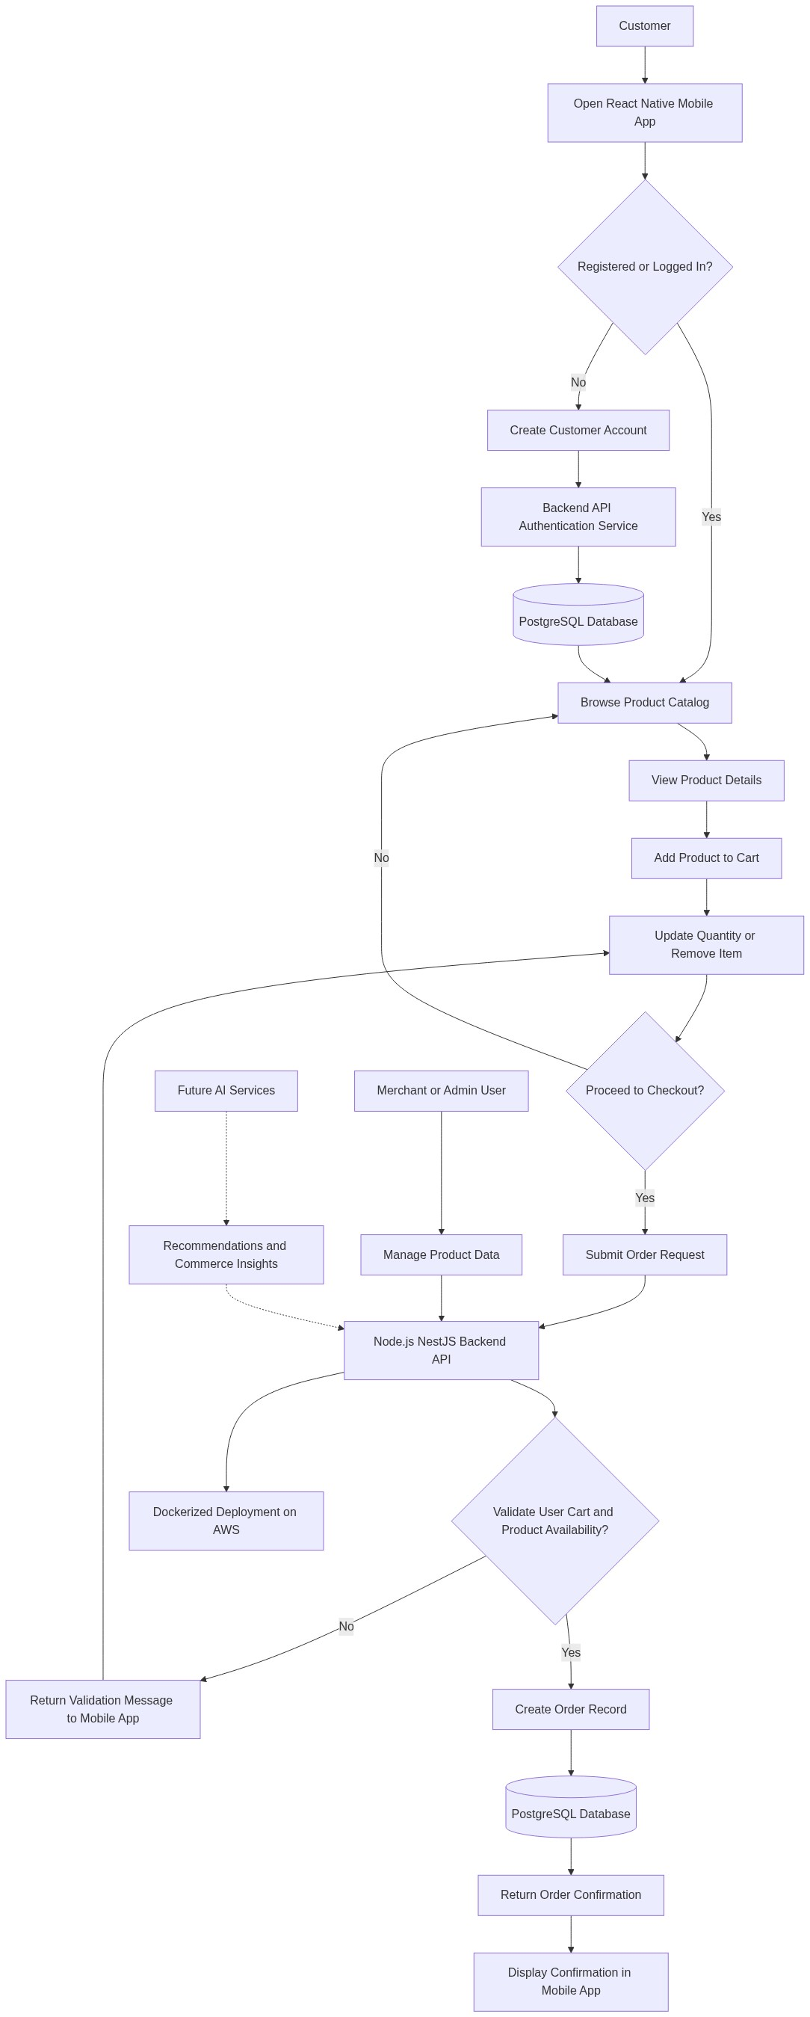
Diagram successfully loaded from mermaid.ink.

6. Development Plan & Timeline
The development cycle is projected at 2 Months 15 Days. Following the structure of our standard Proof of Concept delivery pipeline, the specific deliverables and timeline phases are detailed below:
Phase | Duration | Output
Discovery, Backlog Finalization, and Architecture Planning | 5 Days | Confirmed MVP scope, prioritized product backlog, user journey definition, architecture approach, delivery plan, and acceptance criteria aligned with the mobile-first e-commerce objectives.
User Interface and User Experience Design | 15 Days | Mobile application wireframes, visual design screens, checkout journey prototype, reusable design components, and design specifications for product catalog, customer registration, cart, and order confirmation flows.
Backend Foundation and Database Development | 15 Days | NestJS backend structure, PostgreSQL schema, customer authentication services, product catalog endpoints, cart services, order processing APIs, validation rules, and Docker-ready backend configuration.
React Native Mobile Application Development | 20 Days | Functional mobile application covering customer registration, login, product browsing, product details, cart management, order submission, confirmation screens, API integration, and mobile-first usability refinements.
System Integration and Quality Assurance Testing | 10 Days | Integrated frontend and backend environment, manual and automated test execution, defect tracking, regression validation, mobile compatibility checks, API validation, and readiness report for stakeholder review.
User Acceptance Support and Production Readiness | 5 Days | User acceptance testing support, issue resolution, environment verification, deployment checklist, operational handover notes, and confirmation that the MVP meets the agreed business requirements.
Deployment, Knowledge Transfer, and Closure | 5 Days | Dockerized deployment package on AWS, final demonstration, technical walkthrough, source code handover, configuration documentation, backlog for post-MVP enhancements, and project closure summary.

7. Assumptions & Key Risks
Assumptions
- The client will provide timely confirmation of business priorities, product categories, sample product data, branding assets, and any mandatory customer registration fields required for the MVP.
- AWS cloud account access, required permissions, domain-related information, and deployment approvals will be made available before the production readiness phase begins.
- Third-party integrations such as payment gateways, logistics providers, inventory systems, and external notification services are excluded from the MVP unless separately approved through change control.
- Artificial Intelligence models are not part of the MVP implementation; any AI-enabled product recommendation, personalization, or analytics capability will be treated as a future enhancement after the core commerce workflow is validated.
- Client stakeholders will be available for sprint reviews, design approvals, requirement clarifications, and user acceptance testing within agreed response timelines to avoid delivery delays.
- A representative testing environment with realistic product, customer, cart, and order scenarios will be available for quality assurance validation before user acceptance testing.
- Security approvals for authentication approach, API exposure, data handling, and deployment configuration will be reviewed by the client or its nominated technical authority before go-live.
- Deployment approvals, application store readiness decisions, and production release windows will be coordinated by the client, with the delivery team supporting technical packaging and handover.
- The MVP budget and timeline are based on the selected resources, current scope, and provided technology stack; material scope changes will require impact assessment and approval.
- Product images and media storage needs will be supported through AWS S3 where required, while advanced digital asset management workflows will be considered outside the MVP scope.
Risks & Mitigation
- Risk: Changes in business requirements during development may increase delivery complexity and affect the fixed MVP timeline. Mitigation: The project will use Agile sprint planning, backlog prioritization, and formal change control so that only approved and high-value scope changes are introduced.
- Risk: Delayed client feedback on designs, user flows, or acceptance criteria may slow development and quality assurance activities. Mitigation: Weekly review checkpoints, defined approval windows, and escalation paths will be established during project initiation.
- Risk: Product catalog rules may become more complex than initially defined, especially if variants, inventory constraints, promotions, or merchant-specific pricing are introduced. Mitigation: The MVP will implement a controlled catalog model and defer advanced merchandising rules to the post-MVP roadmap unless formally approved.
- Risk: Authentication and customer data handling may require additional security controls based on client compliance requirements. Mitigation: The backend will follow secure API design principles, token-based authentication, input validation, and environment-based configuration, with security review checkpoints before deployment.
- Risk: Mobile application behavior may vary across device sizes, operating system versions, and network conditions. Mitigation: The quality assurance plan will include representative mobile testing, responsive layout validation, negative testing, and regression checks for critical purchase journeys.
- Risk: Deployment readiness may be impacted if AWS access, permissions, or infrastructure decisions are not finalized on time. Mitigation: Infrastructure prerequisites will be identified early, Docker-based deployment artifacts will be prepared, and environment setup tasks will be tracked as project dependencies.
- Risk: Future integration expectations, such as payments or logistics, may be assumed by users even though they are outside the MVP scope. Mitigation: Scope boundaries will be clearly documented, and API structures will be designed for extensibility without committing to unapproved third-party integration delivery.
- Risk: Limited availability of selected resources could affect continuity if project priorities change internally. Mitigation: The project manager will monitor resource allocation, maintain sprint-level visibility, and escalate capacity risks early so that corrective planning can be executed.
- Risk: Data model changes late in the project may require rework across backend APIs and the mobile application. Mitigation: Core entities such as customer, product, cart, and order will be validated during the architecture phase, with schema changes controlled through documented migration practices.
8. Allocated Technical Resources
Resource Name | Assigned Role | Allocated Hours
Dipti Bhowmick | Project Manager | 321 Hours
Abhijit Dutta | User Interface/User Experience (UI/UX) Designer | 160 Hours
Rohit Mukherjee | React Native Developer | 321 Hours
Tanya Iyer | React Native Developer | 107 Hours
Serya Mallick | Backend Developer | 267 Hours
Abhijit Bhowmick | Automation Tester | 214 Hours

