PROOF OF CONCEPT (POC) & DEVELOPMENT PROPOSAL
MANMANAGE
Custom Software Engineering and Implementation Blueprint
Document Version: 1.0
Estimated Budget: $1,220.00 USD
Development Timeline: 1 Week
Proposal Type: MVP

1. Executive Summary
Organizations that rely on manual spreadsheets, fragmented communication, and disconnected workforce tracking often experience limited visibility into personnel availability, inefficient scheduling decisions, and delayed operational reporting. ManManage addresses this challenge by delivering a modern web-based workforce and resource management platform that centralizes personnel records, scheduling activities, resource allocation, and management dashboards within a secure and scalable application experience. The Minimum Viable Product (MVP) will focus on enabling the client to validate the core operational workflow quickly while establishing a foundation that can support future enterprise expansion.
2. Proposed Solution & Scope
- Personnel management will allow authorized users to create, view, update, and manage workforce records, including basic profile information, role classification, availability status, and team assignment data required for operational planning.
- Scheduling and resource allocation workflows will enable managers to assign personnel to activities, review availability, identify basic allocation conflicts, and maintain visibility into how resources are distributed across teams or operational needs.
- The user workflow will begin with secure login, proceed to a role-based dashboard, allow managers or administrators to maintain personnel data and schedules, and conclude with updated dashboards that reflect current workforce utilization and team activity.
- The major MVP modules will include authentication, dashboard overview, personnel directory, scheduling interface, resource allocation management, administrative configuration, and quality-tested user flows for the primary workforce management journeys.
- Artificial Intelligence (AI) capability in the MVP will be positioned as an AI-ready analytics foundation, using structured workforce, availability, and allocation data to support future intelligent recommendations for staffing optimization, workload balancing, and scheduling risk detection without introducing a complex machine learning dependency in the one-week delivery window.
- Authentication will be implemented through a secure role-based access model that separates administrative and operational access, ensuring that sensitive workforce and scheduling data can only be managed by authorized users.
- Resource allocation within the delivery team will prioritize rapid MVP execution, with frontend development focused on responsive dashboards and forms, backend development focused on Application Programming Interface (API) services and PostgreSQL data modeling, quality assurance focused on functional validation, and data science support focused on analytics readiness and future AI enablement.
- The proposal generation workflow is not part of the business operating scope for ManManage; however, the platform will generate operational outputs such as dashboard views, personnel summaries, allocation status, and scheduling visibility that support management decisions.
- Reporting will be delivered through intuitive dashboard components that summarize workforce counts, allocation status, schedule visibility, and team activity indicators in a format suitable for operational review and MVP validation.
- Administrative features will include user access control, workforce data maintenance, schedule management, and controlled updates to core operational records so the client can manage platform data without direct database intervention.
- Integration possibilities will be considered in the architecture by designing clean RESTful Application Programming Interfaces (APIs) that can later connect with Human Resources Information Systems (HRIS), payroll platforms, calendar systems, notification services, or enterprise identity providers.
- Future scalability will be supported through a modular Next.js, NestJS, and PostgreSQL architecture, containerized deployment patterns using Docker, and cloud-ready infrastructure alignment with Amazon Web Services (AWS) and Kubernetes when the platform grows beyond the MVP stage.
3. Estimated Budget & Cost Structure
The total estimated cost for this custom software development solution is $1,220.00 USD. This includes full engineering resources, quality assurance testing, architecture design, and final deployment setup. The detailed cost breakdown is aligned with the technical roles and allocated task hours detailed in Section 7.
4. Proposed Technology Stack
Layer | Technology / Framework | Purpose
Database | PostgreSQL | Primary platform layer for the Database requirements.
Backend | Node.js, NestJS | Primary platform layer for the Backend requirements.
Frontend | React, Next.js, TypeScript | Primary platform layer for the Frontend requirements.
Cloud | AWS | Primary platform layer for the Cloud requirements.
Artificial intelligence | AI-ready analytics using structured application data | Primary platform layer for the Artificial Intelligence requirements.
Authentication | NestJS role-based authentication | Primary platform layer for the Authentication requirements.
Storage | PostgreSQL | Primary platform layer for the Storage requirements.
Deployment | Docker, Kubernetes, CI/CD | Primary platform layer for the Deployment requirements.

5. System Workflow Diagram
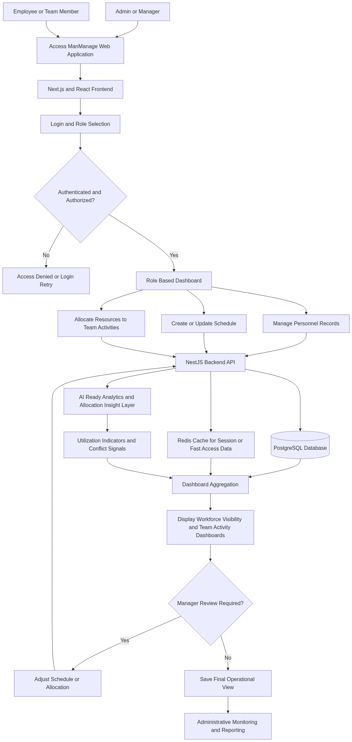
Diagram successfully loaded from mermaid.ink.

6. Development Plan & Timeline
The development cycle is projected at 1 Week. Following the structure of our standard Proof of Concept delivery pipeline, the specific deliverables and timeline phases are detailed below:
Phase | Duration | Output
Phase 1: Discovery, Workflow Confirmation, and Experience Blueprint | 1 Day | Validated MVP workflow, role definitions, core data entities, Figma-aligned screen direction, and confirmed implementation backlog for personnel management, scheduling, allocation, and dashboard visibility.
Phase 2: Backend Foundation and Database Model | 2 Days | NestJS backend foundation, PostgreSQL schema for users, personnel, schedules, and allocations, secure API structure, role-based access patterns, and baseline service logic for core workforce management workflows.
Phase 3: Frontend Dashboard and Operational Screens | 2 Days | Responsive Next.js and React user interface with TypeScript, including authenticated dashboard, personnel directory, scheduling view, resource allocation screens, and operational summary components for MVP validation.
Phase 4: Integration, Analytics Readiness, and Quality Validation | 1 Day | Integrated frontend and backend workflows, dashboard data aggregation, AI-ready analytics data structure, functional test execution, API validation, defect resolution, and user acceptance testing support.
Phase 5: Deployment Preparation and MVP Handover | 1 Day | Docker-ready deployment package, environment configuration guidance for AWS readiness, final walkthrough, MVP handover notes, known limitations register, and recommendations for the next enterprise expansion phase.

7. Assumptions & Key Risks
Assumptions
- The client will provide timely clarification on workforce roles, scheduling rules, access levels, and the minimum data fields required for personnel and resource allocation records.
- The MVP will be delivered as a focused validation release within one week, and any advanced enterprise features such as payroll integration, complex approval hierarchies, and predictive optimization will be considered for later phases.
- The client will provide access to any existing branding guidelines, preferred dashboard references, or Figma inputs required to align the user experience with organizational expectations.
- The initial infrastructure will be prepared for cloud deployment on Amazon Web Services (AWS), while production-grade Kubernetes scaling and multi-environment automation may be expanded after MVP acceptance.
- No mandatory third-party system integration is assumed for the MVP; however, the backend will be structured to support future integrations with Human Resources Information Systems, calendar tools, or notification platforms.
- Artificial Intelligence (AI) functionality in the MVP is assumed to be limited to analytics readiness and structured data preparation, with advanced machine learning recommendations requiring additional data, validation, and model governance in a future phase.
- Client stakeholders will be available for daily review checkpoints, rapid decision-making, user acceptance testing, and final approval within the one-week delivery period.
- A testing environment with required access credentials, sample workforce data, and approval to test core user journeys will be available before integration validation begins.
- Security and deployment approvals required from the client side will be completed promptly so that delivery is not delayed by environment access, credential provisioning, or internal review cycles.
Risks & Mitigation
- Risk: Business rules for scheduling and allocation may not be fully defined at the start of the MVP, which could affect implementation accuracy. Mitigation: Conduct a rapid discovery session on Day 1 and document only the confirmed rules for MVP implementation while placing unresolved scenarios into the post-MVP backlog.
- Risk: The one-week delivery timeline may constrain the depth of advanced functionality and user interface refinement. Mitigation: Prioritize the highest-value workforce management journeys, use reusable components, and apply time-boxed Agile execution with daily stakeholder validation.
- Risk: Insufficient sample personnel and scheduling data may limit the accuracy of dashboard validation. Mitigation: Request representative sample data early and create controlled seed data where client-provided data is unavailable.
- Risk: Security expectations may expand beyond basic role-based access during MVP execution. Mitigation: Implement secure authentication and authorization foundations while documenting enhanced security requirements such as single sign-on, audit logging, and policy-based access for later phases.
- Risk: Future integration needs may influence data model decisions if not considered early. Mitigation: Design normalized PostgreSQL entities and RESTful Application Programming Interfaces (APIs) that can accommodate Human Resources Information Systems, calendar, and notification integrations without major rework.
- Risk: Artificial Intelligence (AI) expectations may exceed the practical scope of a one-week MVP. Mitigation: Establish an AI-ready data foundation in the MVP and define a separate roadmap for intelligent scheduling recommendations once sufficient historical data and business validation are available.
- Risk: Resource availability constraints may affect delivery velocity during a compressed schedule. Mitigation: Assign clear ownership by workstream, maintain daily progress reviews, and focus each resource on specialized deliverables aligned with their strongest skills.
- Risk: Deployment may be delayed if cloud credentials, container registry access, or environment approvals are not available. Mitigation: Prepare Docker-based deployment artifacts and environment documentation so the MVP can be demonstrated locally or in a staging environment while cloud approval is finalized.
8. Allocated Technical Resources
Resource Name | Assigned Role | Allocated Hours
Sayan Sen | Frontend Developer | 40 Hours
Serya Mallick | Backend Developer | 25 Hours
Ankita Sen | QA Engineer | 20 Hours
Arijit Sarkar | Data Scientist | 20 Hours

