PROOF OF CONCEPT (POC) & DEVELOPMENT PROPOSAL
YOURNARI
Custom Software Engineering and Implementation Blueprint
Document Version: 1.0
Estimated Budget: $28,395.00 USD
Development Timeline: 2 Months 15 Days
Proposal Type: MVP

1. Executive Summary
YourNari is intended to address the growing need for a mobile-first e-commerce experience where customers expect relevant product discovery, fast purchasing journeys, and personalized engagement rather than static product browsing. The primary business challenge is to create a differentiated digital commerce platform that can reduce product discovery friction, improve customer conversion, and provide the business with actionable intelligence on customer behavior from the earliest Minimum Viable Product (MVP) release.
2. Proposed Solution & Scope
- Customer-facing e-commerce experience: The Minimum Viable Product (MVP) will include a mobile-first storefront where customers can browse product categories, view product detail pages, search products, add items to cart, and complete a structured checkout workflow designed to minimize friction and support future payment gateway integration.
- Personalized recommendation workflow: The platform will capture customer interaction signals such as product views, category preferences, cart activity, and order history, then use Artificial Intelligence (AI) and machine learning logic to generate product recommendations that improve product discovery and increase the likelihood of conversion.
- Customer segmentation: The Artificial Intelligence (AI) capability will classify customers into meaningful behavioral segments using available profile and activity data, enabling the business to understand customer groups, support targeted merchandising, and prepare for future campaign personalization.
- User workflow: A customer will access the React (Next.js) frontend, register or sign in, browse the catalog, receive personalized recommendations, add selected products to the cart, proceed through checkout, and receive confirmation of order placement while the backend stores transactional and behavioral data in PostgreSQL.
- Major modules: The solution scope includes storefront user interface, user registration and login, product catalog management, product listing and detail views, cart management, checkout workflow, order creation, recommendation service integration, customer segmentation service integration, and administrative data management for products and orders.
- Authentication and access control: The application will include secure authentication through the Node.js (NestJS) backend, enabling controlled access for customers and administrative users while establishing a foundation for role-based access control as the platform matures.
- Administrative features: The Minimum Viable Product (MVP) will provide administrative capabilities for managing product records, reviewing orders, and monitoring key customer and product activity required to validate business operations during the initial launch.
- Reporting and insights: The system will provide foundational reporting for product activity, customer segmentation outputs, order activity, and recommendation performance indicators so that business stakeholders can evaluate platform adoption and personalization effectiveness.
- Artificial Intelligence (AI) service architecture: The recommendation and segmentation functions will be implemented through Python (FastAPI for AI/ML) and scikit-learn, separated from the commerce backend to support maintainability, independent tuning, and future model enhancements without disrupting core transaction processing.
- Resource allocation: The delivery will use a focused cross-functional team comprising business analysis, user experience design, frontend engineering, backend engineering, Artificial Intelligence (AI) engineering, and quality assurance to ensure the Minimum Viable Product (MVP) is delivered within the planned budget and timeline.
- Integration possibilities: The architecture will support future integration with payment gateways, shipping providers, customer relationship management platforms, marketing automation systems, analytics platforms, and notification services without requiring a major redesign of the core application.
- Future scalability: The solution will be structured using modern software engineering practices, containerized deployment with Docker, cloud readiness on Amazon Web Services (AWS), modular Application Programming Interface (API) design, and a data model that can support additional product categories, higher transaction volumes, and advanced personalization features.
3. Estimated Budget & Cost Structure
The total estimated cost for this custom software development solution is $28,395.00 USD. This includes full engineering resources, quality assurance testing, architecture design, and final deployment setup. The detailed cost breakdown is aligned with the technical roles and allocated task hours detailed in Section 7.
4. Proposed Technology Stack
Layer | Technology / Framework | Purpose
Database | PostgreSQL | Primary platform layer for the Database requirements.
Backend | Node.js (NestJS) | Primary platform layer for the Backend requirements.
Frontend | React (Next.js) | Primary platform layer for the Frontend requirements.
Cloud | AWS | Primary platform layer for the Cloud requirements.
Artificial intelligence | Python (FastAPI for AI/ML), scikit-learn | Primary platform layer for the Artificial Intelligence requirements.
Authentication | Node.js (NestJS) | Primary platform layer for the Authentication requirements.
Storage | PostgreSQL, AWS | Primary platform layer for the Storage requirements.
Deployment | Docker, AWS | Primary platform layer for the Deployment requirements.

5. System Workflow Diagram
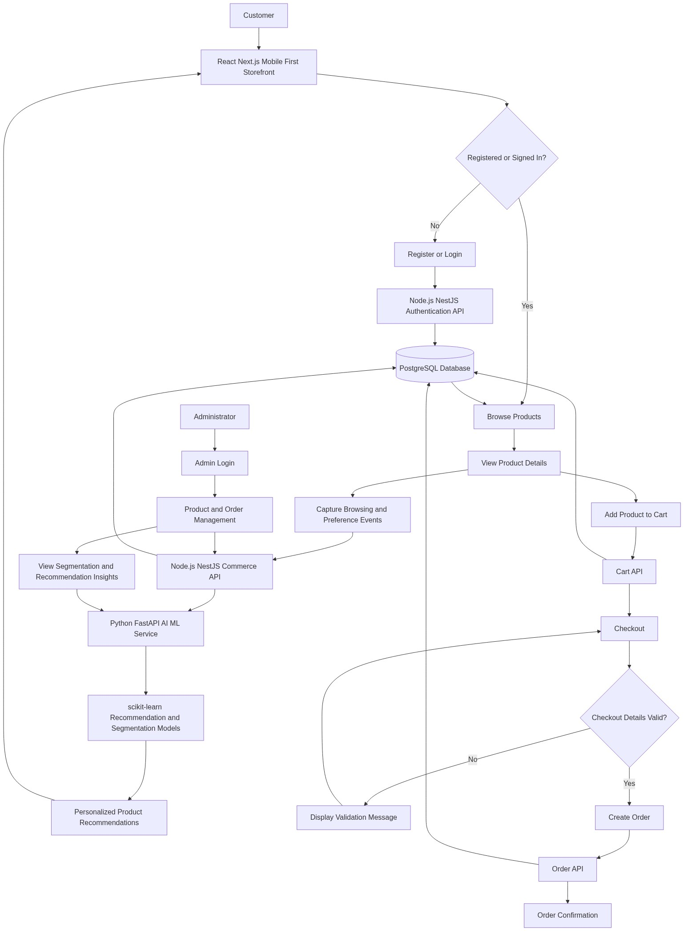
Diagram successfully loaded from mermaid.ink.

6. Development Plan & Timeline
The development cycle is projected at 2 Months 15 Days. Following the structure of our standard Proof of Concept delivery pipeline, the specific deliverables and timeline phases are detailed below:
Phase | Duration | Output
Phase 1: Discovery, Requirements Validation, and Product Backlog Definition | 7 Days | A validated Minimum Viable Product (MVP) backlog, prioritized user journeys, functional acceptance criteria, initial data requirements for personalization, and a delivery plan aligned with the business objectives, budget, and 2 Months 15 Days implementation window.
Phase 2: User Experience Design and Solution Architecture | 10 Days | Mobile-first Figma designs, customer journey flows, administrative screen concepts, technical architecture, database structure, Application Programming Interface (API) contract approach, and Artificial Intelligence (AI) service interaction model for recommendations and segmentation.
Phase 3: Core Commerce Backend and Database Development | 16 Days | Node.js (NestJS) backend services, PostgreSQL schema, authentication foundation, product catalog Application Programming Interfaces (APIs), cart Application Programming Interfaces (APIs), order creation workflow, and structured event capture required for Artificial Intelligence (AI) processing.
Phase 4: Frontend Storefront and Administrative Interface Development | 16 Days | React (Next.js) customer storefront, responsive product listing and product detail pages, registration and login screens, cart and checkout screens, administrative product and order management interface, and integration with backend Application Programming Interfaces (APIs).
Phase 5: Artificial Intelligence Recommendation and Customer Segmentation Implementation | 11 Days | Python (FastAPI for AI/ML) service, scikit-learn based recommendation logic, foundational customer segmentation model, integration endpoints, test data processing flow, and recommendation response integration with the storefront experience.
Phase 6: Integration, Quality Assurance, Security Validation, and Regression Testing | 10 Days | Integrated end-to-end Minimum Viable Product (MVP), functional test execution, checkout workflow validation, Application Programming Interface (API) testing, cross-browser testing using Playwright and Selenium, defect resolution, and verification of authentication, data persistence, and Artificial Intelligence (AI) response accuracy.
Phase 7: Deployment Readiness, User Acceptance Support, and Handover | 5 Days | Dockerized deployment package prepared for Amazon Web Services (AWS), user acceptance testing support, release readiness checklist, technical handover documentation, environment configuration guidance, and final Minimum Viable Product (MVP) demonstration for stakeholder approval.

7. Assumptions & Key Risks
Assumptions
- The client will provide timely access to business stakeholders who can validate product categories, customer journeys, administrative workflows, and acceptance criteria within the planned delivery schedule.
- The client will provide representative product data, pricing rules, product images, category structures, and any required sample customer behavior data needed to build and validate the Minimum Viable Product (MVP).
- Amazon Web Services (AWS) account access, deployment permissions, and required environment credentials will be made available before deployment readiness activities begin.
- Any third-party payment gateway, shipping provider, marketing platform, or notification service integration beyond the Minimum Viable Product (MVP) scope will be treated as a future enhancement unless formally approved through change control.
- The Artificial Intelligence (AI) recommendation and segmentation models will initially operate on available platform data and realistic sample data, with model accuracy expected to improve as live customer interactions accumulate.
- A dedicated testing environment will be available for functional testing, Application Programming Interface (API) testing, cross-browser validation, and user acceptance testing without impacting production or business-critical systems.
- Security, compliance, and deployment approvals required by the client organization will be completed within the agreed project timeline to avoid delays in release readiness.
- The Minimum Viable Product (MVP) will focus on essential e-commerce and personalization capabilities, while advanced loyalty, marketplace, inventory automation, and enterprise analytics features will be considered for future phases.
- The client will review deliverables and provide consolidated feedback within agreed review windows so that design, development, testing, and deployment activities can proceed without rework caused by delayed decisions.
Risks & Mitigation
- Risk: Product catalog data may be incomplete, inconsistent, or unavailable during development, which can affect storefront quality and Artificial Intelligence (AI) model validation. Mitigation: Establish a product data readiness checklist during discovery and use structured sample data where production-ready content is not yet available.
- Risk: Artificial Intelligence (AI) recommendation accuracy may be limited during the Minimum Viable Product (MVP) phase because new platforms typically have limited historical customer behavior data. Mitigation: Implement a practical hybrid approach using product attributes, category affinity, and early behavioral signals, then improve model performance as real usage data increases.
- Risk: Changes in business requirements during development may affect the planned budget and 2 Months 15 Days delivery timeline. Mitigation: Apply Agile sprint planning, maintain a prioritized backlog, and manage material scope changes through formal impact assessment and approval.
- Risk: Checkout workflow expectations may expand to include payment, shipping, tax, or promotional capabilities not included in the initial Minimum Viable Product (MVP) scope. Mitigation: Define checkout acceptance criteria early and design the architecture to support future third-party integrations without including unapproved scope in the initial release.
- Risk: Mobile-first user experience expectations may require additional design iterations if stakeholder feedback is not consolidated. Mitigation: Conduct early Figma prototype reviews and obtain structured approval before full frontend implementation begins.
- Risk: Integration issues may occur between the React (Next.js) frontend, Node.js (NestJS) backend, PostgreSQL database, and Python (FastAPI for AI/ML) service. Mitigation: Define Application Programming Interface (API) contracts early, implement incremental integration checkpoints, and maintain automated regression coverage for critical workflows.
- Risk: Deployment delays may occur if Amazon Web Services (AWS) access, security approvals, or environment configuration decisions are not available on time. Mitigation: Identify infrastructure prerequisites during the first phase and track deployment readiness as a formal project dependency.
- Risk: Quality assurance coverage may be constrained if test data and user acceptance scenarios are not finalized early. Mitigation: Prepare test scenarios during requirements validation and use Playwright and Selenium to support repeatable validation of high-priority customer and administrative workflows.
8. Allocated Technical Resources
Resource Name | Assigned Role | Allocated Hours
Sarthak Bhowmick | Project Manager / Business Analyst | 220 Hours
Abhijit Dutta | UI/UX Designer | 160 Hours
Sayan Sen | Frontend Developer | 420 Hours
Serya Mallick | Backend Developer | 360 Hours
Avijit Chowdhury | AI/ML Engineer | 240 Hours
Ankita Sen | QA Engineer | 220 Hours

