PROOF OF CONCEPT (POC) & DEVELOPMENT PROPOSAL
SHOPY
Custom Software Engineering and Implementation Blueprint
Document Version: 1.0
Estimated Budget: $40,148.00 USD
Development Timeline: 4 Months
Proposal Type: FULL

1. Executive Summary
Shopy addresses a critical healthcare access and operational efficiency challenge by enabling patients and healthcare providers to receive instant, context-aware medical information, basic triage guidance, and appointment scheduling support through an Artificial Intelligence (AI)-powered chatbot platform. Healthcare organizations often face high volumes of repetitive patient inquiries, delayed responses, inconsistent information delivery, and administrative bottlenecks in appointment coordination. The proposed solution is required to create a secure, scalable, and clinically governed digital engagement channel that improves patient responsiveness while reducing avoidable workload for healthcare staff.
The platform will use advanced natural language processing, retrieval-augmented generation, and controlled medical knowledge retrieval to provide more reliable responses than a generic conversational chatbot. By integrating OpenAI Application Programming Interface (API), LangChain, and Pinecone, Shopy will retrieve relevant contextual information from approved medical content before generating responses, thereby improving answer consistency, traceability, and suitability for healthcare workflows. The system will be designed to support basic triage routing, appointment request handling, escalation to healthcare providers when required, and auditability of conversations for operational oversight.
The expected business outcomes include faster patient query resolution, improved patient engagement, reduced administrative dependency for common inquiries, better appointment scheduling efficiency, and a more standardized patient support experience. The implementation approach will follow modern software engineering practices, including modular service design, secure Application Programming Interface (API) development, automated testing, containerized deployment, continuous integration and continuous delivery, role-based access considerations, observability, and cloud-native scalability on Amazon Web Services (AWS). The solution will be built with maintainability, security, and future extensibility as core principles so that additional specialties, provider integrations, multilingual capabilities, and enhanced clinical workflows can be introduced without redesigning the platform.
2. Proposed Solution & Scope
- Patient chatbot experience: The platform will provide a responsive conversational interface where patients can ask medical questions, receive context-aware informational responses, request appointment support, and receive guidance on whether their query should be escalated to a healthcare provider.
- Healthcare provider support workflow: Providers and authorized staff will be able to review relevant patient interactions, understand triage context, and act on appointment or escalation requests through a structured operational flow that improves patient management efficiency.
- Retrieval-augmented generation capability: The Artificial Intelligence (AI) layer will use LangChain, OpenAI Application Programming Interface (API), and Pinecone to retrieve relevant medical knowledge from approved content sources before generating responses, reducing unsupported answers and improving consistency across patient interactions.
- Basic triage and escalation logic: The chatbot will classify patient intent, identify urgency indicators based on configured triage rules, and route high-risk or unclear cases toward provider review rather than attempting to provide definitive clinical judgment.
- Appointment scheduling workflow: Patients will be able to initiate appointment requests through the chatbot, and the backend will capture required details, validate availability or integration readiness, store scheduling requests, and prepare the workflow for future connectivity with electronic health record, calendar, or provider scheduling systems.
- Authentication and access control: The platform will include secure authentication patterns for administrative and healthcare staff users, with role-aware access to conversations, patient engagement records, configuration settings, and reporting functions.
- Administrative configuration: Administrative users will be able to manage approved content sources, monitor chatbot usage, review escalation categories, configure operational settings, and support controlled updates to the knowledge base used by the retrieval-augmented generation pipeline.
- Reporting and operational visibility: The system will provide reporting foundations for conversation volumes, common inquiry categories, escalation trends, appointment request activity, response quality review, and system usage patterns to support healthcare workflow optimization.
- Backend and data services: The solution will include secure FastAPI services for conversation orchestration, user access, appointment request capture, triage workflow processing, integration endpoints, caching through Redis, and persistent data management through PostgreSQL.
- Frontend application: The user experience will be implemented using Next.js, React, and TypeScript to deliver a modern, responsive, and maintainable interface for patients, healthcare staff, and administrators.
- Deployment and scalability: The application will be containerized using Docker and deployed using Kubernetes on Amazon Web Services (AWS), enabling horizontal scalability, environment consistency, operational resilience, and controlled release management.
- Integration readiness: The Proof of Concept (POC) will establish clean Application Programming Interface (API) boundaries for future integration with appointment systems, electronic health record platforms, notification services, identity providers, and analytics platforms, without creating dependency on unavailable third-party systems during the initial implementation.
3. Estimated Budget & Cost Structure
The total estimated cost for this custom software development solution is $40,148.00 USD. This includes full engineering resources, quality assurance testing, architecture design, and final deployment setup. The detailed cost breakdown is aligned with the technical roles and allocated task hours detailed in Section 7.
4. Proposed Technology Stack
Layer | Technology / Framework | Purpose
Database | PostgreSQL, Redis | Primary platform layer for the Database requirements.
Backend | Python, FastAPI | Primary platform layer for the Backend requirements.
Frontend | Next.js, React, TypeScript | Primary platform layer for the Frontend requirements.
Cloud | AWS | Primary platform layer for the Cloud requirements.
Artificial intelligence | OpenAI API, LangChain, Pinecone | Primary platform layer for the Artificial Intelligence requirements.
Authentication | FastAPI security with AWS-based authentication services | Primary platform layer for the Authentication requirements.
Storage | AWS, PostgreSQL, Pinecone | Primary platform layer for the Storage requirements.
Deployment | Docker, Kubernetes, AWS | Primary platform layer for the Deployment requirements.

5. System Workflow Diagram
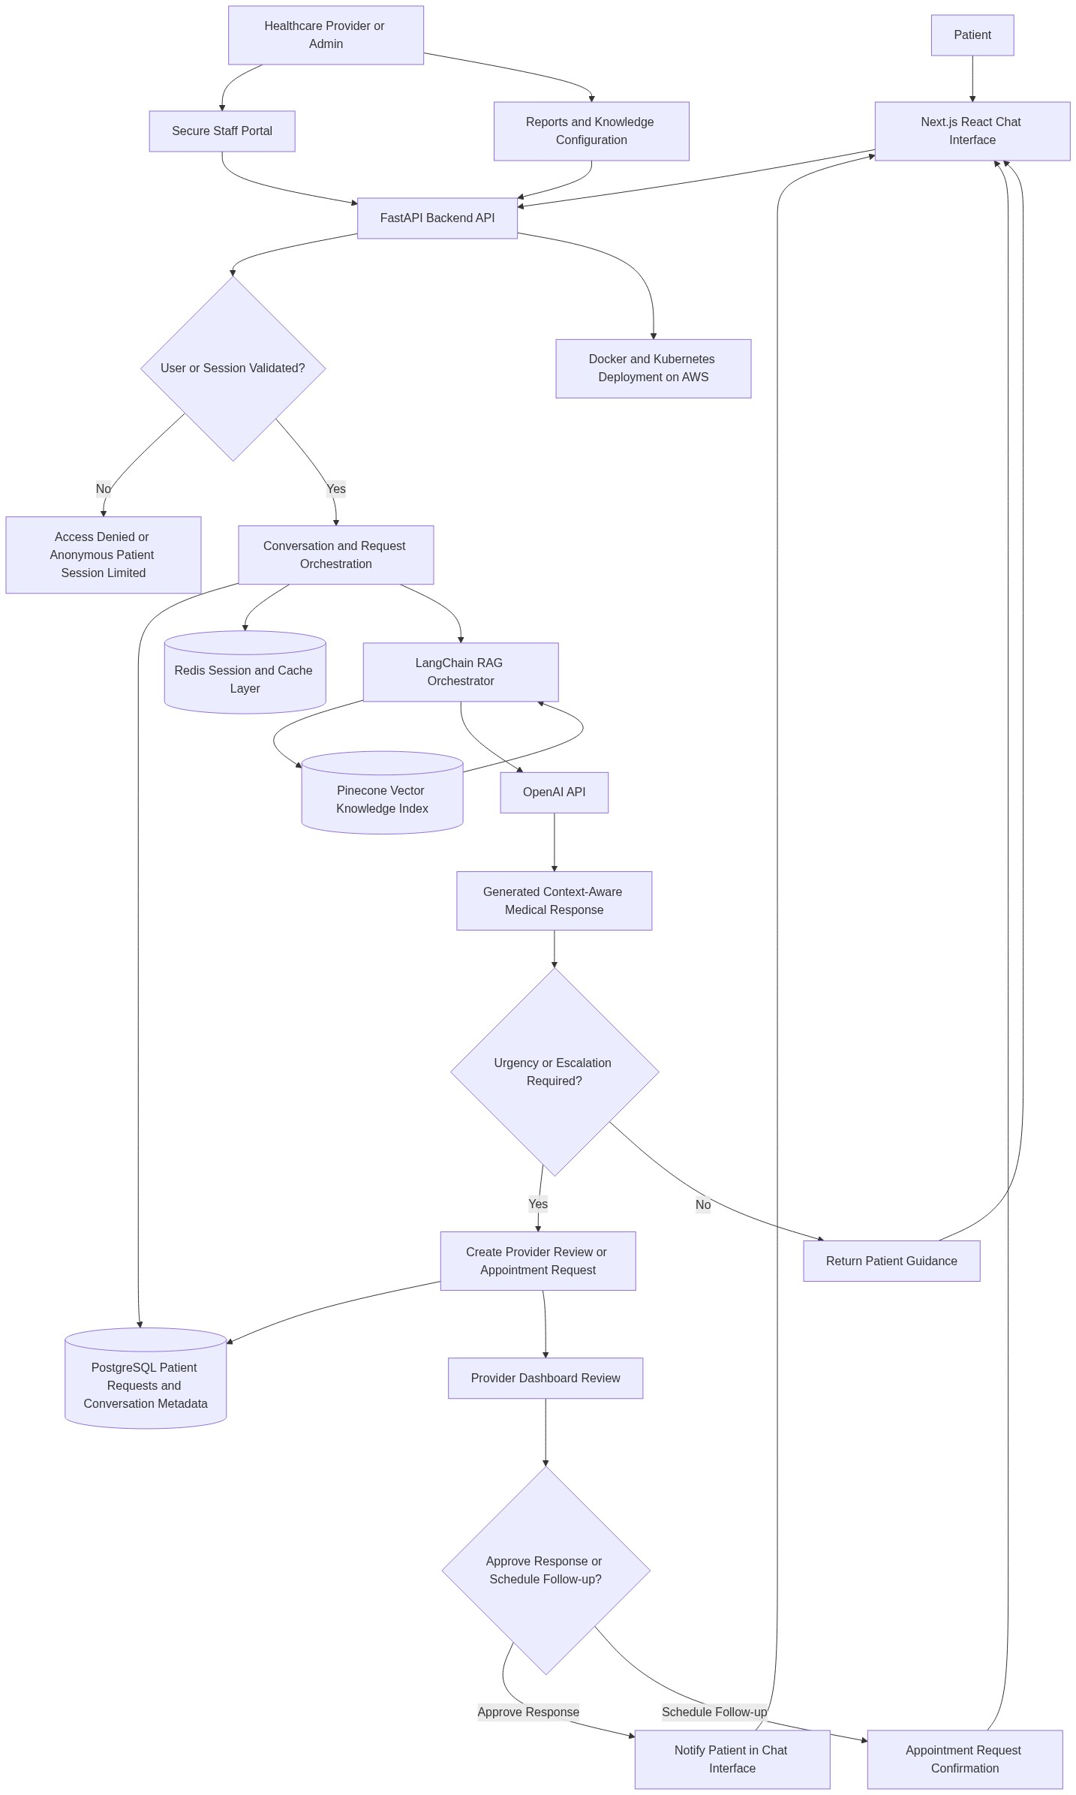
Diagram successfully loaded from mermaid.ink.

6. Development Plan & Timeline
The development cycle is projected at 4 Months. Following the structure of our standard Proof of Concept delivery pipeline, the specific deliverables and timeline phases are detailed below:
Phase | Duration | Output
Discovery, Solution Architecture, and Healthcare Workflow Definition | 0.5 Month | Validated functional scope, patient and provider workflow definition, system architecture, data flow design, Artificial Intelligence (AI) safety approach, integration assumptions, and implementation backlog aligned to the Proof of Concept objectives.
User Experience Design and Frontend Foundation | 0.75 Month | Responsive Next.js, React, and TypeScript application foundation covering patient chatbot screens, secure staff portal structure, administrative navigation, reusable interface components, and workflow-ready user journeys.
Backend Services, Data Model, and Authentication Foundation | 0.75 Month | FastAPI backend services, PostgreSQL schema, Redis caching layer, secure access patterns, conversation persistence, appointment request workflow, administrative service endpoints, and Application Programming Interface (API) documentation.
Artificial Intelligence, Retrieval-Augmented Generation, and Triage Workflow | 1 Month | LangChain-based retrieval-augmented generation pipeline, Pinecone vector index integration, OpenAI Application Programming Interface (API) orchestration, prompt templates, medical response guardrails, basic triage classification, escalation logic, and response quality evaluation approach.
Testing, Security Validation, Deployment, and Proof of Concept Handover | 1 Month | End-to-end testing, healthcare workflow validation, automation test coverage for critical flows, containerized deployment using Docker and Kubernetes on Amazon Web Services (AWS), operational monitoring baseline, release documentation, and final Proof of Concept handover.

7. Assumptions & Key Risks
Assumptions
- The client will provide timely access to healthcare stakeholders, administrative users, and subject matter experts who can validate triage scenarios, appointment workflows, response expectations, and operational review requirements.
- The client will provide or approve the medical knowledge content that will be indexed into Pinecone for retrieval-augmented generation, and the implementation team will not be responsible for independently validating clinical correctness beyond the agreed technical quality controls.
- The Proof of Concept will provide medical information and workflow assistance, but it will not replace licensed medical diagnosis, emergency response, or professional clinical decision-making.
- Amazon Web Services (AWS) account access, deployment permissions, networking constraints, domain configuration, and environment-level credentials will be made available before the deployment phase begins.
- OpenAI Application Programming Interface (API) access, usage limits, billing configuration, and compliance review approvals will be provided by the client or authorized by the client for implementation use.
- Third-party scheduling, electronic health record, Short Message Service (SMS), email, or hospital system integrations are considered integration-ready extension points unless specific access credentials and interface documentation are provided during the Proof of Concept timeline.
- A representative testing environment with non-production or anonymized data will be available for functional testing, security validation, and user acceptance review.
- Client security, compliance, and deployment approvals will be completed within the agreed project timeline, and any additional regulatory certification requirements will be treated as a separate workstream.
- Stakeholder feedback will be consolidated through designated decision-makers to prevent conflicting requirements and to maintain delivery alignment within the four-month timeline.
Risks & Mitigation
- Risk: Medical responses generated by the Artificial Intelligence (AI) model may be perceived as clinical advice if not properly controlled.
Mitigation: The solution will use retrieval-augmented generation, approved knowledge sources, response disclaimers, escalation rules, prompt guardrails, and provider review workflows for sensitive or urgent scenarios.
- Risk: The quality of chatbot responses may be limited if the medical knowledge base is incomplete, outdated, or insufficiently structured.
Mitigation: The project will define a controlled knowledge ingestion process, use approved content only, validate retrieval performance, and recommend ongoing governance for content updates.
- Risk: Changes in healthcare workflow requirements during development may affect the agreed timeline and delivery scope.
Mitigation: The project will follow iterative delivery with stakeholder reviews, backlog prioritization, documented change control, and early validation of patient, provider, and administrator workflows.
- Risk: Third-party Application Programming Interface (API) access for appointment scheduling or clinical systems may not be available during the Proof of Concept.
Mitigation: The solution will implement clean integration boundaries and configurable service interfaces so that live integrations can be added later without redesigning core modules.
- Risk: Data privacy, security, or compliance approvals may delay production-like deployment.
Mitigation: The implementation will use secure architecture practices, environment separation, access control, audit-friendly data handling, and early review of deployment and security requirements.
- Risk: OpenAI Application Programming Interface (API) rate limits, latency, or service availability may affect response performance.
Mitigation: The architecture will include Redis caching where appropriate, timeout controls, fallback messaging, observability, and configuration options for performance tuning.
- Risk: User acceptance may be impacted if chatbot responses do not align with provider communication standards.
Mitigation: The project will include prompt refinement, response review cycles, sample scenario validation, and alignment with client-approved tone, escalation, and content rules.
- Risk: Kubernetes deployment complexity may introduce environment configuration delays.
Mitigation: The DevOps workstream will establish containerization standards, deployment manifests, environment variables, observability baseline, and controlled deployment procedures early in the project lifecycle.
8. Allocated Technical Resources
Resource Name | Assigned Role | Allocated Hours
Avijit Chowdhury | AI Engineer | 685 Hours
Serya Mallick | Backend Developer | 428 Hours
Anu Banerjee | Frontend Developer | 428 Hours
Sayan Sen | Frontend Developer | 257 Hours
Abhijit Bhowmick | Automation Tester | 342 Hours
Arijeet Bhowmick | DevOps Engineer | 514 Hours
Monojit Sarkar | DevOps Engineer | 171 Hours

