PROOF OF CONCEPT (POC) & DEVELOPMENT PROPOSAL
SAMSUNG
Custom Software Engineering and Implementation Blueprint
Document Version: 1.0
Estimated Budget: $8,362.00 USD
Development Timeline: 1 Month 15 Days
Proposal Type: MVP

1. Executive Summary
Samsung requires a scalable and modern digital commerce channel that enables customers to browse, compare, and purchase mobile phones online through a secure, high-performance, and mobile-responsive experience. The business challenge is not limited to launching an online storefront; it includes establishing a dependable product catalog, a streamlined checkout journey, secure payment processing, and an operational foundation that can support future traffic growth, campaign-driven demand spikes, and continuous product expansion across Samsung mobile categories.
The proposed Minimum Viable Product (MVP) will deliver the essential e-commerce capabilities required to validate the online sales journey, reduce dependency on offline or fragmented sales channels, and create a controlled foundation for future enterprise-scale enhancements. Artificial Intelligence (AI) can improve the customer and administrative experience by supporting future product recommendations, intelligent search relevance, and AI-assisted quality assurance activities, while the MVP architecture will be designed so these capabilities can be introduced without major platform rework. The initial implementation will prioritize reliable catalog management, cart and checkout flows, Stripe payment integration, order creation, and administrative product controls.
The solution will be built using modern software engineering practices, including modular application architecture, Application Programming Interface (API)-first backend design, responsive user interface development, containerized deployment, environment-based configuration, automated testing practices, and secure handling of customer and payment-related data. The selected stack of Next.js, React, Node.js, NestJS, PostgreSQL, Redis, Stripe, Amazon Web Services (AWS), Docker, and Kubernetes provides a strong foundation for maintainability, scalability, and operational resilience.
Implementation will follow a focused MVP delivery strategy over one month and fifteen days, beginning with requirements refinement and user experience design, followed by parallel frontend and backend development, payment integration, quality assurance, deployment readiness, and user acceptance support. The expected business outcome is a production-ready MVP that allows Samsung to demonstrate and operate a secure online mobile phone sales journey, while preserving architectural flexibility for advanced merchandising, analytics, personalization, loyalty integration, and omnichannel capabilities in future releases.
2. Proposed Solution & Scope
- Functional scope will include a customer-facing e-commerce storefront where users can browse Samsung mobile phones, view product details, review pricing and specifications, add products to a cart, proceed through a secure checkout flow, complete payment through Stripe, and receive order confirmation.
- The product catalog module will support structured product information including model name, description, images, pricing, stock status, key specifications, and category-level organization so that Samsung can manage mobile phone listings consistently and present them in a commercially effective format.
- The user workflow will begin with customers accessing the Next.js storefront, browsing available mobile phone products, selecting a product, adding it to the cart, entering checkout details, authenticating or continuing through the approved checkout model, completing payment via Stripe, and receiving a final order confirmation after backend validation.
- The administrative workflow will allow authorized business users to manage catalog content, maintain product availability, review submitted orders, and validate payment and order status through controlled backend services.
- The backend scope will include Node.js and NestJS-based Application Programming Interfaces for product catalog retrieval, cart operations, checkout orchestration, order creation, payment session handling, payment status confirmation, and database persistence using PostgreSQL.
- Secure checkout will be implemented through Stripe integration so that sensitive payment processing is handled by a specialized payment platform, reducing direct exposure of payment card data and supporting a more secure compliance posture for the MVP.
- Authentication and authorization will be designed for administrative access control, ensuring only approved Samsung administrators can create, update, or manage catalog and order-related records, while customer checkout access will follow the selected MVP user journey.
- Artificial Intelligence capabilities will be positioned as an extensible layer for future enhancement, particularly for intelligent product recommendations, search relevance optimization, customer behavior insights, and AI-assisted testing support, while the MVP will keep the core transaction journey stable and commercially usable.
- Reporting scope will include foundational order and catalog visibility so Samsung stakeholders can review product availability, submitted orders, and payment outcomes, with the structure prepared for future dashboards and advanced analytics.
- Integration scope will include Stripe for payments and deployment readiness on Amazon Web Services using Docker-based packaging, with the architecture prepared for Kubernetes-based orchestration as the platform scales.
- Resource allocation will include frontend engineering, backend engineering, user experience design, and quality assurance coverage, ensuring that the MVP is delivered with balanced attention to usability, technical reliability, checkout integrity, and test coverage.
- Future scalability will be supported through modular services, PostgreSQL relational data design, Redis-ready caching patterns, containerized deployment, and cloud-native infrastructure alignment, allowing the platform to evolve into a broader Samsung commerce ecosystem.
3. Estimated Budget & Cost Structure
The total estimated cost for this custom software development solution is $8,362.00 USD. This includes full engineering resources, quality assurance testing, architecture design, and final deployment setup. The detailed cost breakdown is aligned with the technical roles and allocated task hours detailed in Section 7.
4. Proposed Technology Stack
Layer | Technology / Framework | Purpose
Database | PostgreSQL | Primary platform layer for the Database requirements.
Backend | Node.js, NestJS | Primary platform layer for the Backend requirements.
Frontend | Next.js, React | Primary platform layer for the Frontend requirements.
Cloud | AWS | Primary platform layer for the Cloud requirements.
Artificial intelligence | AI-assisted Testing | Primary platform layer for the Artificial Intelligence requirements.
Authentication | NestJS Authentication and Authorization | Primary platform layer for the Authentication requirements.
Storage | AWS | Primary platform layer for the Storage requirements.
Deployment | Docker, Kubernetes | Primary platform layer for the Deployment requirements.

5. System Workflow Diagram
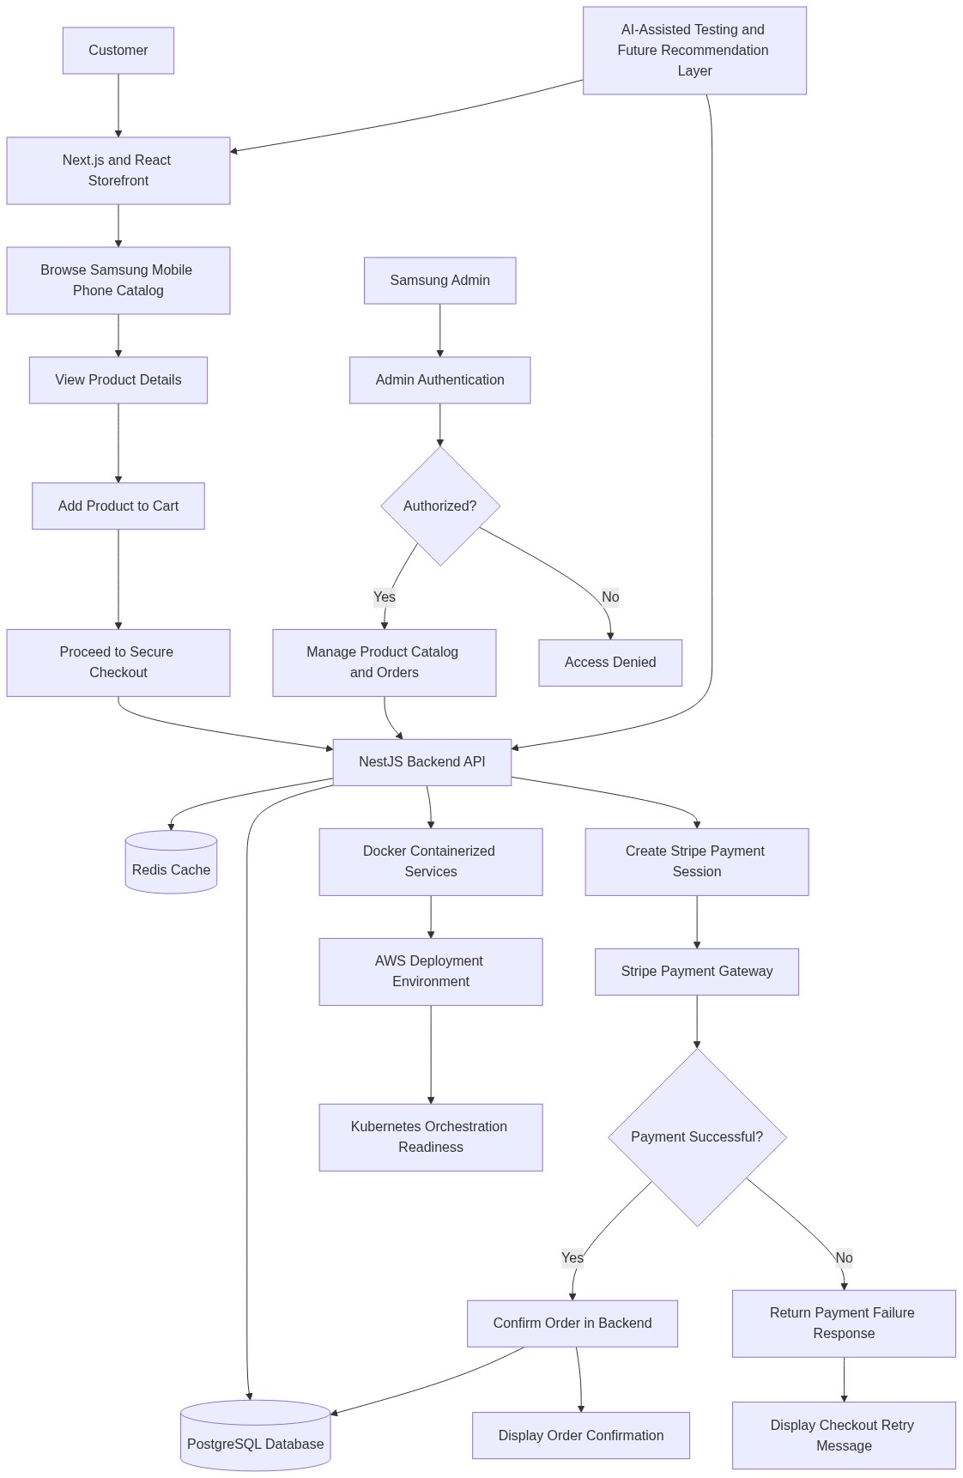
Diagram successfully loaded from mermaid.ink.

6. Development Plan & Timeline
The development cycle is projected at 1 Month 15 Days. Following the structure of our standard Proof of Concept delivery pipeline, the specific deliverables and timeline phases are detailed below:
Phase | Duration | Output
Discovery, Requirements Validation, and MVP Planning | 5 Days | Validated MVP scope, refined user journeys for catalog browsing and checkout, payment integration assumptions, delivery backlog, and acceptance criteria for the Samsung mobile phone e-commerce platform.
User Experience Design and Frontend Architecture | 7 Days | Responsive e-commerce wireframes, visual design direction, reusable interface components, storefront navigation model, product detail layout, cart journey, and checkout screen structure aligned to modern mobile-first commerce standards.
Backend Foundation, Database Design, and API Development | 10 Days | NestJS backend foundation, PostgreSQL schema for products and orders, catalog management Application Programming Interfaces, cart and checkout service structure, Redis-ready caching approach, and secure administrative access patterns.
E-Commerce Feature Build and Stripe Payment Integration | 12 Days | Completed customer storefront flows, product catalog display, product detail pages, cart functionality, secure checkout orchestration, Stripe payment session integration, order confirmation handling, and administrative catalog management capabilities.
Quality Assurance, Security Validation, and Deployment Preparation | 8 Days | Functional test execution, checkout flow validation, payment success and failure testing, regression testing, containerized Docker build readiness, deployment configuration review, and defect remediation for MVP stability.
User Acceptance Support, Handover, and MVP Closure | 3 Days | Stakeholder walkthrough, user acceptance testing support, final issue resolution, deployment handover notes, operational guidance, and MVP completion sign-off documentation.

7. Assumptions & Key Risks
Assumptions
- Samsung will provide timely access to approved product information, pricing rules, mobile phone specifications, product images, branding guidelines, and any mandatory content required for storefront readiness.
- Samsung stakeholders will be available for requirements clarification, design review, payment workflow validation, and user acceptance testing within the agreed delivery timeline.
- Stripe account configuration, payment credentials, webhook settings, and any required merchant approvals will be provided or enabled by Samsung before payment integration testing begins.
- Amazon Web Services infrastructure access, environment details, domain configuration, and deployment permissions will be made available in time for deployment preparation and validation.
- The MVP will focus on the sale of Samsung mobile phones and will not include complex marketplace, multi-vendor, financing, trade-in, loyalty, or regional tax automation features unless separately prioritized.
- Artificial Intelligence capabilities in the MVP will be limited to architecture readiness and AI-assisted quality assurance practices, with advanced recommendation or personalization models treated as future enhancements.
- A representative testing environment will be available for functional testing, checkout testing, payment simulation, security review, and stakeholder validation before production deployment.
- Security and compliance approvals related to cloud access, administrative roles, payment processing, and release authorization will be completed by Samsung within the project timeline.
- Third-party service availability, especially Stripe and Amazon Web Services, is assumed to remain stable during development, testing, and deployment activities.
- Final production deployment approval will be provided by Samsung after successful user acceptance testing and review of the MVP deliverables.
Risks & Mitigation
- Risk: Product catalog content may be incomplete or delayed, which can affect storefront readiness and user acceptance testing.
Mitigation: Establish an early content checklist, use structured sample data during development, and schedule catalog validation before the final testing phase.
- Risk: Stripe merchant configuration or payment credential availability may be delayed, which can impact checkout integration timelines.
Mitigation: Begin payment integration planning in the first phase, use Stripe test mode during development, and track merchant-side dependencies as critical delivery items.
- Risk: Changes in business requirements during the MVP cycle may create scope pressure within the one month and fifteen day timeline.
Mitigation: Apply disciplined MVP backlog control, conduct regular stakeholder reviews, and defer non-critical enhancements to a post-MVP roadmap.
- Risk: Cloud environment access or deployment approvals may not be available when required, delaying release readiness.
Mitigation: Confirm Amazon Web Services access requirements at project initiation, prepare Docker-based deployment artifacts early, and maintain a deployment readiness checklist.
- Risk: Checkout defects can directly affect customer trust and transaction completion rates.
Mitigation: Prioritize end-to-end checkout testing, validate payment success and failure scenarios, and include regression testing for cart, order, and payment flows.
- Risk: Performance degradation may occur if product catalog traffic increases beyond MVP assumptions.
Mitigation: Use efficient Application Programming Interface design, PostgreSQL indexing practices, Redis-ready caching patterns, and cloud-native scaling preparation.
- Risk: Administrative access control gaps may expose catalog or order management functions to unauthorized users.
Mitigation: Implement role-based administrative authorization, secure backend endpoints, and validate access scenarios during quality assurance.
- Risk: Integration behavior may vary between test and production payment environments.
Mitigation: Validate webhook handling, payment status transitions, and error responses in Stripe test mode before production credential activation.
- Risk: Limited time for advanced analytics, personalization, or Artificial Intelligence-driven recommendations may create stakeholder expectation gaps.
Mitigation: Clearly define MVP boundaries, include architectural readiness for future Artificial Intelligence capabilities, and document a phased enhancement roadmap.
8. Allocated Technical Resources
Resource Name | Assigned Role | Allocated Hours
Sayan Sen | Frontend Developer | 257 Hours
Serya Mallick | Backend Developer | 160 Hours
Abhijit Dutta | UI/UX Designer | 96 Hours
Ankita Sen | QA Engineer | 128 Hours
Ankan Bhowmick | QA Automation Engineer | 128 Hours

