PROOF OF CONCEPT (POC) & DEVELOPMENT PROPOSAL
SHOPY
Custom Software Engineering and Implementation Blueprint
Document Version: 1.0
Estimated Budget: $9,792.00 USD
Development Timeline: 1 Month 15 Days
Proposal Type: MVP

1. Executive Summary
Shopy addresses a critical commercial challenge for e-commerce businesses: customers often need immediate, contextual, and trustworthy assistance while browsing products, comparing alternatives, and making purchase decisions, while internal support teams are constrained by volume, response time, and inconsistent product knowledge. The proposed Minimum Viable Product (MVP) will establish an Artificial Intelligence (AI)-powered shopping assistant that helps customers discover relevant products, receive automated support, and interact through a conversational interface connected to product and business data.
The solution is required to improve conversion, reduce repetitive support workload, and create a scalable digital engagement layer that can operate continuously across the online shopping journey. By using Machine Learning (ML), Retrieval-Augmented Generation (RAG), prompt engineering, and large language model orchestration, Shopy will provide grounded product recommendations, answer product-related questions, and support customer service scenarios using information retrieved from the approved product catalog and knowledge sources.
The expected business outcomes include improved customer engagement, faster response handling, better product discovery, and enhanced operational visibility through structured interaction data. The platform will be designed with maintainability, modular Application Programming Interface (API) architecture, secure authentication patterns, structured database design, automated testing, and continuous integration practices so that the MVP can evolve into a production-grade enterprise commerce assistant.
Implementation will follow modern software engineering practices, including iterative delivery, API-first backend development, component-based frontend implementation, AI workflow validation, quality assurance automation, and controlled deployment. The strategy prioritizes a practical MVP that validates the most valuable customer-facing and operational workflows within the agreed budget and timeline while preserving extensibility for additional integrations, analytics, personalization, and enterprise governance in later releases.
2. Proposed Solution & Scope
- Functional scope: The MVP will include an AI-powered shopping assistant capable of receiving customer questions, interpreting shopping intent, retrieving relevant product and knowledge information, generating contextual responses, and presenting recommendations through a responsive web interface.
- User workflow: Customers will access the storefront assistant, ask product or support-related questions, receive AI-generated responses grounded in available product data, review recommended products, and continue the shopping journey with reduced friction and improved confidence.
- Major modules: The solution will include a customer-facing conversational interface, backend API services, AI orchestration layer, product and knowledge retrieval service, administrative data management capability, recommendation response pipeline, testing framework, and deployment automation.
- Artificial Intelligence capabilities: The system will use Retrieval-Augmented Generation, prompt engineering, OpenAI API integration, LangChain-based orchestration, and vector retrieval patterns to generate responses that are more relevant, context-aware, and aligned with available e-commerce information.
- Authentication: The MVP will support secure access patterns for administrative users through Supabase capabilities, ensuring that product data management, configuration, and operational controls are restricted to authorized personnel.
- Resource allocation: The delivery team will combine Artificial Intelligence engineering, full stack development, and quality assurance expertise to cover AI workflow design, backend services, frontend experience, database integration, automated testing, and deployment readiness.
- Recommendation and response generation workflow: Customer queries will be captured by the frontend, processed by the FastAPI backend, enriched through LangChain and retrieval workflows, sent to the OpenAI API when generation is required, validated against available product context, stored for traceability, and returned to the user interface in a structured conversational format.
- Reporting: The MVP will capture essential interaction and operational data that can support future reporting on customer questions, recommendation patterns, unanswered queries, and assistant usage trends, while keeping the initial implementation focused on business validation.
- Administrative features: Authorized users will be able to manage or prepare product and knowledge data sources, review assistant behavior during testing, validate response quality, and support controlled updates to the information used by the AI assistant.
- Integration possibilities: The architecture will allow future integration with e-commerce platforms, product information management systems, customer relationship management platforms, order management systems, payment providers, notification services, and analytics tools through API-based extension points.
- Future scalability: The MVP will be structured so that additional channels, multilingual support, advanced personalization, customer segmentation, human handoff, analytics dashboards, and enterprise-grade governance can be introduced without redesigning the foundational architecture.
3. Estimated Budget & Cost Structure
The total estimated cost for this custom software development solution is $9,792.00 USD. This includes full engineering resources, quality assurance testing, architecture design, and final deployment setup. The detailed cost breakdown is aligned with the technical roles and allocated task hours detailed in Section 7.
4. Proposed Technology Stack
Layer | Technology / Framework | Purpose
Database | PostgreSQL, Supabase | Primary platform layer for the Database requirements.
Backend | Python (FastAPI), LangChain, OpenAI API | Primary platform layer for the Backend requirements.
Frontend | Next.js, React, TypeScript, Tailwind CSS, SvelteKit, Remix | Primary platform layer for the Frontend requirements.
Cloud | Supabase (as BaaS), GitHub Actions (for CI) | Primary platform layer for the Cloud requirements.
Artificial intelligence | Python, LangChain, OpenAI API, RAG, Prompt Engineering, LlamaIndex, Pinecone, Hugging Face | Primary platform layer for the Artificial Intelligence requirements.
Authentication | Supabase | Primary platform layer for the Authentication requirements.
Storage | Supabase | Primary platform layer for the Storage requirements.
Deployment | GitHub Actions, Jenkins | Primary platform layer for the Deployment requirements.

5. System Workflow Diagram
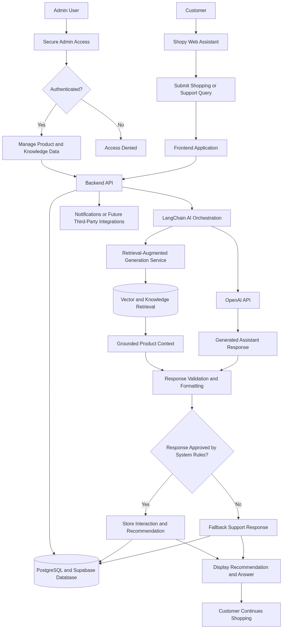
Diagram successfully loaded from mermaid.ink.

6. Development Plan & Timeline
The development cycle is projected at 1 Month 15 Days. Following the structure of our standard Proof of Concept delivery pipeline, the specific deliverables and timeline phases are detailed below:
Phase | Duration | Output
Discovery, MVP Planning, and Solution Architecture | 5 Days | Validated MVP scope, confirmed user journeys, AI assistant success criteria, high-level architecture, data flow definition, delivery backlog, and implementation plan aligned to the business requirements and available technology stack.
User Experience, Frontend Foundation, and Admin Access Setup | 7 Days | Responsive customer assistant interface, initial admin access flow, frontend component structure, Tailwind CSS styling foundation, and integration-ready screens for conversational shopping and operational validation.
Backend API, Database Design, and Supabase Integration | 8 Days | FastAPI service layer, PostgreSQL and Supabase data structures, secured backend endpoints, product and knowledge data handling patterns, interaction storage, and integration contracts for frontend and AI services.
Artificial Intelligence Workflow, Retrieval, and Recommendation Logic | 12 Days | LangChain-based AI orchestration, OpenAI API integration, Retrieval-Augmented Generation workflow, prompt templates, product context retrieval, recommendation response generation, fallback handling, and initial AI quality validation.
End-to-End Integration, Testing, and Quality Assurance | 10 Days | Integrated MVP workflow, functional testing, API testing, chatbot response testing, browser-based validation using Playwright and Selenium, defect resolution, regression checks, and readiness assessment against agreed acceptance criteria.
Deployment, Knowledge Transfer, and MVP Handover | 3 Days | Continuous integration setup, deployment preparation, environment validation, final demonstration, technical handover documentation, operational guidance, and prioritized recommendations for post-MVP enhancements.

7. Assumptions & Key Risks
Assumptions
- The client will provide timely access to sample product catalog data, frequently asked questions, support content, and any existing e-commerce workflow information required to ground the AI assistant.
- The client will nominate business and technical stakeholders who can review user journeys, validate AI responses, and provide feedback during scheduled checkpoints within the 1 Month 15 Days timeline.
- Supabase will be acceptable as the Backend-as-a-Service platform for database, authentication, and storage capabilities required for the MVP implementation.
- The client will approve the use of OpenAI API and associated third-party AI services, including any required account setup, usage limits, data processing terms, and commercial billing arrangements.
- The initial Artificial Intelligence model behavior will be optimized for MVP validation using prompt engineering and Retrieval-Augmented Generation rather than custom model training, unless additional scope and budget are approved.
- A suitable testing environment will be available or approved early in the engagement so that frontend, backend, database, and AI workflows can be validated before final handover.
- Security, privacy, and deployment approvals will be provided within the planned delivery windows, including approval for storing interaction logs and product-related data necessary for system validation.
- The MVP will focus on product discovery, recommendations, and automated support assistance, while advanced enterprise features such as order-specific personalization, human agent escalation, multilingual support, and deep analytics will be treated as future enhancements unless explicitly prioritized.
- Any integration with live e-commerce platforms, customer relationship management systems, order management systems, or payment providers will depend on the availability and readiness of third-party Application Programming Interfaces.
- The estimated cost assumes the selected resources and allocated hours remain available as planned and that material changes to scope, compliance requirements, or data readiness do not occur during the delivery period.
Risks & Mitigation
- Risk: Product catalog or support knowledge data may be incomplete, inconsistent, or unavailable during early development. Mitigation: Establish a minimum viable data set during discovery, define data quality expectations, and implement retrieval workflows that can be progressively improved as richer content becomes available.
- Risk: Artificial Intelligence responses may occasionally be inaccurate, overly broad, or insufficiently aligned with product information. Mitigation: Use Retrieval-Augmented Generation, controlled prompt templates, response validation rules, fallback messages, and stakeholder review cycles to improve answer quality and reduce hallucination risk.
- Risk: Changes in business requirements during the MVP timeline may affect delivery predictability. Mitigation: Use a prioritized backlog, confirm acceptance criteria at the start of each phase, and route scope changes through impact assessment before implementation.
- Risk: Third-party services such as OpenAI API or Supabase may experience usage limits, configuration delays, or service availability issues. Mitigation: Confirm account readiness early, monitor service constraints, design modular integration boundaries, and document fallback options for critical workflows.
- Risk: Authentication and data access requirements may require additional security review before deployment. Mitigation: Incorporate secure access patterns from the beginning, use Supabase authentication capabilities, restrict administrative functionality, and schedule security approval checkpoints before handover.
- Risk: The conversational user experience may require refinement after users interact with realistic shopping scenarios. Mitigation: Conduct iterative usability review, analyze test conversations, refine prompts and interface behavior, and prioritize changes that improve customer decision support within MVP constraints.
- Risk: Automated testing may not cover all AI response variations because generative outputs are probabilistic. Mitigation: Combine deterministic API and functional tests with AI-assisted test scenarios, curated prompt test suites, response quality checks, and manual validation of high-value customer journeys.
- Risk: Integration with existing or future e-commerce systems may require additional API mapping and data transformation. Mitigation: Design the MVP with API-first architecture, maintain clear data contracts, and document integration assumptions for future platform connectivity.
- Risk: Budget and timeline pressure may limit the number of advanced personalization and analytics capabilities delivered in the MVP. Mitigation: Focus delivery on core shopping assistant value, separate foundational capabilities from enhancement backlog items, and provide a roadmap for post-MVP scaling.
- Risk: Stakeholder unavailability may delay feedback on workflows, response quality, and acceptance criteria. Mitigation: Agree review dates during project initiation, use structured demonstrations, and maintain decision logs to prevent unresolved questions from blocking development progress.
8. Allocated Technical Resources
Resource Name | Assigned Role | Allocated Hours
Nahid Sinha | AI Engineer | 64 Hours
Avijit Chowdhury | AI Engineer | 192 Hours
Afzal Iyer | Full Stack Developer | 160 Hours
Serya Bose | Full Stack Developer | 96 Hours
Ankita Sen | QA Engineer | 128 Hours
Ankan Bhowmick | QA Engineer | 128 Hours

