PROOF OF CONCEPT (POC) & DEVELOPMENT PROPOSAL
LOVY
Custom Software Engineering and Implementation Blueprint
Document Version: 1.0
Estimated Budget: $65,116.00 USD
Development Timeline: 6 Months
Proposal Type: FULL

1. Executive Summary
Lovy is being positioned as a modern relationship-focused dating platform that must deliver a seamless mobile experience while maintaining trust, safety, responsiveness, and operational scalability. The core business challenge is to create a differentiated digital product in a competitive market where users expect intuitive onboarding, meaningful profile discovery, real-time communication, secure interactions, and reliable subscription or payment experiences from the first release. A full product implementation is required to move beyond a basic Minimum Viable Product (MVP) and establish a secure, extensible, and commercially viable platform that can support user growth, moderation workflows, monetization, and future feature expansion.
The proposed solution will deliver a cross-platform mobile application, an administrative web portal, a scalable backend, real-time messaging, intelligent matchmaking, notification delivery, secure data persistence, and payment integration. Artificial Intelligence (AI) will improve the user experience by supporting intelligent compatibility scoring, preference-driven discovery, and match recommendations based on profile attributes, behavioral signals, and interaction patterns. This will help Lovy increase user engagement, reduce irrelevant matches, and create a more meaningful relationship discovery journey while maintaining transparency and responsible use of user data.
The expected business outcomes include faster market readiness, improved user retention, secure and moderated interactions, monetization readiness through Stripe, and a technology foundation capable of scaling across geographies and user volumes. The architecture will use React Native for mobile delivery, Next.js for the administrative interface, Node.js and NestJS for maintainable backend services, PostgreSQL and Redis for transactional and high-performance data use cases, WebSocket for real-time chat, Amazon Web Services (AWS) for cloud infrastructure, Firebase Cloud Messaging for push notifications, and Docker-enabled deployment practices.
Implementation will follow modern software engineering practices including modular architecture, secure Application Programming Interface (API) design, environment separation, structured quality assurance, automated regression coverage where appropriate, and production-oriented deployment planning. The delivery strategy will be phased across discovery, design, core engineering, integrations, testing, and launch readiness so that business stakeholders can validate functionality progressively while the technical team maintains control over scalability, maintainability, security, and release quality.
2. Proposed Solution & Scope
- Functional scope: The full product scope will include user registration, secure login, profile creation, photo and interest management, preference configuration, profile discovery, like/pass actions, mutual match creation, real-time chat, push notifications, payment-enabled premium flows, user reporting, moderation, and administrative oversight.
- User workflow: A user will onboard through the mobile application, authenticate securely, create a profile, define dating preferences, browse suggested profiles, interact through likes or passes, receive a match when interest is mutual, communicate through real-time chat, receive Firebase Cloud Messaging notifications, and access premium functionality where enabled through Stripe.
- Major modules: The platform will include the React Native mobile application, Next.js administrative dashboard, NestJS backend services, PostgreSQL relational data layer, Redis caching and session acceleration layer, WebSocket messaging service, notification service, payment service, matchmaking service, moderation workflow, and deployment configuration on Amazon Web Services (AWS).
- Artificial Intelligence capabilities: The intelligent matchmaking capability will use profile attributes, stated preferences, location or distance parameters where enabled, interaction behavior, and compatibility rules to generate ranked recommendations that improve relevance and reduce repetitive or unsuitable profile suggestions.
- Authentication: The system will implement secure authentication and session handling for mobile users and administrative users, with role-based access controls for administrative functions such as user review, moderation actions, reporting access, and configuration management.
- Resource allocation: Delivery will be supported by dedicated mobile, backend, frontend, User Interface/User Experience (UI/UX), quality assurance, solution architecture, and technical architecture resources, with responsibilities aligned to mobile app delivery, scalable service design, administrative tooling, test coverage, system architecture, and cloud deployment readiness.
- Proposal generation workflow: As this is a full product delivery proposal, the implementation workflow will progress from validated requirements and design assets into engineered application modules, integrated backend services, quality assurance cycles, stakeholder acceptance, and controlled production deployment.
- Reporting: The administrative dashboard will provide operational visibility into users, reported profiles, moderation queues, match and engagement indicators, subscription or payment-related views, and system-level activity metrics required for business and support operations.
- Administrative features: Administrators will be able to review user accounts, manage reported content, monitor platform activity, support user safety processes, review moderation queues, and access controlled analytics without requiring direct database access.
- Integration possibilities: The architecture will support integration with Stripe for payments, Firebase Cloud Messaging for mobile notifications, WebSocket channels for real-time communication, and future third-party services such as identity verification, image moderation, analytics platforms, customer support tools, and advanced Artificial Intelligence (AI) recommendation engines.
- Future scalability: The solution will be designed with modular backend services, cache-assisted performance optimization, cloud-native deployment practices, and clean separation between mobile, administrative, API, messaging, and data layers so that new features, markets, monetization models, and compliance capabilities can be added without major re-engineering.
3. Estimated Budget & Cost Structure
The total estimated cost for this custom software development solution is $65,116.00 USD. This includes full engineering resources, quality assurance testing, architecture design, and final deployment setup. The detailed cost breakdown is aligned with the technical roles and allocated task hours detailed in Section 7.
4. Proposed Technology Stack
Layer | Technology / Framework | Purpose
Database | PostgreSQL, Redis | Primary platform layer for the Database requirements.
Backend | Node.js, NestJS | Primary platform layer for the Backend requirements.
Frontend | React Native, Next.js | Primary platform layer for the Frontend requirements.
Cloud | AWS | Primary platform layer for the Cloud requirements.
Artificial intelligence | Node.js, NestJS | Primary platform layer for the Artificial Intelligence requirements.
Authentication | Node.js, NestJS | Primary platform layer for the Authentication requirements.
Storage | AWS | Primary platform layer for the Storage requirements.
Deployment | Docker, AWS | Primary platform layer for the Deployment requirements.

5. System Workflow Diagram
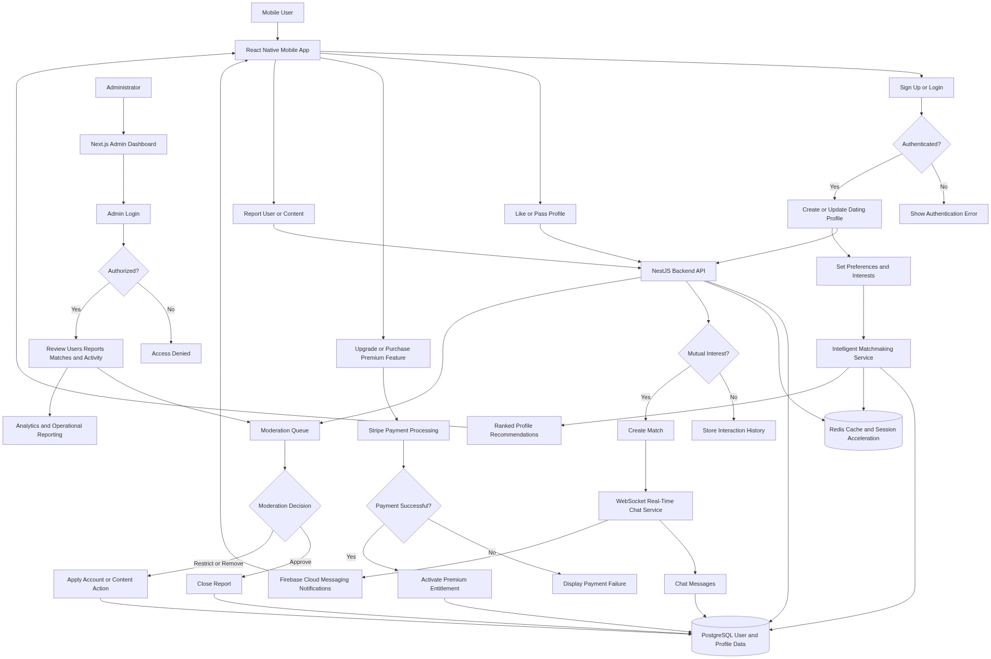
Diagram successfully loaded from mermaid.ink.

6. Development Plan & Timeline
The development cycle is projected at 6 Months. Following the structure of our standard Proof of Concept delivery pipeline, the specific deliverables and timeline phases are detailed below:
Phase | Duration | Output
Discovery, Solution Architecture, and Product Planning | 0.5 Month | Confirmed full-product requirements, finalized functional backlog, user journey definition, solution architecture, security approach, data model direction, integration plan, delivery governance, and release roadmap.
User Experience Design and Design System | 1 Month | High-fidelity mobile application designs, administrative dashboard designs, reusable design system, onboarding flows, profile discovery flows, chat experience, moderation screens, and stakeholder-approved interactive prototypes.
Core Mobile, Backend, and Data Platform Development | 1.5 Months | React Native mobile foundation, NestJS backend services, PostgreSQL schema, Redis integration, authentication workflows, user profile management, preference management, profile discovery, and foundational Application Programming Interface (API) endpoints.
Real-Time Communication, Matchmaking, Notifications, and Payments | 1 Month | Mutual match workflows, intelligent matchmaking logic, WebSocket-based real-time chat, Firebase Cloud Messaging push notifications, Stripe payment integration, premium entitlement handling, and integration-tested service flows.
Admin Portal, Moderation, Reporting, and Hardening | 1 Month | Next.js administrative dashboard, user management views, reporting and moderation queues, operational analytics, role-based administrative controls, performance optimization, security hardening, and cloud deployment readiness.
Quality Assurance, User Acceptance Testing, Deployment, and Launch Support | 1 Month | End-to-end testing, mobile regression testing, Application Programming Interface (API) testing, performance validation, defect remediation, stakeholder user acceptance testing support, production deployment, release documentation, and launch stabilization.

7. Assumptions & Key Risks
Assumptions
- The client will provide timely access to business stakeholders for requirement validation, design review, sprint demonstrations, and user acceptance decisions throughout the six-month delivery period.
- The client will confirm the final monetization model, subscription tiers, premium feature rules, refund expectations, and Stripe account configuration before payment integration development begins.
- The client will provide or approve all branding assets, application name usage, logo files, color guidelines, content tone, legal copy, privacy policy, terms of service, and user safety disclaimers required for production release.
- Amazon Web Services (AWS), Firebase Cloud Messaging, Stripe, app store accounts, and any required third-party credentials will be provisioned by the client or made available to the delivery team through secure access management processes.
- The intelligent matchmaking capability for the initial full release will use structured profile data, user preferences, and interaction-based compatibility logic, with the option to evolve toward more advanced machine learning models after sufficient production data is available.
- A dedicated testing environment will be made available with representative test data, non-production credentials, and environment separation so that quality assurance activities do not affect production users or live payment flows.
- Security, privacy, and compliance approvals will be completed by the client within agreed review windows, especially for personal data handling, profile images, chat messages, payment data, and moderation processes.
- Deployment approvals, app store submission approvals, and production release sign-offs will be provided by authorized client representatives according to the agreed release calendar.
- Any third-party service limitations, pricing changes, account restrictions, app store review delays, or regional compliance requirements outside the agreed scope may require schedule or cost reassessment.
- The available resource allocation and estimated budget are assumed to be sufficient for the described full product scope when requirements remain stable and decisions are made within agreed governance timelines.
Risks & Mitigation
- Risk: Dating application requirements may expand during implementation as stakeholders review user experience flows and competitor features. Mitigation: Adopt structured change control, maintain a prioritized backlog, and review scope impact during sprint planning before introducing new features.
- Risk: Real-time chat performance may be affected as concurrent user activity increases. Mitigation: Design WebSocket services with scalable connection handling, use Redis where appropriate for performance optimization, and conduct performance testing before production release.
- Risk: Matchmaking quality may initially be limited if the platform has low user density or limited behavioral data. Mitigation: Start with transparent preference-based and compatibility-rule logic, continuously capture interaction signals, and establish a roadmap for more advanced Artificial Intelligence (AI) optimization after launch.
- Risk: App store approval may be delayed due to dating category policies, privacy disclosures, payment rules, or user-generated content moderation expectations. Mitigation: Prepare compliant privacy documentation, moderation features, reporting mechanisms, and store submission assets early in the delivery lifecycle.
- Risk: Payment integration may be delayed if Stripe account setup, tax rules, subscription products, or client approvals are incomplete. Mitigation: Define the payment model during discovery and validate Stripe configuration in a controlled test environment before production activation.
- Risk: Sensitive user data, chat messages, and profile images create privacy and security exposure if access controls are not implemented correctly. Mitigation: Enforce secure authentication, role-based administrative access, encrypted transport, least-privilege access, secure environment configuration, and formal security review before launch.
- Risk: Moderation workload may increase rapidly after launch if reporting volumes are higher than expected. Mitigation: Provide administrative moderation queues, structured status tracking, account action workflows, and reporting views that allow the operations team to prioritize safety cases effectively.
- Risk: Integration dependencies such as Firebase Cloud Messaging, Stripe, and cloud services may experience configuration issues or external service interruptions. Mitigation: Use environment-specific credentials, implement error handling and retry strategies where appropriate, and document operational procedures for incident response.
- Risk: Quality assurance coverage may be challenged by device fragmentation across iOS and Android ecosystems. Mitigation: Define a representative device testing matrix, combine manual mobile testing with regression test planning, and prioritize critical journeys such as onboarding, matching, chat, payments, and reporting.
- Risk: Production deployment may be delayed if infrastructure, domain, certificate, monitoring, or approval activities are deferred. Mitigation: Initiate deployment planning early, maintain environment readiness checkpoints, and include production release validation as a formal delivery milestone.
8. Allocated Technical Resources
Resource Name | Assigned Role | Allocated Hours
Tanya Iyer | React Native Developer | 1028 Hours
Serya Mallick | Backend Developer | 642 Hours
Sayan Sen | Frontend Developer | 1028 Hours
Abhijit Dutta | UI/UX Designer | 385 Hours
Abhijit Bhowmick | Automation Tester | 514 Hours
Tanya Saha | Solution Architect | 385 Hours
Shreya Sarkar | Technical Architect | 642 Hours

