PROOF OF CONCEPT (POC) & DEVELOPMENT PROPOSAL
PRE-SALES AI PLATFORM
Custom Software Engineering and Implementation Blueprint
Document Version: 1.0
Estimated Budget: $8,189.00 USD
Development Timeline: 2 Months
Proposal Type: MVP

1. Executive Summary
Technology service providers often face delays, inconsistencies, and high dependency on senior pre-sales teams when converting client requirements into reliable proposals, budgets, timelines, technology recommendations, and resource plans. The Pre-Sales AI Platform addresses this challenge by creating a structured, intelligent, and collaborative environment where clients can submit requirements, internal teams can validate and refine opportunities, and leadership roles can govern proposal quality before client submission.
The proposed Minimum Viable Product (MVP) will use Artificial Intelligence (AI) to analyze submitted project requirements and generate preliminary estimates for cost, delivery duration, technology stack, and resource allocation. This AI-assisted approach reduces manual estimation effort, improves response consistency, accelerates pre-sales turnaround time, and enables business teams to handle a higher volume of opportunities without proportionally increasing operational overhead.
The solution will be designed as a cloud-enabled web platform using React for the user experience, FastAPI for secure backend services, PostgreSQL for structured transactional data, and OpenAI API for intelligent requirement interpretation and proposal recommendation logic. The platform will incorporate role-based access for clients, employees, admins, and super admins, while supporting real-time collaboration workflows that improve transparency across proposal preparation, review, approval, and decision-making activities.
The implementation strategy will focus on delivering a production-ready MVP foundation that follows modern software engineering practices, including modular architecture, Application Programming Interface (API)-driven integration, secure authentication, maintainable code structure, database normalization, and scalable AI service orchestration. The expected business outcomes include faster proposal generation, improved estimation traceability, better collaboration among stakeholders, stronger governance over pre-sales outputs, and a scalable foundation for future enhancements such as advanced analytics, Customer Relationship Management integration, and enterprise approval workflows.
2. Proposed Solution & Scope
- Functional scope: The platform will allow clients to submit structured project requirements, including business objectives, functional needs, preferred technologies, timeline expectations, and budget considerations, so the pre-sales process begins with consistent and analyzable input data.
- User workflow: A client will register or log in, submit a project requirement, review AI-generated recommendations, participate in clarification discussions, and receive an updated proposal output after internal review by employees, admins, or super admins.
- Major modules: The MVP will include role-based dashboards, requirement submission, AI estimation, proposal management, resource allocation visibility, collaboration chat, administrative user management, proposal status tracking, and basic reporting for pre-sales activity monitoring.
- Artificial Intelligence capabilities: OpenAI API will analyze requirement narratives and structured inputs to produce estimated project budget, estimated delivery timeline, recommended technology stack, indicative team composition, and proposal guidance aligned with technology service delivery patterns.
- Authentication: FastAPI-based backend services will support authenticated access and role-based authorization for clients, employees, admins, and super admins, ensuring each user group can only access actions and information appropriate to its responsibilities.
- Resource allocation: The system will represent available delivery resources and align proposed project roles with relevant skills, estimated hours, and cost assumptions, enabling the business team to create more realistic pre-sales estimates during the MVP stage.
- Proposal generation workflow: Submitted requirements will be stored in PostgreSQL, processed through backend services, enriched through OpenAI API analysis, converted into proposal-ready outputs, reviewed by authorized internal users, and shared with the client through the platform workflow.
- Reporting: The MVP will provide visibility into submitted requirements, proposal statuses, estimated budgets, estimated timelines, and stakeholder activity so management teams can monitor pre-sales pipeline performance and operational responsiveness.
- Administrative features: Admins and super admins will be able to manage user access, monitor submitted requirements, review generated proposal outputs, supervise approval status, and maintain operational control over the pre-sales lifecycle.
- Integration possibilities: The architecture will remain API-driven so future releases can integrate with Customer Relationship Management platforms, notification services, document generation tools, calendar systems, enterprise identity providers, and project management applications without redesigning the core system.
- Future scalability: The MVP will be structured so additional AI models, advanced estimation rules, document export capabilities, analytics dashboards, audit trails, and multi-tenant organizational controls can be added progressively as business adoption grows.
3. Estimated Budget & Cost Structure
The total estimated cost for this custom software development solution is $8,189.00 USD. This includes full engineering resources, quality assurance testing, architecture design, and final deployment setup. The detailed cost breakdown is aligned with the technical roles and allocated task hours detailed in Section 7.
4. Proposed Technology Stack
Layer | Technology / Framework | Purpose
Database | PostgreSQL | Primary platform layer for the Database requirements.
Backend | FastAPI | Primary platform layer for the Backend requirements.
Frontend | React | Primary platform layer for the Frontend requirements.
Cloud | OpenAI API | Primary platform layer for the Cloud requirements.
Artificial intelligence | OpenAI API | Primary platform layer for the Artificial Intelligence requirements.
Authentication | FastAPI | Primary platform layer for the Authentication requirements.
Storage | PostgreSQL | Primary platform layer for the Storage requirements.
Deployment |  | Primary platform layer for the Deployment requirements.

5. System Workflow Diagram
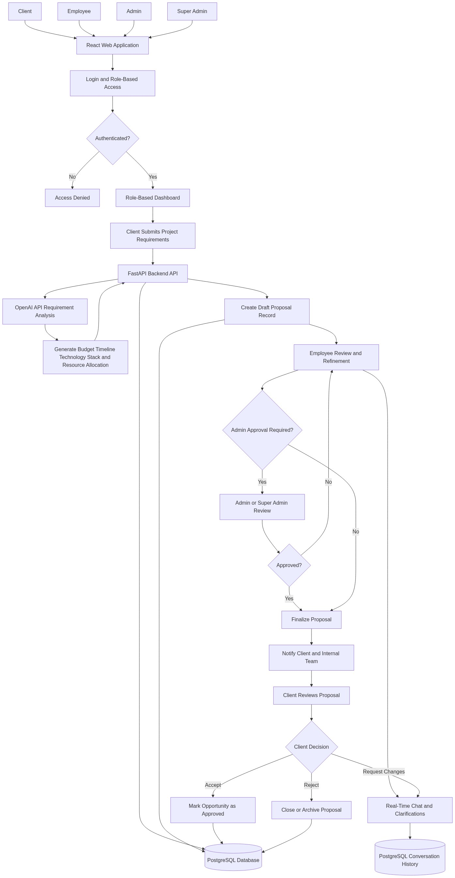
Diagram successfully loaded from mermaid.ink.

6. Development Plan & Timeline
The development cycle is projected at 2 Months. Following the structure of our standard Proof of Concept delivery pipeline, the specific deliverables and timeline phases are detailed below:
Phase | Duration | Output
Phase 1: Discovery, Solution Architecture, and MVP Backlog Finalization | 2 Weeks | Validated MVP scope, user roles and permissions model, core workflow definition, database entity design, Artificial Intelligence (AI) estimation approach, Application Programming Interface (API) contract baseline, and implementation backlog aligned with the two-month delivery objective.
Phase 2: Core Platform Development and Authentication | 2 Weeks | React-based role dashboards, FastAPI backend foundation, PostgreSQL schema implementation, authenticated user access, role-based authorization, requirement submission flow, and initial proposal data management capabilities.
Phase 3: Artificial Intelligence Estimation, Collaboration, and Proposal Workflow | 2 Weeks | OpenAI API integration for requirement analysis, budget and timeline recommendation logic, technology stack recommendation flow, indicative resource allocation generation, proposal review process, and real-time collaboration workflow for client and internal stakeholder communication.
Phase 4: Testing, Stabilization, Deployment Readiness, and Handover | 2 Weeks | End-to-end functional testing, security validation for role-based access, defect remediation, user acceptance testing support, deployment-ready build, technical handover documentation, and MVP demonstration for business stakeholders.

7. Assumptions & Key Risks
Assumptions
- The client will provide timely access to business stakeholders who can validate the pre-sales workflow, user roles, proposal review steps, and estimation expectations during the discovery and user acceptance testing phases.
- The initial MVP will use OpenAI API for Artificial Intelligence analysis and will not require the development or training of a custom machine learning model within the two-month timeline.
- The client will provide sample historical proposals, representative requirement documents, or estimation examples where available, so the Artificial Intelligence prompts and recommendation logic can be aligned with real business practices.
- Infrastructure, environment access, domain configuration, and deployment approvals will be made available in a timely manner to avoid delays during testing and release preparation.
- Third-party services, including OpenAI API access, will be provisioned by the client or approved for use before development of Artificial Intelligence capabilities begins.
- The MVP will focus on structured proposal generation and collaboration workflows, while advanced document formatting, enterprise Customer Relationship Management integration, and complex pricing automation will be considered future enhancements unless separately prioritized.
- A dedicated testing environment with representative user accounts for client, employee, admin, and super admin roles will be available before user acceptance testing begins.
- Security, compliance, and data privacy reviews will be completed by the client within the project timeline, and any additional mandatory controls will be communicated early enough to be incorporated without affecting delivery.
- Deployment approval and final acceptance will be based on the agreed MVP scope, validated workflows, and successful completion of the defined test scenarios.
Risks & Mitigation
- Risk: Business requirements may evolve as stakeholders see early versions of the Artificial Intelligence-generated proposal workflow.
Mitigation: The project will use iterative sprint reviews, maintain a controlled MVP backlog, and prioritize changes based on business value, implementation impact, and timeline feasibility.
- Risk: Artificial Intelligence-generated estimates may require calibration to match the client’s internal pricing and delivery standards.
Mitigation: Prompt engineering, sample proposal validation, and stakeholder review cycles will be used to tune outputs, while the MVP will position Artificial Intelligence recommendations as assistive outputs subject to internal review.
- Risk: Limited availability of historical estimation data may reduce the precision of early recommendation outputs.
Mitigation: The solution will combine structured requirement inputs, configurable assumptions, and human review to improve practical usefulness while allowing future enhancement with historical proposal datasets.
- Risk: Third-party OpenAI API availability, usage limits, or cost constraints may affect Artificial Intelligence response performance.
Mitigation: The backend will isolate Artificial Intelligence service calls through FastAPI service layers, enabling retry handling, controlled usage, response logging, and future replacement or extension of model providers if required.
- Risk: Real-time collaboration workflows may introduce complexity around message visibility, role permissions, and auditability.
Mitigation: Collaboration capabilities will be implemented with clear role-based access rules, database-backed conversation records, and defined visibility boundaries between client-facing and internal discussions.
- Risk: Security expectations may expand beyond the MVP baseline, particularly around enterprise identity management, audit logs, or compliance approvals.
Mitigation: The architecture will support future enterprise authentication integration, while the MVP will implement role-based access control and secure backend validation using FastAPI.
- Risk: Resource availability constraints may affect delivery velocity because some allocated specialists have limited daily availability.
Mitigation: Work will be sequenced so frontend, backend, and Artificial Intelligence tasks can progress in parallel where possible, while the senior Artificial Intelligence engineers will focus on high-impact design, integration, and validation activities.
- Risk: User acceptance testing may be delayed if client reviewers are not available during the final phase.
Mitigation: Acceptance scenarios will be defined early, review checkpoints will be scheduled in advance, and interim demonstrations will be conducted to reduce late-stage feedback concentration.
8. Allocated Technical Resources
Resource Name | Assigned Role | Allocated Hours
Sayan Sen | Frontend Developer | 342 Hours
Serya Mallick | Backend Developer | 214 Hours
Nahid Sinha | AI Engineer | 85 Hours
Avijit Chowdhury | AI Engineer | 42 Hours

