PROOF OF CONCEPT (POC) & DEVELOPMENT PROPOSAL
SHPY
Custom Software Engineering and Implementation Blueprint
Document Version: 1.0
Estimated Budget: $14,100.00 USD
Development Timeline: 2 Months
Proposal Type: MVP

1. Executive Summary
The Shpy project addresses the growing demand for a seamless, mobile-first e-commerce experience by providing a robust cross-platform application that enables users to browse, search, and purchase products with ease. In today’s competitive retail landscape, customers expect intuitive interfaces, rapid product discovery, and frictionless checkout processes. Shpy is designed to meet these expectations by leveraging modern mobile technologies and cloud infrastructure, ensuring a responsive and reliable shopping journey.
The necessity for this solution is underscored by the shift in consumer behavior towards mobile commerce and the need for businesses to rapidly adapt to digital-first strategies. By implementing a scalable and maintainable architecture, Shpy will empower retailers to reach a broader audience while maintaining operational efficiency. The platform’s modular design allows for future enhancements, such as advanced analytics, third-party integrations, and enterprise-grade administrative controls, ensuring long-term business agility.
Artificial Intelligence (AI) capabilities, while not part of the initial Minimum Viable Product (MVP), are considered in the platform’s roadmap to enhance product recommendations, personalize user experiences, and optimize inventory management. The architecture is designed to accommodate these enhancements, ensuring that the platform remains competitive as AI-driven commerce becomes the industry standard.
Security, scalability, and maintainability are foundational to Shpy’s implementation strategy. The solution leverages Amazon Web Services (AWS) for secure, scalable cloud deployment, and follows modern software engineering practices such as containerization, automated testing, and continuous integration/continuous deployment (CI/CD). This approach ensures that Shpy can efficiently scale to meet increasing user demand while maintaining high standards of data protection and operational resilience.
2. Proposed Solution & Scope
The functional scope of Shpy encompasses the development of a cross-platform mobile application using React Native, enabling users to register, authenticate, browse product catalogs, search for items, manage shopping carts, and place orders. The user workflow begins with secure authentication, followed by intuitive navigation through product categories, detailed product views, and seamless cart management. The checkout process is streamlined to minimize friction, supporting multiple payment options and real-time order confirmation.
Major modules include user authentication and profile management, product catalog and search, cart management, order processing, and a basic administrative interface for product and order oversight. The backend, developed with Node.js and Express, provides RESTful Application Programming Interfaces (APIs) for all core functionalities, ensuring robust communication between the mobile frontend and the MongoDB database. The administrative module allows authorized personnel to manage inventory, view order histories, and generate basic reports, laying the groundwork for future enterprise-grade features.
While the MVP does not include advanced Artificial Intelligence (AI) features, the architecture is designed to integrate AI-driven modules in subsequent phases. These may include personalized product recommendations, dynamic pricing, and predictive analytics. Authentication is handled securely, leveraging industry best practices for password management and session handling, with the potential for integration with third-party identity providers as the platform evolves.
Resource allocation is optimized to ensure efficient delivery within the two-month timeline, with dedicated roles for frontend and backend development, as well as quality assurance. The proposal generation workflow includes requirements analysis, iterative development, continuous testing, and stakeholder feedback loops to ensure alignment with business objectives. Reporting capabilities in the MVP focus on essential sales and inventory metrics, with extensibility for advanced analytics in future releases.
Integration possibilities are considered from the outset, with RESTful APIs designed for interoperability with payment gateways, shipping providers, and external analytics platforms. The platform’s modular architecture and use of containerization via Docker facilitate seamless deployment and future scalability, ensuring that Shpy can evolve to meet the needs of enterprise clients and adapt to emerging market trends.
3. Estimated Budget & Cost Structure
The total estimated cost for this custom software development solution is $14,100.00 USD. This includes full engineering resources, quality assurance testing, architecture design, and final deployment setup. The detailed cost breakdown is aligned with the technical roles and allocated task hours detailed in Section 7.
4. Proposed Technology Stack
Layer | Technology / Framework | Purpose
Database | MongoDB | Primary platform layer for the Database requirements.
Backend | Node.js, Express | Primary platform layer for the Backend requirements.
Frontend | React Native | Primary platform layer for the Frontend requirements.
Cloud | AWS (basic deployment) | Primary platform layer for the Cloud requirements.
Artificial intelligence | Planned for future phases; not included in MVP | Primary platform layer for the Artificial Intelligence requirements.
Authentication | Custom authentication with secure password management (expandable to OAuth in future) | Primary platform layer for the Authentication requirements.
Storage | MongoDB (product, user, and order data) | Primary platform layer for the Storage requirements.
Deployment | Docker containers on AWS | Primary platform layer for the Deployment requirements.

5. System Workflow Diagram
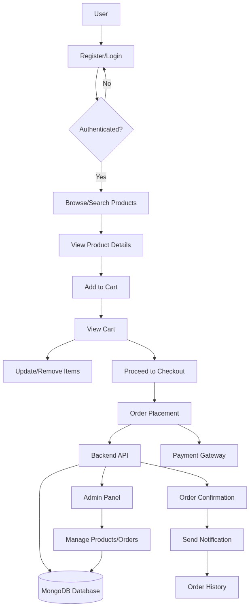
Diagram successfully loaded from mermaid.ink.

6. Development Plan & Timeline
The development cycle is projected at 2 Months. Following the structure of our standard Proof of Concept delivery pipeline, the specific deliverables and timeline phases are detailed below:
Phase | Duration | Output
Requirements Analysis & Solution Design | 1 Week | Detailed requirements documentation, technical architecture, and project plan
Frontend & Backend Development | 4 Weeks | Core mobile application (React Native), backend APIs (Node.js/Express), and MongoDB schema
Integration & Feature Completion | 2 Weeks | Integration of frontend with backend, implementation of authentication, cart, and order modules
Quality Assurance & User Acceptance Testing | 1 Week | Automated and manual test cases executed, bug fixes, and user acceptance sign-off
Deployment & Handover | 1 Week | Production deployment on AWS, Docker configuration, and project documentation handover

7. Assumptions & Key Risks
Assumptions
The client will provide timely access to all required business stakeholders for requirements validation and feedback. All necessary infrastructure, including AWS accounts and domain registrations, will be provisioned by the client prior to deployment. Third-party APIs for payment processing and notifications will be available and accessible during the development and testing phases. Artificial Intelligence (AI) features are not part of the MVP and will be considered in future phases. The client will facilitate access to any existing product or inventory data required for initial population of the database. Stakeholders will be available for regular sprint reviews and acceptance testing. The client will be responsible for securing all necessary compliance and security approvals prior to go-live. A staging environment will be provided for user acceptance testing. All content, including product images and descriptions, will be supplied by the client. Deployment approvals will be granted within two business days of final user acceptance.
Risks & Mitigation
Risk: Delays in stakeholder feedback or requirements clarification may impact the project timeline. Mitigation: Schedule regular review meetings and maintain clear communication channels to ensure timely feedback.
Risk: Third-party API availability or integration issues could delay feature completion. Mitigation: Engage with API providers early and conduct integration testing as soon as possible.
Risk: Changes in business requirements during development may lead to scope creep. Mitigation: Adopt Agile sprint planning with strict change control and regular stakeholder alignment.
Risk: Security vulnerabilities in authentication or data storage could compromise user data. Mitigation: Implement industry-standard security practices, conduct code reviews, and perform penetration testing.
Risk: Insufficient test coverage may result in undetected defects. Mitigation: Employ both automated and manual testing, with dedicated QA resources.
Risk: Resource unavailability due to unforeseen circumstances could affect delivery. Mitigation: Maintain a backup resource pool and cross-train team members.
Risk: Delays in AWS infrastructure provisioning may postpone deployment. Mitigation: Coordinate with the client to ensure early setup of cloud resources.
Risk: Incomplete or inaccurate product data may affect user experience. Mitigation: Establish data validation procedures and require client sign-off on initial data loads.
Risk: Regulatory or compliance requirements may change during the project. Mitigation: Monitor relevant regulations and engage compliance experts early in the process.
Risk: Performance issues under load may impact user satisfaction. Mitigation: Conduct load testing and optimize application performance prior to launch.
8. Allocated Technical Resources
Resource Name | Assigned Role | Allocated Hours
Rohit Mukherjee | React Native Developer | 257 Hours
Tanya Iyer | React Native Developer | 85 Hours
Serya Mallick | Backend Developer | 214 Hours
Serya Reddy | Backend Developer | 85 Hours
Abhijit Bhowmick | Automation Tester | 171 Hours

