PROOF OF CONCEPT (POC) & DEVELOPMENT PROPOSAL
HEALTHFIX
Custom Software Engineering and Implementation Blueprint
Document Version: 1.0
Estimated Budget: $7,808.00 USD
Development Timeline: 1 Month 15 Days
Proposal Type: MVP

1. Executive Summary
HealthFix addresses the growing need for digital transformation in healthcare by providing a mobile-first platform that empowers patients to proactively manage their health and engage seamlessly with healthcare providers. In an environment where patient engagement, appointment scheduling, and health record management are often fragmented and inefficient, HealthFix offers a unified solution that streamlines these critical workflows. The platform is designed to enhance user experience, reduce administrative overhead, and improve the overall quality of care through digital enablement.
The proposed software solution is essential for modern healthcare organizations seeking to increase patient satisfaction, operational efficiency, and data-driven decision-making. By centralizing health metrics tracking, appointment management, and provider communication, HealthFix enables users to take control of their health journey while ensuring healthcare providers have timely access to relevant patient information. The inclusion of Artificial Intelligence (AI) capabilities in future phases will further enhance the platform by enabling predictive analytics, personalized health recommendations, and automated appointment reminders, thereby driving proactive care and reducing missed appointments.
From a business perspective, HealthFix is engineered for scalability, maintainability, and robust security. The architecture leverages cloud-native deployment on Amazon Web Services (AWS), containerization with Docker, and a modular backend built on Node.js (Express) and Java (Spring Boot), ensuring the solution can scale to accommodate growing user bases and evolving feature sets. Security best practices, including secure authentication and encrypted data storage, are integral to the platform, ensuring compliance with healthcare data protection standards.
The implementation strategy follows modern software engineering practices, including agile development, automated testing, and continuous integration/continuous deployment (CI/CD). This approach ensures rapid delivery of a Minimum Viable Product (MVP) while laying the foundation for future enhancements such as advanced analytics, third-party integrations, and automation. HealthFix is positioned to deliver measurable improvements in patient engagement, operational efficiency, and clinical outcomes for healthcare organizations.
2. Proposed Solution & Scope
- User registration, secure authentication, and profile management for patients and healthcare providers.
- Health metrics tracking, including input and visualization of key health indicators (e.g., blood pressure, glucose levels, weight).
- Appointment scheduling, rescheduling, and cancellation with real-time availability for healthcare providers.
- In-app communication between patients and providers, supporting secure messaging and notifications.
- Basic health record management, allowing users to view and update essential medical information.
- Administrative dashboard for providers to manage appointments, patient records, and communication.
- Reporting module for users and providers to review appointment history and health trends.
- Resource allocation management to ensure optimal utilization of development and testing resources.
- Proposal generation workflow for future enhancements, including advanced analytics and automation.
- Integration-ready architecture for future connectivity with Electronic Health Record (EHR) systems and third-party health data sources.
- Scalable infrastructure leveraging AWS and Docker for efficient deployment and future growth.
3. Estimated Budget & Cost Structure
The total estimated cost for this custom software development solution is $7,808.00 USD. This includes full engineering resources, quality assurance testing, architecture design, and final deployment setup. The detailed cost breakdown is aligned with the technical roles and allocated task hours detailed in Section 7.
4. Proposed Technology Stack
Layer | Technology / Framework | Purpose
Database | MongoDB | Primary platform layer for the Database requirements.
Backend | Node.js (Express), Java (Spring Boot) | Primary platform layer for the Backend requirements.
Frontend | React Native | Primary platform layer for the Frontend requirements.
Cloud | AWS (basic deployment) | Primary platform layer for the Cloud requirements.
Artificial intelligence | Planned for future phases | Primary platform layer for the Artificial Intelligence requirements.
Authentication | Secure authentication module (custom implementation using JWT and OAuth2 standards) | Primary platform layer for the Authentication requirements.
Storage | AWS Cloud Storage | Primary platform layer for the Storage requirements.
Deployment | Docker containers on AWS | Primary platform layer for the Deployment requirements.

5. System Workflow Diagram
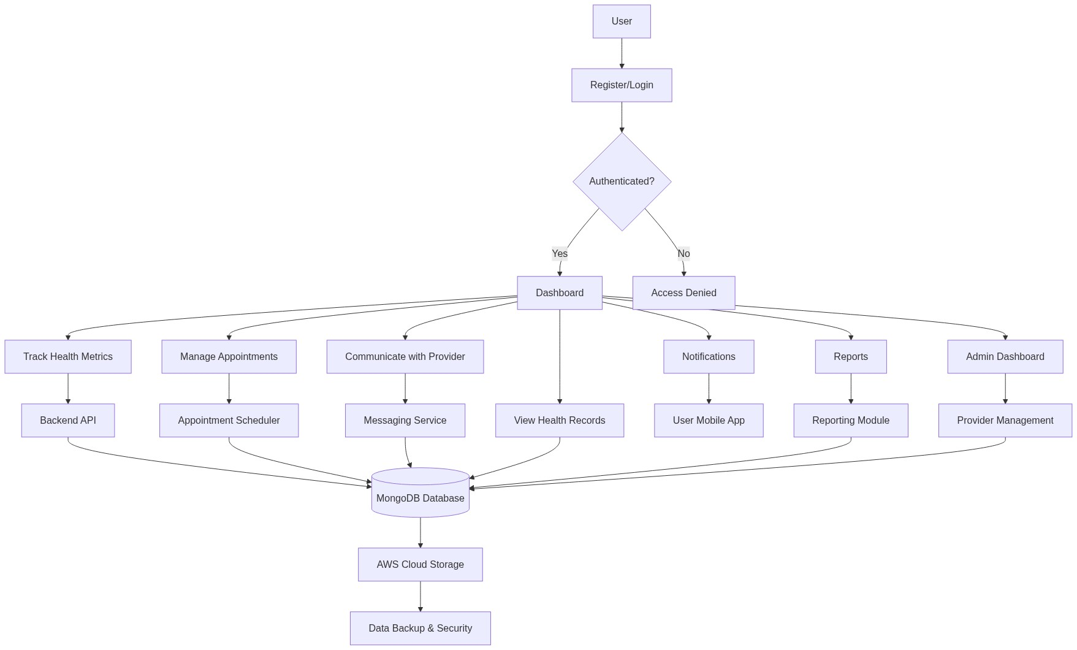
Diagram successfully loaded from mermaid.ink.

6. Development Plan & Timeline
The development cycle is projected at 1 Month 15 Days. Following the structure of our standard Proof of Concept delivery pipeline, the specific deliverables and timeline phases are detailed below:
Phase | Duration | Output
Requirements Analysis & Solution Design | 1 Week | Detailed requirements documentation, technical architecture, and UI/UX wireframes
Frontend and Backend Development | 3 Weeks | Functional React Native mobile application, backend APIs with Node.js (Express) and Java (Spring Boot), integrated with MongoDB
Integration & Internal Testing | 1 Week | Integrated system with end-to-end workflows, initial test cases executed, bug fixes applied
Quality Assurance & User Acceptance Testing | 1 Week | Comprehensive QA testing, user acceptance testing completed, final refinements
Deployment & Handover | 1 Week 5 Days | Production deployment on AWS, Dockerized containers, documentation, and knowledge transfer

7. Assumptions & Key Risks
Assumptions
- The client will provide timely access to subject matter experts and key stakeholders for requirements validation and user acceptance testing.
- All necessary infrastructure, including AWS accounts and cloud resources, will be provisioned and accessible to the development team prior to project commencement.
- Third-party integrations, such as Electronic Health Record (EHR) systems or external health data sources, are not required for the MVP phase but will be considered for future releases.
- Artificial Intelligence (AI) and advanced analytics features are planned for future phases and are not included in the current MVP scope.
- The client will be responsible for providing branding assets, legal disclaimers, and compliance requirements relevant to healthcare data management.
- A dedicated testing environment will be made available for quality assurance and user acceptance testing activities.
- Security and privacy approvals, including compliance with relevant healthcare regulations (e.g., HIPAA), will be coordinated by the client in collaboration with the development team.
- Deployment approvals and access to production environments will be granted in a timely manner to avoid delays.
- All user data for testing purposes will be anonymized to ensure privacy and compliance.
- Any changes to project scope or requirements after the initial sign-off may impact the timeline and budget.
Risks & Mitigation
- Risk: Delays in stakeholder feedback or requirements clarification.
Mitigation: Establish a regular cadence of review meetings and clear escalation paths for unresolved issues.
- Risk: Integration challenges with AWS cloud services or infrastructure provisioning.
Mitigation: Allocate dedicated time for environment setup and leverage AWS best practices for deployment.
- Risk: Potential changes in healthcare compliance or regulatory requirements during development.
Mitigation: Engage compliance experts early and conduct periodic reviews to ensure ongoing alignment.
- Risk: Limited availability of key resources due to unforeseen circumstances.
Mitigation: Maintain a resource backup plan and cross-train team members on critical tasks.
- Risk: Security vulnerabilities in authentication or data storage modules.
Mitigation: Implement secure coding practices, conduct regular security audits, and utilize encryption for sensitive data.
- Risk: Performance bottlenecks under high user load.
Mitigation: Design for scalability from the outset and conduct load testing prior to deployment.
- Risk: Incomplete or ambiguous user requirements leading to rework.
Mitigation: Use detailed requirements documentation and obtain formal sign-off before development.
- Risk: Insufficient user adoption or engagement post-launch.
Mitigation: Incorporate user feedback loops and plan for iterative enhancements based on real-world usage.
- Risk: Delays in deployment approvals or access to production environments.
Mitigation: Coordinate deployment schedules in advance and maintain clear communication with client IT teams.
8. Allocated Technical Resources
Resource Name | Assigned Role | Allocated Hours
Rohit Mukherjee | React Native Developer | 192 Hours
Sandipan Banerjee | QA Engineer | 64 Hours
Serya Mallick | Backend Developer | 160 Hours
Serya Reddy | Backend Developer | 64 Hours
Abhijit Bhowmick | Automation Tester | 128 Hours

