PROOF OF CONCEPT (POC) & DEVELOPMENT PROPOSAL
SHOPY
Custom Software Engineering and Implementation Blueprint
Document Version: 1.0
Estimated Budget: $41,097.00 USD
Development Timeline: 4 Months
Proposal Type: FULL

1. Executive Summary
Small and medium-sized businesses face significant barriers when attempting to establish a robust online presence, including high development costs, complex integrations, and the need for scalable, secure infrastructure. Shopy addresses these challenges by providing a comprehensive e-commerce platform that empowers businesses to launch and manage their online stores efficiently, without the overhead of building and maintaining custom solutions. The platform is designed to deliver a seamless shopping experience for end customers, while equipping store owners with intuitive tools for product management, order tracking, and actionable analytics.
The necessity for a modern, scalable, and secure e-commerce solution is underscored by the rapidly evolving digital marketplace. Shopy’s architecture leverages cloud-native technologies and a modular design, ensuring that the platform can adapt to increasing user demand and evolving business requirements. Artificial Intelligence (AI) capabilities are embedded within the analytics and recommendation engines, enabling store owners to gain deeper insights into customer behavior and optimize their offerings for improved conversion rates and customer retention.
By adopting best-in-class security practices, including robust authentication mechanisms and continuous monitoring, Shopy ensures that both customer and business data remain protected. The platform’s maintainability is enhanced through the use of containerization, automated testing, and continuous integration/continuous deployment (CI/CD) pipelines, facilitating rapid iteration and reliable updates. The implementation strategy is grounded in agile methodologies, enabling close collaboration with stakeholders and iterative delivery of value.
Shopy’s solution is engineered to be future-proof, supporting integrations with third-party services, advanced reporting, and extensibility for new business models. The platform’s adherence to modern software engineering practices guarantees a high-quality, resilient, and scalable product that positions clients for long-term digital success.
2. Proposed Solution & Scope
The functional scope of Shopy encompasses all critical workflows necessary for a modern e-commerce platform. Customers are able to register, authenticate securely, browse product catalogs, manage shopping carts, and complete purchases through an intuitive mobile interface built with React Native. Store owners access a dedicated admin dashboard developed in React, where they can manage product listings, inventory, pricing, and promotional campaigns. The order management module provides real-time tracking of orders, status updates, and integrated notifications to both customers and store owners.
Artificial Intelligence (AI) capabilities are integrated into the analytics and recommendation modules. Store owners benefit from AI-driven insights, such as sales trends, customer segmentation, and personalized product recommendations, which are generated using advanced data models and presented through interactive dashboards. The platform’s authentication system employs secure protocols, supporting both traditional email/password logins and federated identity providers, ensuring a frictionless yet secure user experience.
Resource allocation is optimized through the use of containerized microservices, orchestrated via Kubernetes on Amazon Web Services (AWS). This approach enables efficient scaling of backend services, including Node.js and Java (Spring Boot) microservices, and supports high availability. The proposal generation workflow is streamlined through RESTful Application Programming Interfaces (APIs), facilitating integration with third-party payment gateways, shipping providers, and marketing tools.
Reporting features include customizable dashboards for sales, inventory, and customer analytics, leveraging PostgreSQL for complex queries and MongoDB for operational data. Administrative features encompass user management, access control, and audit logging, ensuring compliance and traceability. The platform is architected for future scalability, with support for additional modules such as loyalty programs, multi-store management, and advanced marketing automation, as business needs evolve.
Integration possibilities are extensive, with support for external APIs, event-driven communication via Kafka, and seamless deployment pipelines using Docker and CI/CD tools. This ensures that Shopy can adapt to new business requirements and integrate with the broader digital ecosystem, providing a sustainable foundation for growth.
3. Estimated Budget & Cost Structure
The total estimated cost for this custom software development solution is $41,097.00 USD. This includes full engineering resources, quality assurance testing, architecture design, and final deployment setup. The detailed cost breakdown is aligned with the technical roles and allocated task hours detailed in Section 7.
4. Proposed Technology Stack
Layer | Technology / Framework | Purpose
Database | MongoDB, PostgreSQL | Primary platform layer for the Database requirements.
Backend | Node.js + Express, Java (Spring Boot) for microservices | Primary platform layer for the Backend requirements.
Frontend | React Native (mobile), React (admin dashboard) | Primary platform layer for the Frontend requirements.
Cloud | AWS (EC2, S3, RDS, CloudWatch) | Primary platform layer for the Cloud requirements.
Artificial intelligence | AI-driven analytics and recommendation engines integrated with reporting modules | Primary platform layer for the Artificial Intelligence requirements.
Authentication | Secure authentication with support for email/password and federated identity providers | Primary platform layer for the Authentication requirements.
Storage | AWS S3 for media and document storage | Primary platform layer for the Storage requirements.
Deployment | Docker, Kubernetes (for orchestration), CI/CD (Jenkins, GitHub Actions) | Primary platform layer for the Deployment requirements.

5. System Workflow Diagram
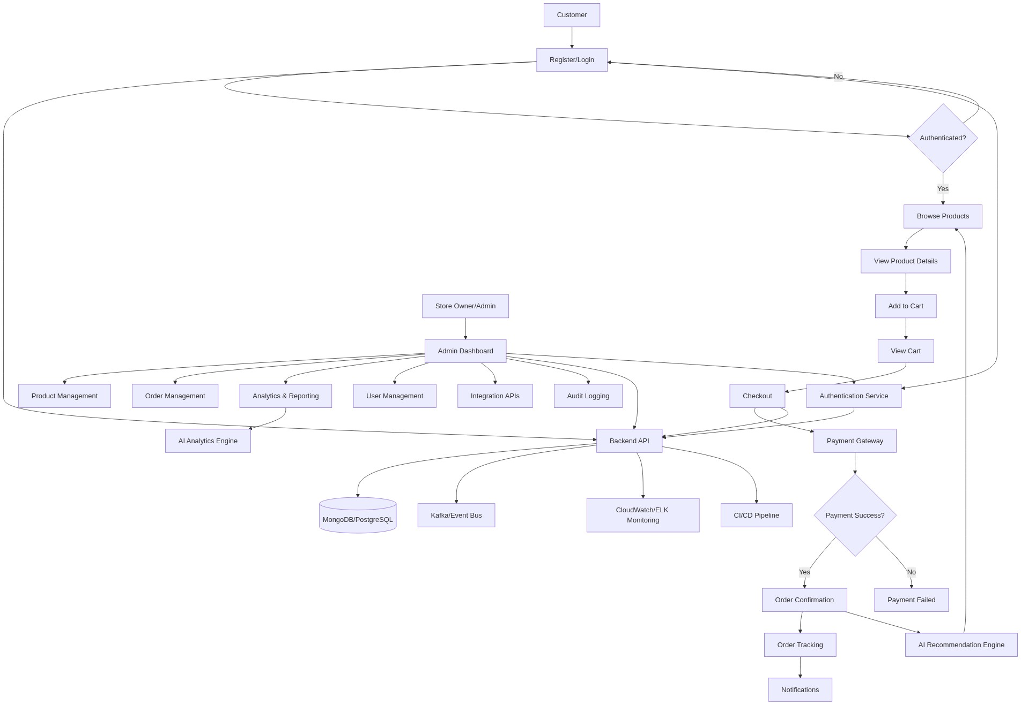
Diagram successfully loaded from mermaid.ink.

6. Development Plan & Timeline
The development cycle is projected at 4 Months. Following the structure of our standard Proof of Concept delivery pipeline, the specific deliverables and timeline phases are detailed below:
Phase | Duration | Output
Requirements Analysis & Solution Architecture | 2 Weeks | Detailed requirements documentation, system architecture diagrams, and finalized technology stack selection
UI/UX Design & Prototyping | 2 Weeks | Interactive wireframes and high-fidelity prototypes for mobile and admin interfaces
Core Platform Development (MVP) | 6 Weeks | Implementation of essential e-commerce workflows including product catalog, cart, checkout, and order management
Advanced Features & AI Integration | 3 Weeks | Development of analytics dashboards, AI-driven recommendation engine, and reporting modules
Integration & API Development | 2 Weeks | Integration with payment gateways, shipping providers, and third-party APIs
Testing & Quality Assurance | 2 Weeks | Comprehensive manual and automated testing, bug fixing, and performance optimization
Deployment & User Training | 1 Week | Production deployment on AWS, user onboarding, and training documentation

7. Assumptions & Key Risks
Assumptions
The client will provide timely access to key stakeholders for requirements validation and feedback throughout the project lifecycle. All necessary infrastructure components, including AWS accounts and third-party API credentials, will be provisioned by the client prior to the relevant development phases. The client will be responsible for securing any required licenses or agreements with payment gateway and shipping providers. Artificial Intelligence models for analytics and recommendations will be developed using anonymized data, with the client ensuring compliance with all applicable data privacy regulations. Stakeholder availability for user acceptance testing and training sessions will be ensured as per the agreed project schedule. The client will facilitate access to branding assets, product information, and content required for platform configuration. Security and compliance approvals will be coordinated by the client in alignment with internal policies. A staging environment will be provided for integration and user acceptance testing. Deployment approvals will be granted within two business days of release candidate submission. Any changes to scope or requirements will be communicated and agreed upon through formal change management procedures.
Risks & Mitigation
There is a risk of changes in business requirements during development, which could impact timelines and deliverables. This will be mitigated by adopting agile sprint planning with regular stakeholder reviews and formal change management. Delays in third-party API integration, such as payment gateways or shipping providers, may affect the project schedule; early engagement with vendors and parallel development of integration modules will minimize this risk. Insufficient or delayed access to client infrastructure or credentials could impede progress; proactive coordination and early provisioning will be enforced. Data privacy or compliance concerns may arise, particularly in relation to Artificial Intelligence analytics; all models will be developed using anonymized data and reviewed for regulatory compliance. Limited stakeholder availability for feedback, testing, or training could delay acceptance; regular communication and advance scheduling will address this. Security vulnerabilities may be discovered during testing; comprehensive automated and manual security testing will be conducted, with rapid remediation protocols in place. Performance bottlenecks under high load could affect user experience; load testing and scalable architecture design will ensure system robustness. Integration failures with external services could disrupt workflows; robust error handling and fallback mechanisms will be implemented. Resource attrition or unavailability may impact delivery; cross-training and backup resource planning will mitigate this risk. Deployment approval delays could postpone go-live; clear deployment schedules and stakeholder alignment will be maintained.
8. Allocated Technical Resources
Resource Name | Assigned Role | Allocated Hours
Sayan Sen | Frontend Developer | 685 Hours
Serya Reddy | Backend Developer | 171 Hours
Serya Mallick | Backend Developer | 428 Hours
Sandipan Banerjee | QA Engineer | 171 Hours
Tanya Saha | Solution Architect | 257 Hours
Shreya Sarkar | Technical Architect | 428 Hours
Dipti Bhowmick | Project Manager | 514 Hours

