PROOF OF CONCEPT (POC) & DEVELOPMENT PROPOSAL
SHOPYFY
Custom Software Engineering and Implementation Blueprint
Document Version: 1.0
Estimated Budget: $57,008.00 USD
Development Timeline: 4 Months
Proposal Type: FULL

1. Executive Summary
Shopyfy addresses the commercial need for a mobile-first e-commerce platform that enables merchants to establish, operate, and scale online storefronts without requiring extensive technical administration. The business challenge is to deliver a secure and intuitive shopping experience for customers while giving store owners reliable control over product catalogs, inventory visibility, cart conversion, checkout flows, and order fulfillment activities. A professionally engineered platform is required because fragmented manual processes, inconsistent mobile experiences, and limited operational visibility can directly reduce customer retention, payment completion rates, and merchant productivity.
The proposed solution will provide a scalable mobile application supported by a structured backend service layer, a relational data model, secure authentication, automated testing, and cloud-ready deployment practices. Artificial Intelligence (AI) will improve the delivery and operational lifecycle through AI-assisted planning, AI-assisted test case generation, regression prioritization, and future-ready enablement for personalized product discovery, recommendation logic, and intelligent search. This approach ensures that the initial full-scope implementation is practical for near-term delivery while maintaining an architecture that can support advanced commerce intelligence as the platform matures.
The expected business outcomes include faster merchant onboarding, improved customer shopping journeys, stronger checkout reliability, better order management efficiency, and a maintainable technology foundation for future enterprise-grade capabilities. The solution will be implemented using modern software engineering practices, including component-based mobile development, Application Programming Interface (API)-first backend design, database normalization, automated quality assurance, containerized environments, Continuous Integration and Continuous Delivery (CI/CD), and security-aware development. Scalability, maintainability, and security will be addressed through modular architecture, cloud-native deployment readiness on Amazon Web Services (AWS), role-based access patterns, encrypted communications, structured logging, and disciplined release governance.
2. Proposed Solution & Scope
- Customer mobile shopping experience: The platform will provide a React Native mobile interface that enables end-users to browse products, view product details, manage a shopping cart, proceed through secure checkout, and track order status through a streamlined mobile-first user journey.
- Merchant store management: Store owners will be able to manage product information, pricing, images, inventory-related attributes, order records, and fulfillment updates through backend-supported administrative workflows designed to reduce manual operational effort.
- User workflow: Customers will register or sign in, browse the catalog, add items to the cart, confirm shipping and payment details, submit orders, and receive order confirmation, while merchants will authenticate, maintain catalog data, monitor orders, and update fulfillment progress.
- Major platform modules: The full implementation scope includes authentication, customer profile management, product catalog management, cart management, checkout orchestration, order management, merchant administration, reporting dashboards, and deployment automation foundations.
- Artificial Intelligence capabilities: The initial delivery will use AI-assisted planning and testing practices to improve implementation quality, while the architecture will remain extensible for future AI-driven product recommendations, intelligent search ranking, fraud signal enrichment, and customer behavior analytics.
- Authentication and authorization: The solution will include secure sign-in flows and role-based access separation for customers, merchants, and administrators, ensuring that sensitive store, order, and customer data is accessed only by authorized users.
- Proposal generation workflow: As this is a full software delivery proposal rather than a proposal automation product, the project workflow will focus on business requirement validation, user experience prototyping, engineering delivery, quality assurance, release approval, and production-ready deployment documentation.
- Reporting and operational visibility: The platform will provide reporting foundations for merchants and administrators, including order status visibility, catalog activity, sales-related operational summaries, and data structures that can support expanded analytics in later releases.
- Administrative features: Administrative capabilities will include merchant oversight, product and order monitoring, access control governance, issue review support, and operational configuration where required for controlled platform management.
- Integration possibilities: The architecture will support integration with payment gateways, shipping providers, notification services, analytics tools, and third-party commerce services through secure Application Programming Interfaces (APIs), subject to client-selected vendors and approval processes.
- Future scalability: The system will be designed with modular backend services, PostgreSQL schema discipline, containerized deployment practices, and AWS-compatible infrastructure patterns so that future enhancements can support higher traffic, more merchants, additional sales channels, and enterprise-grade observability.
3. Estimated Budget & Cost Structure
The total estimated cost for this custom software development solution is $57,008.00 USD. This includes full engineering resources, quality assurance testing, architecture design, and final deployment setup. The detailed cost breakdown is aligned with the technical roles and allocated task hours detailed in Section 7.
4. Proposed Technology Stack
Layer | Technology / Framework | Purpose
Database | PostgreSQL | Primary platform layer for the Database requirements.
Backend | Node.js (NestJS) | Primary platform layer for the Backend requirements.
Frontend | React Native | Primary platform layer for the Frontend requirements.
Cloud | AWS | Primary platform layer for the Cloud requirements.
Artificial intelligence | AI-assisted Planning and AI-assisted Testing | Primary platform layer for the Artificial Intelligence requirements.
Authentication | AWS Cognito | Primary platform layer for the Authentication requirements.
Storage | AWS S3 | Primary platform layer for the Storage requirements.
Deployment | Docker, CI/CD | Primary platform layer for the Deployment requirements.

5. System Workflow Diagram
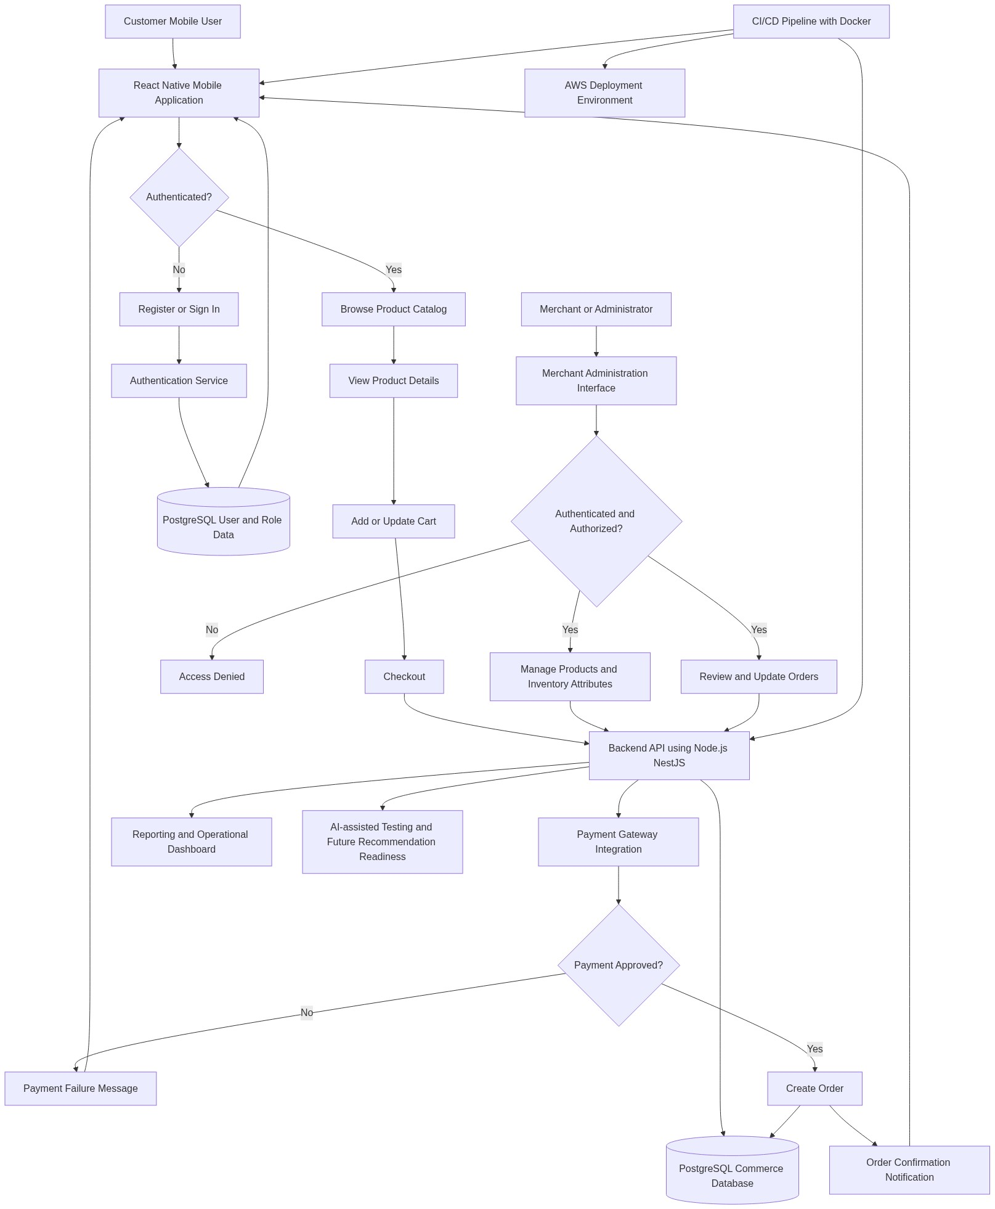
Diagram successfully loaded from mermaid.ink.

6. Development Plan & Timeline
The development cycle is projected at 4 Months. Following the structure of our standard Proof of Concept delivery pipeline, the specific deliverables and timeline phases are detailed below:
Phase | Duration | Output
Phase 1 - Discovery, Architecture, and Experience Design | 1 Month | Validated functional requirements, user journey definitions, mobile-first information architecture, Figma design prototypes, solution architecture, data model baseline, security approach, sprint plan, and delivery governance framework.
Phase 2 - Core Platform Engineering | 1 Month | Implemented React Native application foundations, Node.js (NestJS) backend services, PostgreSQL schema, authentication workflows, product catalog services, cart services, merchant product management capabilities, and initial containerized development environment.
Phase 3 - Checkout, Order Management, Integrations, and Quality Automation | 1 Month | Completed checkout orchestration, order management workflows, payment integration readiness, merchant order administration, reporting foundations, Application Programming Interface (API) validation, Selenium and Playwright automation coverage, and regression testing execution.
Phase 4 - Hardening, User Acceptance Testing, Deployment Readiness, and Handover | 1 Month | Completed performance tuning, security validation, defect remediation, User Acceptance Testing support, release documentation, CI/CD pipeline stabilization, AWS deployment readiness, operational handover, and final production release recommendation.

7. Assumptions & Key Risks
Assumptions
- The client will provide timely access to business stakeholders, merchant representatives, and decision-makers so that product, checkout, order, and administrative requirements can be validated without delivery delays.
- The client will confirm the preferred payment gateway, shipping integration requirements, tax handling expectations, and notification channels before the integration design is finalized.
- AWS account access, cloud environment permissions, deployment approvals, and any required organizational security policies will be made available in alignment with the agreed implementation schedule.
- Third-party Application Programming Interface (API) credentials, sandbox environments, webhook documentation, and vendor support contacts will be provided by the client or the relevant service provider before integration development begins.
- Artificial Intelligence (AI) capabilities in the initial release will focus on AI-assisted planning, testing, and architecture readiness, while production-grade recommendation engines or intelligent search models will be treated as future enhancements unless separately prioritized.
- The client will provide brand guidelines, product taxonomy expectations, sample product data, legal content, privacy policy inputs, and terms of service content required for mobile application readiness.
- A dedicated testing environment will be available for functional testing, regression testing, integration testing, and User Acceptance Testing before deployment approval.
- Security, compliance, and application store approval requirements will be reviewed early, and final approvals will be dependent on timely client-side validation and any external marketplace review timelines.
- The estimated budget and resource allocation assume a full delivery scope consistent with the stated requirements and do not include paid third-party licenses, payment gateway transaction fees, cloud consumption charges, or application marketplace fees unless explicitly confirmed.
Risks & Mitigation
- Risk: Payment gateway, shipping, or notification vendor decisions may be delayed, which can affect checkout and order workflow completion. Mitigation: Define vendor selection milestones during discovery and implement adapter-based integration patterns so that core commerce flows can progress while vendor-specific details are finalized.
- Risk: Business requirements may expand during delivery as additional merchant features, promotions, loyalty, or multi-store capabilities are identified. Mitigation: Apply Agile sprint planning, maintain a prioritized backlog, and use formal change control to protect the agreed timeline, budget, and release quality.
- Risk: Mobile performance may be affected by large product catalogs, unoptimized media, or inefficient network interactions. Mitigation: Implement mobile performance optimization practices, pagination, caching strategies, image optimization, and backend response monitoring during development and testing.
- Risk: Security exposure may arise if authentication, authorization, or sensitive checkout data handling is not validated thoroughly. Mitigation: Use secure authentication patterns, role-based authorization, encrypted communications, code reviews, secure configuration management, and targeted security testing before release.
- Risk: Data model changes late in the project may impact product, cart, and order workflows. Mitigation: Establish the PostgreSQL schema baseline during the architecture phase, conduct early data model reviews, and apply controlled migration practices throughout development.
- Risk: Test coverage gaps may occur across device types, operating system versions, and checkout edge cases. Mitigation: Combine manual mobile quality assurance with Playwright, Selenium, and regression automation to validate critical customer and merchant workflows across representative scenarios.
- Risk: Cloud deployment readiness may be impacted by access constraints, environment configuration issues, or approval dependencies. Mitigation: Begin AWS environment planning early, use Docker-based repeatable builds, implement CI/CD practices, and schedule deployment readiness reviews before the final phase.
- Risk: Stakeholder availability constraints may delay design approvals, User Acceptance Testing, or release sign-off. Mitigation: Establish a governance calendar, define approval turnaround expectations, and provide structured review artifacts to accelerate business validation.
8. Allocated Technical Resources
Resource Name | Assigned Role | Allocated Hours
Dipti Bhowmick | Project Manager | 514 Hours
Shreya Roy | UI/UX Designer | 342 Hours
Sandipan Reddy | React Native Developer | 685 Hours
Serya Mallick | Backend Developer | 428 Hours
Shreya Karmakar | QA Engineer | 342 Hours
Sandipan Banerjee | QA Engineer | 171 Hours
Ankan Bhowmick | QA Engineer | 171 Hours
Tanya Saha | Solution Architect | 257 Hours
Shreya Sarkar | Technical Architect | 428 Hours

