PROOF OF CONCEPT (POC) & DEVELOPMENT PROPOSAL
SHOPY
Custom Software Engineering and Implementation Blueprint
Document Version: 1.0
Estimated Budget: $33,898.00 USD
Development Timeline: 4 Months
Proposal Type: FULL

1. Executive Summary
Shopy addresses the client's requirement to establish a modern digital commerce channel that enables businesses to manage products, register customers, support shopping cart interactions, and process customer orders through a seamless online experience. The business challenge is not limited to launching an e-commerce website; it is to create a scalable, secure, and maintainable commerce foundation that can support future growth, increasing product volumes, higher transaction activity, enhanced customer engagement, and operational improvements without requiring a major platform rebuild.
The proposed solution is required to centralize product catalog management, customer account handling, cart management, and order processing into a structured web platform built on React with Next.js, Node.js with NestJS, PostgreSQL, and Amazon Web Services. This architecture enables a clean separation between presentation, business logic, persistence, and deployment layers, allowing the platform to evolve incrementally while maintaining reliability and performance. The implementation will follow modern software engineering practices, including modular application design, Application Programming Interface (API)-driven development, source control discipline, automated testing, containerized deployment using Docker, and Continuous Integration and Continuous Delivery (CI/CD) practices.
Although the first production release is focused on core e-commerce capabilities rather than advanced Artificial Intelligence (AI) automation, the platform will be designed with AI-readiness in mind. This means the data model, product interaction flows, and order history structure can support future AI capabilities such as product recommendations, intelligent search ranking, demand pattern analysis, customer segmentation, and operational insights. By designing for these future capabilities from the outset, Shopy can progressively adopt AI without disrupting the foundational commerce workflows.
The expected business outcomes include faster digital sales enablement, improved customer experience, better operational control over products and orders, reduced manual intervention in order handling, and a technical foundation that supports future enhancements such as payment integrations, promotions, analytics, inventory synchronization, and AI-driven personalization. Security, scalability, and maintainability will be addressed through role-based access patterns, secure authentication, structured backend services, relational database design, cloud deployment on Amazon Web Services, automated quality assurance using Selenium and Playwright, and a phased delivery approach that reduces implementation risk while ensuring business stakeholders can review and validate the solution throughout the engagement.
2. Proposed Solution & Scope
- Product catalog management will allow authorized administrative users to create, update, categorize, publish, and maintain product information required for online selling, including product names, descriptions, pricing, imagery references, availability status, and catalog visibility rules. This capability is required to give business teams direct operational control over the storefront and will be implemented through secure backend services, PostgreSQL data models, and responsive administrative user interfaces.
- Customer registration and authentication will enable shoppers to create accounts, securely sign in, maintain basic profile information, and access their shopping activity. This is required to support a personalized and trusted buying journey and will be implemented using secure authentication flows in the Node.js NestJS backend, protected routes in the React Next.js frontend, and persistent customer identity records in PostgreSQL.
- The customer storefront workflow will provide a responsive and intuitive shopping experience where users can browse the product catalog, view product details, add products to the shopping cart, modify cart quantities, proceed to checkout, and submit orders. This workflow is required to convert browsing intent into completed transactions and will be implemented using component-based frontend development, reusable user interface patterns, and backend Application Programming Interfaces for cart and order orchestration.
- Shopping cart functionality will support product selection, quantity updates, item removal, cart persistence for authenticated users, and cart validation before order creation. This is required to reduce customer friction and prevent invalid orders, and it will be implemented through backend validation rules, database-backed cart state, and real-time frontend feedback to the user.
- Order processing will convert validated cart contents into structured customer orders with order status tracking, order item records, pricing calculations, and order confirmation views. This is required to provide operational traceability and customer confidence, and it will be implemented through transactional backend services, PostgreSQL relational integrity, and clear order lifecycle states.
- Administrative features will include secure access to catalog administration, order visibility, basic order status management, and user activity support functions appropriate for the initial full release. These features are required to allow the business to operate the platform after launch and will be delivered through role-aware backend endpoints and protected administrative screens.
- Reporting will focus on foundational operational visibility, including product listings, registered customers, submitted orders, and order status summaries. This is required to help business stakeholders monitor launch performance and operational activity, and it will be implemented using database queries exposed through controlled backend services and presented through administrative dashboard views.
- Artificial Intelligence capabilities are not proposed as mandatory production features in the initial release because the stated business requirements prioritize core e-commerce functionality. However, the architecture will preserve future AI enablement by maintaining structured customer, product, cart, and order data that can later support recommendation engines, intelligent catalog search, customer segmentation, demand analysis, and automated merchandising insights.
- The commercial transaction and order generation workflow will replace any manual sales intake process by allowing customers to generate orders directly from the digital storefront. The workflow will begin with product discovery, continue through cart validation and checkout submission, create an auditable order record, and conclude with customer-facing order confirmation and administrative order visibility.
- Integration possibilities will be considered through extensible backend service boundaries so that future phases can incorporate payment gateways, inventory systems, shipping providers, notification services, analytics platforms, customer relationship management systems, and AI services without requiring significant rework to the core application architecture.
- Resource allocation will use the available delivery team across frontend engineering, backend engineering, user experience design, quality assurance automation, solution architecture, and technical architecture. The work will be distributed to ensure that user experience design, platform architecture, application development, testing, and deployment planning progress in a coordinated delivery model.
- Future scalability will be supported through Amazon Web Services deployment patterns, Docker-based containerization, modular NestJS backend services, Next.js frontend optimization, PostgreSQL relational modeling, and Continuous Integration and Continuous Delivery pipelines. This approach will allow the platform to scale from an initial market launch to future releases that may include higher traffic volumes, expanded catalog complexity, and additional business capabilities.
3. Estimated Budget & Cost Structure
The total estimated cost for this custom software development solution is $33,898.00 USD. This includes full engineering resources, quality assurance testing, architecture design, and final deployment setup. The detailed cost breakdown is aligned with the technical roles and allocated task hours detailed in Section 7.
4. Proposed Technology Stack
Layer | Technology / Framework | Purpose
Database | PostgreSQL | Primary platform layer for the Database requirements.
Backend | Node.js (NestJS) | Primary platform layer for the Backend requirements.
Frontend | React (Next.js) | Primary platform layer for the Frontend requirements.
Cloud | AWS | Primary platform layer for the Cloud requirements.
Artificial intelligence |  | Primary platform layer for the Artificial Intelligence requirements.
Authentication | Node.js (NestJS) | Primary platform layer for the Authentication requirements.
Storage | AWS | Primary platform layer for the Storage requirements.
Deployment | Docker, CI/CD | Primary platform layer for the Deployment requirements.

5. System Workflow Diagram
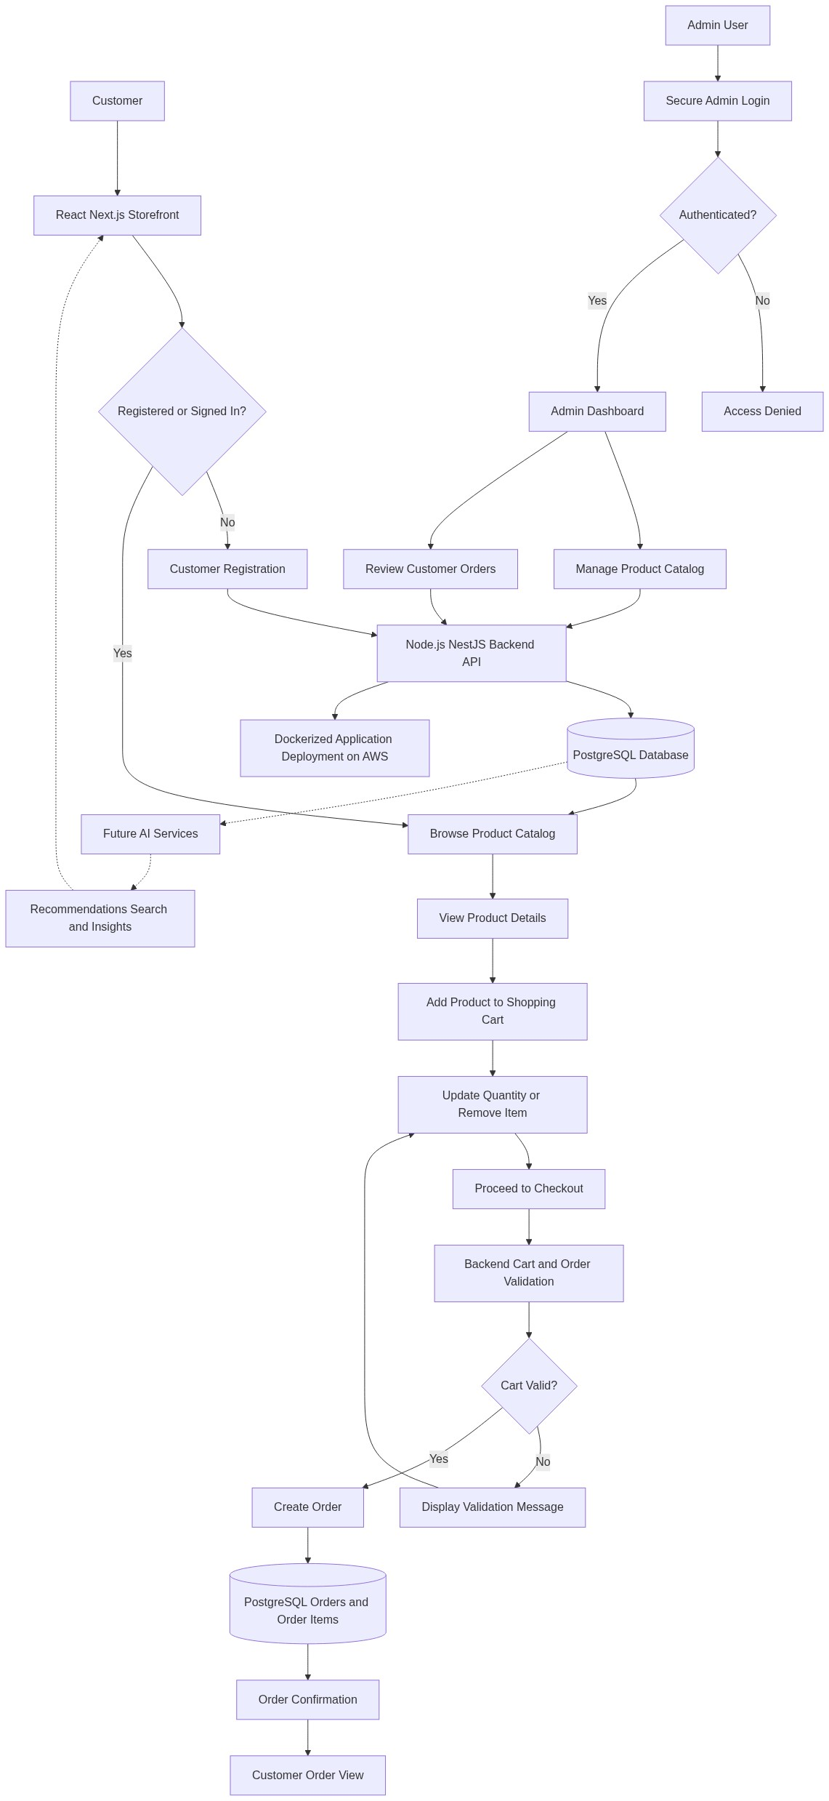
Diagram successfully loaded from mermaid.ink.

6. Development Plan & Timeline
The development cycle is projected at 4 Months. Following the structure of our standard Proof of Concept delivery pipeline, the specific deliverables and timeline phases are detailed below:
Phase | Duration | Output
Phase 1: Discovery, Solution Architecture, and Experience Design | 1 Month | Validated functional backlog, e-commerce user journeys, Figma design prototypes, target solution architecture, data model approach, security considerations, and delivery plan aligned with the Shopy business requirements.
Phase 2: Core Platform Foundation and Catalog Capability | 1 Month | Configured project repositories, Docker-based development setup, initial Continuous Integration and Continuous Delivery pipeline, PostgreSQL schema foundation, authentication framework, product catalog backend services, and initial React Next.js storefront components.
Phase 3: Customer, Cart, Order, and Administrative Modules | 1 Month | Completed customer registration and login flows, shopping cart functionality, checkout and order creation workflow, administrative catalog management, order visibility features, responsive frontend integration, and backend Application Programming Interface validation.
Phase 4: Testing, Stabilization, Deployment Readiness, and Handover | 1 Month | End-to-end testing using Selenium and Playwright, defect remediation, cross-browser validation, deployment readiness on Amazon Web Services, release documentation, administrative handover, and final stakeholder acceptance support.

7. Assumptions & Key Risks
Assumptions
- The client will provide timely confirmation of product catalog attributes, user roles, order lifecycle expectations, branding guidelines, and business rules required to finalize the functional design before development begins.
- The client will make key business stakeholders available for requirement validation, design review, sprint demonstrations, user acceptance feedback, and final launch approval throughout the four-month delivery period.
- Amazon Web Services account access, cloud governance requirements, networking constraints, and deployment approval processes will be made available early enough to avoid delays during environment configuration and release readiness activities.
- Third-party integrations such as payment gateways, shipping providers, inventory management systems, tax engines, and marketing platforms are considered future extensibility points unless explicitly prioritized and approved as part of the current release scope.
- Artificial Intelligence models are not assumed to be implemented as production features in the initial release; however, the platform will maintain structured product, customer, cart, and order data to support future Artificial Intelligence-enabled recommendations, insights, and personalization.
- A dedicated testing environment with representative test data will be available to support functional testing, regression testing, cross-browser validation, and automated test execution using Selenium and Playwright.
- Security approvals, authentication requirements, password policies, administrative access rules, and any organization-specific compliance expectations will be reviewed and approved by the client before production deployment.
- Deployment approvals, domain configuration, Secure Sockets Layer certificate readiness, release windows, and production access procedures will be coordinated by the client in collaboration with the delivery team.
- Product images, brand assets, content copy, category structure, and any legal or policy content required for the storefront will be provided by the client or approved business representatives.
- The estimated budget and delivery timeline are based on the selected resource allocation and the business requirements provided, assuming no material changes to scope, technology direction, or compliance obligations during implementation.
Risks & Mitigation
- Risk: Changes in product catalog rules, order workflows, or administrative requirements during development may increase delivery complexity and affect the four-month timeline. Mitigation: The project will use structured backlog management, stakeholder review checkpoints, and formal change control to assess impact before incorporating scope changes.
- Risk: Delayed access to Amazon Web Services environments, deployment credentials, or infrastructure approvals may postpone integration testing and production readiness. Mitigation: Cloud access requirements will be confirmed during the discovery phase, and environment preparation will be tracked as an early delivery dependency.
- Risk: Misalignment between the approved user experience design and business expectations may lead to rework in the storefront or administrative screens. Mitigation: Figma prototypes will be reviewed with stakeholders before build activities, and agreed design patterns will be used to guide frontend implementation.
- Risk: Authentication and administrative access requirements may become more complex if additional user roles or compliance controls are introduced late in the project. Mitigation: Role and access expectations will be baselined during architecture and backlog planning, with additional access models handled through controlled enhancement requests.
- Risk: Data quality issues in product information, images, pricing, or category structures may affect storefront readiness and customer experience. Mitigation: The delivery team will define required catalog fields and validation rules, while the client will be responsible for providing complete and approved product data.
- Risk: Performance constraints may emerge if expected traffic volumes, catalog size, or order volume assumptions increase beyond the initial launch profile. Mitigation: The architecture will use scalable application patterns on Amazon Web Services, and performance considerations will be reviewed during backend and database design.
- Risk: Automated testing coverage may be constrained if user journeys are changed late or test data is not representative of real business scenarios. Mitigation: Test scenarios will be prepared in parallel with development, and Selenium and Playwright coverage will focus on critical customer and administrative workflows.
- Risk: Future integrations such as payment gateways, shipping services, or inventory synchronization may require additional design decisions not included in the initial release. Mitigation: Backend service boundaries and database models will be designed for extensibility, while integration implementation will be planned as a separate approved phase if required.
- Risk: Resource availability constraints may affect sprint throughput if assigned resources are required to support parallel organizational priorities. Mitigation: Resource allocation will be monitored regularly, priorities will be managed through sprint planning, and escalation will be used if availability materially impacts delivery commitments.
8. Allocated Technical Resources
Resource Name | Assigned Role | Allocated Hours
Anu Banerjee | Frontend Developer | 428 Hours
Serya Mallick | Backend Developer | 428 Hours
Abhijit Dutta | UI/UX Designer | 257 Hours
Abhijit Bhowmick | Automation Tester | 342 Hours
Tanya Saha | Solution Architect | 257 Hours
Shreya Sarkar | Technical Architect | 428 Hours

