NAME: AGNIV PRAMANICK SECTION: A USN: 1NT21IS017 DATE: 29/12/22

Q. Write a program to Convert POSTFIX to PREFIX
THEORY
Prefix Expression:
Another way to describe anything is with a prefix notation, which does not require knowledge about precedence or associativity but does when used with an infix notation. It is also known as polish notation. In prefix notation, an operator comes before the operands.

The syntax of prefix notation is given below:
<operator> <operand> <operand>
Example:
A B - C D - /

Postfix Expression:
When the operator is written after the operands, then it is known as postfix notation. Operand does not have to be always a constant or a variable; it can also be an expression itself.

The syntax for postfix notation is given below:
<operand> <operand> <operator>
Example:
/ - A B - C D
*+AB-CD is the obtained PREFIX expression.
ALGORITHM
Step-1: Scan the postfix expression from left to right.
Step-2: If the element is an operand, then push it into the stack.
Step-3: If the element is an operator, then pop two operands from the stack.
Step-4: Create an expression by concatenating two operands and adding operator before the operands.
Step-5: Push the result back to the stack.
Step-6: Repeat the above steps until we reach the end of the postfix expression.
CODE
#include<stdio.h>
#include<string.h> //library functions are included
#include<stdlib.h>
#define MAX 20 // max size is 20
char str[MAX], stack[MAX]; a string of max size is taken of chartype
int top = -1;
//------------------------------------------------------------------------------------------
void push (char c) // push operation is defined
{
stack[++top] = c; //top incremented
}
//------------------------------------------------------------------------------------------
char pop() //pop function is defined
{
return stack[top--]; //top decremented
}
//-------------------------------------------------------------------------------------------

// A utility function to check if the given character is operand
int checkIfOperand(char ch)
{
return (ch >= 'a' && ch <= 'z') || (ch >= 'A' && ch <= 'Z'); //condition given
}

//-------------------------------------------------------------------------------------------
//function to check if it is an operator
int isOperator(char n) //character is given to check operator
{
switch (n) {
case '+': //addition
case '-': //difference
case '/': //multiplication
case '*': //division
return 1;
}
return 0;
}
//------------------------------------------------------------------------------------------
void postfixToprefix() //conversion will take place here
{
int n, i, j = 0;
char c[20]; //character type array
char a, b, op;
printf("Enter the postfix expression\n");
scanf("%s", str);
n = strlen(str); //string length is taken
for (i = 0; i < MAX; i++)
stack[i] = '\0'; // means null equivalent
printf("Prefix expression is:\t");
for (i = n - 1; i >= 0; i--) //condition
{
if (isOperator(str[i])) //operator is checked
{
push(str[i]); //string is pushed
} else
{
c[j++] = str[i];
while ((top != -1) && (stack[top] == '#')) //condition
{
a = pop(); //pop function called
c[j++] = pop();
}
push('#');
}
}
c[j] = '\0';
i = 0;
j = strlen(c) - 1; j value is equivalent to string length of c -1
char d[20];
while (c[i] != '\0') {
d[j--] = c[i++];
}
printf("%s\n", d); //print the value
}
//------------------------------------------------------------------------------------------
int main() //main function defined
{
postfixToprefix(); //conversion function is called
return 0;
}
//end of code
//------------------------------------------------------------------------------------------
OUTPUT
NOTE: BELOW FIRST ONE IS A LINUX O/P SCREENSHOT

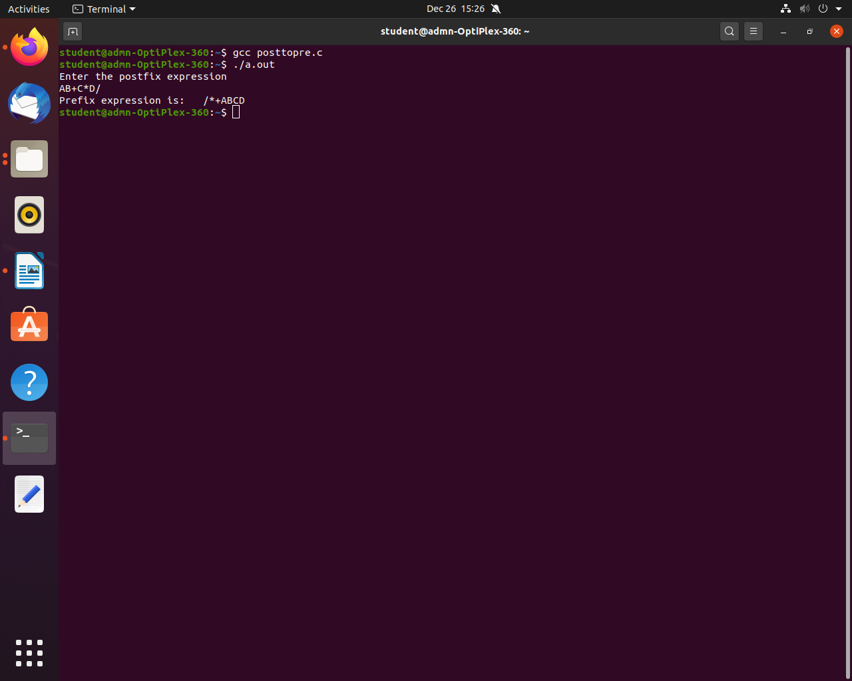
THE NEXT SCREENSHOT IS FROM WINDOWS ON AN ONLINE C COMPILER (programiz.com)

