**Biodepot-workflow-builder**

# 

# USER MANUAL

**Latest version** available at <https://github.com/BioDepot/BioDepot-workflow-builder>

BioDepot can be used to build bioinformatics workflows by combining interchangeable and encapsulated widgets, allowing researchers to easily test other algorithms and observe how the outputs differ. Each of these widgets call a Docker container to execute software tools that could potentially be written in a different programming language, require different system configurations and/or developed by different research groups.

This manual demonstrates the installation and instructions to run orange inside docker.

Docker Image : <https://hub.docker.com/r/biodepot/guidock-lite-orange-qt5>

Dockerfile : [https://github.com](https://github.com/lhhunghimself/guidock-lite-orange-qt5)/[BioDepot/BioDepot-workflow-builder](https://github.com/BioDepot/BioDepot-workflow-builder)

# *Authors*

# Ling-Hong Hung*, Trevor Meiss*, Jayant Keswani, Ka Yee Yeung

# Institute of Technology University of Washington Tacoma, WA, 98402, USA

*Equal contributors.

Corresponding author: Ka Yee Yeung ([kayee@uw.edu](mailto:kayee@uw.edu))

# 

# Table of content

1. Docker Installation

Linux

Mac OS X

Windows

1. Running the Orange application
2. On the Cloud

AWS

1. [Demo](https://drive.google.com/file/d/0BwrbXzAQnOkpTm1iRVFqcTlnQmc/view?usp=sharing)

# 

# 

# 

# 

# 

# 

# Docker Installation

# Linux

## Installing Docker

To install docker go to the terminal and follow the steps

1. Update your APT package index.

#sudo apt-get update

1. Install Docker.

#sudo apt-get install docker-engine

1. Start the docker daemon.

#sudo service docker start

1. Verify docker is installed correctly.

#sudo docker run hello-world

The last command downloads a test image and runs it in a container. When the container runs, it prints an informational message. Then, it exits.

For more information please refer to -

<https://docs.docker.com/engine/installation/linux/ubuntulinux/>

# 

# Mac OS X

# Installing Docker

Your Mac must be running OS X 10.8 “Mountain Lion” or newer to run Docker software or If you have Mac OS X 10.10.3 Yosemite or newer, consider using [Docker for Mac](https://docs.docker.com/docker-for-mac/) instead. It runs natively on the Mac, so there is no need for a preconfigured Docker QuickStart shell. It uses xhyve for virtualization, instead of VirtualBox. Full install prerequisites are provided in the Docker for Mac topic in [Docker for Mac](https://docs.docker.com/docker-for-mac/#what-to-know-before-you-install).

To download to the package - <https://www.docker.com/products/docker-toolbox>

1. Install Docker Toolbox by double-clicking the package or by right-clicking and choosing “Open” from the pop-up menu.
2. The installer launches an introductory dialog, followed by an overview of what’s installed.
3. Press Continue to install the toolbox.
4. The installer presents you with options to customize the standard installation.
5. By default, the standard Docker Toolbox installation:
   * installs binaries for the Docker tools in /usr/local/bin
   * makes these binaries available to all users
   * updates any existing VirtualBox installation
6. For now, don’t change any of the defaults.
7. Press Install to perform the standard installation.
8. The system prompts you for your password.
9. Provide your password to continue with the installation.
10. When it completes, the installer provides you with some shortcuts. You can ignore this for now and click Continue.
11. Then click Close to finish the installer.

**To run a Docker container:**

* create a new (or start an existing) Docker Engine host running
* switch your environment to your new VM
* use the docker client to create, load, and manage containers

Once you create a machine, you can reuse it as often as you like. Like any Virtual Box VM, it maintains its configuration between uses.

1. Open the Launchpad and locate the Docker Quickstart Terminal icon.
2. Click the icon to launch a Docker Quickstart Terminal window.
3. The terminal does a number of things to set up Docker Quickstart Terminal for you.
4. Click your mouse in the terminal window to make it active.
5. The prompt is traditionally a $ dollar sign. You type commands into the *command line* which is the area after the prompt. Your cursor is indicated by a highlighted area or a | that appears in the command line. After typing a command, always press RETURN.
6. Type the docker run hello-world command and press RETURN.

The last command downloads a test image and runs it in a container. When the container runs, it prints an informational message. Then, it exits.

# Windows

## Installing Docker

If you have a newer system, specifically 64bit Windows 10 Pro, with Enterprise and Education (1511 November update, Build 10586 or later), consider using [Docker for Windows](https://docs.docker.com/docker-for-windows) instead. It runs natively on the Windows, so there is no need for a preconfigured Docker QuickStart shell. It also uses Hyper-V for virtualization.

To download to the package - <https://www.docker.com/products/docker-toolbox>

1. Go to folder where the installation file is saved and run the installation file.
2. Click the installer link to download.
3. Install Docker Toolbox by double-clicking the installer.
4. The installer launches the “Setup - Docker Toolbox” dialog.
5. If Windows security dialog prompts you to allow the program to make a change, choose Yes. The system displays the Setup - Docker Toolbox for Windows Wizard.
6. Press Next to accept all the defaults and then Install.
7. Accept all the installer defaults. The installer takes a few minutes to install all the components:
8. When notified by Windows Security the installer will make changes, make sure you allow the installer to make the necessary changes.
9. When it completes, the installer reports it was successful:

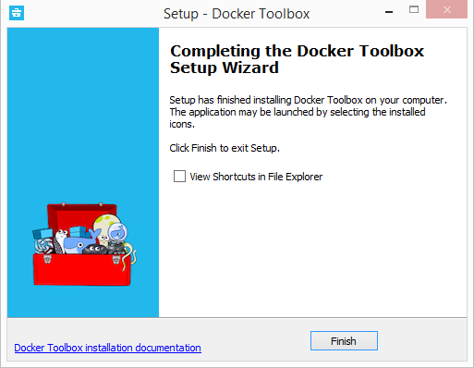

1. Uncheck “View Shortcuts in File Explorer” and press Finish.

**To run a Docker container:**

The installer places Docker Toolbox and VirtualBox in your Applications folder. In this step, you start Docker Toolbox and run a simple Docker command.

1. On your Desktop, find the Docker Toolbox icon.

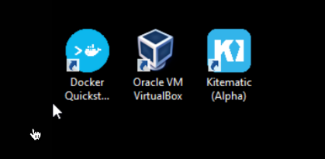

1. Click the icon to launch a Docker Toolbox terminal.
2. If the system displays a User Account Control prompt to allow VirtualBox to make changes to your computer. Choose Yes.
3. The terminal does several things to set up Docker Toolbox for you. When it is done, the terminal displays the $ prompt.

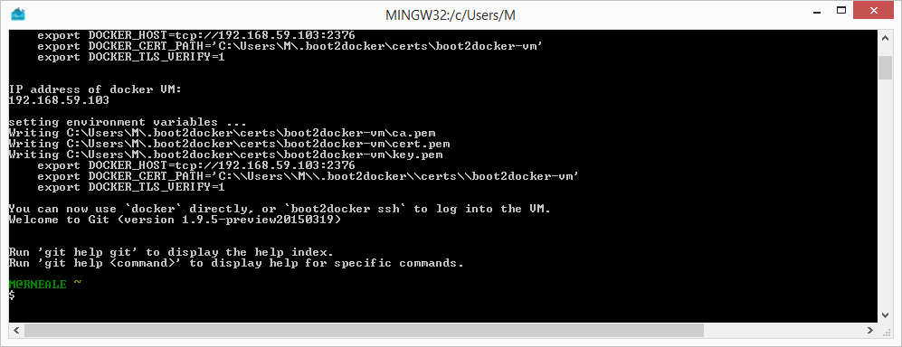

1. The terminal runs a special bash environment instead of the standard Windows command prompt. The bash environment is required by Docker.
2. Make the terminal active by click your mouse next to the $ prompt.



1. The prompt is traditionally a $ dollar sign. You type commands into the *command line* which is the area after the prompt. Your cursor is indicated by a highlighted area or a | that appears in the command line. After typing a command, always press RETURN.
2. Type the docker run hello-world command and press RETURN.

The last command downloads a test image and runs it in a container. When the container runs, it prints an informational message. Then, it exits.

# **Running the** Orange **application**

After you have installed docker on your machine, launch docker and type the following commands on Docker terminal to install and run the Orange application (same across all the platforms)

1. Downloading the image

# docker pull biodepot/guidock-lite-orange-qt5:biowidgets

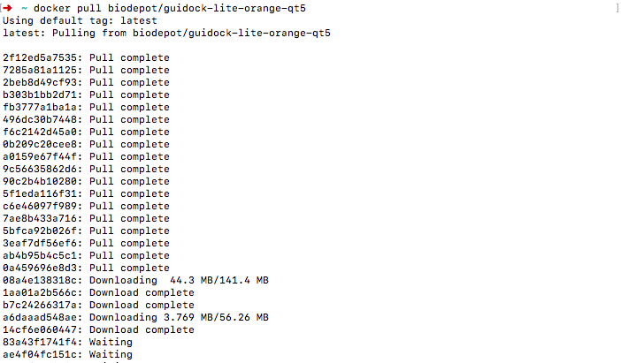

1. Running the application

# docker run -it -v /var/run/docker.sock:/var/run/docker.sock -p 6080:6080 biodepot/guidock-lite-orange-qt5:biowidgets

Once the container is running you can open any of the browser to interact with it by using the default alpine port 6080 or you can check the port and IP at which the service is running by using docker command – # docker ps

Type the URL http://dockerMachineIPAddress:6080 on the browser and Orange window should popup.

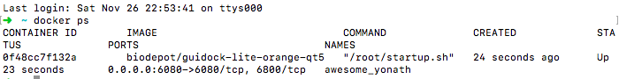

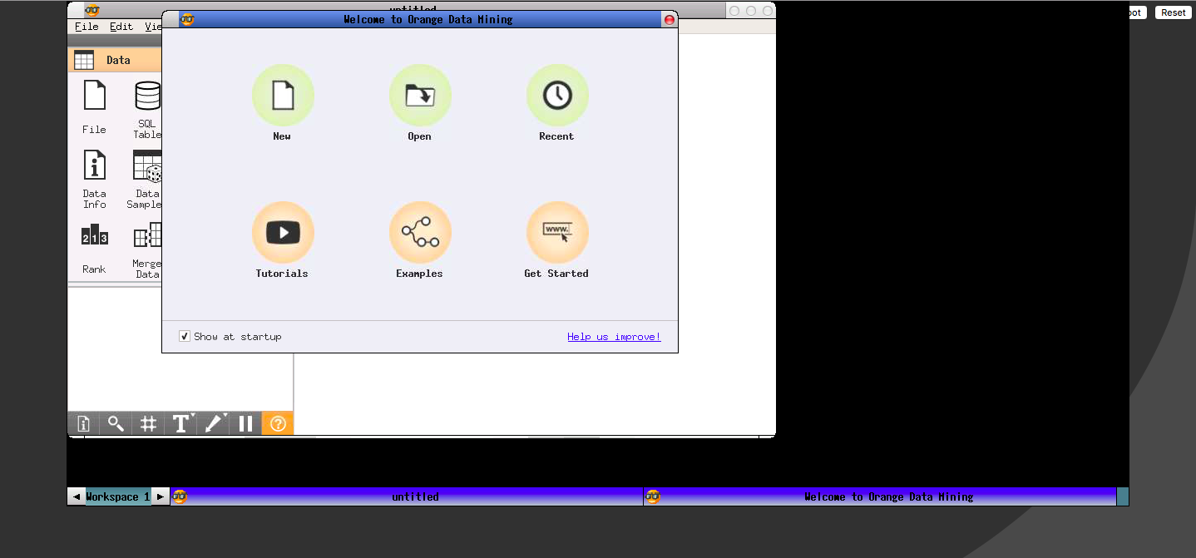

Fig: Orange running in browser

# 

# 

# 

# 

# 

# On The Cloud

On the cloud, GUIdock-lite-orange can also be run on any cloud instances. Please refer to the Linux and Windows to install GUIdock-lite-orange on the cloud corresponds with the operating system installed for the cloud instance.

# Amazon AWS

1. Login to your console and create a new EC2 instance of ubuntu (Here we are using ubuntu you can choose operating system of your choice)
2. Select the configuration and click on “Review and Launch”
3. You will be prompted to associate a ssh key pair with the instance, you can use an existing key pair or create a new one. The key will be downloaded onto the computer which will be later used to ssh into the machine.
4. Once the instance is running select your instance and scroll right for security groups.

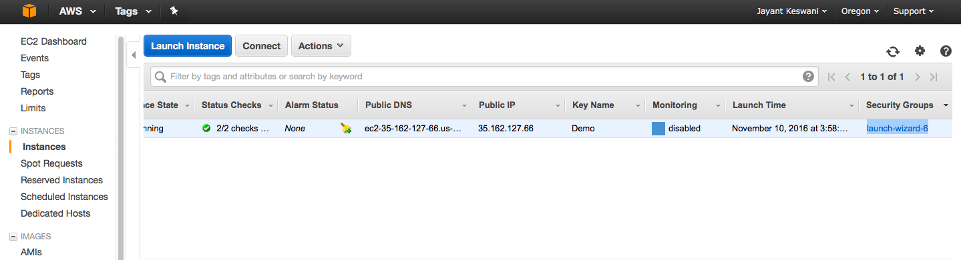

1. From “Actions” button select “Edit inbound rules”

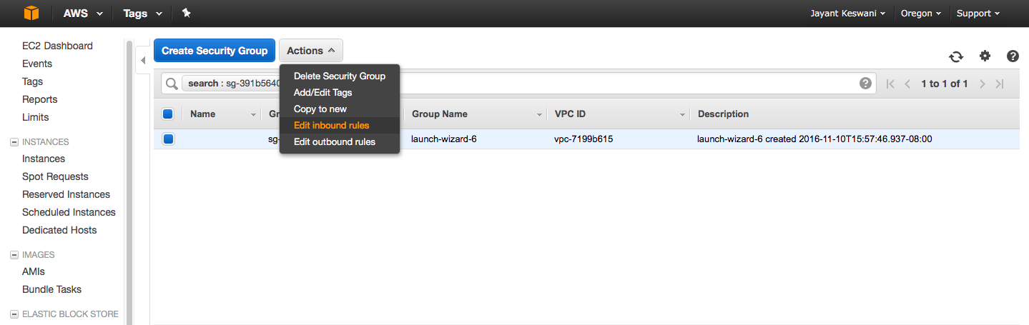

1. Add a new http rule for port 6080 to access the GUI from the container

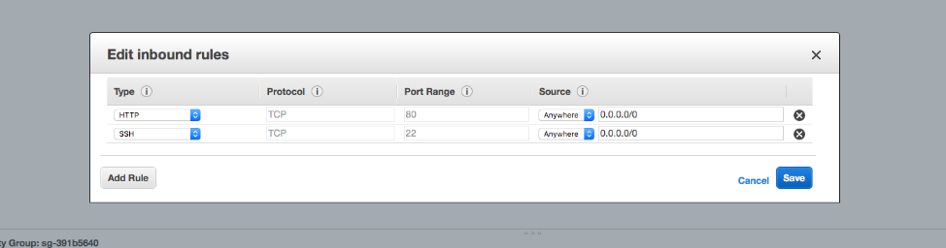

1. Copy the public dns of the instance

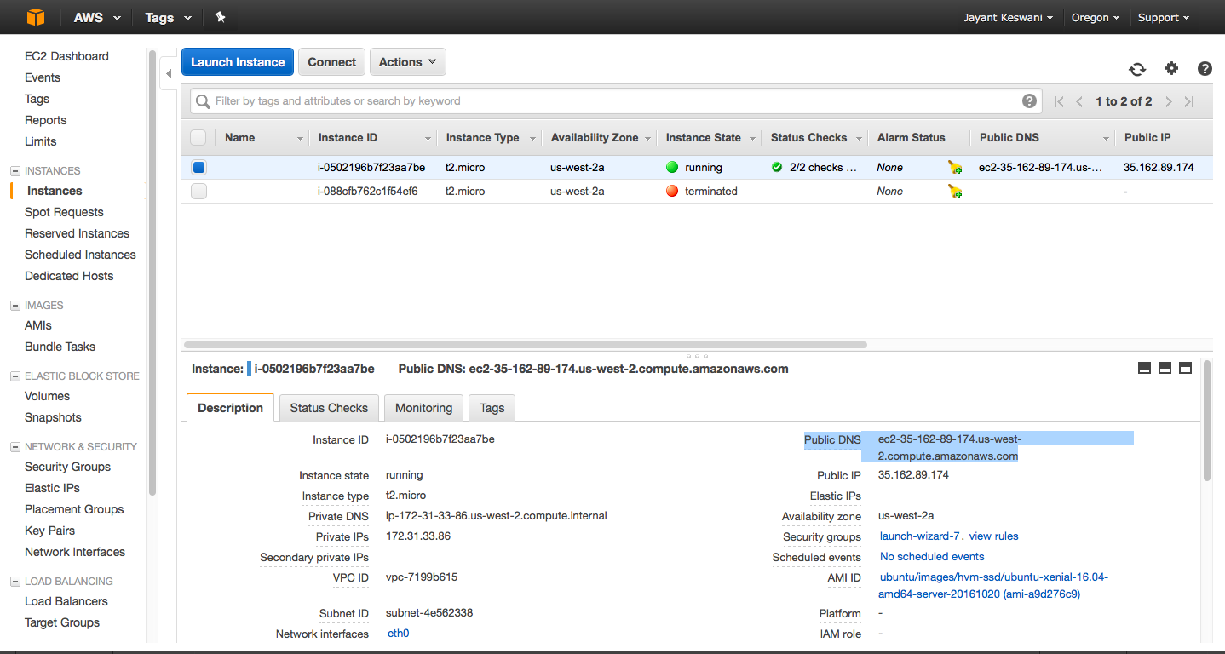

1. SSH into the instance by typing the following command into the terminal.

(Type the commands in the directory where the ssh key of AWS instance was downloaded)

# chmod 400 demo.pen (demo.pen is name of the key)

# ssh -i demo.pen ubuntu@public-dns-of-aws-instance

1. After you are logged in type these commands to install docker on the instance

# sudo apt-get update

# sudo apt-get install docker.io

# sudo docker run -it -p 6080:6080 -v ${PWD}:/local guidock-lite-orange

1. Use your favorite browser and go to the address to access the container

public-dns-of-aws-instance:6080

public-ip-of aws-instance:6080

1. Select the cytoscape application from the start menu

## Firewall Configurations

Please refer to the following documentations for more information:

* Google Cloud Platform: <https://cloud.google.com/compute/docs/networking>
* Amazon Web Services: <http://docs.aws.amazon.com/AWSEC2/latest/UserGuide/authorizing-access-to-an-instance.html>
* Microsoft Azure: <https://azure.microsoft.com/en-us/documentation/articles/virtual-machines-windows-classic-setup-endpoints/>

## On Distributed Docker Platform

GUIdock-lite-orange can also be run on a distributed Docker Platform (e.g. Google Container, Docker Swarm, or Amazon EC2 Container Service). GUIdock-lite-orange is not designed for distributed system, hence, running multiple container does not increase the container’s performance --instead each single containers serve as an independent container. Accessing the container can be performed using the container’s public IP address from a web browser.

**Demo**Here is the link to the -- [demo](https://drive.google.com/drive/u/3/folders/0B6xuS_tbRDJ0aUFFaFhGQjZaM2s)