Angerona — System Architecture Flow
AngeronaSuite (canonical GUI app) · src/angerona/
Document version 1.6.1 · 2026-07-11
Supersedes the earlier 7-node data-flow diagram of the same document name — see §3

1. Current Flow — 6-Node World View Grid
This is the operational cycle as actually shipped in gui/flow_window.py + core/flow_metrics.py and shown live in the app behind the 🌐 World View button. It replaced an earlier 7-node single-row layout (1460px wide, whose fitInView scale made 11pt node text render at ~7.5pt — effectively invisible) with a compact 2×3 grid at a readable scale.
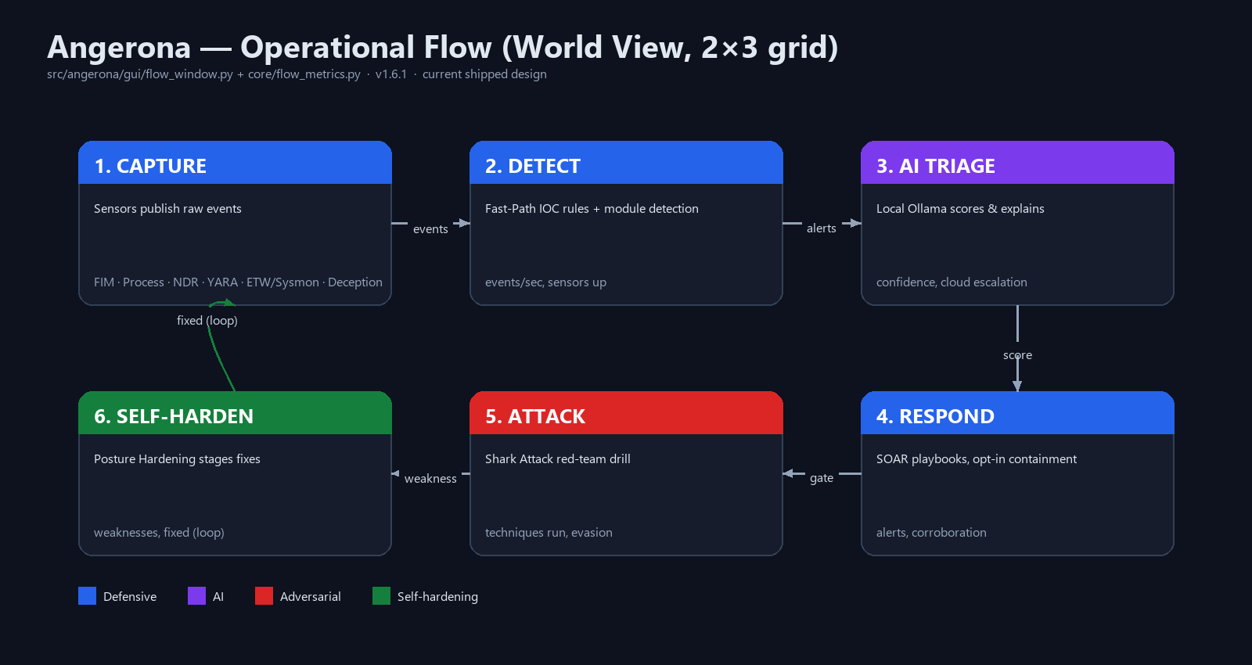
2. Node Reference
# | Node | Colour | Role | Live metrics
1 | CAPTURE | Blue — defensive | Sensors publish raw events: File Integrity Monitor, Process Monitor, Network/NDR, YARA, ETW/Sysmon listeners, Active Deception canaries. | events/sec, sensors up, state
2 | DETECT | Blue — defensive | EventBus fan-out plus the 17-rule deterministic Fast-Path Interceptor (FPTH), which can emit CRITICAL immediately, bypassing AI triage. | events/sec, sensors up
3 | AI TRIAGE | Purple — AI | Local Ollama (llama3) scores and explains serious events; escalates to opt-in cloud (Gemini → OpenRouter) only above the confidence/severity threshold. | confidence, cloud escalation
4 | RESPOND | Blue — defensive | SOAR plays a recommendation, or (opt-in) auto-contains — kill/suspend/isolate — after SOAR Corroboration confirms a second sensor. | alerts, corroboration
5 | ATTACK | Red — adversarial | The Shark Attack red-team engine (shark/shark_attack.py) drills the whole loop end-to-end using benign tagged footprints only. | techniques run, evasion level
6 | SELF-HARDEN | Green — self-hardening | Posture Hardening tails the after-action report; any SUCCESS/low-detection technique becomes a staged, review-gated remediation, then the cycle loops to CAPTURE. | weaknesses found, fixed count

3. Retired Design — Why This Document Was Regenerated
An existing file of the same name (Angerona_System_Flow.docx, found both at the repository root and in AngeronaSuite/) describes a different, older architecture: a 7-node single-row data-flow pipeline — Sensors → Telemetry Bus → Dynamic Patch Engine → GPU Offload → AI Guardrail → Ollama LLM → Self-Hardening Core — with a separate “Circular trust” section on hook/blinding/tamper scenarios. That diagram describes real subsystems (the GPU entropy pipeline, the AI guardrail proxy) but is not the flowchart the running application renders or that tools/selfcheck.py validates.
tools/selfcheck.py itself carried two assertions still checking that retired 7-node shape until this pass (see the Vulnerabilities Assessment & Remediation document, finding V-02) — direct evidence the 7-node description had drifted from the shipped 6-node grid. Rather than editing the old file's different diagram in place, this is a new deliverable describing the current, correct flow; the older file is left untouched at its existing path for historical reference.
4. Trust & Failure Modes (carried forward, still accurate)
- Hook APIs to blind sensors → caught by APID (API-patch / anti-blinding detector) comparing live export prologues against pristine System32 copies.
- Drop telemetry without hooking → DRILL canary misses (no 4688 echo within 6s) raise a telemetry-blinding alert.
- Freeze the process to stop DRILL → FRZ's out-of-process Go watchdog detects the stalled heartbeat and isolates the host / hard-kills the interpreter.
- Tamper a staged fix on disk → the SHA-256 Judgment Gate re-verifies the exact bytes at execution time and blocks a mismatch.

