Angerona — System Architecture Flow
AngeronaSuite (canonical GUI app) · src/angerona/
Document version 1.7.6 · 2026-07-14
Supersedes the earlier 7-node data-flow diagram of the same document name — see §3

1. Current Flow — 6-Node World View Grid
This is the operational cycle as actually shipped in gui/flow_window.py + core/flow_metrics.py and shown live in the app behind the 🌐 World View button. It replaced an earlier 7-node single-row layout (1460px wide, whose fitInView scale made 11pt node text render at ~7.5pt — effectively invisible) with a compact 2×3 grid at a readable scale.
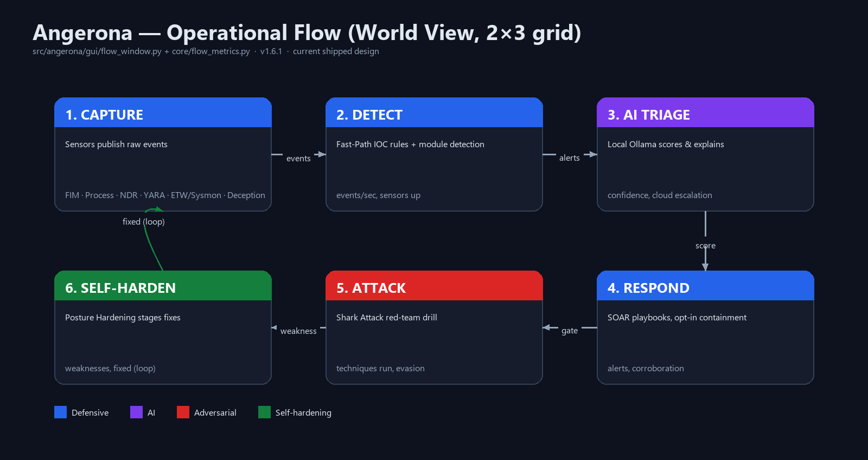
2. Node Reference
# | Node | Colour | Role | Live metrics
1 | CAPTURE | Blue — defensive | Sensors publish raw events. DRILL arms a bounded Telemetry Expectation Contract and accepts only the matching trusted ETW/EID 4688 process-creation echo before its deadline. | events/sec, sensors up, state
2 | DETECT | Blue — defensive | EventBus fan-out, deterministic Fast-Path rules, and Evidence Lattice Fusion. ELAT emits an explainable HIGH only when three modules across two sensor domains corroborate the same structured entity. | events/sec, sensors up
3 | AI TRIAGE | Purple — AI | Local Ollama (llama3) scores and explains serious events; escalates to opt-in cloud (Gemini → OpenRouter) only above the confidence/severity threshold. | confidence, cloud escalation
4 | RESPOND | Blue — defensive | SOAR plays a recommendation, or (opt-in) auto-contains — kill/suspend/isolate — after SOAR Corroboration confirms a second sensor. | alerts, corroboration
5 | ATTACK | Red — adversarial | The Shark Attack red-team engine (shark/shark_attack.py) drills the whole loop end-to-end using benign tagged footprints only. | techniques run, evasion level
6 | SELF-HARDEN | Green — self-hardening | Posture Hardening tails the after-action report; any SUCCESS/low-detection technique becomes a staged, review-gated remediation, then the cycle loops to CAPTURE. | weaknesses found, fixed count

3. Retired Design — Why This Document Was Regenerated
An existing file of the same name (Angerona_System_Flow.docx, found both at the repository root and in AngeronaSuite/) describes a different, older architecture: a 7-node single-row data-flow pipeline — Sensors → Telemetry Bus → Dynamic Patch Engine → GPU Offload → AI Guardrail → Ollama LLM → Self-Hardening Core — with a separate “Circular trust” section on hook/blinding/tamper scenarios. That diagram describes real subsystems (the GPU entropy pipeline, the AI guardrail proxy) but is not the flowchart the running application renders or that tools/selfcheck.py validates.
tools/selfcheck.py itself carried two assertions still checking that retired 7-node shape until this pass (see the Vulnerabilities Assessment & Remediation document, finding V-02) — direct evidence the 7-node description had drifted from the shipped 6-node grid. Rather than editing the old file's different diagram in place, this is a new deliverable describing the current, correct flow; the older file is left untouched at its existing path for historical reference.
4. Trust & Failure Modes (carried forward, still accurate)
- Hook APIs to blind sensors → caught by APID (API-patch / anti-blinding detector) comparing live export prologues against pristine System32 copies.
- Drop telemetry without hooking → DRILL canary misses (no 4688 echo within 6s) raise a telemetry-blinding alert.
- Freeze the process to stop DRILL → FRZ's out-of-process Go watchdog detects the stalled heartbeat and isolates the host / hard-kills the interpreter.
- Tamper a staged fix on disk → the SHA-256 Judgment Gate re-verifies the exact bytes at execution time and blocks a mismatch.
- Reach a C2 after containment → the RESPOND node's active-defense isolation adds a hidden netsh outbound-block firewall rule for the contained process (Angerona-Isolate-<name>-<pid>), so a suspended or resumed process still cannot beacon out. Corroborated attacks are also reconstructed as ATT&CK kill-chains (core/incident_timeline.py) for triage.

Stability and Remediation Sweep — 14 July 2026
This addendum records the code, performance, crash-log, and remediation-report sweep completed against the Angerona v1.7.4 baseline. It supplements earlier assessment text; it is internal validation evidence, not an independent certification.

Evidence reviewed
- Native crash history, UI non-response snapshots, remediation-attempt logs, and current after-action reports.
- Security Assessment v2.0, Vulnerabilities Assessment/Remediation v1.7.4, and loop remediation summaries.
- Current source, GUI refresh paths, event/storage behavior, module discovery, and PowerShell remediation gates.

Implemented corrections
Area | Status | Correction
Native stability | Fixed by safe default | Twenty-one recorded native access violations converged on direct in-process AmsiScanBuffer health checks. AMSI Bridge now defaults to ETW/Sysmon observation; direct ctypes AMSI is explicit compatibility-test opt-in only.
Long-run UI | Fixed | Flight Instructor work is bounded to one worker and an eight-item coalescing queue; flow-metric disk writes are off the Qt thread; alert-table gap rebuilds are burst-throttled.
Diagnostics | Fixed | UI watchdog snapshots are main-thread focused, rate-limited to 60 seconds, and rotated at 4 MB instead of growing without bound.
Event delivery | Fixed | Removed permanent INFO suppression after the in-memory history reached 85% capacity. The bounded deque rolls off old history while new events continue to subscribers and storage.
History dialogs | Fixed | Interactive 24-hour event views use severity-filtered SQL capped at 500 newest rows. After-Action Reports retain complete, uncapped run-window queries.
GUI exceptions | Fixed | Sandbox Editor uses valid QTextCursor movement enums; Settings uses the implemented autostart enable/disable functions; unchanged module-status tables are no longer rebuilt every 1.5 seconds.
A-04 | Closed in default configuration | External Python drop-ins no longer execute automatically. Trusted development environments must explicitly set ANGERONA_EXTERNAL_MODULES=1.
A-07 | Closed | Shadow Shield path identifiers now use SHA-256 instead of SHA-1.
A-06 | Partially addressed | AI fix and revert scripts now reject additional defense-weakening, persistence, remote-execution, scheduled-task/service, Run-key, and firewall-disable patterns. A single centralized PowerShell executor/audit boundary remains recommended.

Validation
Compilation and focused event-bus, storage, AMSI-default, and CVE-guardrail tests passed. The complete headless regression suite completed 26 of 26 phases with zero failures and a clean process exit, including the live benign red-team simulation and After-Action path.

Residual assurance work
- Run a true multi-hour desktop soak with representative alert and red-team bursts; the headless suite is not a substitute for elapsed-time GUI validation.
- Keep ANGERONA_AMSI_INPROCESS disabled unless testing a known-compatible runtime; native ctypes failures cannot be recovered by Python exception handling.
- Centralize every PowerShell invocation behind one policy, approval, integrity, and append-only audit boundary to fully close A-06.
- Treat external modules as privileged code and leave external discovery disabled in normal deployments.
Superseding validation note: where an earlier 14 July addendum cites a 61-check module report, this sweep's final release-gate result is 26/26 end-to-end phases; individual stopped/idle modules remain reported as expected skips inside the module-level diagnostic output.

Improvement Loop Release - 14 July 2026 (v1.7.5)
Architecture changes
- ELAT sits in DETECT as a bounded, response-free evidence-quality layer. TECT connects DRILL's benign CAPTURE probe to an exact DETECT echo and cannot itself alert, persist, or act.
- Event history remains bounded while new INFO events continue to every subscriber and the signed recorder. Generated YARA now crosses a compile/atomic-activation boundary; generated containment crosses a strict command gate before staging and an AST gate before execution.
- Performance changes are outside the logical six-node sequence: static Coverage content builds once, flow-metric writes leave the Qt thread, history dialogs are query-bounded, Flight Cache inserts avoid per-event COUNT scans, and shared sensor-cache misses coalesce.

Validation and remaining work
- Release gates passed: 177/177 Python files compiled; 62/62 module files imported; 61 modules discovered with zero errors or duplicate codes; the full self-check passed 26/26 phases with zero failures.
- Deferred security boundaries: Remote Bridge mutual authentication plus AEAD/mTLS (R2-02), an Administrator-owned packaged runtime and plug-in trust root (R3-01), and privileged/non-exportable ledger-key custody (R3-02). Broad PowerShell execution centralization (A-06) also remains open.
- Proposed, not shipped: detector reuse of the shared connection cache, a global MCP request-worker cap, bounded reverse/indexed Evolution-feed lookup, isolated counterfactual replay, offline telemetry-failure mutation, keyed causal-ledger checkpoints, and local novelty sketches.
v1.7.6 note: the planned unifying layer is the Angerona Cortex (core/cortex.py) — an entity-graph correlation brain that fuses every module's signals into one per-entity malice verdict feeding the RESPOND node and the single Angerona Score. Built as an additive, read-only MVP (self-tested, unwired).

